How to install and use rsync?

|  |  |  |  |  |  |
| --- | --- | --- | --- | --- | --- |
| No. | Version | Date | Description | Modified By | Document Name |
| 1 | V0.1 | Sept 26 2023 | Draft version | Marco Antonio Jimenez Cornejo | How to install and use rsync |

Rsync can simplify file transfer over network connections and strengthen local directory synchronization. The flexibility of rsync makes it a good choice for many operations with different file levels.

Mastering rsync allows you to design complex backup operations and get detailed control over what is transferred and how.The basic syntaxis of rsync is very simple, and operates similarly to ssh, scp, and cp and because of its popularity it is included in systems for Linux and default for Linux and Unix.

**Transfer files between the same ECS**

Step 1: Create a Linux ECS

Step 2: Login to the ECS

Step 3: Create two test directories and some test files

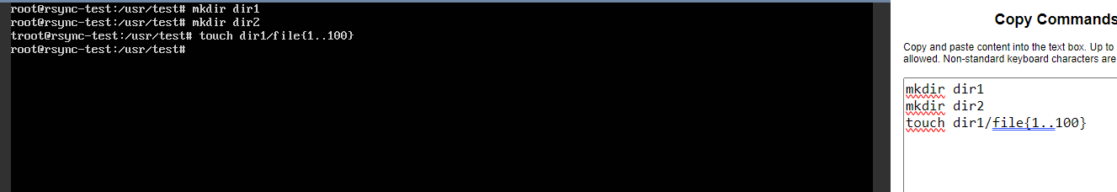

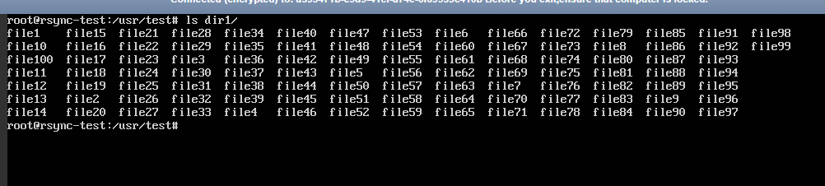

Now we have a directory called dir1 with 100 empty files and an empty directory called dir2.

Step 4: To synchronize the contents of dir1 to dir2 on the same system we need run the following command.

>rsync -r dir1/ dir2

**Note:** The -r option means recursive. Which is necessary to directory synchronization.

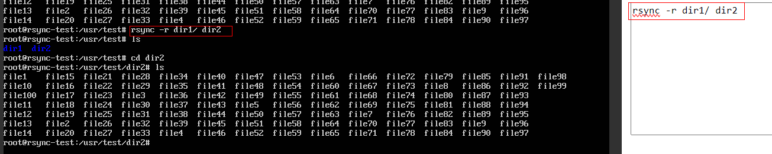

**Migrating Local ECS with a remote system**

**Scenario:** We can synchronize with another ECS if we have SSH to the remote computer and rsync installed on both sites.



Step 1: Run the full migration command.

>rsync -avHPX --sparse --one-file-system --numeric-ids --stats /usr/test/dir1/ root@119.8.10.243:/usr/target_rsync_test/dir1/

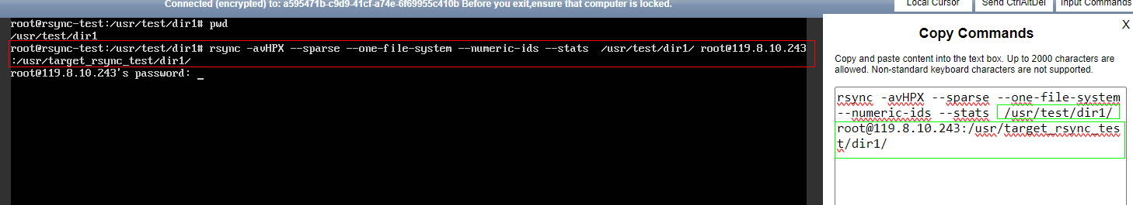

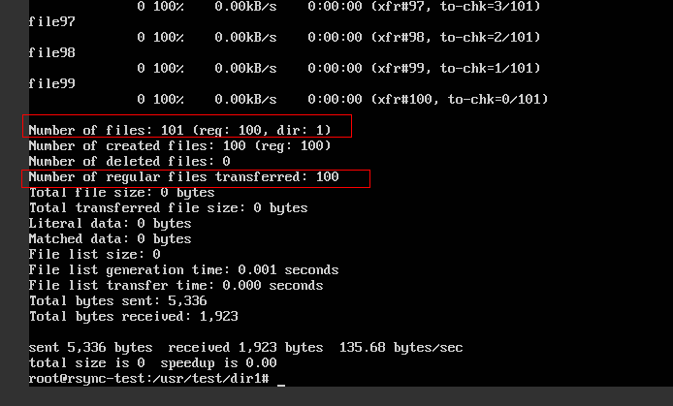

Step 2: You can make sure that the data verification is complete.

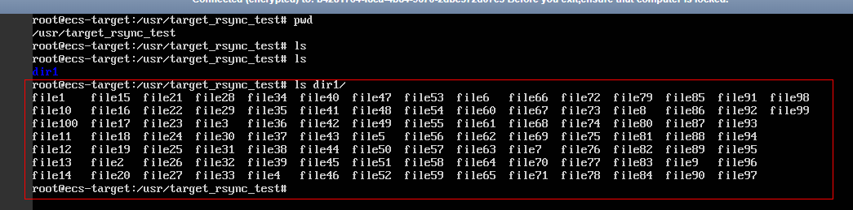

**Migrating Local EVS Data to SFS**

**Scenario:** Data migration from local EVS to SFS storage in the same region.

Step 1: Log in the source ECS using the console or remote access tool (such as PuTTY).

Step 2: Run the following command to check whether the NFS client is installed on the ECS.

>rmp -qa|grep nfs

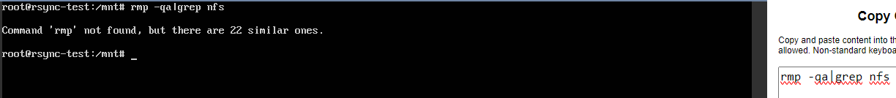

Step 3: Run the following command to install the nfs client

>apt install nfs-common

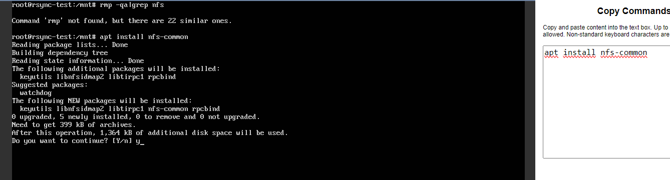

Step 4: Run the following command to mount the SFS.

> mount -t nfs -o vers=3,nolock 192.168.0.51:/ /mnt/sfs_turbo

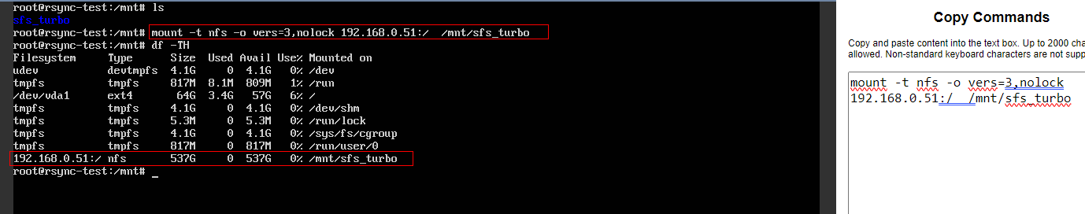

Step 5: To synchronize the contents of “dir1” to “sfs-b” on the same system we need run the following command.

> rsync -r /usr/test/dir1/ /mnt/sfs_turbo/sfs-b/

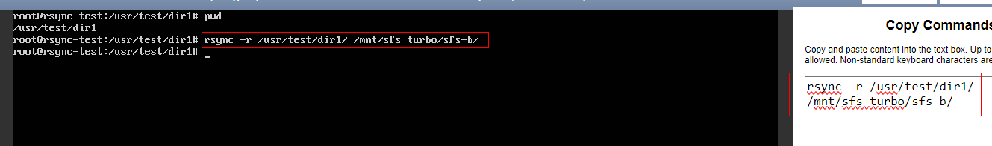

Step 6: You can make sure that the data verification is complete.

