How to install and use Fpsync?

|  |  |  |  |  |  |
| --- | --- | --- | --- | --- | --- |
| No. | Version | Date | Description | Modified By | Document Name |
| 1 | V0.1 | Sep 27 2023 | Draft version | Marco Antonio Jimenez Cornejo | How to install and use Fpsync |

This tool is a shell that wraps fpart, rsync, cpio and tar to launch several synchronization jobs in parallel. It can execute several synchronization processes locally or launch them on several nodes through SSH, fpsync has quickly evolved into a powerful migration tool and has been successfully used to boost migration of several PB of data.

In addition to being very fast, fpsync is able to resume or replay synchronization and presents an overall progress status. It also has a small memory footprint compared to rsync itself when migrating file systems with a big number of files.

Principle of fpsync, “through 8 concurrent synchronization jobs spread over two machines (machine 1 & machine 2)”.

|  |
| --- |
| fpsync -n 8 -w login@machine1 -w login@machine2 -d /mnt/fpsync /mnt/src/ /mnt/dst/ |

Synchronizes /mnt/src/ to /mnt/dst/ using 8 concurrent executed jobs remotely on 2 SSH workers (machine1 and machine2). The shared directory is set to /mnt/fpsync and mounted on the machine running fpsync, as well as on machine 1 and machine 2. The source directory (/mnt/src/) is also available on those 3 machines while the destination directory (/mnt/dst/) is mounted on SSH workers only (machine1 and machine2).

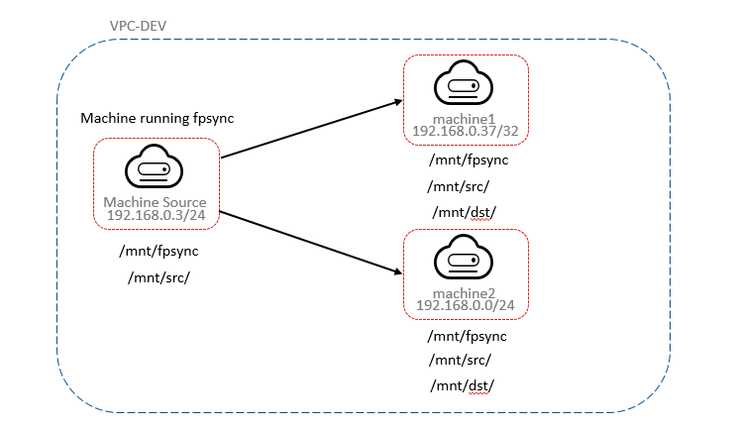

**Transfer files between the same ECS**

Step 1: Create a Linux ECS

Step 2: Login to the ECS

Step 3: Install fpsync

Ubuntu: apt-get install fpart

Centos: yum intstall fpart

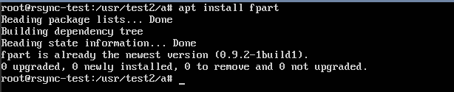

Step 4: Create two test directories and some test files

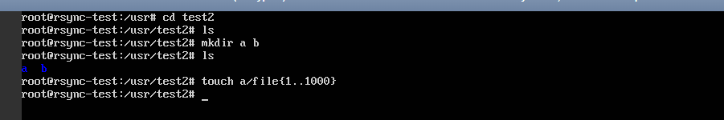



Now we have a directory called “a” with 1000 empty files and an empty directory called “b”.

Step 5: To synchronize the contents of dir1 to dir2 on the same system we need run the following command.

>fpsync -n 4 /usr/test2/a /usr/test2/b

**Note:** The “-n 4” option means we will use 4 local workers per job.



Step 6: You can make sure that the data verification is complete.

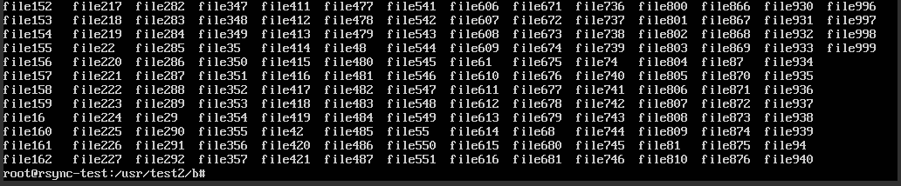

**Migrating Local EVS Data to SFS**

**Scenario:** Data migration from local EVS to SFS storage in the same region.

Step 1: Log in the source ECS using the console or remote access tool (such as PuTTY).

Step 2: Run the following command to check whether the NFS client is installed on the ECS.

>rmp -qa|grep nfs

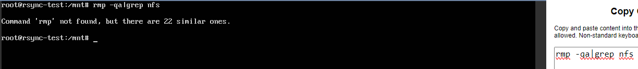

Step 3: Run the following command to install the nfs client

>apt install nfs-common

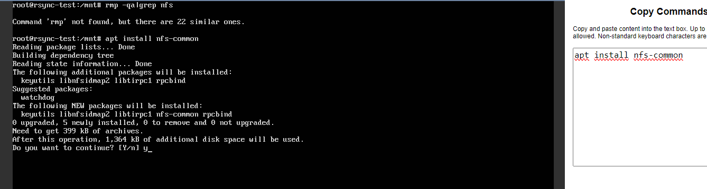

Step 4: Run the following command to mount the SFS.

> mount -t nfs -o vers=3,nolock 192.168.0.51:/ /mnt/sfs_turbo

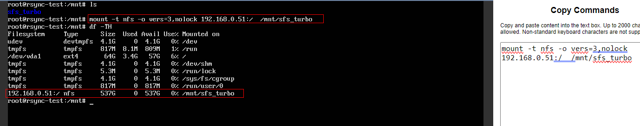

Step 5: To synchronize the contents of “a” to “sfs_c” on the same system we need run the following command.

> fpsync -n 4 /usr/test2/a /mnt/sfs_turbo/sfs_c/

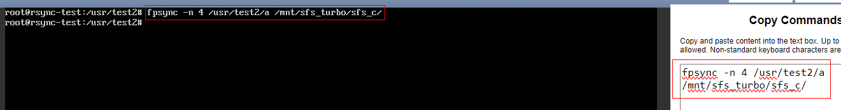

Step 6: You can make sure that the data verification is complete.

