MPEG-7 Audio provides structures—in conjunction with the Multimedia Description Schemes part of the standard—for describing audio content. Utilizing those structures are a set of low-level Descriptors, for audio features that cut across many applications (e.g., spectral, parametric, and temporal features of a signal), and high-level Description Tools that are more specific to a set of applications. Those high-level tools include general sound recognition and indexing Description Tools, instrumental timbre Description Tools, spoken content Description Tools, an audio signature Description Scheme, and melodic Description Tools to facilitate query-by-humming.
Figure 1 below shows a highly abstract block diagram of a possible MPEG-7 processing chain, included here to explain the scope of the MPEG-7 standard. This chain includes feature extraction (analysis), the description itself, and the search engine (application). To fully exploit the possibilities of MPEG-7 descriptions, automatic extraction of features will be extremely useful. It is also clear that automatic extraction is not always possible, however. As was noted above, the higher the level of abstraction, the more difficult automatic extraction is, and interactive extraction tools will be of good use. However useful they are, neither automatic nor semi-automatic feature extraction algorithms are inside the scope of the standard. The main reason is that their standardization is not required to allow interoperability, while leaving space for industry competition. Another reason not to standardize analysis is to allow making good use of the expected improvements in these technical areas.
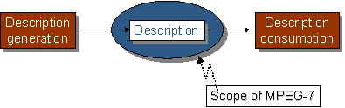
Figure 1: Scope of MPEG-7
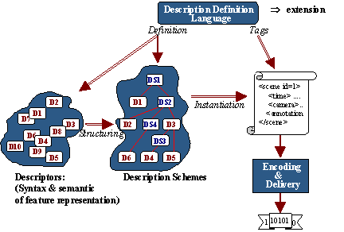
Figure 2: MPEG-7 main elements
Figure 2 shows the relationship among the different MPEG-7 elements introduced above. The DDL allows the definition of the MPEG-7 description tools, both Descriptors and Description Schemes, providing the means for structuring the Ds into DSs. The DDL also allows the extension for specific applications of particular DSs. The description tools are instantiated as descriptions in textual format (XML) thanks to the DDL (based on XML Schema). Binary format of descriptions is obtained by means of the BiM defined in the Systems part.
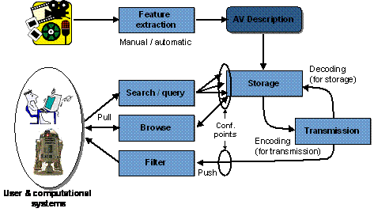
Figure 3: Abstract representation of possible applications using MPEG-7
AV- Audio Visual
Figure 3 explains a hypothetical MPEG-7 chain in practice. From the multimedia content an Audio-visual description is obtained via manual or semi-automatic extraction. The AV description may be stored (as depicted in the figure) or streamed directly. If we consider a pull scenario, client applications will submit queries to the descriptions repository and will receive a set of descriptions matching the query for browsing (just for inspecting the description, for manipulating it, for retrieving the described content, etc.). In a push scenario a filter (e.g., an intelligent agent) will select descriptions from the available ones and perform the programmed actions afterwards (e.g., switching a broadcast channel or recording the described stream). In both scenarios, all the modules may handle descriptions coded in MPEG-7 formats (either textual or binary), but only at the indicated conformance points it is required to be MPEG-7 conformant (as they show the interfaces between an application acting as information server and information consumer).
Query Example: Play a few notes on a keyboard and retrieve a list of musical pieces similar to the required tune.
The goal of the MPEG-7 standard is to allow interoperable searching, indexing, filtering and access of audio-visual (AV) content. MPEG-7 describes specific features of AV content as well as information related to AV content management. MPEG-7 descriptions take two possible forms: (1) a textual XML form suitable for editing, searching, and filtering, and (2) a binary form suitable for storage, transmission, and streaming delivery. Overall, the standard specifies four types of normative elements: Descriptors, Description Schemes (DSs), a Description Definition Language (DDL), and coding schemes.
The MPEG-7 Descriptors are designed primarily to describe low-level audio or visual features such as color, texture, motion, audio energy, and so forth, as well as attributes of AV content such as location, time, quality, and so forth. It is expected that most Descriptors for low-level features shall be extracted automatically in applications.

MPEG-7 Audio
MPEG-7 Audio provides structures—building upon some basic structures from the MDS—for describing audio content. Utilizing those structures are a set of low-level Descriptors, for audio features that cut across many applications (e.g., spectral, parametric, and temporal features of a signal), and high-level Description Tools that are more specific to a set of applications. Those high-level tools include the audio signature Description Scheme, musical instrument timbre Description Schemes, the melody Description Tools to aid query-by-humming, general sound recognition and indexing Description Tools, and spoken content Description Tools.

MPEG-7 Audio Framework
The Audio Framework contains low-level tools designed to provide a basis for the construction of higher level audio applications. By providing a common platform for the structure of descriptions and the basic semantics for commonly regarded audio features, MPEG-7 Audio establishes a platform for interoperability across all applications that might be built on the framework. The framework provides structures appropriate for representing audio features, and a basic set of features.

Structures
There are essentially two ways of describing low-level audio features. One may sample values at regular intervals or one may use Segments to demark regions of similarity and dissimilarity within the sound. Both of these possibilities are embodied in two low-level descriptor types (one for scalar values, such as power or fundamental frequency, and one for vector types, such as spectra), which create a consistent interface. Any descriptor inheriting from these types can be instantiated, describing a segment with a single summary value or a series of sampled values, as the application requires.
The sampled values themselves may be further manipulated through another unified interface: they can form a Scalable Series. The Scalable Series allows one to progressively down-sample the data contained in a series, as the application, bandwidth, or storage requires. This hierarchical re-sampling forms a sort of ‘scale tree,’ which may also store various summary values along the way, such as minimum, maximum, mean, and variance of the descriptor values.

Features
The low-level audio Descriptors are of general importance in describing audio. There are seventeen temporal and spectral Descriptors that may be used in a variety of applications. They can be roughly divided into the following groups:
- Basic
- Basic Spectral
- Signal Parameters
- Timbral Temporal
- Timbral Spectral
- Spectral Basis
Additionally, a very simple but useful tool is the MPEG-7 silence Descriptor. Each of these classes of audio Descriptors can be seen in Figure 26 and are briefly described below.
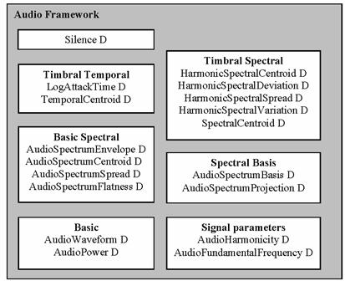
Figure 26: Overview of Audio Framework including Descriptors.

1. Basic
The two basic audio Descriptors are temporally sampled scalar values for general use, applicable to all kinds of signals.
The Audio-Waveform Descriptor describes the audio waveform envelope (minimum and maximum), typically for display purposes.
The Audio-Power Descriptor describes the temporally-smoothed instantaneous power, which is useful as a quick summary of a signal, and in conjunction with the power spectrum, below.

2. Basic Spectral
The four basic spectral audio Descriptors all share a common basis, all deriving from a single time-frequency analysis of an audio signal. They are all informed by the first Descriptor, the Audio-Spectrum-Envelope Descriptor, which is a logarithmic-frequency spectrum, spaced by a power-of-two divisor or multiple of an octave. This Audio Spectrum Envelope is a vector that describes the short-term power spectrum of an audio signal. It may be used to display a spectrogram, to synthesize a crude “auralization” of the data, or as a general-purpose descriptor for search and comparison.
The Audio-Spectrum-Centroid Descriptor describes the center of gravity of the log-frequency power spectrum. This Descriptor is an economical description of the shape of the power spectrum, indicating whether the spectral content of a signal is dominated by high or low frequencies.
The Audio-Spectrum-Spread Descriptor complements the previous Descriptor by describing the second moment of the log-frequency power spectrum, indicating whether the power spectrum is centered near the spectral centroid, or spread out over the spectrum. This may help distinguish between pure-tone and noise-like sounds.
The Audio-Spectrum-Flatness Descriptor describes the flatness properties of the spectrum of an audio signal for each of a number of frequency bands. When this vector indicates a high deviation from a flat spectral shape for a given band, it may signal the presence of tonal components.

3. Signal Parameters
The two signal parameter Descriptors apply chiefly to periodic or quasi-periodic signals.
The Audio-Fundamental-Frequency descriptor describes the fundamental frequency of an audio signal. The representation of this descriptor allows for a confidence measure in recognition of the fact that the various extraction methods, commonly called “pitch-tracking,” are not perfectly accurate, and in recognition of the fact that there may be sections of a signal (e.g., noise) for which no fundamental frequency may be extracted.
The Audio-Harmonicity Descriptor represents the harmonicity of a signal, allowing distinction between sounds with a harmonic spectrum (e.g., musical tones or voiced speech [e.g., vowels]), sounds with an inharmonic spectrum (e.g., metallic or bell-like sounds) and sounds with a non-harmonic spectrum (e.g., noise, unvoiced speech [e.g., fricatives like ‘f’], or dense mixtures of instruments).

4. Timbral Temporal
The two timbral temporal Descriptors describe temporal characteristics of segments of sounds, and are especially useful for the description of musical timbre (characteristic tone quality independent of pitch and loudness). Because a single scalar value is used to represent the evolution of a sound or an audio segment in time, these Descriptors are not applicable for use with the Scalable Series.
The Log-Attack-Time Descriptor characterizes the “attack” of a sound, the time it takes for the signal to rise from silence to the maximum amplitude. This feature signifies the difference between a sudden and a smooth sound.
The Temporal-Centroid-Descriptor also characterizes the signal envelope, representing where in time the energy of a signal is focused. This Descriptor may, for example, distinguish between a decaying piano note and a sustained organ note, when the lengths and the attacks of the two notes are identical.

5. Timbral Spectral
The five timbral spectral Descriptors are spectral features in a linear-frequency space especially applicable to the perception of musical timbre.
The Spectral-Centroid-Descriptor is the power-weighted average of the frequency of the bins in the linear power spectrum. As such, it is very similar to the Audio-Spectrum-Centroid Descriptor, but specialized for use in distinguishing musical instrument timbres. It is has a high correlation with the perceptual feature of the “sharpness” of a sound.
The four remaining timbral spectral Descriptors operate on the harmonic regularly-spaced components of signals. For this reason, the descriptors are computed in linear-frequency space.
The Harmonic-Spectral-Centroid is the amplitude-weighted mean of the harmonic peaks of the spectrum. It has a similar semantic to the other centroid Descriptors, but applies only to the harmonic (non-noise) parts of the musical tone.
The Harmonic-Spectral-Deviation Descriptor indicates the spectral deviation of log-amplitude components from a global spectral envelope.
The Harmonic-Spectral-Spread describes the amplitude-weighted standard deviation of the harmonic peaks of the spectrum, normalized by the instantaneous Harmonic-Spectral-Centroid.
The Harmonic-Spectral-Variation Descriptor is the normalized correlation between the amplitude of the harmonic peaks between two subsequent time-slices of the signal.

6. Spectral Basis
The two spectral basis Descriptors represent low-dimensional projections of a high-dimensional spectral space to aid compactness and recognition. These descriptors are used primarily with the Sound Classification and Indexing Description Tools, but may be of use with other types of applications as well.
The Audio-Spectrum-Basis-Descriptor is a series of (potentially time-varying and/or statistically independent) basis functions that are derived from the singular value decomposition of a normalized power spectrum.
The Audio-Spectrum-Projection-Descriptor is used together with the Audio-Spectrum-Basis Descriptor, and represents low-dimensional features of a spectrum after projection upon a reduced rank basis.
Together, the descriptors may be used to view and to represent compactly the independent subspaces of a spectrogram. Often these independent subspaces (or groups thereof) correlate strongly with different sound sources. Thus one gets more salience and structure out of a spectrogram while using less space. For example, in Figure 27, a pop song is represented by an Audio-Spectrum-Envelope Descriptor, and visualized using a spectrogram. The same song has been data-reduced in Figure 28, and yet the individual instruments become more salient in this representation.
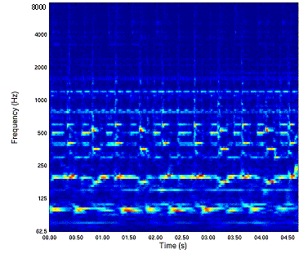
Figure 27: Audio-Spectrum-Envelope description of a pop song. The required data storage is NM values where N is the number of spectrum bins and M is the number of time points

7. Silence segment
The silence segment simply attaches the simple semantic of “silence” (i.e. no significant sound) to an Audio Segment. Although it is extremely simple, it is a very effective descriptor. It may be used to aid further segmentation of the audio stream, or as a hint not to process a segment.

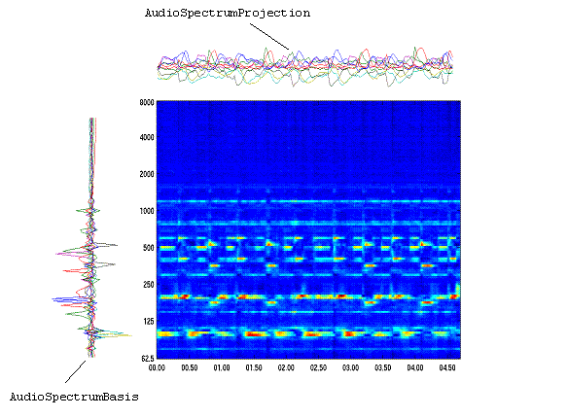
Figure 28: A 10-basis component reconstruction showing most of the detail of the original spectrogram including guitar, bass guitar, hi-hat and organ notes. The left vectors are an Audio-Spectrum-Basis Descriptor and the top vectors are the corresponding Audio-Spectrum-Projection Descriptor. The required data storage is 10(M+N) values

High-level audio Description Tools (Ds and DSs)
Because there is a smaller set of audio features (as compared to visual features) that may canonically represent a sound without domain-specific knowledge, MPEG-7 Audio includes a set of specialized high-level tools that exchange some degree of generality for descriptive richness. The five sets of audio Description Tools that roughly correspond to application areas are integrated in the standard: audio signature, musical instrument timbre, melody description, general sound recognition and indexing, and spoken content. The latter two are excellent examples of how the Audio Framework and MDS Description Tools may be integrated to support other applications.

1. Audio Signature Description Scheme
While low-level audio Descriptors in general can serve many conceivable applications, the spectral flatness Descriptor specifically supports the functionality of robust matching of audio signals. The Descriptor is statistically summarized in the Audio-Signature-Description-Scheme as a condensed representation of an audio signal designed to provide a unique content identifier for the purpose of robust automatic identification of audio signals. Applications include audio fingerprinting, identification of audio based on a database of known works and, thus, locating metadata for legacy audio content without metadata annotation.

2. Musical Instrument Timbre Description Tools
Timbre Descriptors aim at describing perceptual features of instrument sounds. Timbre is currently defined in the literature as the perceptual features that make two sounds having the same pitch and loudness sound different. The aim of the Timbre Description Tools is to describe these perceptual features with a reduced set of Descriptors. The Descriptors relate to notions such as “attack”, “brightness” or “richness” of a sound.
Within four possible classes of musical instrument sounds, two classes are well detailed, and had been the subject of extensive development within MPEG-7:
Harmonic, coherent, sustained sounds, and non-sustained, percussive sounds are represented in the standard.
The Harmonic-Instrument-Timbre Descriptor for sustained harmonic sounds combines the four harmonic timbral spectral Descriptors [Harmonic-Spectral-Centroid, Harmonic-Spectral-Deviation, Harmonic-Spectral-Spread, Harmonic-Spectral-Variation] with the Log-Attack-Time Descriptor.
The Percussive-Instrument-Timbre Descriptor combines the timbral temporal Descriptors with a Spectral-Centroid Descriptor.
Comparisons between descriptions using either set of Descriptors are done with an experimentally-derived scaled distance metric.

3. Melody Description Tools
The melody Description Tools include a rich representation for monophonic melodic information to facilitate efficient, robust, and expressive melodic similarity matching. The Melody Description Scheme includes a Melody-Contour Description Scheme for extremely terse, efficient melody contour representation, and a Melody-Sequence Description Scheme for a more verbose, complete, expressive melody representation. Both tools support matching between melodies, and can support optional supporting information about the melody that may further aid content-based search, including query-by-humming.
The Melody-Contour Description Scheme uses a 5-step contour (representing the interval difference between adjacent notes), in which intervals are quantized into large or small intervals, up, down, or the same. The Melody Contour DS also represents basic rhythmic information by storing the number of the nearest whole beat of each note, which can dramatically increase the accuracy of matches to a query.
For applications requiring greater descriptive precision or reconstruction of a given melody, the Melody-Sequence Description Scheme supports an expanded descriptor set and high precision of interval encoding. Rather than quantizing to one of five levels, the precise pitch interval (to cent or greater precision) between notes is kept. Precise rhythmic information is kept by encoding the logarithmic ratio of differences between the onsets of notes in a manner similar to the pitch interval. Arrayed about these core Descriptors are a series of optional support Descriptors such as lyrics, key, meter, and starting note, to be used as desired by an application.

4. General Sound Recognition and Indexing Description Tools
The general sound recognition and indexing Description Tools are a collection of tools for indexing and categorization of general sounds, with immediate application to sound effects. The tools enable automatic sound identification and indexing, and the specification of a Classification Scheme of sound classes and tools for specifying hierarchies of sound recognizers. Such recognizers may be used to automatically index and segment sound tracks. Thus the Description Tools address recognition and representation all the way from low-level signal-based analyses, through mid-level statistical models, to highly semantic labels for sound classes.
The recognition tools use the low-level spectral basis Descriptors as their foundation (see Spectral Basis). These basis functions are then collected into a series of states that comprise a statistical model (the Sound-Model Description Scheme), such as a hidden Markov or Gaussian mixture model. The Sound-Classification-Model Description Scheme combines a set of Sound-Models into a multi-way classifier for automatic labelling of audio segments using terms from a Classification Scheme. The resulting probabilistic classifiers may recognize broad sounds classes, such as speech and music, or they can be trained to identify narrower categories such as male, female, trumpet, or violin. Other applications include genre classification and voice recognition.
A Sound-Model-State-Path Descriptor consists of a sequence of indices to states generated by a Sound-Model, given an audio segment. This simple Descriptor provides a compact description of a sound segment, and can be used for quick comparisons with other models. The Sound-Model-State-Histogram Descriptor consists of a normalized histogram of the state sequence generated by a Sound-Model. The descriptor may be used to compare sound segments via their histograms of their state activation patterns.

5. Spoken Content Description Tools
The spoken content Description Tools allow detailed description of words spoken within an audio stream. In recognition of the fact that current Automatic Speech Recognition (ASR) technologies have their limits, and that one will always encounter out-of-vocabulary utterances, the spoken content Description Tools sacrifice some compactness for robustness of search. To accomplish this, the tools represent the output and what might normally be seen as intermediate results of Automatic Speech Recognition (ASR). The tools can be used for two broad classes of retrieval scenario: indexing into and retrieval of an audio stream, and indexing of multimedia objects annotated with speech.
The Spoken Content Description Tools are divided into two broad functional units: the Spoken-Content-Lattice Description Scheme, which represents the actual decoding produced by an ASR engine, and the Spoken-Content-Header, which contains information about the speakers being recognized and the recognizer itself.
The Spoken-Content-Header contains a number of components that are usable by any Spoken-Content-Lattice. The header contains a Word-Lexicon Descriptor and a Phone-Lexicon Descriptor, the former being an indexed list of tokens representing the repertoire of words of a recognizer, and the latter being the repertoire of phonetic components for a recognizer. There may be a Confusion-Info Descriptor, which provides a confusion matrix and other insertion and deletion statistics for each entry in the Phone-Lexicon. There must be a Speaker-Info Descriptor, which conveys information about the person speaking in the audio, such as their vocabulary and phonetic repertoire, a characterization of their common speaking habits (Confusion-Info), the language they’re speaking, and information about them as a person (inherited from MDS’s Person-Type) such as their name. Additionally, within the Spoken-Content-Header, there may be additional information on how the description was generated.
The Spoken-Content-Lattice Description Scheme consists blocks of nodes. Nodes are connected by Word-Links or Phone-Links, each of which links refers to a word or phone in the lexicon. Nodes are also indexed and are given a time-Offset from the beginning of the lattice. This highly flexible, but relatively compact, description format thus allows one to represent utterances with combinations of alternatives between words and phonemes. By combining these lattices, the problem of out-of-vocabulary words is greatly alleviated and retrieval may still be carried out when the original word recognition was in error. A simplified Spoken-Content-Lattice is depicted in Figure 29.
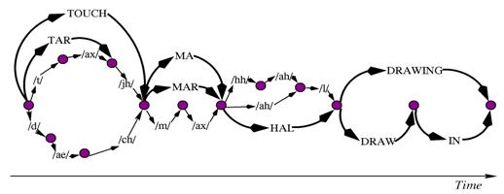
Figure 29: A lattice structure for an hypothetical (combined phone and word) decoding of the expression “Taj Mahal drawing …”. It is assumed that the name ‘Taj Mahal’ is out of the vocabulary of the ASR system
Example applications for the spoken content Description Tools include:
• Recall of audio/video data by memorable spoken events. An example would be a film or video recording where a character or person spoke a particular word or sequence of words. The source media would be known, and the query would return a position in the media.
• Spoken Document Retrieval. In this case, there is a database consisting of separate spoken documents. The result of the query is the relevant documents, and optionally the position in those documents of the matched speech.
• Annotated Media Retrieval. This is similar to spoken document retrieval, but the spoken part of the media would generally be quite short (a few seconds). The result of the query is the media which is annotated with speech, and not the speech itself. An example is a photograph retrieved using a spoken annotation.
=======================================
In MPEG-7, the DSs are categorized as pertaining to the multimedia, audio, or visual domain. Typically, the multimedia DSs describe content consisting of a combination of audio, visual data, and possibly textual data, whereas, the audio or visual DSs refer specifically to features unique to the audio or visual domain, respectively. In some cases, automatic tools can be used for instantiating the DSs, but in many cases instantiating DSs requires human assisted extraction or authoring tools.
Figure 4 provides an overview of the organization of MPEG-7 Multimedia DSs into the following areas: Basic Elements, Content Description, Content Management, Content Description, Content Organization, Navigation and Access, and User Interaction.
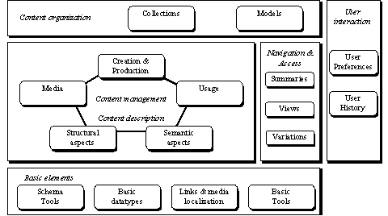
Figure 4: Overview of the MPEG-7 Multimedia DSs

Content Description
MPEG-7 provides DSs for description of the structure and semantics of AV content. The structural tools describe the structure of the AV content in terms of video segments, frames, still and moving regions and audio segments. The semantic tools describe the objects, events, and notions from the real world that are captured by the AV content.
The functionality of each of these classes of DSs is given as follows:
Structural aspects: describes the audio-visual content from the viewpoint of its structure. The Structure DSs are organized around a Segment DS that represents the spatial, temporal or spatio-temporal structure of the audio-visual content. The Segment DS can be organized into a hierarchical structure to produce a Table of Content for accessing or Index for searching the audio-visual content. The Segments can be further described on the basis of perceptual features using MPEG-7 Descriptors for color, texture, shape, motion, audio features, and so forth, and semantic information using Textual Annotations. The MPEG-7 Structure DSs are further discussed in Section Error: Reference source not found.
Conceptual aspects: describes the audio-visual content from the viewpoint of real-world semantics and conceptual notions. The Semantic DSs involve entities such as objects, events, abstract concepts and relationships. The Structure DSs and Semantic DSs are related by a set of links, which allows the audio-visual content to be described on the basis of both content structure and semantics together. The links relate different Semantic concepts to the instances within the audio-visual content described by the Segments.

Navigation and Access
MPEG-7 provides also DSs for facilitating browsing and retrieval of audio-visual content by defining summaries, partitions and decompositions, and variations of the audio-visual material.
Summaries: provide compact summaries of the audio-visual content to enable discovery, browsing, navigation, visualization and sonification of audio-visual content. The Summary DSs involve two types of navigation modes: hierarchical and sequential. In the hierarchical mode, the information is organized into successive levels, each describing the audio-visual content at a different level of detail. In general, the levels closer to the root of the hierarchy provide more coarse summaries, and levels further from the root provide more detailed summaries. The sequential summary provides a sequence of images or video frames, possibly synchronized with audio, which may compose a slide-show or audio-visual skim.
Partitions and Decompositions: describe different decompositions of the audio-visual signals in space, time and frequency. The partitions and decompositions can be used to describe different views of the audio-visual data, which is important for multi-resolution access and progressive retrieval.
Variations: provide information about different variations of audio-visual programs, such as summaries and abstracts; scaled, compressed and low-resolution versions; and versions with different languages and modalities – audio, video, image, text, and so forth. One of the targeted functionalities of the Variation DS is to allow the selection of the most suitable variation of an audio-visual program, which can replace the original, if necessary, to adapt to the different capabilities of terminal devices, network conditions or user preferences.

Content Organization
MPEG-7 provides also DSs for organizing and modeling collections of audio-visual content and of descriptions. The Collection DS organizes collections of audio-visual content, segments, events, and/or objects. This allows each collection to be described as a whole based on the common properties.

User Interaction
Finally, the last set of MPEG-7 DSs deals with User Interaction. The User Interaction DSs describe user preferences and usage history pertaining to the consumption of the multimedia material. This allows, for example, matching between user preferences and MPEG-7 content descriptions in order to facilitate personalization of audio-visual content access, presentation and consumption.
Abstractions
Beside the semantic description of individual instances in audio-visual content, MPEG-7 Semantic DSs also allow the description of abstractions. Abstraction refers to the process of taking a description from a specific instance of audio-visual content and generalizing it to a set of multiple instances of audio-visual content or to a set of specific descriptions.
Beside the semantic description of individual instances in audio-visual content, MPEG-7 Semantic DSs also allow the description of abstractions. Abstraction refers to the process of taking a description from a specific instance of audio-visual content and generalizing it to a set of multiple instances of audio-visual content or to a set of specific descriptions.
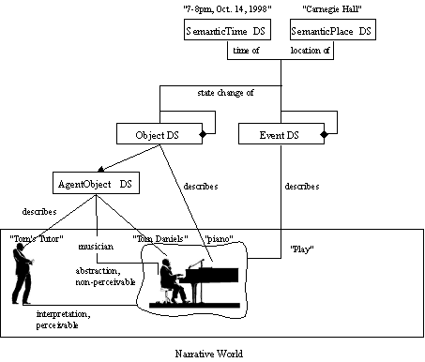

Summaries
HierarchicalSummary DS: The HierarchicalSummary DS describes the organization of summaries into multiple levels in order to describe different levels of temporal detail. The HierarchicalSummary DS is constructed around the generic notion of temporal segments of AV content, described by HighlightSegment DSs. Each HighlightSegment contains locators to the AV content that provide access to the associated key-videoclips, key-audioclips, key-frames and key-sounds. Each may also contain textual annotations that describe the key-themes. These audio-visual segments are grouped into summaries, or highlights, using the HighlightSummary DS.

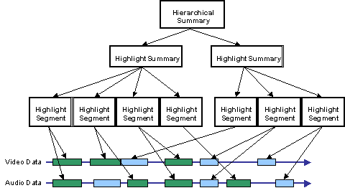
Figure 15: Illustration of HierarchicalSummary DS containing two summaries
Figure 16 shows an example of a hierarchical summary of a soccer video. The HierarchicalSummary description gives three levels of detail. In this example, the video of the soccer game is summarized into a single frame at the root. The next level of the hierarchy provides three frames that summarize different segments of the video. Finally, the bottom level provides additional frames, depicting in more detail the scenes depicted in the segments.
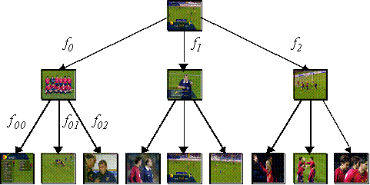
Figure 16: Example of a Hierarchical Summary of a video of a soccer game providing a multiple level key-frame hierarchy. The Hierarchical Summary denotes the fidelity (i.e., f₀, f₁) of each key-frame with respect to the video segment referred to by the key-frames at the next lower level.

View DS: the View DS describes a space or frequency view of an audio or visual signal. The SpaceView DS describes a spatial view of an audio or visual signal, for example, a spatial segment of an image. The FrequencyView DS describes a view of an audio or visual signal within a particular frequency band, for example, a wavelet subband of an audio signal. The SpaceFrequencyView DS describes a multi-dimensional view of an audio or visual signal simultaneously in space and frequency, for example, a wavelet subband of a spatial segment of an image. The ResolutionView DS describes a low-resolution view of an audio or visual signal, such as a thumbnail view of an image. A SpaceResolutionView DS describes a view simultaneously in space and resolution of an audio or visual signal, for example, a low-resolution view of a spatial segment of an image.
Variations of the Content.
The Variation DS describes variations of the AV content, such as compressed or low-resolution versions, summaries, different languages, and different modalities, such as audio, video, image, text, and so forth. One of the targeted functionalities of the Variation DS is to allow a server or proxy to select the most suitable variation of the AV content for delivery according to the capabilities of terminal devices, network conditions, or user preferences. The variation type attribute indicates the type of variation, such as summary, abstract, extract, modality translation, language translation, color reduction, spatial reduction, rate reduction, compression, and so forth.
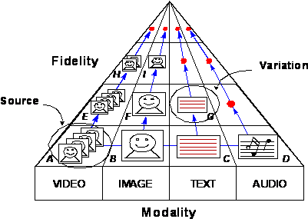
Figure 18: Illustration of variations of a source AV program.

Content Organization
MPEG-7 provides DSs for organizing and modeling collections of audio-visual content, segments, events, and/or objects, and describing their common properties. The collections can be further described using different models and statistics in order to characterize the attributes of the collection members.

Collections
The Collection Structure DS describes collections of audio-visual content or pieces of audio-visual material such as temporal segments of video. The Collection Structure DS groups the audio-visual content, segments, events, or objects into collection clusters and specifies properties that are common to the elements. The CollectionStructure DS describes also statistics and models of the attribute values of the elements, such as a mean color histogram for a collection of images. The CollectionStructure DS also describes relationships among collection clusters.
Figure 19 shows the conceptual organization of the collections within the CollectionStructure DS. In this example, each collection consists of a set of images with common properties, for example, each depicting similar events in a soccer game. Within each collection, the relationships among the images can be specified, such as the degree of similarity of the images in the cluster. Across the collections, the CollectionStructure DS specifies additional relationships, such as the degree of similarity of the collections.
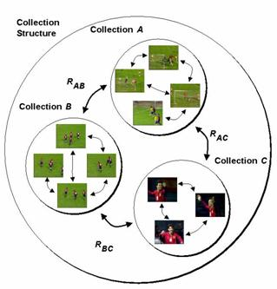
Figure 19: The Collection Structure DS describes collections of audio-visual content including the relationships (i.e., R_{AB}, R_{BC}, R_{AC}) within and across Collection Clusters.

Models
The Analytic Model DSs describe collections of examples of audio-visual data or clusters of Descriptors that provide models for particular semantic classes. The Analytic Model DS specifies semantic labels that indicate the classes being modeled. The Analytic Model DSs also optionally specify the confidence in which the semantic labels are assigned to the models. Further built from the analytic models in MPEG-7 are classifiers. The Classifier DSs describe different types of classifiers that are used to assign semantic labels to audio-visual data based.

MPEG-7 Visual
MPEG-7 Visual Description Tools included in the standard consist of basic structures and Descriptors that cover the following basic visual features: Color, Texture, Shape, Motion, Localization, and Face recognition. Each category consists of elementary and sophisticated Descriptors.

Basic structures
There are five Visual related Basic structures: the Grid layout, and the Time series, Multiple view, the Spatial 2D coordinates, and Temporal interpolation.

1. Grid layout: grid layout is a splitting of the image into a set of equally sized rectangular regions, so that each region can be described separately. Each region of the grid can be described in terms of other Descriptors such as color or texture. Furthermore, the descriptor allows to assign the subDescriptors to all rectangular areas, as well as to an arbitrary subset of rectangular regions.

2. Time Series: This descriptor defines a temporal series of Descriptors in a video segment and provides image to video-frame matching and video-frames to video-frames matching functionalities. Two types of TimeSeries are available:

2.1. RegularTimeSeries: Descriptors locate regularly (with constant intervals) within a given time span. This enables a simple representation for the application that requires low complexity.
2.2. IrregularTimeSeries: Descriptors locate irregularly (with various intervals) within a given time span in the latter. This enables an efficient representation for the application that has the requirement of narrow transmission bandwidth or low storage capability. These are useful in particular to build Descriptors that contain time series of Descriptors.

3. D-3D Multiple View: The 2D/3D Descriptor specifies a structure which combines 2D Descriptors representing a visual feature of a 3D object seen from different view angles. The descriptor forms a complete 3D view-based representation of the object. Any 2D visual descriptor, such as contour-shape, region-shape, color or texture can be used. The 2D/3D descriptor supports integration of the 2D Descriptors used in the image plane to describe features of the 3D (real world) objects. The descriptor allows the matching of 3D objects by comparing their views, as well as comparing pure 2D views to 3D objects.

4. Spatial 2D Coordinates: This description defines a 2D spatial coordinate system and a unit to be used by reference in other Ds/DSs when relevant. The coordinate system is defined by a mapping between an image and the coordinate system. One of the advantages using this descriptor is that MPEG-7 descriptions need not to be modified even if the image size is changed or a part of the image is clipped. In this case, only the description of the mapping from the original image to the edited image is required.
It supports two kinds of coordinate systems: “local” and “integrated” (see Figure 20). In a “local” coordinate system, the coordinates used for the calculation of the description is mapped to the current coordinate system applicable. In an “integrated” coordinate system, each image (frame) of e.g. a video may be mapped to different areas with respect to the first frame of a shot or video.
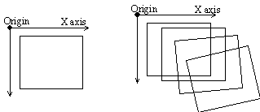
a) “Local” coordinates b) “Integrated” coordinates
Figure 20: “local” and “integrated” coordinate system

5. Temporal Interpolation: Temporal Interpolation D describes a temporal interpolation using connected polynomials. This can be used to approximate multi-dimensional variable values that change with time—such as an object position in a video. The description size of the temporal interpolation is usually much smaller than describing all values. In Figure 21, 25 real values are represented by five linear interpolation functions and two quadratic interpolation functions. The beginning of the temporal interpolation is always aligned to time 0.
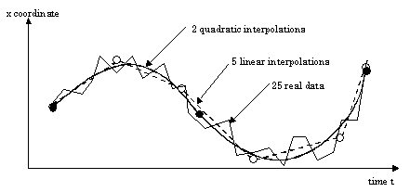
Figure 21: Real Data and Interpolation functions

Color Descriptors
There are seven Color Descriptors: Color space, Color Quantization, Dominant Colors, Scalable Color, Color Layout, Color-Structure, and GoF/GoP Color.

1. Color space: It is to be used in other color based descriptions. In the current description, the following color spaces are supported:
- R, G, B
- Y, Cr, Cb
- H, S, V
- HMMD
- Linear transformation matrix with reference to R, G, B
- Monochrome

2. Color Quantization: This descriptor defines a uniform quantization of a color space. The number of bins which the quantization produces is configurable, such that great flexibility is provided for a wide range of applications. For a meaningful application in the context of MPEG-7, this descriptor has to be combined with dominant color descriptors, e.g. to express the meaning of the values of dominant colors.

3. Dominant Color(s): This color descriptor is most suitable for representing local (object or image region) features where a small number of colors are enough to characterize the color information in the region of interest. Whole images are also applicable, for example, flag images or color trademark images. Color quantization is used to extract a small number of representing colors in each region/image. The percentage of each quantized color in the region is calculated correspondingly. A spatial coherency on the entire descriptor is also defined, and is used in similarity retrieval.

4. Scalable Color: The Scalable Color Descriptor is a Color Histogram in HSV Color Space, which is encoded by a Haar transform [ see: http://amath.colorado.edu/courses/4720/2000Spr/Labs/Haar/haar.html ] . Its binary representation is scalable in terms of bin numbers and bit representation accuracy over a broad range of data rates. The Scalable Color Descriptor is useful for image-to-image matching and retrieval based on color feature. Retrieval accuracy increases with the number of bits used in the representation.

5. Color Layout: This descriptor effectively represents the spatial distribution of color of visual signals in a very compact form. This compactness allows visual signal matching functionality with high retrieval efficiency at very small computational costs. It provides image-to-image matching as well as ultra high-speed sequence-to-sequence matching, which requires so many repetitions of similarity calculations. It also provides very friendly user interface using hand-written sketch queries since this descriptors captures the layout information of color feature. The sketch queries are not supported in other color descriptors.

Color-Structure Descriptor: The Color structure descriptor is a color feature descriptor that captures both color content (similar to a color histogram) and information about the structure of this content. Its main functionality is image-to-image matching and its intended use is for still-image retrieval, where an image may consist of either a single rectangular frame or arbitrarily shaped, possibly disconnected, regions. The extraction method embeds color structure information into the descriptor by taking into account all colors in a structuring element of 8x8 pixels that slides over the image, instead of considering each pixel separately. Unlike the color histogram, this descriptor can distinguish between two images in which a given color is present in identical amounts but where the structure of the groups of pixels having that color is different in the two images. Color values are represented in the double-coned HMMD color space, which is quantized non-uniformly into 32, 64, 128 or 256 bins. Each bin amplitude value is represented by an 8-bit code. The Color Structure descriptor provides additional functionality and improved similarity-based image retrieval performance for natural images compared to the ordinary color histogram.

7. GoF/GoP Color: The Group of Frames/Group of Pictures color descriptor extends the ScalableColor descriptor that is defined for a still image to color description of a video segment or a collection of still images. Additional two bits allows to define how the color histogram was calculated, before the Haar transfor is applied to it: by average, median or intersection. The average histogram, which refers to averaging the counter value of each bin across all frames or pictures, is equivalent to computing the aggregate color histogram of all frames and pictures with proper normalization. The Median Histogram refers to computing the median of the counter value of each bin across all frames or pictures. It is more robust to round-off errors and the presence of outliers in image intensity values compared to the average histogram. The Intersection Histogram refers to computing the minimum of the counter value of each bin across all frames or pictures to capture the “least common” color traits of a group of images. Note that it is different from the histogram intersection, which is a scalar measure. The same similarity/distance measures that are used to compare scalable color descriptions can be employed to compare GoF/GoP color Descriptors.

Texture Descriptors

There are three texture Descriptors: Homogeneous Texture, Edge Histogram, and Texture Browsing.

Homogenous Texture Descriptors: Homogeneous texture has emerged as an important visual primitive for searching and browsing through large collections of similar looking patterns. An image can be considered as a mosaic of homogeneous textures so that these texture features associated with the regions can be used to index the image data. For instance, a user browsing an aerial image database may want to identify all parking lots in the image collection. A parking lot with cars parked at regular intervals is an excellent example of a homogeneous textured pattern when viewed from a distance, such as in an Air Photo. Similarly, agricultural areas and vegetation patches are other examples of homogeneous textures commonly found in aerial and satellite imagery. Examples of queries that could be supported in this context could include “Retrieve all Land-Satellite images of Santa Barbara which have less than 20% cloud cover” or “Find a vegetation patch that looks like this region”. To support such image retrieval, an effective representation of texture is required. The Homogeneous Texture Descriptor provides a quantitative representation using 62 numbers (quantified to 8 bits each) that is useful for similarity retrieval. The extraction is done as follows; the image is first filtered with a bank of orientation and scale tuned filters (modeled using Gabor functions) using Gabor filters. The first and the second moments of the energy in the frequency domain in the corresponding sub-bands are then used as the components of the texture descriptor. The number of filters used is 5x6 = 30 where 5 is the number of “scales” and 6 is the number of “directions” used in the multi-resolution decomposition using Gabor functions. An efficient implementation using projections and 1-D filtering operations exists for feature extraction. The Homogeneous Texture descriptor provides a precise quantitative description of a texture that can be used for accurate search and retrieval in this respect. The computation of this descriptor is based on filtering using scale and orientation selective kernels.

2. Texture Browsing: The Texture Browsing Descriptor is useful for representing homogeneous texture for browsing type applications, and requires only 12 bits (maximum). It provides a perceptual characterization of texture, similar to a human characterization, in terms of regularity, coarseness and directionality. The computation of this descriptor proceeds similarly as the Homogeneous Texture Descriptor. First, the image is filtered with a bank of orientation and scale tuned filters (modeled using Gabor functions); from the filtered outputs, two dominant texture orientations are identified. Three bits are used to represent each of the dominant orientations. This is followed by analyzing the filtered image projections along the dominant orientations to determine the regularity (quantified to 2 bits) and coarseness (2 bits x 2). The second dominant orientation and second scale feature are optional. This descriptor, combined with the Homogeneous Texture Descriptor, provide a scalable solution to representing homogeneous texture regions in images.

3. Edge Histogram: The edge histogram descriptor represents the spatial distribution of five types of edges, namely four directional edges and one non-directional edge. Since edges play an important role for image perception, it can retrieve images with similar semantic meaning. Thus, it primarily targets image-to-image matching (by example or by sketch), especially for natural images with non-uniform edge distribution. In this context, the image retrieval performance can be significantly improved if the edge histogram descriptor is combined with other Descriptors such as the color histogram descriptor. Besides, the best retrieval performances considering this descriptor alone are obtained by using the semi-global and the global histograms generated directly from the edge histogram descriptor as well as the local ones for the matching process.

Shape Descriptors
There are three shape Descriptors: Region Shape, Contour Shape, and Shape 3D.

1. Region Shape: The shape of an object may consist of either a single region or a set of regions as well as some holes in the object as illustrated in Figure 22. Since the Region Shape descriptor makes use of all pixels constituting the shape within a frame, it can describe any shapes, i.e. not only a simple shape with a single connected region as in Figure 22 (a) and (b) but also a complex shape that consists of holes in the object or several disjoint regions as illustrated in Figure 22 (c), (d) and (e), respectively. The Region Shape descriptor not only can describe such diverse shapes efficiently in a single descriptor, but is also robust to minor deformation along the boundary of the object.
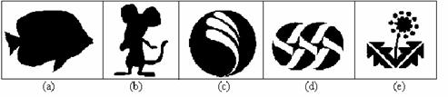
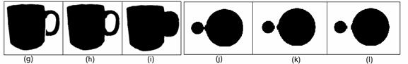
Figure 22: Examples of various shapes
Figure 22 (g), (h) and (i) are very similar shape images for a cup. The differences are at the handle. Shape (g) has a crack at the lower handle while the handle in (i) is filled. The region-based shape descriptor considers (g) and (h) similar but different from (i) because the handle is filled. Similarly, Figure 22 (j-l) show the part of video sequence where two disks are being separated. With the region-based descriptor, they are considered similar.
Note that black pixel within the object corresponds to 1 in an image, while white background corresponds to 0.
The descriptor is also characterized by its small size, fast extraction time and matching. The data size for this representation is fixed to 17.5 bytes. The feature extraction and matching processes are straightforward to have low order of computational complexities, and suitable for tracking shapes in the video data processing.

2. Contour Shape: The Contour Shape descriptor captures characteristic shape features of an object or region based on its contour. It uses so-called Curvature Scale-Space representation, which captures perceptually meaningful features of the shape.
The object contour-based shape descriptor is based on the Curvature Scale Space representation of the contour. This representation has a number of important properties, namely:
- It captures very well characteristic features of the shape, enabling similarity-based retrieval
- It reflects properties of the perception of human visual system and offers good generalization
- It is robust to non-rigid motion
- It is robust to partial occlusion of the shape
- It is robust to perspective transformations, which result from the changes of the camera parameters and are common in images and video
- It is compact
Some of the above properties of this descriptor are illustrated in Figure 23, each frame containing very similar images according to CSS, based on the actual retrieval results from the MPEG-7 shape database.
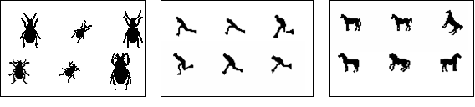
Figure 23: (a) shape generalization properties (perceptual similarity among different shapes), (b) robustness to non-rigid motion (man running), (c) robustness to partial occlusion (tails or legs of the horses)

3. Shape 3D: Considering the continuous development of multimedia technologies, virtual worlds, and augmented reality, 3D contents become a common feature of today’s information systems. Most of the time, 3D information is represented as polygonal meshes. MPEG-4, within the SNHC subgroup, considered this issue and developed technologies for efficient 3D mesh model coding. Within the framework of the MPEG-7 standard, tools for intelligent content-based access to 3D information are needed. The main MPEG-7 applications targeted here are search & retrieval and browsing of 3D model databases.

Motion Descriptors
There are four motion Descriptors: Camera Motion, Motion Trajectory, Parametric Motion, and Motion Activity.

1. Camera Motion: This descriptor characterizes 3-D camera motion parameters. It is based on 3-D camera motion parameter information, which can be automatically extracted or generated by capture devices.
The camera motion descriptor supports the following well-known basic camera operations (see Figure 24): fixed, panning (horizontal rotation), tracking (horizontal transverse movement, also called traveling in the film industry), tilting (vertical rotation), booming (vertical transverse movement), zooming (change of the focal length), dollying (translation along the optical axis), and rolling (rotation around the optical axis).
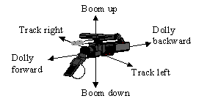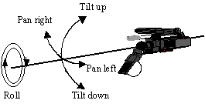
Figure 24: (a) Camera track, boom, and dolly motion modes, (b) Camera pan, tilt and roll motion modes.
The sub-shots for which all frames are characterized by a particular type of camera motion, which can be single or mixed, determine the building blocks for the camera motion descriptor. Each building block is described by its start time, the duration, the speed of the induced image motion, by the fraction of time of its duration compared with a given temporal window size, and the focus-of-expansion (FOE) (or focus-of-contraction – FOC). The Descriptor represents the union of these building blocks, and it has the option of describing a mixture of different camera motion types. The mixture mode captures the global information about the camera motion parameters, disregarding detailed temporal information, by jointly describing multiple motion types, even if these motion types occur simultaneously. On the other hand, the non-mixture mode captures the notion of pure motion type and their union within certain time interval. The situations where multiple motion types occur simultaneously are described as a union of the description of pure motion types. In this mode of description, the time window of a particular elementary segment can overlap with time window of another elementary segment.
2. Motion Trajectory: The motion trajectory of an object is a simple, high level feature, defined as the localization, in time and space, of one representative point of this object.
This descriptor shows usefulness for content-based retrieval in object-oriented visual databases. It is also of help in more specific applications. In given contexts with a priori knowledge, trajectory can enable many functionalities. In surveillance, alarms can be triggered if some object has a trajectory identified as dangerous (e.g. passing through a forbidden area, being unusually quick, etc.). In sports, specific actions (e.g. tennis rallies taking place at the net) can be recognized. Besides, such a description also allows enhancing data interactions/manipulations: for semiautomatic multimedia editing, trajectory can be stretched, shifted, etc, to adapt the object motion to any given sequence global context.
The descriptor is essentially a list of keypoints (x,y,z,t) along with a set of optional interpolating functions that describe the path of the object between keypoints, in terms of acceleration. The speed is implicitly known by the keypoints specification. The keypoints are specified by their time instant and either their 2-D or 3-D Cartesian coordinates, depending on the intended application. The interpolating functions are defined for each component x(t), y(t), and z(t) independently.

3. Parametric Motion: Parametric motion models have been extensively used within various related image processing and analysis areas, including motion-based segmentation and estimation, global motion estimation, mosaicing and object tracking. Parametric motion models have been already used in MPEG-4, for global motion estimation and compensation and sprite generation. Within the MPEG-7 framework, motion is a highly relevant feature, related to the spatio-temporal structure of a video and concerning several MPEG-7 specific applications, such as storage and retrieval of video databases and hyperlinking purposes. Motion is also a crucial feature for some domain specific applications that have already been considered within the MPEG-7 framework, such as sign language indexation.
The basic underlying principle consists of describing the motion of objects in video sequences as a 2D parametric model. Specifically, affine models include translations, rotations, scaling and combination of them, planar perspective models make possible to take into account global deformations associated with perspective projections and quadratic models makes it possible to describe more complex movements.
The parametric model is associated with arbitrary (foreground or background) objects, defined as regions (group of pixels) in the image over a specified time interval. In this way, the object motion is captured in a compact manner as a set of a few parameters. Such an approach leads to a very efficient description of several types of motions, including simple translations, rotations and zoomings, or more complex motions such as combinations of the above-mentioned elementary motions.
Defining appropriate similarity measures between motion models is mandatory for effective motion-based object retrieval. It is also necessary for supporting both low level queries, useful in query by example scenarios, and high level queries such as "search for objects approaching the camera", or for "objects describing a rotational motion", or "search for objects translating left", etc.

4. Motion Activity: A human watching a video or animation sequence perceives it as being a slow sequence, fast paced sequence, action sequence etc. The activity descriptor captures this intuitive notion of ‘intensity of action’ or ‘pace of action’ in a video segment. Examples of high ‘activity’ include scenes such as ‘goal scoring in a soccer match’, ‘scoring in a basketball game’, ‘a high speed car chase’ etc.. On the other hand scenes such as ‘news reader shot’, ‘an interview scene’, ‘a still shot’ etc. are perceived as low action shots. Video content in general spans the gamut from high to low activity, therefore we need a descriptor that enables us to accurately express the activity of a given video sequence/shot and comprehensively covers the aforementioned gamut. The activity descriptor is useful for applications such as video re-purposing, surveillance, fast browsing, dynamic video summarization, content-based querying etc. For example, we could slow down the presentation frame rate if the activity descriptor indicates high activity so as to make the high activity viewable. Another example of an application is finding all the high action shots in a news video program for example, which can be viewed both as browsing and abstraction.

Localization
There two descriptors for localization: Region locator and Spatio-temporal locator.

1. Region Locator: This descriptor enables localization of regions within images or frames by specifying them with a brief and scalable representation of a Box or a Polygon.

2. Spatio Temporal Locator: This describes spatio-temporal regions in a video sequence, such as moving object regions, and provides localization functionality. The main application of it is hypermedia, which displays the related information when the designated point is inside the object. Another main application is object retrieval by checking whether the object has passed particular points. This can be used for surveillance. The SpatioTemporalLocator can describe both spatially connected and non-connected regions.
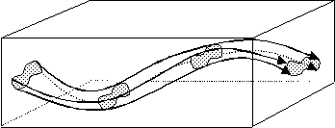
Figure 25: Spatio-Temporal Region.

