**Summer CS 161 – Design and Arch. of Computer Systems 2019 - Homework 3**

**NAME (FIRST LAST) ID#:**

*WRITE THE ANSWERS IN THE TABLE*

1. (14 points) A cache has 32 KB, each cache block is 16 B. The address is 44 bits.

1.a. (12 points) Indicate the size in bits of each of the fields for the four cache architectures

listed (in the table).

1.b. (1 points) Which of these cache architectures would have the lowest miss rate?

1.c. (1 points) Which will have the lowest hit time?

|  |  |  |  |  |  |  |
| --- | --- | --- | --- | --- | --- | --- |
| **CACHE ARCHITECTURE** | | **tag** | **index** | **byte offset** | **lowest miss rate** | **lowest hit time** |
| **A** | direct mapped |  |  |  |  |  |
| **B** | 2-way set associative |  |  |  |  |  |
| **C** | 4-way set associative |  |  |  |  |  |
| **D** | fully associative |  |  |  |  |  |

**CS 161 - HW 3 - Summer 2019**

**NAME (FIRST LAST) ID#:**

2. (10 points) A CPU has an instruction and a data cache. 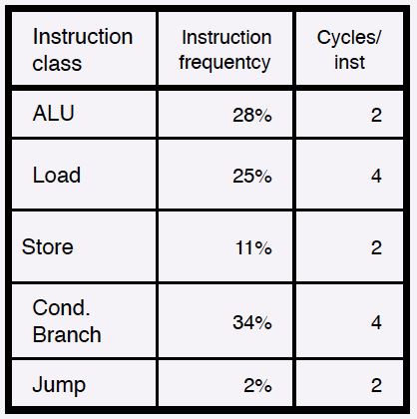

The I$ miss rate is 4% and the D$ miss is 12%. The miss

penalty for both is 80 cycles.

a. (6 points) Compute the miss cycles due to the I$ and

D$ respectively

b. (4 points) How does the CPI with the caches compare

to the ideal CPI (assuming perfect caches)

|  |  |
| --- | --- |
| miss cycles due to I$ |  |
| miss cycles due to D$ |  |
| ideal CPI |  |
| actual CPI |  |

**CS 161 - HW 3 - Summer 2019**

**NAME (FIRST LAST) ID#:**

3. (6 points) Since the CPU need not wait for the result of a store instruction, we change the

design of the cache to use a store buffer. The data is written by the CPU in a store buffer and

then moved to the cache and/or main memory by the memory system. What is the speedup

of this new design?

|  |  |
| --- | --- |
| miss cycles due to D$ |  |
| new actual CPI |  |
| speedup |  |

CS 161 - HW 4 - Summer 2019