**AACS1084**

**Programming Concepts & Design II**

**Assignment**

**2024**

| Programme | : | Diploma In Information Technology |
| --- | --- | --- |
| Tutorial Group | : | 6 |
| Date Submitted to Tutor | : | 3/5/2024 |

**Team Members:**

| **No** | **Student Name** | **Student ID** |
| --- | --- | --- |
| 1. | KER ZHENG FENG | 23WMD03507 |
| 2. | GAN KA CHUN | 23WMD03351 |
| 3. | TAN JIN YUAN | 23WMD03821 |
| 4. | PATRICIA LEE HUAY | 23WMD09002 |

# 

# Task Allocation

| No. | Team Member | Task(s) Allocated | Overall Contribution (%) |
| --- | --- | --- | --- |
| 1. | KER ZHENG FENG | Scheduling Module | 25% |
| 2. | GAN KA CHUN | Member Module | 25% |
| 3. | TAN JIN YUAN | Admin Module | 25% |
| 4. | PATRICIA LEE HUAY | Booking Module | 25% |

**Coursework Declaration**

We confirm that we have read and shall comply with all the terms and conditions of TAR University College’s plagiarism policy. We declare that this assignment is free from all forms of plagiarism and is our own properly derived work.

| Signature | : |  |  |  |  |
| --- | --- | --- | --- | --- | --- |
| Name | : | KER ZHENG FENG | GAN KA CHUN | TAN JIN YUAN | PATRICIA LEE HUAY |
| Photo | : |  | 1 | 2 |  |
| Date | : | 3/5/2024 | 3/5/2024 | 3/5/2024 | 3/5/2024 |

**Assignment Evaluation Form**

| **Student Name** | | KER ZHENG FENG | GAN KA CHUN | TAN JIN YUAN | PATRICIA LEE HUAY |
| --- | --- | --- | --- | --- | --- |
| **Module handled** | | Schedule | Member | Staff | Booking |
| ***Assessment Criteria*** | ***Marks Awarded*** | | | | |
| ***Application of Programming Knowledge*** | |  | | | |
| Structures   * Basic + extra fields, * Use of nesting & arrays * Appropriate usage | **12** |  |  |  |  |
| File Processing   * successful processing * Validation of data * Appropriate usage | **12** |  |  |  |  |
| Functions   * 4 Basic file fns, * Extra file fns, useful/correct * Approp. menu design & process | **12** |  |  |  |  |
| Others   * Use of parameters; correct usage * Subsidiary working functions * Minimized global variables | **12** |  |  |  |  |
| Teamwork   * Main menu, logo etc * System/module integration * Report integration/content * Sharing of files, functions * Communication, cooperation | **12** |  |  |  |  |
| Program originality, efficiency and readability   * Innovation, uniqueness * Approp. logic structures * Code Readability | **10** |  |  |  |  |
| Report (indiv. section)   * Clarity of description * Narrated Screens for all processes (basic + extra) | **20** |  |  |  |  |
| Penalty - Late Submission   * 1-3 days late 🡪 -10 * 4-7 days late 🡪 -20   >7 days late => **Total mark = 0** |  |  |  |  |  |
| **Subtotal (i)** |  |  |  |  |  |
| Presentation   * Organization, explanation * Enthusiasm, preparedness, attitude, understanding * Q&A handling **Subtotal (ii)** | **10** |  |  |  |  |
| **TOTAL MARK** |  |  |  |  |  |

Note: In addition to the late penalty, marks will also be deducted under the different categories for other reasons, eg. bad programming practices, uncooperativeness, etc.

**Table of Contents**

| ***Chapter*** | ***Description*** | ***Page No*** |
| --- | --- | --- |
| 1.0 | Introduction | 1 |
| 2.0 | Overall System - Module Structure Chart | 2 |
| 3.0 | Main Screen Design | 3 |
| 4.0 | System Modules | 4 |
| 4.1 | Staff Module by Tan Jin Yuan | 4 |
| 4.2 | Member Module by Gan Ka Chun | 13 |
| 4.3 | Schedule Module by Ker Zheng Feng | 22 |
| 4.4 | Booking Module by Patricia Lee Huay | 30 |

# Introduction

In this assignment, we have developed a system in C to simulate the daily operations of a ticketing system. Assuming our system is designed for “*RapidEkspres*”, a train service company, it consists of 4 main modules, namely Staff, Member, Booking and Scheduling, each performing different functions from another.

Each function would be able to conduct file functions, such as creating, reading, updating and deleting data from files, which may vary between binary and text files. For instance, the staff module would be able to read staff details/ credentials from the staff binary file and print it out on the user interface.

Other than the file functions stated above, we have also included 2 other functions that we believe may bring ease to the user. For example, the booking module can generate a report based on the bookings made by members, this function may be useful to staff to get an overview of ticket bookings.

More detailed information regarding the system’s modules and its submodules will be explained in the upcoming sections.

# Overall System – Module Structure Chart

## 

# Main Screen Design

Brief Description:

Displays the company logo/banner.

Consists of the main 4 options (modules) to choose from.

* Staff
* Member
* Booking
* Scheduling
* Exit Program

Invalid input will be rejected by the system. (e.g. system prompts a number from 1-3, but the user enters ‘s’)

Sample photos:

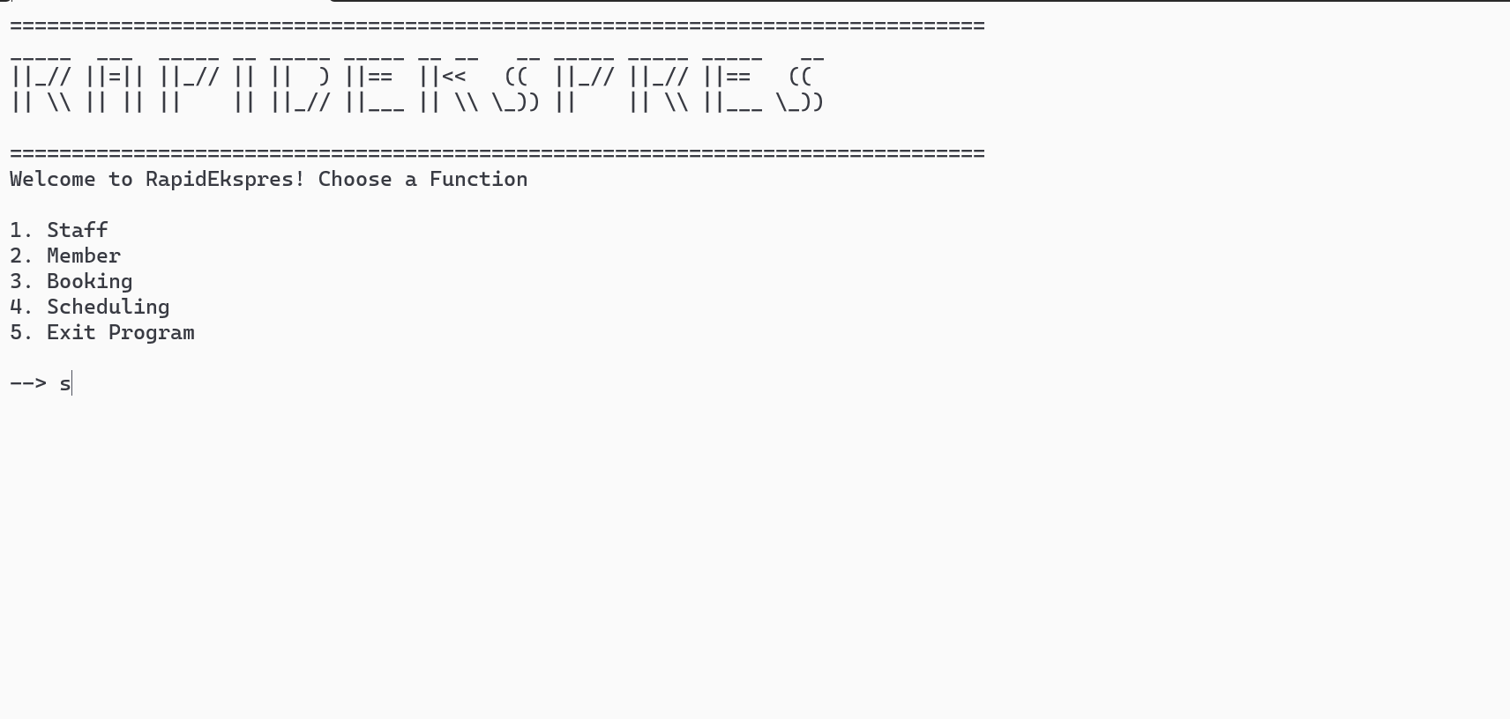

# 

# System Modules

## 4.1 Staff Module by Tan Jin Yuan

### 4.1.1 Brief Description Staff

Before accessing this module from the main menu, the user is required to enter a specific PIN specified by the system as a means of authentication and prevent unauthorised access.

Once logged in, the staff module has 6 different functions for the user to choose from, namely:

* Creating A New Staff Record
  + The user (unregistered staff) enters his unique staff ID, name, password, password recovery PIN, date of employment, unique work/contact email as well as the work department. Additionally registration as “Administration” (system admin) is prohibited to ensure data integrity.
* Viewing Staff Credentials
  + This is an Administration Staff-only function where logging in as an Administration Staff is required. Once logged in, each staff record in the staff file will be displayed, including all relevant information such as password, recovery PIN and email address is displayed.
* Searching For Staff
  + Staff can search for any records within the system by providing a search criteria, including, name, staff ID, email or work department. Search results will be displayed to the user if found.
* Deleting A Staff Record
  + If a staff member wants to delete his/her record, they need to log in by entering his ID and password. When entered successfully, the system will prompt the name and ID of the user and ask for confirmation once. If confirmed, the staff member’s record will proceed to be deleted. Otherwise, the system will return to the staff main page.
* Editing Staff Details
  + Staff ID and password login are needed to access this module before proceeding to allow profile editing. Staff members can choose what to edit such as work department or email. When satisfied, the user saves all changes to the file and exits.
* Checking The Staff Log File
  + Track all staff activities (e.g. search records, add records, delete records, system login). The system will show the latest change made to the file and display out to the user.

### 

### 4.1.2 Outputs & File Contents

Access to the staff module is guarded by a PIN.

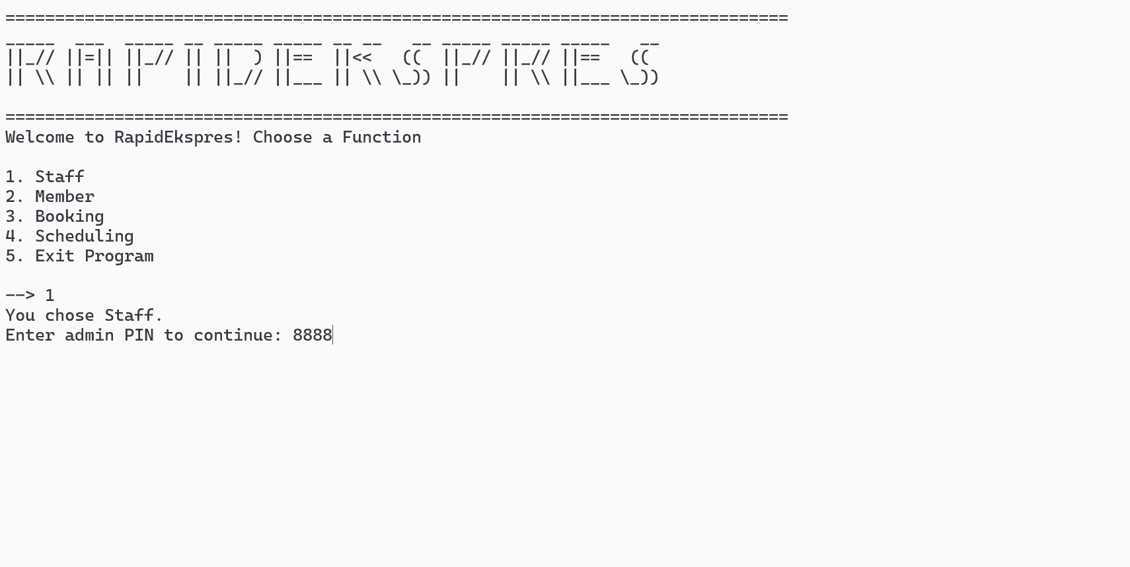

Homepage of the staff menu once logged in.

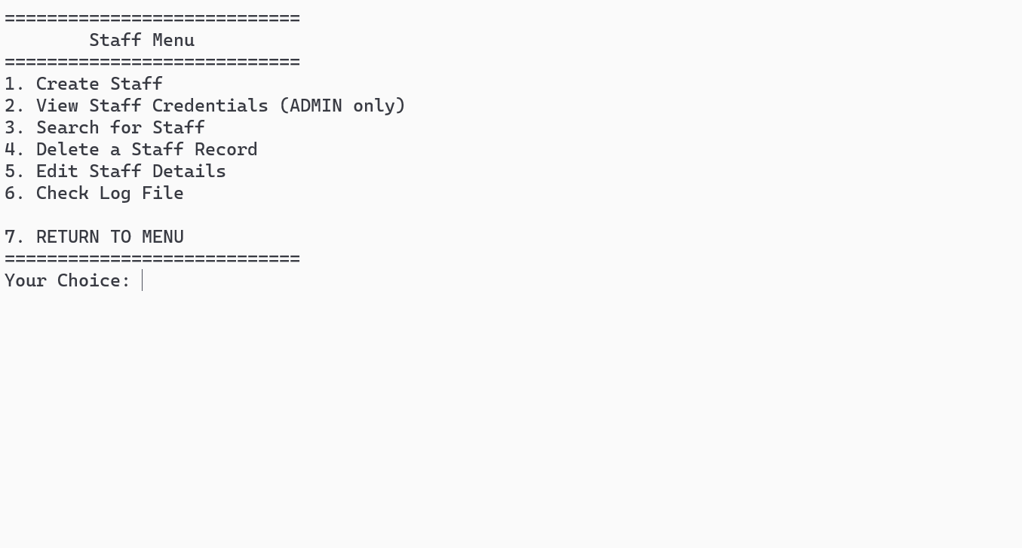

#### 

#### Function 1: Creating a New Staff Record

Validation is applied when creating a new staff record. For example, it should not be possible for the user to register with a staff ID that is already PRESENT in the file. No duplicate email is also allowed, either.

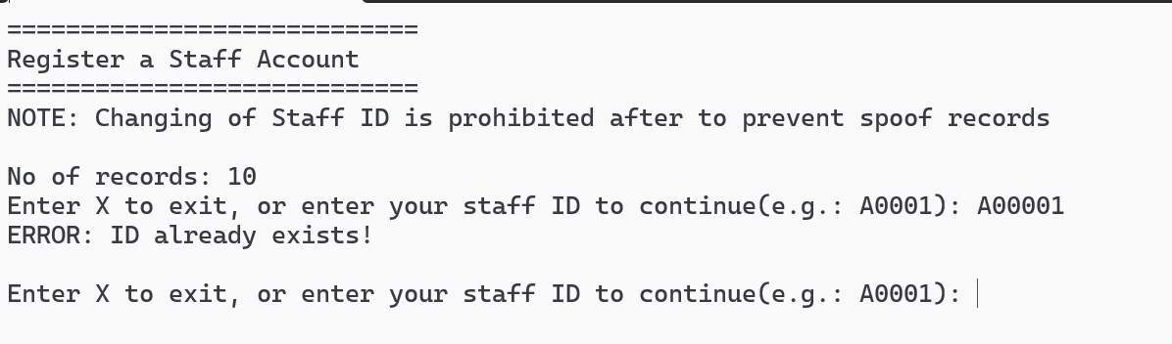

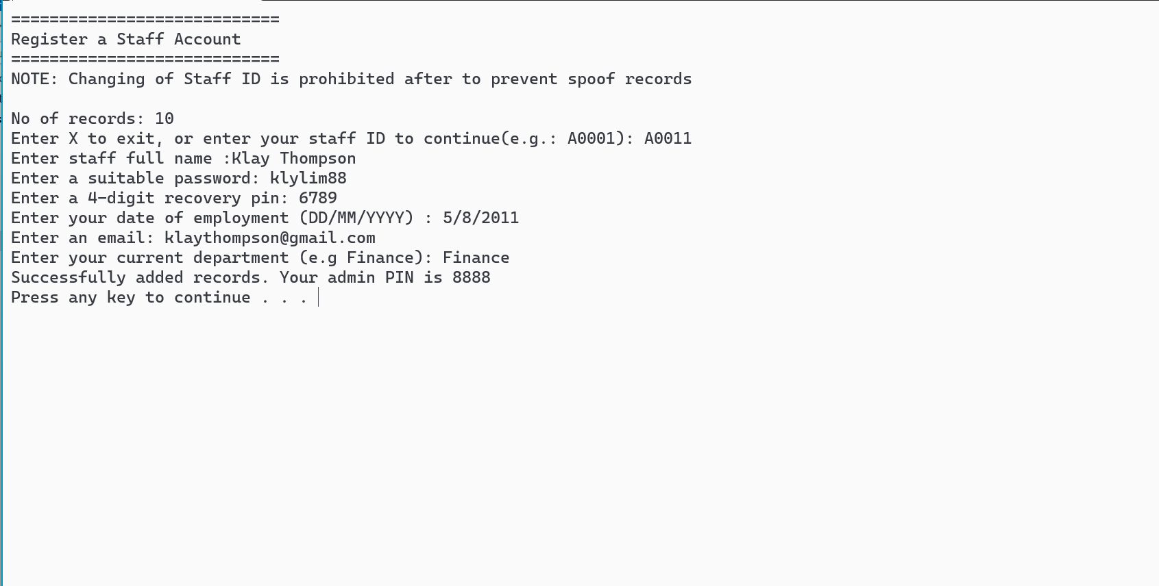

File **before** adding a new record:

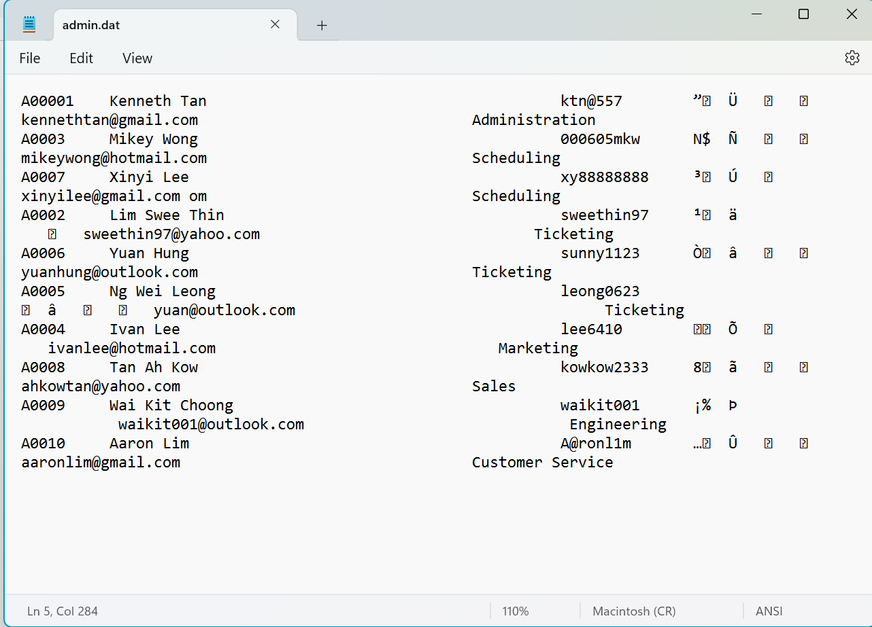

File **after** adding a new record (updated data)

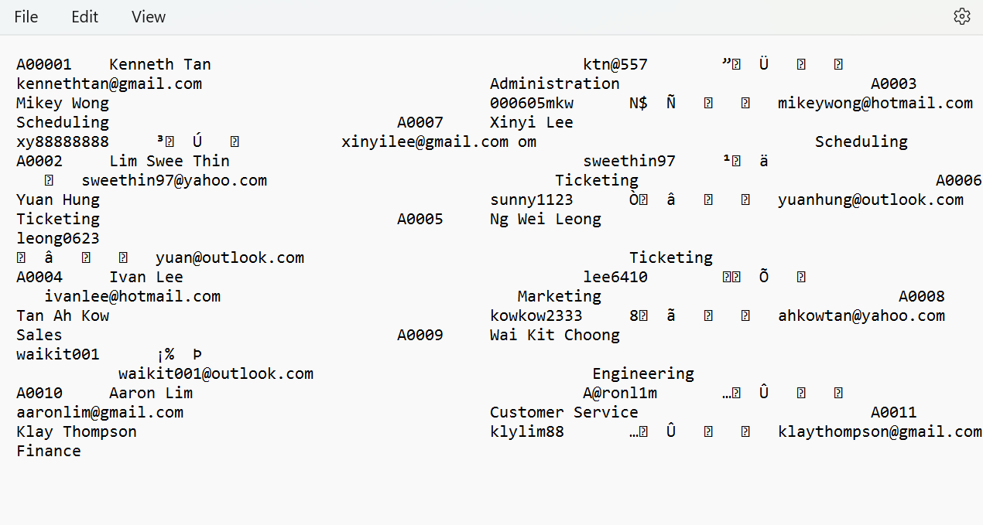

#### 

#### 

#### Function 2: Viewing staff credentials

The user should log in as “Administration staff” to continue.

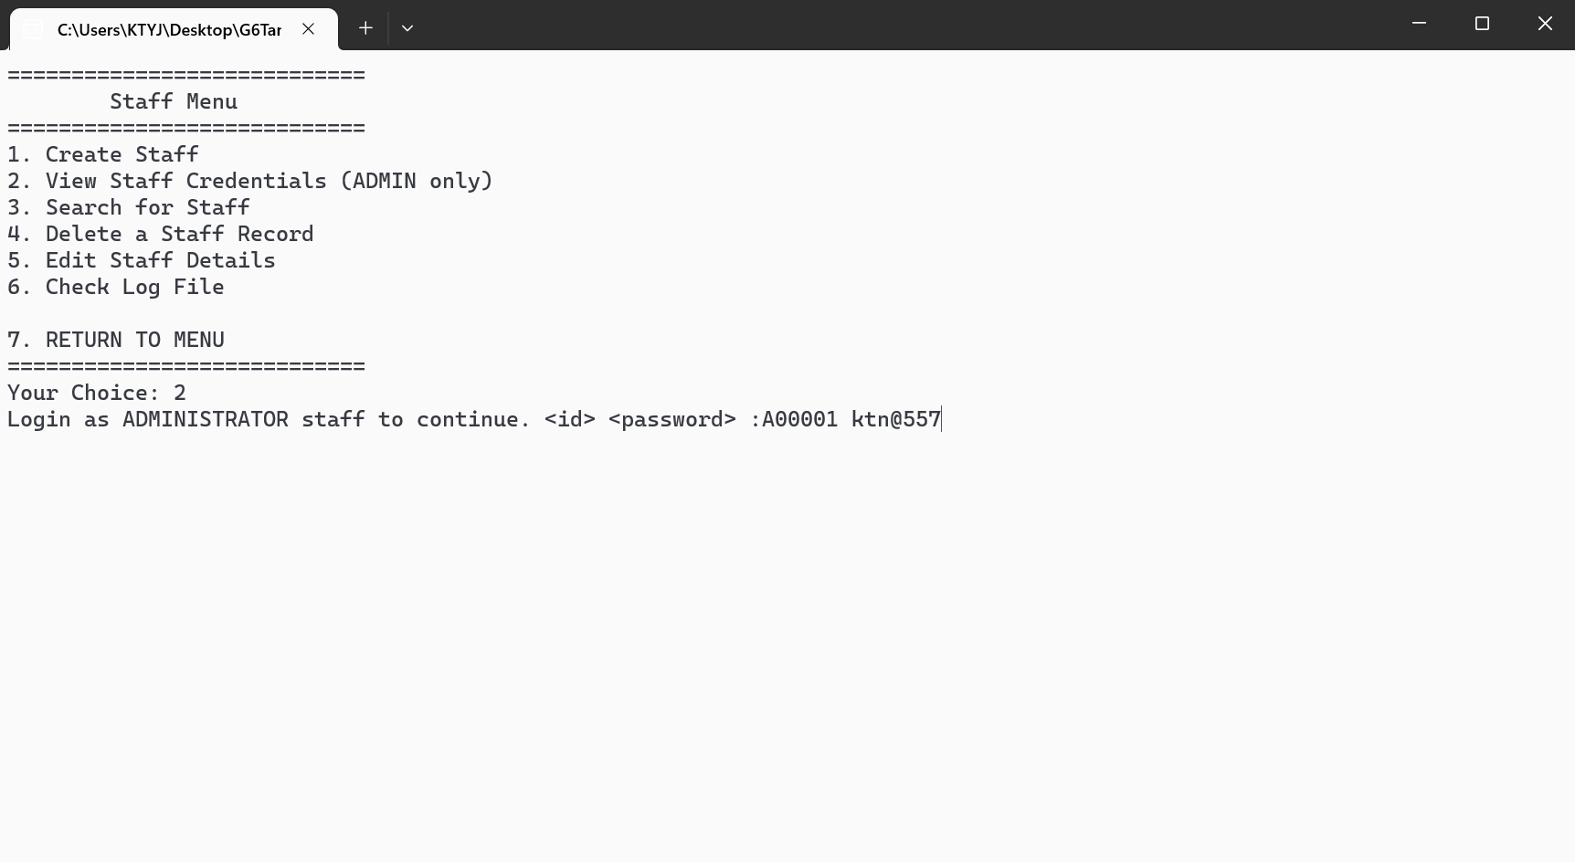

Complete staff record information is shown. (only 4 are shown in this screenshot)

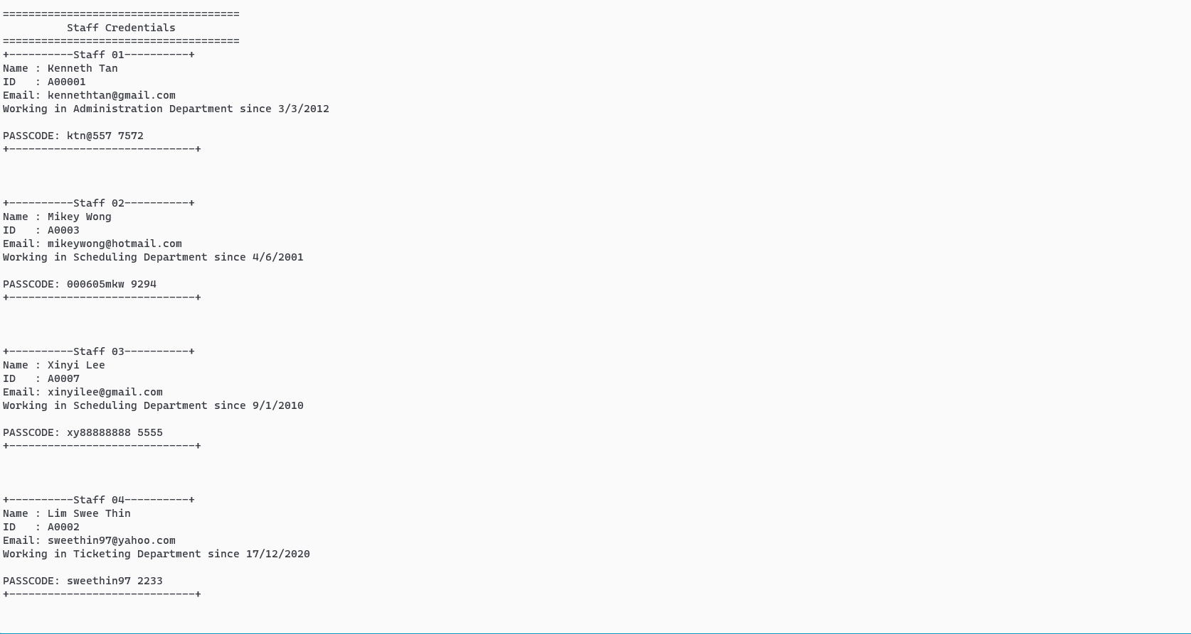

#### 

#### Function 3: Searching for staff

The user should be able to enter a search query. Search Results are displayed on the screen.

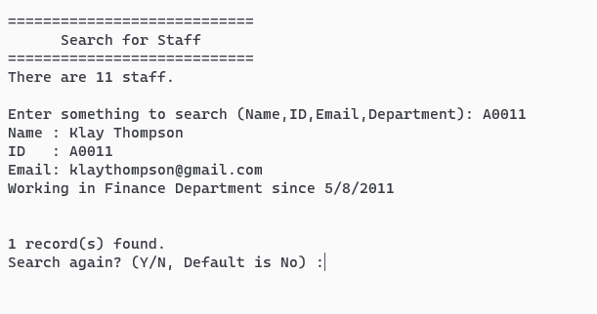

An error message is displayed when the results found are 0.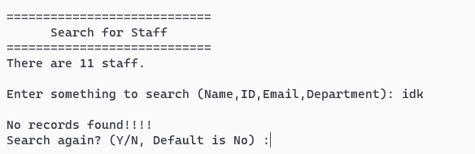

#### Function 4: Deleting staff record

Once the staff is logged in, the system prompts for double confirmation before deleting the record of the logged-in user (staff).

To confirm, the user should type in ‘DELETE’, else the system will return the user to the staff main menu.

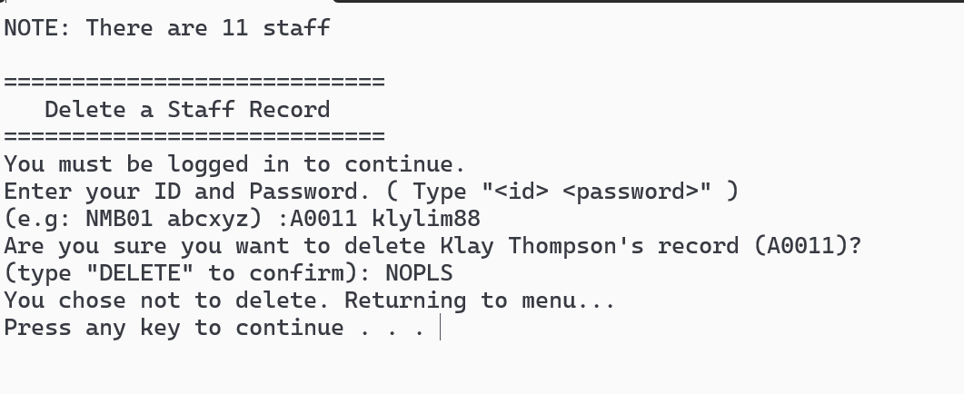

Otherwise, when confirmation is successful, the staff record is permanently deleted from the staff file.

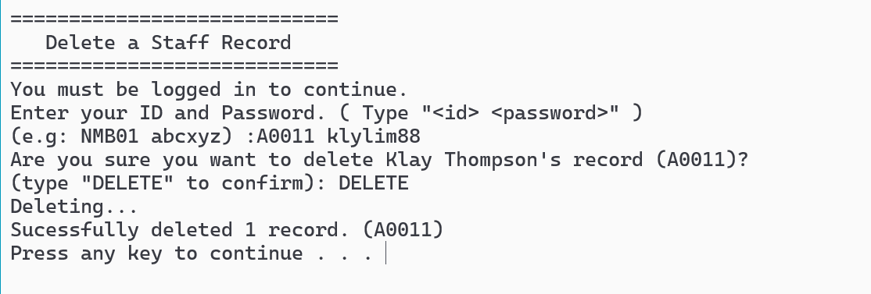

**Updated** contents of staff file. (Deleted 1 record)

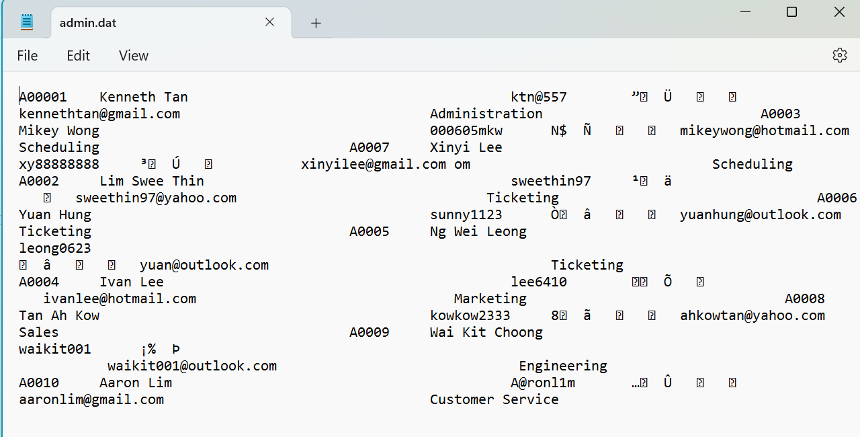

#### 

#### Function 5: Editing staff record

Staff login is required to edit a staff record. If a user fails to log in within 3 attempts, he/she can use the recovery PIN set during staff creation to log in, but her/his ID must match it. If this last login attempt fails, the user is returned to the menu.

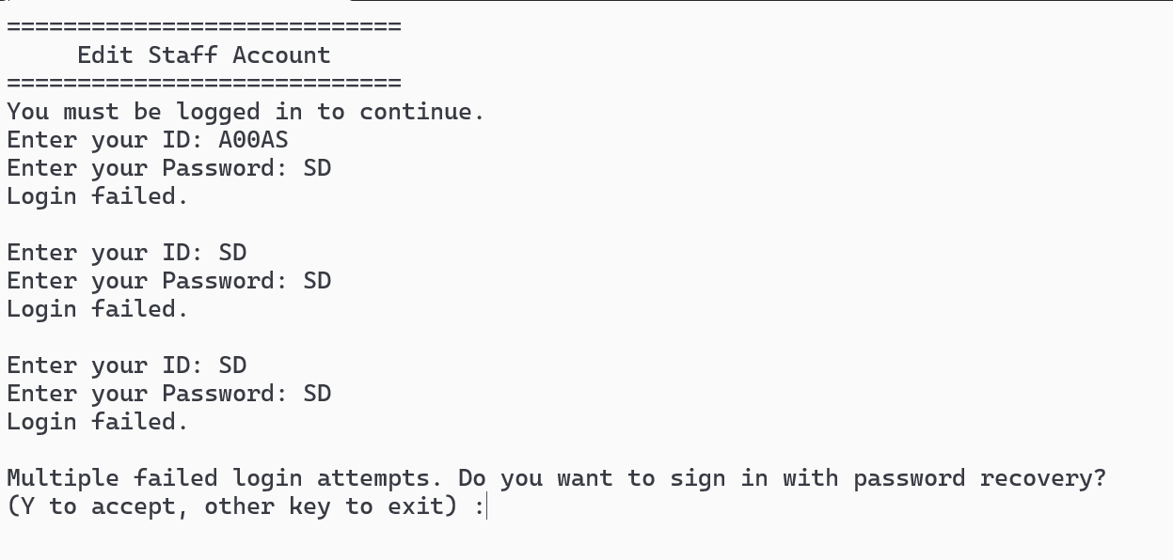

User can choose to edit all his/her staff details except STAFF ID as it is unique

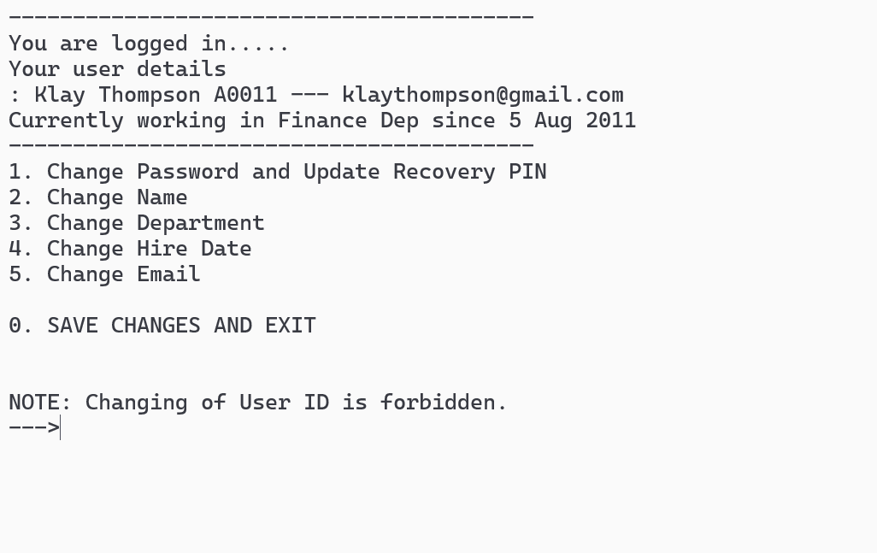

*Example: Assuming “Klay Thompson” changed his name to “Klay Tan” and saved changes*

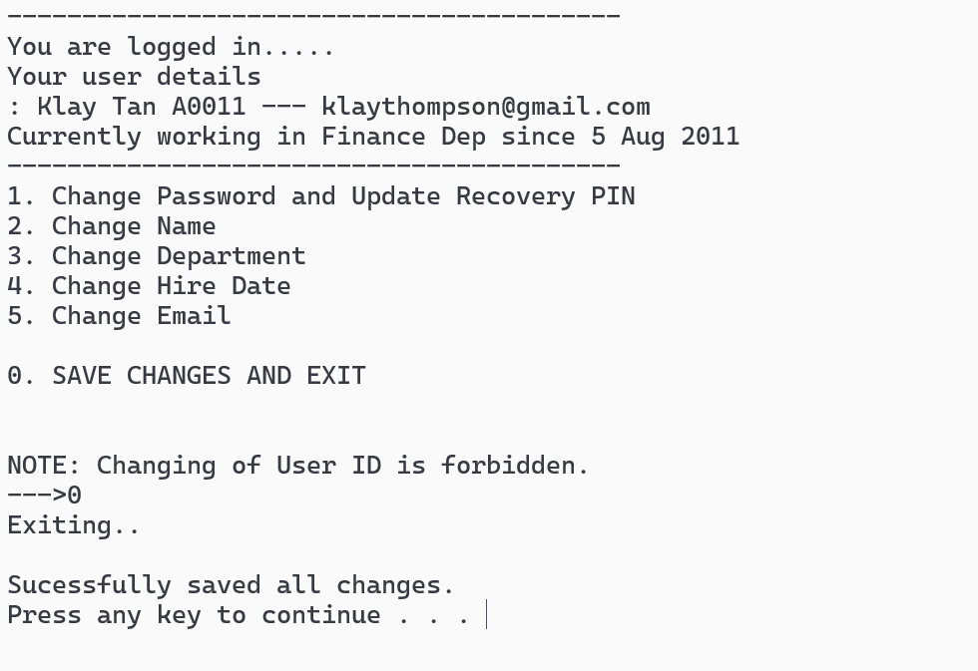

By searching in the new name, it shows results, confirming that the changes were indeed successful.

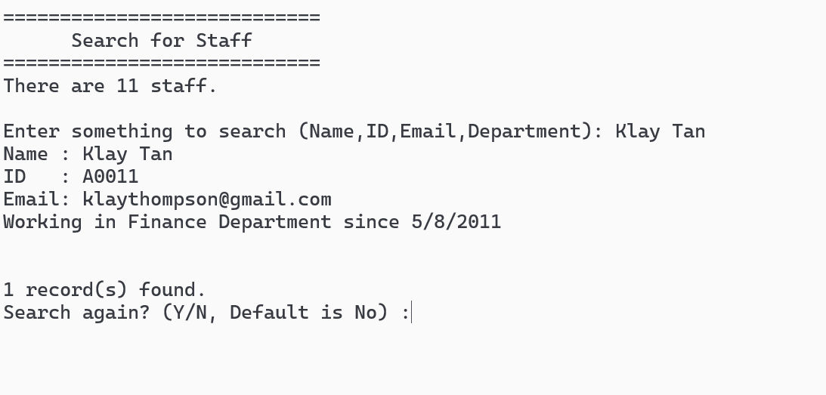

admin.dat after updating.

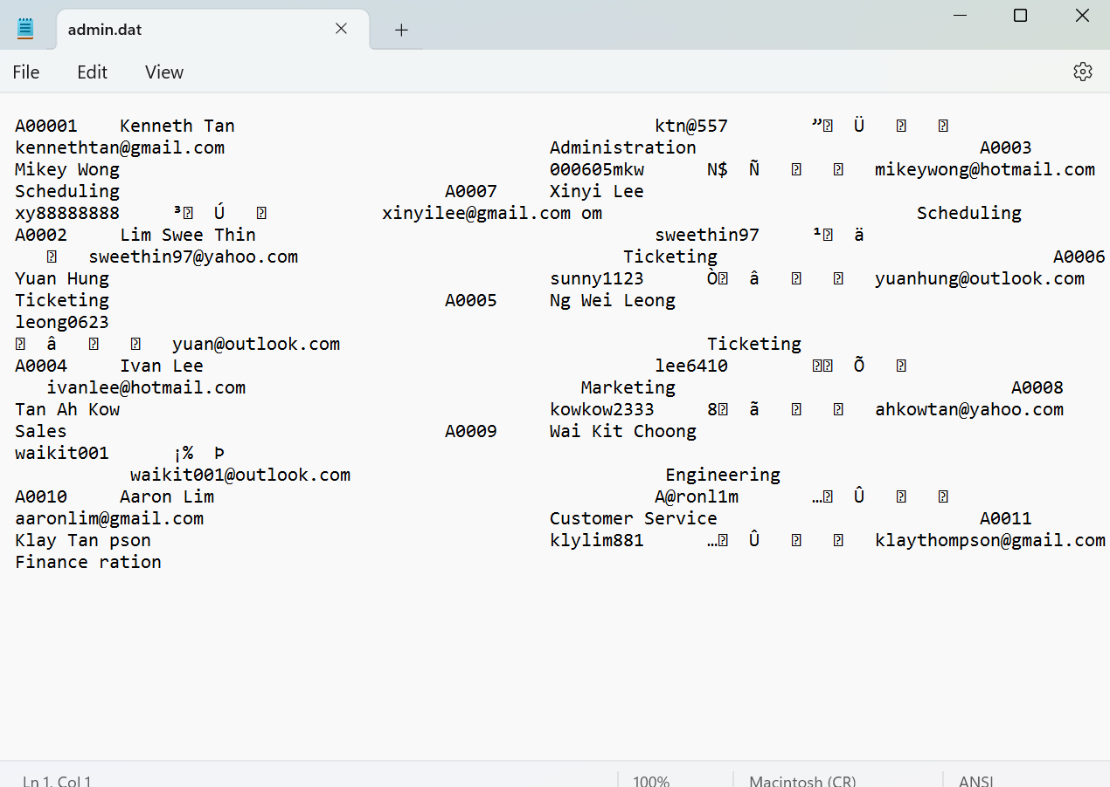

#### Function 6: Staff Log file

The staff log file stores the first latest action. Actions that will be stored include searching, deleting, modifying, creating, and logging in to other modules.

Example: When someone searches for staff ‘A0000’:

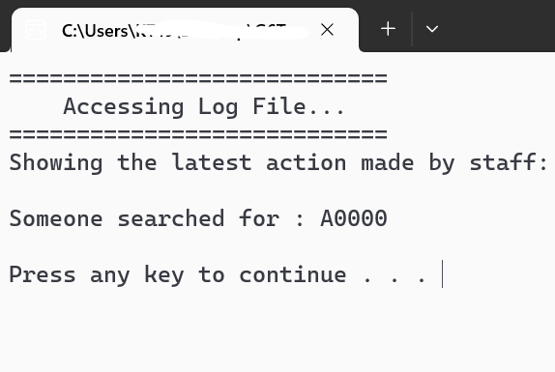

Example: When staff ‘A0011’ changed his/her details;

## 

Example: When staff ‘A0011’ changed his/her details;

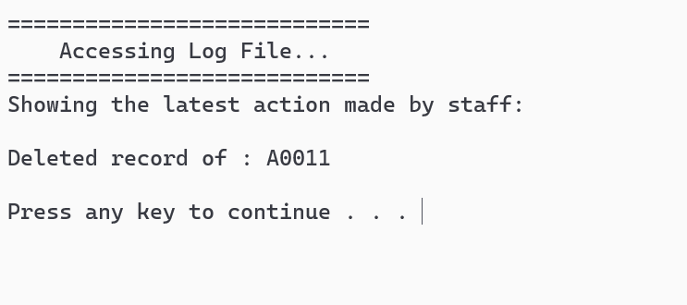

Sample of contents inside the log file (logadmin.bin)

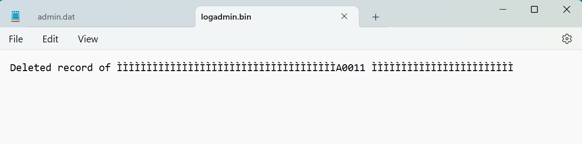

Above concludes all 4 basic functions (add, search, modify, display) with 2 additional functions (staff log file, delete) for the admin module.

## 4.2 Member Module by Gan Ka Chun

### 

For our member modules,we had 6 different function that included add member,which is register,search for member,display member details,delete member,edit member and loyalty.For the search for member and display member details function,it required staff login while the others function such as edit member,delete member and loyalty required member to login with their username and password.

Members may input Member ID , member username , password , email , contact number and IC number. . After inputting every data , the system will prompt member registration successfully. Members need to log in with their username and password . When entered successfully , members will be redirected to the userpage.

Once they enter the userpage,they can select different functions such as check on their account details,edit their account,delete their account and also check their loyalty point while having a look at what rewards they could exchange with their loyalty points.

When member wanted to edit their account,they can choose the edit account details function,After they had choose it,the system will redirect them to the page and let them to edit their account.While they are editing , all the information must be different with their current account or else the system will prompt them to change it to prevent any safety or privacy problem .

When members want to delete their account,they need to enter their username and password for confirmation.After they have entered it,there will be a double confirmation to make sure that they are seriously wanting to delete their account.

Lastly,members can check on their account details and loyalty points just by one click and the system will redirect them to it.

### 4.2.2 - Module’s main page

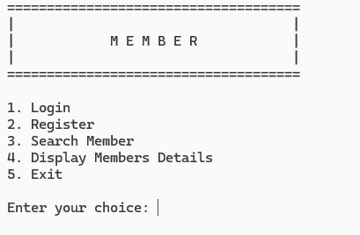

This is the main page before members login.They can do login and register here.Staff can go through the search member and display members details function with their login.

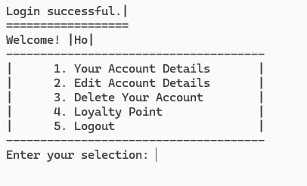

After members have logged into their account,the system will redirect them to this userpage,which provides other functions for members.

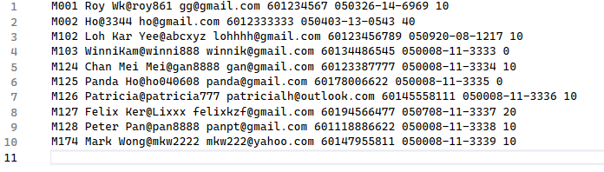

This is our members text file.

### 4.2.2.1 - Add Member(Register)

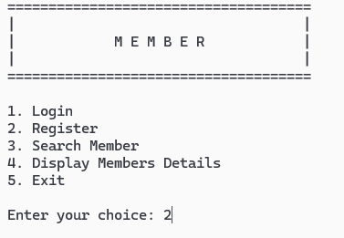

User can enter 2 to register themselves as a member

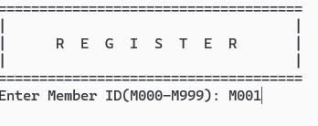

Here is an example while a user is doing their registration.It will be the same for other input data fields which are username,password,email,contact number,IC number.

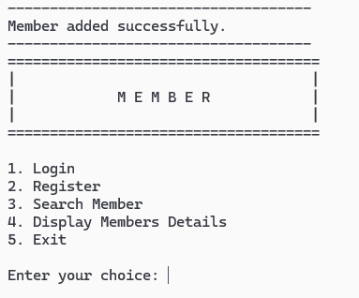

After the user has done all the information input for the registration ,the system will prompt ‘Member added successfully.Now they can proceed to login.

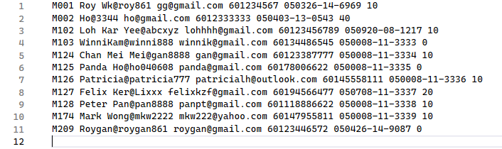

After registering,we can see that M209 Roygan has been added to the text file.

#### Function 1: Search For Member

#### 

Staff can enter 3 to login and search member

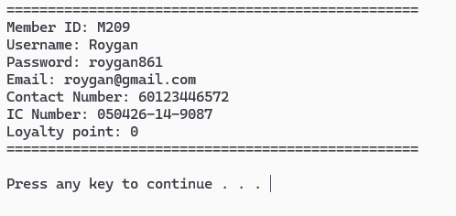

After staff enter member username,it will display the member details for staff

#### 

#### Function 2: Display Member Details

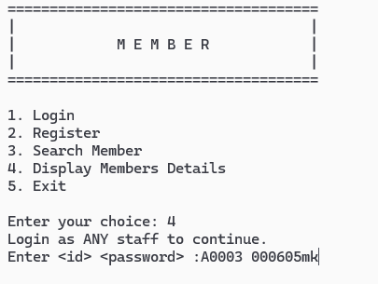

Staff can enter 4 to login and display all members' details.

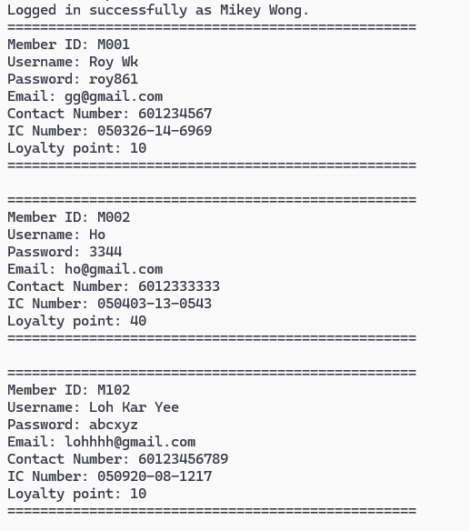

Here is a part of the result from the display members details.

#### Function 3: Member Check Their Own Details

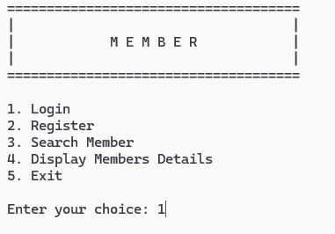

Users can enter 1 to login themselves into their member account.After login,it will redirect them to the userpage.

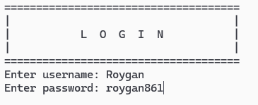

Users enter their username and password for the system to validate and log in into their account.

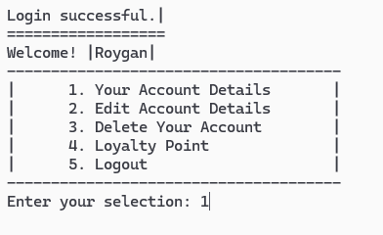

After login,users can enter 1 to check their account details.

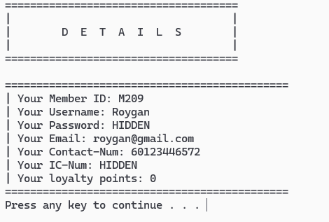

Their details will be displayed to them but cause to privacy issues ,the system will hidden their password and IC num.

#### Function 4: Member Edit Their Account Details

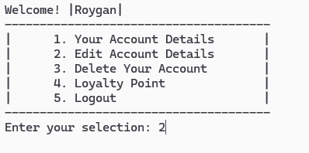

After login,users can enter 2 to edit their account details.

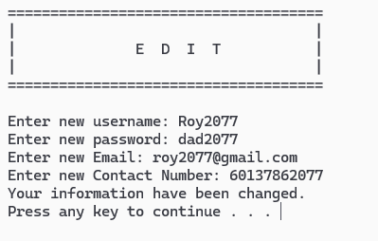

Users enter their new account details.Member ID and IC Number are not allowed to edit or change.

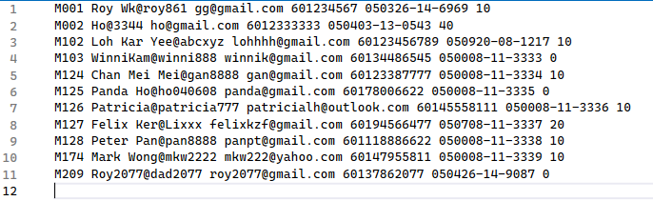

Now we can see that the M209 Roygan details have been changed.

#### Function 5: Member Delete Their Account

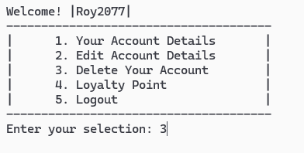

After login,users can enter 3 to delete their account.

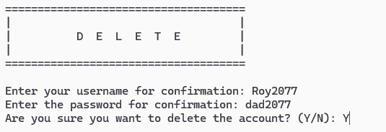

Users are required to enter their username and password for confirmation.After that,the system will prompt to ask again for a double confirmation to delete the member account.

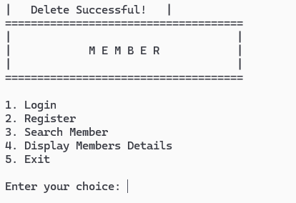

After members confirm the deletion,the system will prompt ‘Delete Successful!’ and the user will be returned back to the main page.

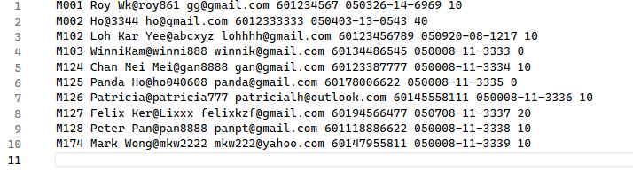

After deletion,the M209 Roy2077 had been removed from the txt file.

#### Function 6: Member check their loyalty point and have a look of the rewards

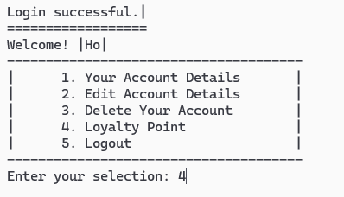

After login,users can enter 4 to check their account loyalty point and have a look the rewards they can exchange at the train station or the train canteen cabin.

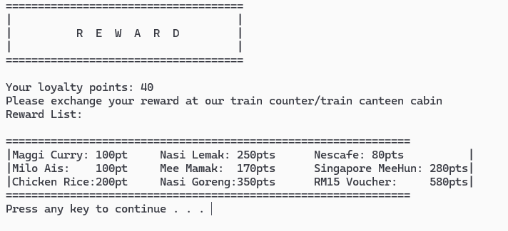

here members can check how many loyalty points they had and how much the rewards cost.

## 4.3 Schedule Module By Ker Zheng Feng

### 4.3.1 Brief Description Scheduling

About the schedule module has 6 different function that included add schedule record , display schedule record , search schedule , edit schedule record , delete schedule record and generate schedule report . This module is allow staff to add schedule record for member ..

* Add Schedule
  + Staff may input train ID , departure time , arrival time , departure from , destination , date and train price for adding the record into binary file
* Display Schedule
  + After input every data , schedule record will be prompt by binary file to let staff confirm their record .
* Edit Schedule
* If staff founded some error information on the record . They can search Train ID or Destination for editing . When the train ID or destinaion is equal to the data from binary file . The information will been displayed and ask staff for the editing confirmation . If yes , staff can input a new record to replace the error record . If no , staff will exit from the function .
* Search Schedule
* When staff want to view the record , staff can search the train record by entering its train ID or destination . Record will be fetch out from binary file and display for staff .
* Delete Schedule
* When the record is expired , staff can search train ID or destination for delete . The train record will display and staff will get a confirmation for deleting the record . If yes , the train record will be deleted . If no , staff will exit from the function .
* Schedule Report
* Lastly , staff can generate a schedule report about the total of train and amount train that will arrive each destination . It is to let staff know each station will arrive how many train .

.

### 

### 

### 

### 

### 

### 

### 4.3.2 - Module’s main page

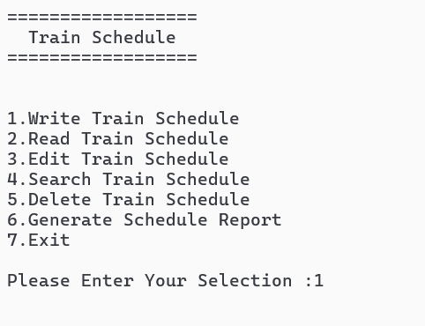

#### 

#### 

#### 

#### 

#### 

#### 

#### 

#### Function 1: Add Schedule Function

Staff can enter train ID , departure time , arrival time , departure location , destination , date and price . When data were entered , staff can enter ‘Y’ or ‘y’ for adding another record .

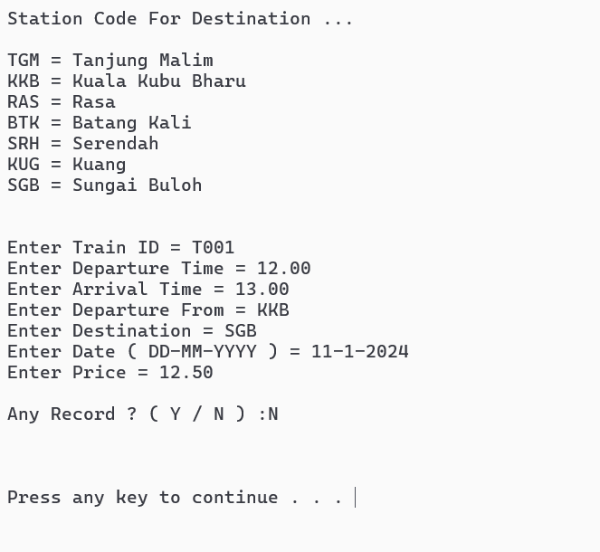

#### 

#### 

#### 

#### 

#### 

#### Function 2: Display Schedule Function

Staff will enter ‘2’ for displaying the record that entered by them , every details of the train record will be displayed on the screen for staff

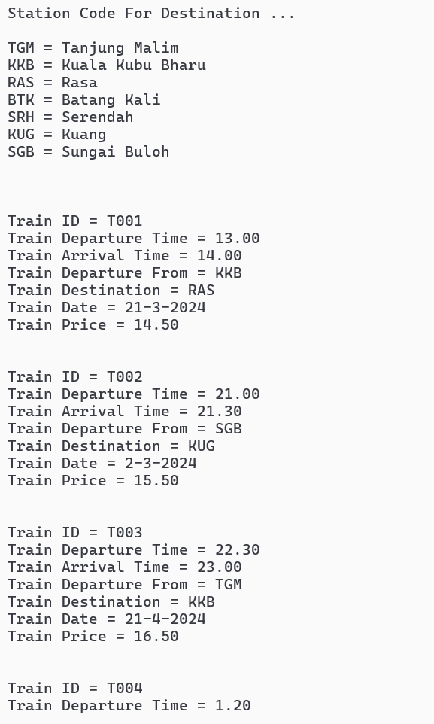

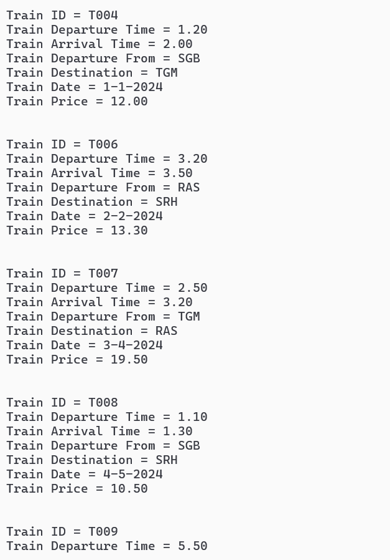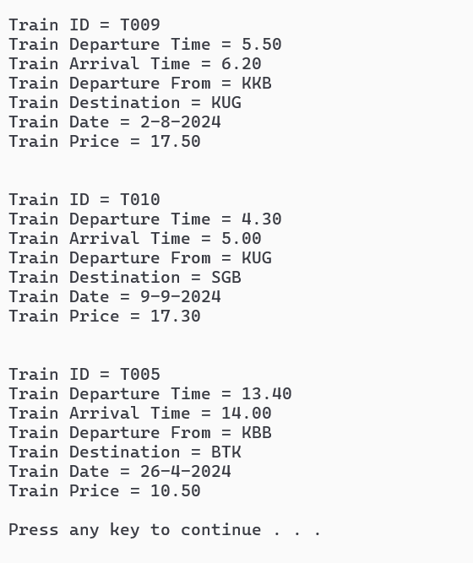

#### Function 3: Edit Schedule Function

Staff is needed to search for the train ID or destination for editing , once staff search successfully , system will display the details of train record and ask staff for edit confirmation . When staff enter ‘1’ , system will proceed to let staff enter a new data for replacing the existing one

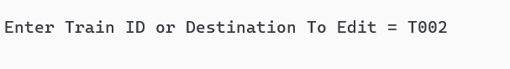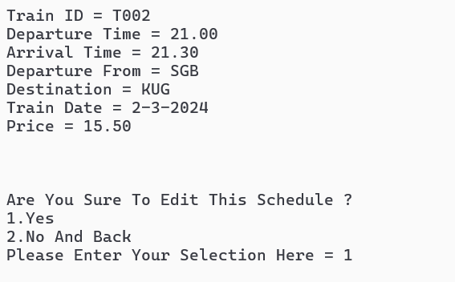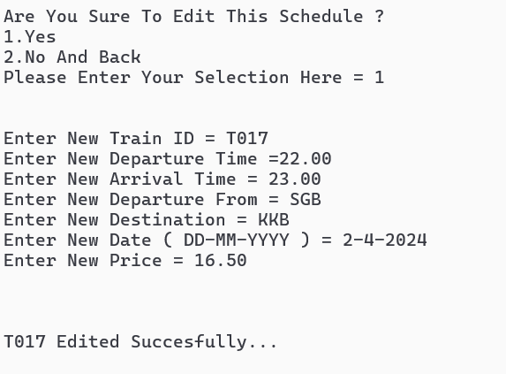

#### Function 4: Search Schedule Function

When staff is able to search details with train ID .When search successfully , system will display the details and information for the train ID

#### 



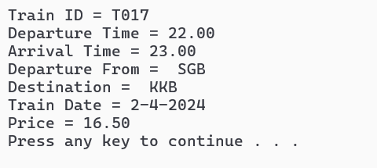

#### 

#### 

#### 

#### 

#### 

#### 

#### 

#### 

#### 

#### 

#### 

#### 

#### 

#### 

#### 

#### Function 5: Delete Schedule Function

If staff want to delete the record , it is needed to search train ID or destination for deleting . When the train ID or destination was found. System will ask for confirmation . If staff enter ‘1’ , system will proceed to delete the details of the record



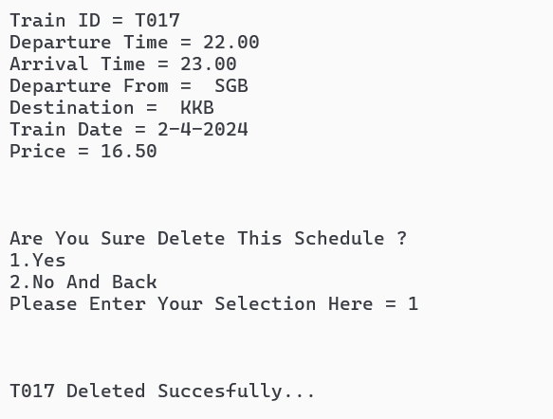

#### Function 6: Schedule Report Function

System will generate record for staff to view according to the train destination and the total of train .

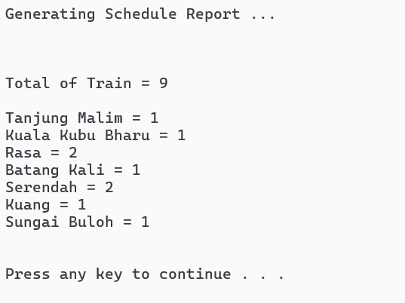

### 

### 

### 

### 

## 4.4 Booking Module By Patricia Lee Huay

### 4.4.1 Brief Description Booking

The booking module has 6 functions that add bookings, search bookings, update bookings, cancel bookings, display all bookings and report of bookings.

* Add Booking
  + This function allows members to add new bookings to the system. Members input relevant details such as member ID, train ID, booking date, passenger name, seat number, coach, payment info with valid member ID.
* Update Booking
  + Members can use this function to update existing bookings. They can modify details such as the train ID, passenger name, seat number, coach, and payment info. After updating, the system and text file will save the changes to the booking record.
* Search Booking
* This function enables members to search for specific bookings based on criteria such as booking ID, member ID, train ID, booking date, or passenger name when . It will display information of the specific bookings if it is found.
* Display booking
* Members and Staff can view a list of successful bookings including Booking ID, Member ID , Train ID, booking date, passenger name, seat number, coach, payment info and amount.
* Cancel booking
* Members can cancel their existing bookings if members wish to cancel or change a mind. The system accepts members' requests to cancel bookings if members enter correct Booking ID
* Report Booking
* Staff can use the reporting feature to track train occupancy and member booking details. This guarantees the efficient management of Rapidekspres train system services and improves the overall member experience.

### **4.4.2 Outputs & File Contents**

**4.4.2 Modules main page**

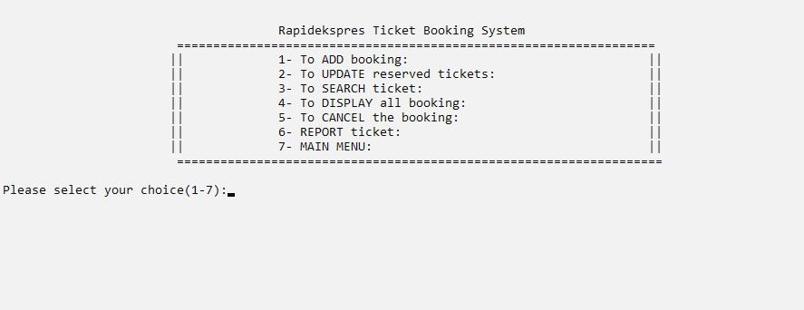

Bookings module menu provide user have a selection of bookings

**4.4.2 File’s existing data**

This bookings text file existing data

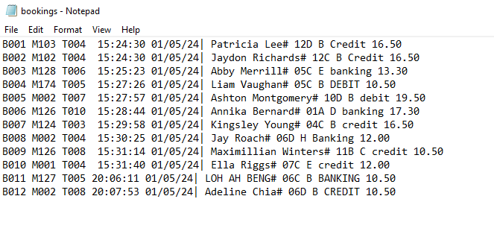

#### Function 1: Add bookings Function

When user choose 1 as want to add booking train ticket from our system

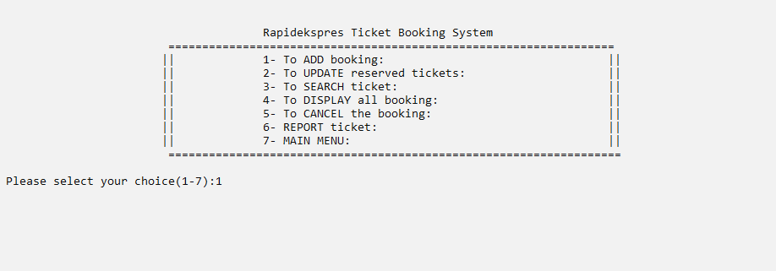

When members want to add booking, this function will display scheduled trains with valid member ID. Upon members entering an invalid or unregistered member ID is can’t add booking.

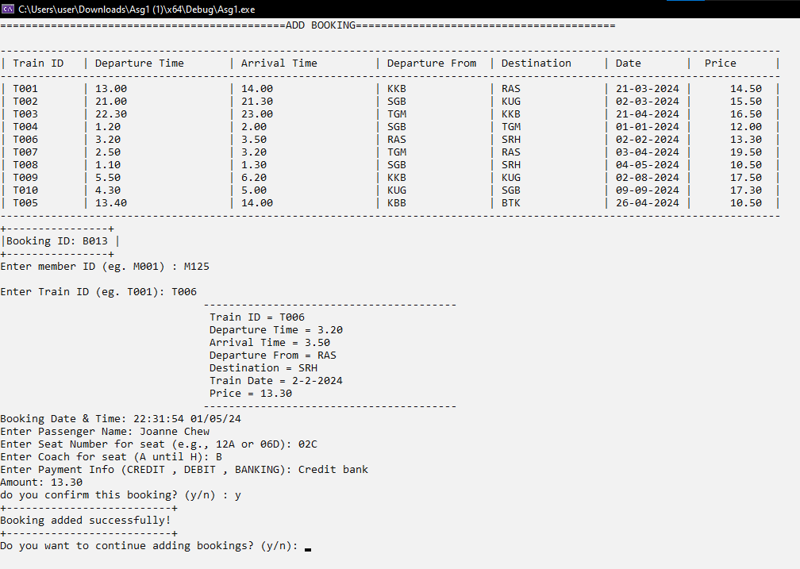

“Invalid Train ID” will be displayed when user enter wrong train id

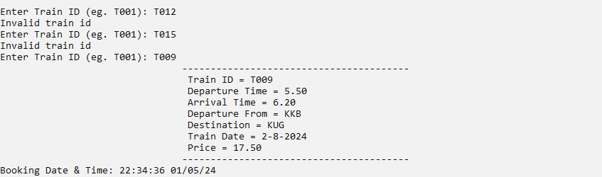

Invalid seat number format and invalid coach will be displayed when the user enters the wrong seat and coach.

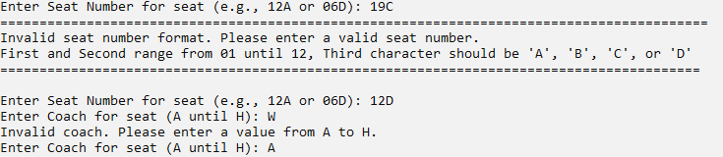

The Booking ID B013 is added and record to the text file

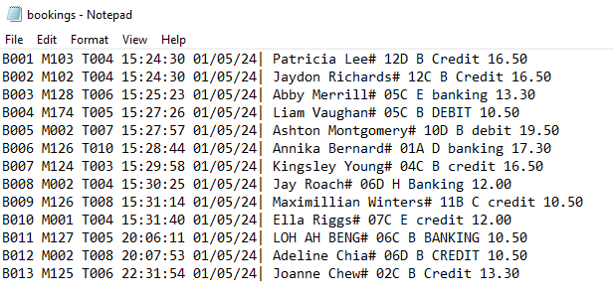

#### Function 2: Update bookings Function

This function is able to modify existing records in this system if members have a mistake or change a mind in bookings. This function also able user to choose which information to update

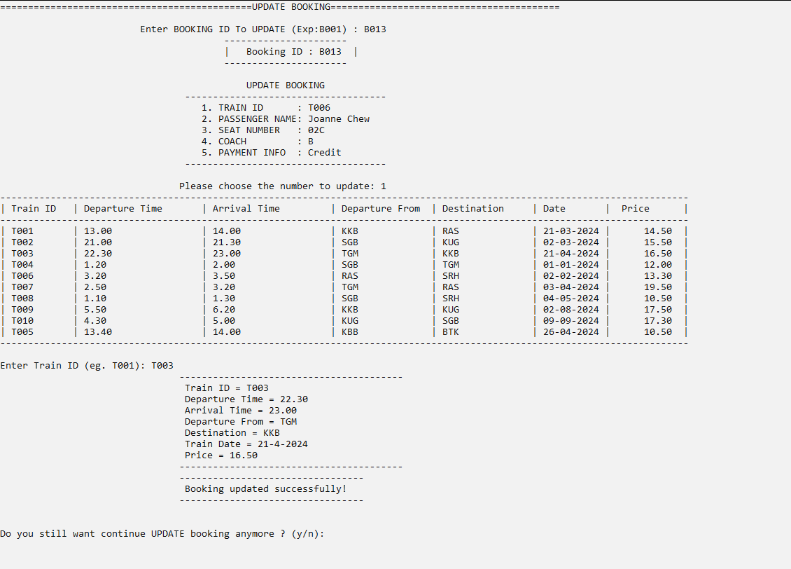

So, now we have saw the train id has been change from T006 to T003 in booking B013

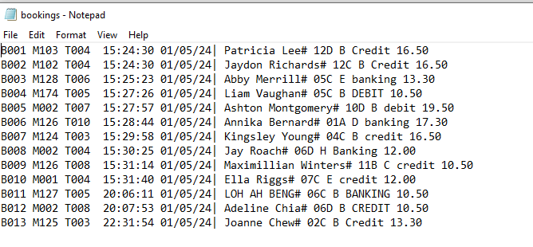

#### Function 3: Search bookings Function

The search bookings function allows users to search for all details of bookings.

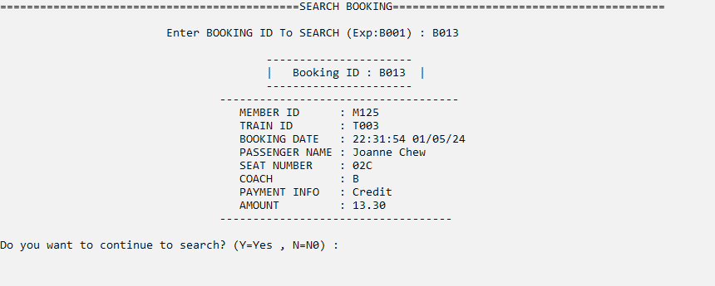

When member entered wrong booking id , the function will display “booking id not found”

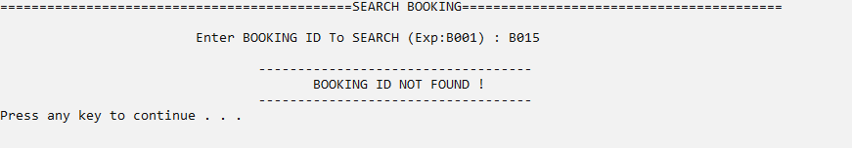

#### 

#### Function 4: Display bookings Function

This display function displays a list of successful bookings.

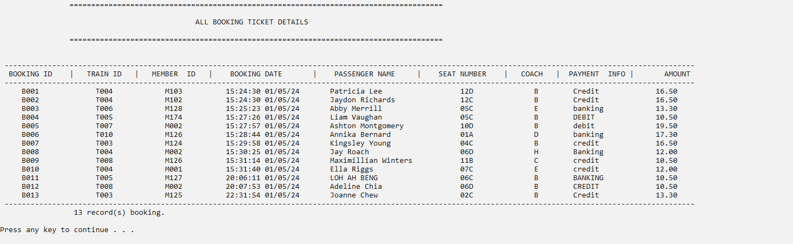

#### Function 5: Cancel bookings Function

The cancel bookings function allows users to cancel existing bookings when they wish to cancel.

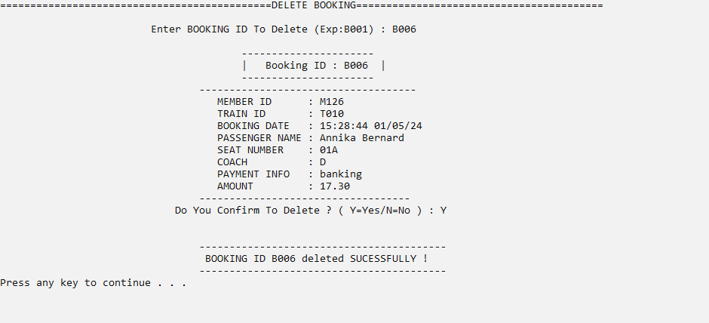

After members successfully cancel their booking , the record of booking will delete that they cancel. We can saw the B006 in text file is was deleted 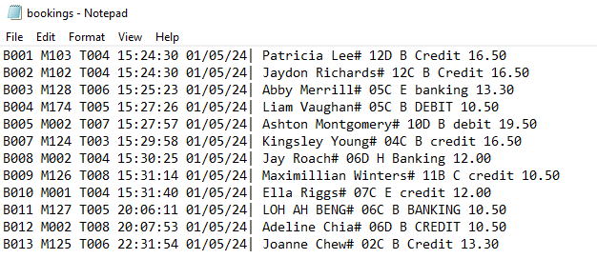

#### Function 6: Report bookings Function

This function can help *RapidEkspres* have a summary view of booking in this system that can help find trends and potential loyalty customers. Overall, this is able to enhance supporting informed decision-making and administrative tasks.

