William Dean

EART 119

Problem Set 6

1. 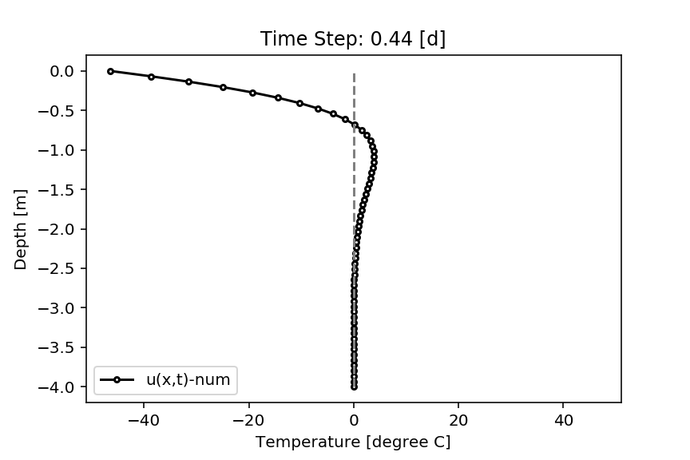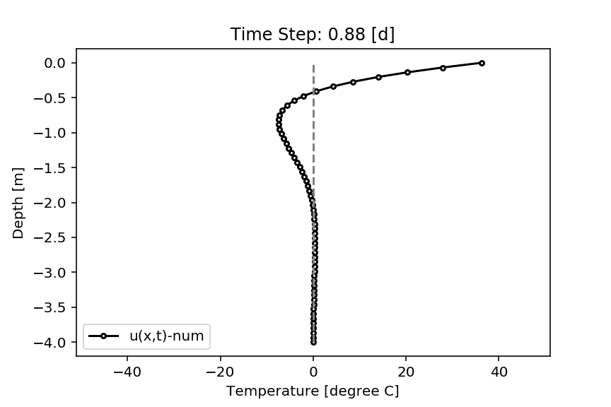

You’d have to live about 2.3m below the surface to survive the temperature fluctuations of +/- 50 C.

1. 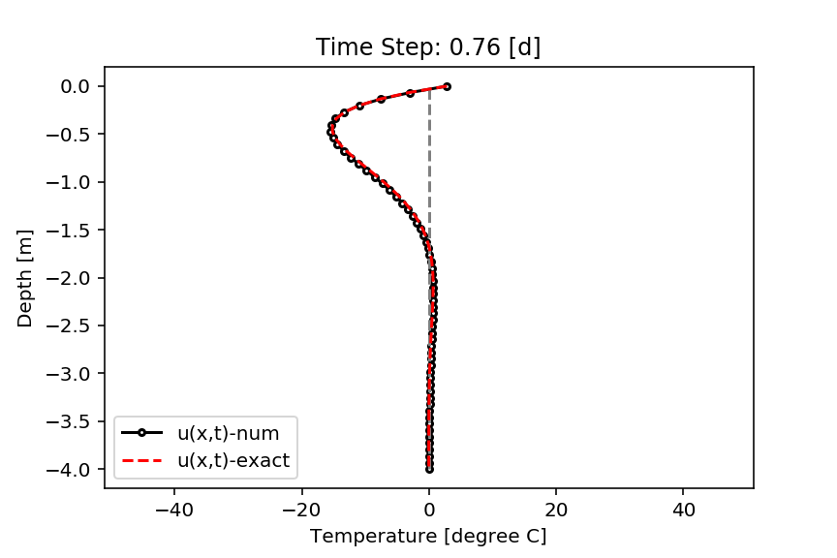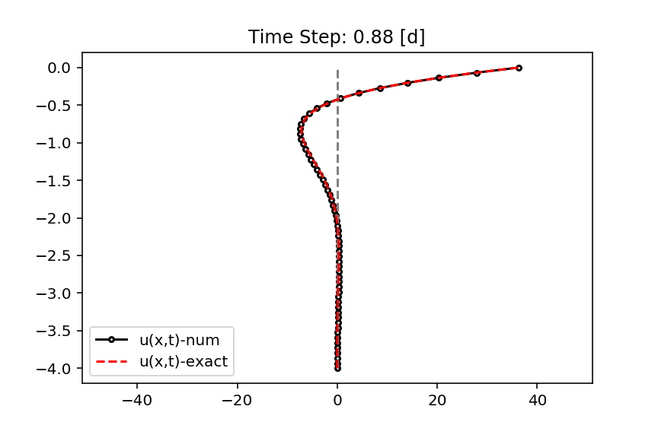

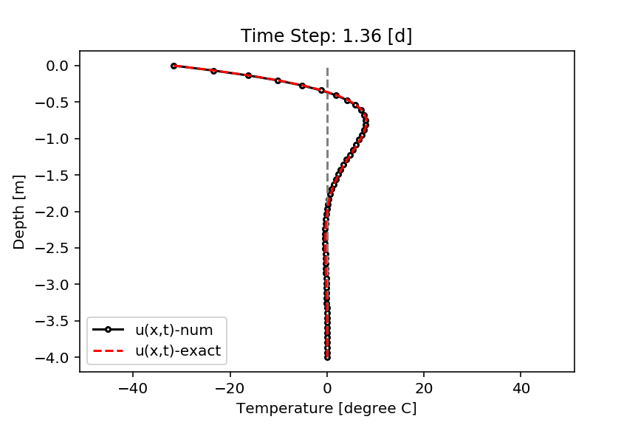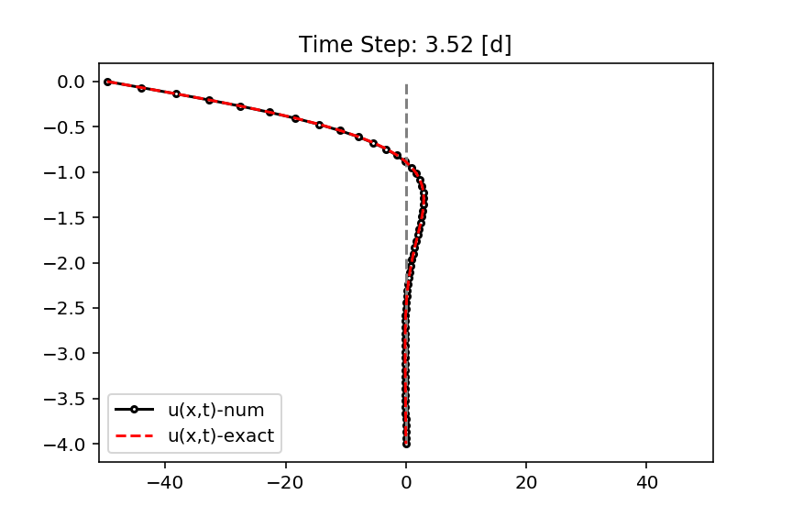

1. 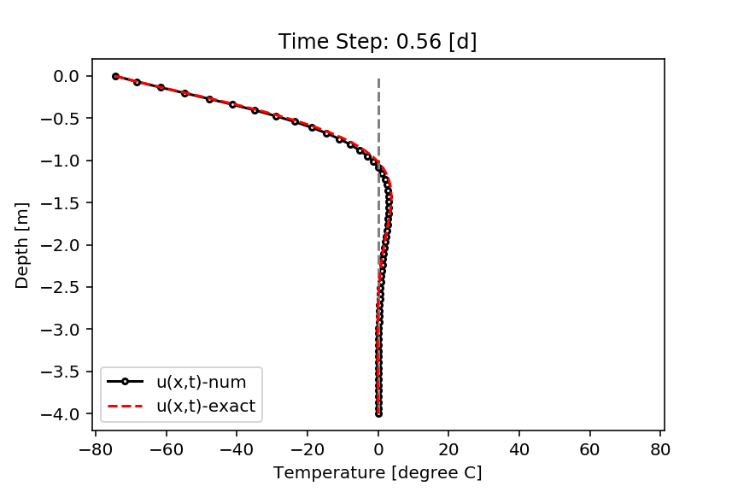 You’d have to stay around 2.6-2.8m below the surface to survive the temperature fluctuations of +/- 80 C.