ipd12 – C#  
Super Mario Project (3D Game)

March 26, 2018

**Name: Qian Gao – Anita Mirshahi**

# Overview

## Description of project content and purpose

## We have a 3D game named Super Mario. It is a known nostalgic game including platform video games.

## Player can run and jump across platforms and jump on top of the enemies in different levels. There are multitude of power-ups and items that give Mario special magic.

## There is only one player mode in the game.

## List of technologies, libraries, components used

|  |
| --- |
| * Entity Framework FOR Database SQLite * Unity platform by C# |
|  |  |

## Database structure:

* We save only top score on Database.

## Screenshots of all the project’s windows:

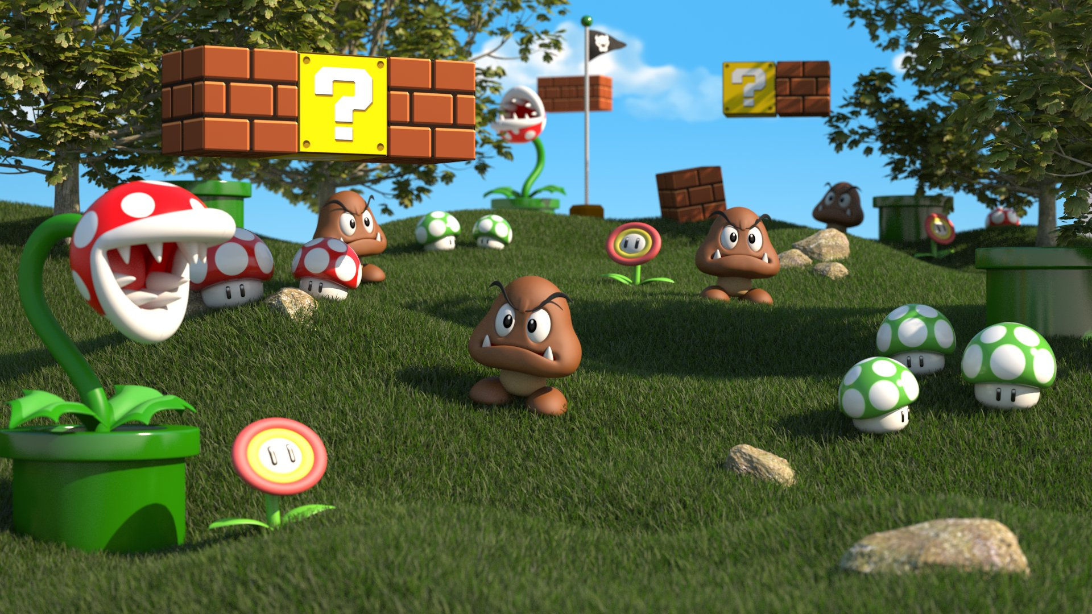

## Game elements:

* logic:

Game logic: user input by mouse or keyboard

Physical logic: gravity, collision detector, inertia, speed and other physical calculations

AI: NPC (non-player character) interactive

* Display:

Animation

Underlay rendering

* Voice
* Video