# I. Purpose and overview

Water quality and quantity data are collected for the Upper Clark Fork River (UCFR) National Science Foundation-funded Long Term Research in Environmental Biology (LTREB) project. This project includes bi-weekly sampling across a 200-km river restoration-contamination-enrichment gradient to track biogeochemical dynamics, biotic standing stocks, and metal contamination. The project is a multi-disciplinary assessment along the UCFR that links multiple drivers of ecological response. The LTREB project maintains historical monitoring along the UCFR initiated by the Tri State Water Council in the early 1980s to address water quality parameter threatened by historical mining within the UCFR headwaters. Moreover, the project extends monitoring to include ecologically-relevant measures along the UCFR. The core of the program involves monitoring sixteen study sites to address a range of water quality variable including inorganic nitrogen (N) in the form of nitrate (NO3-) and ammonium (NH4+), NO3- isotopic composition (i.e., 15N18O3-), inorganic phosphorus (P, as soluble reactive phosphorus, SRP), dissolved organic carbon (DOC) and DOC composition, inorganic carbon metrics including total alkalinity, and metal/metalloid (Cu, Zn, Pb, Cd, As) concentrations. Benthic biomass as organic matter and as chlorophyll a are also monitored at selected sites. Automated sensors are included among many of the monitoring sites.

# II. Individual task protocols

Six sampling tasks are assigned to personnel before sampling begins. The following protocols are associated independently with each task:

1. Water collection
2. Water processing/filtration
3. YSI Probe data collection
4. Inorganic C sampling
5. Sensor use and maintenance
6. Laboratory sample processing/storage in the Valett lab

1) *Task #1 Bulk water collection*

Bulk water samples are collected using collection vessels marked A, B, C and distributed among sample types. Bulk samples are collected as follows:

1. Move into the channel to a well-mixed portion of the thalweg.
2. Submerge each sample vessel and partially fill with river water as needed for rinsing. To rinse, secure cap over the vessel and shake vigorously. Repeat to provide three rinses. Submerge and fill each vessel simultaneously after three rinses.

Deliver water samples to appointed water filtration personnel promptly.

## Task #2 Bulk water processing and sample procurement

## Once bulk water samples are collected, they are refined at the water processing site (located on tailgate of truck). When filtration is required, a designated water filtration unit is used to process raw water samples. Water is distributed into designated vials (see below) associated with different water quality parameters. Bulk water samples are used to provide replicates as needed (one each from vessel A, B, C). Water filtration is not required for total dissolved nutrient samples and raw/unfiltered metal samples.

At each site sample vials are provided in a numbered Ziploc bag. After bulk water samples are collected (see Task #1 above), raw water samples are filtered and distributed into designated vials for each water quality parameter and replicate. Each bag designates site number and contains the following number and types of sample:

* + (3) 50-mL amber glass vials for DOC (dissolved organic carbon)
  + (3) 15-mL Falcon tubes for dissolved nutrients
  + (1) 60-mL Falcon tube for total nutrient assessment
  + (1) 10-mL amber glass vials for EEMS (excitation emission matrix spectroscopy)
  + (1) 60-mL Falcon tube for 15N isotope
  + (1) 20-mL raw/unfiltered metal sample
  + (1) 40-mL filtered size fractioned metal sample

For analytes requiring replicates, vials should be sorted based on replicate ID (i.e., A, B, and C). Vials labeled replicate A should be processed first, followed by replicates B and C, respectively. A portable water filtration station is used at each site to filter water when required. The water filtration unit includes a diaphragm driven piston pump, a Millipore water collection vessel, Whatman® glass fiber filters (pore size 0.7µm), forceps, and a 12V battery. Whatman® glass fiber filters are ashed at 500◦C for one hour before use.

The process of water filtration includes an initial deionized water (DI) water rinse, a stream water rinse, and sample filtration:

1. Set up Millipore filtering vessel (Figure 1). Be sure that all rubber gaskets and tubing are in their proper locations.
2. Before filtering bulk water samples, the Millipore filtration unit is cleaned once using the DI water provided in the one-liter container accompanying the filtration unit. No filter is used during this step. Cleaning is completed by pouring 250-mL of DI water (into top of unit and allowing it to passively drain to the bottom collection vessel. Detach the bottom vessel and discard the rinse water.
3. A clean, ashed Whatman® 47-mm glass fiber filter is then applied to the top of the Millipore unit (Figure 2). Forceps are utilized to remove any used filter and a different set of forceps (marked with the letter C) are used to apply new filter. Alternatively, the same forceps can be used to remove and replace filters as long as they are rinsed with DI water in between.
4. Once a new filter is applied, ca. 200-mL of river water is poured from water collection vessel A to the top of Millipore unit.
5. Filter the 200-mL of river water provided in step iv to provide a filtered sample rinse. To activate pump, the power lines attached to the pump must be connected to a 12V battery. The red cable connects to the post marked with an embossed (+) sign, the black line connects to the post marked with a (-) sign. The black cable should be connected first and unplugged first when finished. The pump will use vacuum power to draw water through the filter into the bottom of Millipore unit. Swirl water as it moves through the filter being sure to rinse all sides of unit top and bottom.
6. Once all the water has drained to the bottom of Millipore unit, pull rubber nipple from unit to depressurize and allow top to be removed.
7. Discard the filtered rinse water from the bottom vessel.
8. Add a second 200-mL of river water from water collection vessel A to top of the Millipore unit. Filter water as above without need for swirling.
9. Fill all vials designated A as follows:
   1. 40-mL filtered size fractioned metal sample (this vial should be filled in the first round of filtering).
   2. 50-mL DOC vial and 10-mL EEMs vial. Fill and discard to provide a required rinse before re-filling.
   3. 15-mL Falcon tubes to the 13.5-mL mark. Do not overfill!
   4. 60-mL Falcon tubes to the 45-mL mark. Do not overfill!
10. Repeat steps 1-9 at each site.
11. Unfiltered samples (i.e. total dissolved nutrients and 20 mL raw metal sample) are filled last directly from sample vessel A and do not undergo the filtration process.
12. Put vials in perspective site bag and place in cooler on ice.

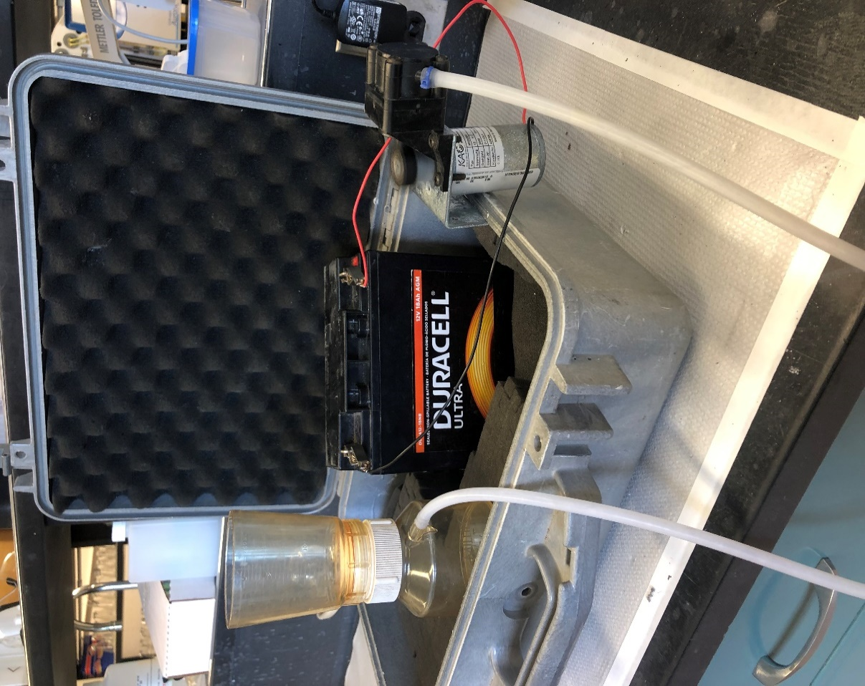

Figure 1. Filtration station setup

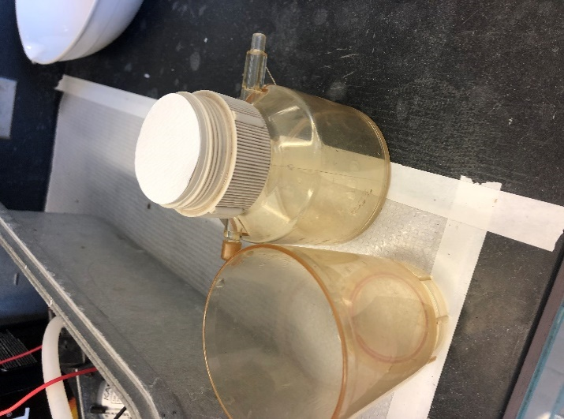

Filter placed here

Figure 2. Millipore unit close up

Filter placed here

*Task #3: Physicochemistry measures using YSI probes*

Two YSI probes handheld water quality monitors are used at each site including: YSI Pro2030 for dissolved oxygen (DO) concentration(mg/L), DO (% saturation), electrical conductivity (μS/cm), specific conductivity (μS/cm), and temperature (°C) and YSI Professional Plus temperature (°C), pressure (mmHg), pH, and oxidation reduction potential (ORP, mV).

Collect physicochemical data as follows:

1. Go into thalweg where water collection occurred.
2. Turn on both probes by pushing power button.
3. Make sure probes are fully immersed in the water, roughly 34 centimeters (forearm length) into water column.
4. Wait for readings to stabilize and write them down on designated data collection sheet (found inside clipboard). Use a pencil to avoid smearing.
5. After data collection turn probes off and put into respective storing sleeves. Make sure there is a small amount of water in storage sleeves for sensor membrane protection.

*3) Task #4 Inorganic Carbon sampling*

Two sample types are collected at each site for DIC assessment using DIC vials and CRM bottles with the following protocols:

1. Obtain the three DIC vials, the CRM bottle, and the grease-filled syringe before moving to a well-mixed portion of the river near location of bulk water collection to a depth of at least 30-40 cm.
2. Rinse each of the three 50-mL DIC vials with raw-unfiltered river water before collecting the samples.
3. Immerse each DIC vial into the water column to mid-column depth and fill vial completely with water that is bubble-free while holding the vial under water. Be sure that the sample contains no air bubbles.
4. Cap vial while underwater to ensure no gas exchange occurs.
5. Return the DIC vials to the shore and store in cooler on ice until transfer to refrigerator.
6. Obtain CRM bottle for the given site (a site ID with corresponding bottle ID list is located within clipboard storage).
7. Take off cap by twisting and pulling from the bottle. Keep cap in hand. Caution: cap is hollow glass.
8. Face bottle downward and submerge into water until you reach a depth of 20 cm or more. Be sure bottle is deep enough to avoid turbulent aerated water.
9. At desired depth, turn the bottle upward and upstream, allow water to fill the bottle. Lift the bottle out of the water, and empty the bottle to provide a thorough rinse. Keep the bottle facing downward to avoid introducing particles during sampling.
10. Repeat the rinsing process (step 9) two more times to provide three rinses before sampling.
11. Rinse the CRM cap for a few seconds.
12. In one hand, hold the CRM bottle facing downwards along with the CRM cap (in between your fingers usually works).
13. Take out the syringe full of grease and apply a small bead around the middle of the portion of the cap that will be touching the CRM bottle’s neck.
14. Return the syringe to a bag or pocket to allow use of both hands.
15. In one hand, hold the bottle downward. In the other, hold the grease cap positioned for use.
16. Place bottle into the water following the steps described above. Fill bottle completely while trying to remove all air bubbles by gently shaking the bottle. A few small remaining bubbles are acceptable.
17. While the bottle is still in the water, use your other hand to cap the bottle. Place the cap gently on the bottle by twisting and pushing it. This allows the grease to spread out to ensure a strong seal.
18. Once the bottle is capped and out of the water, place the rubber band and zip tie around the cap.
19. Return the CRM bottle to respective storage crate inside cooler marked DIC.

*5) Task #5 Cleaning and locating autonomous data loggers*

An array of autonomous data loggers are used across sites. Sensors are anchored to the bank and attached with paracord for security. Each sensor must be identified and cleaned during each site visit.

1. Locate each sensor. Sensor location will be acknowledged by indicating a check mark on sensor data sheet (located on the back of data collection sheet). A small letter ‘c’ is used to indicate the sensor has been cleaned.
2. Each sensor should be cleaned with a soft brush in the water column to remove any organic buildup.
3. After the sensor is cleaned lightly place it back into the water column.
4. Document time of sensor removal on datasheet.
5. Uploading data from autonomous sensors is described in a separate protocol.

*6) Task #6 Sample storage in Valett laboratory*

Once LTREB monitoring is completed it is essential that all samples be stored in the correct locations. The following are general procedures for sample organization and storage.

1. Organize samples so they are in the order of site 1-16, A-C.
2. All dissolved nutrient samples must be frozen and stored in Valett lab freezer A.
3. Store all 15N and Total samples in Valett lab freezer B.
4. Store all DOC and EEMs samples upright in the refrigerator (never frozen).
5. All boxes and racks containing samples must be marked with date and contents.
6. Metal samples will be given to a Colman lab representative upon arrival at the Health Science building.
7. DIC and alkalinity sample will be given to a Degrandpre lab representative upon arrival at the Health Science building.
8. Remainder of supplies should be put in designated areas and waders must be hung up.