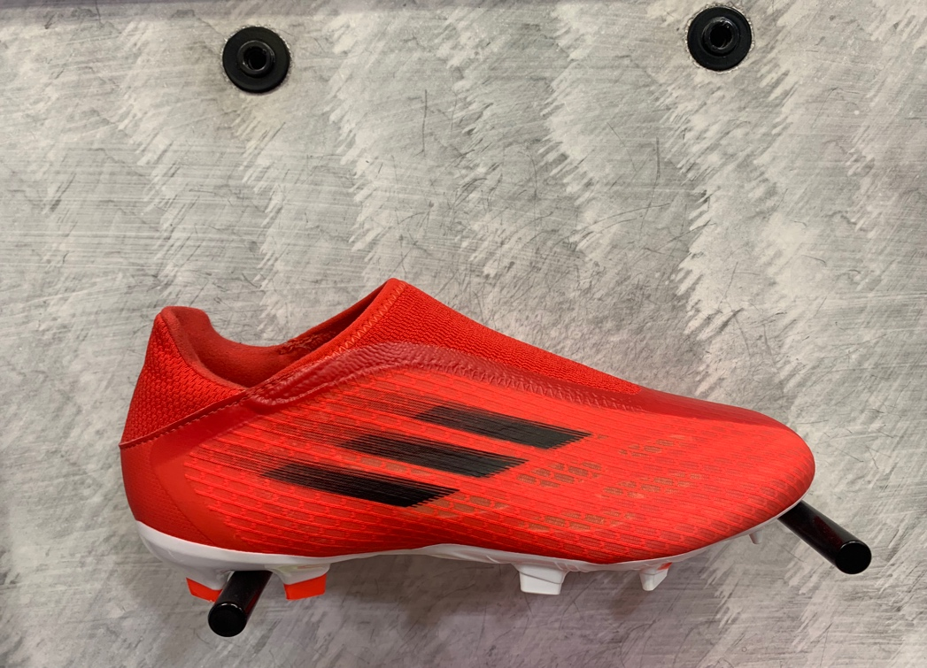

X.3 Football Boots Firm Grounds, Red/SolarRed

Product code: AR367

Price: 35

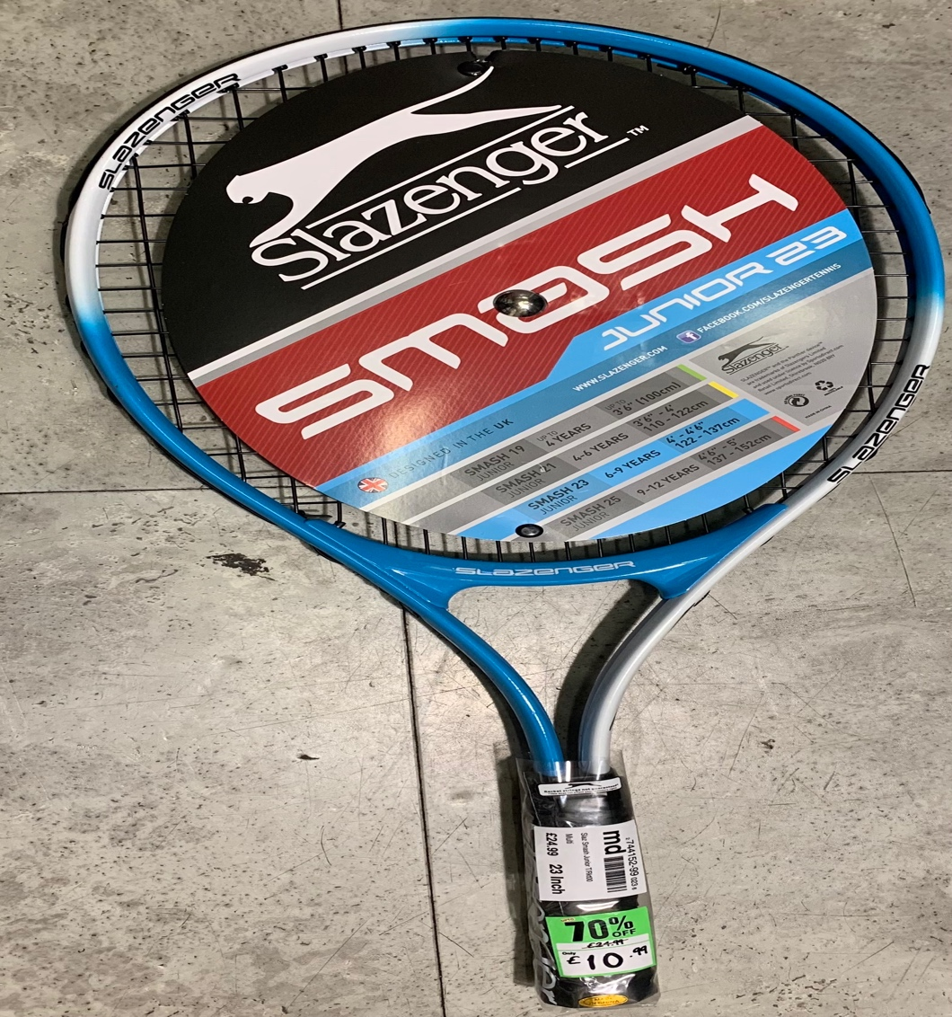

Slazenger Tennis Racket, White/Blue

Product code: TE837

Price: 10.99

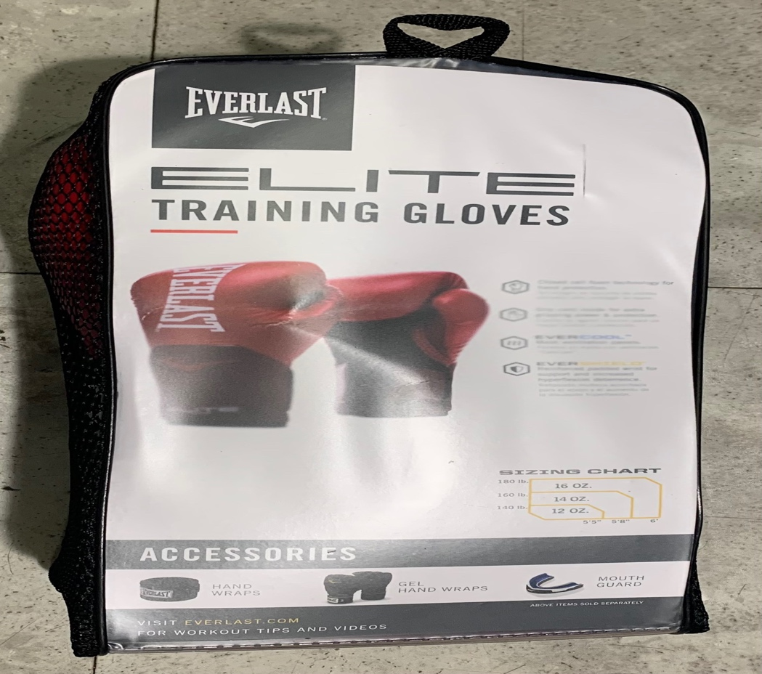

Pro Styling Elite Boxing Gloves, Flame Red

Product code: BO287

Price: 9.99

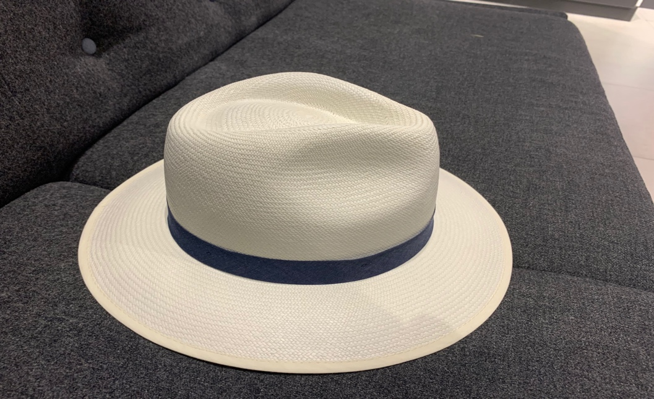

Christys’ Panama Hat, White

Product code: HA395

Price: 20

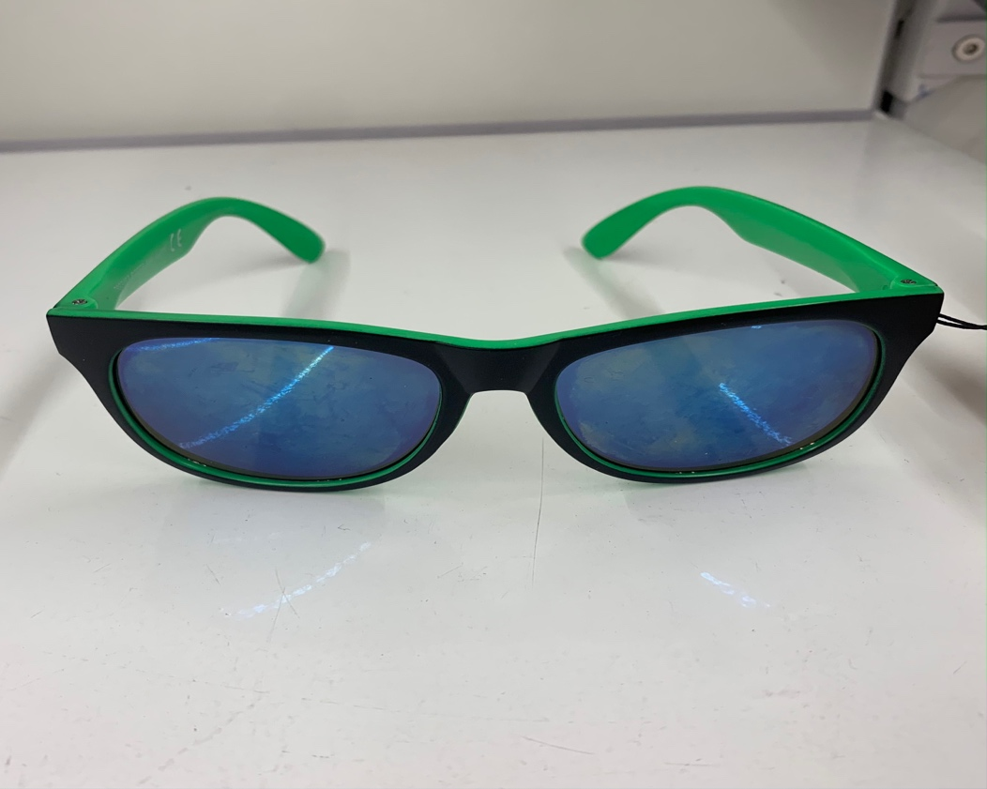

Unisex Sunglasses, Black/Green

Product code: SG736

Price: 9.99

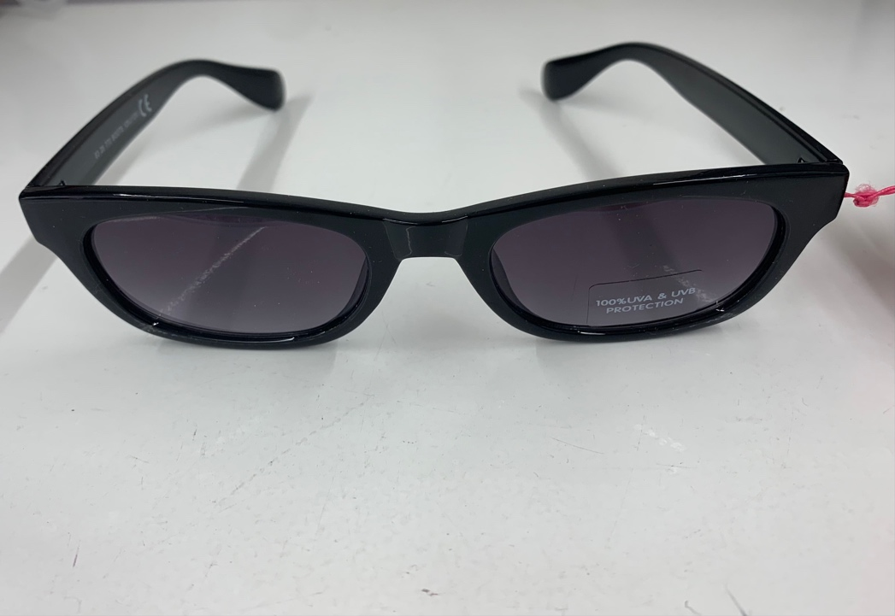

Unisex Sunglasses, Black

Product code: SG733

Price: 9.99

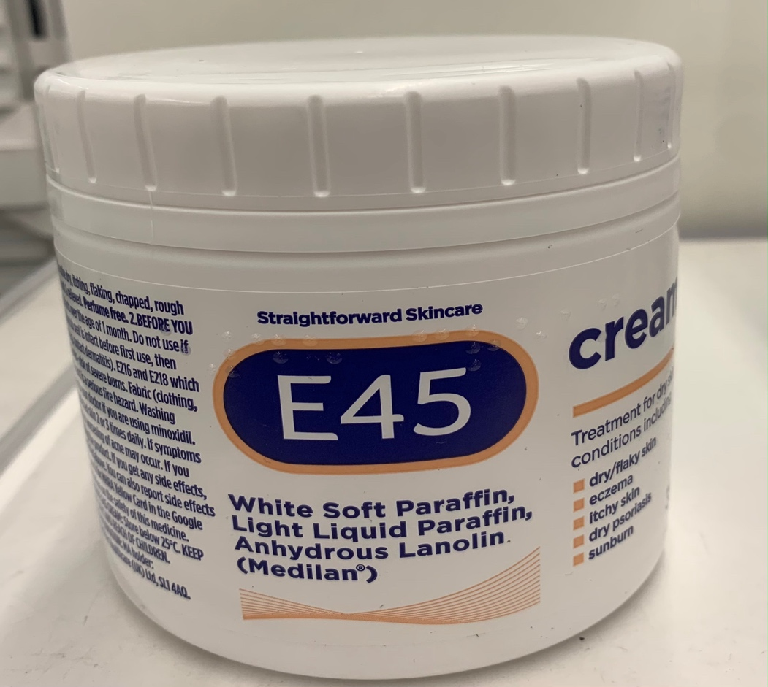

E45 Cream for Dry Skin and Eczema / 350g

Product code: SC333

Price: 8.99

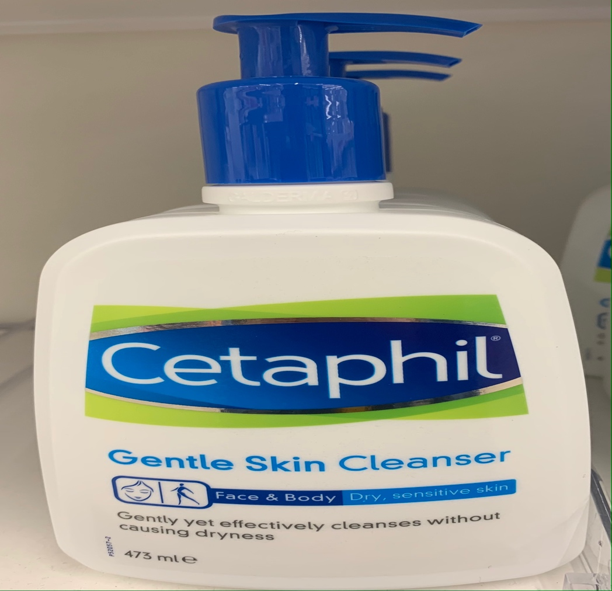

Cetaphil Gentle Skin Cleanser / 473ml

Product Code: SC738

Price: 8.99

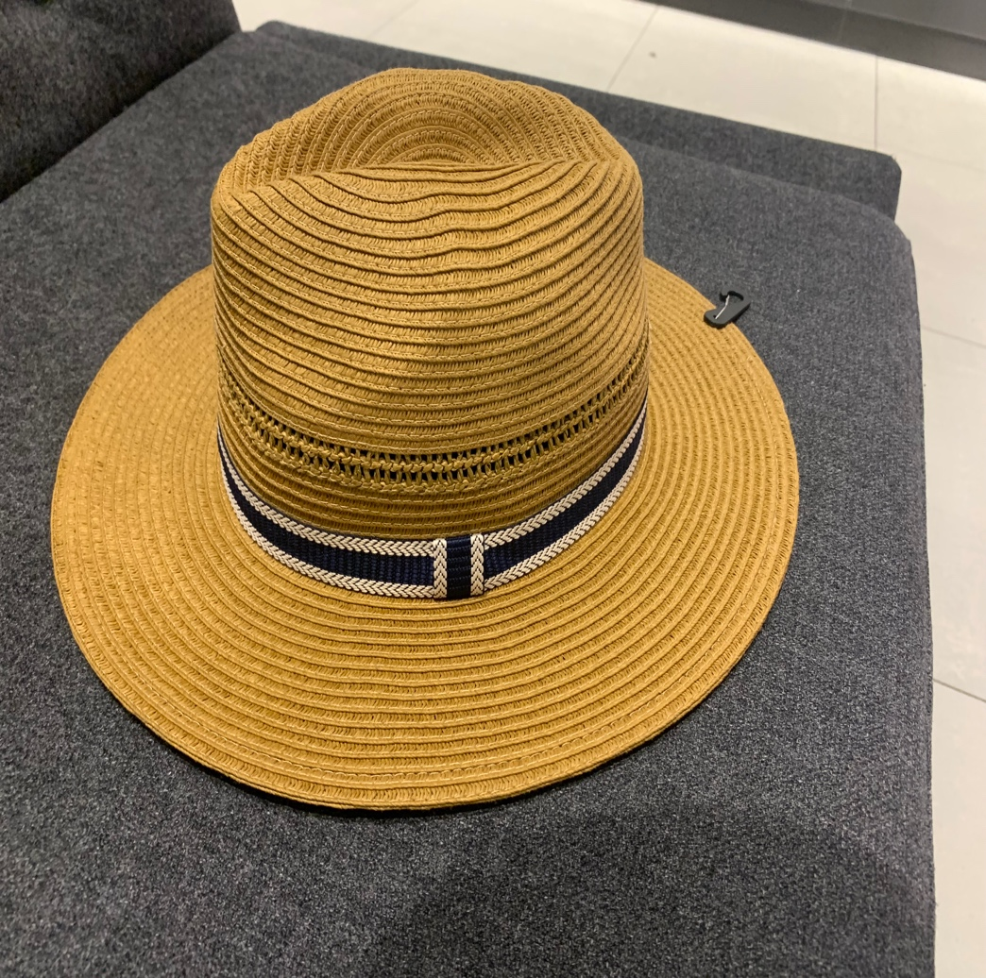

John Lewis and Partners Failsworth Straw Fedora Had, Natural

Product Code: HA244

Price: 20

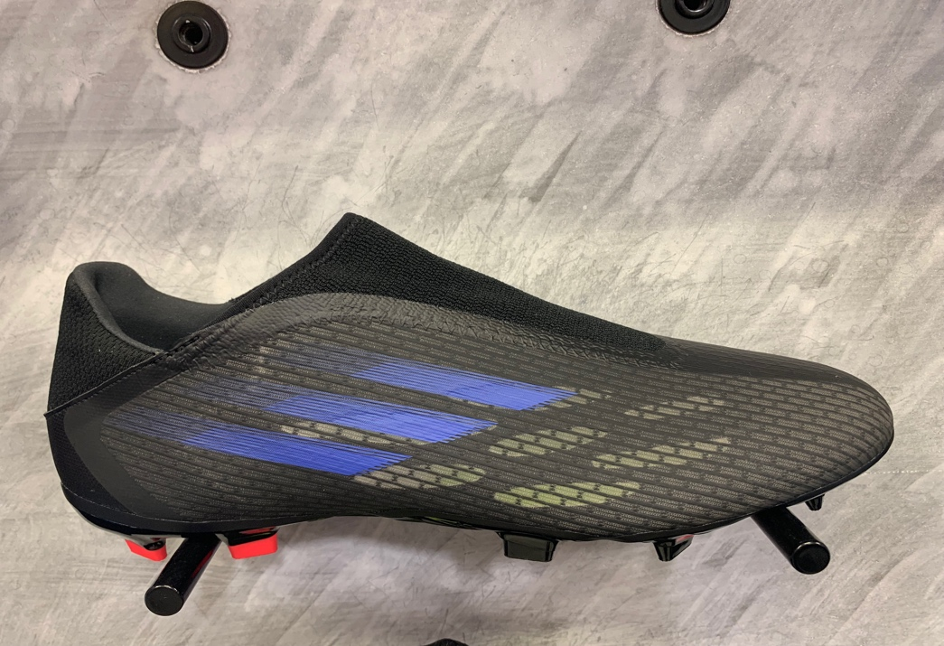

X.3 Football Boots Firm Grounds, Black/SonicInk

Product code: AT584

Price: 35