Zach Howell

HDR Creation & Tone Mapping

I completed both parts of the assignment. They are attached in this zip as combine_exposures.py and tonemap.py. I also implemented some simple hacks for HDR creation – ie, I chose random values that were at least a certain distance apart.

Here are my results for creating an HDR image using main.

In general, I got some output that doesn’t look perfect, but I think is pretty reasonable.

With taking only 500 pixels as input, it looks mostly like garbage:

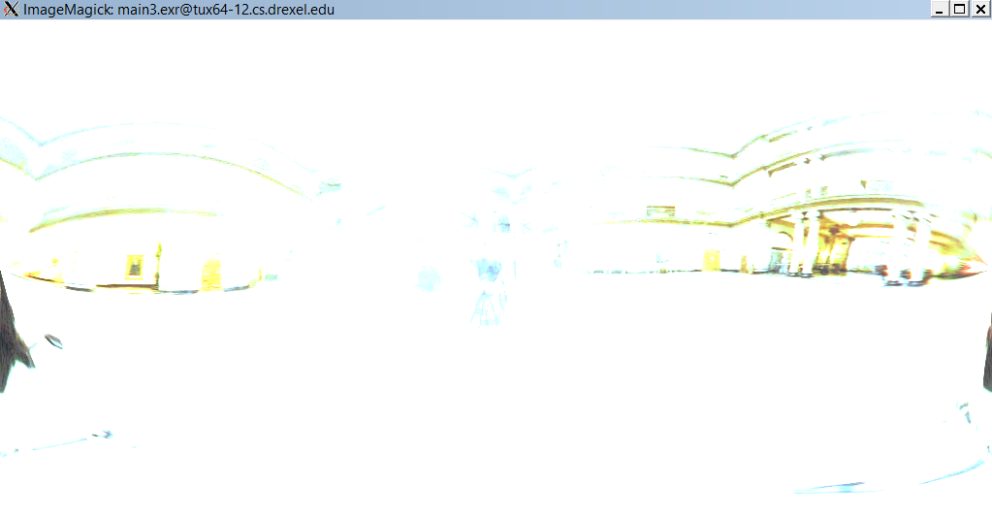

However, increase that to a 1000 pixel sample:

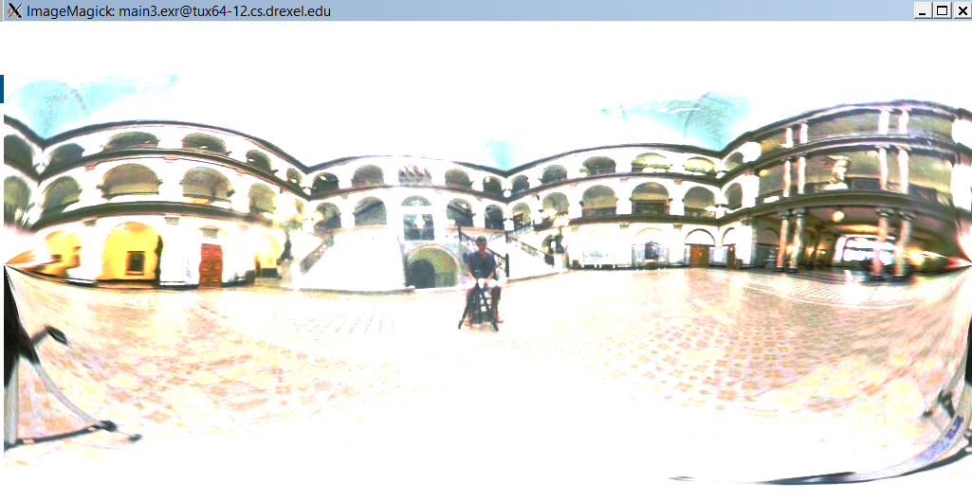

And it looks quite good!

Here’s that same image (1000 sample) tone mapped back down using my second program:

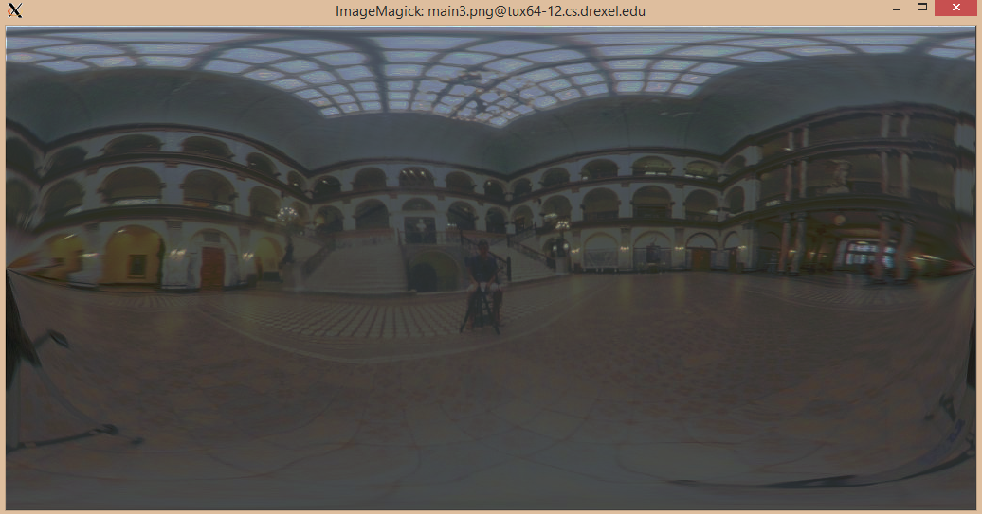

Here’s my result from tone mapping down garden.exr:

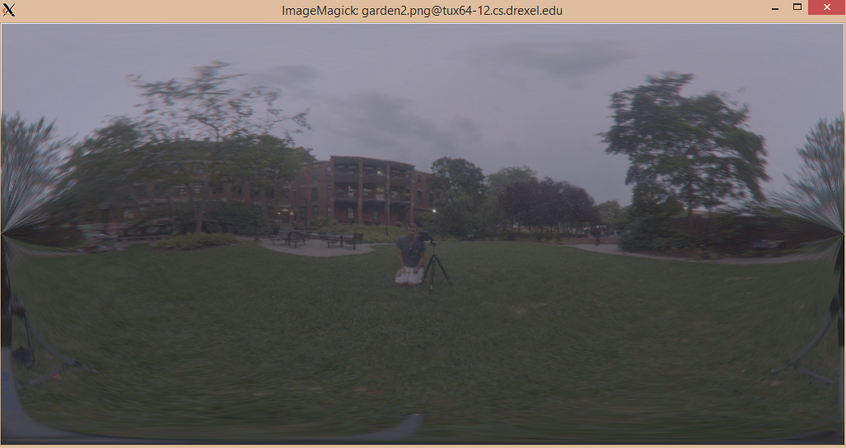

Also, for reference on the HDR image creation, here’s a plot of my response function for main:

