# Zach Howell, Project 2

I got seam carving & resizing to work. I did extra credit to make it run faster, achieving speed-ups of 66%.

## Resizes of boringTent.jpg:

Source image (720w x 960h):

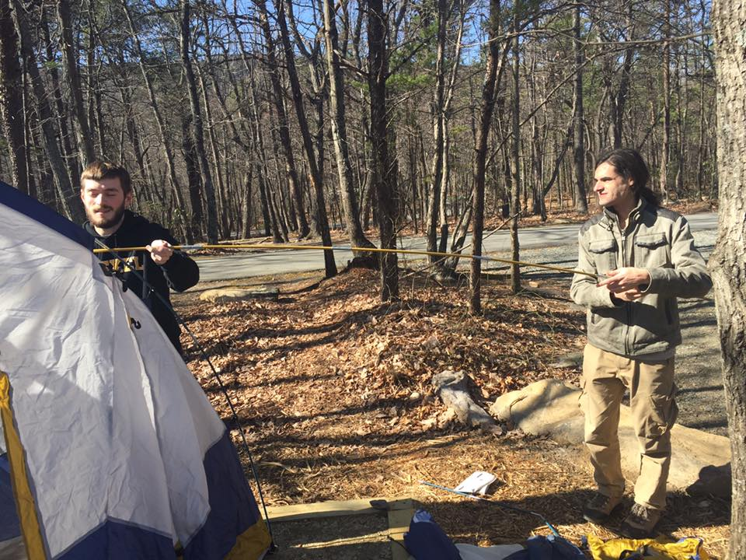

Resized to 500x500 (removed 600 seams, took 23 minutes):

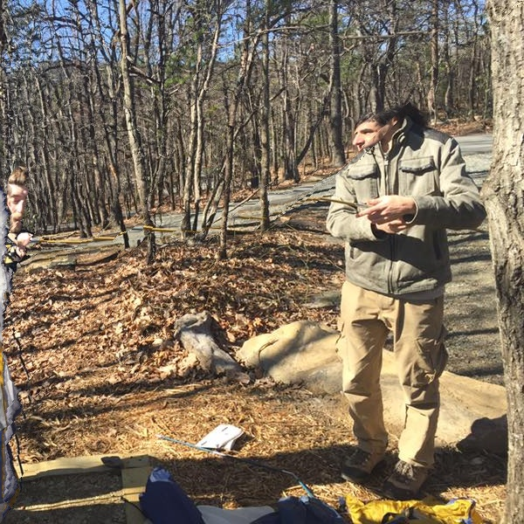

This looks really odd, but it makes sense if we look at the original energy picture:

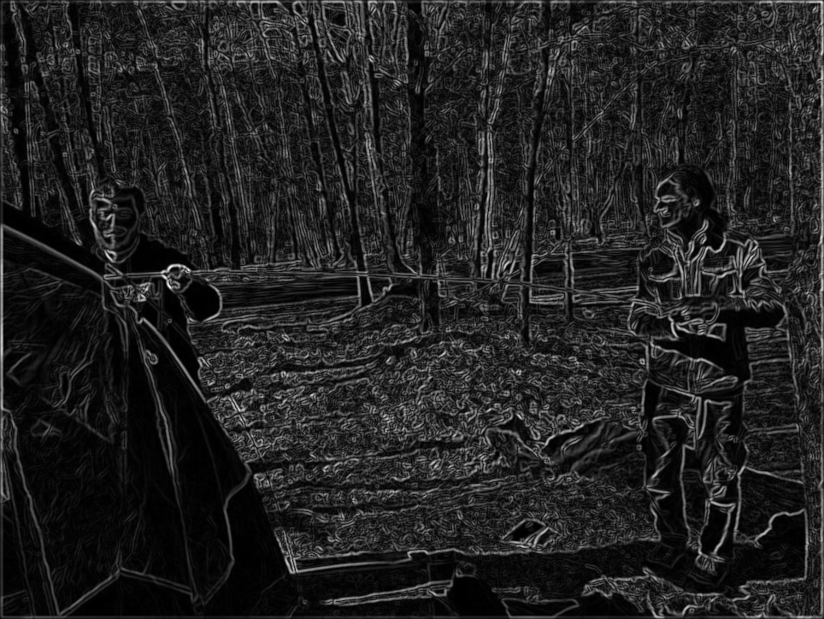

All the lines for the trees (and even the leaves) create a lot of noise and really make the trees stand out. In contrast, the flat tent and flat colors of my friend’s hoodie are pretty low cost. This would be good for preservation, but I probably won’t do that.

## Resizes of manDesert.jpg:

Source image, with size 640w x 360h

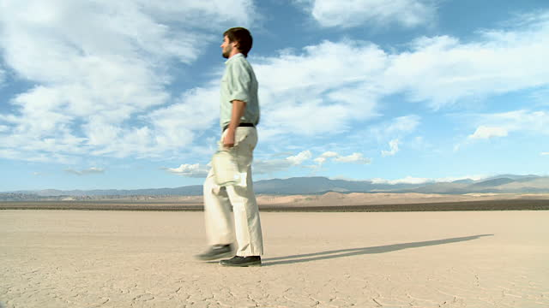

Reduced to 320h x 400w (time 551.73)

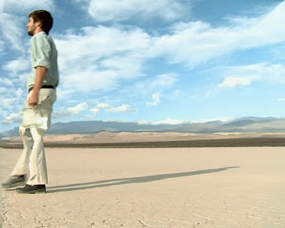

I’m not entirely sure why it took out most of the left side first – I’m guessing the mountains were just thinner on that side. Keeping loose symmetry might be an interesting addition.

## Extra Credit – Speed up the minimization process

I sped up the minimization process by caching the minimized images/values (the matrix M) between each seam cut. It wasn’t too complicated; I set all the values that could possibly have been affected (basically a fan beneath the top pixel) to a starting bogus value, removed the seam, and recalculated those values. That meant I avoided recalculating about half the values in the image, especially if a seam was found on the edges. I further improved this by removing 4 seams at once before recalculating anything.

Run time for reducing images – Comparison between fast & slow version:

From outDesert (already processed to 320h x 400w) to (300h x 300w)

With improvements: 18.45 seconds, 18.49

Without improvements: 28.60, 28.80

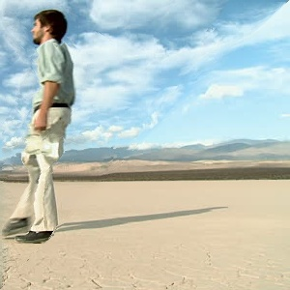

outDesert (already at 320h x 400w) to (300h x 300w)

With improvements: 204.1seconds

