ANOVA Lecture Material

Table of Contents

Prof. Dr. Stephan Huber1,2

1 Fresenius University of Applied Science

2 Charlotte Fresenius University

Author note

All files related to that paper are hostes on github. see: <https://github.com/hubchev/ewa>.

Correspondence concerning this article should be addressed to Prof. Dr. Stephan Huber, Im Mediapark 4e. E-mail: [stephan.huber@hs-fresenius.de](mailto:stephan.huber@hs-fresenius.de)

Abstract

In this paper, I illustrate the process of making nice tables and graphics that are related to ANOVA and had been shown in the lecture. The paper adheres to the APA style, implementing the R template provided by the ‘papaja’ package (Aust & Barth, 2023).

*Keywords:* papaja, descriptive statistics

ANOVA Lecture Material

# 1 Summary

I create many of the tables and figures of lecture in this report. In particular, I show the full dataset in Table 1. Table 2 contains summary statistics for all variables and  
Table 3 for all values of the combinations of variables of modus and kognition. Table 4 shows the ANOVA results. Table 5 also shows ANOVA results but with more interactions.

Figure 1 shows boxplots for all combinations of variables of modus and kognition. Figure 3 shows an interaction plot of dauer and modus. Figure 2 shows an interaction plot of dauer and kognition. Figure 4 shows boxplots for all combinations of variables of modus, kognition, and interviewer.

# 2 Data Preperation

if (!require(pacman)) install.packages("pacman")  
pacman::p_load(tidyverse, janitor, psych, magick,   
 car, knitr, papaja, kableExtra, stargazer)  
rm(list = ls())  
  
ModKogDat <- read.csv("../data/ModKogDat.csv", header=TRUE, sep=",")   
# Read in data  
df <- ModKogDat |>   
 mutate(  
 modus = as.factor(modus),  
 kognition = as.factor(kognition)  
 ) |>   
 group_by(modus, kognition) |>   
 mutate(  
 id_num = cur_group_id(),  
 m_str = substr(modus, 1, 2),  
 k_str = substr(kognition, 1, 2),  
 id = paste(m_str, k_str, sep = "_")  
 ) |>   
 select(-m_str, -k_str) |>   
 tibble() |>   
 ungroup()

# 3 Inspect Data

Table   
 *Full Dataset*

| dauer | modus | kognition | id_num | id |
| --- | --- | --- | --- | --- |
| 8 | a1 telefon | b1 altersadaequat | 1 | a1_b1 |
| 16 | a1 telefon | b1 altersadaequat | 1 | a1_b1 |
| 12 | a1 telefon | b1 altersadaequat | 1 | a1_b1 |
| 7 | a1 telefon | b1 altersadaequat | 1 | a1_b1 |
| 17 | a1 telefon | b1 altersadaequat | 1 | a1_b1 |
| 20 | a1 telefon | b2 lkb | 2 | a1_b2 |
| 26 | a1 telefon | b2 lkb | 2 | a1_b2 |
| 20 | a1 telefon | b2 lkb | 2 | a1_b2 |
| 14 | a1 telefon | b2 lkb | 2 | a1_b2 |
| 20 | a1 telefon | b2 lkb | 2 | a1_b2 |
| 10 | a1 telefon | b3 begdem | 3 | a1_b3 |
| 7 | a1 telefon | b3 begdem | 3 | a1_b3 |
| 11 | a1 telefon | b3 begdem | 3 | a1_b3 |
| 9 | a1 telefon | b3 begdem | 3 | a1_b3 |
| 13 | a1 telefon | b3 begdem | 3 | a1_b3 |
| 15 | a2 besuch | b1 altersadaequat | 4 | a2_b1 |
| 25 | a2 besuch | b1 altersadaequat | 4 | a2_b1 |
| 22 | a2 besuch | b1 altersadaequat | 4 | a2_b1 |
| 19 | a2 besuch | b1 altersadaequat | 4 | a2_b1 |
| 29 | a2 besuch | b1 altersadaequat | 4 | a2_b1 |
| 32 | a2 besuch | b2 lkb | 5 | a2_b2 |
| 27 | a2 besuch | b2 lkb | 5 | a2_b2 |
| 26 | a2 besuch | b2 lkb | 5 | a2_b2 |
| 20 | a2 besuch | b2 lkb | 5 | a2_b2 |
| 25 | a2 besuch | b2 lkb | 5 | a2_b2 |
| 30 | a2 besuch | b3 begdem | 6 | a2_b3 |
| 21 | a2 besuch | b3 begdem | 6 | a2_b3 |
| 33 | a2 besuch | b3 begdem | 6 | a2_b3 |
| 39 | a2 besuch | b3 begdem | 6 | a2_b3 |
| 27 | a2 besuch | b3 begdem | 6 | a2_b3 |

Table   
 *Summary Statistics*

| Variables | n | mean | sd | median | min | max | se |
| --- | --- | --- | --- | --- | --- | --- | --- |
| dauer | 30.00 | 20.00 | 8.44 | 20.00 | 7.00 | 39.00 | 1.54 |
| modus* | 30.00 | 1.50 | 0.51 | 1.50 | 1.00 | 2.00 | 0.09 |
| kognition* | 30.00 | 2.00 | 0.83 | 2.00 | 1.00 | 3.00 | 0.15 |
| id_num | 30.00 | 3.50 | 1.74 | 3.50 | 1.00 | 6.00 | 0.32 |
| id* | 30.00 | 3.50 | 1.74 | 3.50 | 1.00 | 6.00 | 0.32 |

*Note.* This table contains all variables.

Table   
 *Summary Statistics for the Variable dauer*

| id | count | mean | sd | COV (sd/mean) | min | q25 | median | q75 | max |
| --- | --- | --- | --- | --- | --- | --- | --- | --- | --- |
| a1_b1 | 5 | 12.00 | 4.53 | 0.38 | 7 | 8.00 | 12 | 16.00 | 17 |
| a1_b2 | 5 | 20.00 | 4.24 | 0.21 | 14 | 20.00 | 20 | 20.00 | 26 |
| a1_b3 | 5 | 10.00 | 2.24 | 0.22 | 7 | 9.00 | 10 | 11.00 | 13 |
| a2_b1 | 5 | 22.00 | 5.39 | 0.24 | 15 | 19.00 | 22 | 25.00 | 29 |
| a2_b2 | 5 | 26.00 | 4.30 | 0.17 | 20 | 25.00 | 26 | 27.00 | 32 |
| a2_b3 | 5 | 30.00 | 6.71 | 0.22 | 21 | 27.00 | 30 | 33.00 | 39 |

*Note.* This table contains summary statistics for each combination of modus and kognition

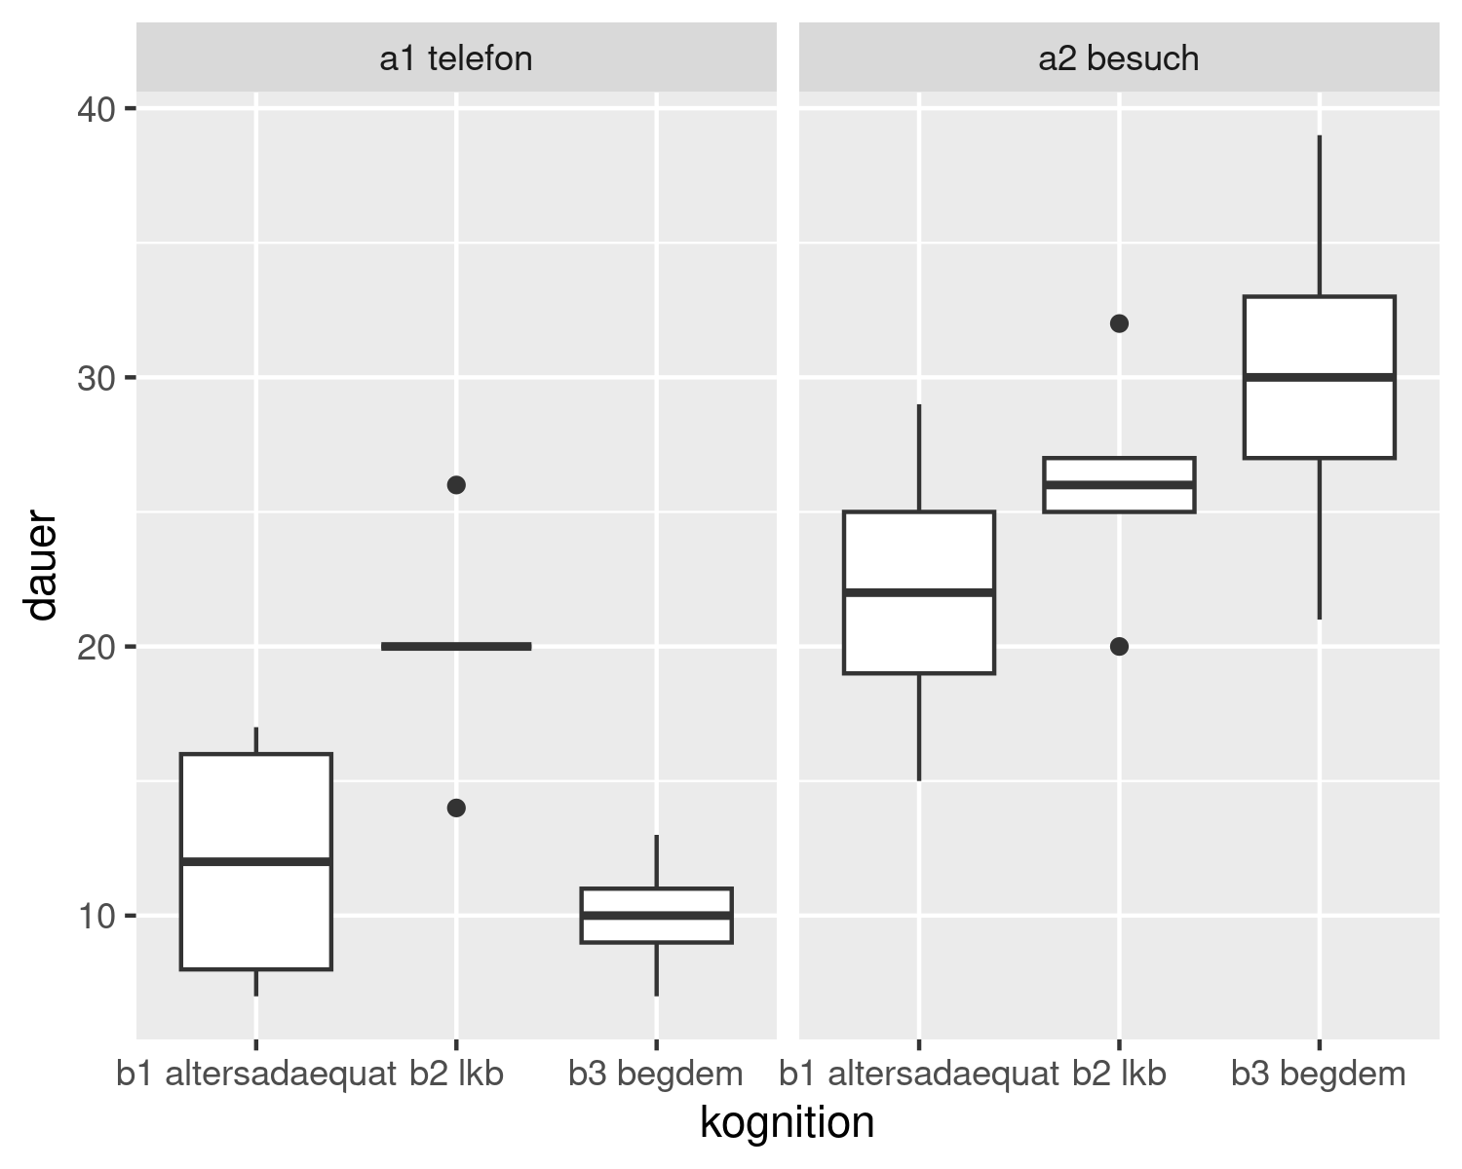

Figure 1: Boxplots of all combinations of modus and kognition

# 4 Interaction Plots

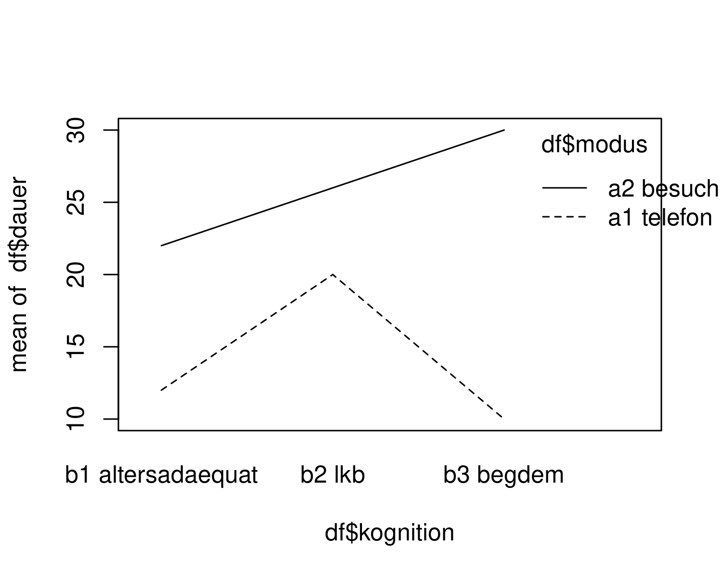

Figure 2: Interaction Plot: dauer and modus

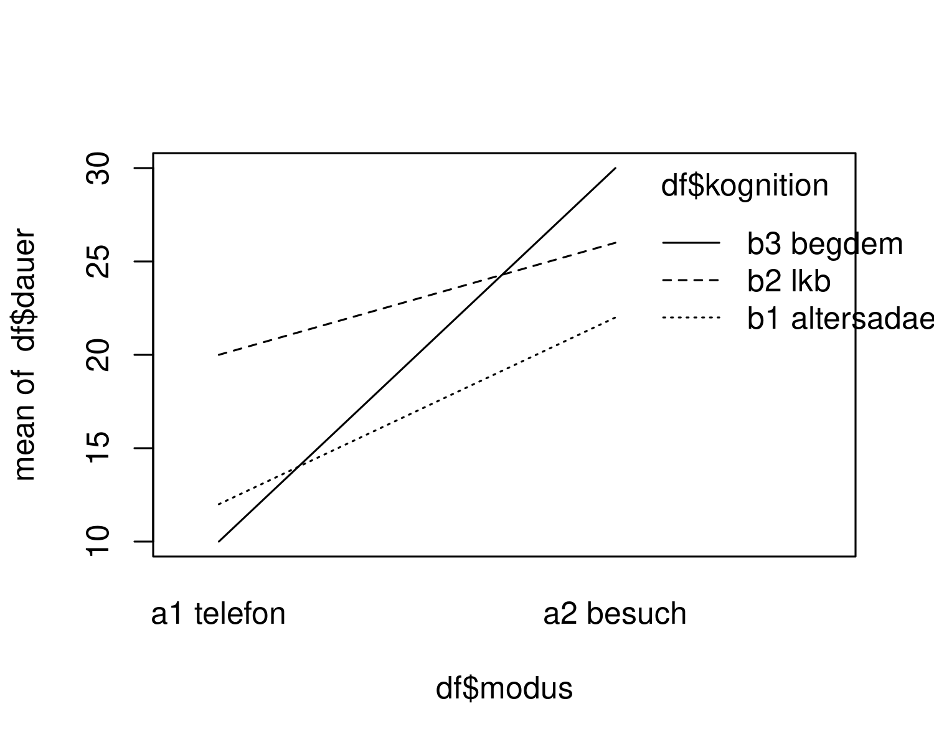

Figure 3: Interaction Plot: dauer and kognition

Table   
 *A beautiful ANOVA table.*

| Effect | ${\hat{η}}_{G}^{2}$ | 90% CI | $F$ | $df$ | ${df}_{res}$ | $p$ |
| --- | --- | --- | --- | --- | --- | --- |
| Modus | .665 | [.462, .778] | 47.65 | 1 | 24 | < .001 |
| Kognition | .249 | [.014, .450] | 3.97 | 2 | 24 | .032 |
| Modus $×$ Kognition | .323 | [.062, .517] | 5.74 | 2 | 24 | .009 |

*Note.* Bli bla blubb.

# 5 Contrast Matrix

contrasts(df$kognition) <- cbind(c(2, -1, -1), c(0, 1,-1))

Table   
 *A beautiful ANOVA table.*

| Effect | ${\hat{η}}_{G}^{2}$ | 90% CI | $F$ | $df$ | ${df}_{res}$ | $p$ |
| --- | --- | --- | --- | --- | --- | --- |
| Modus | .665 | [.462, .778] | 47.65 | 1 | 24 | < .001 |
| Kognition | .249 | [.014, .450] | 3.97 | 2 | 24 | .032 |
| Kognition $×$ altersadäquat vs beeinträchtigt | .199 | [.018, .419] | 5.96 | 1 | 24 | .022 |
| Kognition $×$ LKB vs beginnende Demenz | .076 | [.000, .282] | 1.99 | 1 | 24 | .172 |
| Modus $×$ Kognition | .323 | [.062, .517] | 5.74 | 2 | 24 | .009 |
| Modus $×$ Kognition $×$ altersadäquat vs beeinträchtigt | .199 | [.018, .419] | 5.96 | 1 | 24 | .022 |
| Modus $×$ Kognition $×$ LKB vs beginnende Demenz | .187 | [.013, .407] | 5.51 | 1 | 24 | .027 |

*Note.* Bli bla blubb.

# 6 Data ModKogDat3F.csv

df3 <- read.csv("../data/ModKogDat3F.csv", header=TRUE, sep=",") |>   
 mutate(  
 modus = as.factor(modus),  
 kognition = as.factor(kognition),  
 interviewer = as.factor(interviewer)  
 ) |>   
 group_by(modus, kognition, interviewer) |>   
 mutate(  
 id_num = cur_group_id(),  
 m_str = substr(modus, 1, 2),  
 k_str = substr(kognition, 1, 2),  
 i_str = substr(interviewer, 1, 2),  
 id = paste(m_str, k_str, i_str, sep = "_")  
 ) |>   
 select(-m_str, -k_str, -i_str) |>   
 tibble()

Table   
 *Full Dataset: ModKogDat3F.csv*

| dauer | modus | kognition | interviewer | id_num | id |
| --- | --- | --- | --- | --- | --- |
| 8 | telefon | altersadaequat | ehrenamt | 7 | te_al_eh |
| 16 | telefon | altersadaequat | ehrenamt | 7 | te_al_eh |
| 12 | telefon | altersadaequat | ehrenamt | 7 | te_al_eh |
| 7 | telefon | altersadaequat | ehrenamt | 7 | te_al_eh |
| 17 | telefon | altersadaequat | ehrenamt | 7 | te_al_eh |
| 20 | telefon | lkb | ehrenamt | 11 | te_lk_eh |
| 26 | telefon | lkb | ehrenamt | 11 | te_lk_eh |
| 20 | telefon | lkb | ehrenamt | 11 | te_lk_eh |
| 14 | telefon | lkb | ehrenamt | 11 | te_lk_eh |
| 20 | telefon | lkb | ehrenamt | 11 | te_lk_eh |
| 10 | telefon | begdem | ehrenamt | 9 | te_be_eh |
| 7 | telefon | begdem | ehrenamt | 9 | te_be_eh |
| 11 | telefon | begdem | ehrenamt | 9 | te_be_eh |
| 9 | telefon | begdem | ehrenamt | 9 | te_be_eh |
| 13 | telefon | begdem | ehrenamt | 9 | te_be_eh |
| 15 | hausbesuch | altersadaequat | ehrenamt | 1 | ha_al_eh |
| 25 | hausbesuch | altersadaequat | ehrenamt | 1 | ha_al_eh |
| 22 | hausbesuch | altersadaequat | ehrenamt | 1 | ha_al_eh |
| 19 | hausbesuch | altersadaequat | ehrenamt | 1 | ha_al_eh |
| 29 | hausbesuch | altersadaequat | ehrenamt | 1 | ha_al_eh |
| 32 | hausbesuch | lkb | ehrenamt | 5 | ha_lk_eh |
| 27 | hausbesuch | lkb | ehrenamt | 5 | ha_lk_eh |
| 26 | hausbesuch | lkb | ehrenamt | 5 | ha_lk_eh |
| 20 | hausbesuch | lkb | ehrenamt | 5 | ha_lk_eh |
| 25 | hausbesuch | lkb | ehrenamt | 5 | ha_lk_eh |
| 30 | hausbesuch | begdem | ehrenamt | 3 | ha_be_eh |
| 21 | hausbesuch | begdem | ehrenamt | 3 | ha_be_eh |
| 33 | hausbesuch | begdem | ehrenamt | 3 | ha_be_eh |
| 39 | hausbesuch | begdem | ehrenamt | 3 | ha_be_eh |
| 27 | hausbesuch | begdem | ehrenamt | 3 | ha_be_eh |
| 8 | telefon | altersadaequat | profi | 8 | te_al_pr |
| 16 | telefon | altersadaequat | profi | 8 | te_al_pr |
| 12 | telefon | altersadaequat | profi | 8 | te_al_pr |
| 7 | telefon | altersadaequat | profi | 8 | te_al_pr |
| 17 | telefon | altersadaequat | profi | 8 | te_al_pr |
| 20 | telefon | lkb | profi | 12 | te_lk_pr |
| 26 | telefon | lkb | profi | 12 | te_lk_pr |
| 20 | telefon | lkb | profi | 12 | te_lk_pr |
| 14 | telefon | lkb | profi | 12 | te_lk_pr |
| 20 | telefon | lkb | profi | 12 | te_lk_pr |
| 10 | telefon | begdem | profi | 10 | te_be_pr |
| 7 | telefon | begdem | profi | 10 | te_be_pr |
| 11 | telefon | begdem | profi | 10 | te_be_pr |
| 9 | telefon | begdem | profi | 10 | te_be_pr |
| 13 | telefon | begdem | profi | 10 | te_be_pr |
| 15 | hausbesuch | altersadaequat | profi | 2 | ha_al_pr |
| 25 | hausbesuch | altersadaequat | profi | 2 | ha_al_pr |
| 22 | hausbesuch | altersadaequat | profi | 2 | ha_al_pr |
| 19 | hausbesuch | altersadaequat | profi | 2 | ha_al_pr |
| 29 | hausbesuch | altersadaequat | profi | 2 | ha_al_pr |
| 32 | hausbesuch | lkb | profi | 6 | ha_lk_pr |
| 27 | hausbesuch | lkb | profi | 6 | ha_lk_pr |
| 26 | hausbesuch | lkb | profi | 6 | ha_lk_pr |
| 20 | hausbesuch | lkb | profi | 6 | ha_lk_pr |
| 25 | hausbesuch | lkb | profi | 6 | ha_lk_pr |
| 30 | hausbesuch | begdem | profi | 4 | ha_be_pr |
| 21 | hausbesuch | begdem | profi | 4 | ha_be_pr |
| 33 | hausbesuch | begdem | profi | 4 | ha_be_pr |
| 39 | hausbesuch | begdem | profi | 4 | ha_be_pr |
| 27 | hausbesuch | begdem | profi | 4 | ha_be_pr |

Table   
 *Summary Statistics: ModKogDat3F.csv*

| Variables | n | mean | sd | median | min | max | se |
| --- | --- | --- | --- | --- | --- | --- | --- |
| dauer | 30.00 | 20.00 | 8.44 | 20.00 | 7.00 | 39.00 | 1.54 |
| modus* | 30.00 | 1.50 | 0.51 | 1.50 | 1.00 | 2.00 | 0.09 |
| kognition* | 30.00 | 2.00 | 0.83 | 2.00 | 1.00 | 3.00 | 0.15 |
| id_num | 30.00 | 3.50 | 1.74 | 3.50 | 1.00 | 6.00 | 0.32 |
| id* | 30.00 | 3.50 | 1.74 | 3.50 | 1.00 | 6.00 | 0.32 |

*Note.* This table contains all variables.

Table   
 *Summary Statistics for the Variable dauer: ModKogDat3F.csv*

| id | count | mean | sd | COV (sd/mean) | min | q25 | median | q75 | max |
| --- | --- | --- | --- | --- | --- | --- | --- | --- | --- |
| ha_al_eh | 5 | 22.00 | 5.39 | 0.24 | 15 | 19.00 | 22 | 25.00 | 29 |
| ha_al_pr | 5 | 22.00 | 5.39 | 0.24 | 15 | 19.00 | 22 | 25.00 | 29 |
| ha_be_eh | 5 | 30.00 | 6.71 | 0.22 | 21 | 27.00 | 30 | 33.00 | 39 |
| ha_be_pr | 5 | 30.00 | 6.71 | 0.22 | 21 | 27.00 | 30 | 33.00 | 39 |
| ha_lk_eh | 5 | 26.00 | 4.30 | 0.17 | 20 | 25.00 | 26 | 27.00 | 32 |
| ha_lk_pr | 5 | 26.00 | 4.30 | 0.17 | 20 | 25.00 | 26 | 27.00 | 32 |
| te_al_eh | 5 | 12.00 | 4.53 | 0.38 | 7 | 8.00 | 12 | 16.00 | 17 |
| te_al_pr | 5 | 12.00 | 4.53 | 0.38 | 7 | 8.00 | 12 | 16.00 | 17 |
| te_be_eh | 5 | 10.00 | 2.24 | 0.22 | 7 | 9.00 | 10 | 11.00 | 13 |
| te_be_pr | 5 | 10.00 | 2.24 | 0.22 | 7 | 9.00 | 10 | 11.00 | 13 |
| te_lk_eh | 5 | 20.00 | 4.24 | 0.21 | 14 | 20.00 | 20 | 20.00 | 26 |
| te_lk_pr | 5 | 20.00 | 4.24 | 0.21 | 14 | 20.00 | 20 | 20.00 | 26 |

*Note.* This table contains summary statistics for each combination of modus, kognition, and interviewer

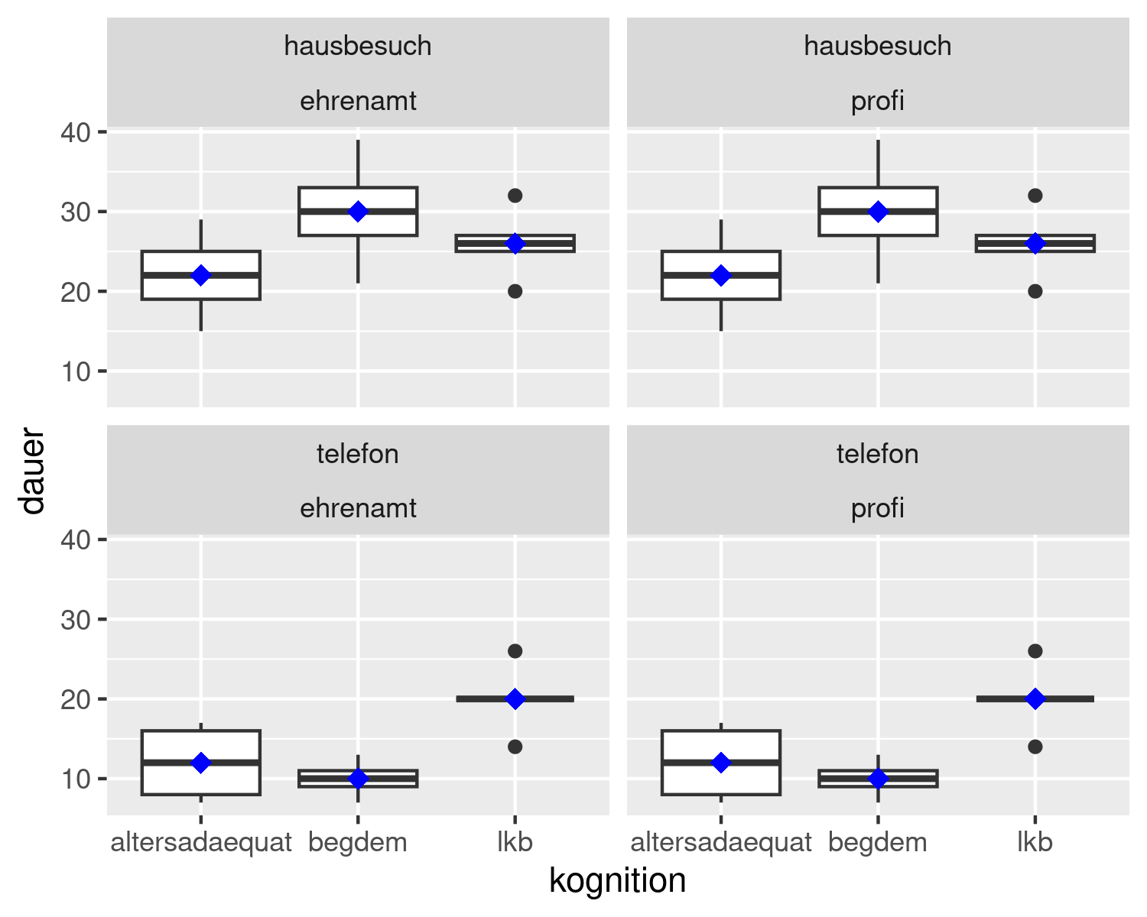

Figure 4: Boxplots of all combinations of modus, kognition, and interviewer

Table   
 *A beautiful ANOVA table with interviewer.*

| Effect | ${\hat{η}}_{G}^{2}$ | 90% CI | $F$ | $df$ | ${df}_{res}$ | $p$ |
| --- | --- | --- | --- | --- | --- | --- |
| Modus | .665 | [.533, .751] | 95.29 | 1 | 48 | < .001 |
| Kognition | .249 | [.077, .398] | 7.94 | 2 | 48 | .001 |
| Interviewer | .000 | [.000, .000] | 0.00 | 1 | 48 | > .999 |
| Modus $×$ Kognition | .323 | [.140, .469] | 11.47 | 2 | 48 | < .001 |
| Modus $×$ Interviewer | .000 | [.000, .000] | 0.00 | 1 | 48 | > .999 |
| Kognition $×$ Interviewer | .000 | [.000, .000] | 0.00 | 2 | 48 | > .999 |
| Modus $×$ Kognition $×$ Interviewer | .000 | [.000, .000] | 0.00 | 2 | 48 | > .999 |

*Note.* Bli bla blubb.

# 7 Excercises

1. In Table 7 is an error. What is wrong here? Please correct.
2. Table 6 is too long. Please split it up to two tables by interviewer.
3. Tables that relate to ModKogDat3F.csv data are not yet mentioned in the summary. Please add them, because, according to APA rules, each Figure and Table, respectively, must be mentioned in the text.

# 8 Solutions

1. The wrong dataframe was used here. The correct data is df3. Table 10 is the correct one.

tabsumstat3 <- df3 |>  
 psych::describe() |>   
 as_tibble(rownames="Variables") |>   
 select(-skew, -kurtosis, -range, -vars, -trimmed, -mad)   
  
apa_table(  
 tabsumstat3  
 , caption = "Summary Statistics: `ModKogDat3F.csv`"  
 , note = "This table contains all variables."  
 , escape = TRUE  
)

Table   
 *Summary Statistics: ModKogDat3F.csv*

| Variables | n | mean | sd | median | min | max | se |
| --- | --- | --- | --- | --- | --- | --- | --- |
| dauer | 60.00 | 20.00 | 8.36 | 20.00 | 7.00 | 39.00 | 1.08 |
| modus* | 60.00 | 1.50 | 0.50 | 1.50 | 1.00 | 2.00 | 0.07 |
| kognition* | 60.00 | 2.00 | 0.82 | 2.00 | 1.00 | 3.00 | 0.11 |
| interviewer* | 60.00 | 1.50 | 0.50 | 1.50 | 1.00 | 2.00 | 0.07 |
| id_num | 60.00 | 6.50 | 3.48 | 6.50 | 1.00 | 12.00 | 0.45 |
| id* | 60.00 | 6.50 | 3.48 | 6.50 | 1.00 | 12.00 | 0.45 |

*Note.* This table contains all variables.

1. The splitted tables are shown in Tables 11 and 12 and here is the corresponding code:

df3p <- df3 |>   
 filter(interviewer == "profi")  
df3e <- df3 |>   
 filter(interviewer == "ehrenamt")

apa_table(df3p, caption = "Interviews by Professionals")

Table   
 *Interviews by Professionals*

| dauer | modus | kognition | interviewer | id_num | id |
| --- | --- | --- | --- | --- | --- |
| 8 | telefon | altersadaequat | profi | 8 | te_al_pr |
| 16 | telefon | altersadaequat | profi | 8 | te_al_pr |
| 12 | telefon | altersadaequat | profi | 8 | te_al_pr |
| 7 | telefon | altersadaequat | profi | 8 | te_al_pr |
| 17 | telefon | altersadaequat | profi | 8 | te_al_pr |
| 20 | telefon | lkb | profi | 12 | te_lk_pr |
| 26 | telefon | lkb | profi | 12 | te_lk_pr |
| 20 | telefon | lkb | profi | 12 | te_lk_pr |
| 14 | telefon | lkb | profi | 12 | te_lk_pr |
| 20 | telefon | lkb | profi | 12 | te_lk_pr |
| 10 | telefon | begdem | profi | 10 | te_be_pr |
| 7 | telefon | begdem | profi | 10 | te_be_pr |
| 11 | telefon | begdem | profi | 10 | te_be_pr |
| 9 | telefon | begdem | profi | 10 | te_be_pr |
| 13 | telefon | begdem | profi | 10 | te_be_pr |
| 15 | hausbesuch | altersadaequat | profi | 2 | ha_al_pr |
| 25 | hausbesuch | altersadaequat | profi | 2 | ha_al_pr |
| 22 | hausbesuch | altersadaequat | profi | 2 | ha_al_pr |
| 19 | hausbesuch | altersadaequat | profi | 2 | ha_al_pr |
| 29 | hausbesuch | altersadaequat | profi | 2 | ha_al_pr |
| 32 | hausbesuch | lkb | profi | 6 | ha_lk_pr |
| 27 | hausbesuch | lkb | profi | 6 | ha_lk_pr |
| 26 | hausbesuch | lkb | profi | 6 | ha_lk_pr |
| 20 | hausbesuch | lkb | profi | 6 | ha_lk_pr |
| 25 | hausbesuch | lkb | profi | 6 | ha_lk_pr |
| 30 | hausbesuch | begdem | profi | 4 | ha_be_pr |
| 21 | hausbesuch | begdem | profi | 4 | ha_be_pr |
| 33 | hausbesuch | begdem | profi | 4 | ha_be_pr |
| 39 | hausbesuch | begdem | profi | 4 | ha_be_pr |
| 27 | hausbesuch | begdem | profi | 4 | ha_be_pr |

apa_table(df3e, caption = "Interviews by Volunteers (Ehrenamt)")

Table   
 *Interviews by Volunteers (Ehrenamt)*

| dauer | modus | kognition | interviewer | id_num | id |
| --- | --- | --- | --- | --- | --- |
| 8 | telefon | altersadaequat | ehrenamt | 7 | te_al_eh |
| 16 | telefon | altersadaequat | ehrenamt | 7 | te_al_eh |
| 12 | telefon | altersadaequat | ehrenamt | 7 | te_al_eh |
| 7 | telefon | altersadaequat | ehrenamt | 7 | te_al_eh |
| 17 | telefon | altersadaequat | ehrenamt | 7 | te_al_eh |
| 20 | telefon | lkb | ehrenamt | 11 | te_lk_eh |
| 26 | telefon | lkb | ehrenamt | 11 | te_lk_eh |
| 20 | telefon | lkb | ehrenamt | 11 | te_lk_eh |
| 14 | telefon | lkb | ehrenamt | 11 | te_lk_eh |
| 20 | telefon | lkb | ehrenamt | 11 | te_lk_eh |
| 10 | telefon | begdem | ehrenamt | 9 | te_be_eh |
| 7 | telefon | begdem | ehrenamt | 9 | te_be_eh |
| 11 | telefon | begdem | ehrenamt | 9 | te_be_eh |
| 9 | telefon | begdem | ehrenamt | 9 | te_be_eh |
| 13 | telefon | begdem | ehrenamt | 9 | te_be_eh |
| 15 | hausbesuch | altersadaequat | ehrenamt | 1 | ha_al_eh |
| 25 | hausbesuch | altersadaequat | ehrenamt | 1 | ha_al_eh |
| 22 | hausbesuch | altersadaequat | ehrenamt | 1 | ha_al_eh |
| 19 | hausbesuch | altersadaequat | ehrenamt | 1 | ha_al_eh |
| 29 | hausbesuch | altersadaequat | ehrenamt | 1 | ha_al_eh |
| 32 | hausbesuch | lkb | ehrenamt | 5 | ha_lk_eh |
| 27 | hausbesuch | lkb | ehrenamt | 5 | ha_lk_eh |
| 26 | hausbesuch | lkb | ehrenamt | 5 | ha_lk_eh |
| 20 | hausbesuch | lkb | ehrenamt | 5 | ha_lk_eh |
| 25 | hausbesuch | lkb | ehrenamt | 5 | ha_lk_eh |
| 30 | hausbesuch | begdem | ehrenamt | 3 | ha_be_eh |
| 21 | hausbesuch | begdem | ehrenamt | 3 | ha_be_eh |
| 33 | hausbesuch | begdem | ehrenamt | 3 | ha_be_eh |
| 39 | hausbesuch | begdem | ehrenamt | 3 | ha_be_eh |
| 27 | hausbesuch | begdem | ehrenamt | 3 | ha_be_eh |

1. The unmentioned tables are Tables 6, 7, 8, 9, and Figure 4.

# References

Aust, F., & Barth, M. (2023). *papaja: Prepare reproducible APA journal articles with R markdown*. Retrieved from <https://github.com/crsh/papaja>