Academia JournalAcadXXXXXXXX
Research Article
Importance-Balanced Interleaved Feature Projection for Quantum-Inspired Variational Classifiers: A Controlled Study of Feature Allocation and Interaction Topology in Breast Cancer Diagnosis
Daksh Kaila^{1,*}, Monika Aggarwal², Samya Muhuri¹
1 Thapar Institute of Engineering and Technology, Patiala, Punjab, India
2 Indian Institute of Technology Delhi, New Delhi, Delhi, India
* Correspondence: dkaila_be25@thapar.edu
Received: [Day Month Year] | Accepted: [Day Month Year] | Published: [Day Month Year]
Abstract
Introduction: Quantum-inspired machine learning borrows the structure of parameterized quantum circuits for models that are simulated entirely on classical hardware. A quantum-inspired variational classifier must compress many continuous features into a small number of simulated qubits. How features are allocated across these qubits, and how the qubits interact, are rarely examined under controlled conditions, so it is unclear which design choices actually drive performance.
Materials and methods: We study an Importance-Balanced Interleaved Projection (IBIP) strategy that ranks features on training data with XGBoost permutation importance and distributes them cyclically across qubits. A quantum-inspired variational classifier (classical non-linear projection followed by exact statevector simulation) was evaluated on the Wisconsin Diagnostic Breast Cancer (WDBC) dataset with five two-qubit and seven three-qubit interaction topologies, each under IBIP and sequential allocation, using matched seeds, five-fold cross-validation and paired statistics. The primary comparison was replicated over 20 seeds. A four-way ablation compared sequential, random, importance-blocked and IBIP allocation; six classical baselines and two external datasets (Parkinson's disease, Cleveland heart disease) provided context.
Results: On WDBC, sequential allocation, which places the mean, standard-error and worst-value descriptors on separate qubits, outperformed IBIP for the three-qubit CNOT-Star model (97.68% ± 1.15% vs. 96.62% ± 1.69% accuracy over 20 seeds; paired difference −1.05 points, 95% CI [−1.86, −0.25], p = 0.013), while ROC-AUC did not differ (0.9935 vs. 0.9922, p = 0.455). IBIP was more accurate than importance-blocked allocation on all three datasets (+1.03 to +8.20 points; significant for heart disease, p = 0.009). Under IBIP, no entangling topology outperformed the uncoupled circuit, whereas the cyclic CNOT-Ring reduced accuracy by about 14 points. After correcting an implementation error, iSWAP performed comparably to the other exchange gates (95.96%). The best quantum-inspired configuration matched the accuracy of an RBF-kernel SVM (97.72%) but not its ROC-AUC.
Conclusions: In the tested two- and three-qubit configurations, feature allocation affected accuracy more than interaction topology; topology comparisons used five seeds and are exploratory. Concentrating top-ranked features in one qubit should be avoided. A semantically meaningful grouping that already spreads informative features across qubits, as in WDBC, performed best; interleaving is a reasonable default otherwise. Quantum-inspired models did not surpass classical baselines on these tabular tasks.
Keywords: Quantum-Inspired Machine Learning; Variational Quantum Classifier; Feature Allocation; Circuit Topology; Breast Cancer Diagnosis; Statistical Validation
1. Introduction
Breast cancer remains one of the leading causes of cancer-related mortality among women worldwide, and early, accurate diagnosis is essential for timely clinical intervention. Machine learning has been applied extensively to this problem, and classical models such as Support Vector Machines (SVMs) [1], Random Forests [5] and gradient boosting [6] achieve high accuracy on benchmark data such as the Wisconsin Diagnostic Breast Cancer (WDBC) dataset [24]. Understanding how alternative learning paradigms represent and process such features remains an active area of research.
Recent advances in quantum machine learning (QML) [2,3,7] have introduced variational quantum classifiers (VQCs) and quantum-inspired architectures built from parameterized rotations, interaction gates and expectation-value measurements [8–11]. On near-term processors and in classical simulation, these models use only a few qubits, so a high-dimensional feature vector must be compressed into a small number of simulated qubits. This creates a feature allocation problem: deciding which features feed which qubit. Many implementations assign features in their original column order, which can concentrate the most informative features in a single qubit, and the effect of this choice is rarely tested. Likewise, interaction topologies are usually chosen ad hoc rather than compared under matched conditions.
This work studies both questions under controlled conditions. We examine an Importance-Balanced Interleaved Projection (IBIP) strategy, which ranks features on training data using permutation importance [5,6,23] and distributes them cyclically across qubits, and compare it against sequential, random and importance-blocked allocation. We also compare five two-qubit and seven three-qubit interaction topologies, each under two allocations, using identical seeds and data splits.
Preliminary experiments suggested that IBIP improved accuracy over sequential allocation on WDBC. Under matched seeds, paired tests and a 20-seed replication, that result did not hold: sequential allocation was better on WDBC. We report this directly and examine why. The primary contributions are:
- A controlled, paired comparison of IBIP and sequential allocation on WDBC across 5 seeds, five-fold cross-validation and a 20-seed replication.
- A four-way allocation ablation that identifies when interleaving helps (relative to concentrating top features) and when it does not (relative to a meaningful feature grouping).
- A matched comparison of twelve interaction topologies, showing that, in the tested configurations, allocation matters more than topology and entanglement offers no consistent benefit.
- A transparent comparison against six classical baselines, an operating-threshold analysis, and a secondary evaluation on two external biomedical datasets.
1.1 Related Work
Foundational studies established how parameterized quantum circuits can act as trainable models [7–10], and circuit-centric VQCs have become one of the most widely studied architectures [11]. Breast cancer diagnosis is a common QML benchmark because of the availability and clinical relevance of WDBC. Premanand et al. compared quantum machine learning models with conventional classifiers [12], Pagadala et al. proposed a quantum convolutional neural network with Boruta and genetic-algorithm feature selection [13], and Xiang et al. developed a hybrid quantum-classical convolutional network [14].
Feature encoding [15] and projection strategies are central to these models because classical information must be compressed into a few quantum states [16,17]. Existing approaches typically use fixed partitions, sequential grouping or dimensionality reduction before encoding; how the distribution of feature importance across qubits affects learning has received little attention. Separately, gate choice and circuit connectivity influence expressibility, entanglement and trainability [18–21], and barren plateaus constrain deeper circuits [4]. Quantum-inspired optimizers such as Superpositional Gradient Descent (SuperGD) [22] modulate gradient updates with sinusoidal interference terms. The present work differs from prior breast cancer QML studies by focusing not on maximizing accuracy but on controlled measurement of how allocation and topology shape performance, with classical baselines reported under the same protocol.
2. Materials and methods
The overall workflow is illustrated in Figure 1.
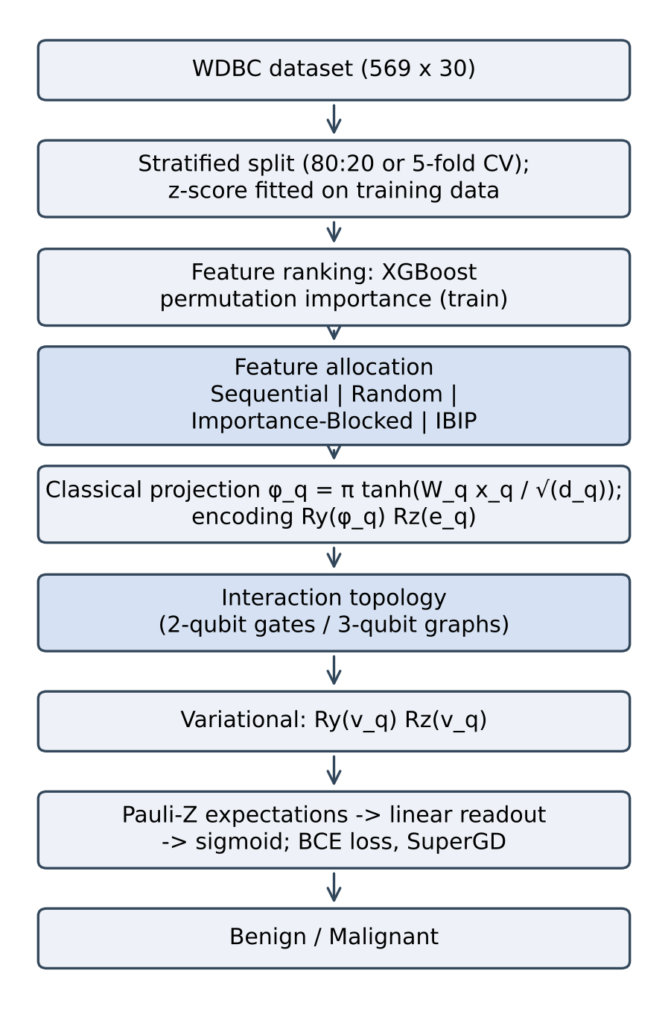
Figure 1. Overview of the quantum-inspired classification framework and evaluation pipeline.
2.1 Dataset and Preprocessing
Experiments used the WDBC dataset from the UCI Machine Learning Repository [24]: 569 fine-needle aspiration samples, each described by 30 real-valued nuclear morphology features. The features are ten measurements (radius, texture, perimeter, area, smoothness, compactness, concavity, concave points, symmetry, fractal dimension), each summarized as a mean (features 1–10), standard error (11–20) and worst value (21–30). Of the 569 samples, 212 (37.3%) are malignant and 357 benign. Malignant is treated as the positive class for sensitivity, specificity, precision and F1-score.
Data were split 80:20 with stratification, giving 114 test samples (42 malignant, 72 benign) per split. Features were z-score standardized using the mean and standard deviation of the training partition only. Feature ranking was likewise computed on the training partition of each split or fold, so test samples were never used for standardization, ranking or parameter fitting.
2.2 Feature Ranking via Permutation Importance
Feature importance was estimated with permutation importance [23] on an XGBoost classifier [6] (100 trees, depth 3, learning rate 0.05, row and column subsampling 0.8) fitted to the training partition. Each feature was shuffled 10 times within the training partition, and its importance was taken as the mean decrease in training accuracy. Features were then sorted by mean importance in descending order; features with zero or negative importance are simply ranked last. Permutation importance was chosen because it measures relevance directly with respect to predictive performance and avoids the biases of impurity-based measures. The random state of both the XGBoost model and the permutations was set to the seed of each split (42 within cross-validation folds).
2.3 Feature Allocation Strategies
Let n ∈ {2, 3} be the number of qubits and D the number of features. Four allocation strategies were compared (Table 1). The two central ones differ in what they use: sequential allocation follows the dataset's column order and ignores feature importance, whereas IBIP follows the training-set importance ranking and ignores column order.
- Sequential: contiguous blocks in original column order. For WDBC with three qubits, Q₀ receives the mean descriptors, Q₁ the standard errors and Q₂ the worst values.
- Random: features randomly partitioned into equal groups, using the seed of each split.
- Importance-Blocked: features ranked by importance and assigned in contiguous blocks, so Q₀ receives the top-ranked third.
- IBIP: ranked features distributed round-robin, so that qubit q receives ranks q+1, q+1+n, q+1+2n, … (Figure 2).
When D is not divisible by n, the first qubits receive one extra feature. IBIP is designed to give every qubit a comparable share of informative features before the interaction layer. Round-robin allocation does not equalize the total importance of each qubit exactly, but it bounds the imbalance: for equal-sized qubits and features sorted by importance, the total importance of Q₀ exceeds that of any other qubit by at most the difference between the largest and smallest single-feature importance. Importance-blocking, in contrast, places the entire top-ranked third on Q₀.
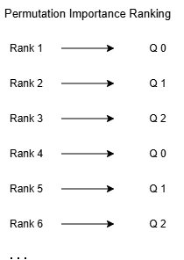
Figure 2. Illustration of Importance-Balanced Interleaved Projection (IBIP). Ranked features are distributed cyclically across qubits.
Strategy | Q0 | Q1 | Q2
Sequential | Mean descriptors (1–10) | Standard errors (11–20) | Worst values (21–30)
Random | 10 random features | 10 random features | 10 random features
Importance-Blocked | Ranks 1–10 | Ranks 11–20 | Ranks 21–30
IBIP | Ranks 1, 4, 7, …, 28 | Ranks 2, 5, 8, …, 29 | Ranks 3, 6, 9, …, 30
Table 1. Feature allocation strategies for the three-qubit (10–10–10) WDBC configuration. Two-qubit models use 15–15 splits by the same rules; there, sequential allocation places features 1–15 (all mean descriptors and the first five standard errors) on Q0 and features 16–30 on Q1, so it does not follow the three feature families.
2.4 Quantum-Inspired Variational Classifier
For each qubit q, the assigned feature subvector x_{q} ∈ ℝ^{dq} is mapped to a rotation angle by a trainable classical projection:
φ_{q} = π · tanh( W_{q}^{T} x_{q} / √d_{q} )
The hyperbolic tangent bounds the angle to (−π, π), and the 1/√d_{q} factor prevents saturation. This projection is a classical layer. The circuit is then simulated exactly as a complex statevector in (ℂ²)^{⊗n}, starting from |0…0⟩: each qubit is rotated by R_{y}(φ_{q}) followed by R_{z}(e_{q}), the interaction gates of the chosen topology are applied, and each qubit is then rotated by R_{y}(v_{q}) followed by R_{z}(v_{q}). Because R_{z}(e_{q}) acts after R_{y}(φ_{q}), it changes the relative phase of the qubit state and therefore affects the output. Pauli-Z expectation values z_{q} = ⟨ψ|Z_{q}|ψ⟩ are combined linearly and passed through a sigmoid:
ŷ = σ( Σ_{q} β_{q} z_{q} + b )
The output ŷ is the predicted probability of the benign class, and the malignancy score is 1 − ŷ. The final R_{z}(v_{q}) commutes with the Z measurement and does not affect the output, so the variational angle v_{q} acts only through R_{y}(v_{q}). All parameters influence the output; the three-qubit model has 40 trainable parameters (30 projection weights, 3 encoding angles, 3 variational angles, 3 readout weights and 1 bias); the two-qubit model has 37. At this scale the entire model is a small, classically computable function, and no quantum computational advantage is implied: the term quantum-inspired refers to its circuit structure.
2.5 Interaction Topologies
The interaction layer is applied once, between the encoding and variational rotations, and is the only part of the model that differs between topologies. Two-qubit models (15–15 allocation) used one of five interaction layers: SWAP (exchanges the two qubit states), √SWAP (half of a SWAP, which can entangle the qubits), iSWAP (an exchange that adds an i phase to |01⟩ and |10⟩, also entangling), CNOT (flips Q₁ when Q₀ is |1⟩, entangling), or Independent (no interaction).
Three-qubit models (10–10–10 allocation) used one of seven interaction graphs: CNOT-Star (Q₀ controls both Q₁ and Q₂), CNOT-Chain (Q₀ → Q₁, then Q₁ → Q₂), CNOT-Ring (the chain closed by a third CNOT, Q₂ → Q₀), Full-Mesh (Q₀ → Q₁, Q₁ → Q₂, Q₀ → Q₂), SWAP-Star (SWAPs between Q₀ and each other qubit), SWAP-Chain (SWAPs between neighbouring qubits), and Independent. Arrows denote control → target, and gates are applied in the order listed. SWAP gates permute qubit states without creating entanglement. Because every qubit has its own trainable rotations and readout weight, SWAP-based circuits represent the same family of functions as the Independent circuit up to relabeling; any difference between them reflects optimization rather than expressive capacity.
2.6 Hybrid Optimization Framework
Labels follow the dataset's native coding, with y = 1 for benign and y = 0 for malignant cases, so that ŷ = P(benign). Training minimized the Binary Cross-Entropy loss with per-sample updates over 50 epochs:
L = − [ y·log(ŷ) + (1 − y)·log(1 − ŷ) ]
Gradients for the encoding and variational angles were estimated with a parameter-shift-style rule, evaluating the model at θ ± π/2. This shift rule is exact for the expectation value of a single rotation; because it is applied here to the sigmoid output rather than to the expectation value, it serves as a gradient estimate rather than an exact gradient. Gradients for the projection weights were obtained by applying the same shift to φ_{q} and the chain rule through the tanh projection. Parameters were updated with Superpositional Gradient Descent [22]:
p ← p − η·g·(1 + λ·sin(πp))
where η is the learning rate and λ the interference strength. Hyperparameters were held constant for all models (Table 2). All diagnostic metrics treat malignant as the positive class and use the malignancy score P(malignant) = 1 − ŷ.
Parameter | Value
Learning rate (η) | 0.01
Interference strength (λ) | 0.5
Epochs | 50
BCE stability constant | 10⁻⁷
Train–test split | 80:20, stratified
Seeds | 0, 42, 123, 777, 2025 (20-seed replication: 0–19)
Table 2. Experimental hyperparameters.
2.7 Classical Baselines
Six classical models were evaluated under the same splits and preprocessing: SVM with RBF kernel (C = 1.0) [1], SVM with linear kernel (C = 1.0), logistic regression (C = 1.0, L2), XGBoost (100 trees, depth 3, learning rate 0.1) [6], Random Forest (100 trees, depth 5) [5], and Ridge classifier (α = 1.0).
2.8 External Datasets
To check whether allocation effects observed on WDBC also appear in data with different feature structures, two additional UCI datasets were evaluated with the three-qubit CNOT-Star model under all four allocations and 5 seeds:
- Parkinson's disease [25]: 195 voice recordings from 31 individuals (23 with Parkinson's disease), of which 147 recordings come from patients and 48 from controls; 22 acoustic features, allocated 8–7–7. Parkinson's disease is the positive class. In column order, sequential allocation places fundamental-frequency and jitter measures on Q₀, shimmer and noise-to-harmonic measures on Q₁, and the harmonics-to-noise ratio together with the non-linear dynamical measures (RPDE, DFA, spread1, spread2, D2, PPE) on Q₂.
- Cleveland heart disease [26]: 303 patients, 13 clinical features, allocated 5–4–4. The original 0–4 diagnosis was binarized (0 = no disease, 1–4 = disease; 164 vs. 139 patients), and disease is the positive class. The six missing values (vessel count and thalassemia) were imputed with column medians. Sequential allocation places age, sex, chest-pain type, resting blood pressure and cholesterol on Q₀; fasting blood sugar, resting ECG, maximum heart rate and exercise angina on Q₁; and ST depression, ST slope, number of major vessels and thalassemia on Q₂.
For both datasets, standardization and feature ranking were fitted on each training partition, exactly as for WDBC. No resampling or class weighting was applied; splits were stratified by class.
2.9 Evaluation Protocol and Statistics
Three evaluation schemes were used. (i) Five-seed hold-out: five independent stratified 80:20 splits (seeds 0, 42, 123, 777, 2025), used for all allocation and topology comparisons. (ii) Five-fold stratified cross-validation (shuffled, random state 42), generated independently of the hold-out splits, used to check performance across folds. (iii) Twenty-seed hold-out (seeds 0–19), used to confirm the primary comparison (three-qubit CNOT-Star, IBIP vs. sequential). In every scheme, standardization and feature ranking were recomputed on each training partition. Reported metrics are accuracy, sensitivity (malignant recall), specificity, precision, F1-score and ROC-AUC, as mean ± standard deviation. Allocation comparisons are paired by seed or fold and use the paired t-test, the Wilcoxon signed-rank test, Cohen's d_{z} and the 95% confidence interval of the paired difference. Because five paired runs provide limited power, five-seed comparisons are treated as exploratory, and conclusions about the primary comparison rest on the 20-seed replication. Each seed determines both the stratified train–test split and the parameter initialization, so variation across seeds reflects data-split as well as initialization variability; cross-validation provides a second, independent resampling scheme. Hyperparameters were fixed in advance for all quantum-inspired and classical models, and no model was tuned on test data. Per-seed and per-fold results, including all paired differences, are released with the code. Finally, the effect of the decision threshold on sensitivity was examined by classifying a sample as malignant when its malignancy score exceeded τ ∈ {0.5, 0.4, 0.3, 0.2}.
3. Results
[Revision note: Sections 3, 4 and 5, including all of their tables and figures, were rewritten in full in this revision. Only their headings are highlighted.]
3.1 Primary Comparison on WDBC: IBIP vs. Sequential Allocation
Table 3 compares IBIP and sequential allocation for the three-qubit CNOT-Star model under three protocols. Sequential allocation achieved higher accuracy in all three. In the 20-seed replication the paired difference was −1.05 points (95% CI [−1.86, −0.25]; t(19) = −2.73, p = 0.013; Wilcoxon p = 0.010; d_{z} = −0.61). The difference in ROC-AUC was not significant (−0.0013, p = 0.455), indicating that the two allocations rank cases similarly and differ mainly near the decision threshold. Across the 20 matched seeds, IBIP was less accurate in 13, equal in 6 and more accurate in 1, with per-seed differences ranging from −6.14 to +2.63 points. Sequential allocation also showed lower variability across seeds (SD 1.15 vs. 1.69 points).
Protocol | Allocation | Accuracy (%) | Sensitivity (%) | Specificity (%) | ROC-AUC
5 seeds | IBIP | 95.26 ± 2.02 | 91.43 ± 5.22 | 97.50 ± 2.06 | 0.9853 ± 0.0127
 | Sequential | 97.37 ± 2.24 | 95.24 ± 6.94 | 98.61 ± 1.70 | 0.9929 ± 0.0097
5-fold CV | IBIP | 96.14 ± 2.28 | 94.36 ± 5.87 | 97.21 ± 2.60 | 0.9926 ± 0.0067
 | Sequential | 97.54 ± 1.69 | 95.77 ± 5.06 | 98.60 ± 1.40 | 0.9891 ± 0.0144
20 seeds | IBIP | 96.62 ± 1.69 | 94.64 ± 3.53 | 97.78 ± 1.45 | 0.9922 ± 0.0067
 | Sequential | 97.68 ± 1.15 | 96.19 ± 2.72 | 98.54 ± 1.23 | 0.9935 ± 0.0069
Paired difference (20 seeds) |  | −1.05 [−1.86, −0.25]; p = 0.013 |  |  | −0.0013; p = 0.455
Table 3. Three-qubit CNOT-Star on WDBC under IBIP and sequential allocation (mean ± SD). Paired difference = IBIP − Sequential, with 95% CI.
The advantage of sequential allocation on WDBC is consistent with the dataset's structure: column order already groups the features into three semantically coherent families (mean, standard error, worst value), and sequential allocation assigns one family to each qubit. IBIP instead mixes families within every qubit.
3.2 Four-Way Allocation Ablation
To isolate the role of interleaving, the CNOT-Star model was trained under all four allocations with the same five seeds (Table 4, Figure 3). IBIP was more accurate than importance-blocked allocation (+2.46 points, d_{z} = 0.92), although with five seeds this difference was not significant (p = 0.108). IBIP and random allocation were statistically indistinguishable (+0.53, p = 0.374), and sequential allocation was the most accurate.
Allocation | Accuracy (%) | Sensitivity (%) | ROC-AUC | IBIP − strategy [95% CI] | p (paired t)
Sequential | 97.37 ± 2.24 | 95.24 ± 6.94 | 0.9929 | −2.11 [−3.76, −0.45] | 0.024
Random | 94.74 ± 2.24 | 91.43 ± 3.19 | 0.9896 | +0.53 [−0.93, +1.99] | 0.374
Importance-Blocked | 92.81 ± 2.51 | 89.52 ± 5.48 | 0.9793 | +2.46 [−0.85, +5.76] | 0.108
IBIP | 95.26 ± 2.95 | 93.33 ± 4.58 | 0.9909 | — | —
Table 4. Four-way allocation ablation on WDBC (three-qubit CNOT-Star, 5 matched seeds).
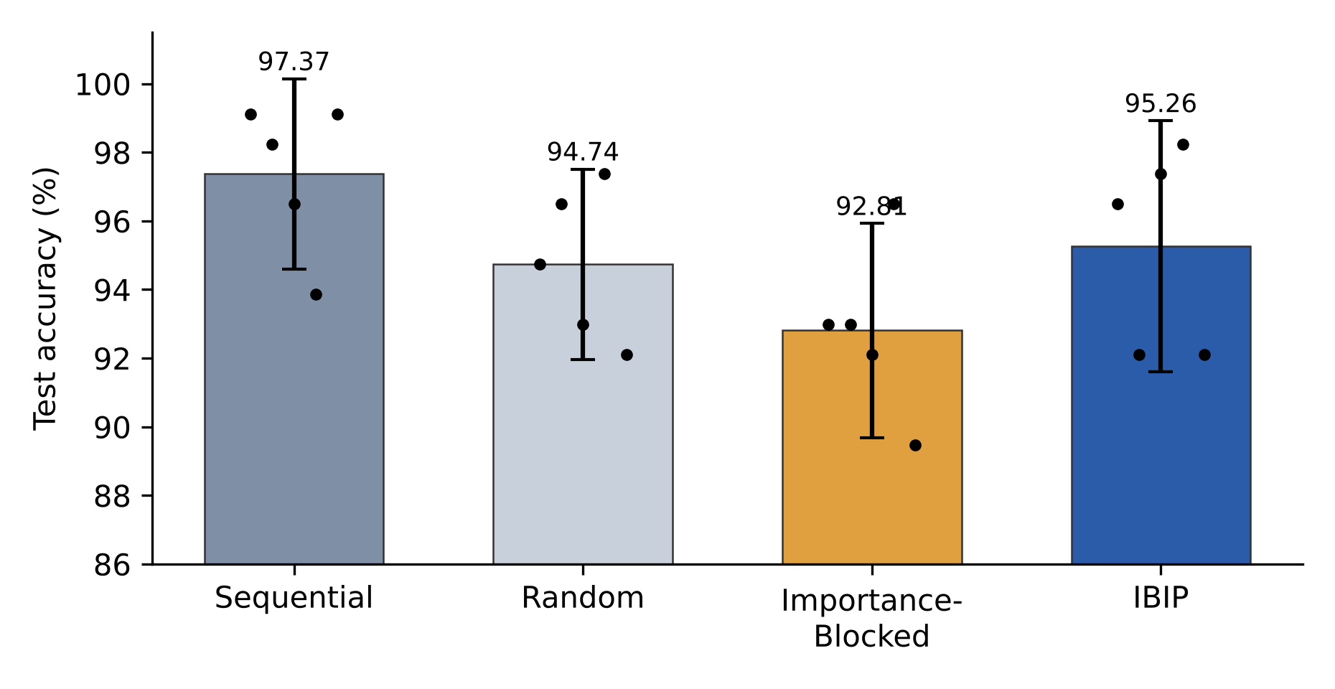
Figure 3. Test accuracy of the four allocation strategies on WDBC (CNOT-Star, 5 seeds). Bars show means with 95% CIs; dots show individual seeds.
Importance-blocking places the ten highest-ranked features on Q₀ and the ten weakest on Q₂, leaving one qubit with little discriminative signal. Interleaving avoids this imbalance. The ablation was run separately from the topology suite with the same seeds and splits. Sequential results are identical in the two experiments, but per-seed IBIP accuracies differ (their means coincide at 95.26%). Since only IBIP depends on the feature ranking, this indicates that the rankings were not bit-identical across runs, most likely because XGBoost and permutation importance were executed with multithreading. Sequential allocation, which needs no ranking, is unaffected by this source of variance.
3.3 Two-Qubit Interaction Suite
Table 5 reports the five two-qubit interaction layers. Differences between gates were small (95.96%–96.84% under IBIP; 94.56%–97.02% under sequential allocation). The iSWAP accuracy of 58.80% observed in preliminary experiments (and reported in the original submission) was the result of an implementation error. The original prototype code was not preserved, so we tested candidate errors with a diagnostic script (released with the code). Discarding the imaginary part of the statevector did not degrade accuracy; storing the iSWAP matrix with a real data type, which zeroes its i entries and makes the gate non-unitary, was the only tested error that produced a comparable collapse (72.8% accuracy, ROC-AUC 0.78), and we regard it as the most likely cause. With exact complex simulation, iSWAP achieved 95.96% ± 2.20%, comparable to the other gates. SWAP and Independent reached the same mean accuracy under IBIP (96.84%), consistent with their equivalence as function classes. Unlike the three-qubit case, IBIP matched or exceeded sequential allocation for four of the five two-qubit layers (significantly for Independent, +2.28 points, p = 0.007). This is consistent with the interpretation in Section 3.1, because the 15–15 sequential split does not follow the three feature families (Table 1).
Interaction | IBIP accuracy (%) | IBIP ROC-AUC | Sequential accuracy (%) | Sequential ROC-AUC
SWAP | 96.84 ± 2.29 | 0.9919 | 95.44 ± 1.57 | 0.9897
√SWAP | 96.84 ± 2.20 | 0.9921 | 96.49 ± 1.75 | 0.9930
iSWAP | 95.96 ± 2.20 | 0.9900 | 94.56 ± 1.44 | 0.9884
CNOT (Q0 → Q1) | 96.14 ± 2.02 | 0.9914 | 97.02 ± 1.00 | 0.9943
Independent | 96.84 ± 2.11 | 0.9907 | 94.56 ± 1.44 | 0.9871
Table 5. Two-qubit interaction layers on WDBC (15–15 allocation, 5 seeds, mean ± SD).
3.4 Three-Qubit Topology Suite
Table 6 and Figure 4 report the seven three-qubit topologies. Two patterns emerge. First, under IBIP, no entangling topology outperformed the uncoupled Independent circuit (95.44%); paired differences against Independent ranged from −1.23 to −0.18 points (all p ≥ 0.089). Under sequential allocation, CNOT-based topologies were 1.6–2.1 points more accurate than Independent (CNOT-Chain +2.11, p = 0.051; CNOT-Star +1.75, p = 0.142), a suggestive but not significant trend with five seeds. Second, the cyclic CNOT-Ring markedly degraded performance under both allocations (−14.91 points vs. Independent under sequential allocation, p = 0.002), with sensitivity falling to 62%–65%.
Topology | IBIP accuracy (%) | Sequential accuracy (%) | IBIP ROC-AUC | Sequential ROC-AUC | 5-fold CV IBIP / Seq. (%)
CNOT-Star | 95.26 ± 2.02 | 97.37 ± 2.24 | 0.9853 | 0.9929 | 96.14 / 97.54
CNOT-Chain | 94.21 ± 2.20 | 97.72 ± 1.33 | 0.9831 | 0.9931 | 95.25 / 97.72
Full-Mesh | 94.39 ± 2.53 | 97.19 ± 1.69 | 0.9834 | 0.9921 | 94.55 / 97.37
SWAP-Star | 95.09 ± 3.70 | 96.14 ± 2.11 | 0.9877 | 0.9872 | 96.14 / 96.49
SWAP-Chain | 94.56 ± 2.73 | 94.74 ± 3.56 | 0.9880 | 0.9858 | 96.49 / 97.19
Independent | 95.44 ± 3.13 | 95.61 ± 1.64 | 0.9892 | 0.9869 | 96.14 / 96.84
CNOT-Ring | 81.75 ± 7.11 | 80.70 ± 4.34 | 0.8616 | 0.8575 | 83.67 / 83.49
Table 6. Three-qubit topologies on WDBC (10–10–10 allocation, 5 seeds, mean ± SD; final column: five-fold cross-validation means).
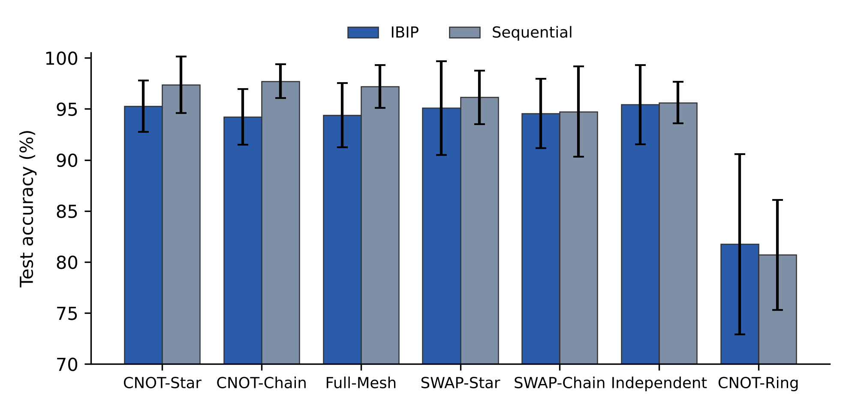
Figure 4. Three-qubit topologies on WDBC under IBIP and sequential allocation (5 seeds; error bars show 95% CIs).
To examine the CNOT-Star and CNOT-Chain geometries more closely, we computed graph path lengths, single-qubit von Neumann entanglement entropies on the test set and gradient norms during training, for one training run (seed 42, IBIP allocation). The star topology has a shorter mean path (1.33 vs. 1.67) and a more entangled hub qubit (0.498 vs. 0.310 bits), but the mean single-qubit entropy was slightly higher for the chain (0.409 vs. 0.393 bits) and gradient norms were similar (1.73 vs. 1.81). Since the ordering of these two topologies reverses with allocation (Table 6), and since the unentangled circuit performs as well under IBIP, these quantities do not explain accuracy differences and are reported descriptively.
3.5 Sensitivity to the Ranking Criterion
IBIP was repeated with four ranking criteria over 10 seeds: XGBoost permutation importance (96.23% ± 2.30%), Random Forest permutation importance (95.88% ± 2.07%), mutual information (96.40% ± 1.13%) and ANOVA F-statistic (96.32% ± 2.14%). ROC-AUC exceeded 0.990 in every case. IBIP performance is therefore insensitive to the choice of ranker.
3.6 Comparison with Classical Baselines
Table 7 compares the classical baselines with the best quantum-inspired configurations under identical splits. The RBF-kernel SVM and logistic regression were the strongest models. The best quantum-inspired configuration, sequential CNOT-Chain, matched the SVM's mean accuracy (97.72%) but had slightly lower ROC-AUC (0.9931 vs. 0.9944), so the two are not equivalent on all metrics; while CNOT-Star under IBIP was 2.5 points less accurate. Logistic regression reached comparable accuracy with 31 parameters, fewer than the 40 of the three-qubit model.
Model | Accuracy (%) | Sensitivity (%) | Specificity (%) | Precision (%) | F1 (%) | ROC-AUC | 5-fold CV accuracy (%)
SVM (RBF) | 97.72 ± 1.59 | 95.24 ± 4.12 | 99.17 ± 1.24 | 98.57 | 96.82 | 0.9944 | 97.72 ± 1.82
Logistic Regression | 97.54 ± 1.69 | 94.76 ± 3.91 | 99.17 ± 0.76 | 98.51 | 96.57 | 0.9939 | 97.37 ± 1.86
SVM (Linear) | 97.02 ± 2.37 | 93.81 ± 6.43 | 98.89 ± 1.52 | 98.09 | 95.78 | 0.9928 | 97.37 ± 2.48
XGBoost | 96.49 ± 1.39 | 94.76 ± 1.99 | 97.50 ± 2.06 | 95.78 | 95.23 | 0.9919 | 95.26 ± 2.02
Random Forest | 94.91 ± 2.27 | 92.38 ± 3.91 | 96.39 ± 1.58 | 93.71 | 93.03 | 0.9872 | 95.08 ± 1.32
Ridge Classifier | 94.74 ± 2.06 | 86.67 ± 5.98 | 99.44 ± 0.76 | 98.96 | 92.30 | 0.9933 | 95.61 ± 1.86
QIVC CNOT-Chain (Seq.) | 97.72 ± 1.33 | 96.19 ± 4.33 | 98.61 ± 1.70 | 97.71 | 96.86 | 0.9931 | 97.72 ± 1.71
QIVC CNOT-Star (Seq.) | 97.37 ± 2.24 | 95.24 ± 6.94 | 98.61 ± 1.70 | 97.71 | 96.29 | 0.9929 | 97.54 ± 1.69
QIVC CNOT-Star (IBIP) | 95.26 ± 2.02 | 91.43 ± 5.22 | 97.50 ± 2.06 | 95.64 | 93.39 | 0.9853 | 96.14 ± 2.28
Table 7. Classical baselines and quantum-inspired variational classifiers (QIVC) on WDBC (5 seeds; accuracy, sensitivity, specificity and CV accuracy as mean ± SD, other metrics as means).
Table 8 gives the confusion matrices for the 570 test predictions pooled across the five repeated hold-out evaluations (210 malignant, 360 benign). Because the test sets of different splits overlap, these are not 570 distinct patients. The RBF-SVM and sequential CNOT-Star missed the same number of malignant cases (10), while CNOT-Star under IBIP missed 18.
Model | TP | FN | FP | TN
SVM (RBF) | 200 | 10 | 3 | 357
Logistic Regression | 199 | 11 | 3 | 357
QIVC CNOT-Chain (Seq.) | 202 | 8 | 5 | 355
QIVC CNOT-Star (Seq.) | 200 | 10 | 5 | 355
QIVC CNOT-Star (IBIP) | 192 | 18 | 9 | 351
Table 8. Confusion matrices on WDBC for test predictions pooled across five repeated hold-out evaluations (malignant = positive class; TP/FN = malignant cases detected/missed, FP/TN = benign cases misclassified/correctly classified).
3.7 Operating Threshold and Diagnostic Metrics
In diagnosis, a missed malignancy is more costly than a false alarm. Table 9 shows how lowering the threshold τ on the malignancy score trades specificity for sensitivity. At τ = 0.5, sequential CNOT-Star missed on average 2.0 of 42 malignant cases per test split; at τ = 0.3 this fell to 1.4, with specificity of 96.4%. The quantum-inspired models and the SVM followed nearly identical trade-off curves. These are diagnostic classification metrics on a public benchmark, not results of clinical validation.
Model | τ = 0.5 | τ = 0.4 | τ = 0.3 | τ = 0.2
QIVC CNOT-Star (Seq.) | 95.24 / 98.61 (2.0) | 96.19 / 98.33 (1.6) | 96.67 / 96.39 (1.4) | 97.14 / 95.56 (1.2)
QIVC CNOT-Chain (Seq.) | 96.19 / 98.61 (1.6) | 96.67 / 98.33 (1.4) | 97.14 / 96.94 (1.2) | 97.14 / 95.00 (1.2)
SVM (RBF) | 95.71 / 98.33 (1.8) | 96.19 / 96.67 (1.6) | 96.67 / 94.72 (1.4) | 97.14 / 93.89 (1.2)
Table 9. Sensitivity / specificity (%) and mean missed malignant cases per split (in parentheses) at decreasing thresholds τ on the malignancy score (WDBC, 5 seeds, 42 malignant test cases per split). For the SVM, thresholds are applied to Platt-scaled probabilities, so values at τ = 0.5 differ slightly from Table 7.
3.8 Secondary Evaluation on External Datasets
Table 10 and Figure 5 report the two external datasets. On both, IBIP was more accurate than importance-blocked allocation, significantly so for heart disease (+8.20 points, 95% CI [3.42, 12.97], p = 0.009). Relative to sequential allocation, the outcome depended on the dataset. On Parkinson's disease, IBIP was 5.64 points more accurate, a trend that did not reach significance (p = 0.063). Although the columns are grouped by acoustic family, the sequential layout places the harmonics-to-noise ratio and all non-linear dynamical measures, the combination that best separated patients from controls in the original study [25], on a single qubit. On heart disease, sequential allocation, whose column order already spreads strong predictors (chest-pain type, maximum heart rate, vessel count, thalassemia) across all three qubits, was marginally better (−0.98 points, p = 0.070). IBIP and random allocation were again indistinguishable, and the RBF-SVM remained the most accurate model on both datasets.
Dataset | Allocation | Accuracy (%) | ROC-AUC | IBIP − strategy [95% CI] | p (paired t)
Parkinson's disease | IBIP | 84.10 ± 5.85 | 0.8524 | — | —
(195 × 22) | Importance-Blocked | 83.08 ± 2.92 | 0.8731 | +1.03 [−8.15, +10.20] | 0.772
 | Random | 84.10 ± 4.93 | 0.9007 | 0.00 [−3.18, +3.18] | 1.000
 | Sequential | 78.46 ± 1.40 | 0.8717 | +5.64 [−0.48, +11.77] | 0.063
 | SVM (RBF) | 88.21 ± 3.44 | 0.9152 | — | —
Heart disease | IBIP | 80.66 ± 4.24 | 0.8695 | — | —
(303 × 13) | Importance-Blocked | 72.46 ± 4.55 | 0.8173 | +8.20 [+3.42, +12.97] | 0.009
 | Random | 80.66 ± 2.14 | 0.8842 | 0.00 [−3.22, +3.22] | 1.000
 | Sequential | 81.64 ± 3.36 | 0.8944 | −0.98 [−2.10, +0.13] | 0.070
 | SVM (RBF) | 85.25 ± 2.32 | 0.9193 | — | —
Table 10. Allocation strategies on two external datasets (three-qubit CNOT-Star, 5 seeds, mean ± SD).
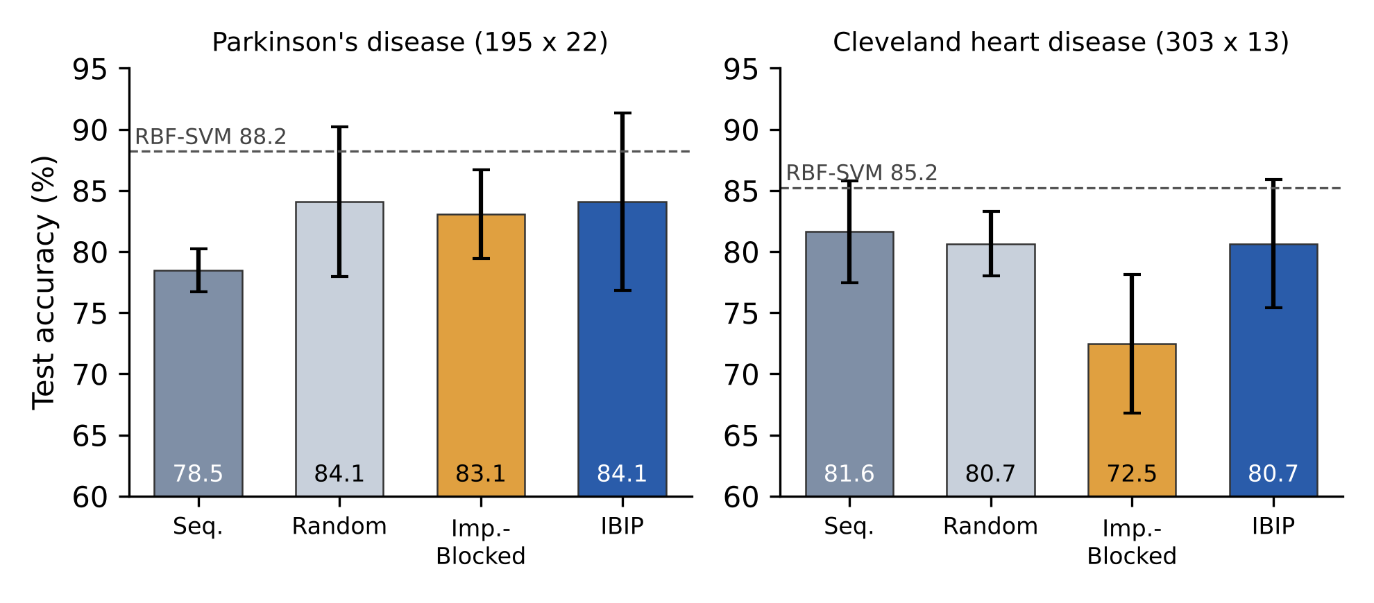
Figure 5. Allocation strategies on the external datasets (CNOT-Star, 5 seeds; error bars show 95% CIs). Dashed lines mark RBF-SVM accuracy.
4. Discussion
4.1 Feature Allocation Matters More than Topology
Across all experiments, changing the allocation moved accuracy by 5–9 points between the best and worst strategy, whereas entangling topologies other than CNOT-Ring stayed within about two points of the uncoupled circuit. In low-qubit quantum-inspired classifiers, the decision of which features share a qubit is therefore the more consequential design choice.
The ablation clarifies what interleaving does. Its benefit is relative to concentration: when the most informative features are packed into one qubit, the remaining qubits carry little signal, and accuracy drops (by 2.5 points on WDBC, not significant with five seeds, and by 8.2 points on heart disease). IBIP prevents this by construction. It does not, however, outperform an allocation that follows a meaningful feature grouping. On WDBC, assigning the mean, standard-error and worst-value families to separate qubits was the best strategy, and the 20-seed replication shows that this advantage is consistent across seeds, though small (about one point) and confined to accuracy rather than ROC-AUC. These results suggest that what matters is whether each qubit receives informative features: when column order already spreads them, as in WDBC and heart disease, sequential allocation performs well; when it concentrates them, as in Parkinson's disease, IBIP is a reasonable default. IBIP also inherits variance from the stochastic ranking step, which sequential allocation avoids.
4.2 Topology and Entanglement
Under IBIP, entangling topologies offered no advantage over independent qubits, and SWAP-based circuits are equivalent to the Independent circuit as function classes. Under sequential allocation, CNOT-based coupling showed a modest, non-significant advantage, suggesting that interaction may be more useful when each qubit encodes a distinct, coherent feature family that benefits from being combined. The failure of CNOT-Ring is the clearest topology effect: closing the loop with a CNOT from Q₂ back to Q₀ consistently degraded learning under this optimizer and readout. Entanglement entropy and path length did not track accuracy, so we refrain from attributing performance differences to entanglement.
4.3 Relation to Classical Models
Classical baselines matched or exceeded every quantum-inspired configuration, on WDBC and, by wider margins, on the external datasets. Logistic regression achieved comparable accuracy with fewer parameters, so parameter efficiency does not favor the quantum-inspired model either. The contribution of this study is thus not a better diagnostic model but a controlled account of which design decisions matter in this model class. Because the circuit structure mirrors that of hardware VQCs, these findings on allocation are relevant to future hardware studies, although this study does not test hardware execution.
Prior breast cancer QML studies [12–14] used different encodings, qubit counts, feature-selection or dimensionality-reduction steps and evaluation protocols. Their reported accuracies are therefore not directly comparable with ours, and we do not rank them; the common lesson is that reporting matched classical baselines and repeated, paired evaluation is necessary before claiming an advantage.
4.4 Scalability
The number of parameters grows as O(D + n), since each projection vector absorbs its qubit's share of the features. Exact statevector simulation requires O(2^{n}) memory and O(N·n·2^{n}) time per epoch, which limits classical simulation to roughly 25–30 qubits on a single workstation (a 30-qubit statevector holds 2³⁰ complex amplitudes, about 16 GB in double precision). On hardware, each expectation value would be estimated from repeated measurements; a standard error below 0.02 requires on the order of 1,000–2,500 shots per value. As n grows, each qubit receives fewer features, and whether allocation remains as influential at larger scale is an open question.
4.5 Limitations
Five-seed comparisons in the topology suites and on the external datasets have limited statistical power and should be read as exploratory; only the primary WDBC comparison was replicated over 20 seeds. The topology suite was run on WDBC only, and the external datasets were evaluated with a single topology. A third dataset, Breast Cancer Coimbra (116 samples, 9 serum biomarkers), was also evaluated; all quantum-inspired configurations remained close to chance level (55.8%–65.8% accuracy, vs. 78.3% for the RBF-SVM), indicating that this model class is poorly suited to very small, low-dimensional data. These results are included in the released code. Two dataset-specific caveats also apply: Parkinson's recordings were split at the recording level, so recordings from the same individual can appear in both training and test sets, which may make those results optimistic; and the six missing heart-disease values were imputed with medians computed on the full dataset before splitting. Finally, all experiments used noiseless simulation, a single optimizer and fixed hyperparameters, and the threshold analysis was performed for sequential allocation only.
5. Conclusions
This study examined feature allocation and interaction topology in quantum-inspired variational classifiers for breast cancer diagnosis under matched, statistically paired conditions. Feature allocation influenced performance more than interaction topology. Interleaving ranked features across qubits (IBIP) was more accurate than concentrating the top-ranked features in one qubit on all three datasets (significantly on heart disease), and it tended to outperform sequential allocation where column order placed the most informative features on a single qubit (Parkinson's disease). On WDBC, however, where column order separates the mean, standard-error and worst-value descriptors, sequential allocation was more accurate than IBIP over 20 seeds (97.68% vs. 96.62%, p = 0.013), with equivalent ROC-AUC.
Entangling topologies did not improve on independent qubits under IBIP, the cyclic CNOT-Ring consistently degraded performance, and iSWAP, once correctly simulated, behaved like the other exchange gates. The best quantum-inspired configuration matched the accuracy of an RBF-kernel SVM but not its ROC-AUC. For practitioners, the recommendation is to group features by meaning where a natural grouping already spreads informative features across qubits, to interleave ranked features otherwise, and never to concentrate the most informative features in a single qubit. Future work will extend the topology analysis to further datasets, larger qubits and hardware noise models.
Artificial Intelligence (AI) Use
The author(s) acknowledge the use of the AI tool Claude (Anthropic) for language editing, for checking the internal consistency of the manuscript against the released result files, and for manuscript reformatting and reference management. All experimental design, data analysis, modeling and scientific conclusions are the authors' own, and all edits were carefully reviewed and validated by the author(s) to ensure accuracy, compliance with academic standards, and research integrity. The author(s) fully support Academia.edu Journals' adherence to COPE guidelines on AI in publication ethics and confirm that this use has been managed responsibly and ethically.
Funding
This research received no external funding.
Author Contributions
Conceptualization, D.K.; methodology, D.K.; software, D.K.; validation, D.K.; formal analysis, D.K.; investigation, D.K.; resources, M.A. and S.M.; data curation, D.K.; writing—original draft preparation, D.K.; writing—review and editing, M.A. and S.M.; supervision, M.A. and S.M. All authors have read and agreed to the published version of the manuscript.
Conflict of Interest
The authors declare that they have no competing interests.
Data Availability Statement
The WDBC [24], Parkinson's disease [25], Cleveland heart disease [26] and Breast Cancer Coimbra datasets are publicly available from the UCI Machine Learning Repository. The complete source code, fixed seeds, per-seed and per-fold result tables, and scripts that generate every table and figure are available at https://github.com/hubdk17/Breast_Cancer_QML-Wisconsin-.
Institutional Review Board Statement
Not applicable. This study did not involve human or animal participants; it used publicly available, de-identified datasets.
Informed Consent Statement
Not applicable.
Supplementary Materials
No supplementary materials are associated with this manuscript. Per-seed and per-fold results are available in the code repository.
Publisher's Note
Academia.edu Journals stays neutral regarding jurisdictional claims in published maps and institutional affiliations. All claims expressed in this article are solely those of the authors and do not necessarily represent those of their affiliated organizations, or those of the publisher, the editors, and the reviewers.
References
1. Cortes C, Vapnik V. Support-vector networks. Mach Learn. 1995;20(3):273-297.
2. Feynman RP. Simulating physics with computers. Int J Theor Phys. 1982;21(6):467-488.
3. Nielsen MA, Chuang IL. Quantum Computation and Quantum Information. Cambridge, UK: Cambridge University Press; 2010.
4. McClean JR, Boixo S, Smelyanskiy VN, Babbush R, Neven H. Barren plateaus in quantum neural network training landscapes. Nat Commun. 2018;9:4812.
5. Breiman L. Random forests. Mach Learn. 2001;45(1):5-32.
6. Chen T, Guestrin C. XGBoost: a scalable tree boosting system. In: Proceedings of the 22nd ACM SIGKDD International Conference on Knowledge Discovery and Data Mining; 2016. p. 785-794.
7. Biamonte J, Wittek P, Pancotti N, Rebentrost P, Wiebe N, Lloyd S. Quantum machine learning. Nature. 2017;549:195-202.
8. Mitarai K, Negoro M, Kitagawa M, Fujii K. Quantum circuit learning. Phys Rev A. 2018;98(3):032309.
9. Havlíček V, Córcoles AD, Temme K, Harrow AW, Kandala A, Chow JM, et al. Supervised learning with quantum-enhanced feature spaces. Nature. 2019;567:209-212.
10. Cerezo M, Arrasmith A, Babbush R, Benjamin SC, Endo S, Fujii K, et al. Variational quantum algorithms. Nat Rev Phys. 2021;3:625-644.
11. Schuld M, Bocharov A, Svore KM, Wiebe N. Circuit-centric quantum classifiers. Phys Rev A. 2020;101(3):032308.
12. Premanand V, Sai MS, Srinivas S, Reddy S. Quantum machine learning for breast cancer detection: a comparative study with conventional machine learning methods. Indian J Nat Sci. 2023;14(78):57728-57736.
13. Pagadala V, Venkatesh B, Boinapalli S, Dhulipalla RK, Annapoorna S. A quantum convolutional neural network for breast cancer classification using Boruta and GA-based feature selection with quantum feature maps. J Electron Electromed Eng Med Inform. 2025;7(3).
14. Xiang Q, Li D, Hu Z, Yuan Y, Sun Y, Zhu Y, et al. Quantum classical hybrid convolutional neural networks for breast cancer diagnosis. Sci Rep. 2024;14:24699.
15. Pérez-Salinas A, Cervera-Lierta A, Gil-Fuster E, Latorre JI. Data re-uploading for a universal quantum classifier. Quantum. 2020;4:226.
16. Yano H, Suzuki Y, Itoh KM, Raymond R, Yamamoto N. Efficient discrete feature encoding for variational quantum classifier. IEEE Trans Quantum Eng. 2021;2. doi:10.1109/TQE.2021.3103050.
17. Thumwanit N, Lortaraprasert C, Yano H, Raymond R. Trainable discrete feature embeddings for variational quantum classifier. arXiv:2106.09415. 2021.
18. Sim S, Johnson PD, Aspuru-Guzik A. Expressibility and entangling capability of parameterized quantum circuits for hybrid quantum-classical algorithms. Adv Quantum Technol. 2019;2(12):1900070.
19. Du Y, Huang T, You S, Hsieh MH, Tao D. Quantum circuit architecture search for variational quantum algorithms. npj Quantum Inf. 2022;8:62.
20. Nakhl AC, Quella T, Usman M. Calibrating the role of entanglement in variational quantum circuits. Phys Rev A. 2024;109(3):032413.
21. Ballarin M, Mangini S, Montangero S, Macchiavello C, Mengoni R. Entanglement entropy production in quantum neural networks. Quantum. 2023;7:1023.
22. Pamuk AE, Ozdemir EK, Kocabay ST. Superpositional gradient descent: harnessing quantum principles for model training. In: IEEE International Conference on Quantum Artificial Intelligence; 2025.
23. Altmann A, Toloşi L, Sander O, Lengauer T. Permutation importance: a corrected feature importance measure. Bioinformatics. 2010;26(10):1340-1347.
24. Wolberg WH, Street WN, Mangasarian OL. Breast Cancer Wisconsin (Diagnostic) Data Set. UCI Machine Learning Repository; 1995.
25. Little MA, McSharry PE, Hunter EJ, Spielman J, Ramig LO. Suitability of dysphonia measurements for telemonitoring of Parkinson's disease. IEEE Trans Biomed Eng. 2009;56(4):1015-1022.
26. Detrano R, Janosi A, Steinbrunn W, Pfisterer M, Schmid JJ, Sandhu S, et al. International application of a new probability algorithm for the diagnosis of coronary artery disease. Am J Cardiol. 1989;64(5):304-310.

