1. Get me IP address of a particular domain (guvi.in)

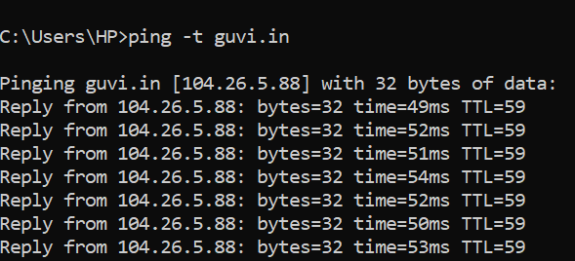

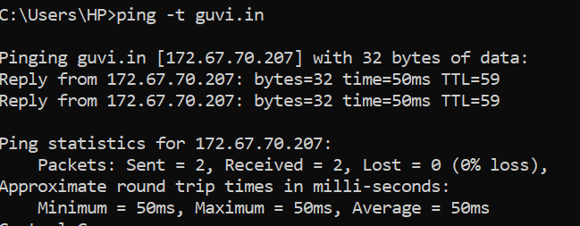

2. How do I find my CPU/memory usage of my server?

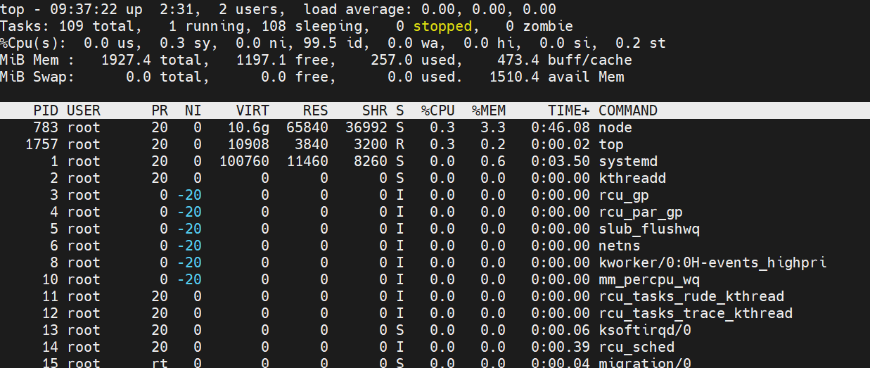

3. Test the connectivity between 2 nodes?

Using ssh the connectivity can be tested using publickey (ssh-keygen) on each nodes using ssh-copyid

After placing ssh key we could able to establish the ssh connection.

4. I have deployed an application in guvi.com:9000, and logs shows my app is running, but I’m unable to view the page. Check whether my port is open or not ?"



firewall-cmd --add-port=9000/tcp