# Introduction

## Project Summary

* “IBARIZE SERVICES” web application project is a project which would facilitate online consultation, where a patient can talk to his/her doctor about how he/she feels at the moment.

## Problem statement

* Wasting time; what I mean by wasting time is that sometimes people rush to the hospital due to simple symptoms when it was not really important while it could have been prevented through online consultation.
* ; sometimes also don’t take some symptoms seriously and end-up paying the heavy price.

## Objectives

* State your project objectives.

## Project Rationale

* Importance of your project solution. Beneficiaries.

# Methodologies and Methods

## Data collection methodology

* How did you know the problem? By observation? Did you make a site visit? Details?

## Tools to be used

### Hardware tools

* Personal computer

### Software tools

* HTML
* JS(Javascript)
* CSS
* PHP
* MYSQL
* XAMMP

# System Analysis and Design

## Requirement Specifications

### Functional requirements

* User authentication module in order to log in
* user registration modules so that you can create a new account

### Data Requirements

### 

### C:\Users\HP\Desktop\yes.JPG3.1.3 User Requirements

* Admin
* Patient
* Doctors

### Security Requirements

* Password encryption

## System Design

### System overall architecture

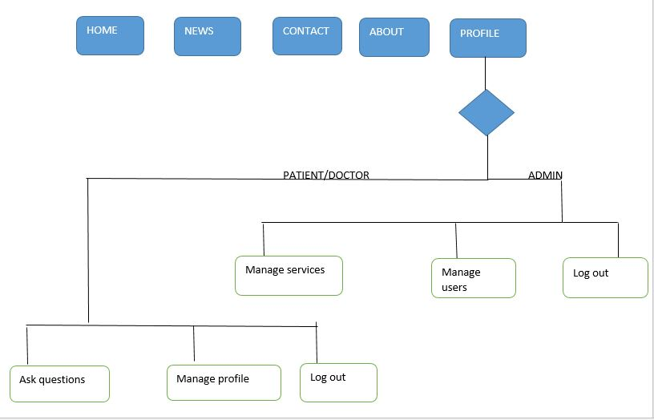

### System information flow

* Flow chart for Login
* 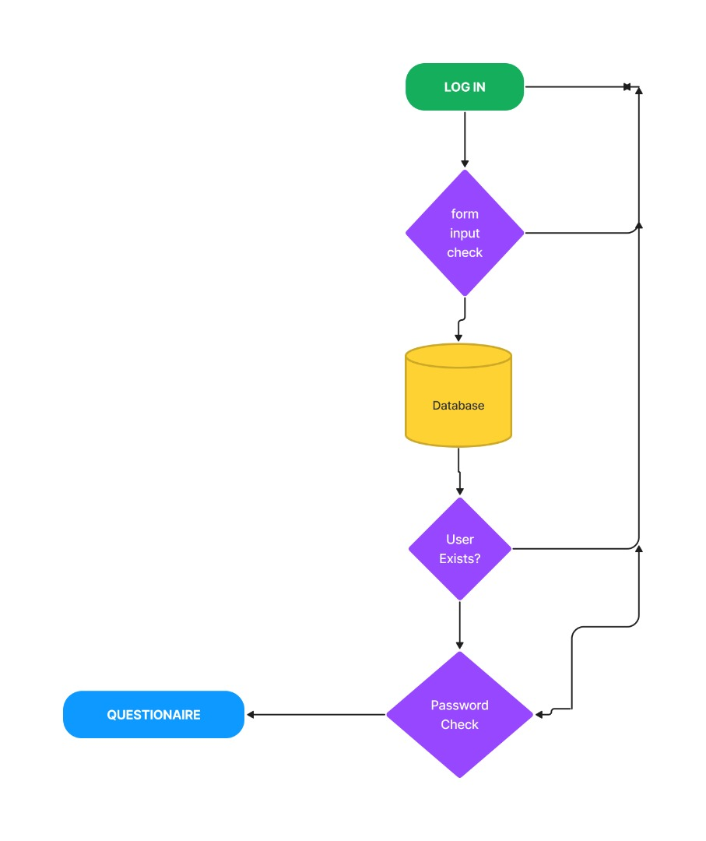
* User registration
* 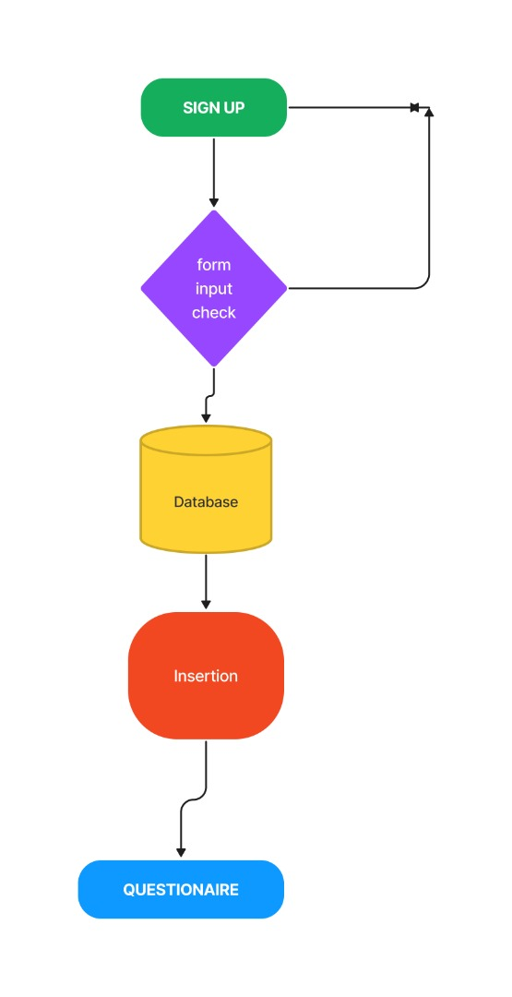
* Messaging process
* 

# System Implementation

## Landing page

This picture detail the landing page of the proposed project. From this page you can click on login button to log in or on sign up button to sign up.

The get started button also sends you on the login page.

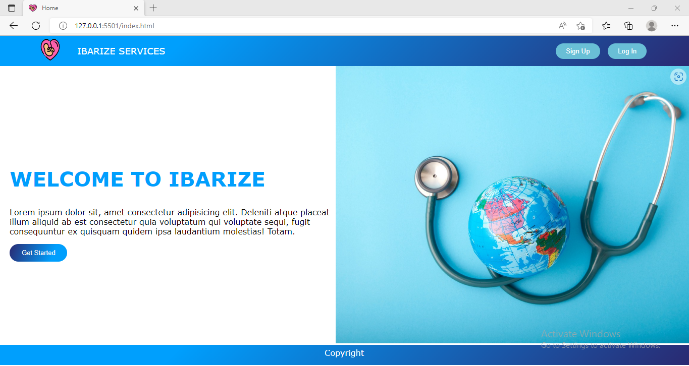

## Login page

This page detail the login process of the proposed project, you enter your username and your password if you have them or else you click on ” Create An Account”.

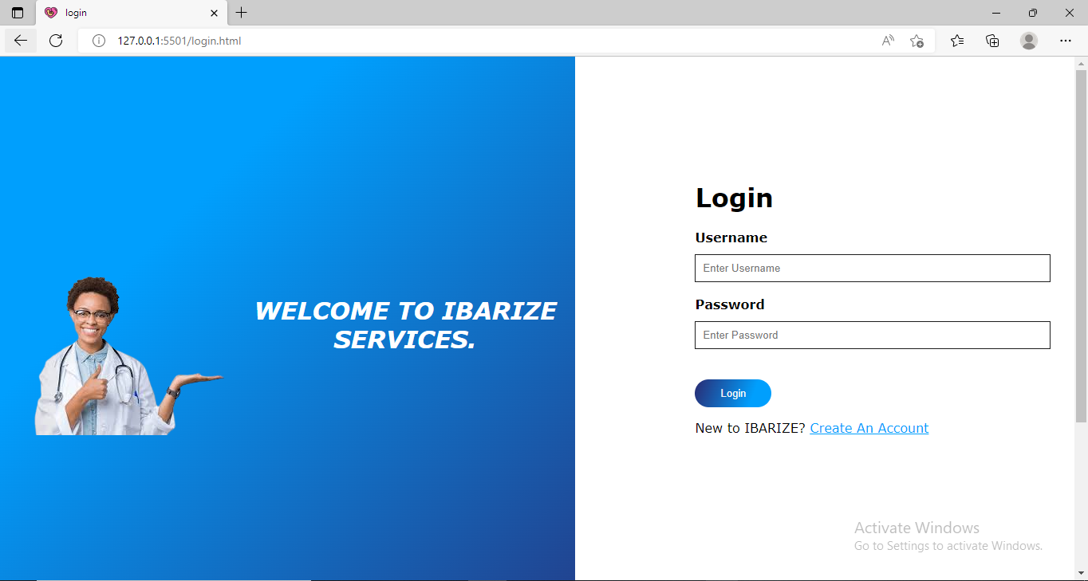

## 4.3Sign up page

On this page you can create your account if you don’t normally have one.

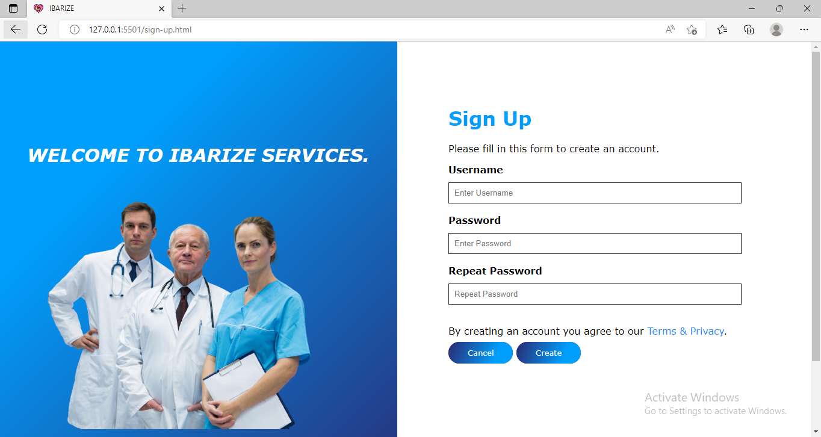

## Questionaire page

On this page you can ask the doctor whatever you want and when the doctor sees your question he can then answer you accordingly.

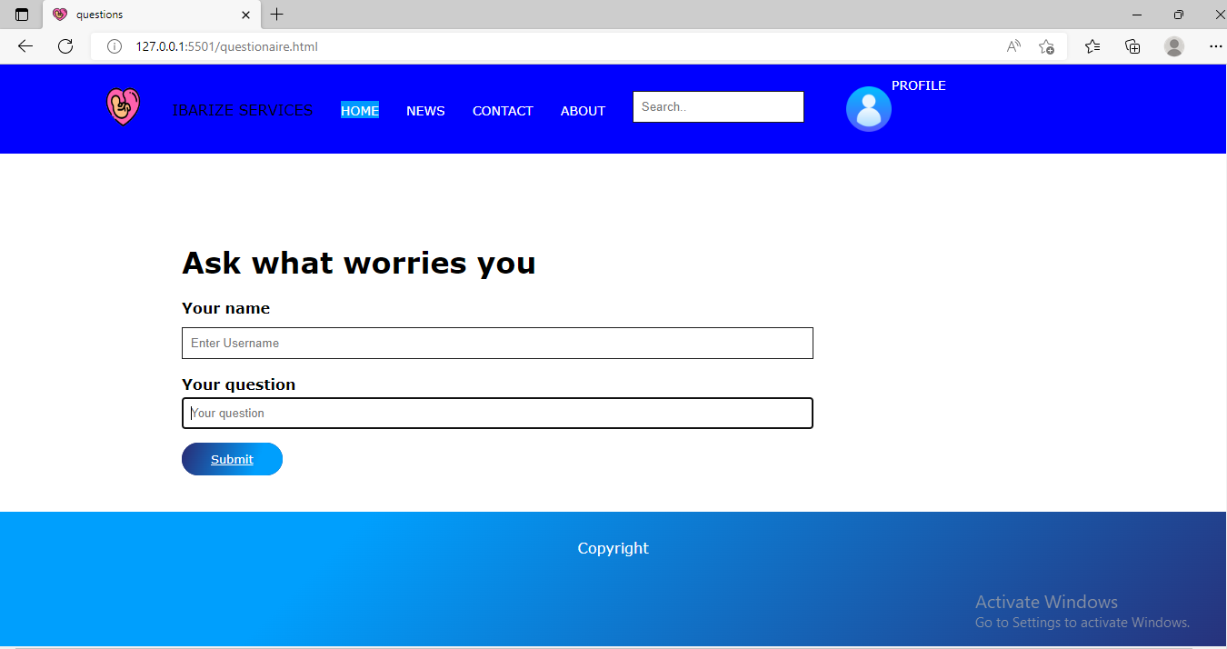

## Contacts page

On this page you can find different contacts of doctors, in case you need to contact on privately/ personally or in case of emergency.

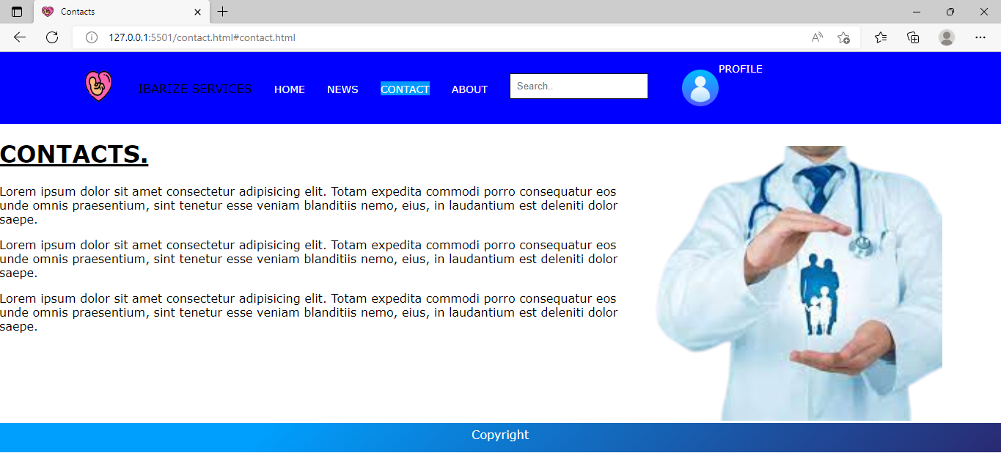

## ABOUT US page

On this page you can find other information about this site or the services given here.

# C:\Users\HP\Desktop\ibar\5assign.PNG

# Conclusion

* Briefly, this project would be the best solution to the problems listed above, this project would at least decrease the risk of miscarriage by at least 40% of the actual rate of miscarriage as the doctors may be able to monitor their patients (pregnant women and new born babies).

# Recommendation

* What do you recommend to:

1. **Other students:**

-HTML

-Javascript

-Mysql

-PHP

-CSS

1. **Beneficiaries** of your project proposal:

-As we know pregnant women and new born babies who would be the patients, are always at risk so they should always pay attention to their health as they are fragile.

# Appendix

https://github.com/hubert-333/ibarize