Bài viết gửi ấn phẩm Khoa học Dữ liệu và Trí tuệ Nhân tạo châu Á
Quantum Sentiment Classification with DisCoCat:
A Controlled Empirical Study on a Short Phrase SST-2 Subset
Nhat-Linh Do$​^{1,*}$, Quang-Thai Le$​^{1}$, Minh-Tan Tran-Huynh$​^{2}$
$​^{1}$Faculty of Business Data Science, Banking University of Ho Chi Minh City, Vietnam
$​^{2}$Faculty of Management Information Systems, Banking University of Ho Chi Minh City, Vietnam
linh.do@hub.edu.vn, thailq@hub.edu.vn, tanthm@hub.edu.vn
$​^{*}$Corresponding author.
Structured Abstract
Purpose — This study examines whether variational quantum circuits built from Distributional Compositional Categorical (DisCoCat) diagrams can match classical baselines of comparable scale on a short-phrase subset of the Stanford Sentiment Treebank, and which design choices (reader, ansatz, depth) govern trainability.
Design/methodology/approach — A controlled grid of 60 quantum training runs is reported on a class-balanced $5,000/400/400$ short-phrase subset, spanning two readers (Spiders, Cups), two ansatz families (IQP, Sim14), three depths and five seeds. Three classical baselines (LR + TF–IDF, LR + GloVe-50d, BiLSTM) are evaluated on the same split. Pairwise differences use McNemar tests with Holm–Bonferroni correction.
Findings — Spiders attains $92.05\%±0.64\%$ accuracy with $2,940$ parameters. Against BiLSTM ($91.83\%$, $82,369$ parameters) the difference is not significant (McNemar $p=0.60$) at $28×$ fewer parameters. Against LR + TF–IDF ($94.25\%$, $2,829$ parameters) the linear baseline is leaner and 2.2 points more accurate; raw $p=0.045$ but $p_{\text{Holm}}=0.39$ after Holm–Bonferroni adjustment. Two structural findings: under single-qubit atomic types the Spiders reader is representationally degenerate and all six ansatz/depth combinations yield identical accuracy; the Cups + IQP family at depth two falls into a reproducible barren-plateau-like collapse ($62.8\%$ across all five seeds) that persists under standard mitigation strategies.
Originality/value — The paper contributes a reproducible pipeline on a short-phrase subset of SST-2, a systematic 60-run reader $×$ ansatz $×$ depth ablation, an empirical case study of the barren-plateau phenomenon, and a documentation of an infrastructure-level reproducibility issue affecting the lambeq 0.5 BobcatParser distribution.
Practical implications — On this short-phrase subset and a noiseless CPU simulator, variational quantum DisCoCat matches BiLSTM at lower parameter cost but does not beat the sparse LR + TF–IDF baseline. Transfer to longer sentences, NISQ hardware or other domains is an open empirical question.
Keywords: Quantum Natural Language Processing, DisCoCat, Variational Quantum Algorithms, Sentiment Classification, Barren Plateau, Reproducibility
Paper type: Research paper

Introduction
Recent progress in Natural Language Processing (NLP) has been dominated by large pretrained language models whose parameter counts run into the hundreds of millions or billions. While the empirical performance of these models is impressive, their resource requirements place them well beyond the capabilities of current near-term quantum hardware. Quantum Natural Language Processing (QNLP), formalised in the Distributional Compositional Categorical (DisCoCat) framework of Coecke et al. (2010), offers a structurally different approach in which sentence meaning is built compositionally from word tensors according to the pregroup grammar of the sentence. Because grammatical composition maps naturally onto qubit registers and entangling gates, DisCoCat models can be realised directly as variational quantum circuits and trained on simulators or, in principle, on NISQ hardware (Kartsaklis et al., 2021; Lorenz et al., 2023).
We address three questions in this practical context. How does a variational quantum DisCoCat model trained on a public sentiment benchmark compare with classical baselines of comparable size? Which design choices in the QNLP pipeline (reader, ansatz, or circuit depth) are the primary drivers of performance? And how reliably can such models be trained in practice given the well-known optimisation pathologies of variational quantum algorithms (McClean et al., 2018)?
To answer these questions, a controlled experimental grid of 60 quantum training runs is conducted on a class-balanced $5,000/400/400$ subset of the Stanford Sentiment Treebank (Socher et al., 2013), spanning two readers, two ansatz families, three circuit depths and five random seeds. Three classical baselines of different inductive bias (Logistic Regression with TF–IDF bigrams, Logistic Regression with averaged GloVe embeddings, and a single-layer Bidirectional LSTM) are evaluated on the same split.
The contributions of the paper are threefold. First, a fully reproducible pipeline from raw Stanford Sentiment Treebank data, through DisCoCat diagrams and quantum circuits, to final evaluation metrics is released as open source at https://github.com/hublinhdn/nlp_quantum_hub, including all preprocessing decisions, hyperparameters, evaluation procedures and the per-seed prediction artefacts required to reproduce every figure and table in this paper. Second, the 60-run grid produces two methodologically informative observations: the Spiders reader with single-qubit atomic types is representationally degenerate, and the Cups + IQP family falls into a reproducible barren-plateau-like collapse at depth two. Third, an infrastructure-level reproducibility issue is documented (the deprecated qnlp.cambridgequantum.com domain referenced by lambeq 0.5.0 for the BobcatParser model), and a workaround based on the self-contained Spiders and Cups readers is described.
The remainder of the paper is organised as follows. Section 2 reviews the DisCoCat framework, QNLP literature and variational quantum circuit ansatzes. Section 3 describes the data pipeline, models and training protocol. Section 4 reports the main experimental results. Section 5 discusses implications, limitations and practical considerations. Section 6 concludes.

Literature Review

DisCoCat and Compositional Distributional Semantics
The Distributional Compositional Categorical model (Coecke et al., 2010) unifies two strands of computational semantics: distributional word representations, in which words are vectors in a high-dimensional space, and compositional grammar, in which sentences are constructed by combining word meanings according to syntactic structure. The framework uses pregroup grammar (Lambek, 1958) to assign each word a type formed from atomic categories (e.g. $n$ for noun, $s$ for sentence) and their adjoints. A sentence is grammatical if its sequence of types reduces to $s$ under contraction; the resulting reduction is represented as a string diagram in a monoidal category, simultaneously encoding the syntactic derivation and the semantic composition.
In the categorical formulation, words are morphisms from the monoidal unit to a tensor product of atomic types, and the sentence is the composition of those morphisms. Realising the composition in a finite-dimensional Hilbert space therefore yields a direct mapping between sentences and quantum states: words become parameterised quantum states, atomic types become qubit registers, and grammatical contractions are realised by measurement-induced post-selection or by measurement of an output register.

Quantum Natural Language Processing
Practical QNLP toolchains have been developed by Quantinuum and collaborators. The lambeq library (Kartsaklis et al., 2021) implements the full DisCoCat pipeline (CCG parsing, pregroup conversion, rewriter application and ansatz functor) in Python and provides interfaces to multiple quantum back-ends, including PennyLane (Bergholm et al., 2018). Lorenz et al. (2023) demonstrate that small DisCoCat models can be trained on real Quantinuum H1 hardware for binary classification of 130 phrases, reaching accuracies in the region of $80\%$. Meichanetzidis et al. (2020) provide complementary analysis on near-term quantum devices. More recently, Xu et al. (2024) introduce quantum recurrent architectures for text classification at scale and report results on standard NLP benchmarks. Buonaiuto et al. (2024) investigate quantum transfer learning for grammatical acceptability judgements, demonstrating that QNLP models can transfer linguistic knowledge across related tasks. Our work continues this line of practical QNLP studies, but at order-of-magnitude larger scale than Lorenz et al. (2023) on a public benchmark, with five-seed statistical analysis.

Variational Quantum Ansatzes
A variational quantum ansatz is a parameterised quantum circuit family with fixed topology and trainable rotation angles. The IQP family (Havlı́ček et al., 2019) alternates layers of single-qubit Hadamard gates with diagonal phase entangling gates. Sim et al. (2019) catalogue nineteen hardware-efficient circuit topologies; the Sim14 family uses controlled rotation gates in a hardware-efficient pattern with strong per-layer entanglement. The number of layers controls expressive capacity but also exposes the optimisation landscape to the barren-plateau phenomenon (Cerezo et al., 2021; McClean et al., 2018), in which gradient magnitudes vanish exponentially with circuit size, rendering training intractable. The training dynamics of these ansatzes on DisCoCat-derived circuits are one of the central empirical questions in this paper.

Sentiment Classification and the SST-2 Benchmark
Sentiment classification is one of the most extensively studied tasks in NLP and a canonical setting for evaluating new methods on short text. Classical approaches range from sparse bag-of-words representations combined with logistic regression (Pedregosa et al., 2011) through dense distributed representations such as word2vec (Mikolov et al., 2013) and GloVe (Pennington et al., 2014), to sequential neural models including LSTM-based architectures (Hochreiter and Schmidhuber, 1997) and, more recently, transformer-based pretrained language models such as BERT (Devlin et al., 2019). Each family encodes a different inductive bias: bag-of-words models capture lexical sentiment directly, distributed embeddings encode semantic similarity in continuous spaces, sequential models exploit token order, and transformer models exploit large-scale pretraining. The QNLP framework, by contrast, encodes compositional structure directly into the model’s topology, an inductive bias that is, in principle, particularly well-suited to phenomena such as negation, modification and co-ordination.
The Stanford Sentiment Treebank (Socher et al., 2013) provides fine-grained sentiment annotations on phrases extracted from parse trees of movie reviews. The binary subset (SST-2), derived by thresholding the continuous sentiment score, is one of the canonical benchmarks for binary sentiment classification in classical NLP, and forms part of the GLUE benchmark suite (Wang et al., 2018). The paper restricts attention to phrases of two to five tokens, which is consistent with prior QNLP studies (Lorenz et al., 2023) and keeps quantum simulation tractable on commodity hardware. The restriction is methodological rather than application-driven; the present paper does not evaluate on finance, microblog, or product-review corpora.

Variational Quantum Algorithms and Optimisation Pathologies
Variational quantum algorithms more generally have emerged as the dominant paradigm for near-term quantum machine learning (Cerezo et al., 2021, 2022). The training of these algorithms is performed classically using gradient-based optimisation on a parameterised quantum circuit (Mitarai et al., 2018; Schuld and Killoran, 2019), with the quantum device used only to evaluate expectation values. A line of recent work, including Schuld and Killoran (2022), has prompted a more sober reassessment of whether quantum advantage is the right benchmark for QML in the NISQ era, arguing that practical considerations such as parameter efficiency and trainability may be more immediately useful targets.
Among the most significant practical obstacles to variational quantum training is the barren-plateau phenomenon (McClean et al., 2018), in which the variance of gradients vanishes exponentially with the number of qubits or circuit depth, rendering the loss landscape effectively flat over wide parameter ranges. The theoretical foundations of this phenomenon have been recently consolidated in the review of Larocca et al. (2025) and the Lie algebraic characterisation of Ragone et al. (2024). A range of mitigation strategies has been proposed, including layer-wise pretraining, parameter initialisation heuristics, and adaptive learning-rate schedules. Whether these mitigations are effective in the specific context of DisCoCat-derived circuits is an empirical question, and one to which our experiments contribute a concrete data point.

Methodology
Figure 1 summarises the end-to-end pipeline. An input phrase is tokenised on whitespace, converted into a DisCoCat string diagram by a lambeq reader, parameterised by an ansatz functor at a chosen depth, executed on the PennyLane simulator, and the resulting two-class probability vector is argmax-decoded to a positive or negative label.
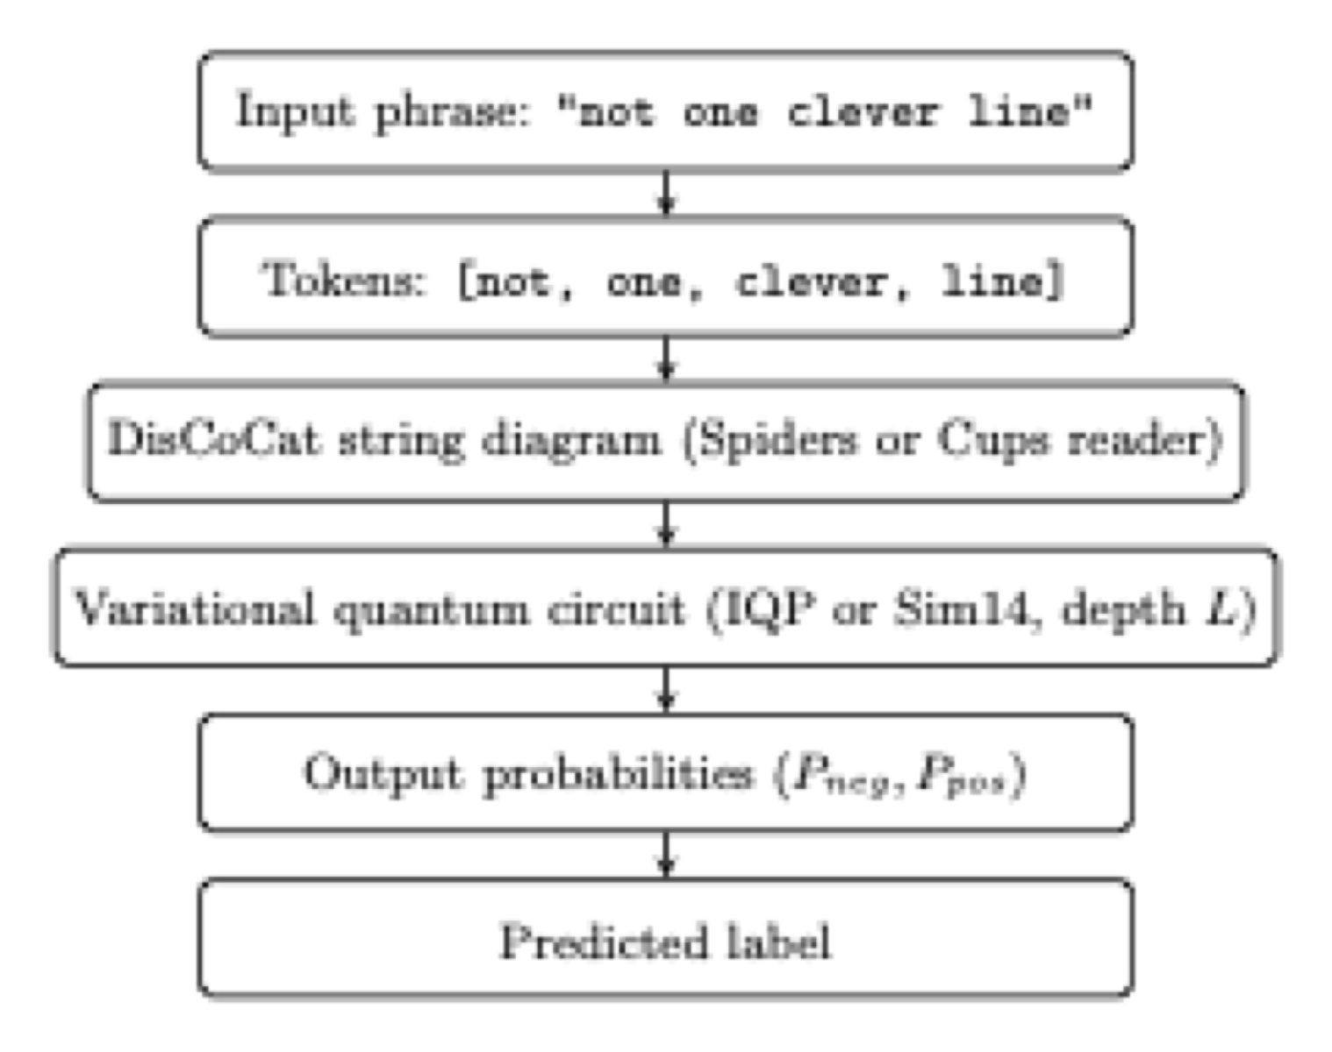
Figure 1. End-to-end QNLP pipeline for binary sentiment classification. The reader (Spiders or Cups) and the ansatz family (IQP or Sim14) are the two methodological choices ablated in this work.

Dataset Preparation
It is worth stating upfront that the dataset constructed here is not the standard SST-2 sentence-level task of the GLUE benchmark (Wang et al., 2018): GLUE SST-2 reports accuracy on full sentences without explicit length or vocabulary restrictions, whereas the present work restricts attention to phrases of two to five tokens drawn from the SST phrase dictionary and applies further filters described below. The accuracy numbers reported in Section 4 are therefore not directly comparable to GLUE SST-2 leaderboard numbers.
The raw Stanford Sentiment Treebank dictionary file contains $239,232$ phrases of variable length; of these, $47,355$ (or roughly $20\%$) contain five tokens or fewer and are candidates for the short-phrase subset used in this study. The processing pipeline applies four sequential filters: (a) restriction to phrases of two to five tokens; (b) binarisation of the continuous sentiment score with the neutral band $[0.4,0.6]$ discarded; (c) lowercase normalisation; and (d) retention of the top 1,000 most frequent training tokens, with phrases containing out-of-vocabulary words discarded. The remaining 9,711 training, 1,172 development and 1,216 test phrases form the in-vocabulary pool from which the final qnlp subset is sampled.
A two-stage sampling protocol is used to ensure that the test vocabulary is a subset of the training vocabulary, a requirement specific to the QNLP setting in which each unique word corresponds to a distinct trainable parameter. The training subset of 5,000 phrases (2,500 positive and 2,500 negative, drawn independently and without replacement) is sampled first. The dev and test pools are then filtered to retain only phrases whose tokens all appear in the sampled training set, and 400 phrases each are subsequently drawn in a class-balanced fashion. Table 1 summarises the preprocessing pipeline.
Table 1. Preprocessing pipeline producing the qnlp subset.
Stage | Train | Dev | Test
Raw phrases (length $≤5$) | 37,883 | 4,735 | 4,737
After $2≤\text{length}≤5$ | 33,399 | 4,195 | 4,162
After lowercase + vocab-1000 + OOV filter | 9,711 | 1,172 | 1,216
After class-balanced sampling (train first) | 5,000 | — | —
After word-coverage filter (dev/test $⊆$ train words) | — | 935 | 1,018
Final balanced 50:50 sample | 5,000 | 400 | 400

DisCoCat Readers
The lambeq library version 0.5.0 is used throughout. The BobcatParser CCG reader, which would be the default choice, was unavailable during the experiments because its model distribution endpoint is no longer reachable (this issue is discussed in Section 5). Two alternative readers are used:
SpidersReader.
Every word is assigned the atomic sentence type $s$ and the word boxes are merged by a Frobenius spider operation. The output is a single wire of type $s$. The resulting diagram is invariant under permutation of input tokens.
CupsReader.
A START token initialises a sentence wire and successive words are assigned the pregroup type $s.r⊗s$. Successive right adjoints are contracted with the preceding sentence wire via cups, yielding a diagram that retains the linear order of tokens and produces multi-qubit boxes per word.
The atomic type dimensions are set to one qubit each ($q_{N}=q_{S}=1$), following the convention of Lorenz et al. (2023). Rewriter rules for prepositional phrases, determiners and auxiliary verbs apply only to CCG-derived diagrams and are therefore not used.

Ansatzes and the Quantum Model
Each diagram is converted into a parameterised quantum circuit using one of two ansatz families: the IQP ansatz of Havlı́ček et al. (2019) or the Sim14 ansatz of Sim et al. (2019), at depths $L∈\{1,2,3\}$. The circuit is wrapped in a PennyLaneModel that exposes its trainable parameters as a torch.nn.Module. Simulation is performed on the lightning.qubit back-end with CPU execution. The model output is a length-two probability vector over the basis states $|0⟩,|1⟩$ of the output register, trained against one-hot labels with cross-entropy loss.

Classical Baselines
Three classical baselines are evaluated on the same $5,000/400/400$ split:
- LR + TF–IDF: logistic regression with unigram and bigram TF–IDF features (min_df=2), with the regularisation strength $C$ grid-searched on the development set over $\{{10}^{−2},{10}^{−1},1,10,{10}^{2}\}$, trained with the liblinear solver.
- LR + GloVe-50d: logistic regression on the mean-pooled GloVe-6B-50d word vector (Pennington et al., 2014) (the 50-dimensional variant of the GloVe-6B release) of the phrase, with the same hyperparameter grid.
- BiLSTM-1L: a randomly initialised embedding of dimension 32, a single-layer bidirectional LSTM (Hochreiter and Schmidhuber, 1997) with hidden size 64, mean-pooling over valid positions, dropout 0.3, and a linear classifier. Trained with Adam ($η={10}^{−3}$) using binary cross-entropy and early stopping on dev loss with patience 5.
Pretrained transformer baselines (e.g. DistilBERT, PhoBERT) are deliberately excluded from this comparison. The framing of the paper is parameter efficiency under controlled, end-to-end training from random initialisation: a 66M-parameter DistilBERT model trained on billions of tokens of additional text is not informative for this research question, since any accuracy difference would primarily reflect the pretraining corpus rather than the inductive bias of the model family. Once a comparable pretrained quantum model becomes available, an equivalent comparison along the pretrained-vs-pretrained axis will become possible.

Training and Evaluation Protocol
All quantum models are trained with Adam (Kingma and Ba, 2015) ($η={10}^{−2}$, weight decay ${10}^{−4}$) and gradient clipping at unit norm. A ReduceLROnPlateau scheduler halves the learning rate when development loss does not improve for seven consecutive epochs. Batch size is 32 and training runs for up to 200 epochs with early stopping on development loss (patience 20). Each configuration is trained from five independent random seeds and the mean and standard deviation are reported. The complete set of hyperparameters is given in Table 2. The test set is touched exactly once at the end of the experiments to evaluate the final checkpoints; no hyperparameter selection is performed on the test set. Pairwise statistical comparisons are conducted using McNemar’s test (McNemar, 1947) with the standard continuity correction on the $n=400$ test predictions.
Table 2. Training hyperparameters for quantum models and classical baselines. The LR regularisation strength $C$ was selected by grid search on the development set.
Component | Hyperparameter | Value
Quantum training
 | Optimiser | Adam
 | Learning rate | 0.01
 | Weight decay | ${10}^{−4}$
 | Gradient clipping (max norm) | 1.0
 | LR scheduler | ReduceLROnPlateau
 | reduction factor | 0.5
 | patience (epochs) | 7
 | minimum LR | ${10}^{−5}$
 | Batch size | 32
 | Max epochs | 200
 | Early-stopping patience | 20
 | Atomic type dimensions | $q_{N}=q_{S}=1$
 | Simulator back-end | pennylane lightning.qubit
 | Loss | Cross-entropy (one-hot 2-class)
 | Seeds per configuration | 5
Classical baselines
LR + TF–IDF | N-gram range | (1, 2)
 | min_df | 2
 | Solver | liblinear
 | $C$ (dev-tuned) | 10 (TF–IDF), 10 (GloVe)
LR + GloVe | Embedding dimension | 50
 | Pooling | mean
BiLSTM | Embedding dimension | 32 (random init)
 | Hidden dimension | 64 (bidirectional)
 | Dropout | 0.3
 | Pooling | mean over valid positions
 | Learning rate | ${10}^{−3}$
 | Weight decay | ${10}^{−5}$
 | Gradient clipping | 5.0
 | Max epochs / patience | 30 / 5

Software and Compute Environment
All experiments were conducted using Python 3.12, lambeq version 0.5.0, PennyLane ($≥0.34$), PyTorch ($≥2.1$) and scikit-learn ($≥1.3$). Computation was performed on a single Linux server with an 8-core CPU and 16 GB of RAM, without GPU acceleration. The complete 60-run quantum grid required approximately 12 hours of wall-clock time; the classical baselines required approximately three minutes; the final test-set evaluation approximately five minutes; and the analysis stage, including all figure generation and statistical tests, approximately two minutes.

Results

Overall Test Accuracy
Table 3 summarises the final test accuracy of all sixteen evaluated models. The classical LR + TF–IDF baseline is the strongest model overall ($94.25\%$), benefiting from bigram features that capture negation patterns such as not good and no sense. The Spiders quantum configuration attains $92.05\%$ accuracy with only $2,940$ trainable parameters, a performance level statistically indistinguishable from the BiLSTM baseline ($91.83\%$, $82,369$ parameters). The Cups + Sim14 family is similarly competitive across all three depths ($91.85$–$92.10\%$).
Table 3. Test-set results on the SST-2 short phrase subset ($n_{\text{test}}=400$, balanced 50:50). Quantum results aggregated over five seeds; classical baselines over three seeds (both logistic regression variants are deterministic given the fixed preprocessing pipeline, so their standard deviations are $0.0000$ by construction; BiLSTM is the only classical model with genuine seed-to-seed stochasticity and was run with three seeds). All six Spiders configurations are bit-identical because of the saturation phenomenon analysed in Section 4.3.
Model | Accuracy | F1-macro | Std | #Params
Majority baseline | 0.5000 | 0.3333 | — | 0
LR + TF–IDF | 0.9425 | 0.9425 | 0.0000 | 2,829
LR + GloVe-50d | 0.8400 | 0.8400 | 0.0000 | 51
BiLSTM-1L | 0.9183 | 0.9183 | 0.0042 | 82,369
Q-spiders (all six configurations) | 0.9205 | 0.9205 | 0.0064 | 2,940
Q-cups-IQP-$L_{1}$ | 0.8715 | 0.8710 | 0.0165 | 983
Q-cups-IQP-$L_{2}$ | 0.6280 | 0.6278 | 0.0426 | 1,963
Q-cups-IQP-$L_{3}$ | 0.8450 | 0.8448 | 0.0454 | 2,943
Q-cups-Sim14-$L_{1}$ | 0.9190 | 0.9190 | 0.0124 | 7,843
Q-cups-Sim14-$L_{2}$ | 0.9185 | 0.9185 | 0.0082 | 15,683
Q-cups-Sim14-$L_{3}$ | 0.9210 | 0.9210 | 0.0103 | 23,523
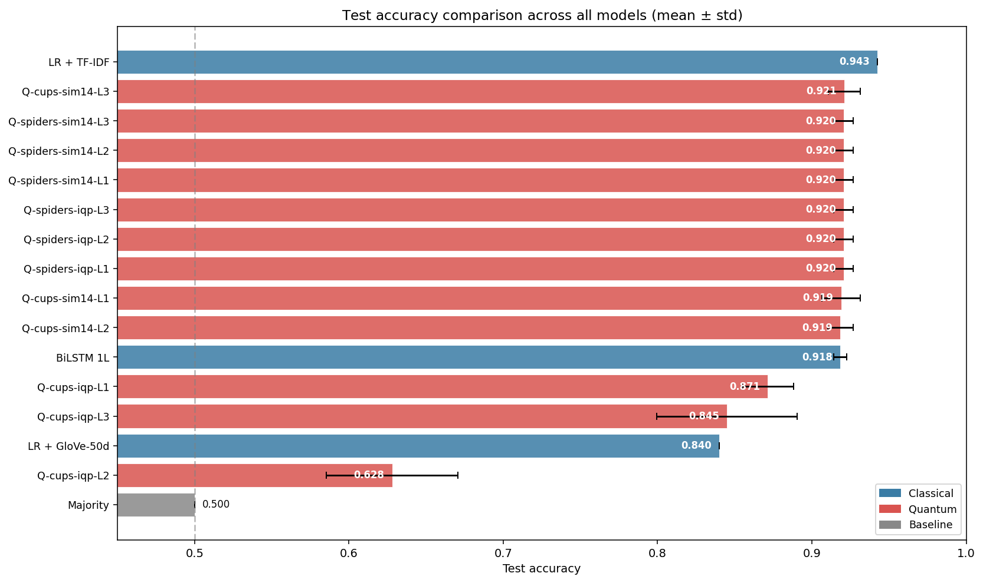
Figure 2. Test accuracy of all evaluated models with one standard deviation across seeds. Sorted in ascending order of mean accuracy.

Parameter Count vs. Accuracy
Figure 3 plots test accuracy against the number of trainable parameters on a logarithmic axis. The Spiders quantum model attains $92.05\%$ accuracy with $2,940$ parameters, a $28$-fold reduction relative to the BiLSTM at marginally higher accuracy. This compactness is observed only relative to the dense BiLSTM baseline; the sparse LR + TF–IDF baseline remains slightly more compact still ($2,829$ parameters), with higher accuracy on this subset, as discussed further in Section 5.
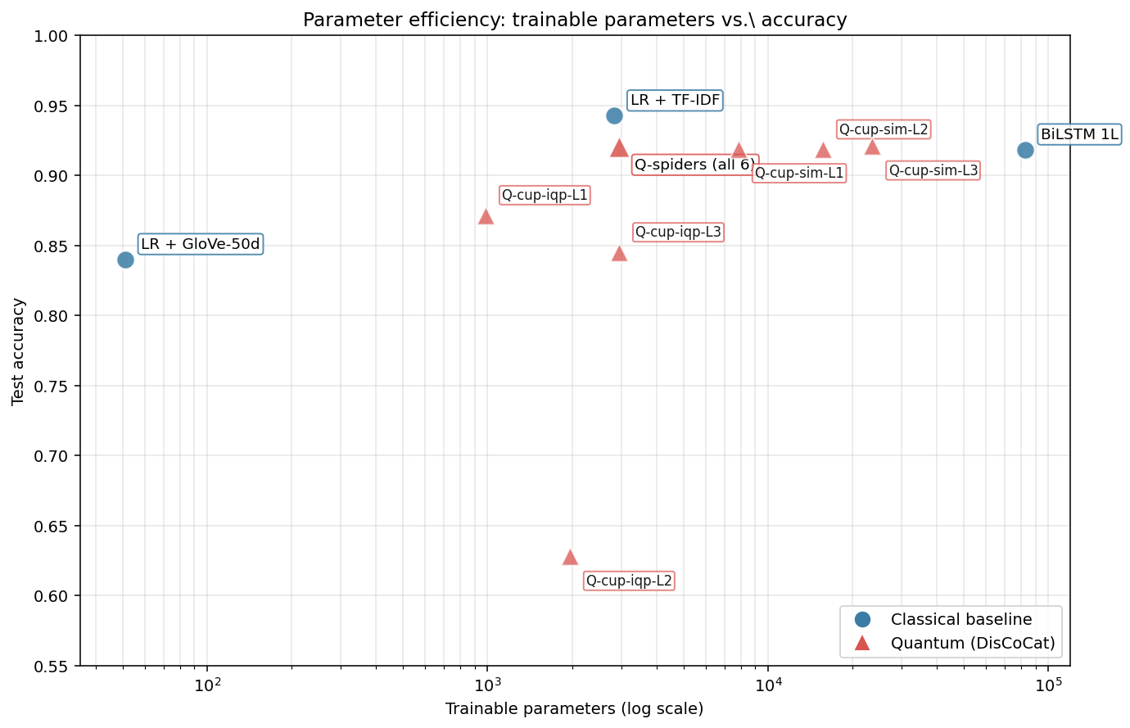
Figure 3. Trainable parameters versus test accuracy. The Spiders quantum model occupies the most favourable region of the parameter-efficiency trade-off relative to dense sequence models, matching BiLSTM accuracy with $28×$ fewer parameters ($2,940$ vs. $82,369$).

Reader $×$ Ansatz $×$ Depth Ablation
The 60-run grid exhibits three qualitatively distinct training regimes, which are analysed separately.

Spiders saturation
When SpidersReader is paired with single-qubit atomic types, each word box reduces to a single-qubit unitary and the spider itself contributes no trainable parameters. The IQP and Sim14 ansatzes become representationally equivalent under this configuration: a single-qubit gate has at most three free parameters, and the product of single-qubit unitaries remains a single-qubit unitary regardless of layer depth. The empirical grid confirms this prediction. All six Spiders configurations attain identical test accuracy ($0.9205±0.0064$) with identical parameter counts ($2,940$). This outcome reflects a structural property of the representation rather than an implementation defect and would dissolve under either wider atomic types or a reader that emits multi-qubit boxes.

Cups + IQP barren-plateau-like collapse at depth two
The Cups reader produces multi-qubit word boxes, so ansatz and depth become genuinely informative. The IQP family yields a non-monotonic depth sweep: test accuracy is $87.15\%$ at $L_{1}$, $62.80\%$ at $L_{2}$ and $84.50\%$ at $L_{3}$. At depth two all five seeds converge to a narrow accuracy band ($σ=0.0426$) marginally above the chance line, a pattern characteristic of an attracting flat region in the loss landscape rather than an unfortunate initialisation. A McNemar test rejects the null hypothesis of equal performance at $L_{2}$ versus both $L_{1}$ and $L_{3}$ at $p<{10}^{−15}$; the comparison $L_{1}$ versus $L_{3}$ yields $p=0.79$, indicating no significant difference. The plateau persists under the standard mitigation strategies (a ReduceLROnPlateau scheduler that reduces the learning rate to $2.5×{10}^{−3}$ and unit-norm gradient clipping), consistent with the barren-plateau phenomenon described by McClean et al. (2018) and the recent theoretical characterisation of (Larocca et al., 2025; Ragone et al.; 2024). The barren-plateau result of McClean et al. (2018) is formally an asymptotic statement in the number of qubits, whereas the circuits studied here use only $5$–$6$ qubits; the phenomenon is therefore described as barren-plateau-like or as a flat region consistent with the barren-plateau characterisation throughout the rest of the paper, in line with the conservative reading recommended by Cerezo et al. (2022).

Cups + Sim14 depth stability
The Sim14 ansatz produces a qualitatively different depth profile. Test accuracy varies only from $91.90\%$ at $L_{1}$ to $91.85\%$ at $L_{2}$ and $92.10\%$ at $L_{3}$, comfortably within the seed-to-seed noise band. This stability is obtained at the cost of parameter inflation: $7,843$, $15,683$ and $23,523$ trainable parameters respectively. The Sim14 family was designed for strong per-layer entanglement coverage (Sim et al., 2019), and the observed depth robustness is consistent with that design objective.
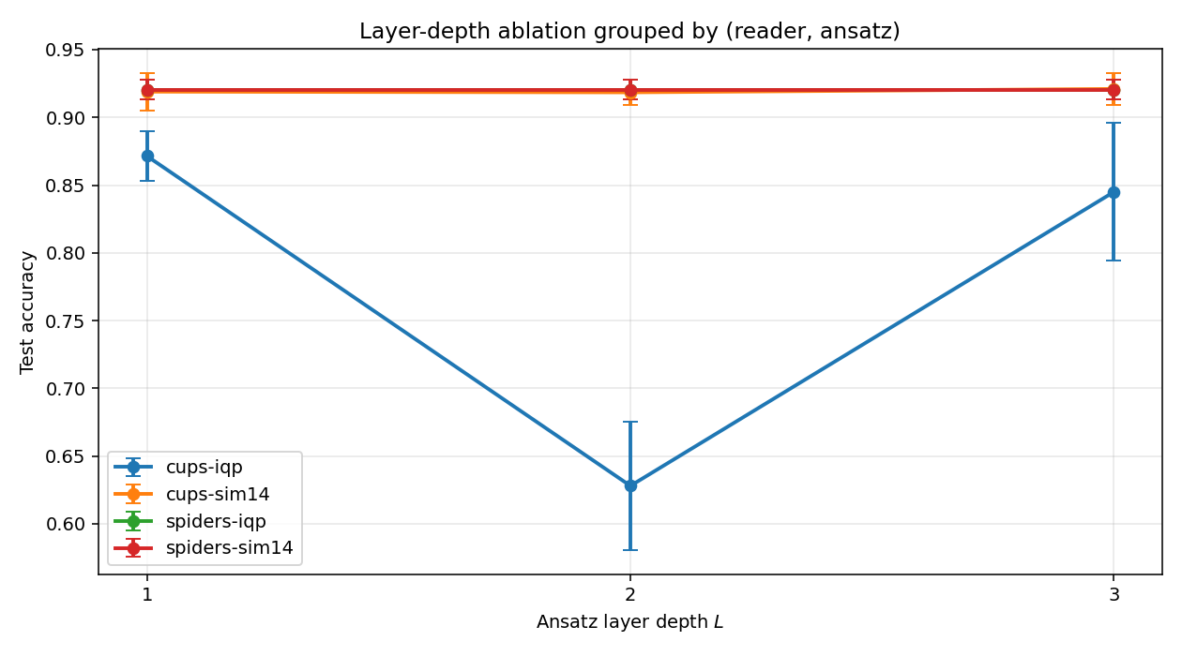
Figure 4. Test accuracy as a function of layer depth $L$, grouped by (reader, ansatz) so that each curve traces one ansatz family across the three depths. The Cups + IQP curve clearly exhibits the $L_{2}$ barren-plateau-like collapse to chance accuracy. The two Spiders curves (Spiders + IQP and Spiders + Sim14) overlap exactly and appear as a single line, a direct consequence of the single-qubit representational saturation analysed in Section 4.3; together they collapse all six Spiders configurations onto one trajectory.

Seed Consistency Across Quantum Configurations
Figure 5 reports the test accuracy of each of the twelve unique quantum configurations across all five random seeds, sorted by descending mean accuracy. Three observations support the ablation analysis. First, for any given seed, all six Spiders configurations produce bit-identical predictions; the residual variation reported in Table 3 ($σ=0.0064$) arises solely across seeds due to differing random parameter initialisation, confirming that the representational saturation is exact rather than approximate at fixed initialisation. Second, the Cups + Sim14 configurations attain high mean accuracy with moderate seed-to-seed variability. Third, the Cups + IQP-$L_{2}$ configuration is reproducibly stuck near the chance baseline across all five seeds, with low variance, confirming that the barren-plateau-like collapse is a structural feature of the optimisation landscape rather than a single unlucky initialisation.
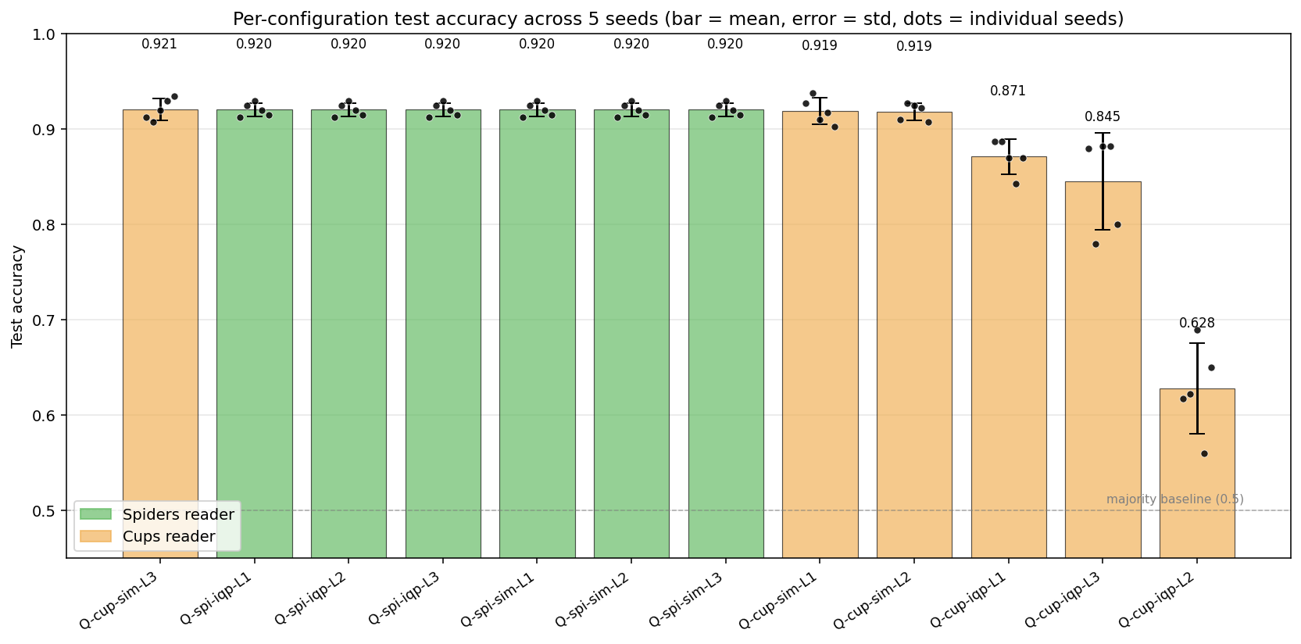
Figure 5. Per-configuration test accuracy across five random seeds. Bars show the mean, error bars show one standard deviation, and dots show individual seed accuracies. Configurations are sorted by descending mean accuracy.

Negation Handling
Figure 6 reports the test error rate of each model on phrases containing negation tokens versus phrases without negation. Out of 400 test phrases, 71 contain at least one negation token. LR + TF–IDF and BiLSTM exhibit the smallest absolute gap between the two categories, consistent with the bigram features and sequential modelling, respectively, capturing the linguistic role of negation directly. The Spiders quantum reader shows a moderate gap, and the depth-2 collapsed configuration Cups + IQP-$L_{2}$ shows the largest absolute error rate in both categories due to its near-random predictions overall.
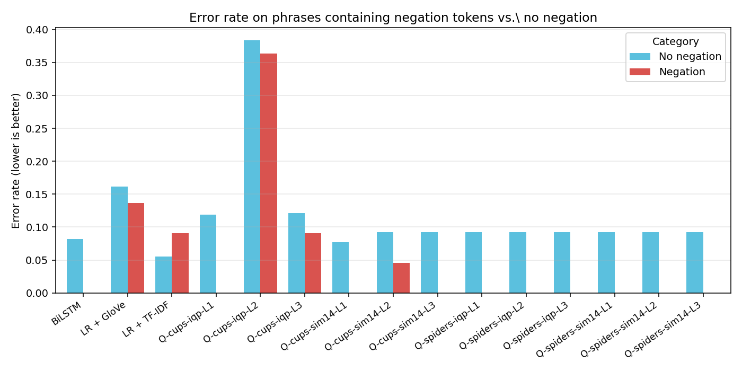
Figure 6. Test error rate on phrases containing negation tokens (red) versus phrases without negation (blue), per model. Out of 400 test phrases, 71 contain at least one negation token from the set {not, n’t, no, never, nor, none, nothing, nobody}.

Statistical Significance
To determine whether the accuracy differences in Table 3 are statistically significant, paired McNemar tests (McNemar, 1947) with the continuity correction were computed on the $n=400$ test predictions of representative quantum and classical configurations. The family of comparisons considered for multiple-comparisons control is defined as every pairwise test that is reported and discussed in the rest of this paper: this includes the classical-vs-classical reference (LR + TF–IDF vs. BiLSTM), the two Spiders-vs-classical comparisons, three Cups-Sim14-$L_{3}$-vs-other comparisons, seven Cups-IQP-vs-classical comparisons, and three within-Cups-IQP ablation comparisons, for a total of $m=16$. No additional McNemar comparisons were computed and then excluded; the family is exactly the set of rows in Table 4. Raw $p$-values are accompanied by Holm–Bonferroni-adjusted values $p_{\text{Holm}}$, and significance is reported with respect to $p_{\text{Holm}}$ (Table 4). Three patterns emerge. First, the Spiders reader is statistically indistinguishable from both BiLSTM ($p=0.60$, $p_{\text{Holm}}=1.00$) and LR + TF–IDF (raw $p=0.045$, $p_{\text{Holm}}=0.39$) after correction; the raw $p=0.045$ margin is therefore best read as an exploratory observation that does not survive multiplicity control. Together with the $28×$ smaller parameter count this is the central comparative result of the paper (the central contributions are the two structural findings, (i)–(ii) above, and the reproducible benchmark). Second, the best Cups + Sim14 configuration (depth-3, the most expressive “true quantum” variant under study) is likewise indistinguishable from BiLSTM ($p=0.64$) and not significantly worse than LR + TF–IDF ($p=0.067$); it is also indistinguishable from Spiders ($p=0.86$). Third, LR + TF–IDF significantly outperforms every Cups + IQP configuration at $p_{\text{Holm}}<0.05$ but ties BiLSTM ($p=0.20$); the depth-2 collapse of Cups + IQP is highly significant against both $L_{1}$ and $L_{3}$ ($p<{10}^{−15}$), while $L_{1}$ and $L_{3}$ themselves are statistically indistinguishable ($p=0.79$).
Table 4. Paired McNemar tests on test-set predictions. Each cell pair uses the seed-0 predictions of the listed configuration (and, for the Spiders reader, the bit-identical Q-spiders-IQP-$L_{1}$ representative, since all six Spiders configurations yield identical predictions per seed). $b$ and $c$ denote the discordant cells (model A wrong / B right, and vice versa); $χ^{2}$ is the continuity-corrected test statistic, $p$ is the two-sided raw $p$-value and $p_{\text{Holm}}$ is the Holm–Bonferroni-adjusted $p$-value across the $m=16$ comparisons in the family. Significance is reported with respect to $p_{\text{Holm}}$: $* p_{\text{Holm}}<0.05$, $** p_{\text{Holm}}<0.01$, $*** p_{\text{Holm}}<0.001$.
Model A | Model B | $b$ | $c$ | $χ^{2}$ | $p$ | $p_{\text{Holm}}$ | Sig.
Classical baselines:
LR + TF–IDF | BiLSTM | 11 | 19 | 1.63 | 0.20 | 1.00
Spiders reader (identical accuracy across all six ansatz–depth configurations):
Q-spiders | BiLSTM | 18 | 14 | 0.28 | 0.60 | 1.00
Q-spiders | LR + TF–IDF | 21 | 9 | 4.03 | 0.045 | 0.39
Best Cups + Sim14 configuration (entangling, depth-3) vs. baselines:
Q-cups-Sim14-$L_{3}$ | BiLSTM | 23 | 19 | 0.21 | 0.64 | 1.00
Q-cups-Sim14-$L_{3}$ | LR + TF–IDF | 24 | 12 | 3.36 | 0.067 | 0.46
Q-cups-Sim14-$L_{3}$ | Q-spiders | 16 | 16 | 0.03 | 0.86 | 1.00
Cups + IQP vs. baselines (depth-2 collapse):
LR + TF–IDF | Q-cups-IQP-$L_{1}$ | 15 | 37 | 8.48 | 0.0036 | 0.040 | *
LR + TF–IDF | Q-cups-IQP-$L_{2}$ | 10 | 140 | 110.94 | $<{10}^{−15}$ | $<{10}^{−14}$ | ***
LR + TF–IDF | Q-cups-IQP-$L_{3}$ | 9 | 34 | 13.40 | 0.00025 | 0.0030 | **
LR + GloVe | Q-cups-IQP-$L_{1}$ | 49 | 30 | 4.10 | 0.043 | 0.39
BiLSTM | Q-cups-IQP-$L_{1}$ | 18 | 32 | 3.38 | 0.066 | 0.46
BiLSTM | Q-cups-IQP-$L_{2}$ | 11 | 133 | 101.67 | $<{10}^{−15}$ | $<{10}^{−14}$ | ***
BiLSTM | Q-cups-IQP-$L_{3}$ | 15 | 32 | 5.45 | 0.020 | 0.20
Within Cups + IQP:
$L_{1}$ | $L_{2}$ | 24 | 132 | 73.39 | $<{10}^{−15}$ | $<{10}^{−14}$ | ***
$L_{1}$ | $L_{3}$ | 26 | 29 | 0.07 | 0.79 | 1.00
$L_{2}$ | $L_{3}$ | 123 | 18 | 76.71 | $<{10}^{−15}$ | $<{10}^{−14}$ | ***

Per-Length Performance
Test phrases are not uniformly distributed in length: the 400 test examples consist of 122 two-token phrases, 131 three-token phrases, 92 four-token phrases and 55 five-token phrases. Because phrase length is a proxy for compositional difficulty, per-length accuracy is informative for distinguishing models that rely on lexical content from those that exploit structural information. Table 5 reports the per-length test accuracy for a representative set of models. Both the Spiders quantum model and LR + TF–IDF maintain near-constant accuracy across the length range, indicating that compositional effects on these short phrases are dominated by lexical content. The Cups + IQP family exhibits its largest accuracy degradation at lengths three and four, which coincides with the depth-2 barren-plateau-like region; this pattern suggests that training instability, rather than expressive insufficiency, accounts for the observed performance gap.
Table 5. Test accuracy by phrase length (number of whitespace-separated tokens). Counts of test phrases per length bucket are shown in parentheses. Identical for all six Spiders configurations.
Model | $n=2$ (122) | $n=3$ (131) | $n=4$ (92) | $n=5$ (55)
LR + TF–IDF | 0.943 | 0.977 | 0.924 | 0.891
LR + GloVe-50d | 0.852 | 0.840 | 0.826 | 0.836
BiLSTM-1L | 0.934 | 0.939 | 0.913 | 0.873
Q-spiders (all six) | 0.926 | 0.947 | 0.880 | 0.855
Q-cups-IQP-$L_{1}$ | 0.926 | 0.893 | 0.870 | 0.818
Q-cups-IQP-$L_{2}$ | 0.631 | 0.580 | 0.620 | 0.673
Q-cups-IQP-$L_{3}$ | 0.918 | 0.939 | 0.815 | 0.764
Q-cups-Sim14-$L_{1}$ | 0.926 | 0.962 | 0.902 | 0.891
Q-cups-Sim14-$L_{2}$ | 0.926 | 0.947 | 0.891 | 0.818
Q-cups-Sim14-$L_{3}$ | 0.943 | 0.947 | 0.880 | 0.818

Error Analysis
The high-accuracy models (LR + TF–IDF, BiLSTM and the Spiders quantum configurations) exhibit approximately balanced false-positive and false-negative rates, consistent with the residual error reflecting genuine semantic difficulty rather than class-imbalance artefacts. By contrast, the Q-cups-IQP-$L_{2}$ configuration produces a near-uniform confusion matrix, which is the expected pattern for a model whose predictions are effectively random.
Phrases containing explicit negation tokens (not, n’t, no, never and related forms) are systematically harder to classify across all models, but the magnitude of this effect varies. LR + TF–IDF exhibits the smallest relative increase in error on negation-bearing phrases, consistent with its bigram features explicitly encoding not-word combinations. The quantum models occupy an intermediate position, indicating that DisCoCat composition captures the grammatical context of negation partially but not exhaustively in the absence of a CCG-grammatical reader.
Six representative test phrases illustrate the qualitative behaviour of the models (Table 6). The three negation-bearing negative examples are correctly classified by all models with high confidence. The Cups quantum variants invert the phrase authentic and dark from positive to negative, an error not made by the classical baselines or by the Spiders quantum model. The word dark likely dominates the Cups composition, which respects token order more strongly than the Spiders composition; this is an example of a case in which the simpler reader is empirically more robust.
Table 6. Predictions of five representative models on six hand-selected test phrases. Each cell reports the predicted label and the probability of the positive class $P_{\text{pos}}$. Incorrect predictions are marked with $†$.
Phrase | True | TF–IDF | BiLSTM | Q-S-IQP-$L_{1}$ | Q-C-IQP-$L_{1}$ | Q-C-S14-$L_{3}$
absolutely no sense | neg | neg (0.01) | neg (0.00) | neg (0.00) | neg (0.11) | neg (0.01)
it’s no classic | neg | neg (0.09) | neg (0.08) | neg (0.07) | neg (0.19) | neg (0.05)
in this pretentious mess | neg | neg (0.04) | neg (0.00) | neg (0.00) | neg (0.00) | neg (0.00)
authentic and dark | pos | pos (0.84) | pos (0.72) | pos (0.86) | neg$​^{†}$ (0.12) | neg$​^{†}$ (0.17)
entertaining his children | pos | pos (0.94) | pos (1.00) | pos (0.97) | pos (0.91) | pos (0.95)
beauty, grace and | pos | pos (0.98) | pos (1.00) | pos (1.00) | pos (0.98) | pos (0.99)

Discussion

Comparison with Prior QNLP Work
Lorenz et al. (2023) report accuracies in the region of $80\%$ on a custom meal-prep/IT dataset of approximately 130 training phrases. Our work extends that line in four directions: an order-of-magnitude larger training set (5,000 phrases); a public standard benchmark (the short-phrase subset of SST-2); a controlled multi-seed protocol with statistical significance testing; and explicit classical baselines on the same data split. Within these extended conditions, variational quantum DisCoCat continues to deliver accuracy comparable with neural classical baselines at substantially lower parameter cost (relative to the dense BiLSTM baseline; see Section 5). The framing aligns with Schuld and Killoran (2022), who argue that practical attributes such as parameter efficiency and trainability are the right near-term targets for quantum machine learning research, rather than a putative computational advantage.

An Honest Tension: Compositionality vs. Bag-of-Words
The theoretical motivation for DisCoCat (Section 3) is that pregroup grammar provides a syntax-aware way to compose word representations into a phrase representation, in contrast to bag-of-words models that ignore word order. The empirical pattern observed here, however, runs in the opposite direction: the Spiders reader, which is permutation-invariant and therefore a quantum bag-of-words by construction, attains the highest accuracy among quantum configurations on this subset and is statistically indistinguishable from BiLSTM, while the order-respecting Cups reader with the most expressive ansatz (Sim14, depth 3) matches but does not exceed it. Two readings are possible. The optimistic reading is that the compositional structure encoded by Cups is real but not informative for the short-phrase sentiment task as formulated here: on phrases of two to five tokens the sentiment signal is dominated by lexical content (a few highly polar words) rather than by combinatorial structure, so a representation that faithfully encodes order has nothing extra to exploit. The pessimistic reading is that the present subset cannot adjudicate between compositional and bag-of-words quantum representations at all, because the task is too lexical. Both readings imply the same follow-up: the compositional advantage of DisCoCat, if it exists, should be sought on longer sentences and on linguistic phenomena where word order is load-bearing (for example, negation scope, or modifier attachment), neither of which can be cleanly tested on the two-to-five-token subset evaluated here.

Methodological Implications for Future QNLP Studies
The implications discussed in this subsection are restricted to the experimental setting actually examined in this paper, namely binary sentiment classification on a $5,000/400/400$ short-phrase subset of SST-2 trained on a noiseless CPU simulator. We do not make claims about finance, banking, NISQ hardware, edge deployment or non-English languages, none of which were tested. Within these limits, four methodological points follow.
First, the choice of reader matters more than the choice of ansatz family or circuit depth, at least under single-qubit atomic types. Future QNLP studies should prioritise the identification of a reader that genuinely produces multi-qubit boxes before investing in ansatz hyperparameter tuning. The Spiders reader, while simple and computationally inexpensive, is representationally degenerate in this configuration and therefore unsuitable for studies that depend on ablation across ansatz topology.
Second, the depth-two barren-plateau-like collapse observed for the Cups + IQP combination is a cautionary observation. The standard mitigation strategies investigated in this work (a ReduceLROnPlateau learning-rate scheduler and unit-norm gradient clipping) were insufficient to escape the plateau. Future QNLP studies should expect that training pathologies can survive textbook remedies, and should include diagnostic instrumentation (per-seed variance plots, learning-rate trajectories, gradient-norm histories) as a standard part of the training pipeline rather than relying on a single training run.
Third, the requirement that the test vocabulary is a subset of the training vocabulary is a feature of QNLP that has no direct classical analogue. Classical models such as BiLSTM or LR with TF–IDF gracefully handle out-of-vocabulary tokens by falling back to a random embedding or a zero feature; the QNLP model has no such fallback, because each token is associated with a distinct trainable parameter in a fixed symbol table. Future QNLP work must therefore include vocabulary-coverage checks as an explicit part of the data preparation pipeline. The two-stage sampling protocol introduced in Section 3.1 provides one workable solution; alternative approaches such as subword tokenisation are open directions.
Fourth, the parameter-efficiency advantage observed against BiLSTM in this controlled subset is not by itself evidence of practical deployability. Whether the advantage transfers to longer sentences, larger vocabularies, noisy NISQ hardware or non-English languages is an open empirical question that would require additional studies on those targets specifically; the present paper does not address any of these conditions.

Open Directions for Future Work
The pregroup-grammatical backbone of DisCoCat is, in principle, language-agnostic, so adapting the same pipeline to non-English short-phrase sentiment benchmarks (for example, a Vietnamese short-phrase benchmark, which to the best of our knowledge does not yet exist as a public resource) is a natural follow-up. Equally natural are: (i) extending the pipeline beyond five-token phrases to full sentences, where the BobcatParser CCG reader would contribute grammatical information not exploited here; (ii) evaluating on noisy NISQ hardware to test whether the simulator-only results transfer; and (iii) replicating the experimental grid on domain-specific short-text corpora (for example, financial or biomedical microblog data) to test whether the conclusions generalise beyond movie-review sentiment. None of these directions are claims of this paper; they are open questions left for subsequent work.

Limitations
The conclusions reported here are subject to several constraints. The first concerns the dataset itself. The evaluation runs on a heavily filtered subset of the Stanford Sentiment Treebank (Socher et al., 2013), not the standard SST-2 task as it appears on the GLUE benchmark (Wang et al., 2018). Specifically, phrases are restricted to two to five whitespace-separated tokens, the continuous sentiment score is binarised with the neutral band $[0.4,0.6]$ discarded, text is lowercased, the vocabulary is truncated to the top-$1,000$ training tokens with out-of- vocabulary phrases discarded, and a deterministic two-stage balanced sampling produces a class-balanced $5,000/400/400$ split with the additional invariant that the development and test vocabularies are subsets of the training vocabulary by construction. These filters keep simulation tractable on a single CPU and remove the out-of-vocabulary issue that has no direct QNLP analogue (Section 3.1), but they also make the resulting subset shorter, more lexically constrained and easier than the standard SST-2 benchmark. The accuracy numbers reported in this paper ($94.25\%$ for LR + TF–IDF, $92.05\%$ for Spiders, $91.83\%$ for BiLSTM) are therefore not directly comparable to SST-2 accuracies reported in the wider literature; the comparisons are valid within this controlled subset only. Extending the framework to longer sequences or to the full GLUE SST-2 task would require either a more efficient simulator or NISQ hardware. The vocabulary restriction biases the corpus toward lexically frequent items. All experiments are conducted on the noiseless lightning.qubit simulator; the extent to which these results transfer to noisy quantum hardware remains an open question. The atomic types are assigned a single qubit each, which collapses the Spiders ansatz comparison. Finally, the BobcatParser CCG reader was unavailable, so the grammatically richest reader in lambeq is absent from the comparison.
A second, more fundamental caveat concerns the interpretation of the parameter-efficiency result. Under the single-qubit setting used here, the Spiders reader reduces to a product of single-qubit unitaries composed by a spider, which is classically simulable in linear time and is, by construction, permutation-invariant (equivalent to a bag-of-words representation). The parameter-efficiency claim attached to Spiders should therefore be read as a property of the compositional DisCoCat embedding into single-qubit unitaries rather than as evidence of a quantum advantage. Only Cups + Sim14, which introduces entangling CNOT layers between adjacent qubits, constitutes a “true quantum” variant in the strict sense; this configuration is statistically indistinguishable from BiLSTM (Section 4) but offers no additional gain over Spiders. On the pure parameter-efficiency axis, the sparse linear baseline LR + TF–IDF ($2,829$ parameters) remains the most compact model in the comparison and is in fact slightly leaner than Spiders ($2,940$); the quantum advantage claimed in this paper is therefore relative to dense sequence models such as BiLSTM, not to sparse linear models in general.

A Note on Reproducibility
During the preparation of the experiments it was observed that lambeq 0.5.0 retains a hard-coded reference to https://qnlp.cambridgequantum.com/ for the BobcatParser model download endpoint. This endpoint became unreachable following the merger of Cambridge Quantum into Quantinuum; the candidate successor qnlp.quantinuum.com does not resolve, and the Wayback Machine contains no usable archived snapshot of the model artefacts. This is a specific instance of the broader machine-learning reproducibility problem in which third-party model artefacts disappear from public endpoints. The mitigation adopted here, the self-contained SpidersReader and CupsReader, preserves the DisCoCat compositional framework but loses the CCG-grammatical information that BobcatParser would have provided.

Conclusion and Future Work

Summary of Contributions
This paper has presented an end-to-end Quantum Natural Language Processing pipeline for binary sentiment classification on a carefully constructed short-phrase subset of SST-2 (phrases of two to five tokens, top-$1,000$ training vocabulary, class-balanced $5,000/400/400$ split with test vocabulary contained in the training vocabulary by construction), evaluated against three classical baselines on the identical split. The Spiders quantum model attains $92.05\%$ test accuracy with $2,940$ trainable parameters. Against the dense sequence baseline (BiLSTM, $91.83\%$, $82,369$ parameters; McNemar $p=0.60$) the Spiders model is statistically indistinguishable while using $28×$ fewer parameters. Against the sparse linear baseline (LR + TF–IDF, $94.25\%$, $2,829$ parameters), however, the linear model is both leaner in parameters and 2.2 percentage points more accurate; this gap reaches raw McNemar $p=0.045$ but is not significant after Holm–Bonferroni adjustment over the family of $16$ comparisons ($p_{\text{Holm}}=0.39$). Beyond these aggregate results, the 60-run ablation reveals three structural phenomena: the representational saturation of the Spiders reader under single-qubit atomic types; a reproducible barren-plateau-like collapse for the Cups + IQP family at depth two; and depth stability for the Cups + Sim14 family at the cost of substantially more parameters. Collectively, these findings indicate that reader and ansatz choice, rather than circuit depth, are the dominant factors governing variational DisCoCat training in the NISQ regime.

Directions for Future Work
Several directions deserve further investigation. Among methodological extensions, higher-dimensional atomic types ($q_{N}=q_{S}=2$ or larger) would remove the Spiders saturation and enable meaningful ansatz ablation under the Spiders reader; the additional simulator cost is approximately quadratic in the per-type qubit count, so even doubling the dimension would demand roughly four times the experimental compute used here, but remains tractable on simulator. An alternative line is the exploration of CCG-grammatical readers other than BobcatParser; one candidate is DepCCG, which has its own installation overhead but is not dependent on the deprecated Quantinuum endpoint. A more ambitious direction is the development of a dedicated CCG parser trained on a smaller corpus suitable for QNLP applications.
Among empirical extensions, the most valuable next step is evaluation on real near-term quantum hardware. Even a partial test of the best checkpoints on a free-tier IBM Quantum or Quantinuum H1 device, restricted to a handful of test samples, would characterise the simulator-to-hardware gap and quantify the effect of realistic noise. Extending the framework to multi-class sentiment (SST-5) and to longer phrases would also be valuable, although both extensions require either larger atomic types or longer circuits and may re-introduce the barren-plateau pathology observed here for the deeper Cups + IQP configurations.
A third direction concerns cross-lingual QNLP. The DisCoCat framework is, in principle, language-agnostic, and could in principle be adapted to languages other than English. The present paper does not test any such adaptation; constructing non-English short-phrase sentiment benchmarks and replicating the pipeline on them would be a natural follow-up.

Acknowledgements
The authors thank Dr. Le Quang Minh of Ho Chi Minh City Open University, instructor of the Natural Language Processing course, for guidance on the direction of this work.

Funding
This research did not receive any specific grant from funding agencies in the public, commercial, or not-for-profit sectors.

Declaration of Conflicting Interests
The authors declare that there is no conflict of interest regarding the publication of this paper.

Data Availability
This work uses two publicly available datasets. The Stanford Sentiment Treebank (Socher et al., 2013) is distributed by the Stanford NLP Group at https://nlp.stanford.edu/sentiment/ (full corpus archive https://nlp.stanford.edu/~socherr/stanfordSentimentTreebank.zip); the 5,000/400/400 short-phrase subset used here is constructed deterministically from this archive by the script scripts/02b_subsample_qnlp.py with seed 42. The GloVe word vectors used by the LR + GloVe baseline (Pennington et al., 2014) are the publicly released GloVe-6B-50d set, available from https://nlp.stanford.edu/data/glove.6B.zip. The code, configurations, training logs and per-seed prediction artefacts produced in this work are released under the MIT licence at https://github.com/hublinhdn/nlp_quantum_hub.
Bergholm, V., Izaac, J., Schuld, M., Gogolin, C., Ahmed, S., Ajith, V., Alam, M.S., et al. (2018), “PennyLane: Automatic differentiation of hybrid quantum-classical computations”, arXiv Preprint arXiv:1811.04968.
Buonaiuto, G., Guarasci, R., Minutolo, A., De Pietro, G. and Esposito, M. (2024), “Quantum transfer learning for acceptability judgements”, Quantum Machine Intelligence, Springer, Vol. 6 No. 1, p. 13, doi: 10.1007/s42484-024-00141-8.
Cerezo, M., Arrasmith, A., Babbush, R., Benjamin, S.C., Endo, S., Fujii, K., McClean, J.R., et al. (2021), “Variational quantum algorithms”, Nature Reviews Physics, Vol. 3 No. 9, pp. 625–644, doi: 10.1038/s42254-021-00348-9.
Cerezo, M., Verdon, G., Huang, H.-Y., Cincio, L. and Coles, P.J. (2022), “Challenges and opportunities in quantum machine learning”, Nature Computational Science, Vol. 2, pp. 567–576, doi: 10.1038/s43588-022-00311-3.
Coecke, B., Sadrzadeh, M. and Clark, S. (2010), “Mathematical foundations for a compositional distributional model of meaning”, Linguistic Analysis, Vol. 36, pp. 345–384.
Devlin, J., Chang, M.-W., Lee, K. and Toutanova, K. (2019), “BERT: Pre-training of deep bidirectional transformers for language understanding”, Proceedings of NAACL-HLT, pp. 4171–4186.
Havlı́ček, V., Córcoles, A.D., Temme, K., Harrow, A.W., Kandala, A., Chow, J.M. and Gambetta, J.M. (2019), “Supervised learning with quantum-enhanced feature spaces”, Nature, Vol. 567 No. 7747, pp. 209–212, doi: 10.1038/s41586-019-0980-2.
Hochreiter, S. and Schmidhuber, J. (1997), “Long short-term memory”, Neural Computation, Vol. 9 No. 8, pp. 1735–1780.
Kartsaklis, D., Fan, I., Yeung, R., Pearson, A., Lorenz, R., Toumi, A., Felice, G. de, et al. (2021), “Lambeq: An efficient high-level python library for quantum NLP”, arXiv Preprint arXiv:2110.04236.
Kingma, D.P. and Ba, J. (2015), “Adam: A method for stochastic optimization”, International Conference on Learning Representations (ICLR).
Lambek, J. (1958), “The mathematics of sentence structure”, The American Mathematical Monthly, Vol. 65 No. 3, pp. 154–170.
Larocca, M., Thanasilp, S., Wang, S., Sharma, K., Biamonte, J., Coles, P.J., Cincio, L., et al. (2025), “Barren plateaus in variational quantum computing”, Nature Reviews Physics, Vol. 7, pp. 174–189, doi: 10.1038/s42254-025-00813-9.
Lorenz, R., Pearson, A., Meichanetzidis, K., Kartsaklis, D. and Coecke, B. (2023), “QNLP in practice: Running compositional models of meaning on a quantum computer”, Journal of Artificial Intelligence Research, Vol. 76, pp. 1305–1342, doi: 10.1613/jair.1.14329.
McClean, J.R., Boixo, S., Smelyanskiy, V.N., Babbush, R. and Neven, H. (2018), “Barren plateaus in quantum neural network training landscapes”, Nature Communications, Vol. 9 No. 1, p. 4812, doi: 10.1038/s41467-018-07090-4.
McNemar, Q. (1947), “Note on the sampling error of the difference between correlated proportions or percentages”, Psychometrika, Vol. 12 No. 2, pp. 153–157.
Meichanetzidis, K., Gogioso, S., Felice, G. de, Chiappori, N., Toumi, A. and Coecke, B. (2020), “Quantum natural language processing on near-term quantum computers”, arXiv Preprint arXiv:2005.04147.
Mikolov, T., Sutskever, I., Chen, K., Corrado, G.S. and Dean, J. (2013), “Distributed representations of words and phrases and their compositionality”, Advances in Neural Information Processing Systems, pp. 3111–3119.
Mitarai, K., Negoro, M., Kitagawa, M. and Fujii, K. (2018), “Quantum circuit learning”, Physical Review A, Vol. 98 No. 3, p. 032309, doi: 10.1103/PhysRevA.98.032309.
Pedregosa, F., Varoquaux, G., Gramfort, A., Michel, V., Thirion, B., Grisel, O., Blondel, M., et al. (2011), “Scikit-learn: Machine learning in Python”, Journal of Machine Learning Research, Vol. 12, pp. 2825–2830.
Pennington, J., Socher, R. and Manning, C.D. (2014), “GloVe: Global vectors for word representation”, Proceedings of the 2014 Conference on Empirical Methods in Natural Language Processing (EMNLP), pp. 1532–1543.
Ragone, M., Bakalov, B.N., Sauvage, F., Kemper, A.F., Ortiz Marrero, C., Larocca, M. and Cerezo, M. (2024), “A Lie algebraic theory of barren plateaus for deep parameterized quantum circuits”, Nature Communications, Vol. 15 No. 1, p. 7172, doi: 10.1038/s41467-024-49909-3.
Schuld, M. and Killoran, N. (2019), “Quantum machine learning in feature Hilbert spaces”, Physical Review Letters, Vol. 122 No. 4, p. 040504, doi: 10.1103/PhysRevLett.122.040504.
Schuld, M. and Killoran, N. (2022), “Is quantum advantage the right goal for quantum machine learning?”, PRX Quantum, Vol. 3 No. 3, p. 030101, doi: 10.1103/PRXQuantum.3.030101.
Sim, S., Johnson, P.D. and Aspuru-Guzik, A. (2019), “Expressibility and entangling capability of parameterized quantum circuits for hybrid quantum-classical algorithms”, Advanced Quantum Technologies, Vol. 2 No. 12, p. 1900070, doi: 10.1002/qute.201900070.
Socher, R., Perelygin, A., Wu, J., Chuang, J., Manning, C.D., Ng, A. and Potts, C. (2013), “Recursive deep models for semantic compositionality over a sentiment treebank”, Proceedings of the 2013 Conference on Empirical Methods in Natural Language Processing (EMNLP), pp. 1631–1642.
Wang, A., Singh, A., Michael, J., Hill, F., Levy, O. and Bowman, S.R. (2018), “GLUE: A multi-task benchmark and analysis platform for natural language understanding”, Proceedings of the 2018 EMNLP Workshop BlackboxNLP, pp. 353–355.
Xu, W., Clark, S., Brown, D., Matos, G. and Meichanetzidis, K. (2024), “Quantum recurrent architectures for text classification”, Proceedings of the 2024 Conference on Empirical Methods in Natural Language Processing, Association for Computational Linguistics, pp. 18020–18027.

