DCEC QAD Installation Documentation
QAD Technical Documentation

Q-Advantage
QAD
DCEC QAD Installation Documentation
Document Identifier:
0000.doc
Abstract: This document records the installation of QAD ERP.
Applicability: This document is applicable for Customers.
Status: Release 1.0
Document Control: Controlled copies of this document bear a control stamp on this page endorsed with the owner’s name in red ink. Updates will be issued only for controlled copies.

The information contained herein is proprietary to QAD and may not be used, amended, modified or adapted in whole or part except for the express purpose as may be stated herein or copied, reproduced or stored by any means including any electronic medium without the prior written consent of QAD.

Review and Approval Authors
Title: 0000.doc
Document Identifier: 0000.doc
Document review and approve Authors:
Signed__________________
James Duan
Technical Consultant
QAD
Date:

Approval of this plan signifies that it has been reviewed and that the proposed installation of software are deemed appropriate for the ERP system which to be used at DCEC (Xiangyang). The signatures of the following representative are indication that the installation of ERP system being approved.
Role | Name (PRINT) | Signature | Date
DCEC Team Leader | Xianggang Liu |  | Aug. 8, 2012
DCEC IT Manager | Yanhong Wan |  | Aug 8, 2012
DCEC PM | Deqiang Qi |  | Aug. 8, 2012
QAD PM | Jack Zheng |  | Aug. 8, 2012
QAD Consultant | James Duan |  | Aug. 8, 2012
Other specialist reviewer
(if required)

Revision History
Revision Number | Date | Author | Description of Change
Version 1.0 | Aug. 8, 2012 | James | Initial Version

Distribution List
Name | Organization | Email address
Xianggang Liu | DCEC
Yanhong Wan | DCEC
Deqiang Qi | DCEC
Jack Zheng | QAD
James Duan | QAD

Responsibilities
Name | Responsibility | Title

Readers Advice
N/A.

Table of Contents
Review and Approval Authors 3
Approval of this plan signifies that it has been reviewed and that the proposed installation of software are deemed appropriate for the ERP system which to be used at DCEC (Xiangyang). The signatures of the following representative are indication that the installation of ERP system being approved. 3
Revision History 4
Distribution List 4
Responsibilities 4
Readers Advice 4
Table of Contents 5
1. Introduction 8
2. Installation Plan 9
2.1. Infrastructure and installation Plan: 9
Application Server: 9
Applications: 9
Scripts: 10
.Net UI environments and services: 11
Tomcat WebServer applications: 11
Database Server: 11
2.2. Add User and User Group: 12
3. Pre-installation Configuration 13
3.1. Add User and User Group: 13
3.2. Check umask: 13
3.3. Disk, File System and folders for installation: 13
4. Install Java (1.5) for Progress on IBM AIX 15
4.1. Set Java Home and Path 15
5. Install Progress 102B SP06 (Chinese cp936) on IBM AIX 16
5.1. Install Progress 102B 16
5.2. Install Progress CP936 for Chinese 18
5.3. Install Progress 102B SP06 18
5.4. Set the Progress environment: 20
6. Install Progress 102B SP06 (Chinese cp936) on Win32 21
6.1. Install Progress 102B 21
6.2. Install Progress 102B SP06 23
7. Install QAD2011 SE CHUI 25
7.1. Install MFGPRO 25
DB Server 25
Language US 25
Language CH 26
CHUI XRC 26
7.2. Setup MFGPRO 27
7.3. CHUI - Compile MFGPRO 34
7.4. Create MFGPRO DB Sets 35
7.5. Generate Scripts 39
7.6. Login and data initialization 39
Add License 39
Load Time Zone 39
Sequence Initialization 39
Load us and ch help 39
8. Install CAS – Chinese Accounting System (2011SE CHUI) 40
8.1. Put the installation files: 40
8.2. Load Schema and Data: 40
8.3. Compile: 42
8.4. Update Propath: 43
8.5. Configuration: 43
Enable CAS: 43
9. Install .Net UI 2.9.4 44
9.1. Create Tomcat Folder 44
9.2. Start DBs 44
9.3. Install Production: 44
9.4. Install Test: 53
9.5. Install Development: 60
10. Install QAD2011 SE GUI 69
10.1. Install clinets: 69
10.2. Compile Programs: 71
10.3. Generate Scriptst: 73
11. Install CAS – Chinese Accounting System (2011SE GUI) 75
11.1. Compile programst: 75
12. Install ICT- (Integrated Customization Toolkits): 76
12.1. Modify Programs: 76
12.2. Compile Programs: 77
12.3. Load Data: 78
13. UI Launch: 81
13.1. CHUI Client Installation: 81
13.2. GUI Launch and Client Installation: 83
13.3. DotNET Launch and Client Installation: 85
13.4. Tomcat Manager: 87
14. Scripts 88
15. Installation Summary 90
16. Database Backup and Restore: 93
17. .Net UI Status Check: 94
17.1. Check Progress Name Server: 94
18. Notes: 96

Introduction
This document describes the installation of the QAD ERP MFGPRO 2011SE (Standard Edition) as well as other necessary components, and the server configuration change during the installation.
SCOPE
The installation of QAD ERP MFG/PRO 2011SE is based on the existing server and operation system, that is, the Solaris system at IBM AIX server, Win32 Server. The installation of computer server, the network and other devices are not included in the task. The installation of operation system to computer is not included in this installation either.
The installation contains following installation:

1. Progress 10.2B (Progress OpenEdge 10.2B IBM AIX 64-bit and Win32)
latest SP (SP06)
2. Tomcat 6.0
3. QAD Enterprise Applications 2011SE, for develop environment, test environment, production environment, (both Chinese and English, both CHUI and GUI)
4. CAS for 2011SE
5. QAD .NET UI 2.9.4 , for develop environment, test environment, production environment(both Chinese and English)
6. QAD ICT 4.0 (both CHUI & GUI)
QAD ERP environments:

Production
Development
Test

Note: If you want to copy some comments from this document should get permission from QAD

Installation Plan

Infrastructure and installation Plan:

File System | Purpose | Mount
/dev/fslv00 | QAD applications | /apps
/dev/fslv01 | Production DB | /data/prod
/dev/fslv01 | Development DB | /data/devl
/dev/fslv01 | Test DB | /data/test

Application Server:

CHUI Application Server: IBM AIX
Name:
dcecssy070

IP Address:
192.168.112.70

mfg@dcecssy070:[/apps/qad2011]uname -a
AIX dcecssy070 1 6 00F686E84C00

GUI Application Server
Name:
dcecssy046
IP Address:
192.168.112.46

Applications:

Product | Installation Path
JAVA 1.5 | /usr/java5_64
PROGRESS 10.2B SP06 | /apps/progress/oe102b  D:\qadapps\OpenEdge
QAD 2011SE | /apps/qad2011  D:\qadapps\2011se
CAS (Chinese Accounting System) | /apps/qad2011/cas  D:\qadapps\2011se\cas
ICT (Integrated Customization Toolkits) | D:\qadapps\2011se\ict
TOMCAT | /apps/tomcat
.Net UI | /apps/qad2011

Scripts:
DB scripts:
Path | Script
/apps/qad2011 | start.Production  stop.Production  client.Production  Production.pf
/apps/qad2011 | start.Development  stop.Development  client.Development  Development.pf
/apps/qad2011 | start.Test  stop.Test  client.Test  Test.pf

.Net scripts:
Path | Script
/apps/scripts | startNetUI  stopNetUI

.Net UI environments and services:

.Net UI Environment | MFGPRO Environment | Service | Service Name | Port
 |  | Name Server | NS1 | 5162
Production | Production | App Server | prod_AS | 55551
 |  | WebSpeed Server | prod_WS | 55552
 |  | Agent Port |  | 55501 ~ 55520
Development | Development | App Server | devl_AS | 55661
 |  | WebSpeed Server | devl_WS | 55662
 |  | Agent Port |  | 55601 ~ 55620
Test | Test | App Server | test_AS | 55771
 |  | WebSpeed Server | test_WS | 55772
 |  | Agent Port |  | 55701 ~ 55720

Tomcat WebServer applications:

.Net Environment | Tomcat Webapp | .Net application installation path
prod | /apps/tomcat/webapps/prod | /apps/qad2011/prod
devl | /apps/tomcat/webapps/devl | /apps/qad2011/devl
test | /apps/tomcat/webapps/test | /apps/qad2011/test

Database Server:

One Database Server:
Mounted on dcecssy070 /data

DB Sets and Services:
DB Set | Location | DBS | Service Name | Service Port
prod | /data/prod | mfgprod  admprod  hlpprod | mfgprod  admprod  hlpprod | 50001  50002  50003
test | /data/test | mfgtest  admtest  hlptest | mfgtest  admtest  hlptest | 50011  50012  50013
devl | /data/devl | mfgdevl  admdevl  hlpdevl | mfgdevl  admdevl  hlpdevl | 50021  50022  50023

Add User and User Group:
Add the following to the system:
User | User ID | Password | Group | Group ID
mfg | 65535 | mfgpro | qad | 65535

Pre-installation Configuration

Add User and User Group:
Add the following to the system:
User | User ID | Password | Group | Group ID
mfg | 65535 | mfgpro | qad | 65535

Check umask:

root@dcecssy070:[/]umask
022

Disk, File System and folders for installation:

Here is the server information:

root@dcecssy070:[/]df -g
Filesystem GB blocks Free %Used Iused %Iused Mounted on
/dev/hd4 20.00 13.75 32% 13294 1% /
/dev/hd2 20.00 16.56 18% 55472 2% /usr
/dev/hd9var 15.00 14.01 7% 8340 1% /var
/dev/hd3 10.00 9.99 1% 63 1% /tmp
/dev/fwdump 10.00 10.00 1% 12 1% /var/adm/ras/platform
/dev/hd1 10.00 10.00 1% 26 1% /home
/dev/hd11admin 10.00 10.00 1% 5 1% /admin
/proc - - - - - /proc
/dev/hd10opt 10.00 9.69 4% 9860 1% /opt
/dev/livedump 10.00 10.00 1% 4 1% /var/adm/ras/livedump
/dev/fslv00 40.00 34.77 14% 82922 2% /apps
/dev/fslv01 195.50 194.73 1% 313 1% /data

Install Java (1.5) for Progress on IBM AIX

Set Java Home and Path
And mfg /home/mfg/. profile

# Add for QAD installation 20120808
export PS1='$'
export JAVA_HOME=/usr/java5_64
export DLC=/apps/progress/oe102b
export PATH=$DLC/bin:$JAVA_HOME/bin:$PATH

Install Progress 102B SP06 (Chinese cp936) on IBM AIX

Install Progress 102B

Destination pathname: /apps/progress/oe102b
Working Dir pathname: /apps/progress/oe102bwrk
Script directory: /apps/progress/oe102b/webcgi
Document Root directory: /apps/progress/oe102b/html

+-----------------------------------------------------------------------------+
| |
| CharacterSet,Collation,Case: ISO8859-1, Basic, Basic |
| Date Format: mdy |
| Number Format: 1,234.56 (comma, period) |
+-----------------------------------------------------------------------------+

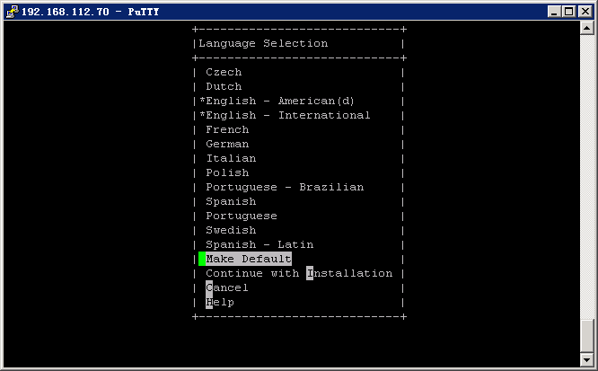

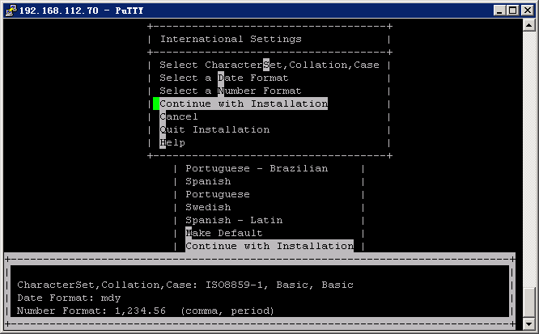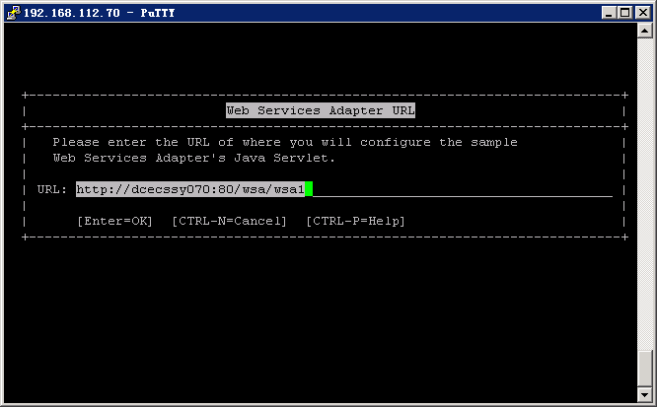

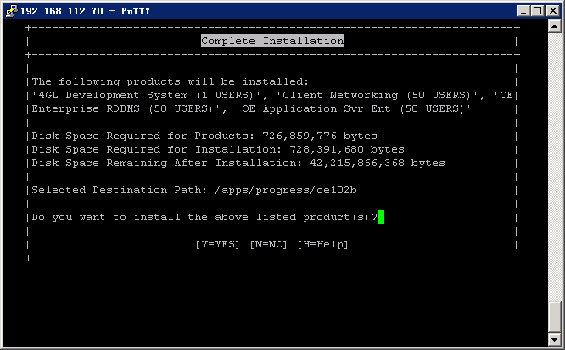

Install Progress CP936 for Chinese
Copy the chlang/sch into the $DLC/prolang:
Cd /qadapp/OE101B/dlc/prolang/sch/gb2312
root@dcecssy070:# cp /QAD/progress/chlang/sch/gb2312/* .

Install Progress 102B SP06
OE_102B_SP6
Enter Progress’s installation path.
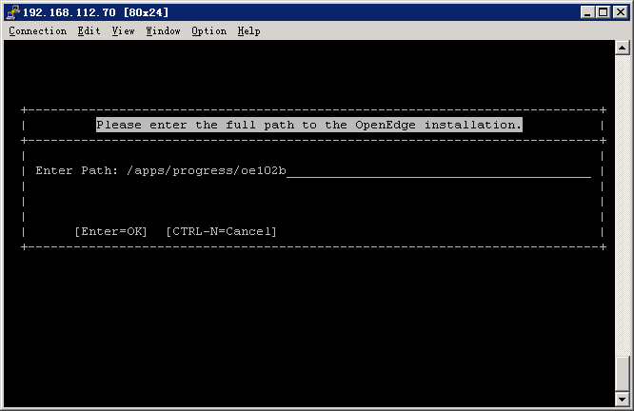
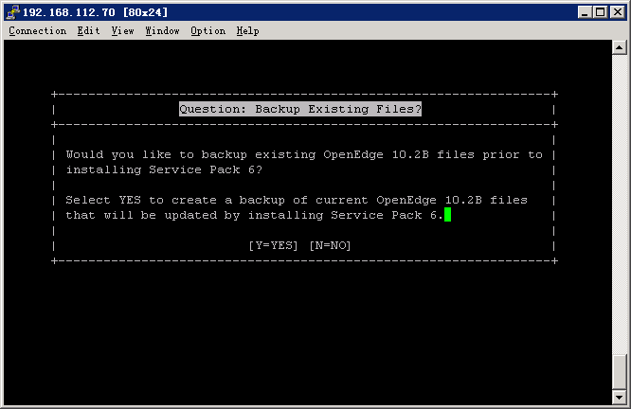

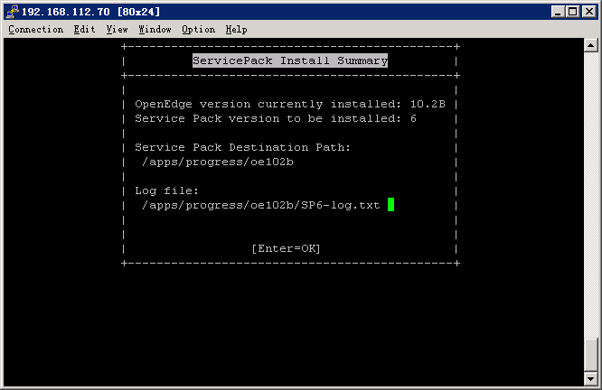

Set the Progress environment:

In /home/mfg/. profile
And /.profile
# Add for QAD installation 20120808
export PS1='$'
export JAVA_HOME=/usr/java5_64
export DLC=/apps/progress/oe102b
export PATH=$DLC/bin:$JAVA_HOME/bin:$PATH

Install Progress 102B SP06 (Chinese cp936) on Win32

Install Progress 102B
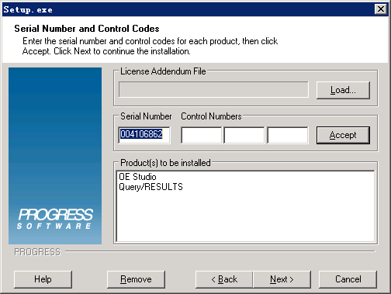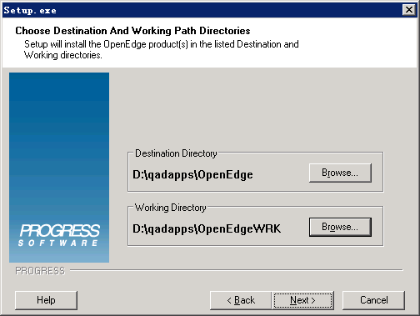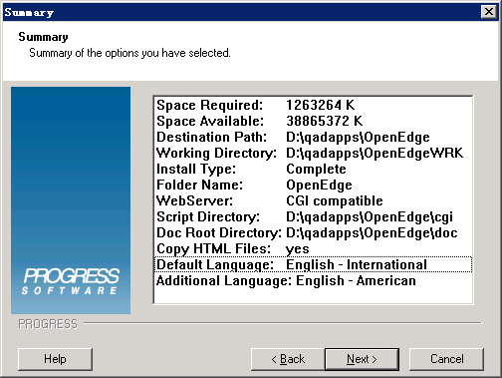

Install Progress 102B SP06

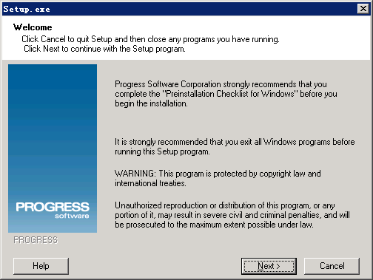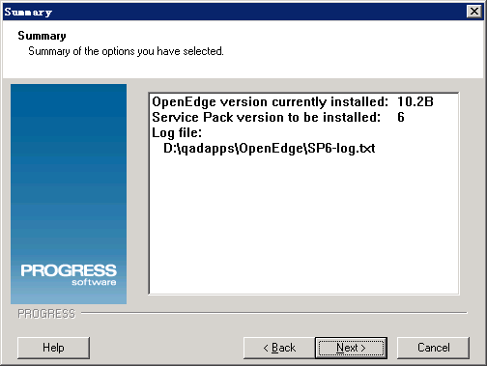

Install QAD2011 SE CHUI
Install use the mfg user

Install MFGPRO

DB Server

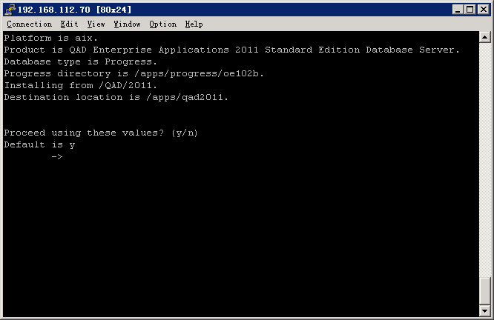

Language US

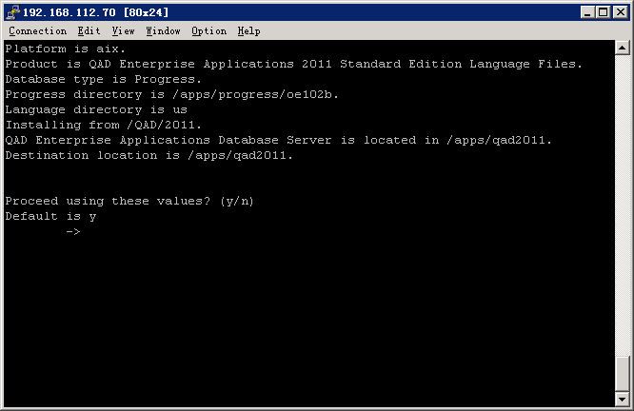

Language CH
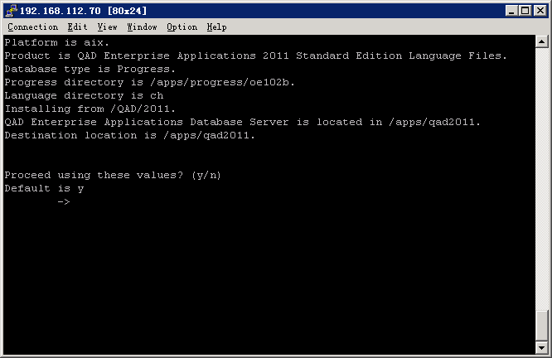

CHUI XRC
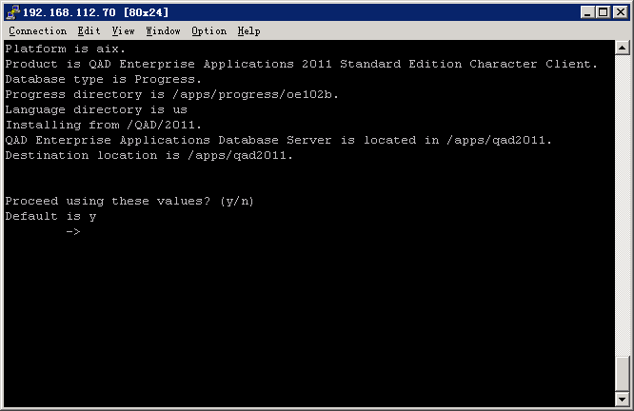

Setup MFGPRO

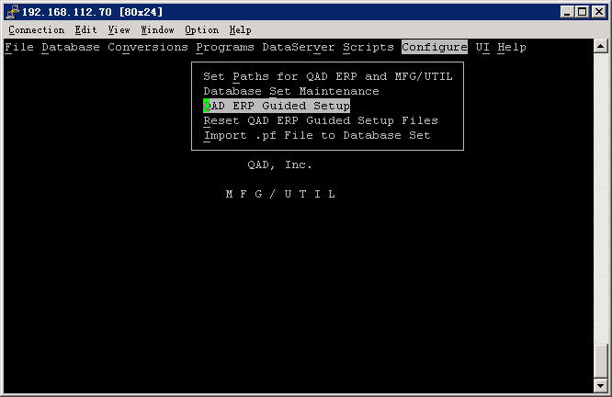
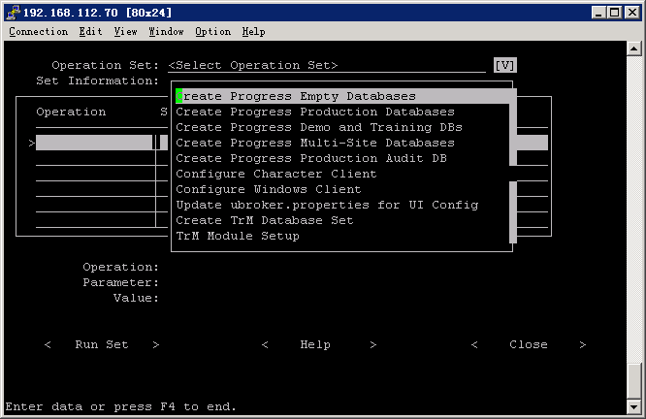

Truncate Database Before Image File(mfgempty,admempty,hlpempty,audempty)

Create Produciton
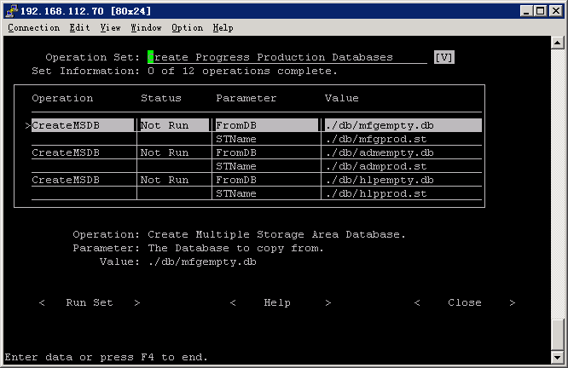

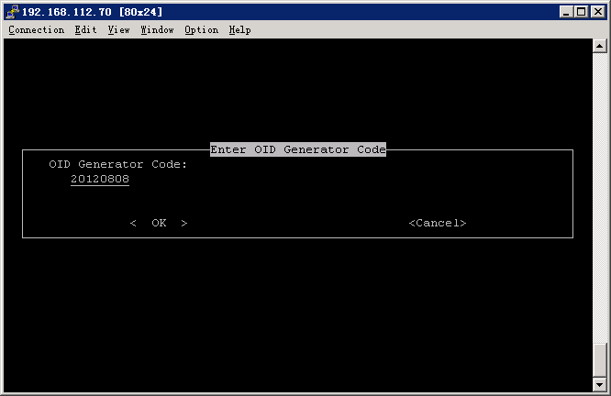

Load system data:
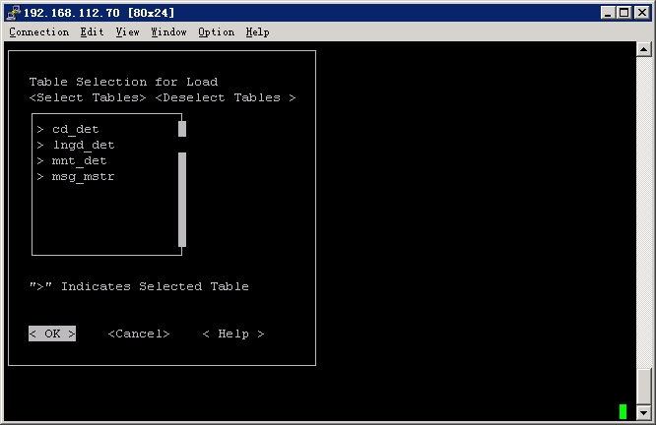
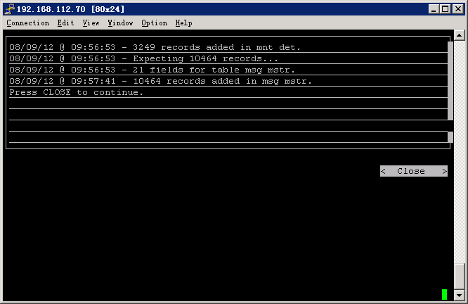

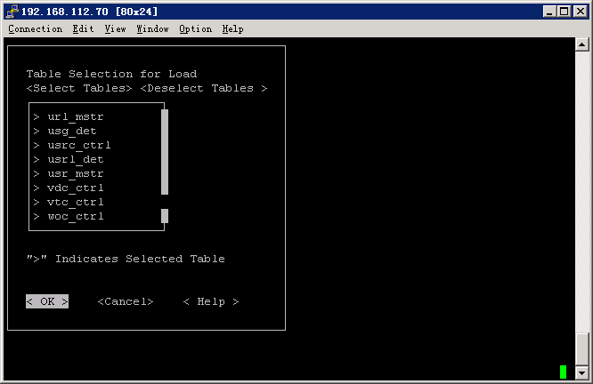

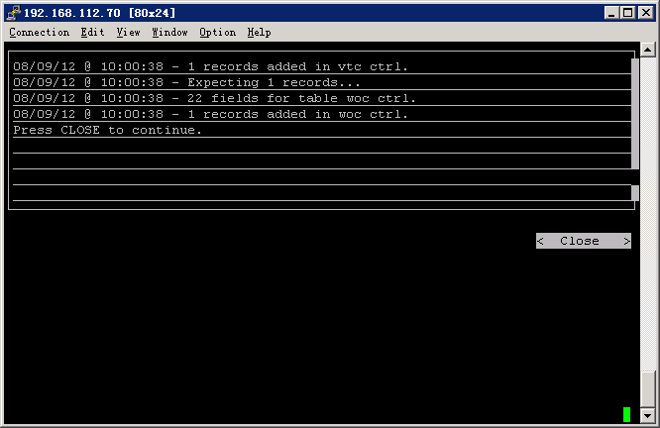

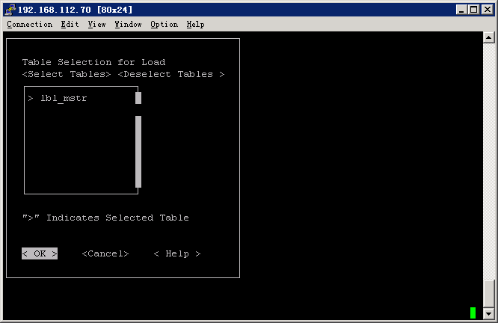

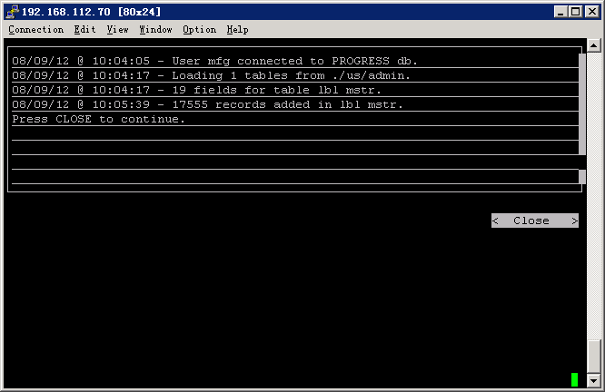
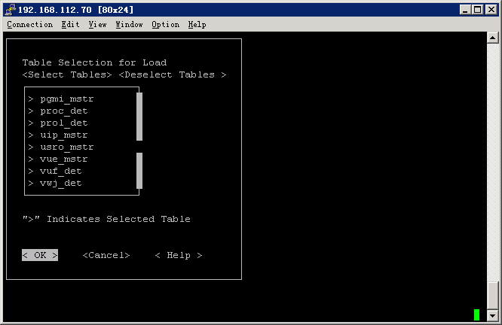

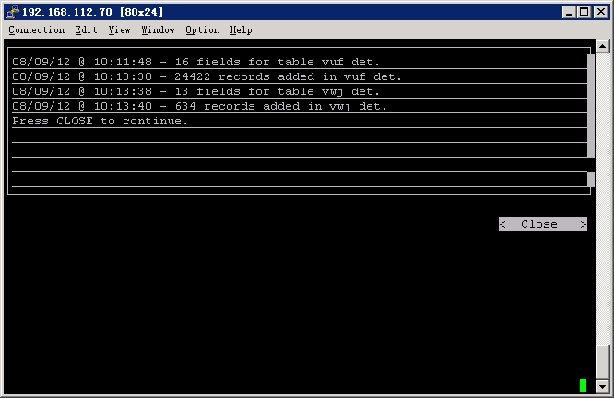

CHUI - Compile MFGPRO

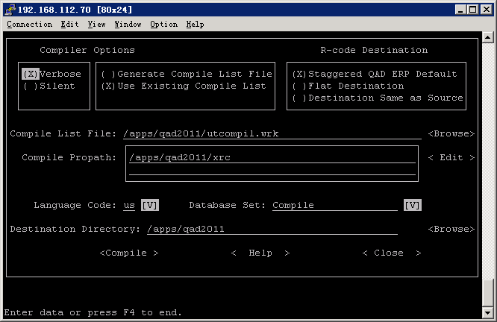
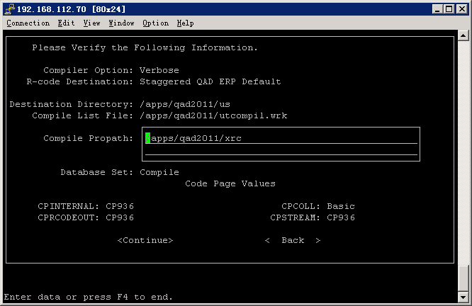

Also compile Chinese
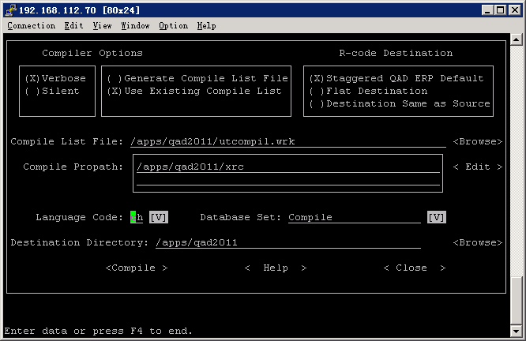

Create MFGPRO DB Sets

/data/* is of mfg:qad ownership

DB Set | Location | DBS | Service Name | Service Port
prod | /data/prod | mfgprod  admprod  hlpprod | mfgprod  admprod  hlpprod | 50001  50002  50003
test | /data/test | mfgtest  admtest  hlptest | mfgtest  admtest  hlptest | 50011  50012  50013
devl | /data/devl | mfgdevl  admdevl  hlpdevl | mfgdevl  admdevl  hlpdevl | 50021  50022  50023

Create Services for MFGPRO DB:

/etc/services:

#QAD 2011 SE Database

mfgprod 50001/tcp
admprod 50002/tcp
hlpprod 50003/tcp

mfgtest 50011/tcp
admtest 50012/tcp
hlptest 50013/tcp

mfgdevl 50021/tcp
admdevl 50022/tcp
hlpdevl 50023/tcp

Backup production restore to test
Backup demo restore to devl
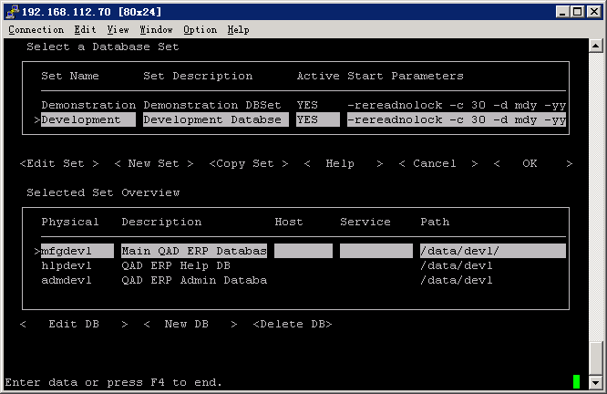

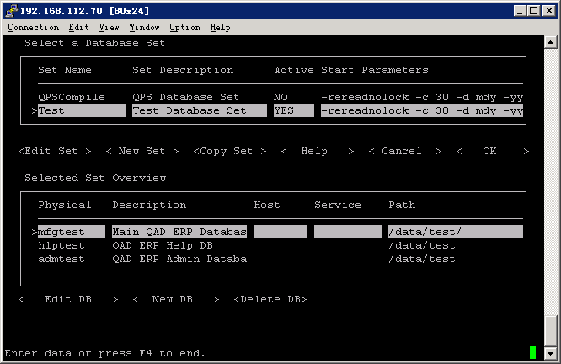

Generate Scripts
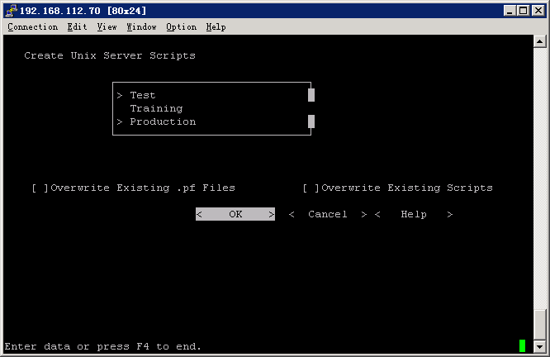

Login and data initialization
For each environment (Production(/Development), Test, Training)

Add License

Load Time Zone
36.16.22.13 Multiple Time Zone Load Utility

Sequence Initialization
36.16.17 Database Sequence Initialization

Load us and ch help
36.4.19 Field Help Load

Install CAS – Chinese Accounting System (2011SE CHUI)

Put the installation files:
Upload the CAS files to /apps/qad2011/cas

Load Schema and Data:
Load DB Schema into qaddb DB:
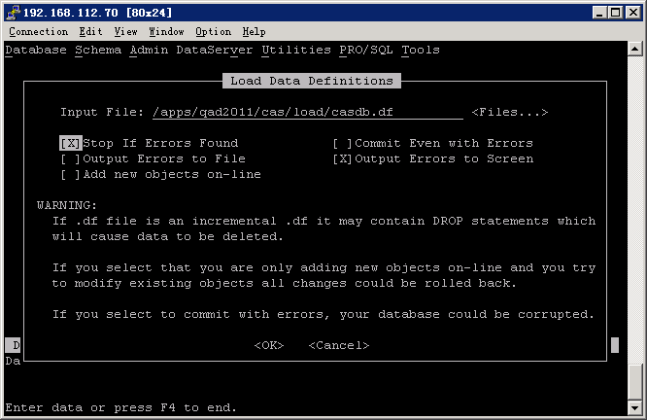

Load the CAS data into the qaddb DB:
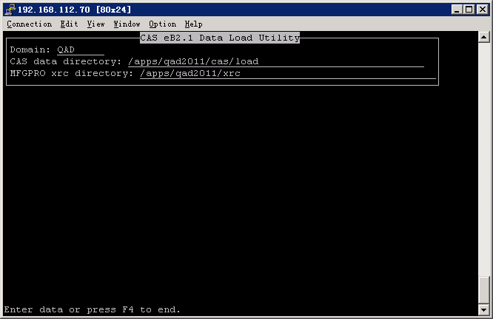

Compile Programs:
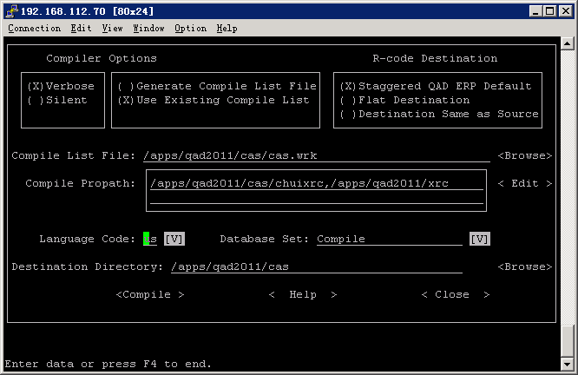

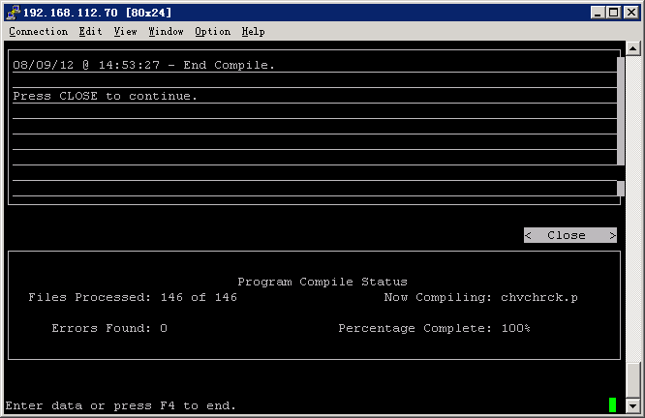

Propath:
.,/apps/qad2011/cas/chuixrc,/apps/qad2011/xrc,

The similar for Chinese Compilation.

Update Propath:

client.Production
client.Development
client.Test

Reset propath, add CAS :
PROPATH=.,/apps/qad2011/cas,/apps/qad2011,/apps/qad2011/bbi;export PROPATH

Configuration:

Enable CAS:
Go through 34.24 and ignore the errors and warnings. (Only after this can run 34.3.14 and 34.3.17)

Install .Net UI 2.9.4
Use mfg user to install
Installation File:
dotNET_UI_2.9.4.zip

Create Tomcat Folder

Use the mfg privilege:

root@dcecssy070:[/apps]mkdir tomcat
root@dcecssy070:[/apps]chown -R mfg:qad tomcat

Start DBs
Run: start.Production
start. Development
start.Test

Install Production:

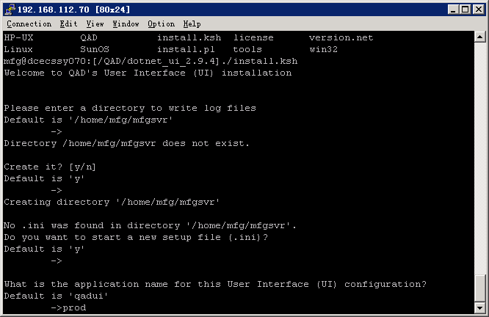

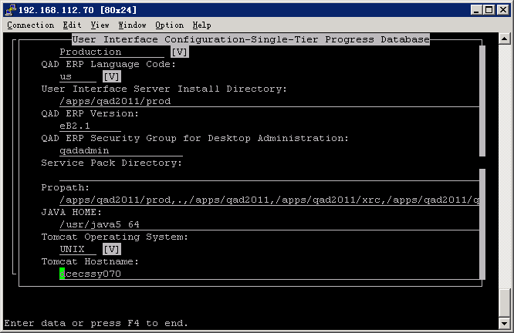
Propath:
/apps/qad2011/prod,.,/apps/qad2011,/apps/qad2011/xrc,/apps/qad2011/bbi,

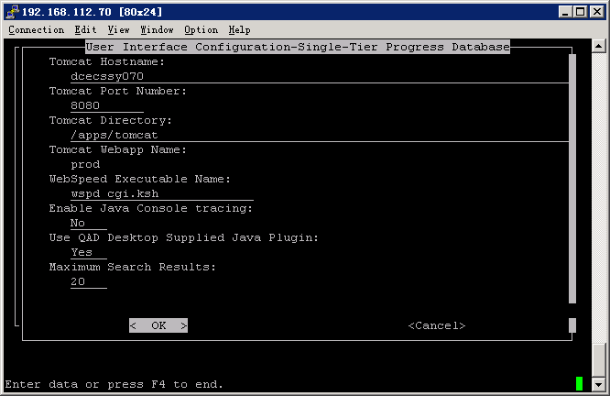

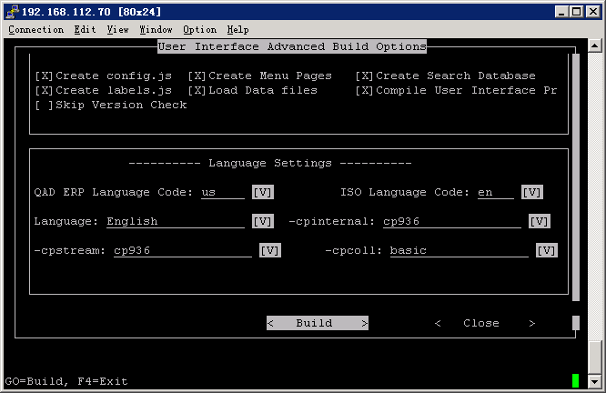

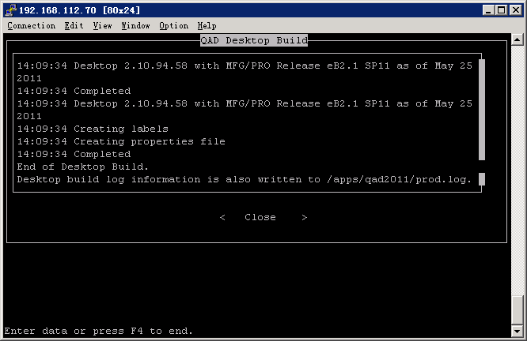

The similar for Chinese Build :
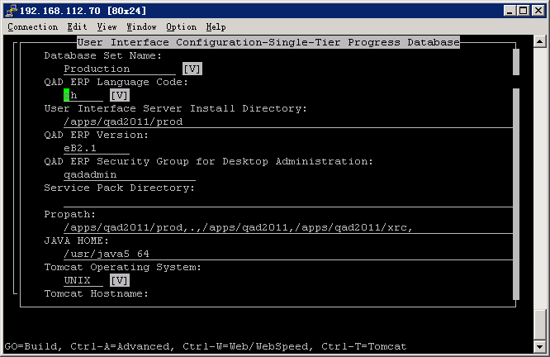
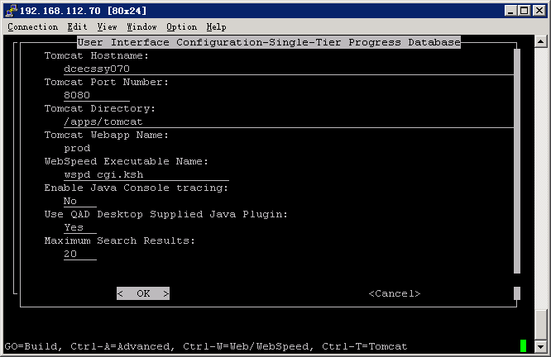

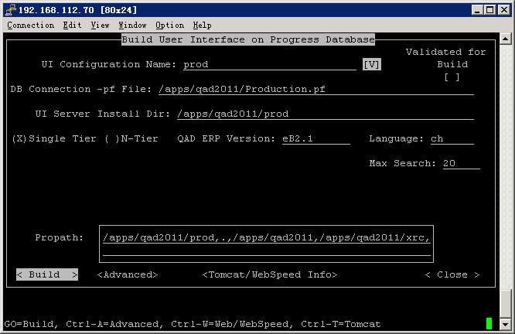

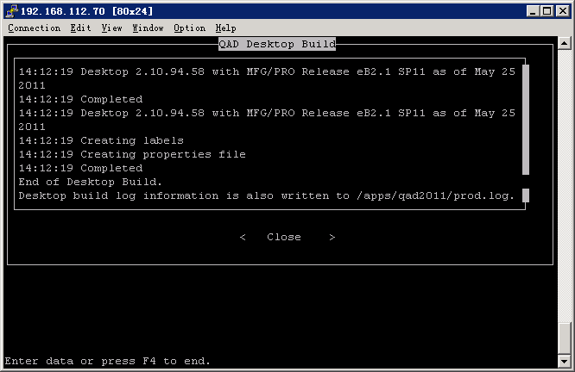
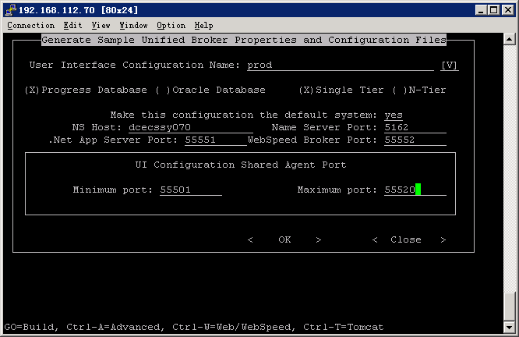

Add user “mfg” to group “qadadmin”

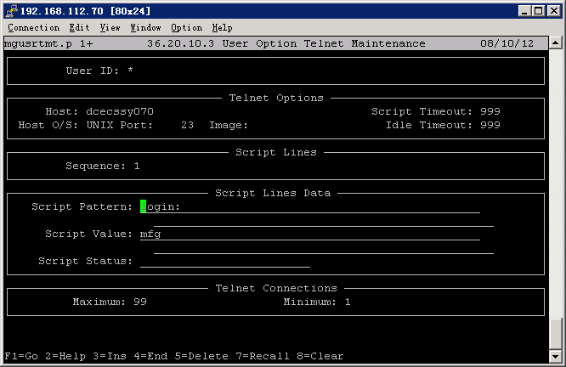

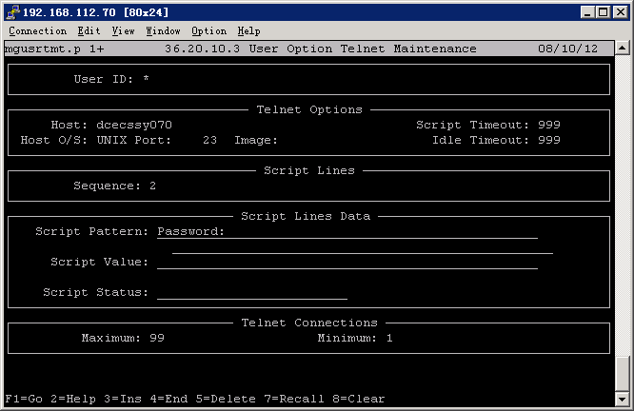

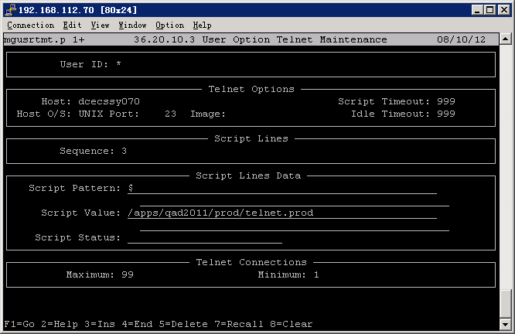

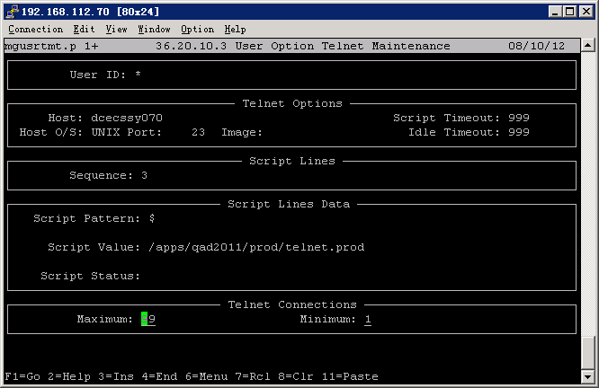

Start the services:
To avoid the service lost due to user logout terminal, add nohup to the start services:
nohup $DLC/bin/proadsv -start
nohup $DLC/bin/nsman -i NS1 -start
nohup $DLC/bin/wtbman -i prod_WS -start
nohup $DLC/bin/asbman -i prod_AS –start
nohup /apps/tomcat/bin/startup.sh

Install Test:
Just the similar as for Production

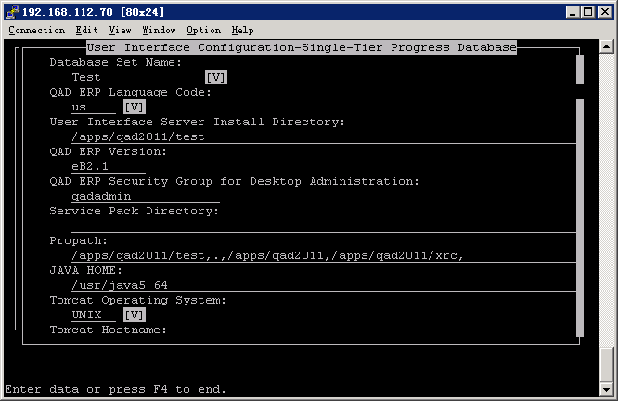
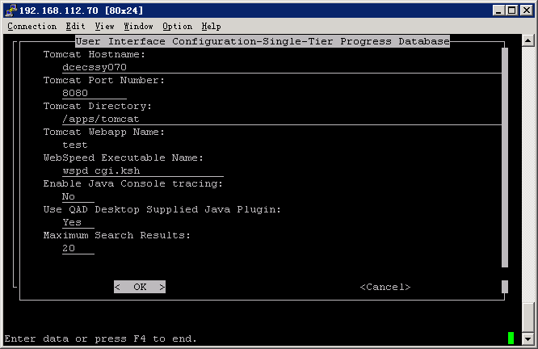

Propath:
/apps/qad2011/test,.,/apps/qad2011,/apps/qad2011/xrc,
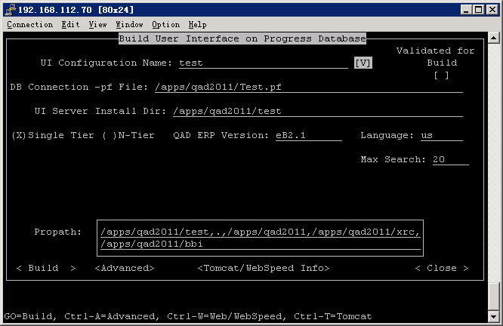

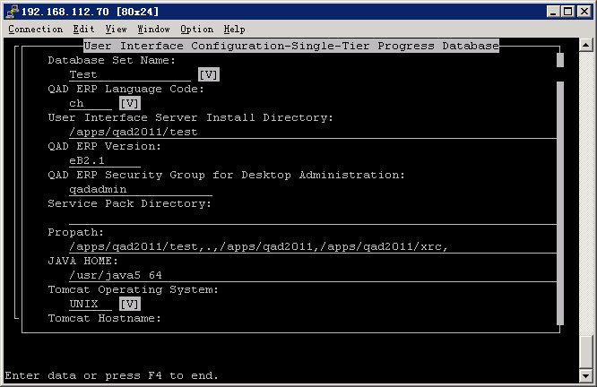
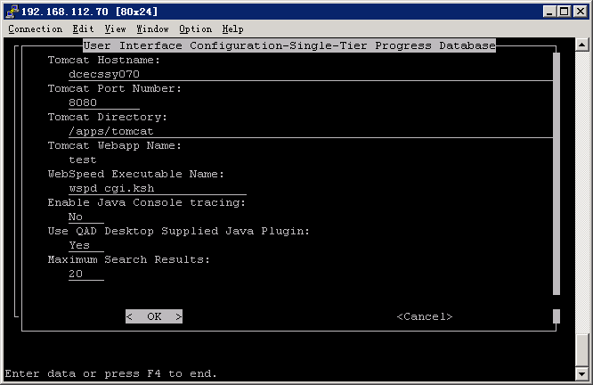
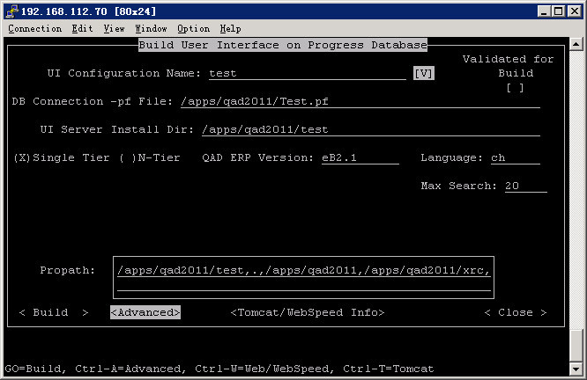

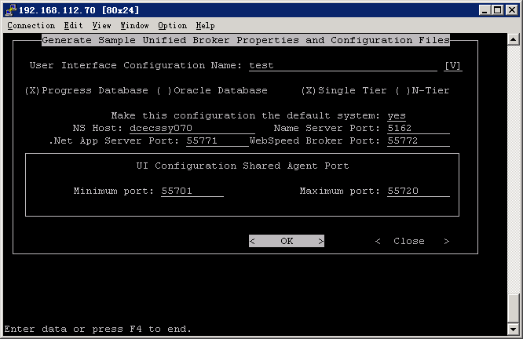

Setup user group qadadmin
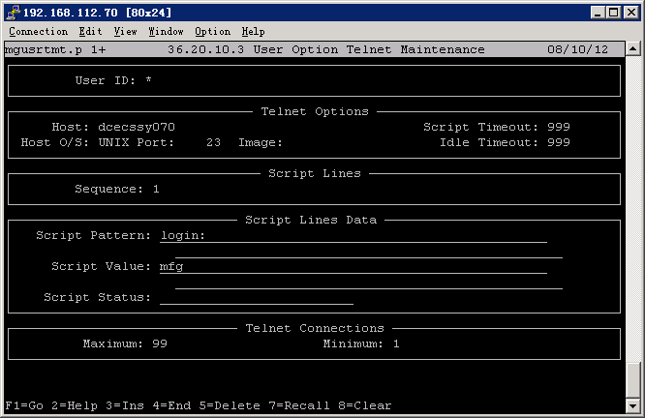
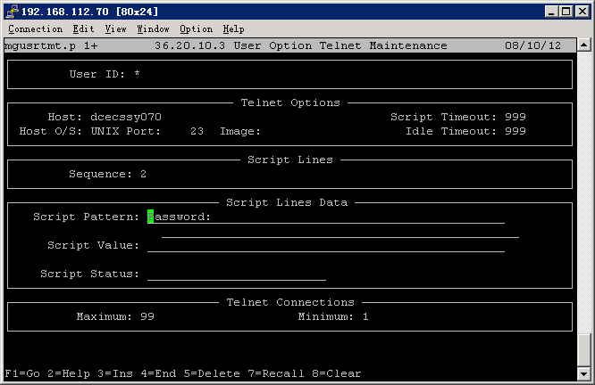
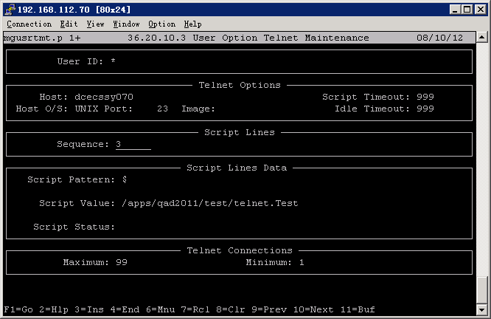

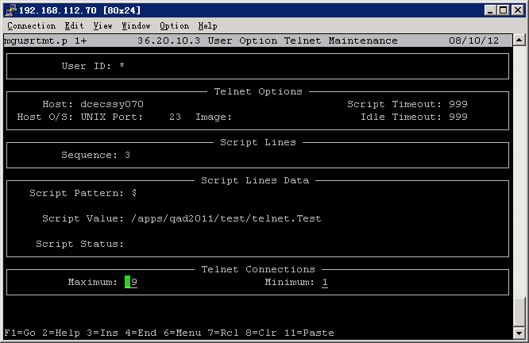

Start the services:
nohup $DLC/bin/wtbman -i test_WS -start
nohup $DLC/bin/asbman –I test_AS -start

Install Development:

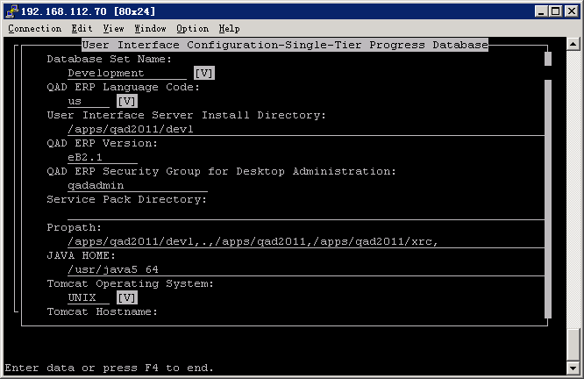

Propath:
/apps/qad2011/devl,.,/apps/qad2011,/apps/qad2011/xrc, 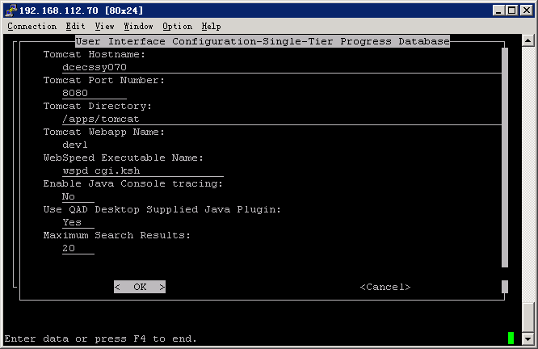
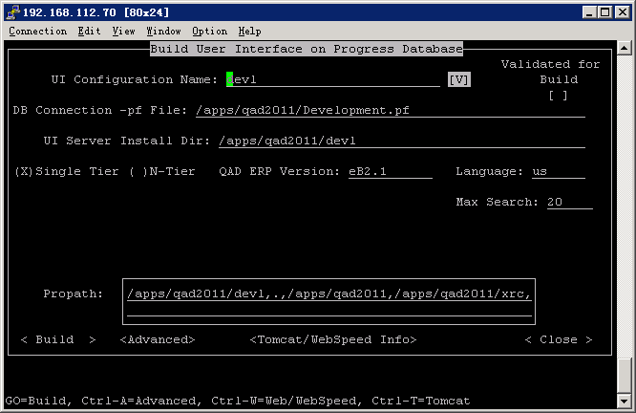

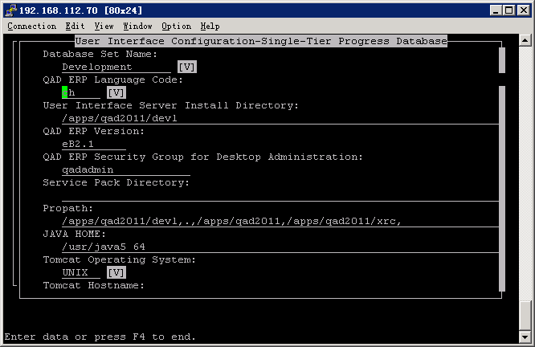
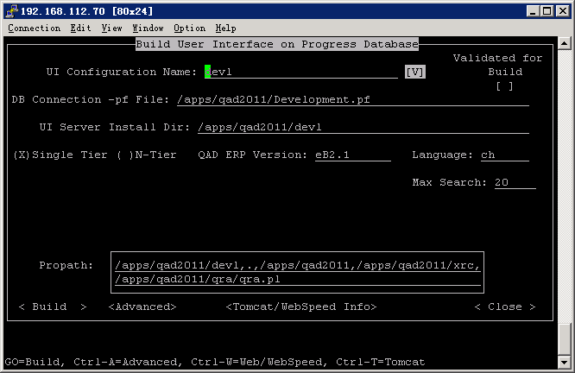

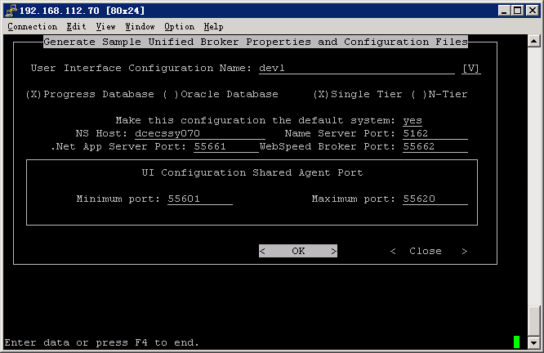

36.3.4 Setup user group qadadmin

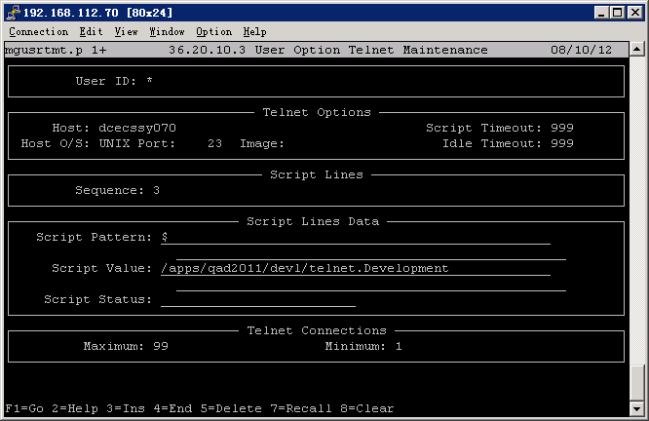
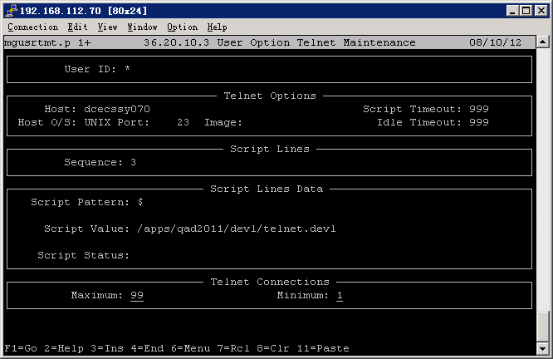

Start Services
nohup $DLC/bin/wtbman -i devl_WS -start
nohup $DLC/bin/asbman -i devl_AS -start

Install QAD2011 SE GUI

Install clinets:

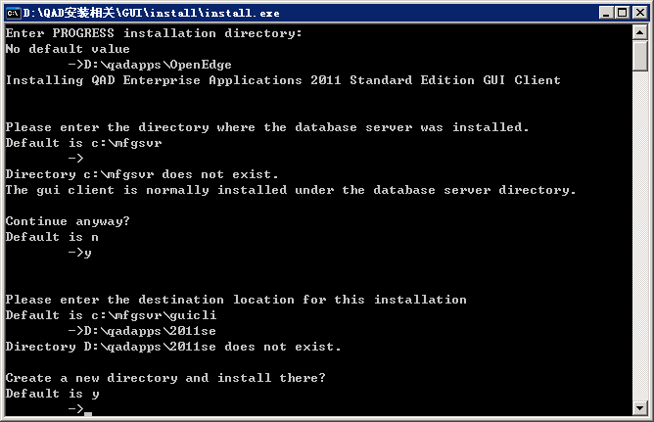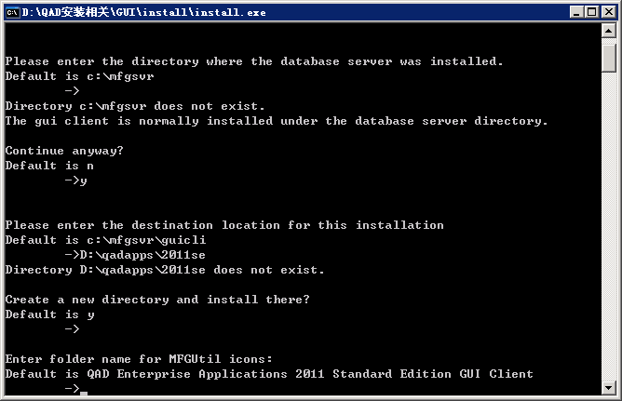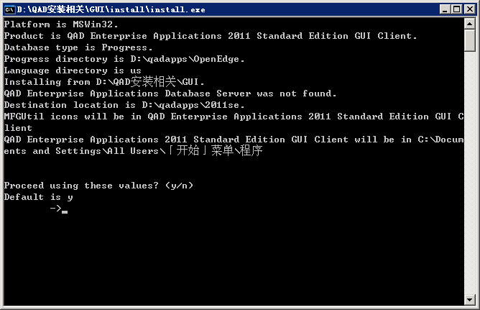

Compile Programs:

Compile programs for both Chinese and English languages
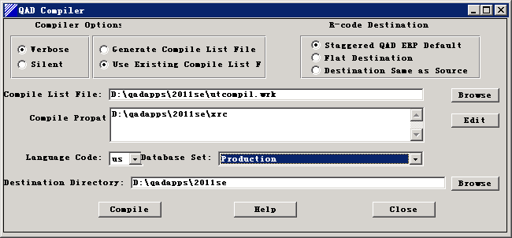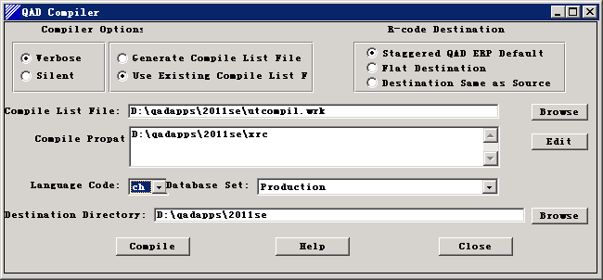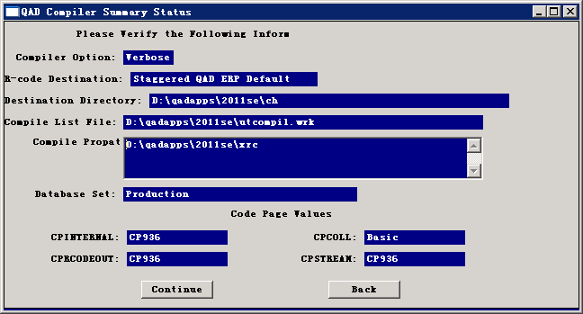

Generate Scriptst:

Create Database Set
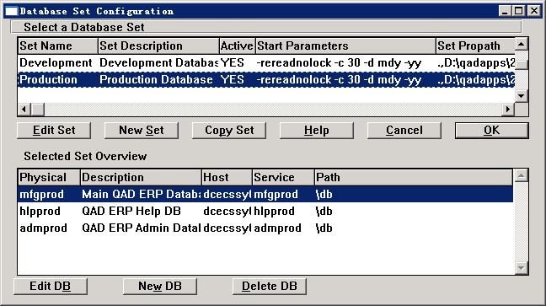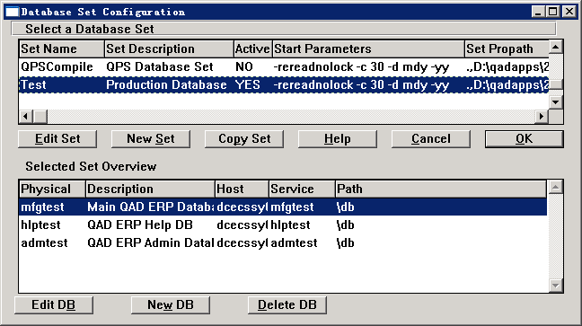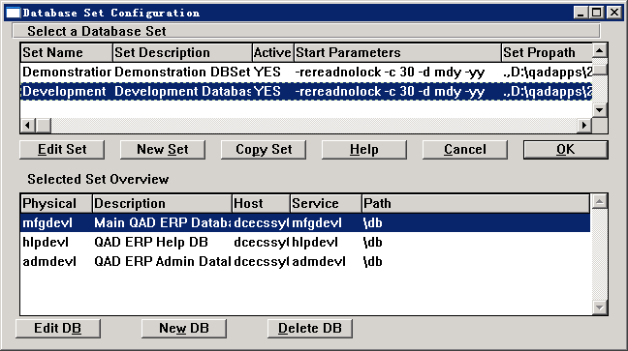
Generate Scripts
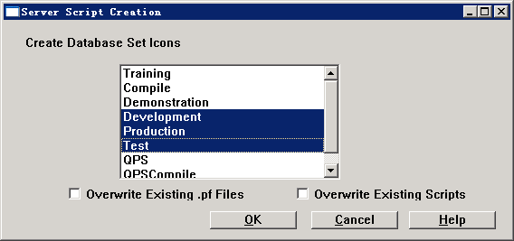

Install CAS – Chinese Accounting System (2011SE GUI)

Compile Programs:
Copy programs to D:\qadapps\2011se\cas
Compile programs for both Chinese and English languages.
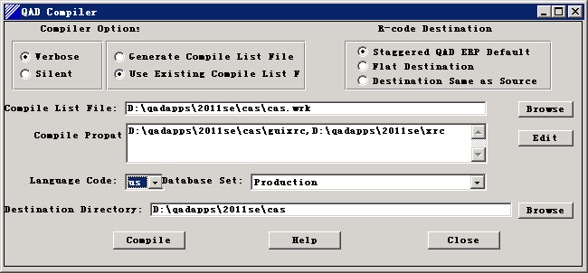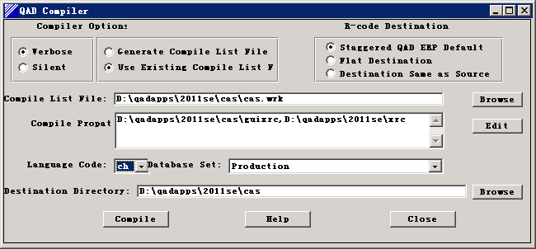
Edit the propath for the client scripts. Add “D:\qadapps\2011se\cas,”

Install ICT- (Integrated Customization Toolkits):

Modify Programs:
Make the following change in standard version of mf1.p:
/* QAD ICT - Integrated Customization Toolkit */
{icmf.i}
/* NOW CALL THE TRANSLATABLE PORTION OF THE (OLD) MF1.P */
{gprun1.i ""mf1a.p""}
PROCEDURE registerReasonMessage:
Make the following change in standard version of mfwb01a.p
/* QAD ICT - Integrated Customization Toolkit */
{icmf.i}
run set-session-formats in mfwb02handle()
(input global_userid).
/*Check license usage*/
{gprunp.i
"lvgenpl" "p"
"validateUserCountExceeded_HTML"
"(input 'MFG/PRO', output licenseMsgNum, output licenseMsgDesc)" }

Compile Programs:
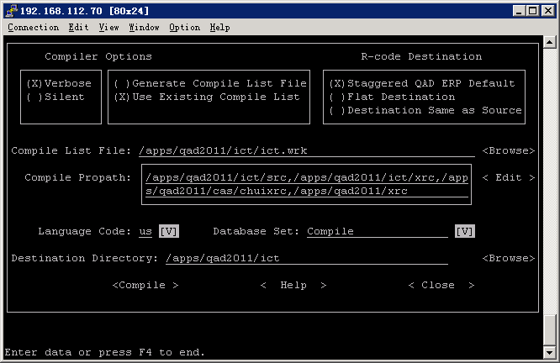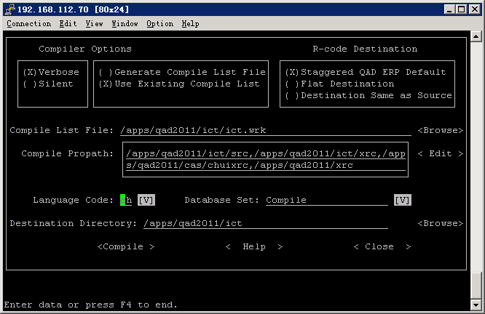

Load Data:
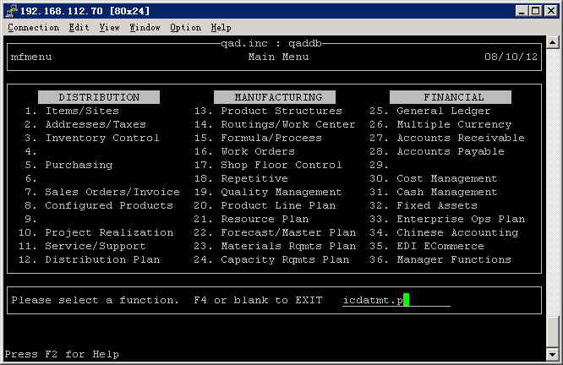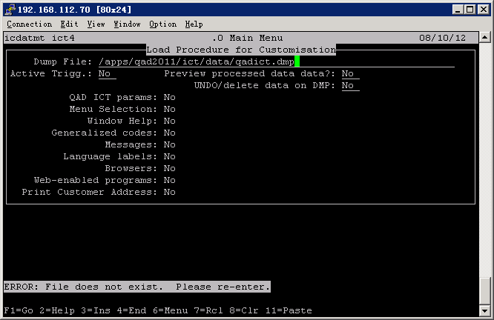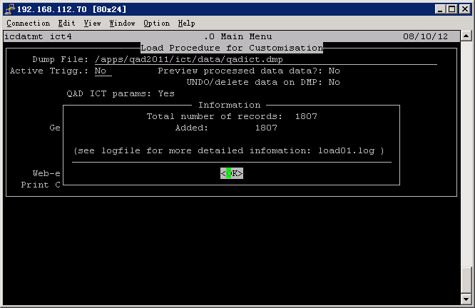
Apply License in 90.24.23
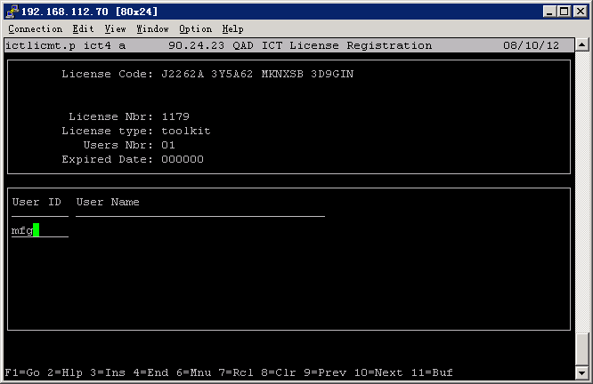
Modify propath of the client scripts, telnet scripts, connection manager scripts and ubroker.properties.
Add “/apps/qad2011se/ict” to the beginning of the propath..
Compiles programs for GUI
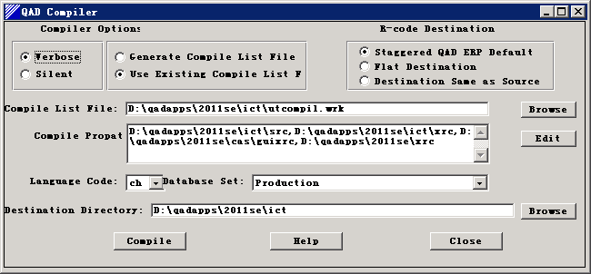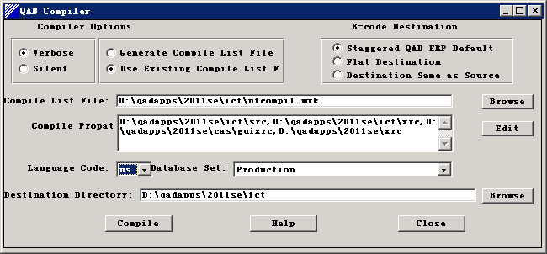

UI Launch:

CHUI Client Installation:

Use putty or telnet:

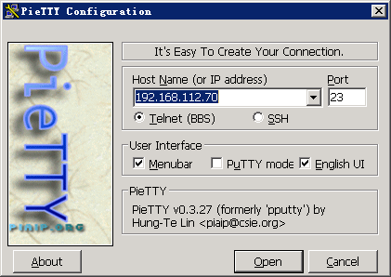
Login:
User: mfg
Password: mfgpro

Go to the QAD MFGPRO installation directory,
If the DB is not started, should start the DB first:
Run: start.Production
start. Development
start.Test
Then run the login the script
cd /apps/qad2011
./client.Production
./client.Test
./client.Development

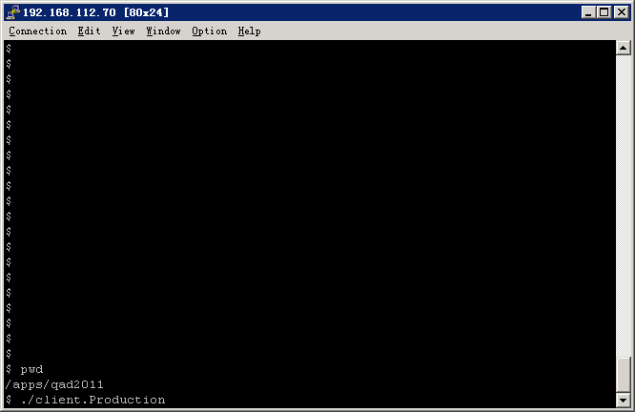
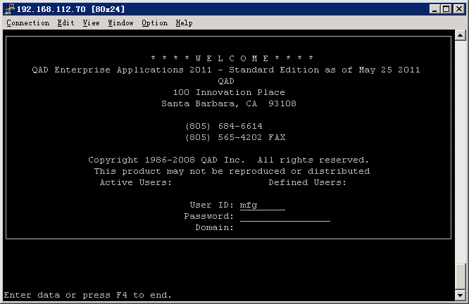
The login User ID = mfg, and Password is blank.

To shutdown the DB:

cd /apps/scripts
./stop.Production
./stop.Develop
./stop.Test

GUI Launch and Client Installation:
Run the scripts: D:\qadapps\2011se\ GUIclientProduction.bat
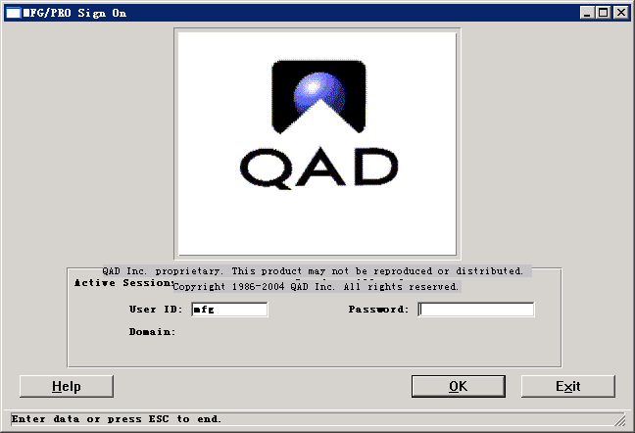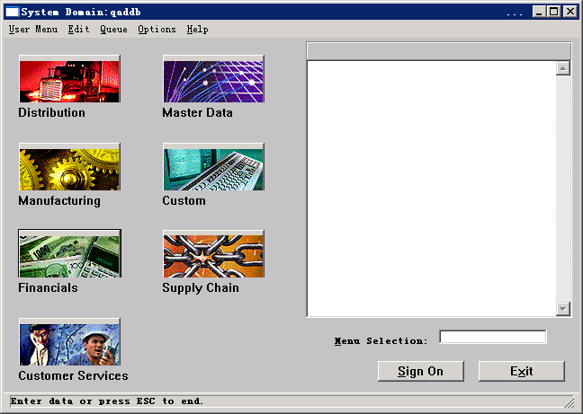

DotNET Launch and Client Installation:

Verify the following are add to the client machine:
C:\windows\system32\drivers\etc\hosts
192.168.112.70 dcecssy070 # DCEC QAD Server

Start the DB, and run the startNetUI: (This script is in /apps/scripts)

./startNetUI

In the Internet Explorer, type the following address:
http://dcecssy070:8080/qadhome

Auto install the client files:

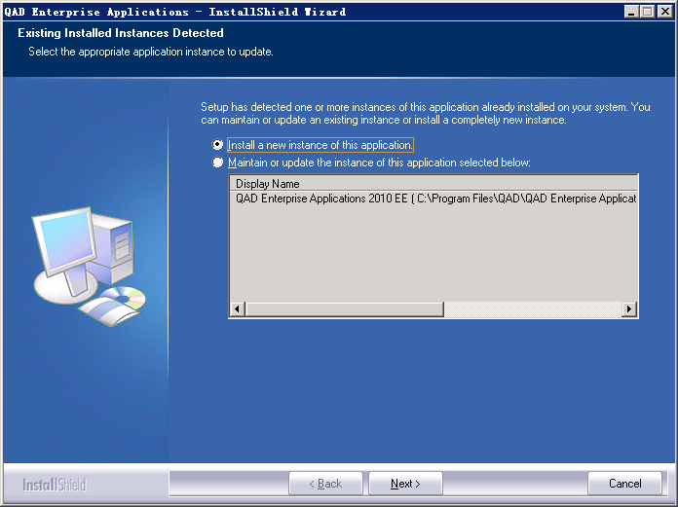

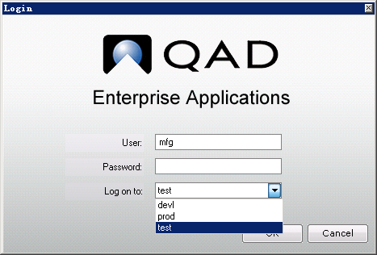
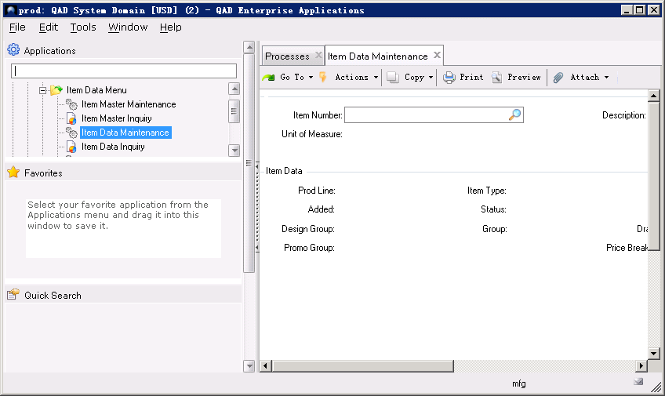

To Stop the DB, and run the stopNetUI: (This script is in /apps/scripts)

./stopNetUI

Tomcat Manager:

User: admin
Password: mfgpro

Scripts
DB scripts:
Path | Script
/apps/qad2011 | start.Production  stop.Production  client.Production  Production.pf
/apps/qad2011 | start.Development  stop.Development  client.Development  Development.pf
/apps/qad2011 | start.Test  stop.Test  client.Test  Test.pf

.Net scripts:
Path | Script
/apps/scripts/ | startNetUI
/apps/scripts/ | stopNetUI

Startup Sequences:
start.Production
start.Development
start.Test
startNetUI
Stop Sequences:
stop.Production
stop.Development
stop.Test
stopNetUI

Installation Summary
RESULT LIST
The validation of installation of QAD ERP MFG/PRO 2008SE are composed by several step and should be validated one by one as following with corresponding test steps and validation criteria. The executors and witness are indicated in above sections of Responsibility.

Items | Test Steps | Criteria | Actual Result
Pre- Installation Configuration | View & check parameters | Successfully prepared | Correct
PROGRESS 102B SP06 | View and check output | Successfully Installed | Good
MFG/PRO QAD2011SE (eB2.1sp4) | View and check output | Successfully Installed | Good
Chinese Accounting System (CAS) | View and check output | Successfully Installed | Good
CHUI Client | View and check output | Successfully Installed | Good
GUI Client | View and check output | Successfully Installed | Good
.Net UI Client | View and check output | Successfully Installed | Good
SCRIPTS | View and check output | Successfully finished | Correct

Summary:
The installation of QAD ERP MFG/PRO 2008SE is successful and the result of installation have been listed in detail as following tables:

DB Server:
dcecssy070
Product | Installation Path
JAVA 1.5 | /usr/java5_64 (Originally installed)
PROGRESS 10.2B SP06 | /apps/progress/oe102b
QAD 2011SE | /apps/qad2011
CAS (Chinese Accounting System) | /apps/qad2011/cas  D:\qadapps\2011se\cas
TOMCAT | /apps/tomcat
.Net UI | /apps/qad2011
GUI | D:\qadapps\2011se
ICT | /apps/qad2011/ict

DB Sets and Services:
DB Set | Location | DBS | Service Name | Service Port
prod | /data/prod | mfgprod  admprod  hlpprod | mfgprod  admprod  hlpprod | 50001  50002  50003
test | /data/test | mfgtest  admtest  hlptest | mfgtest  admtest  hlptest | 50011  50012  50013
devl | /data/devl | mfgdevl  admdevl  hlpdevl | mfgdevl  admdevl  hlpdevl | 50021  50022  50023

.Net UI Environment Info:

Environment | Service | Service Name | Port
 | Name Server | NS1 | 5162
Production | App Server | Production_AS | 55551
 | WebSpeed Server | Production_WS | 55552
 | Agent Port |  | 55501 ~ 55520
Development | App Server | Development_AS | 55661
 | WebSpeed Server | Development_WS | 55662
 | Agent Port |  | 55601 ~ 55620
Test | App Server | Test_AS | 55771
 | WebSpeed Server | Test_WS | 55772
 | Agent Port |  | 55701 ~ 55720

Database Backup and Restore:
Backup
cd [src_dbpath]
$DLC/bin/probkup [src_dbname] [dst_dbname]
For example: $DLC/bin/probkup mfgprod /home/mfg/bk/mfgprod

Restore
For example:
#cd /data/test
#cp /home/mfg/bk/*test .
#$DLC/bin/prorest mfgtest .

cd [rest_path]
cp [bkup_file] .
$DLC/bin/prorest [bkup_file] .

Installed application and DB are backed up on HP Storage:

Application Backup | DB Backup
/apps/backup | /data/backup

.Net UI Status Check:

Check Progress Name Server:
$DLC/bin/nsman -i NS1 -q

If all the Progress services are correct, system will return:
$$DLC/bin/nsman -i NS1 -q
OpenEdge Release 10.2B06 as of Mon Mar 19 19:14:53 EDT 2012

Connecting to Progress AdminServer using rmi://localhost:20931/Chimera (8280)
Searching for NS1 (8288)
Connecting to NS1 (8276)

NameServer NS1 running on Host dcecssy070 Port 5162 Timeout 30 seconds.
Application Service UUID Name Host Port Weight Timeout

WS.devl_WS
86fe5f58ac9174e1:640d6979:1390a4a2eb8:-8000 WS.devl_WS dcecssy0 70/192.168.112.70 55662 0 30

WS.test_WS
86fe5f58ac9174e1:-7024e9bc:1390a4ca09c:-8000 WS.test_WS dcecssy0 70/192.168.112.70 55772 0 30

WS.prod_WS
86fe5f58ac9174e1:-4be1e7b2:1390a1c8de2:-8000 WS.prod_WS dcecssy0 70/192.168.112.70 55552 0 30

AS.devl_AS
86fe5f58ac9174e1:5b9cf4ed:1390a4a3148:-8000 AS.devl_AS dcecssy0 70/192.168.112.70 55661 0 30

AS.test_AS
86fe5f58ac9174e1:-1bd1f913:1390a4ca33b:-8000 AS.test_AS dcecssy0 70/192.168.112.70 55771 0 30

AS.prod_AS
86fe5f58ac9174e1:-66fd3182:1390a1c9084:-8000 AS.prod_AS dcecssy0 70/192.168.112.70 55551 0 30

Notes:
Note:

