Computer Organization and Architecture
Course Design

The Experiment Report

Of

CPU

I . Purpose
The purpose of this project is to design a simple CPU (Central Processing Unit). This CPU has basic instruction set, and we will utilize its instruction set to generate a very simple program to verify its performance. For simplicity, we will only consider the relationship among the CPU, registers, memory and instruction set. That is to say we only need consider the following items: Read/Write Registers, Read/Write Memory and Execute the instructions.
At least four parts constitute a simple CPU: the control unit, the internal registers, the ALU and instruction set, which are the main aspects of our project design and will be studied.
II . Instruction Set
Single-address instruction format is used in our simple CPU design. The instruction word contains two sections: the operation code (opcode), which defines the function of instructions (addition, subtraction, logic operations, etc.); the address part, in most instructions, the address part contains the memory location of the datum to be operated, we called it direct addressing. In some instructions, the address part is the operand, which is called immediate addressing.
For simplicity, the size of memory is 256× 16 in the computer. The instruction word has 16 bits. The opcode part has 8 bits and address part has 8 bits. The instruction word format can be expressed in Figure 1:
OPCODE  [15..8] | ADDRESS  [7..0]
Figure 1 the instruction format
The opcode of the relevant instructions are listed in Table 1.
In Table 1, the notation [x] represents the contents of the location x in the memory. For example, the instruction word 00000011101110012 (03B916) means that the CPU adds word at location B916 in memory into the accumulator (ACC); the instruction word 00000101000001112 (050716) means if the sign bit of the ACC (ACC [15]) is 0, the CPU will use the address part of the instruction as the address of next instruction, if the sign bit is 1, the CPU will increase the program counter (PC) and use its content as the address of the next instruction.
Table 1 List of opcode of the relevant instructions
INSTRUCTION | OPCODE | COMMENTS
STORE X | 01H | ACC→[X]
LOAD X | 02H | [X]→ACC
ADD X | 03H | ACC+[X]→ACC
SUB X | 04H | ACC-[X]→ACC
JMPGZ X | 05H | IF ACC>0 THEN X→PC ELSE PC+1→PC
AND X | 06H | ACC and [X]→ACC
OR X | 07H | ACC or [X]→ACC
NOT X | 08H | Not [X]→ACC
SHIFTR X | 09H | SHIFL ACC to RIGHT 1 bit, Logic Shift
SHIFTL X | 0AH | SHIFT ACC to LEFT 1 bit, Logic Shift
MPY X | 0BH | ACC×[X]→ACC
HALT | 0CH | HALT A PROGRAM
A program is designed to test these instructions:
Calculate the sum of all integers from 1 to 100.
(1), programming with C language:
sum=0;
temp=100;
loop :sum=sum+temp;
temp=temp-1;
if temp>=0 goto loop;
end
(2), Assume in the RAM_DQ:
sum is stored at location A4,
temp is stored at location A3,
the contents of location A0 is 0,
the contents of location A1 is 1,
the contents of location A2 is 10010=6416.
We can translate the above C language program with the instructions listed in Table 1 into the instruction program as shown in Table 2.

Table 2 Example of a program to sum from 1 to 100
Program with C | Program with  instructions | Contents of RAM_DQ in HEX
Program with C | Program with  instructions | Address | Contents
sum=0; | LOAD A0 | 00 | 02A0
sum=0; | STORE A4 | 01 | 01A4
temp=100 | LOAD A2 | 02 | 02A2
temp=100 | STORE A3 | 03 | 01A3
loop:sum=sum+temp; | LOOP:LOAD A4 | 04 | 02A4
loop:sum=sum+temp; | ADD A3 | 05 | 03A3
loop:sum=sum+temp; | STORE A4 | 06 | 01A4
temp=temp-1; | LOAD A3 | 07 | 02A3
temp=temp-1; | SUB A1 | 08 | 04A1
temp=temp-1; | STORE A3 | 09 | 01A3
if temp>0 goto loop; | JMPGZ LOOP | 0A | 0504
end; | HALT | 0B | 0C00
 |  | 0C
 |  | … | …
 |  | A0 | 0000
 |  | A1 | 0001
 |  | A2 | 0064
 |  | A3
 |  | A4
 |  | … | …

III. Internal Registers and Memory
MAR (Memory Address Register)
MAR contains the memory location of the word to be read from the memory or written into the memory. Here, READ operation is denoted as the CPU reads from memory, and WRITE operation is denoted as the CPU writes to memory. In our design, MAR has 8 bits to access one of 256 addresses of the memory.

MBR (Memory Buffer Register)
MBR contains the value to be stored in memory or the last value read from memory. MBR is connected to the address lines of the system bus. In our design, MBR has 16 Bits.

PC (Program Counter)
PC keeps track of the instructions to be used in the program. In our design, PC has 8 bits.

IR (Instruction Register)
IR contains the opcode part of an instruction. In our design, IR has 8 bits.

BR (Buffer Register)
BR is used as an input of ALU, it holds other operand for ALU. In our design, BR has
16 bits.

LPM_RAM_DQ
LPM_RAM_DQ is a RAM with separate input and output ports. It works as a memory, and its size is 256×16. Although it’s not an internal register of CPU, we need it to simulate and test the performance of CPU.

LPM_ROM
LPM_ROM is a ROM with one address input port and one data output port, and its size of data is 32bits which contains control signals to execute micro-operations.

IV.ALU
ALU (Arithmetic Logic Unit) is a calculation unit which accomplishes basic arithmetic and logic operations. In our design, some operations must be supported which are listed as follows:
Table 3 ALU Operations
ALU control signal | Operations | Explanations
3H | ADD | ACC←ACC+BR
4H | SUB | ACC←ACC- BR
6H | AND | ACC←ACC and BR
7H | OR | ACC←ACC or BR
8H | NOT | ACC←not ACC
9H | SHIFTR | ACC←Shift ACC to Right 1 bit
0AH | SHIFTL | ACC←Shift ACC to Left 1 bit
V. Micro-programmed Control Unit
In the Microprogrammed control, the microprogram consists of some microinstruction and the microprogram is stored in control memory that generates all the control signals required to execute the instruction set correctly. The microinstruction contains some micro-operations which are executed at the same time.
Figure 2 shows the key elements of such an implementation.
The set of microinstructions is stored in the control memory. The control address register contains the address of the next microinstructions to be read. When a microinstruction is read from the control memory, it is transferred to a control buffer register. The register connects to the control lines emanating from the control unit. Thus, reading a microinstruction from the control memory is the same as executing that microinstruction. The third element shown in the figure is a sequencing unit that loads the control address register and issues a read command.
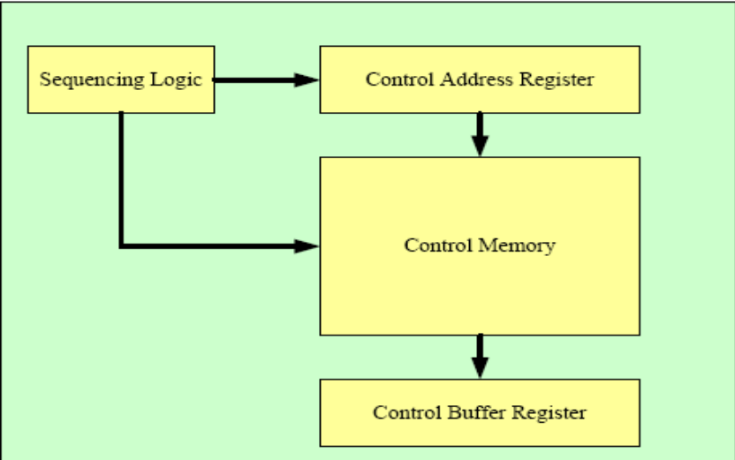
Figure 2 Control Unit Micro-architecture
(I)Total control signals for instructions are listed as follows:
Table 4 Control signals for the micro-operations
Bits in Control Memory | Micro-operation | Meaning
C0~C7 | / | Branch Addresses
C8 | PC←0 | Clear PC
C9 | PC←PC+1 | Increment PC
C10 | PC←MBR[7..0] | MBR[7..0] to PC
C11 | ACC←0 | Clear ACC
C12--C15 | ALU CONTROL | Control operations of ALU
C16 | R | Read data from Memory to MBR
C17 | W | Write data to Memory
C18 | MAR←MBR[7..0] | MBR[7..0] to MAR as address
C19 | MAR←PC | PC value to MAR
C20 | MBR←ACC | ACC value to MBR
C21 | IR←MBR[15..8] | MBR[15..8] to IR as opcode
C22 | BR←MBR | Copy MBR to BR
C23 | CAR←CAR+1 | Increment CAR
C24 | CAR←C0~C7 | C7~C0 to CAR
C25 | CAR←OPCODE+CAR | Add OP to CAR
C26 | CAR←0 | Reset CAR
C27--C31 | Not use | -----------
(II)The contents in rom.mif and the corresponding microprograms are listed as follows:
0 : 00810000; R←1, CAR←CAR+1
1 : 00A00000; OP←MBR[15..8],CAR←CAR+1
2 : 02000000; CAR←CAR+OP
3 : 01000014; CAR←14H
4 : 01000019; CAR←19H
5 : 0100001E; CAR←1EH
6 : 01000023; CAR←23H
7 : 01000041; CAR←41H
8 : 01000028; CAR←28H
9 : 0100002D; CAR←2DH
a : 01000032; CAR←32H
b : 01000037; CAR←37H
c : 0100003C; CAR←3CH
d : 01000046; CAR←46H
e : 0100004B; CAR←4BH
f : 00000000;
… ……
14 : 00840000; MAR←MBR[7..0], CAR←CAR+1 ------STORE
15 : 00920200; MBR←ACC, PC←PC+1,W←1,CAR←CAR+1
16 : 04080000; CAR←0, MAR←PC
17 : 00000000;
18 : 00000000;
19 : 00840000; MAR←MBR[7..0], CAR←CAR+1 ------LOAD
1a : 00810A00; PC←PC+1,R←1,ACC←0,CAR←CAR+1
1b : 00C03000; BR←MBR,ACC←ACC+BR, CAR←CAR+1
1c : 04080000; CAR←0
1d : 00000000;
1e : 00840000; MAR←MBR[7..0], CAR←CAR+1 ----------ADD
1f : 00810200; PC←PC+1,R←1,CAR←CAR+1
20 : 00C03000; BR←MBR,ACC←ACC+BR, CAR←CAR+1
21 : 04080000; CAR←0
22 : 00000000;
23 : 00840000; MAR←MBR[7..0], CAR←CAR+1 ----------SUB
24 : 00810200; PC←PC+1,R←1,CAR←CAR+1
25 : 00C04000; BR←MBR,ACC←ACC-BR, CAR←CAR+1
26 : 04080000; CAR←0
27 : 00000000;
28 : 00840000; MAR←MBR[7..0], CAR←CAR+1 ---------AND
29 : 00810200; PC←PC+1,R←1,CAR←CAR+1
2a : 00C06000; BR←MBR,ACC←ACC AND BR,CAR←CAR+1
2b : 04080000; CAR←0
2c : 00000000;
2d : 00840000; MAR←MBR[7..0], CAR←CAR+1 ---------OR
2e : 00810200; PC←PC+1,R←1,CAR←CAR+1
2f : 00C07000; BR←MBR,ACC←ACC OR BR, CAR←CAR+1
30 : 04080000; CAR←0
31 : 00000000;
32 : 00840000; MAR←MBR[7..0], CAR←CAR+1 ----------NOT
33 : 00808200; PC←PC+1, ACC←NOT ACC,CAR←CAR+1
34 : 04080000; CAR←0
35 : 00000000;
36 : 00000000;
37 : 00840000; MAR←MBR[7..0], CAR←CAR+1 ----------SHIFTR
38 : 08009200; PC←PC+1, ACC←SHIFT ACC to Right 1 bit,CAR←CAR+1
39 : 04080000; CAR←0
3a : 00000000;
3b : 00000000;
3c : 00840000; MAR←MBR[7..0], CAR←CAR+1 -----------SHIFTL
3d : 0080A200; PC←PC+1, ACC←SHIFT ACC to Left 1 bit,CAR←CAR+1
3e : 04080000; CAR←0
3f : 00000000;
40 : 00000000;
41 : 00840000; MAR←MBR[7..0], CAR←CAR+1 -----------JMPGEZ
42 : 00805000; CAR←CAR+1,(if ACC>0 then PCjmp<='1', PCout<=MBR_PC)
43 : 04080000; CAR←0
44 : 00000000;
45 : 00000000;
46 : 00840000; MAR←MBR[7..0], CAR←CAR+1 ------------MPY
47 : 00810200; PC←PC+1,R←1,CAR←CAR+1
48 : 00C0B000; BR←MBR,ACC←ACC*BR, CAR←CAR+1
49 : 04080000; CAR←0
4a : 00000000;
4b : 0100004B; CAR←4BH ------------------------------HALT
4c : 00000000;
(IIa) CPU电路图

(III)The simulation waveforms of some operates
1, load, add, store, halt (22+10)
The contents in RAM:
0 : 022A; Load 2A
1 : 032B; ADD 2B
2 : 012C; Store 2C
3 : 0C00; Halt
2a : 0016;
2b : 000A;
The content in RAM addressed of 2b is 0020(H).
The waveform of the operate:
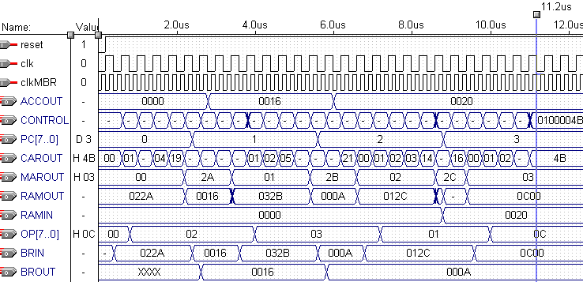
程序1波形图及逐条指令、逐个阶段、逐个操作、逐个部件逐个数据变化的对应关系分析，数据运算过程分析。
详细分析可任选一条指令为例，必须结合测试波形、电路图、代码、指令系统设计具体说明，标注控制信号，地址，数据等信息的每一次流动、变化。
（必做）

2, load, SUB, store, halt (22-10)
The contents in RAM:
0 : 022A; Load 2A
1 : 042B; SUB 2B
2 : 012C; Store 2C
3 : 0C00; Halt
2a : 0016;
2b : 000A;
The content in RAM addressed of 2c is 000C(H).
The waveform of the operate:
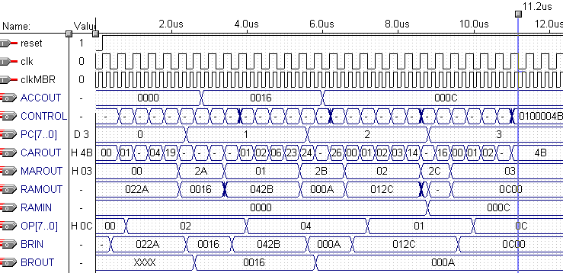
程序2波形图及逐条指令、逐个阶段、逐个操作、逐个部件逐个数据变化的对应关系分析，数据运算过程分析。（可选做）

3, load, mpy, add, store, halt (13*10+22)
The contents in RAM:
0 : 022A; Load 2A
1 : 0B2B; MPY 2B
2 : 032C; ADD 2C
3 : 012D; Store 2D
4 : 0C00; Halt
2a : 000D;
2b : 000A;
2c : 0016;
The content in RAM addressed of 2d is 0098(H).
The waveform of the operate:
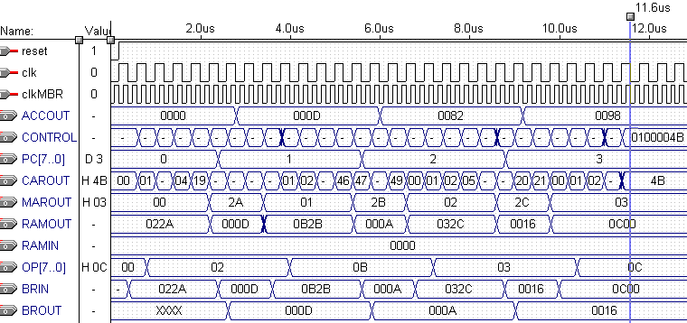
程序3波形图及逐条指令、逐个阶段、逐个操作、逐个部件逐个数据变化的对应关系分析，数据运算过程分析。（可选做）

4, Sum from 1 to 100
The contents in RAM are shown in table2.
The content in RAM addressed of A4 is 13BA(H).
The waveform of the operate:
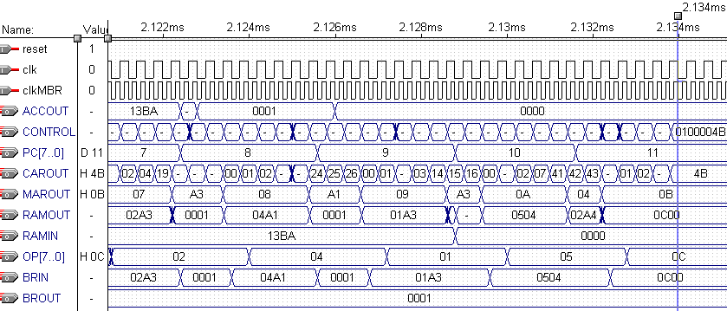
The clock cycle of CAR is 400 ns.
From the waveform, it takes 2.314ms to execute the operate. So the number of the executing cycles is 2.134/0.0004=5335.

程序4波形图及逐条指令、逐个阶段、逐个操作、逐个部件逐个数据变化的对应关系分析，数据运算过程分析。（必做）

VI. Appendix:
(I)The GDF of CPU:
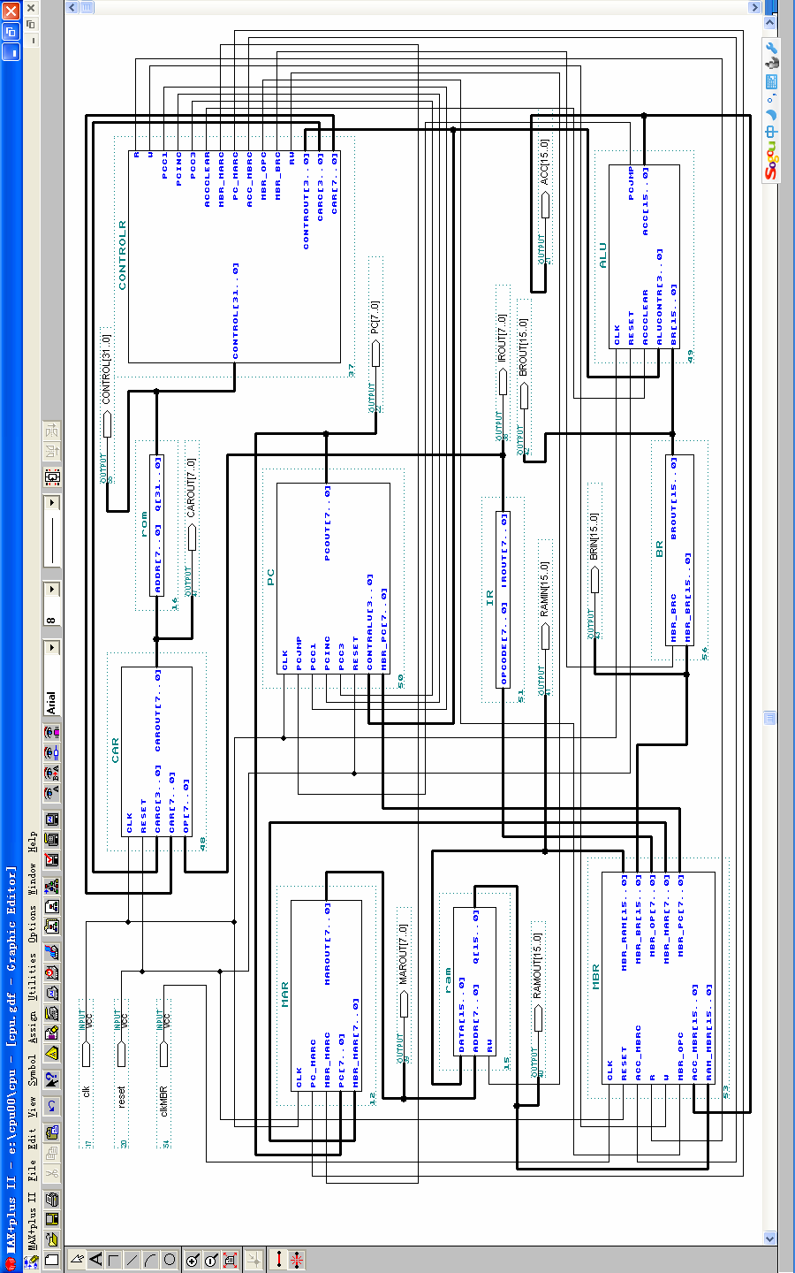
(II) The code of the CPU program:
1, MBR (Memory Buffer Register)
library ieee;
use ieee.std_logic_1164.all;
use ieee.std_logic_unsigned.all;
entity MBR is
port( clk, reset, MBR_OPc, ACC_MBRc,R,W:in std_logic;
ACC_MBR :in std_logic_vector(15 downto 0);
RAM_MBR :in std_logic_vector(15 downto 0);
MBR_RAM :out std_logic_vector(15 downto 0);
MBR_BR :out std_logic_vector(15 downto 0);
MBR_OP :out std_logic_vector(7 downto 0);
MBR_MAR :out std_logic_vector(7 downto 0);
MBR_PC :out std_logic_vector(7 downto 0));
end MBR;
architecture behave of MBR is
begin
process(clk)
variable temp:std_logic_vector(15 downto 0);
begin
if(clk'event and clk='0')then
if reset='1' then
if ACC_MBRc='1' then temp:=ACC_MBR; end if;
if R='1' then MBR_BR<=RAM_MBR; end if;
if W='1' then MBR_RAM<=temp; end if;
MBR_MAR<=RAM_MBR(7 downto 0);
MBR_PC<=RAM_MBR(7 downto 0);
if MBR_OPc='1' then MBR_OP<=RAM_MBR(15 downto 8); end if;
else MBR_BR<=x"0000";
MBR_MAR<="00000000";
MBR_OP<="00000000";
MBR_PC<="00000000";
end if;
end if;
end process;
end behave;

2, BR (Buffer Register)
library ieee;
use ieee.std_logic_1164.all;

entity BR is
port( MBR_BRc:in std_logic;
MBR_BR:in std_logic_vector(15 downto 0);
BRout:out std_logic_vector(15 downto 0));
end BR;
architecture behave of BR is
begin
process
begin
if MBR_BRc='1' then BRout<=MBR_BR; end if;
end process;
end behave;

3, MAR (Memory Address Register)
library ieee;
use ieee.std_logic_1164.all;
use ieee.std_logic_unsigned.all;
entity MAR is
port( clk,PC_MARc,MBR_MARc:in std_logic;
PC,MBR_MAR:in std_logic_vector(7 downto 0);
MARout:out std_logic_vector(7 downto 0));
end MAR;
architecture behave of MAR is
begin
process(clk)
begin
if(clk'event and clk='1')then
if PC_MARc='1' then MARout<=PC; end if;
if MBR_MARc='1' then MARout<=MBR_MAR; end if;
end if;
end process;
end behave;

4, PC (Program Counter)
library ieee;
use ieee.std_logic_1164.all;
use ieee.std_logic_unsigned.all;
entity PC is
port( clk,PCjmp,PCc1,PCinc,PCc3,reset:in std_logic;
CONTRalu :in std_logic_vector(3 downto 0);
MBR_PC :in std_logic_vector(7 downto 0);
PCout :buffer std_logic_vector(7 downto 0));
end PC;
architecture behave of PC is
begin
process(clk)
begin
if(clk'event and clk='0')then
if reset='1' then
if CONTRalu="0101" then
if PCjmp='1' then PCout<=MBR_PC;
elsif PCjmp='0' then PCout<=PCout+1;
end if;
end if;
if PCc1='1' then PCout<="00000000"; end if;
if PCinc='1' then PCout<=PCout+1; end if;
if PCc3='1' then PCout<=MBR_PC; end if;
else PCout<="00000000";
end if;
end if;
end process;
end behave;

5, IR (Instruction Register)
library ieee;
use ieee.std_logic_1164.all;
use ieee.std_logic_unsigned.all;
entity IR is
port( opcode :in std_logic_vector(7 downto 0);
IRout :out std_logic_vector(7 downto 0));
end IR;
architecture behave of IR is
begin
IRout<=opcode;
end behave;

6, CAR (Control Address Register)
library ieee;
use ieee.std_logic_1164.all;
use ieee.std_logic_unsigned.all;
entity CAR is
port( clk,reset :in std_logic;
CARc :in std_logic_vector(3 downto 0);
CAR,OP :in std_logic_vector(7 downto 0);
CARout:buffer std_logic_vector(7 downto 0));
end CAR;
architecture behave of CAR is
begin
process(clk)
begin
if(clk'event and clk='1')then
if reset='1' then
if CARc="1000" then CARout<="00000000"; end if;
if CARc="0100" then CARout<=OP+CARout; end if;
if CARc="0010" then CARout<=CAR; end if;
if CARc="0001" then CARout<=CARout+1; end if;
else CARout<="00000000";
end if;
end if;
end process;
end behave;

7, CONTRALR (Control Buffer Register)
library ieee;
use ieee.std_logic_1164.all;
use ieee.std_logic_unsigned.all;
entity CONTROLR is
port(
control :in std_logic_vector(31 downto 0);
R,W, RW, PCc1,PCinc,PCc3:out std_logic;
ACCclear,MBR_MARc,PC_MARc:out std_logic;
ACC_MBRc,MBR_OPc,MBR_BRc:out std_logic;
CONTRout:out std_logic_vector(3 downto 0);
CARc :out std_logic_vector(3 downto 0);
CAR :out std_logic_vector(7 downto 0));
end CONTROLR;
architecture behave of CONTROLR is
begin
process
begin
CAR<=control(7 downto 0);
PCc1<=control(8);
PCinc<=control(9);
PCc3<=control(10);
ACCclear<=control(11);
CONTRout<=control(15 downto 12);
R<=control(16);
W<=control(17);
MBR_MARc<=control(18);
PC_MARc<=control(19);
ACC_MBRc<=control(20);
MBR_OPc<=control(21);
MBR_BRc<=control(22);
CARc<=control(26 downto 23);
RW<=control(17);
end process;
end behave;

8, ALU (Arithmetic Logic Unit)
library ieee;
use ieee.std_logic_1164.all;
use ieee.std_logic_unsigned.all;
entity ALU is
port( clk,reset,ACCclear:in std_logic;
aluCONTR :in std_logic_vector(3 downto 0);
BR :in std_logic_vector(15 downto 0);
PCjmp :out std_logic;
ACC :buffer std_logic_vector(15 downto 0));
end ALU;
architecture behave of ALU is
begin
process(clk)
begin
if(clk'event and clk='0')then
if reset='0' then ACC<=x"0000";
else
if ACCclear='1' then ACC<=x"0000"; end if;
if aluCONTR="0011" then ACC<=BR+ACC; end if; --ADD
if aluCONTR="0100" then ACC<=ACC-BR; end if; --SUB
if aluCONTR="0110" then ACC<=ACC and BR; end if; --AND
if aluCONTR="0111" then ACC<=ACC or BR; end if; --OR
if aluCONTR="1000" then ACC<=not ACC; end if; --NOT
if aluCONTR="1001" then --SRR
ACC(14 downto 0)<=ACC(15 downto 1); ACC(15)<='0';
end if;
if aluCONTR="1010" then --SRL
ACC(15 downto 1)<=ACC(14 downto 0); ACC(0)<='0';
end if;
if aluCONTR="1011" then ACC<=ACC*BR; end if; --MPY
end if;
end if;
if ACC>0 then PCjmp<='1';
else PCjmp<='0';
end if;
end process;
end behave;

