These codes are only used for providing an intuitive comparison between 1D-PCs and 2D-PCs. The ‘main_function.m’ file contains the operators:
- Random collect image patches for training 1D-PCs and 2D-PCs;
- Calculate 1D-PCs and display them;
- Calculate 2D-PCs and display them;
The ‘.mat’ files are trained with natures image within the ‘images\’ folder.
(1) The users can retrain them (it should be noted that this process needs a long time).
(2) The users can also conduct this comparison using their nature images, if they replace the images within ‘images\’ by their ones.

File | Directions
pca.m | Principal Component Analysis [1]
b2dpca.m | Bilateral 2D Principal Component Analysis [2]
random_collect_patches.m | Random Collect Image Patches for training 1D-PCs and 2D-PCs
calculateGuassianTemplate.m | Calculate a 2D Guassian Template [3]
main_function.m | Calculate 1D-PCs and 2D-PCs  Display 1D-PCs and 2D-PCs
data.mat | Saved Collected data
PCs(1D).mat | Saved PCA Basis Functions (1D-PCs)
PCs(2D).mat | Saved 2DPCS Basis Functions (2D-PCs)
images | Image Folder: contains some nature images
Reference:
[1] M.Turk, and A.Pentland. Eigenfaces for Recognition [J]. JOURNAL OF COGNITIVE NEUROSCIENCE, 3:71-86, 1991.
[2] H. Kong, L. Wang, E.K. Teoh, X.C. Li, J.G. Wang, and R.Venkateswarlu. Generalized 2D principal component analysis for face image representation and recognition [J]. Neural Networks, 5-6:585-594, 2005.
[3] G. Heidemann. The principal components of natural images revisited [J]. IEEE Transactions on Pattern Analysis and Machine Intelligence, 28:822-826, 2006.

1D-PCs:
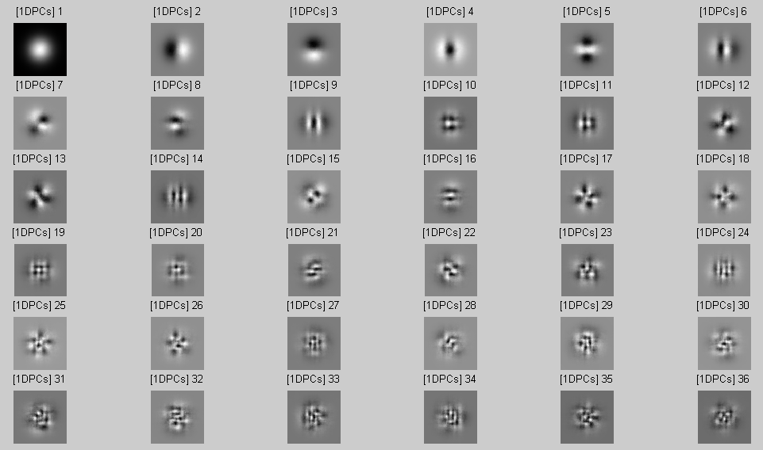
2D-PCs:
