Compare fundamentals

## Compare fundamentals graphically

The red lines are the fundamentals from the app, the black lines from Jan’s Excel sheet. The cone fundamentals from the app are identical to the Stockman 10° fundamentals.

There is a considerable differences in the cone fundamentals but especially in the melanopsin spectrum.

ggplot(melt(fundamentals_jan, id.vars = "Wavelength"), aes(x = Wavelength, y = value, group = variable)) +  
 geom_line() +  
 geom_line(data = melt(fundamentals_cord, id.vars = "Wavelength"), color = "red")

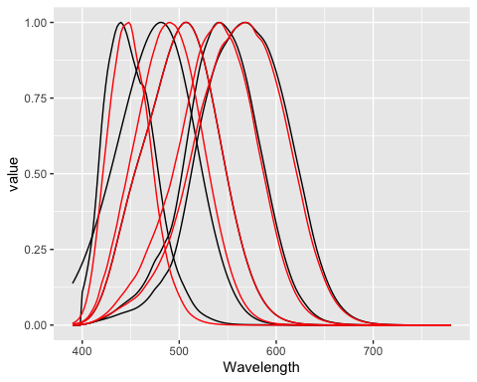 # Comparison with the Stockman fundamentals

The cone fundamentals from the Excel sheet are similar but not identical to the Stockman 2° fundamentals (green). The differ at lower wavelengths.

data.table(Wavelength = wavelengths, analyzeTCS::ConeFundamentals2) %>%  
 melt(id.vars = "Wavelength") %>%  
 ggplot(aes(x = Wavelength, y = value, group = variable)) +  
 geom_line(color = "green") +  
 geom_line(data = melt(fundamentals_jan, id.vars = "Wavelength"))

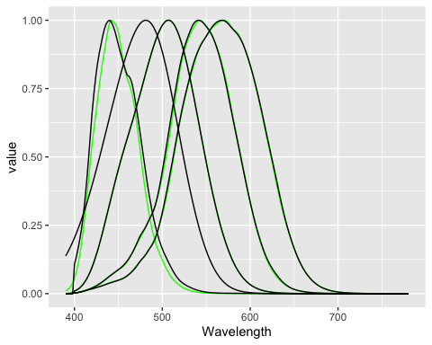

## Calculate A-Matrices

### Fundamentals from the app

s_receptors <-   
 fundamentals_cord %>%  
 get_normalized_spectrum_matrix()   
  
p_led <-   
 led_spectra %>%  
 get_normalized_spectrum_matrix() %>%  
 calculate_power_spectra(c(20, 6, 10, 10, 1), .)  
  
a_matrix_cord <- create_A_matrix(P_led = p_led, s_receptors = s_receptors)  
  
print(a_matrix_cord)

## lcone mcone rod melanopsin scone  
## RED.LED 0.43174212 0.08545099 0.003163588 0.0005786968 0.0002939411  
## AMBER.LED 0.11370219 0.06628726 0.005209928 0.0009878293 0.0002590409  
## GREEN.LED 0.14661402 0.20330506 0.073204443 0.0365620013 0.0005381681  
## CYAN 0.26311910 0.56531892 0.780014933 0.8146727948 0.6850338853  
## BLUE.LED 0.04482256 0.07963777 0.138407108 0.1471986777 0.3138749646

### Fundamentals from Jan’s Excel sheet

s_receptors <-   
 fundamentals_jan %>%  
 get_normalized_spectrum_matrix()   
colnames(s_receptors) <- colnames(a_matrix_cord)  
  
p_led <-   
 led_spectra %>%  
 get_normalized_spectrum_matrix() %>%  
 calculate_power_spectra(c(20, 6, 10, 10, 1), .)  
  
a_matrix_jan <- create_A_matrix(P_led = p_led, s_receptors = s_receptors)  
  
print(a_matrix_jan)

## lcone mcone rod melanopsin scone  
## RED.LED 0.50934962 0.12850280 0.003163588 0.0004446893 0.0003735937  
## AMBER.LED 0.12410632 0.08929438 0.005209928 0.0006534420 0.0003284999  
## GREEN.LED 0.15394228 0.25313486 0.073204443 0.0214419544 0.0013915248  
## CYAN 0.17979804 0.45959445 0.780014933 0.7571003995 0.6478812014  
## BLUE.LED 0.03280373 0.06947351 0.138407108 0.2203595147 0.3500251803

## Compare resulting LED contrasts

Comparison for a 10% l-cone contrast.

### Fundamentals from the app

find_LED_contrasts(c(lcone = .1, mcone = 0, rod = 0, melanopsin = 0, scone = 0), a_matrix_cord)

## RED.LED AMBER.LED GREEN.LED CYAN BLUE.LED   
## 0.375895080 -0.597855271 0.041402399 -0.002332878 0.005161919

### Fundamentals from Jan’s Excel sheet

find_LED_contrasts(c(lcone = .1, mcone = 0, rod = 0, melanopsin = 0, scone = 0), a_matrix_jan)

## RED.LED AMBER.LED GREEN.LED CYAN BLUE.LED   
## 0.324038106 -0.571206640 0.039316177 -0.001779188 0.003327121