# DRAFT

What drives rents in New Zealand? National and regional analysis

**Alan Bentley, Enzo Cassino and Nam Ngo**

**Executive summary**

This paper aims to improve our understanding of the underlying factors that impact rents in New Zealand. The findings will allow us to forecast rents at both the national and regional level, which is beneficial for three main reasons.

Firstly, rent provides a clearer signal of the balance of supply and demand for dwellings than house price as it does not include expectation for future gains. Secondly, providing an outlook on rents can lead to better policy towards wellbeing as renters typically pay a larger proportion of their incomes on housing costs and are more vulnerable to large price movements. Finally, forecasting rents can also improve the accuracy of house prices forecast.

Over the past 20 years, we find that wages and relative dwellings supply and demand are the two key drivers of rental inflation at both the national and regional level, through impacting tenants’ ability and willingness to pay and the availability of rental properties respectively. All else equal, an increase in wages leads directly to a 1-to-1 ratio increase in rents while a 1 percent increase in people per dwelling, an indicator of relative supply and demand, leads to a 1.5 percent increase in rents. These results also hold using Stats NZ’ estimate of rental inflation for all tenancies, albeit with lower magnitudes, as rents for existing tenancies are typically less volatile than new ones.

We also find a positive effect of mortgage rate and a negative effect of unemployment rate on rental inflation at national level, although their contributions are less significant than wages and physical supply and demand. Rising cost of finance reduces the attractiveness of owning or building a house while falling unemployment and better job security can encourage people to form new and smaller households, both in turn increase the gap between demand and supply for rental properties. However, we do not find any statistically significant evidence of the impact of general inflation on rents.

Expanding the research to consider regional council level data, we use panel regressions to provide further evidence to support the identified key drivers of rental inflation: wages or household income, physical supply and demand, and mortgage rate. The key drivers are robust to the local circumstances in different regions: excluding fixed-effects, in a pooled regression, doesn’t materially affect the findings nor the overall explanatory power of the models. Yet, conversely, including regional interactions markedly improves model fit suggesting a variety of unobserved region-specific factors affect the magnitude of impacts on rental price inflation. These differences may include local planning restrictions, infrastructure, and capacity of the local construction industry to respond to changes in demand. Visual inspection of the long-run relationship between people-per-dwelling and rental prices also illuminates temporal variation in the strength of relationships.

Using the increased statistical power available from the regional dataset, due to a greater number of observations, we find evidence that contemporaneous population changes have a stronger impact on rents than dwelling changes. Instead, dwelling changes also impact rents with one– and two–year lags. This supports a view that a capacity constrained construction industry takes time to respond to very strong population growth. Further evidence of this was found by the inclusion of time dummies for periods of relatively higher and lower population growth.

# Key findings

1. **Understanding the key drivers of rents is important to monitor and assess the balance of supply and demand in the housing market, improve the accuracy of house price forecasts, and identify potential hot spots at regional level.**
2. **Wages and relative dwellings supply and demand (measured by people per dwelling) are the two key drivers of rental inflation for new tenancies at the national level.**
3. **The impacts of population and dwellings growth on rental inflation are equally important.**
4. **Rising unemployment rate may lead to lower rental inflation, however the impact is more limited compared to wages and physical supply and demand.**
5. **The vacancy rate, an alternative measure of relative supply and demand, is negatively correlated with rental inflation. This is consistent with the findings of Saunders and Tulip (2019) for the Australian housing market.**
6. **The mortgage (interest) rate elasticity of rents is positive. However, it is quite small and not always statistically significant across model specifications.**
7. **There is no statistically significant evidence of the impact of general inflation on rents.**
8. **All key drivers have similar but smaller effects on the rental inflation of existing tenancies, which is estimated by the stock measure of Stats NZ’s Rental Price Index.**
9. **The identified key drivers are robust to local circumstances, yet unobserved region-specific factors can dampen, or magnify, the effects in particular regions.**
10. **We provide evidence that a capacity constrained construction industry takes time to respond to very strong population growth.**

# Introduction

This paper aims to improve our understanding of the underlying factors that impact rents in New Zealand. The findings will allow us to forecast rents at both the national and regional level, which is beneficial for three main reasons. Firstly, rent provides a clearer signal of the balance of supply and demand for dwellings than house price as it does not include expectation for future gains. Secondly, providing an outlook on rents can lead to better policy towards wellbeing as renters typically pay a larger proportion of their incomes on housing costs and are more vulnerable to large price movements. Finally, forecasting rents can also improve the accuracy of house prices forecast.

Figure 1 – New Zealand rental prices in context

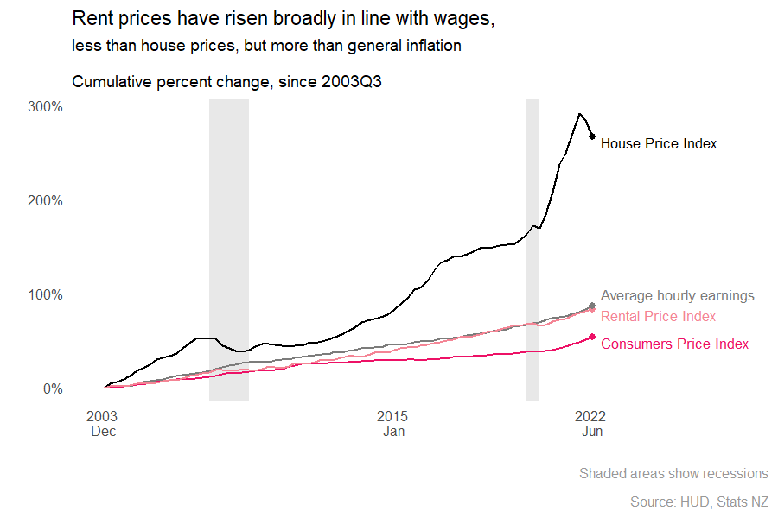

Overall rental prices have increased broadly in line with wage growth over the past two decades, albeit at a faster rate than general inflation, as measured by the Consumers Price Index (Fig. 1). In contrast, house prices have risen further than rents. The tri-agency Housing Technical Working Group (HTWG)[1] identified these differing growth rates, amongst other things, as evidence to support their conclusions presented in *Assessment of the Housing System: with insights from the Hamilton-Waikato Area* (HTWG, 2022). The report demonstrated the relative importance of systematic interest rate declines and the tax system, in the context of restricted land supply (land use rules, regulations, and constraints) above dwelling supply relative to population growth. The group concluded that physical dwelling supply has not been the major driver of house prices over the past 20 years. Had this been the case, they would have expected house price increases to have been more in line with the increase seen in rent. Underpinning this assessment is an assertion that rental prices are influenced by the relative supply and demand of physical dwellings. Research presented in this paper aims to further our understanding of the drivers of rental prices.

The rest of the paper is organized as follows: section 2 summarises key features of rents in New Zealand, section 3 reviews the previous literature on modelling rents internationally and in New Zealand, section 4 describes the framework for analyzing rents, section 5 describes the data and modelling approach. The results are presented in section 6.

# Key facts of rents in New Zealand

New Zealand rental prices are receiving growing attention as the proportion of people who pay rent has been increasing since the early 1990s; households who pay rent has increased from about 23 percent in 1991 to 32 percent in 2018 (Stats NZ, 2020). The decline in home ownership has been acute for young adults: the proportion of New Zealanders aged 25 to 34 who are owner-occupiers declined from about 65 percent in 1988 to 35 percent in 2018 (Bentley, 2021). The number of households in rented dwellings increased from about 290,000 in 1996 to 530,000 in 2018.

From a wellbeing perspective, rents matter since low-income households have little discretion over their level of housing expenditure. Renters typically have lower incomes than owner-occupiers, spend a greater share of their income on housing, and have lower material wealth (ibid). New Zealand rental properties are typically of lower physical quality compared with owner-occupied properties (New Zealand Treasury, 2022).

The usually resident population of New Zealand increased by over 1 million people during the study period; from an estimated 4.0 million as at June 2003 to 5.1 million as at June 2022, at an average growth rate of 1.3% per year. Over the same period, dwellings increased by 500,000 to 2 million as at June 2022. The average dwelling growth rate was also 1.3% per year. Yet, these long-run rates hide periods of mismatch between population and dwelling growth (Fig. 2). Temporal variation in New Zealand’s population growth rate is driven by changes in net external migration. Notably, the population was growing at a faster rate than dwellings during the period 2015–20, increasing the number of people per dwelling to a high of 2.64 as at June 2020. Boarder restrictions over the following two years curtailed population growth, whilst dwelling growth continued, reducing people per dwelling to 2.56 as at June 2022. Strikingly similar to the 2.58 people per dwelling as at June 2003, at the beginning of our study period.

Figure 2 – Population and dwelling growth rates compared

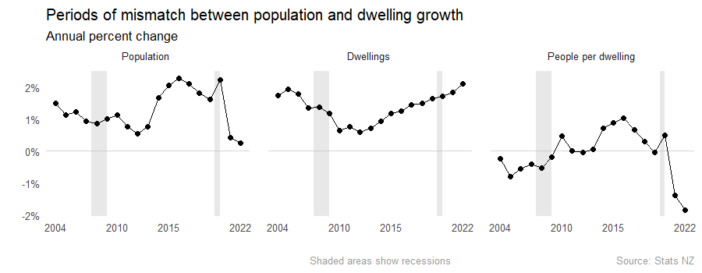

Enhancements to the measurement of rental price inflation, including the use of granular administrative data and a new approach for quality-adjustment, has improved the reliability of rental price indices. The changes also facilitated the introduction of an additional ‘flow’ series, which shows price change for new tenancies (Stats NZ, 2019; Bentley, 2022a). In comparison, the ‘stock’ series, used as an input into the overall Consumers Price Index, measures price change across all tenancies. Movements in the latter series tend to be lagged and less volatile (Fig. 3), reflecting the stickiness of rental prices for sitting tenants, who can be said to enjoy a ‘tenancy discount’ (Bentley, 2021).

Figure 3 – New tenancy rental price inflation compared with inflation for all rentals

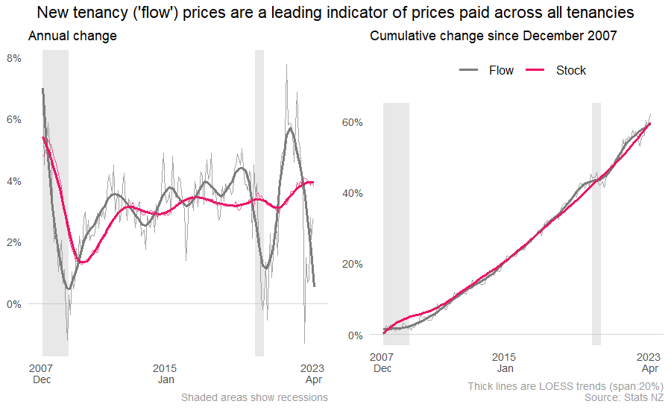

Just over a third of rental households are in Auckland, another third in the major urban areas of Canterbury, Wellington and Waikato, with the remainder in less densely populated regions (Fig. 4). There is notable regional variation in the proportion of households who are not owner-occupiers, the vast majority of who pay rent.[2] Over 40 percent of households are non-homeowners in Gisborne and Auckland, compared with less than 30 percent in Marlborough and Tasman regions.

Figure 4 - Regional diversity in rental markets

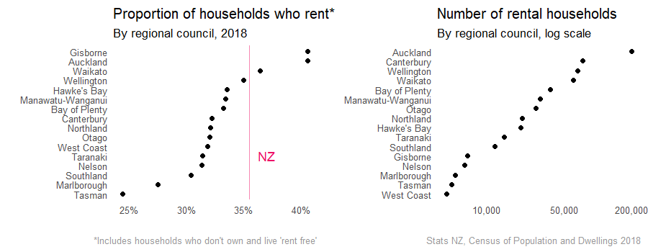

National trends can hide regional diversity of rental price inflation (Fig. 5). We found evidence of spatial correlation in rental price growth, where periods of higher price growth occurred in one region at the same time as neighbouring regions.

Figure 5 – Regional rental price inflation

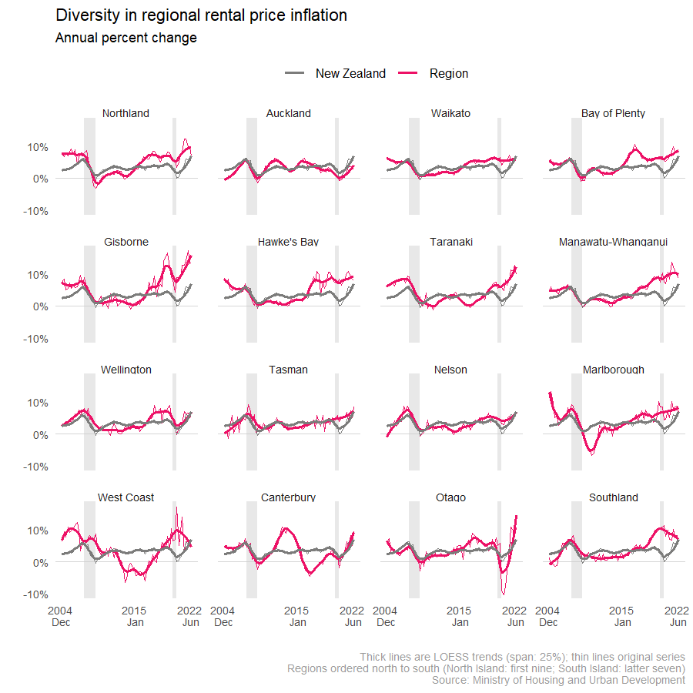

Rental price inflation has been above average in many provincial North Island regions[3] since about 2016. Counter balancing this has been below average growth rate in Auckland, home to over a third of renters. The Canterbury region experienced major earthquakes in 2010 and 2011, reducing the number of dwellings available for habitation. Rent prices increased markedly over the following few years, subsequently reversing once supply and demand were brought back into balance following the substantial rebuild. These key trends hint at the role of physical supply and demand for rental properties on rental prices. Later we provide more rigorous assessment.

# Literature review

A number of different frameworks can be used to model the drivers of rents. Previous studies have used a range of data sources. Some studies have used individual level rent data, whereas other studies have used aggregate data. Individual level data is well suited to inferring the causal impact of specific events or policy changes, such as changes in the level of the Accommodation Supplement. However, aggregate rental data are more useful for estimating the relationship between macroeconomic factors such as rising interest rates or inflation and rents. Our study uses aggregate level data as we are primarily interested in these macroeconomic relationships.

In addition, previous studies have used a variety of modelling techniques to study rent growth. Studies focussed on identifying the impact of individual factors on rents tend to use single equation econometric methods, such as Ordinary Least Squares (OLS) or panel data techniques. In contrast, studies that concentrate on forecasting rents may use methods such as Vector Autoregressions (VARs). In this study we are interested in the macroeconomic relationship between rents and other factors, so we use OLS for the national level analysis and panel estimation for the regional analysis.

Another distinction in the literature is whether to estimate the structural demand and supply curves for rent or the combined reduced form relationship. Based on economic theory and the previous empirical literature, the demand for rental housing depends on factors such as household income, interest rates and inflation. The supply of housing depends on factors including interest rates and inflation.

Compared to the extensive empirical work on drivers of house prices, research on drivers of rents is much more limited, both internationally and in New Zealand.[4] The available studies have used a variety of methods and focus on the role of different factors.

In the time series analysis, much of the empirical work has focussed on modelling US rents. Duca, Muellbauer and Murphy (2016) model real rents (deflated by the PCE deflator). They find a positive long-run impact of real incomes and house prices on rents, and a negative impact of user costs, which incorporates the impact of lagged house price changes and interest rates. Dias and Duarte (2019) use a structural VAR approach to examine the impact of US monetary policy on rents, and find that after a tightening in monetary policy, house prices decline whereas rents increase, indicating that monetary policy may influence households’ decision to own a house or rent.

Saunders and Tulip (2019) include equations for rents and rental vacancies in a broader model of the Australian housing market. They find dwelling completions and changes in population drive the rental vacancy rate, which in turn has a strong impact on rents. In addition, rents have a large impact on house prices, along with interest rates and house price momentum. Howard and Liebersohn (2021) use a spatial equilibrium framework to decompose the drivers of US rents, and find an increasing role for demand to live in cities in which housing supply is inelastic.

Relatively few studies have analysed the New Zealand rental market. Coleman and Scobie (2009) build a simple structural model with parameters of supply and demand for owner-occupied and rental housing to assess the impact of various policy actions. They find a reduction in tax concessions for landlords would increase rents and moderate house prices. In addition, lower housing costs, such as through lower regulatory and consent costs, would reduce rents and house prices. Lower real interest rates would reduce rents and increase house prices. The only study we are aware of that has analysed the New Zealand rental market at a regional level is Nunns (2019). His study develops a calibrated spatial equilibrium model to analyse the impact on regional house prices and rents of rising housing demand arising from population growth, credit availability and tax policy settings combined with constrained supply due to zoning rules. His analysis finds regions with more binding supply constraints have experienced larger rent (and house price) increases in response to migration shocks.

# Theoretical framework of the rental market

The theoretical framework for our model of rents is similar to the approach used by Coleman and Scobie (2009) and Watson (2013) for modelling the property market. Whereas those models allow individuals to choose between renting and owner occupying, our model focuses only on the rental segment of the property market. In the model, rents Pr and the number of households Hr that are renting are determined by the demand for and supply of rental services.

We assume in the short-run the supply of rental properties is fixed. In longer term, the supply can adjust as more (or less) people chose to become landlords or more (or fewer) houses are built to rent to tenants

$S_{r}=f(P_{r},P_{H},i, Inf)$.

Higher rents increase the return to landlords, increasing the supply of rental properties. Higher house prices *PH* reduce the supply of rental properties as the yield to landlords is reduced. Higher mortgage rates i reduce the supply of rentals as the cost of capital to invest in property rises. Higher inflation Inf reduces the supply of rentals as it increases landlords’ expenses.

The demand side of the rental market *Dr* can be written as

$D_{r}=f(P_{r}, P_{H}, Y, i, PPD)$.

Higher rents relative to the cost of buying a house, which is captured by house prices and mortgage interest rates, lowers the demand for rental properties. Higher household income Y increases demand for rent by increasing renters’ ability to pay. We also include the average number of people per dwelling as influencing the demand for rentals. People per dwelling is often used as an indicator of the demand-supply imbalance in the rental market. However, the theoretical relationship between rents and people per dwelling is not clear cut. An increase in people per dwelling may reflect social factors, such as young people choosing to living with the parents for longer. This would reflect a shift down in the rental demand curve, and downward pressure on rents. On the other hand, if people chose to live in large households in response to rising rents, this represents a shift along the demand curve, and higher people per dwelling would be positively correlated with rents. As part of our empirical analysis we also examine the impact of splitting people per dwelling into population growth and increases in the number of dwellings to examine whether each factor has a different impact on rent growth.

We combine the supply and demand equations for rental services to solve the reduced form of the model for rents and the number of households that are renting

$$P_{r}=f(Y, i, PPD, P_{H},Inf)$$

and

$$H_{R}=f\left({Y, PPD, i,P}_{H }, Inf\right).$$

Estimating the demand curve and the supply curve separately would allow us to identify the impact of a shock that shifts the demand curve or a supply curve, such as an income shock or a shock in the number of people per dwelling. However, in this study we are primarily interested in using our models for forecasting changes in rent rather than exploring the change in rent caused by demand shocks or supply shocks. As a result, we concentrate on estimating the reduced form of the relationship between rent growth and exogenous factors that impact it. The parameters we estimate are a combination of the separate coefficients on each factor in the demand curve and the supply curve.

# Data and Methodology

## Data sources

This section describes the data sources used for our empirical analysis. Based on the availability of time series, our study period is 2003Q4 to 2022Q2. Rates of change are derived for all variables: quarterly change is defined as the change from previous quarter; annual change is defined as the change from the same period in the previous year.

Stats NZ’s Rental Price Index (RPI)[5] is used at the national level. This is a quality-adjusted price index of rental inflation, derived from the Ministry of Business, Innovation and Employment’s Tenancy Bond data (Stats NZ, 2019; Bentley, 2022a). The ‘flow’ series is used, which shows the change in rental prices for new tenancies, except where stated that the ‘stock’ series is used. The latter shows rental prices changes across all renters, including sitting tenants. Regional council level RPIs are sourced from the Ministry of Housing and Urban Development (HUD). These use the same quality adjustment methodology as Stats NZ’s national RPI (HUD, 2022). CoreLogic’s House Price Index (HPI) has been sourced from HUD. The index methodology uses a *Sales Price Appraisal Ratio*, a quality adjustment approach widely used in New Zealand for HPIs (ibid). Consumers Price Index less rentals for housing subgroup is a non-standard series available from Stats NZ’s infoshare service (table reference: CPI017AA).

Wage measures are sourced from Stats NZ: average weekly earnings from the Quarterly Employment Survey (QES), a sample survey of about 4,000 enterprises; median earnings per job from the quarterly Linked employer-employee data (LEED), created from administrative pay-as-you-earn income tax data (Stats NZ, 2021). QES data is used for national level regressions. Since the survey does not contain regional breakdowns LEED data is used for regional regressions. Modelled household disposable income timeseries are sourced from HUD, these use quarterly LEED earnings benchmarked to annual household survey estimates of disposable (after tax) income (HUD, 2022). Unemployment rates are sourced from Stats NZ’s Household Labour Force Survey, a sample survey of about 16,000 households (Stats NZ, 2021).

Stats NZ’s national and subnational population estimates are based on Censuses of Population and Dwellings (Stats NZ, 2022a; Stats NZ, 2022b). Intercensal estimates are derived from registered births, deaths, and net migration of residents. Dwelling estimates are based on Censuses of Population and Dwellings, interpolated and extrapolated using Stats NZ’s building consents data (see Bentley, 2022b, for a full description of the methodology used).

Mortgage rates are sourced from the Reserve Bank of New Zealand (RBNZ). Two series were explored, both are a simple average of rates advertised to new customers by registered banks. Floating rate uses standard rates (RBNZ, 2023a). 2-year fixed special rate refers to ‘special rates’ offered to borrowers who meet certain conditions as specified by the bank (RBNZ, 2023b)[6].

## Methodology

For the national-level analysis, we use a simple model of rental inflation on the potential determinants, and use Ordinary Least Squares (OLS) to estimate model coefficients.

${∆Rent}_{t}=f(\sum_{k=1}^{K}{{∆X}_{t}}$) + $ε_{t}$

Where the change in rent $∆Rent$ at time $t$ is a function of $k\left(k=1,…,K\right)$ covariates $X$.

For national level analysis, we use the general-to-specific approach to estimate the models and include both the contemporaneous and lagged values of the covariates. We use quarterly data in order to ensure sufficient sample size for the number of variables. However, there are concerns that for rental inflation and several covariates, quarterly data may include too much noise and hide the underlying signal. Therefore, we test our model with annual change instead of quarterly change. To maintain the sample size but also avoid serial correlation, we include the lag of four instead of one for all variables.

For regional analysis, we use panel regressions to jointly estimate relationships for all regions.

${∆Rent}_{t}=f(\sum_{k=1}^{K}{∆X_{rt}^{Regional}, ∆X_{t}^{National}}$)+ $\sum_{r=1}^{R-1}{β_{r}Z_{r}}$ + $ε_{t}$

Where region $r$ fixed-effects $Z_{r}$ are estimated for all but one region[7] . The structure imposes the same relationships between dependent and independent variables for all regions, but allows for a different constant for each region. We also investigate: (i) the impact of including the interaction of regional fixed-effects with the other covariates; and (ii) omitting the region fixed-effects in a pooled regression.

# Results

## 6.1 National results

In this section we present the results of the aggregate national level modelling. There are a number of findings about the impact of macroeconomic factors on rent growth.

All else equal, an increase in wages leads directly into a 1-to-1 ratio increase in rents, as shown in all columns of Table 1. The correlation is stronger contemporaneously, but we also find that lagged wage inflation contributes towards rental inflation.

In terms of relative supply and demand, a 1 percent increase in people per dwelling leads to a 1.5 per cent increase in rents. There is limited evidence suggesting that the higher the increase in the supply/demand gap, the stronger the wage-rent relationship, as competition for rental properties allow landlords to capitalize on renters’ wage gains. The interaction term between wage and people per dwelling in table A.2 is positive but not statistically significant.

Across all model specifications in table 1, the unemployment rate is negatively correlated with rental inflation, i.e an increase in unemployment rate would lead to a decrease in rental inflation. There are two possible explanations for this. Firstly, better job security can encourage people to form new and smaller households, which in turn, increases the demand for rental properties. Secondly, a strong labour market and positive economic outlook would ensure tenants’ current and future ability to pay, allowing landlords to raise rents.

Table 1: Baseline model

|  |  |  |  |  |
| --- | --- | --- | --- | --- |
|  | **Rent inflation**  **(****nominal, flow)** | **Rent inflation**  **(****nominal, flow)** | **Rent inflation**  **(****nominal, flow)** | **Rent inflation**  **(****nominal, flow)** |
| *Predictors* | *(1)* | *(2)* | *(3)* | *(4)* |
| Rent inflation (lagged) | -0.19  (0.12) | -0.19 *  (0.11) | -0.17  (0.11) | -0.15  (0.11) |
| Wage growth | 0.54 *** (0.11) | 0.56 *** (0.08) | 0.54 ***  (0.09) | 0.54 *** (0.09) |
| Wage growth (lagged) | 0.35 *** (0.12) | 0.36 *** (0.11) | 0.39 ***  (0.12) | 0.39 ***  (0.12) |
| People per dwelling | -0.51  (0.78) |  |  |  |
| People per dwelling (lagged) | 1.97 **  (0.86) | 1.73 ***  (0.52) | 1.63 *** (0.53) | 1.51 ***  (0.53) |
| Mortgage rate | 0.02  (0.02) |  |  |  |
| Mortgage rate (lagged) | 0.02  (0.02) | 0.03  (0.02) | 0.03  (0.02) |  |
| Inflation excluding rents | -0.12  (0.20) |  |  |  |
| Inflation excluding rents (lagged) | 0.15  (0.20) | 0.14  (0.17) | 0.13  (0.17) | 0.15  (0.17) |
| Unemployment rate | 0.01  (0.01) |  |  |  |
| Unemployment rate (lagged) | -0.02  (0.01) | -0.02  (0.01) | -0.02  (0.01) | -0.02 * (0.01) |
| House price inflation | -0.01  (0.06) |  |  |  |
| House price inflation (lagged) | 0.08  (0.07) | 0.08 *  (0.04) |  |  |
| Observations | 73 | 73 | 73 | 73 |
| R2 / R2 adjusted | 0.489 / 0.376 | 0.470 / 0.404 | 0.440 / 0.380 | 0.423 / 0.371 |
| *All variables enter the model as percentage change from the previous quarter*  *\* p<0.1 ** p<0.05 *** p<0.01* | | | | |

We test the robustness of the results by using population growth and dwelling growth separately instead of the change in people per dwelling, as shown in the third column of table 2. The signs and magnitudes of the regression coefficients are as expected. All else equal, an increase in population is positively correlated with rent inflation, while an increase in dwellings is negatively correlated with rental inflation. As the Wald test cannot reject the null hypothesis of equal coefficients, we conclude that the contributions of population and dwellings growth towards rental inflation are equally important, thus combining both into the people per dwelling variable as in the baseline model is plausible.

Although people per dwellings is a frequently used measure of relative supply and demand, there are certain shortcomings as a measure of the supply-demand imbalance. First, the numerator is the number of people, not just renters.Second, the dwellings figure is estimated from building consents for all properties, not just rental properties.

To check the robustness of the results found with people per dwellings, we calculate the vacancy rate of rental properties as an alternative indicator of the supply-demand imbalance. We use unit record bond data to create a measure of the time between tenancies at property level as a proxy for the vacancy rate. Column 4 in table 2 show the results from using the vacancy rate instead of people per dwelling to capture the relative supply-demand balance. These results are consistent with the baseline model. An increase in the vacancy rate signals the easing of pressure in the rental market and leads to a decrease in rental inflation.

Another finding is that the sensitivity of rent inflation to mortgage interest rates is positive. However, the sensitivity is quite small and is not always statistically significant across model specifications. There are several possible explanations for the sensitivity of rent inflation to mortgage rates.

For example, first home buyers may delay buying due to rising mortgage unaffordability, increasing demand for rental property. Higher financing costs and restricted land markets may limit the supply response to increased demand for rentals when interest rates rise, putting further pressure on rent inflation. There may also be feedback loops in the banking sector, which can limit the supply response of rental properties to lower interest rates. As supply begins to increase relative to demand this will increase vacancy rates and reduce yields for property investors. This may lessen banks’ appetite to lend for further rental property development.

Across all specifications in table 1, the impact of general inflation, measured by CPI less rents, is positive but not statistically and economically significant. These results suggest that in an inflationary environment, the rising costs to landlords do not contribute much to rise in rents, compared to wage growth or the overall tightness of the rental market.

Table 2 Alternative measure of relative supply and demand

|  |  |  |  |  |
| --- | --- | --- | --- | --- |
|  | **Rent inflation (nominal, flow)** | **Rent inflation**  **(****nominal, flow)** | **Rent inflation (nominal, flow)** | **Rent inflation**  **(****nominal, flow)** |
| *Predictors* | *(1)* | *(2)* | *(3)* | *(4)* |
| Wage | 0.56 ***  (0.08) | 0.52 ***  (0.08) | 0.54 ***  (0.09) | 0.34 ***  (0.09) |
| Wage (lagged) | 0.36 ***  (0.11) | 0.39 *** (0.11) | 0.39 ***  (0.12) | 0.28 **  (0.12) |
| People per dwelling (lagged) | 1.73 ***  (0.52) |  |  |  |
| Adults per dwelling (lagged) |  | 1.46 ***  (0.46) |  |  |
| Population growth (lagged) |  |  | 1.68 ***  (0.58) |  |
| Dwellings growth (lagged) |  |  | -1.43  (0.97) |  |
| Change in vacant time (lagged) |  |  |  | -0.01 *** (0.00) |
| Observations | 73 | 73 | 73 | 73 |
| R2 / R2 adjusted | 0.470 / 0.404 | 0.445 / 0.385 | 0.441 / 0.371 | 0.457 / 0.398 |
| *All variables enter the model as percentage change from the previous quarter*  *\* p<0.1 ** p<0.05 *** p<0.01* | | | | |

In column 3 of table 3, we look at the impact real wage on real rents by deflating both by the CPI excluding rents. All regression coefficients retain their expected signs and significances which suggest that the impact of wages on rents is direct rather than through inflation.

While the flow RPI, created using new tenancies, is a good real-time indicator of rental inflation, the stock measure of RPI is considered a more comprehensive and reliable representation of the situation facing most tenants, who remain in their current rental properties**.** In column 2 of table 3, we test our model using the stock rental inflation as the dependent variable.

The results are consistent with the flow measure. All regression coefficients retain their expected signs and significances. However, the magnitudes are smaller, which may be because rental inflation for existing tenancies is typically less volatile than rental inflation for new tenancies, according to the sticky rents phenomenon.

Table 3: Alternative measure of rental inflation

|  |  |  |  |
| --- | --- | --- | --- |
|  | **Rent inflation**  **(****nominal, flow)** | **Rent inflation**  **(****nominal, stock)** | **Rent inflation**  **(****real, flow)** |
| *Predictors* | *(1)* | *(2)* | *(3)* |
| Rent inflation (lagged) | -0.17  (0.11) | 0.65 ***  (0.10) | -0.27 **  (0.11) |
| Wage growth | 0.54 ***  (0.09) | 0.09 ***  (0.02) | 0.62 *** (0.08) |
| Wage growth (lagged) | 0.39 *** (0.12) | 0.09 *** (0.03) | 0.38 ***  (0.12) |
| People per dwelling (lagged) | 1.63 *** (0.53) | 0.30 ** (0.14) | 1.99 ***  (0.53) |
| Mortgage rate (lagged) | 0.03  (0.02) | 0.01  (0.00) | 0.03  (0.02) |
| Inflation excluding rents (lagged) | 0.13  (0.17) | 0.02  (0.04) |  |
| Unemployment rate (lagged) | -0.02  (0.01) | -0.00  (0.00) | -0.01  (0.01) |
| Observations | 73 | 61 | 72 |
| R2 / R2 adjusted | 0.440 / 0.380 | 0.573 / 0.516 | 0.560 / 0.520 |
| *All variables enter the model as percentage change from the previous quarter*  *In Model 3, both rents and wages are deflated using CPI excluding rents*  *\* p<0.1 ** p<0.05 *** p<0.01* | | | |

## 6.2 Regional Results

In this section we extend the analysis to consider data for the 16 regional council areas of New Zealand. Our motivation for investigating regional rental price data is two-fold: (i) to increase the amount of data available for modelling, and hence incorporate additional variation in the data due to region-specific events; (ii) understanding differences, and commonalities, between regions.

A demerit of using regional data is the increase in statistical volatility due to smaller quantities of data in any given region compared with modelling the country as a whole. This ‘noise’ lead us to focus on modelling annual change rather than quarterly change. To avoid issues with multicollinearity we retained only one observation per year (June).

### Simple panel regressions, using annual change

A simple model (Table 4: Model R1) with only change in household income and people per dwelling, explains just over 31% of the variation in regional rental prices. Splitting people per dwelling into separate coefficients (people; dwellings) allows us to see the modelled impacts separately (Model R2), and examination of the statistical significance of the covariates shows the relative importance of the explanatory variables, in order of priority: income, population, dwellings.

Household disposable income is a marginally stronger predictor than personal earnings (Model R2: R-squared 29.2%; compared with Model R3: 31.6%). This makes intuitive sense since household income represents the resources of that households collectively have available for rent and other expenditure.

Including national level covariates of CPI and mortgage rates (average 2-year fixed special rates), we observe that price inflation looks to already be captured in (nominal) household income growth. Mortgage rates are significant (Models R4 & R5) and improve the R-squared to nearly 35%.

Table 4 – Regional panel regressions (annual change)

|  |  |  |  |  |  |  |
| --- | --- | --- | --- | --- | --- | --- |
|  | **Model R1** | **Model R2** | **Model R3** | **Model R4** | **Model R5** | **Model R6** |
| *Predictors* | *Estimates* | *Estimates* | *Estimates* | *Estimates* | *Estimates* | *Estimates* |
| Household income | 1.25 *** (0.12) | 1.30 *** (0.14) |  | 1.19 *** (0.14) | 1.21 *** (0.14) | 1.00 *** (0.13) |
| People per dwelling | 0.80 *** (0.23) |  |  |  |  |  |
| Population |  | 0.74 ** (0.24) | 1.10 *** (0.25) | 1.08 *** (0.26) | 1.02 *** (0.25) | 0.54 * (0.24) |
| Dwellings |  | -1.15 * (0.52) | -0.79  (0.51) | -1.44 ** (0.52) | -1.38 ** (0.51) | -2.92 *** (0.50) |
| Median earnings |  |  | 1.43 *** (0.16) |  |  |  |
| CPI |  |  |  | 0.10  (0.15) |  |  |
| Mortgage rate (2-year fixed) |  |  |  | 0.02 ** (0.01) | 0.02 *** (0.01) | 0.02 ** (0.01) |
| Period 2009-15 |  |  |  |  |  | -0.03 *** (0.01) |
| Period post-2016 |  |  |  |  |  | 0.01  (0.00) |
| Observations | 288 | 288 | 288 | 288 | 288 | 288 |
| R2 / R2 adjusted | 0.314 / 0.271 | 0.316 / 0.270 | 0.292 / 0.245 | 0.349 / 0.301 | 0.348 / 0.302 | 0.492 / 0.452 |
| Predictors are expressed as annual percent change (except dummy variables).  Regional dummies and intercept not shown.  *\* p<0.05   ** p<0.01   *** p<0.001* | | | | | | |

### Including period dummy variables

Exploratory data analysis found differences in the relationship between rent and covariates over time (Fig. 6). Including dummy variables for three periods of similar duration, but differing rates of population growth (pre-2009, 2009-15, post-2016),[8] are found to be significant and increase the overall explanatory power (Table 4: Model R6). This suggests compounding factors may be at play during sustained periods of imbalance between the supply and demand of rental properties.

Fig. 6 – Temporal and spatial differences in people-per-dwelling and rental price growth correlations

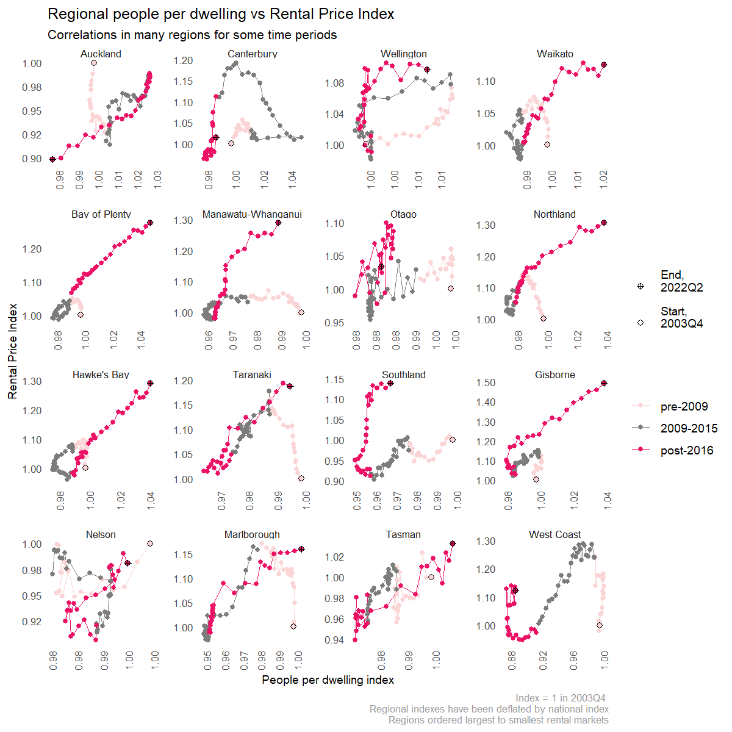

### Including regional interactions and pooled regressions

The models so far have included regional dummy variables, which creates panel fixed-effects: that is, the model allows for an overall higher or lower RPI growth for each region, as a constant factor across all time periods. Alternatively, by including interactions of the regional dummies with other covariates (Table 5: Model R7) the model allows for the estimation of region-specific coefficients for other explanatory variables. Conceptually, this is equivalent to running separate regression models for each region. Such models may be most appropriate if we are interested in the best coefficient estimates for a particular region.

Conversely, if we are attempting to understand the general relationship between the factors in the model and RPI growth we can remove the regional dummy variables and run a pooled regression (Model R8). In this case we are using the regional data to increase the number of data points available for modelling, without a need to understand the impact region-specific effects. We found that the pooled regression coefficients are similar to those in the panel regressions suggesting the key drivers are robust to local circumstances in different regions.

Table 5 – Regional interactions and pooled regressions (annual change)

|  |  |  |  |
| --- | --- | --- | --- |
|  | **Model R5** | **Model R7 (interactions)** | **Model R8 (pooled)** |
| *Predictors* | *Estimates* | *Estimates* | *Estimates* |
| Household income | 1.21 *** (0.14) | 0.55  (0.76) | 1.26 *** (0.13) |
| Population | 1.02 *** (0.25) | 0.15  (0.91) | 1.00 *** (0.23) |
| Dwellings | -1.38 ** (0.51) | -2.13  (1.32) | -1.92 *** (0.41) |
| Mortgage rate (2-year fixed) | 0.02 *** (0.01) | 0.02 *** (0.01) | 0.02 *** (0.01) |
| Observations | 288 | 288 | 288 |
| R2 / R2 adjusted | 0.348 / 0.302 | 0.488 / 0.342 | 0.320 / 0.311 |
| Predictors are expressed as annual percent change (except dummy variables).  Regional dummies and intercept not shown.  *\* p<0.05   ** p<0.01   *** p<0.001* | | | |

Including regional interactions markedly improves model fit (R-squared increases from 34.8% to 48.8%), suggesting a variety of unobserved region-specific factors affect the magnitude of impacts on rental price inflation (Table 5; Fig. 7). These differences may include local planning restrictions, infrastructure, and capacity of the local construction industry to respond to changes in demand.

Including house prices as a covariate (Appendix Table B1) is significant and a positive relationship. This could indicate that many of the unobserved region-specific factors act on the housing market as a whole, rather than just the rental market. It may also reflect less incentive to make properties available for rent in a rising market. Conversely, in a falling market time to sell would be expected to increase which may lead to an increase in the rental stock, and therefore downward pressure on prices.

Fig. 7 – Model fit, with and without regional interactions

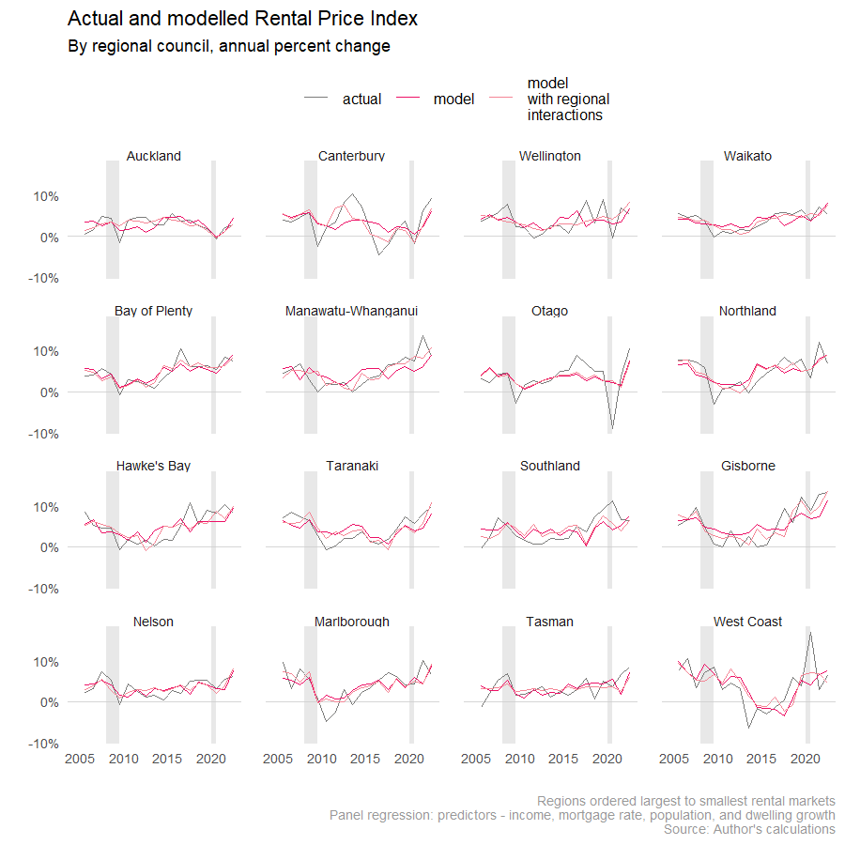

In Model R2 we found evidence that contemporaneous population changes have a stronger impact on rents than dwelling changes. Investigating the impact of including lagged covariates (Appendix Table B2) we found dwelling changes also impact rents with one– and two–year lags. This supports a view that a capacity constrained construction industry takes time to respond to very strong population growth.

As a robustness check on the annual change rates used in the regional regressions reported, we investigated using rates of change over longer time horizons. The models were found to fit the data better over longer time horizons (Appendix Table B3). This may be due to (i) less noise in the series, and/or (ii) that the explanatory variables affect rental prices over a longer time horizon.

# References

# Bentley, A. (2021). Sticky Rents and the Affordability of Rentals for Housing in New Zealand. *New Zealand Population Review,* 47, pp.145-170. Population Association of New Zealand.

Bentley, A. (2022a). Rentals for housing: A property fixed-effects estimator of inflation from administrative data. *Journal of Official Statistics*, 38(1), pp.187-211. <https://doi.org/10.2478/jos-2022-0009>

Bentley, A. (2022b). Timely Rental Price Indices for thin markets: Revisiting a chained property fixed-effects estimator. Paper presented at the 17th meeting of the Ottawa Group on Price Indices, Rome, 7-10 June 2022. Available at [www.ottawagroup.org](http://www.ottawagroup.org)

Coleman, A and Scobie, G (2009) “A Simple Model of Housing Rental and Ownership with Policy Simulations”, *Working Paper 09/05*, New Zealand Treasury

Dias, D. and Duarte, J (2019) “Monetary Policy, Housing Rents, and Inflation Dynamics”, *International Finance Discussion Paper Number 1248,* Board of Governors of the Federal Reserve System

Duca, J, Muellbauer, J and Murphy, A (2016) “How Mortgage Finance Reform Could Affect Housing”, *American Economic Review: Papers and Proceedings*, 106(5), pp.620-624

Duca, J, Muellbauer, J and Murphy, A (2021) “What Drives House Price Cycles? International Experience and Policy Issues”, *Journal of Economic Literature*, 59(3), pp.773-864

Housing Technical Working Group (2022). Assessment of the Housing System: with insights from the Hamilton-Waikato Area. August 2022. Available from [www.treasury.govt.nz](http://www.treasury.govt.nz)

Howard, G and Liebersohn, J (2021) “Why is the rent so darn high? The role of growing demand to live in housing-supply-inelastic cities”, *Journal of Urban Economics*, Vol.124 pp.1-14

Ministry of Housing and Urban Development (2022). Change in housing affordability indicators: Concepts, sources, and methods. November 2022. Available at [www.hud.govt.nz](http://www.hud.govt.nz)

New Zealand Treasury (2022). Trends in Wellbeing in Aotearoa New Zealand: 2000-2020. Background Paper for the 2022 Wellbeing Report. April 2022. Available from <https://www.treasury.govt.nz>

Nunns, P. (2019) “The Causes and Economic Consequences of Rising Regional House Prices in New Zealand”, *Working Paper No.005*, Centre for Applied Research in Economics, University of Auckland

Reserve Bank of New Zealand (2023a). New residential mortgage standard interest rates (B20). May 2023. Available at [www.rbnz.govt.nz](http://www.rbnz.govt.nz)

Reserve Bank of New Zealand (2023b). New residential mortgage special interest rates (B21). May 2023. Available at [www.rbnz.govt.nz](http://www.rbnz.govt.nz)

Saunders, T and Tulip, P (2019) “A Model of the Australian Housing Market”, *Research Discussion Paper RDP 2019-01*, Reserve Bank of Australia

Stats NZ (2019). New methodology for rental prices in the CPI. February 2019. Available at [www.stats.govt.nz](http://www.stats.govt.nz)

Stats NZ (2021). User guide for Stats NZ's employment measures. March 2021. Available at [www.stats.govt.nz](http://www.stats.govt.nz)

Stats NZ (2022a). National population estimates: At 30 June 2022. August 2022. Available at [www.stats.govt.nz](http://www.stats.govt.nz)

Stats NZ (2022b). Subnational population estimates: At 30 June 2022 (provisional). October 2022. Available at [www.stats.govt.nz](http://www.stats.govt.nz)

Watson, E (2013) “A Closer Look at some of the Supply and Demand Factors Influencing Residential Property Markets”, *Analytical Note 2013/11*, Reserve Bank of New Zealand

## Appendix A – Additional National Regression Results

Table A.1: Results using annual change

|  |  |
| --- | --- |
|  | **Annual rent inflation (nominal, flow)** |
| *Predictors* | *(1)* |
| Rent inflation (t-4) | -0.54 ***  (0.14) |
| Wage | 0.62 ***  (0.10) |
| Wage (t-4) | 0.75 ***  (0.14) |
| People per dwelling (t-4) | 1.18 ***  (0.38) |
| Floating mortgage rate (t-4) | 0.01  (0.02) |
| Inflation excluding rents (t-4) | -0.37 ***  (0.12) |
| Unemployment rate (t-4) | -0.03 **  (0.01) |
| Observations | 67 |
| R2 / R2 adjusted | 0.508 / 0.449 |
| *All variables enter the model as change from the same quarter last year*  *\* p<0.1 ** p<0.05 *** p<0.01* | |

Table A.2: Interaction between wage growth and relative supply and demand

|  |  |
| --- | --- |
|  | **Quarterly rent inflation (nominal, flow)** |
| *Predictors* | *(1)* |
| Wage (rolling two-period average) | 0.98 ***  (0.15) |
| People per dwelling (lagged) | 1.57 ***  (0.54) |
| Wage x People per dwelling | 0.04  (0.62) |
| Observations | 73 |
| R2 / R2 adjusted | 0.430 / 0.368 |
| *All variables enter the model as percentage change from the previous quarter.*  *\* p<0.1 ** p<0.05 *** p<0.01* | |

## Appendix B - Additional regional regressions

Table B1 - Panel regressions, including house prices (annual change)

|  |  |  |  |  |  |
| --- | --- | --- | --- | --- | --- |
|  | **Model R5** | **Model R9** | **Model R10** | **Model R11** | **Model R12** |
| *Predictors* | *Estimates* | *Estimates* | *Estimates* | *Estimates* | *Estimates* |
| Household income | 1.21 *** (0.14) | 1.00 *** (0.13) | 0.94 *** (0.13) | 0.85 *** (0.13) | 0.82 *** (0.13) |
| Population | 1.02 *** (0.25) | 0.54 * (0.24) | 0.53 * (0.21) | 0.81 *** (0.22) | 0.57 * (0.23) |
| Dwellings | -1.38 ** (0.51) | -2.92 *** (0.50) | -1.21 ** (0.46) | -1.44 ** (0.45) | -2.50 *** (0.48) |
| Mortgage rate (2-year fixed) | 0.02 *** (0.01) | 0.02 ** (0.01) |  | 0.02 *** (0.01) | 0.02 *** (0.01) |
| Period 2009-15 |  | -0.03 *** (0.01) |  |  | -0.02 *** (0.01) |
| Period post-2016 |  | 0.01  (0.00) |  |  | 0.01  (0.00) |
| House Price Index |  |  | 0.15 *** (0.02) | 0.15 *** (0.02) | 0.10 *** (0.02) |
| Observations | 288 | 288 | 288 | 288 | 288 |
| R2 / R2 adjusted | 0.348 / 0.302 | 0.492 / 0.452 | 0.456 / 0.417 | 0.489 / 0.451 | 0.542 / 0.504 |
| Predictors are expressed as annual percent change (except dummy variables).  Regional dummies and intercept not shown.  *\* p<0.05   ** p<0.01   *** p<0.001* | | | | | |

Table B2 - Panel regressions with lagged covariates (annual change)

|  |  |  |  |  |  |  |  |
| --- | --- | --- | --- | --- | --- | --- | --- |
|  | **Model R5** | **Model R13** | **Model R14** | **Model R15** | **Model R16** | **Model R17** | **Model R18** |
| *Predictors* | *Estimates* | *Estimates* | *Estimates* | *Estimates* | *Estimates* | *Estimates* | *Estimates* |
| Household income | 1.21 *** (0.14) |  |  | 1.11 *** (0.15) | 1.13 *** (0.14) | 1.26 *** (0.13) | 0.86 *** (0.13) |
| Population | 1.02 *** (0.25) |  |  | 0.98 ** (0.30) | 0.97 *** (0.24) | 0.84 *** (0.23) | 0.84 *** (0.22) |
| Dwellings | -1.38 ** (0.51) |  |  | -1.71 ** (0.56) | -1.64 ** (0.53) | -1.68 ** (0.52) | -1.62 *** (0.47) |
| Mortgage rate (2-year fixed) | 0.02 *** (0.01) |  |  | 0.02  (0.02) | 0.02 *** (0.01) |  | 0.02 *** (0.01) |
| Household income (1-year lagged) |  | 0.27  (0.15) |  | 0.08  (0.15) |  |  |  |
| Population (1-year lagged) |  | -0.10  (0.27) |  | 0.03  (0.31) |  |  |  |
| Dwellings (1-year lagged) |  | 1.87 ** (0.57) |  | 1.06  (0.54) | 1.17 * (0.49) |  |  |
| Mortgage rate (1-year lagged) |  | 0.02 ** (0.01) |  | -0.00  (0.02) |  |  |  |
| Household income (2-year lagged) |  |  | 0.21  (0.15) |  |  |  |  |
| Population (2-year lagged) |  |  | 0.15  (0.28) |  |  |  |  |
| Dwellings (2-year lagged) |  |  | 1.45 * (0.58) |  |  |  |  |
| Mortgage rate (2-year lagged) |  |  | 0.02 ** (0.01) |  |  |  |  |
| Rental Price Index (1-year lagged) |  |  |  |  |  | 0.24 *** (0.05) | 0.11 * (0.05) |
| House Price Index |  |  |  |  |  |  | 0.14 *** (0.02) |
| Observations | 288 | 287 | 286 | 287 | 287 | 287 | 287 |
| R2 / R2 adjusted | 0.348 / 0.302 | 0.188 / 0.130 | 0.155 / 0.094 | 0.363 / 0.308 | 0.362 / 0.315 | 0.367 / 0.322 | 0.498 / 0.458 |
| Predictors are expressed as annual percent change (except dummy variables).  Regional dummies and intercept not shown.  *\* p<0.05   ** p<0.01   *** p<0.001* | | | | | | | |

Table B3 - Panel regressions with longer time horizons

|  |  |  |  |  |
| --- | --- | --- | --- | --- |
|  | **1 year** | **2 year** | **3 year** | **4 year** |
| *Predictors* | *Estimates* | *Estimates* | *Estimates* | *Estimates* |
| Household income | 1.21 *** (0.14) | 1.66 *** (0.18) | 1.56 *** (0.23) | 1.48 *** (0.26) |
| Population | 1.02 *** (0.25) | 0.84 *** (0.30) | 1.25 *** (0.40) | 1.34 *** (0.47) |
| Dwellings | -1.38 *** (0.51) | -1.43 ** (0.65) | -1.01  (0.78) | -1.07  (1.08) |
| Observations | 288 | 144 | 96 | 64 |
| R2 / R2 adjusted | 0.348 / 0.302 | 0.489 / 0.415 | 0.517 / 0.404 | 0.559 / 0.383 |
| Predictors are expressed as annual percent change (except dummy variables).  Regional dummies and intercept not shown  *\* p<0.1   ** p<0.05   *** p<0.01* | | | | |

1. Members are affiliated with the Treasury, Reserve Bank of New Zealand, and Ministry of Housing and Urban Development.
2. A small proportion of household who are not owner-occupiers do not pay rent.
3. Namely, Northland, Waikato, Bay of Plenty, Gisborne, Hawke’s Bay, Taranaki, Manawatu-Whanganui.
4. For a broader review of the literature on modelling house prices and rents, see Duca, Muellbauer and Murphy (2021)
5. Backcast using longer timeseries from Ministry of Housing and Urban Development prior to Stats NZ RPI, which starts in November 2006.
6. Backcast using standard rates prior to the start of special rate series in 2017
7. One region is omitted to identify the model.
8. Period mean annual population growths: 2002-08 (‘pre-2009’): 1.3%; 2009-15: 1.1%; 2016-2022 (‘post-2016’): 1.5%