# What’s the default size of stack and heap and what are the consideration?

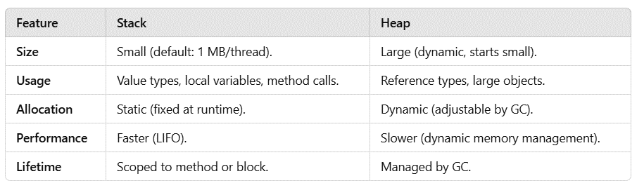

# What is time complexity ?

**Time complexity** is a measure of the computational complexity of an algorithm, how the time it takes to run an algorithm increases as the size of the input grows it helps to predict its behavior as input sizes scale up.