Software Requirements

Specification

for

Studious

Version 1.0 approved

Prepared by Hudson Cho

JHET Innovations

10.21.25

Table of Contents
Table of Contents ii
Revision History iii
Contribution Summary iiii
1. Introduction 1
1.1 Purpose 1
1.2 Document Conventions 1
1.3 Intended Audience and Reading Suggestions 1
1.4 Product Scope 1
1.5 References 1
2. Overall Description 2
2.1 Product Perspective 2
2.2 Product Functions 2
2.3 User Classes and Characteristics 2
2.4 Operating Environment 2
2.5 Design and Implementation Constraints 2
2.6 User Documentation 3
2.7 Assumptions and Dependencies 3
3. External Interface Requirements 3
3.1 User Interfaces 3
3.2 Hardware Interfaces 4
3.3 Software Interfaces 4
3.4 Communications Interfaces 4
4. System Features 5
5. Other Nonfunctional Requirements 6
5.1 Performance Requirements 6
5.2 Safety Requirements 6
5.3 Security Requirements 6
5.4 Software Quality Attributes 7
6. Other Requirements 7
7. User Stories 8
Appendix A: Glossary 8
Appendix B: To Be Determined List 8

Revision History
Name | Date | Reason For Changes | Version
Hudson | 10.19.25 | Added sections 4 and functional requirements user stories | 1.0
Hudson | 10.20.25 | Added sections 1 and 2 | 1.1
Hudson | 10.20.25 | Edited Sections 1 and 2  - Revised wording for clarity  - Revised formatting for consistency  - Rewrote 1.4 to align with instructions  - Removed unneeded information | 1.2
Hudson | 10.20.25 | Edited Section 3  - Reordered listings for consistency  - Added listings where needed  Edited Section 2  - Added diagram for 2.1  Edited Section 6  - Reordered listings  - Revised/added listings where needed  Formatted document for consistency | 1.3

SRS Document Contribution Summary
Completed refers to work done nearly or entirely solo. Contributed refers to work done as partners or a team
Name | Contributions
Hudson | - Completed section 4  - Contributed to section 7  - Assembled, formatted, and submitted final document  - Revised other sections, see Revision History
Eddie | - Completed section 1  - Completed section 2
Tehrence | - Completed section 3  - Completed section 6
Jaden | - Completed section 5  - Contributed to section 7

SRS PowerPoint Contribution Summary
Completed refers to work done nearly or entirely solo. Contributed refers to work done as partners or a team
Name | Contributions
Hudson | - Completed slide 1  - Completed slide 7  - Completed slide 8  - Completed slide 9  - Formatted, assembled, and stylized final document
Eddie | - Completed slide 2  - Completed slide 3  - Completed slide 4  - Completed slide 5  - Completed slide 6
Tehrence | - Completed slide 11  - Completed slide 12  - Completed slide 13
Jaden | - Completed slide 10

1. Introduction
1.1 Purpose
This Software Requirements Specification (SRS) document defines the software requirements for Studious, a study-themed web application designed to enhance productivity and collaboration for students and self-learners.
This document specifies all functional and non-functional requirements for the Studious v1.0 release. It focuses on the web application portion of the system. Any unrelated components, such as mobile versions, End-to-end encryption, and AI implementation, are excluded.

1.2 Document Conventions
This document follows the IEEE Std. 830-1998 format and uses the following conventions:
- Headings: Major sections are numbered (e.g., 1.0, 1.1).
- Bold Text: Indicates key terms and section titles.
- “Must” statements: Indicate mandatory requirements.
- Priorities are explicitly stated for each major requirement and are not inherited by default.

1.3 Intended Audience and Reading Suggestions
This document is intended for:
- Developers: To understand system architecture and implement features.
- Project Managers: To plan and manage deliverables and milestones.
- Testers: To develop test cases ensuring the system meets specifications.
- Stakeholders: To validate that the platform aligns with academic collaboration goals.

Document Organization:
- Section 1: Introduction
- Section 2: Overall Description
- Section 3: External interface requirements
- Section 4: System Features
- Section 5: Other Nonfunctional Requirements
- Section 6: Other Requirements
- Section 7: User Stories
- Appendixes A & B: Glossary/To Be Determined List
Readers should read through the document in sequential order to gain a full understanding of the product.

1.4 Product Scope
The scope for Studious defines the boundaries, objectives, and key use cases for the application, focusing on its academic and collaborative features. For a detailed review of the scope of our application please refer to our Scope and Vision Document located in the GitHub.

1.5 References
- IEEE Std. 830-1998: IEEE Recommended Practice for Software Requirements Specifications
- W3C Web Standards Documentation - https://www.w3.org/TR/html52/
- MDN Web Docs - https://developer.mozilla.org/
- React Developer Documentation - https://react.dev/
- Node.js Official Documentation - https://nodejs.org/
- PostgreSQL Documentation - https://www.postgresql.org/docs/
- Scope and Vision Document - https://github.com/hudcho/Studious/

2. Overall Description

2.1 Product Perspective
Studious is a standalone web application that operates as a centralized platform for academic collaboration and productivity. It does not replace any existing system but complements students’ study routines through interactive and communication-focused tools.
It will be deployed using modern web technologies, including:
- Frontend: React (with Tailwind CSS for UI styling)
- Backend: Node.js and Express
- Database: PostgreSQL
- Real-Time Communication: Socket.io
- Deployment: Frontend hosted on Vercel, Backend hosted on Render

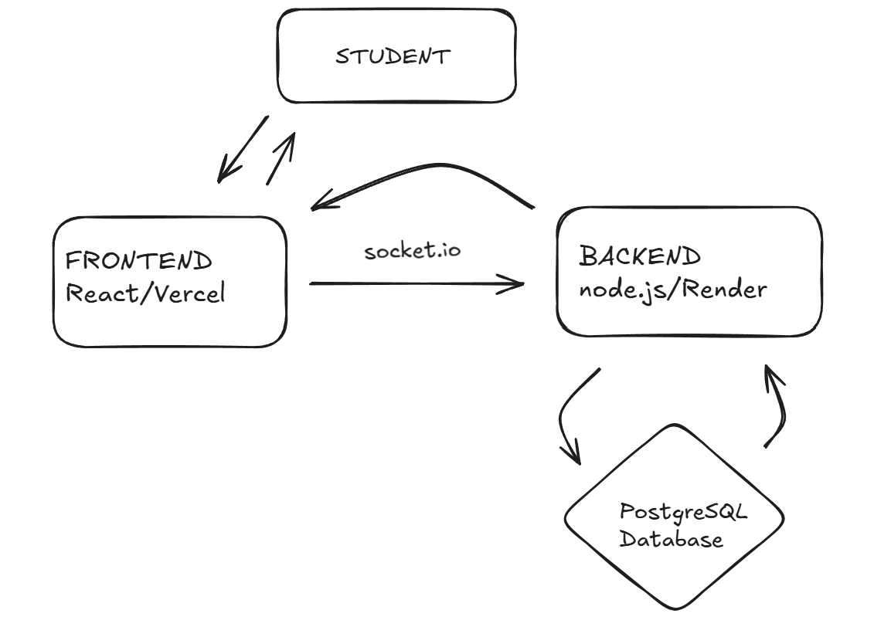
High-Level Component Diagram

2.2 Product Functions
Studious offers the following primary functions:
- Study Circles
  - Create and join collaborative study groups.
  - Group chat with text, images, and file sharing.
  - Search and discover study circles by school, class, or topic.
- Direct Messaging
  - Private one-to-one messaging between users.
  - Real-time communication supported by Socket.io.
- User Profiles
  - Customizable profiles with names, photos, schools, and subjects.
  - Friend requests and presence indicators (online, studying, offline).
- Note Sharing & Requesting
  - Upload and share study notes in groups or on user profiles.
  - Request access to shared files from other users.
- Calendar & Assignment Tracking
  - Create, view, and manage assignments or study tasks.
  - Automatically populate due dates in an interactive calendar.
- Pomodoro Timer
  - Individual or group timer sessions for productivity.
  - Track and record focus session durations.
- Interactive Study Tools
  - Flashcards, quizzes, and polls for personal or group use.

2.3 User Classes and Characteristics
User Class | Description | Technical Expertise | Frequency of Use
Students: | Primary users who collaborate in study circles and track study progress. | Basic–Moderate | Daily
Educators/Tutors: | Create or oversee group study sessions. | Moderate | Weekly
Administrators: | Manage user accounts, data integrity, and system maintenance. | Advanced | As needed

2.4 Operating Environment
Studious will operate as a web-based platform accessible from most modern browsers and desktop systems.
Supported Environments:
- Operating Systems: Windows 10+, macOS 12+, Linux (Ubuntu 20.04+)
- Browsers: Chrome (v110+), Edge (v110+), Firefox (v100+), Safari (v15+)
- Internet Connection: Required for messaging, data storage, and collaboration.

2.5 Design and Implementation Constraints
- Must be implemented using React, Node.js, Express, and PostgreSQL.
- Must use Socket.io for real-time study circle and messaging functionality.
- Must follow GDPR and FERPA compliance for data security.
- Must use HTTPS for secure client-server communication.
- Must ensure page load and response times within 3 seconds under normal load.
- Must be designed for scalability to support future cloud migration.

2.6 User Documentation
- User Manual: Comprehensive online help section within the app.
- Quick Start Guide: Provides first-time users with onboarding steps.
- FAQ Page: Accessible through the main menu.
- Developer Documentation (Internal): Covers system setup and deployment processes.

2.7 Assumptions and Dependencies
Assumptions:
- Users have reliable internet access and a modern browser.
- Users are familiar with basic online collaboration tools.
- Students and tutors will actively engage with the app’s productivity and communication features.
Dependencies:
- Node.js and Express for backend logic.
- PostgreSQL for database management.
- Socket.io for real-time communication.
- Vercel (frontend) and Render (backend) for hosting and deployment.

3. External Interface Requirements
Section 3 covers requirements related to external software, input interfaces, and other system interactions. Items listed as medium or low priority may not be included in the initial release.

3.1 User Interfaces
Req # | Features/  Function | External Interface Requirement Statement | Priority  (L, M, H)
EIR#1.0 | User  Interface | Category Header | -
EIR#1.1 | User  Interface | The system must run on a web browser via desktop and tablet interfaces. | H
EIR#1.2 | User  Interface | The system must make use of navy-blue color palette with accents of gray and white. | M
EIR#1.3 | User  Interface | The system must use Atkinsons Hyperlegible as the main font of the interface. | M
EIR#1.4 | User  Interface | The system must have a text box for writing messages to send | H
EIR#1.5 | User  Interface | The system must have a button for creating polls located beneath the text box | H
EIR#1.6 | User  Interface | The system must have a button for creating quizzes located beneath the text box | H
EIR#1.7 | User  Interface | The system must have a button for creating flashcards located beneath the text box | H

Below is an AI generated sketch of the general layout we plan to implement.
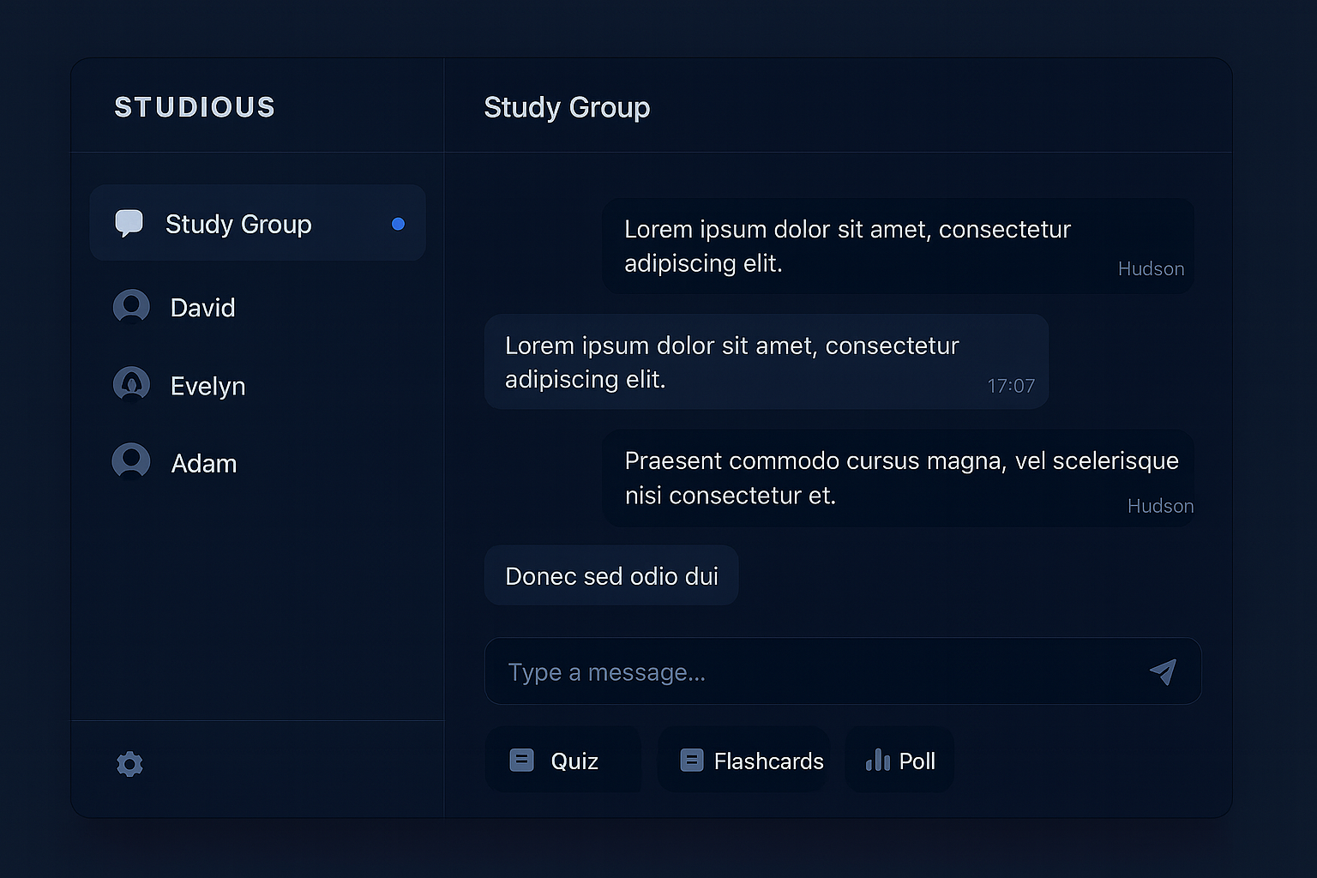

3.2 Hardware Interfaces
Req # | Features/  Function | Hardware Interface Requirement Statement | Priority  (L, M, H)
EIR#2.0 | Hardware | Category Header | -
EIR#2.1 | Hardware | The system must operate without the use of specialized hardware. | H

3.3 Software Interfaces
Req # | Features/  Function | External Interface Requirement Statement | Priority  (L, M, H)
EIR#3.0 | Software  Requirements | Category Header | -
EIR#3.1 | Software Requirements | The system must utilize a React based frontend hosted on Vercel | M
EIR#3.2 | Software Requirements | The system must utilize a Node.js based backend hosted on Render | M
EIR#3.3 | Software  Requirements | The system must utilize a PostgreSQL database to store user data, chat logs, and other relevant system data. | L
EIR#4.0 | Security | Category Header | -
EIR#4.1 | Security | The system must utilize JSON Web Tokens to support secure authentication and session management. | H

3.4 Communications Interfaces
EIR#5.0 | Communication | Category Header | -
EIR#5.1 | Communication | The system must allow real-time communication using Socket.io services. | H
EIR#5.2 | Communication | The system will support HTTPS and SSL certificates for all client-server communication. | H

4. System Features
Below are the core functional requirements that will be included in the Studious application. Items listed as medium or low priority may not be included in the initial release.

Req # | Features/  Function | Functional Requirement Statement | Priority  (L, M, H)
FR#1.0 | Profile  Management | Category Header
FR#1.1 | Profile Management | The system must allow users to create an account profile. | H
FR#1.2 | Profile Management | The system must allow users to delete their account profile. | H
FR#1.3 | Profile Management | The system must allow users to reset their password. | H
FR#1.4 | Profile Management | The system must allow users to log into the system. | H
FR#1.5 | Profile Management | The system must allow users to log out of the system. | H
FR#1.6 | Profile Management | The system must allow users to modify/edit their account profile information. | H
FR#1.7 | Profile Management | The system must allow users to upload a profile photo. The system must validate file type and size. | H
FR#1.8 | Profile Management | The system must allow users to upload a bio to their profile. The system must limit the bio to 600 characters | M
FR#1.9 | Profile Management | The system must allow users to upload school information to their profile including school, graduation year, and currently enrolled classes. | H
FR#1.10 | Profile Management | The system must allow users to upload files to their profile that can be downloaded by other users. | L
FR#1.11 | Profile  Management | The system must allow users to set a status indicator: online, away, studying, or offline | L
FR#2.0 | Communication | Category Header | -
FR#2.1 | Communication | The system must allow users to send text and images through a study circle | H
FR#2.2 | Communication | The system must allow users to send text and images through direct messaging | H
FR#2.3 | Communication | The system must allow users to create study circles. | H
FR#2.4 | Communication | The system must allow users to delete study circles they have created. | H
FR#2.5 | Communication | The system must allow users to join study circles. | H
FR#2.6 | Communication | The system must allow users to leave study circles. | H
FR#2.7 | Communication | The system must allow users to vote kick members of the study circle for moderation purposes. | M
FR#2.8 | Communication | The system must allow users to invite other users into a study circle via direct messaging. | M
FR#2.9 | Communication | The system must allow users to send direct messages to each other. | H
FR#3.0 | File  Sharing | Category Header | -
FR#3.1 | File  Sharing | The system must allow users to upload files to a shared repository located in each study circle. | H
FR#3.2 | File  Sharing | The system must allow users to send files in direct messaging. | H
FR#4.0 | Assignment  Tracking | Category Header | -
FR#4.1 | Assignment Tracking | The system must allow users to create tasks. | H
FR#4.2 | Assignment Tracking | The system must allow users to delete tasks. | H
FR#4.3 | Assignment Tracking | The system must allow users to edit tasks. | H
FR#4.4 | Assignment Tracking | The system must allow users to add due dates for tasks. | H
FR#4.5 | Assignment Tracking | The system must allow users to edit due dates for tasks. | H
FR#4.6 | Assignment Tracking | The system must allow users to filter tasks by class, due date, or name. | H
FR#4.7 | Assignment Tracking | The system must have a calendar and list view of all tasks. | H
FR#4.8 | Assignment Tracking | The system must allow users to mark tasks as complete. | H
FR#4.9 | Assignment Tracking | The system must allow users to share tasks as group tasks. | M
FR#4.10 | Assignment Tracking | The system must allow users to assign subtasks to group members. | M
FR#5.0 | Study  Tools | Category Header | -
FR#5.1 | Study  Tools | The system must allow users to start a pomodoro timer for individual use. | H
FR#5.2 | Study  Tools | The system must allow users to start a pomodoro timer that syncs across all users in a study circle. | H
FR#5.3 | Study  Tools | The system must allow users to create polls within a study circle. | M
FR#5.4 | Study  Tools | The system must allow users to create quizzes within a study circle. | M
FR#5.5 | Study  Tools | The system must allow users to create flashcards within a study circle. | M
FR#6.0 | Social  Networking | Category Header | -
FR#6.1 | Social  Networking | The system must allow users to send friend requests. | H
FR#6.2 | Social  Networking | The system must allow users to accept or decline friend requests. | H
FR#6.3 | Social  Networking | The system must allow users to remove friends. | H
FR#6.4 | Social  Networking | The system must allow users to view their friend list. | H
FR#7.0 | Security | Category Header | -
FR#7.1 | Security | The system must securely store user data. | H
FR#7.2 | Security | The system must securely store user passwords as encrypted hashes. | H
FR#7.3 | Security | The system must allow users to set their profile to public or private. | H
FR#7.5 | Security | The system must validate all user input to prevent injection attacks. | M
FR#8.0 | Search | Category Header | -
FR#8.1 | Search | The system must allow users to search for study circles by name, class, or school. | H
FR#8.2 | Search | The system must allow users to search for other users by username, school, or class. | M
FR#9.0 | Data  Storage | Category Header | -
FR#9.1 | Data  Storage | The system must ensure user data remains persistent across sessions. | H
FR#10.0 | Administrative  Tools | Category Header | -
FR#10.1 | Administrative  Tools | The system must support administrator users that will have special privileges. | H
FR#10.2 | Administrative  Tools | The system must allow administrators to delete users and study circles. | H
FR#10.3 | Administrative  Tools | The system must log errors for administrators to review. | H
FR#10.4 | Administrative  Tools | The system must allow administrators to configure system settings. | H
FR#10.5 | Administrative  Tools | The system must log every administrative action with a user and timestamp for later review | H
FR#11.0 | System  Requirements | Category Header | -
FR#11.1 | System  Requirements | The system must respond to user actions within 3 seconds under normal conditions. | H
FR#11.2 | System  Requirements | The system must support concurrent user access for multiple users. | H
FR#11.3 | System  Requirements | The system must be able to support TBD users concurrently | H
FR#11.4 | System  Requirements | The system must allow users to permanently delete their data upon request. | H
FR#11.5 | System  Requirements | The system must permanently delete all data associated with a study circle when the study circle is deleted. | H

5. Other Nonfunctional Requirements

5.1 Performance Requirements
<If there are performance requirements for the product under various circumstances, state them here and explain their rationale, to help the developers understand the intent and make suitable design choices. Specify the timing relationships for real time systems. Make such requirements as specific as possible. You may need to state performance requirements for individual functional requirements or features.>

Only work when connected to wifi
Think of more, communicate w team for help, possibly use chatgpt for ideas (make sure they are realistic and align with the project/other members work)

Req # | Technical  Category | Non-Functional Requirement Statement | Priority  (L, M, H)
PR#1 | Performance | The system will …….. | H

5.2 Safety Requirements
<Specify those requirements that are concerned with possible loss, damage, or harm that could result from the use of the product. Define any safeguards or actions that must be taken, as well as actions that must be prevented. Refer to any external policies or regulations that state safety issues that affect the product’s design or use. Define any safety certifications that must be satisfied.>

Req # | Technical  Category | Non-Functional Requirement Statement | Priority  (L, M, H)
SR#1 | Safety | The system will …….. | H

Research any policies or regulations that would apply to our project
Research if well have any of these

5.3 Security Requirements
<Specify any requirements regarding security or privacy issues surrounding use of the product or protection of the data used or created by the product. Define any user identity authentication requirements. Refer to any external policies or regulations containing security issues that affect the product. Define any security or privacy certifications that must be satisfied.>

JSON Web tokens for authentiaiton
Researfh external security policies
We want secure authentication
We want users to trust the system
Find stuff that satifies above thigns

Req # | Technical  Category | Non-Functional Requirement Statement | Priority  (L, M, H)
SC#1 | Security | The system will …….. | H

5.4 Software Quality Attributes
<Specify any additional quality characteristics for the product that will be important to either the customers or the developers. Some to consider are: adaptability, availability, correctness, flexibility, interoperability, maintainability, portability, reliability, reusability, robustness, testability, and usability. Write these to be specific, quantitative, and verifiable when possible. At the least, clarify the relative preferences for various attributes, such as ease of use over ease of learning.>

Key ones are gonna be maintainability, testability, useability, scaleability, correctness, etc etc etc

Req # | Technical  Category | Non-Functional Requirement Statement | Priority  (L, M, H)
SQ#1 |  | The system will …….. | H

Add any and all of the non-functional requirements defined below, to ensure a complete set of technical and system requirements. Each may include a Section and table of appropriate requirements:

Technical Requirements Statements
- Infrastructure/Connectivity
- Hardware
- Usability
- Technology

System Requirements Statements – covering all areas defined below
- Data Retention
- Backup & Recovery
- System Audit / Logging
- Service Level Agreements
- Disaster Recovery
- Contingency Plans

6. Other Requirements
Below are the other requirements that did not fit elsewhere in the document. Items listed as medium or low priority may not be included in the initial release.

Req # | Features/  Function | Other Requirement Statement | Priority  (L, M, H)
OR#1.0 | Documentation | Content Header | -
OR#1.1 | Documentation | The system must maintain up-to-date project documentation throughout the semester. | H
OR#1.2 | Documentation | The system will include a user guide and quick-start manual for end-users. | M
OR#2.0 | COSC412  Requirements | Content Header | -
OR#2.1 | COSC412  Requirements | The system must be completed and deployed before the semester deadline for evaluation. | H
OR#2.2 | COSC412  Requirements | The system must have all source code version-controlled using GitHub with weekly commits. | H
OR#2.3 | COSC412  Requirements | The system will provide a demo presentation to stakeholders at the end of implementation. | H
OR#3.0 | Scalability | Content Header | -
OR#3.1 | Scalability | The system must be designed to handle multiple concurrent users without performance degradation | M
OR#3.2 | Scalability | The system must be thoughtfully designed to allow for scalability in the future | M
OR#4.0 | MISC. | Content Header | -
OR#4.1 | Open  Source | The system will use only open-source or educational licenses for all libraries and frameworks. | M
OR#4.2 | Backups | The system will back up all design and source artifacts to GitHub weekly. | H
OR#4.3 | Post  Deployment | The system will include a post-release maintenance plan following MVP delivery. | L
OR#4.4 | Accessibility | The system’s UI must meet accessibility standards aligned with WCAG 2.1 AA guidelines. | M

7. User Stories
<Define a series of user stories representative of the core functionality from the perspective of your various users. The user stories will define what the system will do and WHY the system will do it for the specific users. Follow the format below, and ensure your user stories are aligned to the functionality you defined above in your functional requirements>

<Below are some examples using the format required>

USER STORY ID |  | ROLE |  | FUNCTION PERFORMED |  | BUSINESS REASON
US#1 | As a | Student | I need the system to | Provide a way for users to upload information about their current coursework, grade level, and attending school | so that I may | Connect with my peers that are taking similar courses, in the same grade, or in the same school as collaborating with these peers would be the most beneficial.
US#2 | As a | Student | I need the system to | Support sharing text, images, and files within direct messaging and within study circles | so that I may | Share notes, assignments, and collaborate more effectively with my peers
US#3 | As a | Student | I need the system to | Support messaging through both direct messaging as well as study circles | so that I may | Collaborate with my peers over a service that is specifically designed to support learning and education

Appendix A: Glossary
<Define all the terms necessary to properly interpret the SRS, including acronyms and abbreviations. You may wish to build a separate glossary that spans multiple projects or the entire organization, and just include terms specific to a single project in each SRS.>

After everyone has submitted their work go through and fill out the Appendix sections

Appendix B: To Be Determined List
<Collect a numbered list of the TBD (to be determined) references that remain in the SRS so they can be tracked to closure.>

List here any open questions or things you know still need to be done to the SRS, but haven’t been addressed yet.

Not sure what tbd means if that means documents or features or idk. Researfh the correct answer.

