This project is a simple multiplayer game, written in Java and using UDP sockets. Each player controls a colored rectangle in a 2d environment with the ability to move (left and right arrows), jump (space bar), and push each other around.

Compilation: “make”, “make all”, or “make DistGame”
Execution: “java DistGame”

Upon startup, the program joins a multicast socket group (the lobby), allowing the user to see a list of all currently running instances of the game. If the player joins an existing game (by selecting it in the list and clicking “Join Game”), they enter a separate socket group specifically for that game and begin to update other players on their location. Each machine is responsible for informing all other machines of their location in real time. Each player also keeps their own dynamic list of other players present in the game, so that players can join or leave at any time. The only partial exception to this is the host: when a player creates a new game (by entering a game name in the top text field and clicking “New Game”), they become the host of that game and their machine is responsible for sending continuous messages to the lobby group so that new players can see their game. If the host leaves their game, other players that are already present will be unaffected, but new players will be unable to see or join the game.
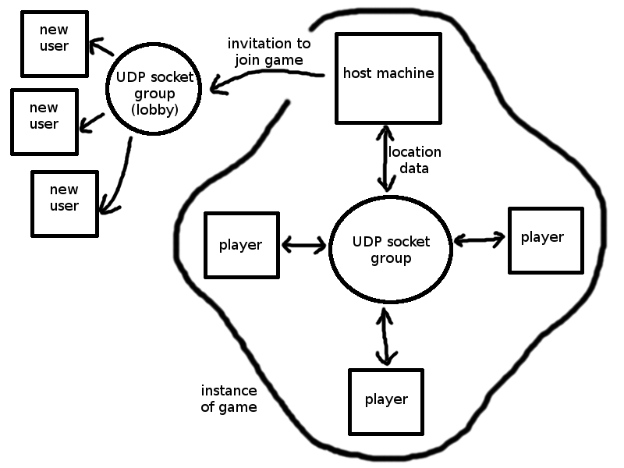
Usage notes: If two players create games with the same name, they will effectively be in the same game, but both attempting to fill the role of the host. This causes undefined behavior. Also, an empty string is a valid game name, but will be effectively invisible in the game list.

