

Project Proposal

**WebShelf**

Prepared by

Jacinta Mba

Ramya Paarthasarathy

Venkata SrivalliPrasanna

Xianying Liu

CIS 435/525

Web Technology

Department of Computer & Information Science

Submitted to Professor Jinhua Guo

Oct 2nd, 2014

**TABLE OF CONTENTS**

Contents

1. STUDENT COMMUNITY WEBSTORE 3

1.1 OBJECTIVE 3

1.2 PURPOSE 3

1.3 PROJECT SCOPE 3

2. HIGH-LEVEL DESIGN 3

2.1 USER PROFILES 3

2.1.1 Seller Menu 3

2.1.2 Buyer Menu 4

2.1.3 Administrator Menu 4

2.1.4 General Menu 4

2.2 USE CASES 4

2.3 USE CASE DIAGRAM 4

3. PROJECT PLAN 8

3.1 TASKS, WORK ALLOCATION & MILESTONES 8

3.2 MILESTONES & PROGRESS MEASUREMENTS 9

3.2 PLATFORM & TECHNOLOGIES 9

3.3 OPEN ISSUES 10

4. APPENDIX 10

# **1. STUDENT COMMUNITY WEBSTORE**

## 1.1 OBJECTIVE

Aim of the project is to develop a web store that provides C2C sales services for the student community of a university. The web application will basically enable the students to buy and sell books - textbooks, competitive exam materials and other literary works – both in new and used condition.

## 1.2 PURPOSE

It is well known that students are forced to buy new books each term at exorbitant rates only to discard them after the end of the term. Also newly admitted students spend lot of money buying school supplies and dorm essentials. Creating an online platform where the students can collaborate and connect with each other seems beneficial to everyone so they can buy items for affordable prices and others trade off old ones for reasonable cash. Also this eliminates credit card charges and shipping costs as the students can arrange to meet at the campus and collect the items in person. The web store would also feature other used items for sale such as calculators, small utility appliances, electrical and electronic stuff at lower prices.

## 1.3 PROJECT SCOPE

The web store application to be developed comprises a database at the back-end and a web-based user interface to access the system. The web application provides the following features to its users:

1. Buy and sell books and other items
2. Browse through the catalog
3. Search for items by name or category
4. Display information about the item listed on the web store –
5. In case of the book the information includes name, author, publisher, genre, edition, year, reviews
6. In case of other goods, the information can include name, description, size, condition etc.
7. Display list of related items or suggestions for future purchase
8. Seller's profile
9. Buyer's profile
10. Share your purchases on Facebook/email
11. Buyers and sellers can send messages to each other in the web store

# **2. HIGH-LEVEL DESIGN**

## 2.1 USER PROFILES

The major users of this application are the students with two profiles – Buyer and Seller. The application would customize the menus/options based on the profile selected. However the search and browse feature would always be available from any screen or page. Following are initial set of menus to be designed.

### 2.1.1 Seller Menu

· Seller Information – Name, Email Id and Contact number

· View Item listings

· Sold item history

· Add items to catalog

· Positive feedback percentage

· Edit an item – prices, description or to mark it as ‘Sold’ etc.

### 2.1.2 Buyer Menu

· Buyer Information – Name, Email Id and Contact number

· View Purchase orders

· Leave feedback/review

### 2.1.3 Administrator Menu

· Add users to blacklist

· Delete an item posted

· Send broadcast message to all buyers/sellers

### 2.1.4 General Account Menu

· · Register with university email id

· Log in

· My Account

Change email, password or phone number

Sign out

· Sell Item (Post an item for sale)

· Search field

· Catalog to browse

· Mail box

## 2.2 USE CASES

Following are the use cases identified as part of the initial design:

1. Register (Create an account with university email id for new users)
2. Log in to the user account
3. Change/update profile information
4. Search for an item
   1. Search by name, category
   2. Browse through the catalog
5. Buy Items
6. View Purchase orders
7. Give feedback/review
8. Add items to catalog
9. Change/update Item details
10. View Items listings
11. View sold history
12. Buyer/Seller messaging (i.e. Contact seller/buyer via email)

## 2.3 USE CASE DIAGRAM

**1.** **Register**

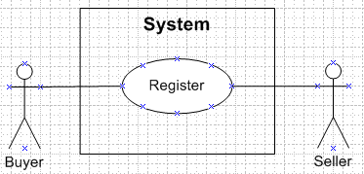

**2.** **Log in to the user account**

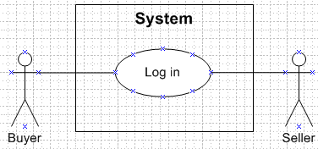

**3.** **Change/update Profile information**

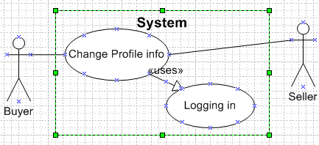

**4.** **Search for an item**

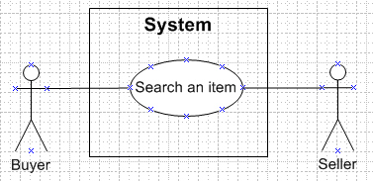

**5.** **Buy Items**

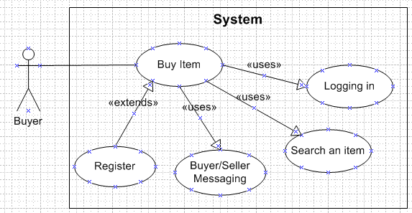

**6.** **View Purchase Orders**

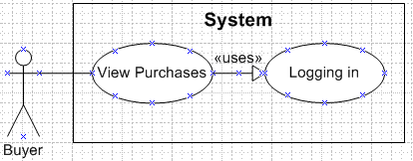

**7.** **Give feedback or review**

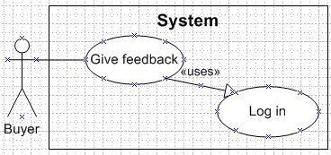

**8.** **Add Items to Catalog**

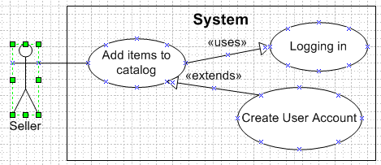

**9.** **Change/update Item details**

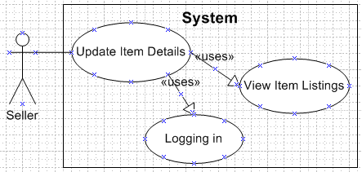

**10. View item listings**

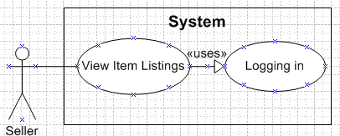

**11.** **View sold history**

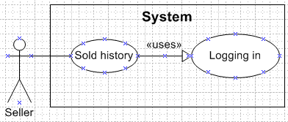

**12. Buyer/Seller messaging**

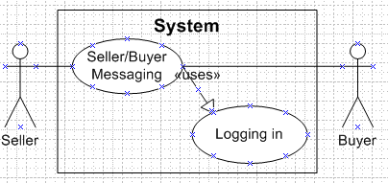

# **3. PROJECT PLAN**

## 3.1 TASKS & WORK ALLOCATION

Listed below is snapshot of Tasks involved in building the web application:

1. Analyze the requirements
2. Prepare detailed level design for use cases
3. Describe in detail the functionalities of the application
4. Design and construct the database
5. Develop program/modules to achieve the functionalities
6. Design and implement Login/Logout/Signup modules
7. Design and implement logics for Buyer/Seller/Administrator pages
8. Design and implement views for Buyer/Seller/Administrator pages
9. Design and implement message/order/report modules
10. Review the code and perform unit testing
11. Integrate the modules and perform system level testing

A team of four members would work on the project. Work will be allocated at the start of each task. Following is the allocation for the first deliverable ‘Project proposal’:

**Team members Tasks**

Jacinta Mba Application logic, Code review and testing

Ramya Paarthasarathy Use case diagrams, Database design and creation, data upload

Venkata SrivalliPrasanna Screen design, Front end interface development

Xinyang Liu Application logic implementation, review and testing

**3.2 MILESTONES & PROGRESS MEASUREMENT**

As the complete web store is a complicated system, we set up 3 milestones to measure the progress of our project. We will get to Milestone A in October. After that, the main structure of our web store will be settle down. Then we can move forward to Milestone B. For the progress report on November 6, we will report all the work done in Milestone A and part of the work in B. Before December 4, the final presentation, we will get to Milestone B and most of the functions for our web store should be completed. If we get to Milestone B early, we will try to work on C. As those listed in C are challenge problems, we can’t promise to finish all of them.

**Milestone A:**

1. Login/Logout/Signup as Buyer
2. Retrieve the posts from database and display them
3. Display the detail information of the products in selected post
4. Jump between pages and keep login state

**Milestone B:**

1. Login/Logout/Signup as Buyer/Seller/Administrator
2. Sellers can create and edit posts
3. Buyers can look for products by catalog
4. Buyers and Sellers can send message to each other
5. Administrator can manage the website and users

**Milestone C:**

1. Users can search products by keywords
2. Users can online chat with each other
3. Buyers can review and edit shopping carts on most pages
4. For a complete order, sellers and buyers can close it, generate reports, give feedbacks to each other or give reviews to the products.

## 3.3 PLATFORM & TECHNOLOGIES

Web Hosting service: AWS EC2, RDS

OS: Amazon Linux AMI release 2014.03

Web server: Apache2

Front -end language: HTML5, CSS, Javascript

Back-end language: PHP

Database: RDS MySQL

## 3.4 OPEN ISSUES

1. Two of the team members are new to PHP platform. It has been decided that the new developers would learn and ramp up to speed on PHP programming.
2. As the online chatting may be hard to implement, we will implement the static message(like email) first.
3. Online cooperation in design/coding/testing is a big challenge for us, we may need to have online meeting frequently, make the interfaces clear and manage the codes by git.

**4. APPENDIX**

**4.1 SAMPLE SCREEN SHOTS**

**Home screen**

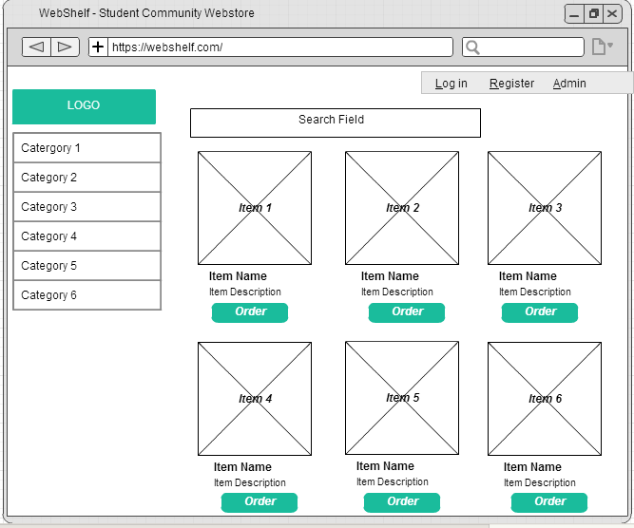

**Item Details**

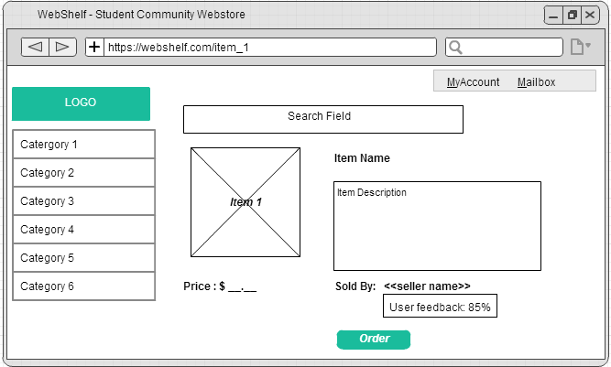

**Log in Screen**

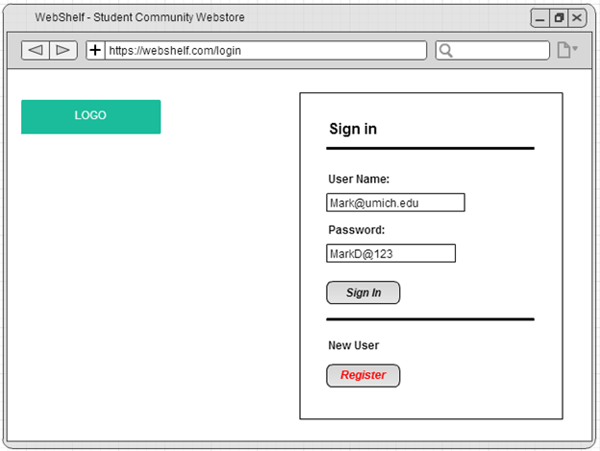

**Register**

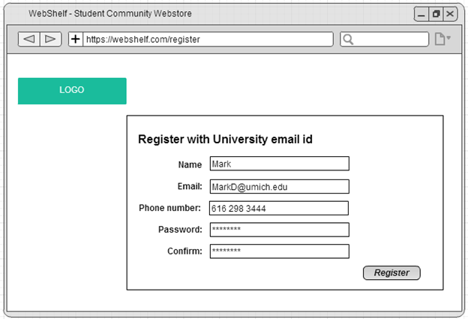

**User Menu - MyAccount**

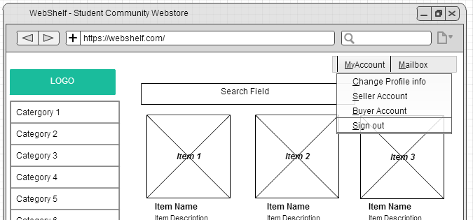

**Change Profile info**

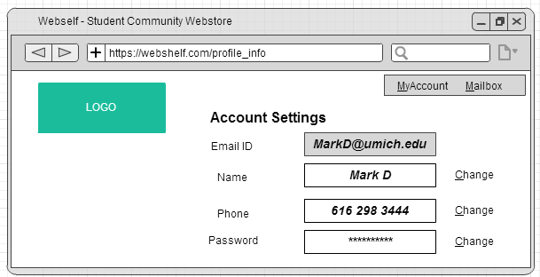

**Buyer Account: View Order history**

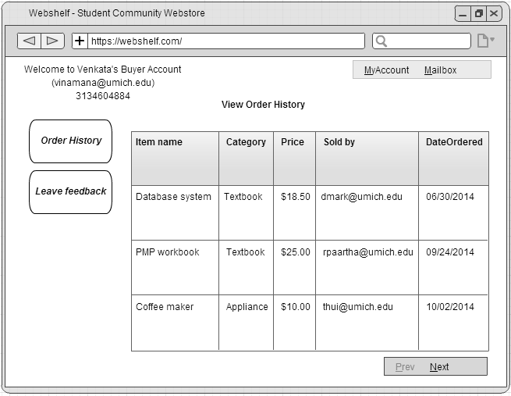

**Buyer: Leave feedback**

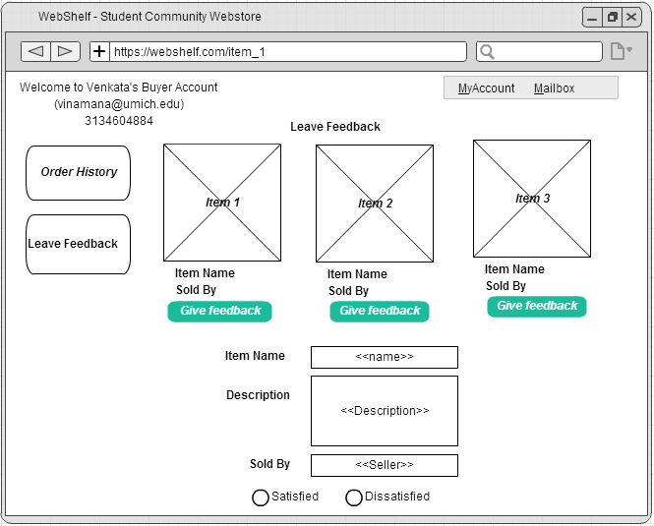

**Seller: Add Item for sale**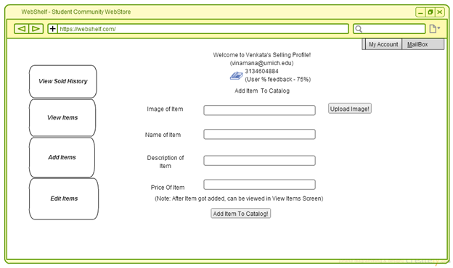

**Seller: View Item Listings**

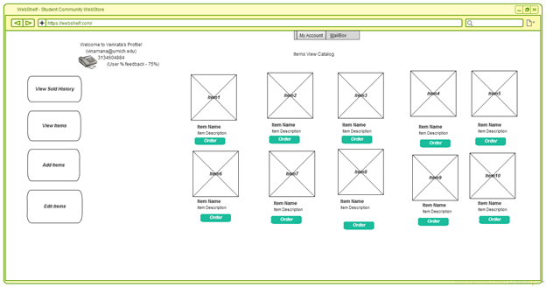

**Seller: Edit Item**

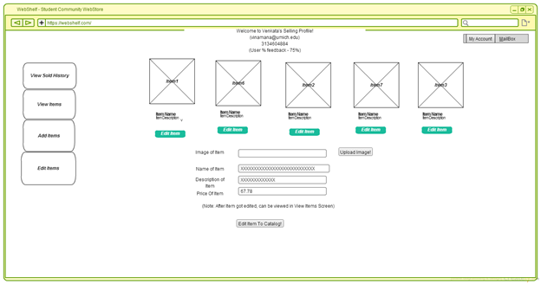

**Seller:View sold history**

