Integrador Sistema Avon

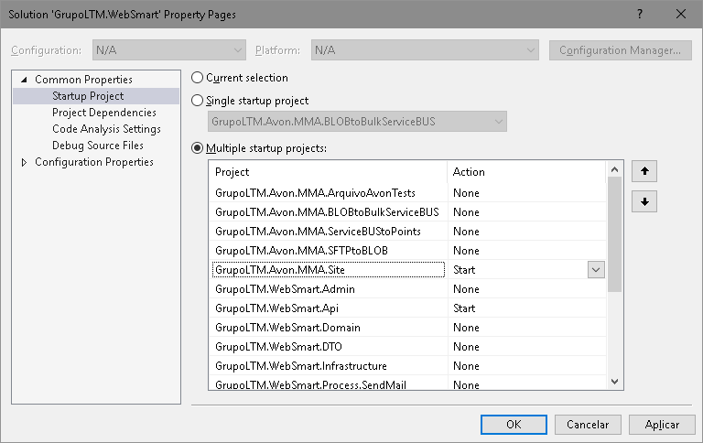

WebJobs (Executa como se fosse um console application)

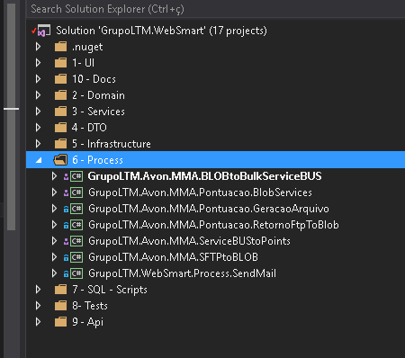

URLS Base

73751407

73751407AvonLtm (MD5 maiúsculo) = EC3996236727397A698E9F12F3100D3E

.../avonAuthentication/40267/catalogo/?a=73751407&encryptedKey=EC3996236727397A698E9F12F3100D3E

.../avonAuthentication/40267/extrato/?a=73751407&encryptedKey=EC3996236727397A698E9F12F3100D3E