Use of Musculoskeletal Rodent Models for Investigating Neuromuscular Injury and Rehabilation
Hudson Burke
Table of contents

Abstract

Acknowledgements
To my advisor, Dr. Shawn Russell for his mentorship, guidance, and support throughout this project. To Dr. Xiao Hu, for his invaluable insights and contributions to the development of the musculoskeletal model. To Dr. Siddharth Singh, for his continual reminder of what’s important and his unwavering support.
To my parents, who have always believed in me, encouraged me to pursue my passions, and supported me in every step of my journey.

1. Introduction
- ~1.5 pgs

2. Rat VML Analysis

2.1 Introduction
Volumetric muscle loss (VML) causes permanent loss of functional muscle tissue and often leads to long-term deficits in strength, coordination, and locomotor performance. In both preclinical and clinical settings, histologic evidence of tissue remodeling does not always translate to functional recovery, making biomechanics a critical endpoint for evaluating treatment efficacy.
Rodent gait analysis paired with inverse dynamics provides a sensitive framework for detecting compensatory strategies that may persist even when gross behavior appears improved. Joint-level kinematic and kinetic metrics can reveal whether therapies restore native function or simply shift load to other joints and muscle groups.
This chapter compares long-term functional outcomes across six VML treatment strategies using spatiotemporal parameters, gait kinematics, and inverse-dynamics joint moments. The primary objective is to determine which interventions most effectively reduce pathological gait compensations relative to no repair and to an uninjured control dataset.

2.2 Methods

2.2.1 Experimental Design
Forty-eight 12-week-old female Lewis rats were divided into six treatment groups, with eight rats per group. A 20% by-mass volumetric muscle loss (VML) injury was created in the left lateral gastrocnemius (LG) muscle of each animal. The first group was a No Repair (NR) control, where the injury site was left empty. The second group received a Tissue-Engineered Muscle Repair (TEMR), which involved filling the site with a cell-seeded bioscaffold. The third and fourth groups received acellular treatments, consisting of either a pro-regenerative Healy Hydrogel (HH) or a porous collagen Healy Sponge (HS). The final two groups received combination treatments: one group was given the TEMR construct with the Healy Hydrogel (TEMR+HH), and the other received the TEMR construct with an acellular keratin gel (TEMR+KG). Functional assessment was performed 24 weeks post-surgery and each group was compared to the group that received no repair to clarify trends in recovery or decline. A previously collected dataset of 32 animals was used as the Control group.

2.2.2 Animal Care and Surgical Procedures
All animal procedures were approved by the University of Virginia Animal Care and Use Committee and conducted in compliance with the Guide for the Care and Use of Laboratory Animals, the Animal Welfare Act, and implementing Animal Welfare Regulations. Lewis rats (Charles River Laboratories) were pair-housed in a vivarium accredited by the American Association for the Accreditation of Laboratory Animal Care with ad libitum access to food and water.
The VML injury surgery was performed in accordance with previously published methods (TODO: add Merritt citation key). The LG was exposed and a 20% distal portion was excised by mass. The assigned repair material was then implanted into the defect following published methodologies (TODO: add Corona/Machingal citation keys). No repair material was implanted in the No Repair (NR) group. The overlying fascia was closed with 6-0 vicryl sutures, and the skin was closed with 5-0 prolene interrupted sutures with skin glue to reduce risk of wound reopening.
Prior to surgery, slow-release buprenorphine was administered (0.1 mg/kg, subcutaneously). All surgical procedures along with shaving and motion capture marker placement were performed under continuous isoflurane anesthesia inhalation (1.5–2.5%). The depth of anesthesia was monitored by the response of the animal to a slight toe pinch, where the lack of response was considered the surgical plane of anesthesia. A heated water perfusion system was utilized for core temperature maintenance. Post-operative analgesia was provided with quick-release buprenorphine (0.1 mg/kg, subcutaneously) at 36 and 48 hours. No animal required additional analgesia after 48 hours post-surgery as determined by veterinary staff that monitored for pain and distress.

2.2.3 Motion Capture and Gait Analysis
After 24 weeks to allow for injury progression or healing, gait data was collected for each rat in the treatment groups. Reflective markers were adhered to bony landmarks on the pelvis and joint locations on the hindlimb based on the set described by Johnson et al. (2008) and utilized in previous studies by this group (Dienes 2019, 2022). Marker locations were: (1) L6 vertebra, (2) 5th caudal vertebra, (3-4) left and right anterior iliac crests, (5-6) left and right greater trochanter of the femur, (7-8) left and right lateral femoral epicondyle, (9-10) left and right lateral malleolus, and (11-12) left and right lateral aspect of the distal end of the 5th metatarsal. After an acclimation period, rats walked along an instrumented walkway while motion was captured with a seven-camera Vicon system recording marker data at 200Hz and synchronized with four in-ground ATI six-axis force transducers recording ground reaction forces at 1000 Hz. A minimum of three successful trials wherein one complete steady-state gait cycle, defined from foot strike to foot strike, per hindlimb without overlap on a force plate during stance phase were collected for each rat at each time point.

2.2.4 Gait Modeling and Statistical Analysis
Marker trajectories and ground reaction force data were filtered using a 4th-order low-pass Butterworth filter (cutoff frequencies 15 Hz and 100 Hz, respectively). For each rat, a subject-specific OpenSim model of the hindlimbs was generated from limb measurements and previously acquired limb anthropometrics (dienesAnalysisModelingRat2019?; hicksKinematicKineticGait2023?). OpenSim inverse kinematics and inverse dynamics tools were used to compute hindlimb joint angles and joint moments. Reported data correspond to one gait cycle, with stance and swing of the right stride reported independently to minimize apparent phase differences caused by velocity variation.
Moments were normalized to total body mass multiplied by total body length, consistent with common biomechanics practice (winter?). Limitations of this normalization strategy are addressed in the Discussion. Spatiotemporal parameters (STPs) were calculated in Vicon Nexus using standard definitions (TODO: add Huxley citation key). At the 24-week endpoint, STPs were compared between each treatment and the NR group using unpaired two-sided t-tests. For time-series kinematic and kinetic data, Statistical Parametric Mapping (SPM) with unpaired t-tests was used to identify significant regions across the gait cycle (TODO: verify Pataky citation key).
Because multiple endpoints and waveform regions were examined, these analyses should be interpreted as comparative and exploratory in this chapter. Significance was set at alpha = 0.05. In figures, red highlighted regions indicate significant difference versus NR, and black highlighted regions indicate significant difference versus Control.

2.3 Results

2.3.1 Spatiotemporal Parameters
Stride length, step width, and velocity are normalized by leg length calculated by summing the femur and tibia lengths.
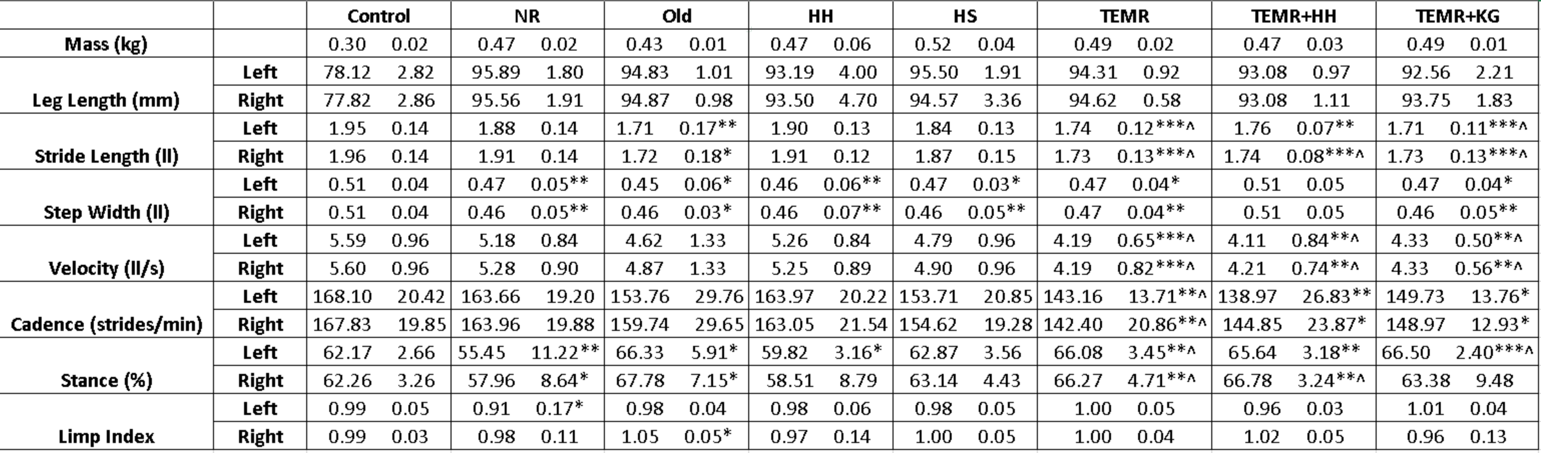
Figure 2.1: Spatiotemporal parameter summary at 24 weeks post-injury, with symbols denoting pairwise significance versus No Repair and Control.
^, , ^ indicates p < 0.05, 0.01, 0.001 respectively compared to NR
*, **, *** indicates p < 0.05, 0.01, 0.001 respectively compared to Control
The No Repair group had a significantly narrower step width and decreased stance percentage compared to the control group. This narrower step width was reflected in nearly every other treatment except the TEMR+HH group. All groups that received some form of TEMR treatment moved significantly slower compared to both the Control and No Repair groups. This was coupled with significant increases in stance percentages and decreases in stride lengths compared to the Control group.

2.3.2 Kinematics and Kinetics

2.3.2.1 No Repair (NR)
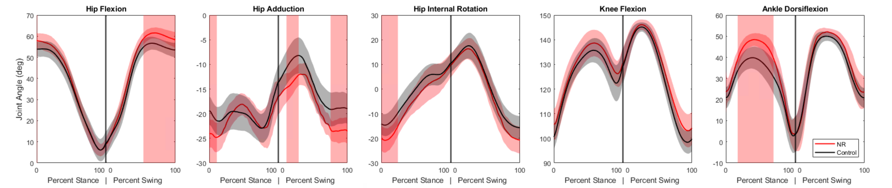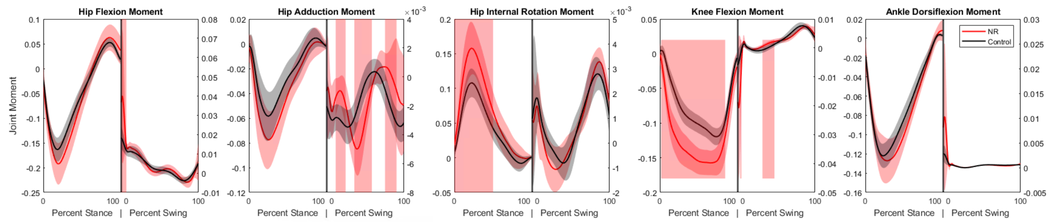
The primary differences seen in the injured subjects compared to the control dataset were an increased ankle dorsiflexion angle during mid-stance coupled with increases in the knee extension and hip internal rotation moments. These changes suggest that to compensate for the loss of plantarflexor function, the animals are adopting a gait strategy that reduces the demand on the ankle joint by increasing dorsiflexion and utilizing more proximal musculature to generate the necessary extension moments at the knee and hip. Effective therapies would be expected to mitigate these compensations and restore more normal kinematic and kinetic patterns.

2.3.2.2 Healy Hydrogel (HH)
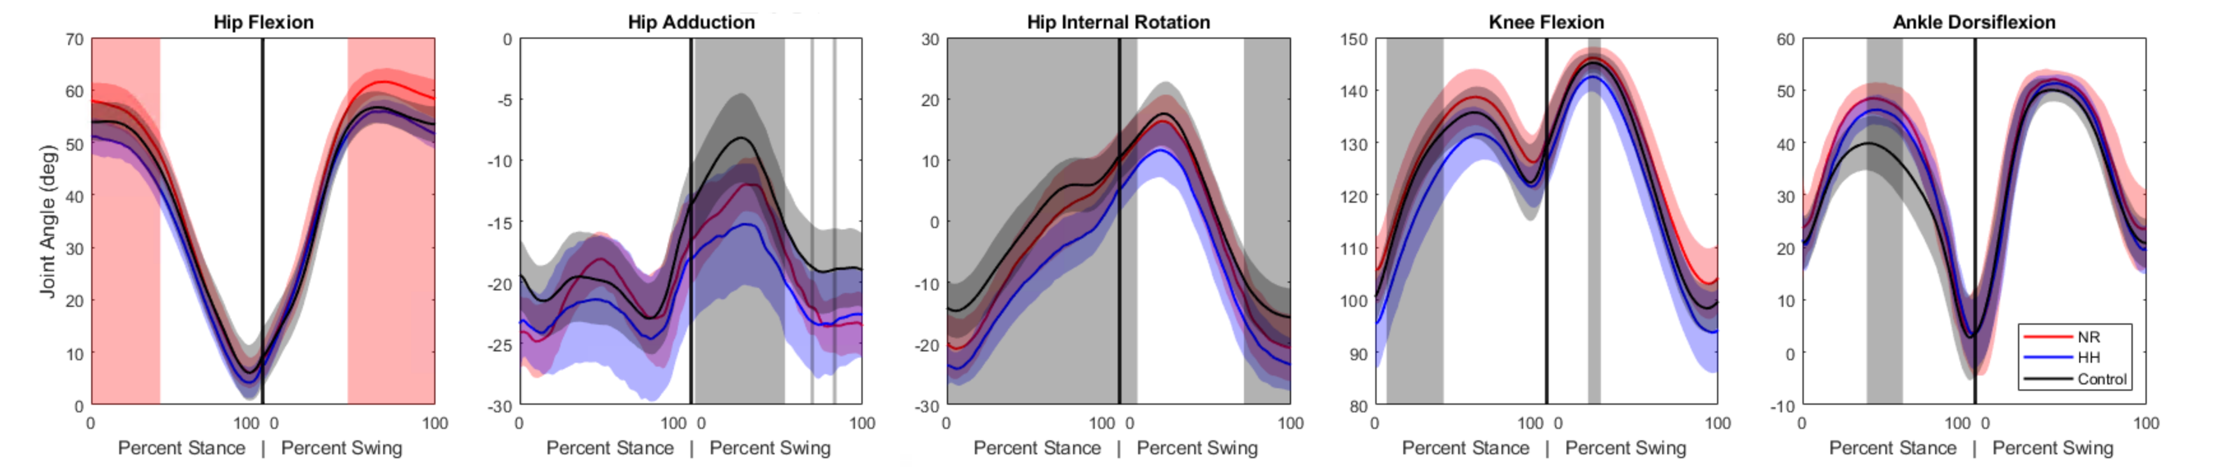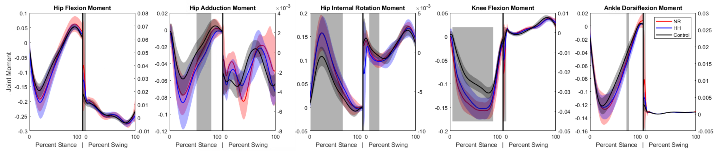
The Healy Hydrogel group demonstrated very similar kinematic and kinetic patterns to the No Repair group, with increased ankle dorsiflexion during mid-stance and elevated knee extension and hip internal rotation moments. Significance was also seen in some other kinematic measures, but this is likely a result of variability in marker placement. This suggests that the hydrogel alone did not provide sufficient functional recovery to alter the compensatory gait strategies observed in the No Repair group.

2.3.2.3 Healy Sponge (HS)
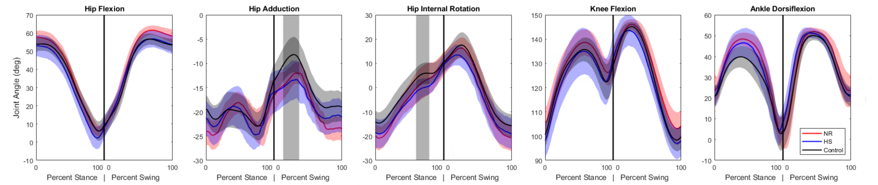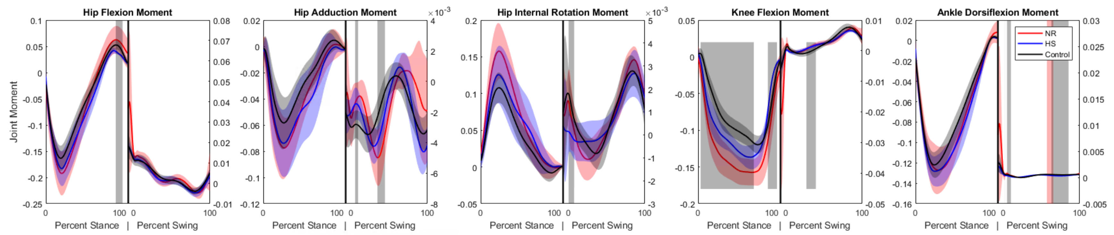
The Healy Sponge group exhibited kinematic and kinetic patterns more similar to the Control group compared to the No Repair and Healy Hydrogel groups. While some significant difference remained in the knee extension moment, the curve shifted away from the trajectory seen in the No Repair group and towards the Control group, and the overall patterns suggested a trend toward normalization of gait mechanics. The difference in ankle dorsiflexion angle did not reach the level of significance compared to either the Control or No Repair groups, but visual inspection of the curves suggests it is still closer to the No Repair values, and the lack of significance is more likely a result of a higher variance. This indicates that the sponge may have provided a more conducive environment for muscle regeneration or functional compensation compared to the hydrogel.

2.3.2.4 Tissue-Engineered Muscle Repair Combination Therapies
Many of the TEMR groups exhibited similar patterns and will be analyzed together.

2.3.2.5 Tissue-Engineered Muscle Repair (TEMR)
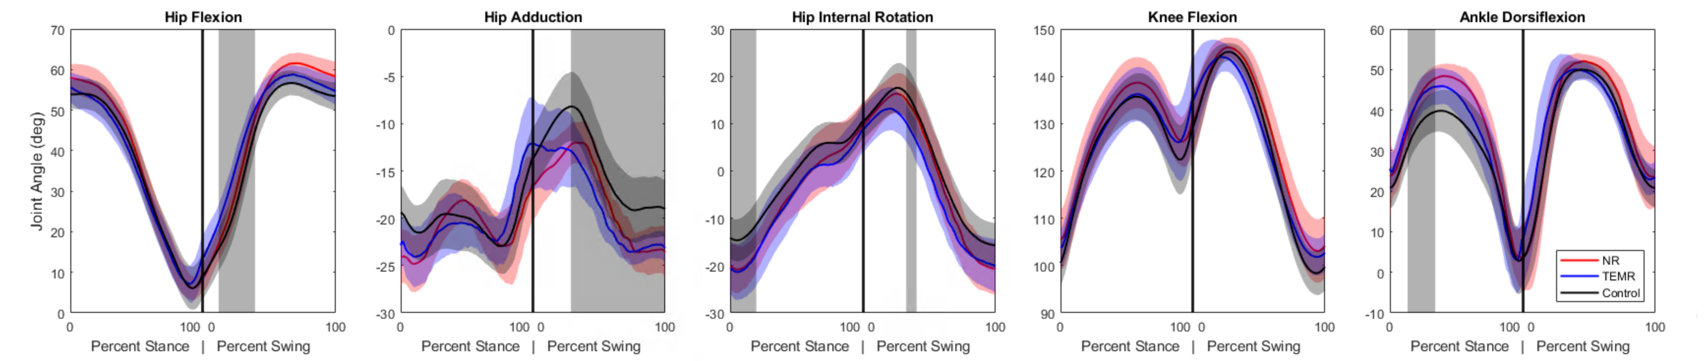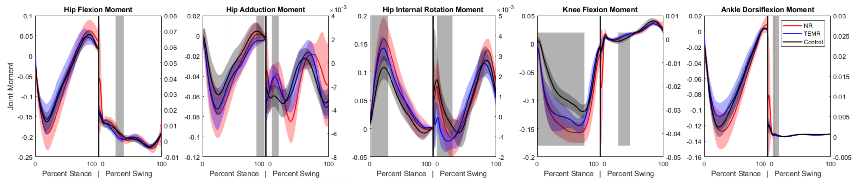

2.3.2.6 TEMR and Hydrogel (TEMR+HH)
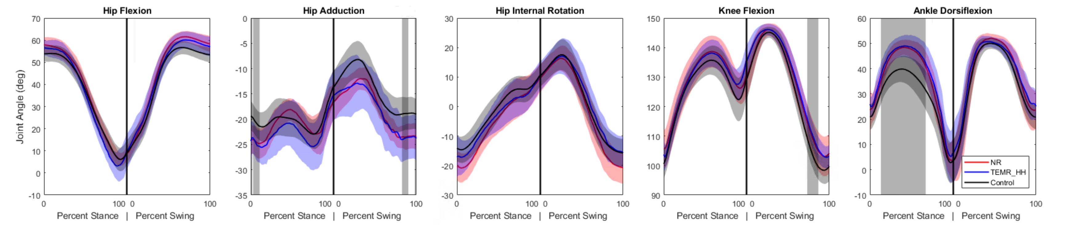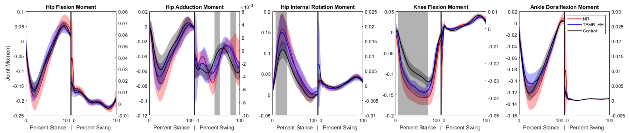

2.3.2.7 TEMR and Keratin Gel (TEMR+KG)
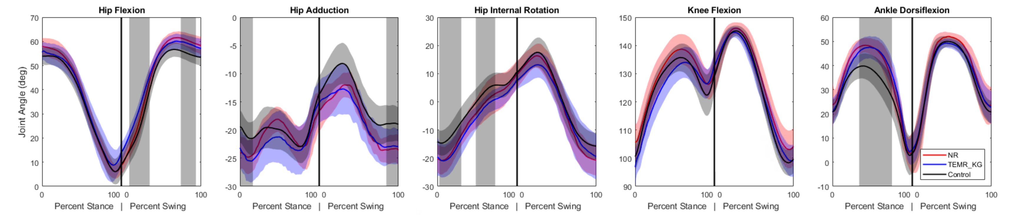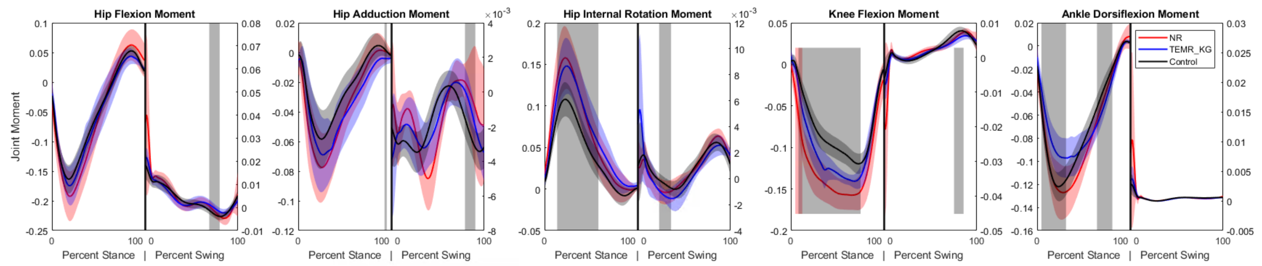
Kinematically, the ankle dorsiflexion angle is still significantly elevated in mid-stance compared to Control. The kinetic profile across all three TEMR groups is similar, with decreased knee extension moment during stance compared to the No Repair group but still significantly greater than the Control group. Similarly, the hip internal rotation moments are significantly greater than Control in mid-stance, akin to the No Repair group. A unique adaptation that surfaces in the TEMR groups is a decrease in ankle plantarflexion moment compared to both the Control and No Repair groups during mid-stance. These findings suggest that while the TEMR treatments may not fully restore normal gait mechanics, they do introduce unique compensatory strategies, particularly at the ankle joint.

2.4 Discussion

2.4.1 Summary of Findings
This study provides a biomechanical comparison of multiple treatment strategies for VML in a rat model at a long-term endpoint. The No Repair group exhibited compensatory gait adaptations, including increased ankle dorsiflexion and elevated knee and hip moments, consistent with persistent plantarflexor impairment. Broadly, treatment groups retained elements of this compensation pattern, suggesting incomplete restoration of native mechanics.
The Healy Hydrogel group was most similar to No Repair. The Healy Sponge group showed the clearest trend toward normalization in several kinematic and kinetic features, though not a complete return to control-like behavior. TEMR-based treatments did not fully restore normal gait but appeared to alter compensation patterns, particularly through ankle moment behavior during stance.

2.4.2 Limitations and Future Directions
In this study, joint moments were normalized to body mass multiplied by total length to account for size differences and facilitate group comparison. However, this strategy assumes geometric scaling relationships that may not fully capture age-related or segment-specific growth effects in rodents. The use of a previously collected control dataset is another limitation, because even with similar acquisition protocols, cross-cohort differences can influence apparent group effects.
This analysis is also limited to a single terminal time point and net joint moments. A longitudinal design would better resolve the timing and progression of compensatory adaptations, while muscle-level simulations (for example, computed muscle control) could help partition net moments into candidate muscle force contributions. Future work should also include age-matched uninjured controls and evaluate alternative normalization strategies that account for differential segment growth (for example, tibia-femur disproportionality).
Finally, integrating biomechanical outcomes with histologic and molecular measurements would improve mechanistic interpretation and help distinguish therapies that produce true functional regeneration from those that primarily redistribute mechanical demand.

2.5 Conclusion
Volumetric muscle loss causes functional impairments that are not adequately addressed by current clinical practice. This study provides a broad comparison of the long-term functional efficacy of several preclinical regenerative strategies. We found that while no treatment achieved a full return to uninjured function, therapies incorporating a specific sponge material produced modest but significant trends toward functional healing, demonstrating mitigated pathological gait compensations. This work emphasizes the utility and importance of detailed biomechanical assessment in evaluating VML treatments and highlights the potential of biomaterials to enhance regenerative outcomes.

3. Normalization of Rodent Inverse Dynamics Data

3.1 Introduction
Inverse dynamics analyses of rodent locomotion can provide valuable insight into how muscles, joints, and segment dynamics interact during gait. However, direct comparison of joint moments across animals is difficult because raw moment magnitudes are influenced by animal size, segment geometry, and locomotor speed. As a result, two animals with similar movement strategies can still exhibit different absolute moments simply because of scale effects.
Normalization methods are designed to reduce this confounding size dependence by expressing joint moments relative to biologically meaningful scaling terms. When successful, normalization improves interpretability across subjects, strengthens between-group comparisons, and makes derived biomechanical conclusions more portable across studies. In this chapter, we evaluate candidate normalization measurements for rodent inverse-dynamics data by first quantifying how strongly each candidate explains variation in joint-moment magnitude.
Wannop et al. (2012) compared several approaches for normalizing ground reaction forces and moments across subjects, including simple division normalization, power-law normalization, and offset normalization. Their key point was that ratio scaling is only appropriate when the relationship between a biomechanical variable and the normalization term is well described by a proportional model with zero intercept. When the intercept is nonzero, simple division can leave residual size dependence; in that case, offset normalization, defined as subtracting the fitted intercept before dividing by the normalization variable, may perform better. They found that if there is a large enough data set, power curve or offset normalization methods are more effective than simple division normalization.
We apply a similar approach by evaluating the scaling relationships between various candidate normalization measurements and the magnitudes of joint moments across a sample of 35 rats. We fit linear, power, and exponential models to these relationships and assess their goodness of fit using the coefficient of determination ($R^{2}$) to screen candidate scaling relationships for later normalization analyses.

3.2 Methods
We analyzed inverse-dynamics data from 35 rats (32 baseline animals: BAA01-BAA32; 3 older animals: Old01-Old03). Candidate normalization measurements included body mass, whole-body and segment lengths, and walking speed, along with simple composite terms motivated by dynamic similarity. Specifically, we evaluated the following predictors: Mass, TotalLength, RightTibiaLength, RightFemurLength, RightFootLength, RightWalkingSpeed, RightLegLength (RightTibiaLength + RightFemurLength), Mass*TotalLength, Mass*RightTibiaLength, and Mass*Speed (Mass * RightWalkingSpeed).
These predictors were selected to span both easily measured global descriptors (e.g., body mass) and limb-specific descriptors that may better capture local mechanical scaling at individual joints. Composite terms were included because many biomechanical quantities are expected to scale with more than one physical dimension (for example, force-like and moment-like terms may couple mass and length).
For each predictor, we modeled the peak magnitude of each right-limb joint moment (hip_r_flx_moment, hip_r_add_moment, hip_r_int_moment, knee_r_flx_moment, ankle_r_flx_moment) from OpenSim inverse-dynamics analysis using two candidate scaling models:
- Linear Offset: $y=ax+b$
- Power: $y=ax^{b}+c$
Prior to fitting, rows with zero values in the current predictor were excluded (e.g., missing TotalLength entries) so that each measurement-moment model used only valid observations for that predictor. Peak joint moments were analyzed in absolute-value form to compare scaling relationships independent of sign convention and moment direction, focusing the analysis on magnitude scaling.
All models were fit with nonlinear least squares (scipy.optimize.curve_fit, max function evaluations = 50,000). Goodness of fit was quantified using the coefficient of determination, $R^{2}=1−\frac{SS_{res}}{SS_{tot}}$, computed for each measurement-moment-model combination. Higher $R^{2}$ indicates that the candidate measurement explains a larger fraction of variation in joint-moment magnitude under the specified model form.
In this chapter, $R^{2}$ is used as an initial screening metric for plausible normalization variables rather than as a direct test of normalization effectiveness. This distinction is important: a strong scaling fit suggests a useful candidate denominator, but does not by itself confirm that post-normalization values are independent of body size. A closer replication of the Wannop framework would additionally test for residual dependence after normalization.

3.3 Results
We summarized the resulting $R^{2}$ values in heatmaps (measurement × joint moment) separately for linear Figure 3.1 and power Figure 3.2 fits to identify the most consistent candidate predictors across joints. Viewing both model classes side-by-side helps distinguish whether a predictor is broadly useful regardless of model form or only performs well under one functional relationship.
import plotly.express as px
import polars as pl
from pathlib import Path
import numpy as np
from scipy.optimize import curve_fit
df = pl.read_csv(Path("..") / "data" / "normalization_data.csv")
def r2_score(y_true, y_pred):
ss_res = np.sum((y_true - y_pred) ** 2)
ss_tot = np.sum((y_true - np.mean(y_true)) ** 2)
if ss_tot == 0:
# Handles horizontal data: perfect fit if ss_res is also 0
return 1.0 if ss_res == 0 else 0.0
return np.clip(1 - (ss_res / ss_tot), 0, 1)
def lin_off(xx, a, b):
return a * xx + b
def pow_off(xx, a, b, c):
return a * (xx ** b) + c
# def exp_off(xx, a, b, c):
# z = np.clip(xx, a_min=1e-6, a_max=np.inf) # Avoid issues with log(0) in curve fitting
# return a * np.exp(b * z) + c
fit_funcs = {
"Linear": lin_off,
"Power": pow_off,
# "Exponential": exp_off
}
raw_measurements = ["Mass", "TotalLength", "RightTibiaLength", "RightFemurLength", "RightFootLength", "RightWalkingSpeed"]
computed_measurements = {
"RightLegLength": lambda df: df["RightTibiaLength"] + df["RightFemurLength"],
"Mass*TotalLength": lambda df: df["Mass"] * df["TotalLength"],
"Mass*RightTibiaLength": lambda df: df["Mass"] * df["RightTibiaLength"],
"Mass*Speed": lambda df: df["Mass"] * df["RightWalkingSpeed"],
}
measurements = raw_measurements + list(computed_measurements.keys())
moments = [col for col in df.columns if col not in measurements and col != "Subject"]
df = df.with_columns([
*(computed_measurements[name](df).alias(name) for name in computed_measurements)
])
fit_results = pl.DataFrame(schema={
"measurement": pl.String,
"moment": pl.String,
"fit_type": pl.String,
"parameters": pl.List(pl.Float64),
"covariance": pl.List(pl.Float64),
"r2": pl.Float64,
})
for measurement in measurements:
x = df.select(pl.col(measurement)).to_numpy().flatten()
mask = (x != 0) & np.isfinite(x)
x = x[mask]
for moment in moments:
y = df.select(abs(pl.col(moment))).to_numpy().flatten()
y = y[mask]
for name, fit in fit_funcs.items():
params, cov = curve_fit(fit, x, y, maxfev=50000)
r2 = r2_score(y, fit(x, *params))
fit_results = fit_results.vstack(
pl.DataFrame({
"measurement": measurement,
"moment": moment,
"fit_type": name,
"parameters": [params.tolist()],
"covariance": [cov.flatten().tolist()],
"r2": r2,
})
)
# Summary values used in inline text and table output.
knee_best = (
fit_results
.filter(pl.col("moment") == "knee_r_flx_moment")
.sort("r2", descending=True)
.row(0, named=True)
)
knee_best_measurement = knee_best["measurement"]
knee_best_fit_type = knee_best["fit_type"].lower()
knee_best_r2 = knee_best["r2"]
best_fits = fit_results.group_by(["measurement", "moment"]).agg(
pl.col("r2").max().alias("best_r2")
)
best_fits_summary = (
best_fits
.group_by("measurement")
.agg(pl.col("best_r2").mean().alias("mean_best_r2"))
)
fit_type_means = (
fit_results
.group_by(["measurement", "fit_type"])
.agg(pl.col("r2").mean().alias("mean_r2"))
)
linear_means = (
fit_type_means
.filter(pl.col("fit_type") == "Linear")
.select(["measurement", pl.col("mean_r2").alias("mean_linear_offset_r2")])
)
power_means = (
fit_type_means
.filter(pl.col("fit_type") == "Power")
.select(["measurement", pl.col("mean_r2").alias("mean_power_r2")])
)
best_fits_summary_full = (
best_fits_summary
.join(linear_means, on="measurement", how="left")
.join(power_means, on="measurement", how="left")
.sort("mean_best_r2", descending=True)
)
top_measurements = best_fits_summary_full.select("measurement").to_series().to_list()
top_1, top_2, top_3 = top_measurements[:3]
linear_fit_results = fit_results.filter(pl.col("fit_type") == "Linear").to_pandas()
linear_fit_pivot = linear_fit_results.pivot(
index="measurement",
columns="moment",
values="r2",
)
fig = px.imshow(
linear_fit_pivot,
text_auto=".2f",
labels=dict(x="Joint Moment", y="Measurement", color="R² Score"),
title="R² Heatmap of Joint Moment vs. Measurement (Linear Fit: y = ax + b)"
)
fig.show()
Unable to display output for mime type(s): text/html
(a) R^2 values for linear fits of joint moment magnitudes to candidate normalization measurements. Higher values (yellow) indicate better fit.

Unable to display output for mime type(s): text/html
(b)
Figure 3.1
power_fit_results = fit_results.filter(pl.col("fit_type") == "Power").to_pandas()
power_fit_pivot = power_fit_results.pivot(
index="measurement",
columns="moment",
values="r2",
)
fig = px.imshow(
power_fit_pivot,
text_auto=".2f",
labels=dict(x="Joint Moment", y="Measurement", color="R² Score"),
title="R² Heatmap of Joint Moment vs. Measurement (Power Fit: y = a*x^b + c)"
)
fig.show()
Unable to display output for mime type(s): text/html
Figure 3.2: R^2 values for power fits of joint moment magnitudes to candidate normalization measurements. Higher values (yellow) indicate better fit.
# exp_fit_results = fit_results.filter(pl.col("fit_type") == "Exponential").to_pandas()
# exponential_fit_pivot = exp_fit_results.pivot(
# index="measurement",
# columns="moment",
# values="r2",
# )
# fig = px.imshow(
# exponential_fit_pivot,
# text_auto=".2f",
# labels=dict(x="Joint Moment", y="Measurement", color="R² Score"),
# title="R² Heatmap of Joint Moment vs. Measurement (Exponential Fit: y = a*exp(b*x) + c)"
# )
# fig.show()
Figure 3.3
Knee flexion/extension showed the strongest scaling relationships across all joints, with the strongest fitted association given by Mass*RightTibiaLength under a power fit ($R^{2}=$ 0.932). Across joint moments overall (mean of best-per-moment fits), Mass*TotalLength ranked highest, followed by Mass and Mass*RightTibiaLength, indicating that mass-length composite terms showed the most consistent fit across moments.
The mean $R^{2}$ across joints for the best fit per moment can be computed from the fitted models.
from IPython.display import Markdown as md
from tabulate import tabulate
best_fits_summary_display = (
best_fits_summary_full
.rename(
{
"measurement": "Measurement",
"mean_best_r2": "Mean Best R²",
"mean_linear_offset_r2": "Mean Linear Offset R²",
"mean_power_r2": "Mean Power R²",
}
)
)
md(
tabulate(
best_fits_summary_display.to_pandas(),
headers="keys",
showindex=False,
tablefmt="github",
floatfmt=".3f",
)
)
Table 3.1: Mean R² values across joints for the best fit per moment.
Measurement | Mean Best R² | Mean Linear Offset R² | Mean Power R²
Mass*TotalLength | 0.457 | 0.439 | 0.457
Mass | 0.433 | 0.418 | 0.433
Mass*RightTibiaLength | 0.420 | 0.396 | 0.420
TotalLength | 0.410 | 0.399 | 0.410
RightLegLength | 0.392 | 0.366 | 0.392
RightFemurLength | 0.387 | 0.355 | 0.387
RightTibiaLength | 0.359 | 0.301 | 0.359
Mass*Speed | 0.315 | 0.287 | 0.315
RightFootLength | 0.308 | 0.292 | 0.308
RightWalkingSpeed | 0.070 | 0.053 | 0.070

3.4 Discussion
This workflow provides a practical first-pass strategy for identifying candidate scaling variables in rodent inverse dynamics, but several limitations should be considered when interpreting the findings. First, the sample size is modest, which increases sensitivity to subject-level variability and may limit generalizability. Additionally, the dataset is not fully age-balanced, with only three older animals included, which may bias scaling relationships if age-related changes in biomechanics are present. The analysis also focuses on peak moment magnitudes rather than time-series data, which may miss important dynamic scaling effects.
Most importantly, the present analysis evaluates pre-normalization model fit rather than post-normalization independence from size. Consequently, these results should be interpreted as a screening stage for candidate normalization terms, not as a complete validation. A stronger validation pipeline would normalize moments using each candidate term, then explicitly test residual correlations with mass and segment length and evaluate whether between-subject dispersion is reduced in a biologically meaningful way.
Future work should therefore prioritize larger, age-balanced datasets and direct post-normalization diagnostics (residual-trend testing, variance reduction metrics, and cross-cohort reproducibility) to determine which scaling approach is most robust for translational rodent biomechanics.

4. Bilateral Rat Model Refinement

4.1 Introduction
Musculoskeletal simulation of rodent locomotion requires a detailed and physiologically accurate model. The most widely used rat hindlimb model for OpenSim was developed by Johnson et al. (2008) and made available on SimTK. This model has been used in a number of subsequent studies, including functional electrical stimulation applications (Johnson et al. 2011), cross-species comparison (Charles et al. 2016), and gait analysis in injury models (dienesAnalysisModelingRat2019?; hicksKinematicKineticGait2023?). However, the original model is unilateral, relies on older OpenSim conventions, and contains several features that limit its accuracy when scaled to individual subjects or used for muscle-level analyses.
In this chapter, we describe the refinement and extension of the Johnson model into a bilateral rat hindlimb model suitable for subject-specific musculoskeletal simulation. The modifications include: (1) general modernization of naming conventions and coordinate definitions, (2) correction of the knee joint definition to improve scaling behavior, (3) replacement of wrapping-surface-based muscle paths with via-point paths derived from the Animatlab model of Young et al. (2018), (4) conversion from Thelen to Millard muscle dynamics, (5) updated muscle architectural parameters, and (6) mirroring of the right-side anatomy to produce a complete bilateral model. The up-to-date model, version history, and processing code are maintained in the rat-hindlimb-model repository.

4.1.1 Prior Work
The Johnson model (Johnson et al. 2008) was the first three-dimensional musculoskeletal model of the rat hindlimb for OpenSim. It defined 13 degrees of freedom across the hip, knee, and ankle joints with 42 musculotendon actuators and was used by Johnson et al. (2011) to study functional electrical stimulation of the rat hindlimb. (engScalingMuscleArchitecture2008?) provided scaling relationships for muscle architectural parameters across species, and Charles et al. (2016) developed a comparable mouse hindlimb model with detailed musculoskeletal geometry.
Several more recent efforts have built on or adapted the Johnson model. Young et al. (2018) created a detailed neuromechanical rat model in Animatlab software, defining comprehensive muscle attachment points based on (greeneAnatomyRat?) rather than relying on wrapping surfaces. Young et al. (2019) subsequently validated moment arm profiles from that model. (ramalingasettyWholeBodyMusculoskeletalModel2021?) developed a whole-body mouse musculoskeletal model and applied a tendon slack length optimization approach relevant to smaller-scale models. Hunt et al. (2015) explored the use of animal models for neuromechanical simulation, providing context for the broader utility of rodent musculoskeletal models.
On the experimental side, (dienesAnalysisModelingRat2019?) and (hicksKinematicKineticGait2023?) used scaled versions of the Johnson model for gait analysis in the context of volumetric muscle loss injury, which directly motivated the model improvements described here.

4.2 Methods

4.2.1 General Modernization
Several structural updates were made to bring the model in line with current OpenSim conventions and to prepare it for bilateral extension. All body and joint names on the right side were given a _r suffix (e.g., femur became femur_r, knee became knee_r) to allow unambiguous identification after mirroring. Bone geometry files were converted from VTK .vtp format to .stl format for compatibility with common mesh processing tools.
Degrees of freedom that are not actively used in typical rat gait analyses were locked to reduce model complexity and avoid non-physiological solutions during inverse kinematics or computed muscle control. The locked coordinates include ankle adduction (ankle_r_add), ankle internal rotation (ankle_r_int), and sacroiliac flexion (sacroiliac_r_flx). The marker set was also updated to match the marker placement protocol used in our laboratory’s experimental studies (dienesAnalysisModelingRat2019?; hicksKinematicKineticGait2023?).

4.2.2 Knee Joint Definition
In Johnson’s original model, the tibia offset frame used as the parent frame for the knee joint is defined at the distal end of the tibia, and the spatial transform is governed by a SimmSpline component that encodes the non-linear translation of the tibia relative to the femur as a function of knee flexion angle. When the model is scaled to subject-specific parameters, the knee motion becomes incorrect because the SimmSpline trajectory does not change with scaling and the tibia offset frame remains fixed, so there is nothing to account for the new tibia length.
To correct this, we repositioned the tibia offset frame to the approximate joint center of the knee as determined by the instantaneous center of rotation (ICR). The ICR was computed by moving the knee through its full range of motion, sampling the position of the tibia origin at each configuration, and projecting these points into the sagittal plane to identify the center of the arc. The resulting offset frame location was set to $[−0.00057,0.0400,0.0038]$ m in the tibia body frame. The SimmSpline functions governing the three translational components of the spatial transform were re-fit with 14 control points each to preserve the original non-linear knee kinematics while referencing the new frame location. A constant rotation of 0.262 rad (15°) was applied about the third rotation axis to maintain the resting knee angle. The effect of this change is illustrated in Figure 4.1.
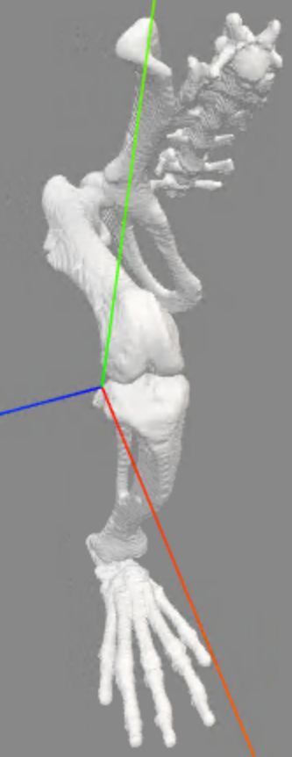
Figure 4.1: Knee joint center before and after adjustment based on instantaneous center of rotation analysis.

4.2.3 Inertial Parameters
Inertial properties were updated based on the methodology described by (hicksKinematicKineticGait2023?), who derived segment-specific inertial parameters from cadaveric measurements and geometric approximations of limb segments as uniform-density solids. These values are used during inverse dynamics to compute net joint moments from measured kinematics and ground reaction forces.

4.2.4 Muscle Path Analysis
In analyzing the original Johnson rat model, we observed that several muscles exhibited discontinuous changes in length during joint rotations. This behavior is non-physiological and can lead to inaccuracies in simulations of muscle function, particularly when computing muscle forces or tendon slack lengths that depend on smoothly varying musculotendon length curves.
The model was moved through its full range of motion and muscle lengths were analyzed to identify discontinuities. The OsimGraph class from the osimpy library was used to represent the OpenSim model as a graph structure, which enables efficient querying of musculotendon length as a function of joint coordinates. The following muscles were identified as having discontinuous length changes:
- BFa (biceps femoris anterior)
- CF (caudofemoralis)
- STp (semitendinosus posterior)
- TA (tibialis anterior)
- VL (vastus lateralis)
Investigating the root cause, we found that the likely culprit is a hard-coded value in OpenSim’s WrapCylinder.cpp code that determines the number of segments used to approximate the muscle path over a wrapping cylinder:
// Each muscle segment on the surface of the cylinder should be
// 0.002 meters long. This assumes the model is in meters, of course.
int numWrapSegments = (int)(aWrapResult.wrap_path_length / 0.002);
if (numWrapSegments < 1) numWrapSegments = 1;
This segment length of 0.002 m is appropriate for human-scale models but is problematic for the rat model, where wrapping cylinders have much smaller circumferences. With fewer discretization segments, the muscle path changes abruptly as it wraps and unwraps, producing step-like discontinuities in musculotendon length. To address this, we chose to replace the wrapping-surface-based muscle paths with via-point paths derived from a more anatomically detailed model.

4.2.5 Muscle Path Redefinition
Johnson’s original model relied heavily on wrapping surfaces to guide muscle paths around bones and joints. A more recent model by Young et al. (2018), which built upon the Johnson model and drew from the original anatomical text of (greeneAnatomyRat?), defined comprehensive muscle attachment and via-point coordinates for all hindlimb muscles instead of relying on wrapping surfaces. This via-point approach avoids the discretization artifacts described above and provides a more physiologically faithful representation of muscle paths at small scales.
Unfortunately, the Young model was created for the Animatlab neuromechanical simulation platform, and no OpenSim version existed. We obtained the original Animatlab files with the assistance of Dr. Young and manually recorded the muscle attachment points from the model. The complete set of attachment coordinates is provided in ?@sec-young-attachments.

4.2.5.1 Coordinate System Transformation via Mesh Registration
The coordinate systems used in Animatlab differ from those in OpenSim, so a direct transfer of attachment coordinates is not possible. To determine the necessary transformations, we performed mesh registration to align the bone geometries from the Animatlab model to those in our OpenSim model. Once aligned, the same transformation could be applied to the muscle attachment points to bring them into the OpenSim coordinate system.
We used the open3d library (Zhou et al. 2018) for the mesh registration pipeline, which proceeded as follows:
- Deterministic preprocessing: Mesh vertices were sorted lexicographically and both source (Animatlab) and target (OpenSim) meshes were normalized to unit size centered at the origin. Threading was restricted to a single thread (OMP_NUM_THREADS=1) to ensure deterministic RANSAC results.
- Global registration: Fast Point Feature Histograms (FPFH) were computed from 5,000 sampled surface points with a normal estimation radius of 0.1. RANSAC-based global registration was performed with 3-point correspondence sets, mutual correspondence checking, and a maximum of 100,000 iterations.
- Local refinement: Point-to-point Iterative Closest Point (ICP) registration with scaling was applied to refine the alignment from the global registration step.
- De-normalization: The combined transformation was mapped back to the original target coordinate system to produce a 4×4 transformation matrix applicable to muscle attachment coordinates.
This registration was performed independently for each body segment (spine, pelvis, femur, tibia, and foot), producing body-specific transformation matrices. For each muscle, the attachment points from the Young model were then transformed into the OpenSim coordinate system using the transformation matrix corresponding to the attachment’s parent body. All existing wrapping geometries were removed and replaced with the transformed via-point paths.

4.2.6 Muscle Parameters

4.2.6.1 Muscle Model Conversion
The original Johnson model uses the Thelen2003 muscle model (thelenAdjustmentMuscleMechanics2003?), which has been largely superseded by the Millard2012 equilibrium muscle model (millardFlexingComputationalMuscle2013?) in OpenSim. The Millard model provides improved numerical stability and more physiologically grounded force-length-velocity curves, making it better suited for muscle-level analyses such as computed muscle control. All 42 muscles were converted from Thelen2003Muscle to Millard2012EquilibriumMuscle components, preserving the original values of maximum isometric force, optimal fiber length, tendon slack length, and pennation angle at optimal fiber length. A default fiber damping coefficient of 0.1 was applied to all muscles.

4.2.6.2 Architectural Parameters
Muscle architectural parameters (maximum isometric force ($F_{o}$), optimal fiber length ($l_{o}^{m}$), and pennation angle at optimal fiber length ($θ_{o}$))were taken from the measurements reported by Johnson et al. (2011). These parameters span a wide range across the 42 muscles in the model: maximum isometric force ranges from 0.25 N (extensor hallucis longus) to 18.74 N (semimembranosus), optimal fiber length from 4.2 mm (popliteus) to 43.6 mm (gracilis anterior), and pennation angle from 0° (several muscles) to 25.4° (tibialis posterior).

4.2.6.3 Tendon Slack Length
Tendon slack length ($l_{s}^{t}$) is one of the most influential parameters in Hill-type muscle models, yet it cannot be measured directly and must be estimated indirectly. Johnson’s original tendon slack length values were derived from anatomical measurements, but the literature has shown that such values can contain substantial errors (Manal and Buchanan 2004). As described in detail in Chapter 5, we applied a numerical optimization approach to estimate tendon slack lengths for all muscles in the model. Muscles for which the optimization yielded a tendon slack length of zero were set to have rigid tendons by enabling the ignore_tendon_compliance flag. When both full range-of-motion and gait-specific optimized values were available, the gait-specific (walking) values were used in the final model, as the model’s full range of motion includes physiologically infeasible configurations that bias the optimization.

4.2.7 Bilateral Mirroring
To create a bilateral model suitable for studies involving both hindlimbs, all right-side anatomy was mirrored to the left side. The mirroring was performed as follows:

4.2.7.1 Body Segments
For each body segment (pelvis, femur, tibia, foot), the right-side body was cloned and renamed with a _l suffix. The bone geometry meshes were reflected across the sagittal (XY) plane by negating the Z-axis scale factor. The center of mass location was mirrored by negating the Z component, while moments of inertia ($I_{xx}$, $I_{yy}$, $I_{zz}$) were preserved and the products of inertia that cross the mirror plane were negated.

4.2.7.2 Joints
Each CustomJoint was cloned and renamed. Frame translation offsets were mirrored by negating the Z component. The spatial transform functions governing joint kinematics were mirrored according to their type: SimmSpline Y-coordinate values were negated to reverse the curve, LinearFunction slopes and intercepts were negated, Constant values were negated, and MultiplierFunction scale factors were negated. This ensures that left-side joint motion is mirror-symmetric to the right side.

4.2.7.3 Muscles
Each muscle was cloned and renamed (e.g., R_RF became L_RF). All muscle path point coordinates were mirrored by negating the Z component, producing the correct medial-lateral orientation for the left side.

4.2.7.4 Marker Set
The marker set was updated to include bilateral markers, with left-side markers placed at the mirrored locations of their right-side counterparts.
The final bilateral model contains the full complement of bodies, joints, and muscles for both hindlimbs, enabling analyses that require bilateral kinematics and kinetics such as those described in Chapter 2.

4.3 Results
The pipeline produces four model variants:
- rat_hindlimb_unilateral.osim — right-side model with muscles
- rat_hindlimb_unilateral_no_muscles.osim — right-side skeleton only
- rat_hindlimb_bilateral.osim — bilateral model with muscles
- rat_hindlimb_bilateral_no_muscles.osim — bilateral skeleton only

4.3.1 Muscle Path Continuity
After replacing the wrapping-surface-based muscle paths with via-point paths from the Young model, the discontinuous muscle length changes observed in the original Johnson model (BFa, CF, STp, TA, and VL; Section 4.2.4) were eliminated. All muscles now exhibit smooth, continuous length changes across the full range of joint motion.
TODO: Plot

4.3.2 Muscle Parameters
The final model contains 42 muscles per side (84 total in the bilateral model), all using the Millard2012 equilibrium muscle model. Architectural parameters (maximum isometric force, optimal fiber length, and pennation angle) are taken from Johnson et al. (2011). Tendon slack lengths were estimated via the optimization methodology described in Chapter 5, with walking-phase values used when available. A comparison of the original Johnson tendon slack lengths and the optimized values is provided in Table 5.3 of Chapter 5.

4.3.3 Bilateral Symmetry
The mirrored left-side anatomy is geometrically symmetric to the right side across the sagittal plane. Joint kinematics, muscle paths, and inertial properties are consistent between sides, enabling direct bilateral comparison of kinematic and kinetic outcomes in experimental studies.

4.4 Discussion

4.4.1 Summary
We have described the refinement of the Johnson rat hindlimb model (Johnson et al. 2008) into a modernized, bilateral musculoskeletal model suitable for subject-specific simulation. The key improvements include a corrected knee joint definition that scales appropriately with subject-specific tibia length, replacement of wrapping-surface muscle paths with anatomically detailed via-point paths from the Young Animatlab model (Young et al. 2018), conversion to the Millard2012 muscle model, numerically optimized tendon slack lengths, and bilateral mirroring.

4.4.2 Muscle Path Improvements
The replacement of wrapping surfaces with via-point paths resolved the discontinuous muscle length artifacts that affected five muscles in the original model. These artifacts arose from the interaction of the rat model’s small geometry with a hard-coded segment length in OpenSim’s wrapping surface implementation. While modifying the OpenSim source code would be an alternative solution, the via-point approach has the advantage of being model-level and therefore portable across OpenSim versions. The via-point paths from the Young model also benefit from being based on detailed anatomical dissection data (greeneAnatomyRat?), rather than the approximate cylindrical wrapping surfaces used in the original model.
The mesh registration approach used to transfer attachment points between coordinate systems introduces some spatial error inherent to the ICP alignment. However, the registration was performed on a per-segment basis using deterministic seeding, and the resulting muscle length profiles are smooth and physiologically plausible across the full range of motion.

4.4.3 Knee Joint Definition
The repositioning of the tibia offset frame to the instantaneous center of rotation of the knee is a critical change for subject-specific scaling. In the original model, scaling the tibia length did not appropriately adjust knee kinematics because the spatial transform functions were defined relative to the distal tibia rather than the joint center. The corrected definition ensures that the knee joint center remains at the proper anatomical location after scaling, producing more accurate kinematics in scaled models.

4.4.4 Muscle Model and Parameters
The conversion from Thelen2003 to Millard2012 muscle dynamics aligns the model with current best practices in OpenSim musculoskeletal modeling. The Millard model’s improved numerical properties are particularly important for the computed muscle control analyses used in subsequent chapters. The optimization of tendon slack lengths, described in detail in Chapter 5, addresses one of the most influential and difficult-to-measure parameters in Hill-type muscle models.

4.4.5 Reproducibility
All model modifications are implemented as a sequence of Jupyter notebooks that can be re-executed to regenerate the final model files from the original Johnson model. This notebook-based pipeline ensures that every edit is documented, version-controlled, and reproducible, which is a substantial improvement over manual model editing in the OpenSim GUI. The pipeline also facilitates future updates as new experimental data or improved muscle parameters become available.

4.4.6 Limitations
Several limitations should be noted. First, the inertial parameters are estimated based off of regressions and may not reflect the specific animals used in our experimental studies. Second, the mesh registration process, while deterministic and reproducible, introduces some spatial error in the transferred attachment points that cannot be fully quantified without independent validation data. Third, the bilateral model assumes perfect sagittal symmetry, which may not hold for animals with unilateral injuries or asymmetric morphology. Finally, the via-point muscle paths, while smoother than the wrapping-surface paths, do not fully capture the dynamic interaction between muscles and bones that wrapping surfaces are designed to model. For analyses where muscle-bone contact mechanics are important, a hybrid approach using both via-points and wrapping surfaces may be warranted.

5. Tendon Slack Length Optimization
 Note
This chapter draws heavily from the abstract and poster presented at the American Society of Biomechanics (ASB) 2025 conference: “Effects of error function selection and normalized fiber length range in numerical estimation of tendon slack length.” Those materials are available at the ASB2025-TSL-Optimization repository.

5.1 Introduction
Musculoskeletal models that incorporate Hill-type muscles require the specification of several parameters to determine the forces generated by each musculotendon unit. Among these, tendon slack length ($l_{s}^{t}$) is one of the most influential, as it defines the length at which the tendon begins to produce a restorative force. Because tendons often run parallel to muscle fibers, tendon slack length cannot be measured directly and must instead be estimated indirectly.
Several approaches for estimating tendon slack length have been proposed. The widely used human lower-limb model of Rajagopal et al. (2016) derives tendon slack length from the fiber length at a single, predefined joint configuration. Manal and Buchanan (2004) proposed a more general optimization-based technique that minimizes the discrepancy among tendon slack lengths estimated across a range of musculotendon lengths, leveraging the active and passive force-length curves for the muscle fiber and the tendon force-length curve.
In this chapter, we extend the approach of Manal and Buchanan (2004) in two ways. First, we systematically investigate the effects of normalized fiber length range and choice of error function on the estimated tendon slack lengths. Second, we evaluate the physiological plausibility of the results by examining the predicted force profiles of the musculotendon units during several different kinematic activities. The goal is to inform a robust methodology for numerically tuning tendon slack length in new musculoskeletal models.

5.2 Methods

5.2.1 Overview
The optimization follows the conceptual framework of Manal and Buchanan (2004), using the musculotendon equilibrium equations derived by (zajacMuscleTendonProperties1989?) to compute tendon slack length from known muscle parameters and interpolated force values. At each sampled musculotendon length, a candidate tendon slack length is calculated using Equation 5.1. The optimizer then searches for the tendon slack length that minimizes the spread of these candidates across all sampled lengths:
$$l_{s}^{t}=\frac{l^{mt}−l_{o}^{m}⋅{\tilde{l}}^{m}cos(α)}{\left[1+\frac{\text{eval}\left[{\tilde{F}}^{m}({\tilde{l}}^{m})\right]cos(α)+0.2375}{37.5}\right]} (5.1)$$
where $l^{mt}$ is the musculotendon length, $l_{o}^{m}$ is the optimal fiber length, ${\tilde{l}}^{m}$ is the normalized fiber length, $α$ is the pennation angle, and ${\tilde{F}}^{m}({\tilde{l}}^{m})$ is the normalized muscle force evaluated from the force-length curve.

5.2.2 Differences from Manal’s Method
Our implementation differs from the original method of Manal and Buchanan (2004) in several respects:
- Optimization algorithm: We use Sequential Least Squares Programming (SLSQP) via the SciPy optimization library (Virtanen et al. 2020) rather than the Generalized Reduced Gradient (GRG) algorithm used by Manal, owing to its availability and widespread use in Python.
- Force-length curves: The active and passive fiber force-length curves as well as the tendon force-length curve were taken from the Millard muscle model (TODO: millardFlexingComputationalMuscle2013?) (?@fig-millard-fl-curves) instead of Zajac’s original curves.
- Musculotendon length sampling: Rather than sampling at only two extreme joint configurations and averaging a third intermediate value, we iterate the model through all relevant degrees of freedom to obtain a minimum of 100 musculotendon length samples per muscle.

5.2.3 Muscle Selection
To demonstrate the method across muscles of differing architectures, we estimated tendon slack lengths for three muscles from the Rajagopal model (Rajagopal et al. 2016) spanning a range of tendon-to-fiber ratios:
- Lateral gastrocnemius (gaslat) — biarticular, long tendon
- Long head of biceps femoris (bflh) — biarticular, moderate tendon
- Soleus — monoarticular, short tendon

5.2.4 Error Functions
In addition to the sum of squared differences of pairs (SSDP) used by Manal and Buchanan (2004), we evaluated three alternative error functions to assess their influence on the optimization:
Table 5.1: Error functions evaluated for tendon slack length optimization.
Error Function | Abbreviation | Formula
Sum of Squared Difference of Pairs | SSDP | i​j​ls,(i)t−ls,(j)t2
Sum of Squared Difference from Mean | SSDM | $∑{\left(l_{s,(i)}^{t}−{\overset{‾}{l}}_{s}^{t}\right)}^{2}$
Standard Deviation | STD | $\sqrt{\frac{∑{\left(l_{s,(i)}^{t}−{\overset{‾}{l}}_{s}^{t}\right)}^{2}}{n}}$
Variance | VAR | $\frac{∑{\left(l_{s,(i)}^{t}−{\overset{‾}{l}}_{s}^{t}\right)}^{2}}{n}$

5.2.5 Normalized Fiber Length Ranges
The optimization was performed under three different normalized fiber length ranges to assess the sensitivity of the results:
- Full range (0.4–1.5): Captures the main force-producing portion of the fiber force-length curve.
- Gait operating range: Estimates of each muscle’s operating range during gait as reported by Arnold [TODO: add citation].
- Ascending limb only: Restricted to the ascending portion of the force-length curve, following the approach of Manal and Buchanan (2004).
SLSQP minimization from SciPy (Virtanen et al. 2020) was then used to minimize each error function over the calculated tendon slack lengths at each musculotendon length.

5.3 Results

5.3.1 Tendon Slack Length Estimates
Using the model’s full range of motion, we generated 125 musculotendon length samples for gaslat, 256 for bflh, and 100 for soleus (481 total). Across all muscles, SSDP optimization produced relatively stable tendon slack length estimates over broad musculotendon length ranges, as summarized in Table 5.2.
Table 5.2: Tendon slack length estimates by SSDP optimization for three muscles from the Rajagopal model.
Muscle | MT length range (m) | SSDP TSL range (m) | SSDP TSL mean $±$ SD (m) | CV (%) | Corr. $r$(MT, TSL)
gaslat | 0.3561–0.4815 | 0.3326–0.3790 | 0.3571 $±$ 0.0068 | 1.89 | 0.7613
bflh | 0.3307–0.5238 | 0.2956–0.3784 | 0.3414 $±$ 0.0125 | 3.66 | 0.7670
soleus | 0.2857–0.3521 | 0.2792–0.2881 | 0.2836 $±$ 0.0013 | 0.47 | 0.6232

Compared with the values reported by Rajagopal et al. (2016) (gaslat: 0.3740 m, bflh: 0.3325 m, soleus: 0.2813 m), the SSDP means were lower for gaslat and slightly higher for bflh and soleus, while all Rajagopal values fell within the estimated TSL range for the respective muscle.

5.3.2 Coordinate Dependence
The dependence of musculotendon length on joint coordinates was muscle-specific. For gaslat, the strongest relationships were with ankle angle ($r=0.7562$) and knee angle ($r=−0.6442$). For bflh, hip flexion ($r=0.8102$) and knee angle ($r=−0.5237$) were dominant. For soleus, ankle angle showed a near-monotonic relationship ($r=0.9919$), while subtalar angle had minimal influence ($r=−0.0546$). The corresponding plots are included in ?@sec-rajagopal-mtl.

5.3.3 Activity-Specific Force Profiles
When overlaid with activity-specific musculotendon length ranges (walking, squatting, and cutting), most functional ranges fell in regions where TSL estimates were comparatively flat. However, some activities approached edge regions where tendon force rose rapidly, particularly for soleus and the long-length end of bflh (Figure 5.1; Figure 5.2; Figure 5.3).
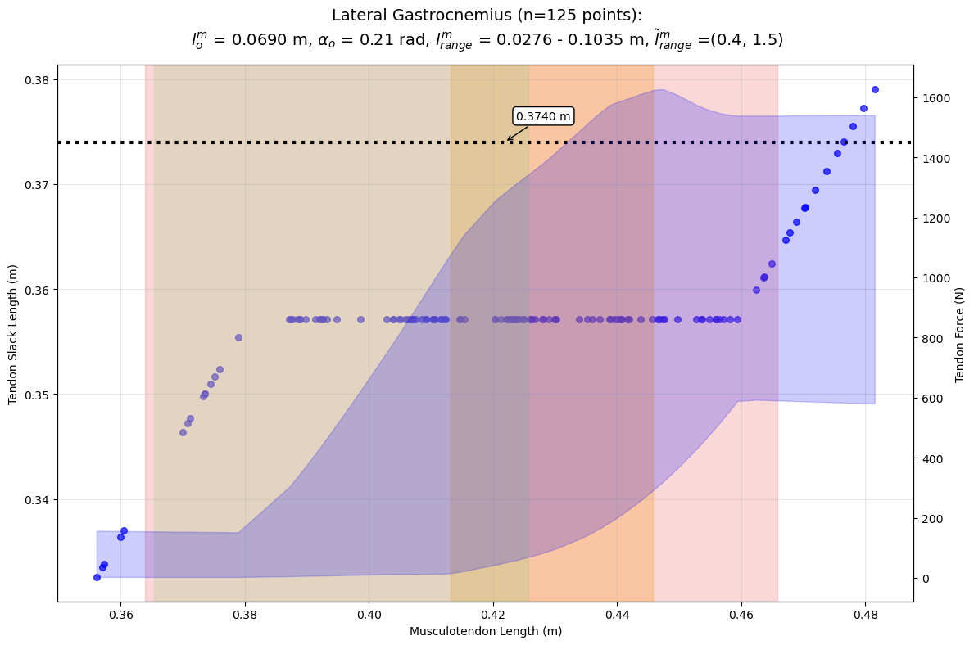
Figure 5.1: SSDP tendon slack length estimates and tendon force envelope for gaslat across musculotendon lengths, with activity-specific length ranges overlaid.

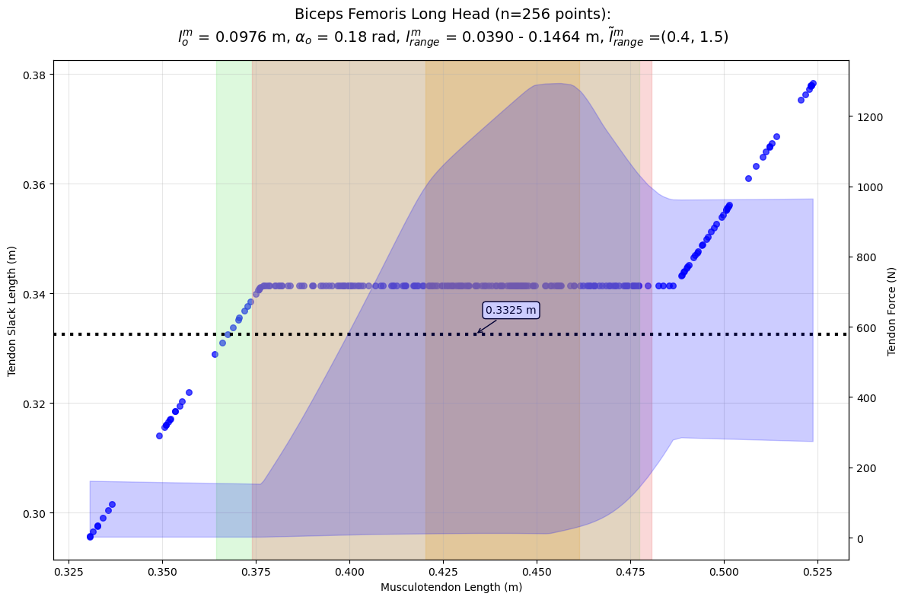
Figure 5.2: SSDP tendon slack length estimates and tendon force envelope for bflh across musculotendon lengths, with activity-specific length ranges overlaid.

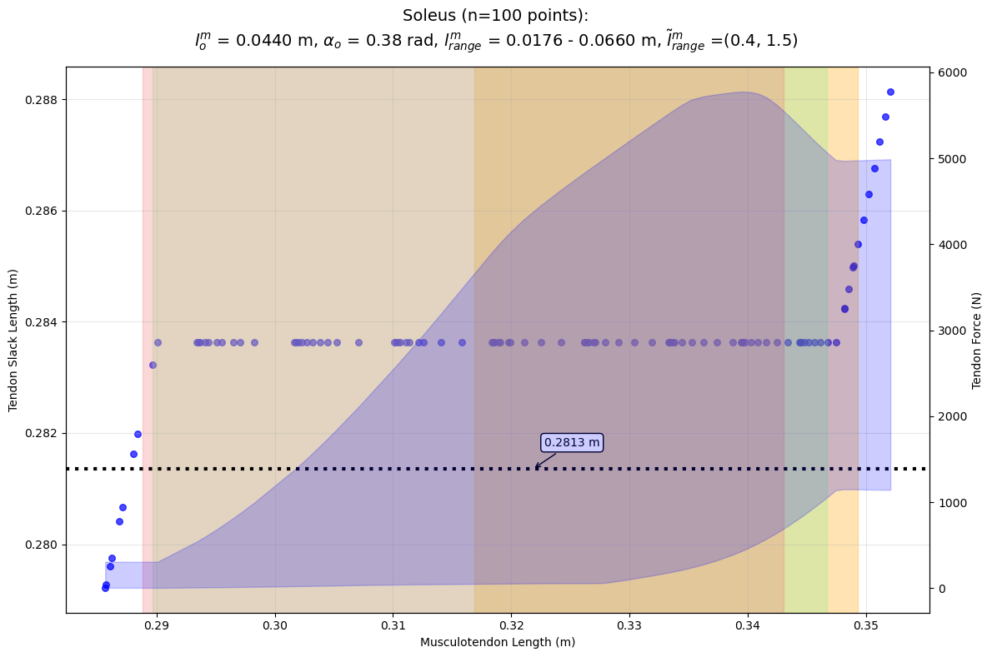
Figure 5.3: SSDP tendon slack length estimates and tendon force envelope for soleus across musculotendon lengths, with activity-specific length ranges overlaid.

5.4 Discussion

5.4.1 Effect of Error Function
Across all three muscles, the choice of error function had negligible influence on the optimized tendon slack length. All four formulations—SSDP, SSDM, STD, and VAR—converged to nearly identical estimates. This is consistent with the fact that each function penalizes the spread of the candidate TSL values, differing only in how the spread is aggregated. From a practical standpoint, any of these error functions can be used interchangeably, though SSDP remains the default given its precedent in the literature.

5.4.2 Effect of Normalized Fiber Length Range
In contrast to the error function, the normalized fiber length range used during optimization had a substantial effect on the estimated tendon slack lengths. The full range (0.4–1.5) produced the most stable estimates across musculotendon lengths, while narrower ranges led to greater sensitivity to the specific lengths sampled. This finding underscores the importance of carefully selecting the fiber length range when applying this methodology to new models or muscles.

5.4.3 Activity Dependence
The tendon slack length plots in Figure 5.1 through Figure 5.3 show the estimates produced by SSDP optimization across a normalized fiber length range of 0.4 to 1.5, along with the corresponding tendon force envelope. The highlighted regions indicate the range of musculotendon lengths encountered during walking, squatting, and athletic cutting motions. For most muscles and activities, the functional musculotendon length range falls in a region where the TSL estimate is relatively flat and the tendon force is moderate. However, when the musculotendon length approaches the extremes of its range—as occurs for soleus during cutting or for the long-length end of bflh—the tendon force rises steeply and the TSL estimate becomes less stable. This suggests that a single optimized tendon slack length may introduce activity-dependent inaccuracies for muscles that operate near the boundaries of their length range. For example, the soleus TSL estimate that performs well for squatting may be less appropriate for an athletic cutting motion.

5.5 Application to Rodent Model
As discussed in Section 4.2.6, many muscles in the rat hindlimb model lacked values for tendon slack length or had unreliable values, preventing muscle-level analyses such as computed muscle control. To address this, we applied the tendon slack length optimization methodology described above to estimate tendon slack lengths for all muscles in the rat hindlimb model.
Given the more limited availability of rodent muscle parameter data compared to human models, the optimization was performed using only the full normalized fiber length range (0.4–1.5) and the SSDP error function. For the musculotendon length sampling, we compared two approaches: the model’s full range of motion and the observed range of motion during normal gait, compiled from baseline walking trials in the study detailed in Chapter 2. The results, compared with the parameters from Johnson et al. (2011), are summarized in Table 5.3.
Table 5.3
Abbreviation | Johnson TSL (mm) | Full ROM TSL (mm) | Walk TSL (mm)
AB | 0.00 | 0.00 | 4.82
AL | 4.50 | 0.00 | 0.00
AM | 0.00 | 4.49 | 7.03
BFa | 0.00 | 0.19 | 8.51
BFp | 0.00 | 4.87 | 6.35
CF | 0.00 | 0.00 | 0.00
EDL | 9.00 | 41.56 | 43.47
FDL | 8.70 | 47.23 | 48.64
FHL | 9.70 | 42.73 | 44.28
GA | 0.00 | 3.59 | 5.27
GI | 0.00 | 8.44 | 8.59
GMa | 4.80 | 0.00 | 0.00
GMe | 0.00 | 4.93 | 7.70
GMi | 0.00 | 10.84 | 12.49
GP | 0.90 | 6.24 | 6.39
GS | 0.00 | 12.59 | 12.34
IP | 4.10 | 0.00 | 0.00
LG | 9.40 | 33.06 | 33.48
MG | 9.10 | 31.88 | 33.22
OE | 0.00 | 3.34 | 4.02
OI | 2.80 | 8.31 | 8.27
Pec | 0.00 | 8.01 | 12.64
Per | 12.70 | 38.56 | 39.88
Pir | 0.00 | 2.13 | 4.04
Pla | 6.70 | 33.14 | 33.09
Pop | 0.00 | 13.08 | 12.49
QF | 0.00 | 3.01 | 3.91
RF | 6.60 | 26.58 | 28.29
SM | 0.00 | 0.00 | 5.83
STa | 0.00 | 9.70 | 13.25
STp | 0.00 | 0.00 | 0.00
Sol | 9.50 | 22.34 | 24.49
TA | 11.90 | 23.94 | 25.13
TFL | 0.00 | 1.65 | 0.34
TP | 12.40 | 37.59 | 38.56
VI | 6.60 | 23.26 | 26.95
VL | 6.60 | 20.38 | 24.47
VM | 6.60 | 23.51 | 27.82

We selected the tendon slack lengths optimized from observed gait kinematics for use in the final model, as the model’s full range of motion includes physiologically infeasible joint configurations that would bias the optimization.

6. Rodent Muscle Analysis

6.1 Introduction
While inverse kinematics and inverse dynamics analyses can provide insight into the overall movement and forces at the joints, they do not directly inform us about the behavior of individual muscles. To gain a deeper understanding of muscle function during movement, we can utilize muscle analysis tools in OpenSim like computed muscle control (CMC). This allows us to estimate muscle lengths, forces, and activations based on the kinematics and kinetics of the movement.

6.1.1 Computed Muscle Control (CMC)
CMC is an optimization-based algorithm that computes muscle excitations required to produce a desired movement. It takes into account the muscle’s force-length and force-velocity properties, as well as the geometry of the musculoskeletal model.

6.2 Methods
- 3 Baseline rats
  - 6 trials per rat
- 3 24w injured rats
  - 6 trials per rat
- CMC analysis using OpenSim API
- Scale new model with new muscles and run CMC

6.3 Results
Muscle activation graph for baseline rats:
import pandas as pd
import matplotlib.pyplot as plt
import seaborn as sns
# x-axis: time (normalized to gait cycle)
# y-axis: muscle
# color: activation level (0 to 1)
# baseline_data = pd.read_csv("../data/baseline_muscle_activation.csv").pivot_table(index='muscle', columns='time', values='activation')
# plt.figure()
# sns.heatmap(baseline_data, cmap='YlOrRd', vmin=0, vmax=1, cbar_kws={'label': 'Activation'})
# plt.xlabel("Time (normalized to gait cycle)")
# plt.ylabel("Muscle")
# plt.title("Muscle Activation Graph for Baseline Rats")
# plt.legend(title="Muscle")
# plt.show()
Figure 6.1
Muscle activation graph for injured rats:

6.4 Discussion
- Expect to see less activation in laterl gastrocnemius and more activation in tibialis anterior in injured rats compared to baseline rats.

7. Conclusions

References
Charles, James P., Ornella Cappellari, Andrew J. Spence, John R. Hutchinson, and Dominic J. Wells. 2016. “Musculoskeletal Geometry, Muscle Architecture and Functional Specialisations of the Mouse Hindlimb.” PLOS ONE 11 (4): e0147669. https://doi.org/10.1371/journal.pone.0147669.
Hunt, Alexander J., Nicholas S. Szczecinski, Emanuel Andrada, Martin Fischer, and Roger D. Quinn. 2015. “Using Animal Data and Neural Dynamics to Reverse Engineer a Neuromechanical Rat Model.” In Biomimetic and Biohybrid Systems, edited by Stuart P. Wilson, Paul F. M. J. Verschure, Anna Mura, and Tony J. Prescott. Springer International Publishing. https://doi.org/10.1007/978-3-319-22979-9_21.
Johnson, Will L., Devin L. Jindrich, Roland R. Roy, and V. Reggie Edgerton. 2008. “A Three-Dimensional Model of the Rat Hindlimb: Musculoskeletal Geometry and Muscle Moment Arms.” Journal of Biomechanics 41 (3): 610–19. https://doi.org/10.1016/j.jbiomech.2007.10.004.
Johnson, Will L., Devin L. Jindrich, Hui Zhong, Roland R. Roy, and V. Reggie Edgerton. 2011. “Application of a Rat Hindlimb Model: A Prediction of Force Spaces Reachable Through Stimulation of Nerve Fascicles.” IEEE Transactions on Biomedical Engineering 58 (12): 3328–38. https://doi.org/10.1109/TBME.2011.2106784.
Manal, Kurt, and Thomas S. Buchanan. 2004. Subject-Specific Estimates of Tendon Slack Length: A Numerical Method. May. https://doi.org/10.1123/jab.20.2.195.
Rajagopal, Apoorva, Christopher L. Dembia, Matthew S. DeMers, Denny D. Delp, Jennifer L. Hicks, and Scott L. Delp. 2016. “Full-Body Musculoskeletal Model for Muscle-Driven Simulation of Human Gait.” IEEE Transactions on Bio-Medical Engineering 63 (10): 2068–79. https://doi.org/10.1109/TBME.2016.2586891.
Virtanen, Pauli, Ralf Gommers, Travis E. Oliphant, et al. 2020. “SciPy 1.0: Fundamental Algorithms for Scientific Computing in Python.” Nature Methods 17 (3): 261–72. https://doi.org/10.1038/s41592-019-0686-2.
Wannop, John, Jay Worobets, and Darren Stefanyshyn. 2012. “Normalization of Ground Reaction Forces, Joint Moments, and Free Moments in Human Locomotion.” Journal of Applied Biomechanics 28 (December): 665–76. https://doi.org/10.1123/jab.28.6.665.
Young, Fletcher, Alexander J. Hunt, and Roger D. Quinn. 2018. “A Neuromechanical Rat Model with a Complete Set of Hind Limb Muscles.” In Biomimetic and Biohybrid Systems, edited by Vasiliki Vouloutsi, José Halloy, Anna Mura, et al. Springer International Publishing. https://doi.org/10.1007/978-3-319-95972-6_57.
Young, Fletcher, Christian Rode, Alex Hunt, and Roger Quinn. 2019. “Analyzing Moment Arm Profiles in a Full-Muscle Rat Hindlimb Model.” Biomimetics 4 (1): 10. https://doi.org/10.3390/biomimetics4010010.
Zhou, Qian-Yi, Jaesik Park, and Vladlen Koltun. 2018. Open3D: A Modern Library for 3D Data Processing. arXiv:1801.09847. arXiv. https://doi.org/10.48550/arXiv.1801.09847.

Appendix A: Young Model Muscle Attachment Points
from pathlib import Path
import pandas as pd
from IPython.display import Markdown
from tabulate import tabulate
data = pd.read_csv(Path("../src/RatHindlimb/data/attachments/young_model_attachments.csv"))
Markdown(tabulate(data, headers="keys", tablefmt="pipe", showindex=False))
Table 7.1: Muscle attachment points from Young’s Animatlab model.
Abbreviation | Type | Frame | X (mm) | Y (mm) | Z (mm) | Notes
AB | Origin | Pelvis | 17.501 | -3.087 | 12.02 | nan
AB | Insertion | Femur | -7.993 | -3.764 | 17 | nan
AL | Origin | Pelvis | 10.522 | -5.42 | 8.854 | nan
AL | Insertion | Femur | -6.94 | -3.6 | 15.053 | nan
AM | Origin | Pelvis | 17.954 | -2.628 | 13.281 | nan
AM | Insertion | Tibia | -3 | -8 | -1.151 | nan
BFa | Origin | Pelvis | 19.501 | -0.571 | -5.385 | nan
BFa | Via | Pelvis | 19.878 | -6.071 | -2.285 | nan
BFa | Via | Pelvis | 19.844 | -8.547 | 1.219 | nan
BFa | Insertion | Tibia | 1.844 | -8.961 | 2.876 | nan
BFp | Origin | Pelvis | 22.456 | -5.732 | -0.362 | nan
BFp | Via | Tibia | 0.864 | -15.061 | 2.014 | nan
BFp | Insertion | Tibia | 0.048477 | -13.338 | -3.851 | nan
CF | Origin | Pelvis | 14.103 | -1.194 | -6.141 | nan
CF | Via | Pelvis | 13.65 | -5.582 | -2.7 | nan
CF | Via | Pelvis | 12.48 | -8.318 | 0.92 | nan
CF | Insertion | Femur | -8.599 | -4.649 | 28.716 | nan
GI | Origin | Pelvis | 18.827 | -4.85 | -2.4 | nan
GI | Insertion | Femur | -2.764 | -2.573 | -0.624 | nan
GS | Origin | Pelvis | -12.003 | -10.383 | -1.711 | nan
GS | Insertion | Femur | -4.996 | -0.965 | 5.543 | nan
GMa | Origin | Pelvis | -7.391 | -9.731 | -2.277 | nan
GMa | Insertion | Femur | -9.394 | -2.368 | 7.021 | nan
GMe | Origin | Pelvis | -18.604 | -14 | -4.228 | nan
GMe | Insertion | Femur | -7 | 0.931 | -2.872 | nan
GMi | Origin | Pelvis | -16.508 | -11.5 | -1.771 | nan
GMi | Insertion | Femur | -6.595 | 0.979 | -1.597 | nan
GA | Origin | Pelvis | 19.282 | -2.5 | 13.354 | nan
GA | Insertion | Tibia | -3.165 | -9.661 | -2.262 | nan
GP | Origin | Pelvis | 20.52 | -4.773 | 8.583 | nan
GP | Insertion | Tibia | -3.246 | -12.196 | -3.335 | nan
IP | Origin | Pelvis | -14.922 | -10.319 | 1.129 | nan
IP | Insertion | Femur | -3.603 | -1.128 | 3.751 | nan
EDL | Origin | Femur | -12.6 | -4.181 | 31.579 | nan
EDL | Via | Tibia | 3.324 | -2.75 | 1.114 | nan
EDL | Via | Tibia | 0.622 | -39.443 | -9.139 | nan
EDL | Via | Foot | 4.347 | -0.954 | 0.908 | nan
EDL | Insertion | Foot | 20.581 | -4.657 | 1.023 | nan
LG | Origin | Femur | -12.9 | -3.824 | 29.6 | nan
LG | Via | TIbia | 3.517 | -6.121 | 3.926 | nan
LG | Via | Tibia | 0.963 | -41.618 | -6.197 | nan
LG | Via | Foot | -4.147 | -1.234 | 1.309 | nan
LG | Insertion | Foot | -3.09 | -2.356 | 1.447 | nan
FDL | Origin | Tibia | -0.7 | -6.64 | 2.559 | nan
FDL | Via | Tibia | -1.135 | -41.666 | -6.5 | nan
FDL | Via | Foot | -4.207 | -1.497 | -0.06603 | nan
FDL | Via | Foot | -1.484 | -2.881 | 0.159 | nan
FDL | Via | Foot | 2.079 | -4.229 | -0.263 | nan
FDL | Insertion | Foot | 19.248 | -6.962 | 1.465 | nan
FHL | Origin | Tibia | -1.427 | -8.55 | 0.486 | nan
FHL | Via | Tibia | -1.952 | -41.859 | -6.38 | nan
FHL | Via | Foot | -3.882 | -1.681 | -0.496 | nan
FHL | Via | Foot | -1.153 | -3.211 | -0.656 | nan
FHL | Via | Foot | 2.963 | -4.29 | -0.567 | nan
FHL | Insertion | Foot | 19.135 | -7.09 | -1.929 | nan
MG | Origin | Femur | -5.6 | -2.026 | 32.495 | nan
MG | Via | Tibia | -4.896 | -6.148 | 1.111 | nan
MG | Via | Tibia | -2.257 | -42.328 | -6.557 | nan
MG | Via | Foot | -3.545 | -1.398 | -0.546 | nan
MG | Insertion | Foot | -3.158 | -2.639 | 0.201 | nan
Per | Origin | Tibia | 3.491 | -5.378 | 2.735 | PerL
Per | Via | Tibia | 1.375 | -41.618 | -6.197 | nan
Per | Via | Foot | -3.636 | -1.164 | 1.761 | nan
Per | Via | Foot | -0.692 | -2.568 | 2.037 | nan
Per | Via | Foot | 2.433 | -3.706 | 2.352 | nan
Per | Insertion | Foot | 6.056 | -4.665 | 0.846 | PerL
Pla | Origin | Femur | -12 | -3.766 | 28.916 | nan
Pla | Via | Tibia | 2.712 | -7.046 | 3.975 | nan
Pla | Via | Tibia | 0.508 | -41.618 | -6.197 | nan
Pla | Via | Foot | -4.157 | -1.334 | 0.796 | nan
Pla | Insertion | Foot | -3.561 | -2.715 | 0.819 | nan
Sol | Origin | Tibia | 0.824 | -7.027 | 4.31 | nan
Sol | Via | Tibia | -0.175 | -41.618 | -6.197 | nan
Sol | Via | Foot | -4.129 | -1.414 | 0.39 | nan
Sol | Insertion | Foot | -3.561 | -2.754 | 0.4 | nan
TA | Origin | Tibia | -2.308 | -4.47 | -3.782 | nan
TA | Via | Tibia | -2.12 | -14.635 | -7.924 | nan
TA | Via | Tibia | -1.431 | -39.204 | -9.245 | nan
TA | Via | Foot | 4.773 | -1.062 | -1.312 | nan
TA | Insertion | Foot | 7.945 | -2.944 | -1.965 | nan
TP | Origin | Tibia | -1.427 | -8.55 | 1.871 | nan
TP | Via | Tibia | -1.554 | -42.19 | -6.45 | nan
TP | Via | Foot | -4.358 | -1.609 | -0.337 | nan
TP | Via | Foot | -1.159 | -3.222 | -0.103 | nan
TP | Insertion | Foot | 4.296 | -4.048 | -1.687 | nan
Pop | Origin | Femur | -13 | -3.331 | 30.766 | nan
Pop | Via | Femur | -12.74 | -5.68 | 29.888 | nan
Pop | Via | Tibia | -0.151 | -6.323 | 3.876 | nan
Pop | Insertion | Tibia | -2.611 | -15.257 | -3.901 | nan
SM | Origin | Pelvis | 21.909 | -6 | 3.732 | nan
SM | Insertion | Tibia | -2.89 | -6.16 | -0.318 | nan
STa | Origin | Pelvis | 20.964 | -1.477 | -4.803 | nan
STa | Via | Pelvis | 21.042 | -4.671 | -2.5 | nan
STa | Via | Pelvis | 21.056 | -6.303 | -0.809 | nan
STa | Insertion | Tibia | -2.449 | -13.114 | -3.591 | ST?
STp | Origin | Pelvis | 22.152 | -5.93 | 0.642 | nan
STp | Insertion | Tibia | -2.449 | -13.114 | -3.591 | nan
VI | Origin | Femur | -9.016 | -1.543 | 8.885 | nan
VI | Via | Femur | -12.538 | -0.655 | 33.545 | nan
VI | Via | Tibia | -0.29 | 0.756 | -2.082 | nan
VI | Insertion | Tibia | -0.527 | -3.598 | -5 | Tibial tuberosity
VL | Origin | Femur | -8.878 | -2.021 | 1.648 | nan
VL | Via | Femur | -12.657 | -2.802 | 32.316 | nan
VL | Via | Tibia | 1.159 | 1.022 | -1.799 | nan
VL | Insertion | Tibia | -0.527 | -3.598 | -5 | nan
VM | Origin | Femur | -4 | -1.169 | 4.662 | nan
VM | Via | Femur | -7.386 | 0.036067 | 33.844 | nan
VM | Via | Tibia | -3.916 | 0.713 | -2.615 | nan
VM | Insertion | Tibia | -0.527 | -3.598 | -5 | nan
OE | Origin | Pelvis | 15.777 | -6.5 | 4.619 | nan
OE | Insertion | Femur | -2.809 | -2.8 | 0.605 | nan
OI | Origin | Pelvis | 19.884 | -6.8 | 3.25 | nan
OI | Via | Femur | -4.066 | -1.597 | -1.22 | nan
Pec | Origin | Pelvis | 20.879 | -3.121 | 12.704 | nan
Pec | Insertion | Femur | -7.5 | -4.5 | 9.344 | nan
Pir | Origin | Pelvis | -5.732 | -10.422 | -3.162 | nan
Pir | Insertion | Femur | -6.145 | 1.521 | -3.3 | nan
QF | Origin | Pelvis | 20.123 | -6 | 6 | nan
QF | Insertion | Femur | -6.201 | -3.976 | -0.436 | nan
RF | Origin | Pelvis | 2.081 | -12 | 1 | nan
RF | Via | Femur | -9.664 | 0.916 | 33.229 | nan
RF | Via | Tibia | -1.716 | 0.815 | -2.518 | nan
TFL | Origin | Pelvis | -9.594 | -9.968 | -0.533 | nan
TFL | Insertion | Femur | -9.139 | -0.491 | 20.484 | nan

Appendix B: Rajagopal Model Muscle-Tendon Lengths Across Joint Configurations
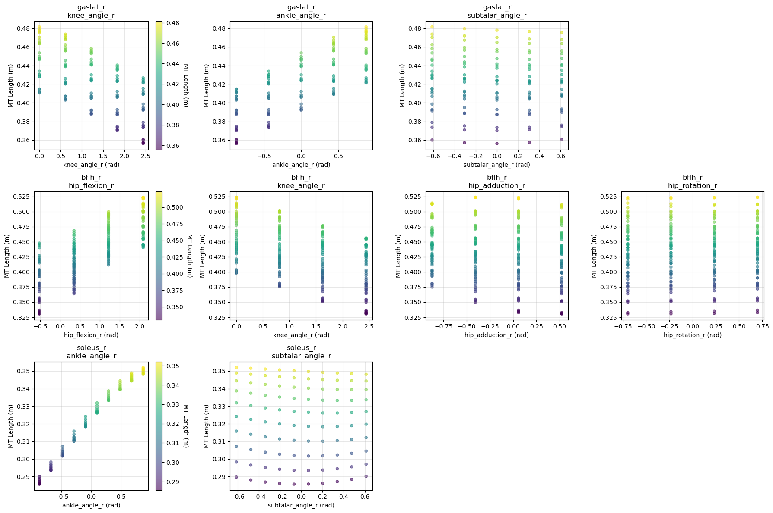
Figure 7.1: Musculotendon length dependence on joint coordinates for gaslat, bflh, and soleus. Color indicates musculotendon length, with stronger coordinate coupling visible for ankle angle in soleus and hip flexion in bflh.

Appendix C: MoveDB

