HASviolet
Installation and User Guide for ESP32

Hudson Valley Digital Network
14 March 2021
v1.1
Table of Contents
Introduction 3
Design 3
Hardware 4
SoC 4
Antenna 4
Firmware 5
Build Environment 5
Setup 5
Build 6
Upload 6
Runtime 6
Appendices 7
XARPS 7
Payload Fields 7

Introduction
Welcome to HASviolet!

Within Hudson Valley Digital Network (HVDN) we look at HASviolet as a project that is as much (if not more) about the journey as it is about the destination. The project’s origins started with a member of HVDN sharing the idea "I've been wanting to do a "communicator" for a while. Something that someone could use over relatively short distances to send text messages back and forth. I have been looking for others to work on a project with too!"
After some investigation LoRa was something to consider since it "should play well with the hacker/maker crowd and possibly the IoT/computer science area." From this point we thought it was a good idea to take forward and started developing a concept around it.

We sifted through a number of existing published LoRa projects using Raspberry Pi and various microcontrollers. We found many github sites with code, libraries, and recommended hardware but most of them were just "proof of concepts", no demonstrations of use cases, or sharing of lessons learned whether as a "lone eagle" or part of a team.
Since we would be building new and flexing existing skillsets along the way our differentiation with this project would be sharing the journey through articles, videos, and (hopefully) good documentation.

This guide will help you get started with HASviolet beginning with recommended ESP32 hardware. We will follow this with HASviolet firmware installation, configuration, and the HASviolet Web UI.

Design
When we embarked on the HASviolet project, we reviewed all the LoRa projects that were already out there. The vast majority of LoRa projects chose microcontrollers as their platform but we noticed many LoRa projects hit a roadblock after they reached basic objectives such as basic text chat between units. We came to the conclusion that unless a project is use-case driven and highlights the journey to a level of detail for others to build with you, the project just whithers over time especially with microcontroller based projects. We opted to lead the HASviolet project with a RPi solution first since it provides an optimal educational platform opportunity and would ease the “learning curve” as microcontroller options are included.
Once HASviolet on RPi was released we started thinking how much parity could we achieve with a version built on ESP32. We defined parity as user experience only since running Python on ESP32 may insulate us from ESP32 platform advantages when coding in C. So we started developing a Web UI first for HASviolet RPi with a standard command sent over Websocket to a backend process. Once that was done we ported the HTML5, CSS, and Javascript code with little change to run on an ESP32 and create the back process specific to the ESP32.
While it is our intention for HASviolet to continue to have user experience and functional parity acorss the RPi and ESP32 platforms, we recognize there may be use cases one platform has advantage over another. In those situations we look to at minimum preserver the Web UI experience.

Hardware
HASviolet ESP32 architecturee is broken down into the following components:

- Microcontroller
- Display (OLED)
- Input (Push-buttons)
- Network (WiFi)
- RF Module(LoRa)
- RF Antenna

With system-on-a-chip (SoC) and development boards, you can find these components often on a single hardware device. While available on a single platform, it is import to be mindful of the components when it comes to coding. You will want to ensure the components are readily supported with
libraries during firmware development.

SoC
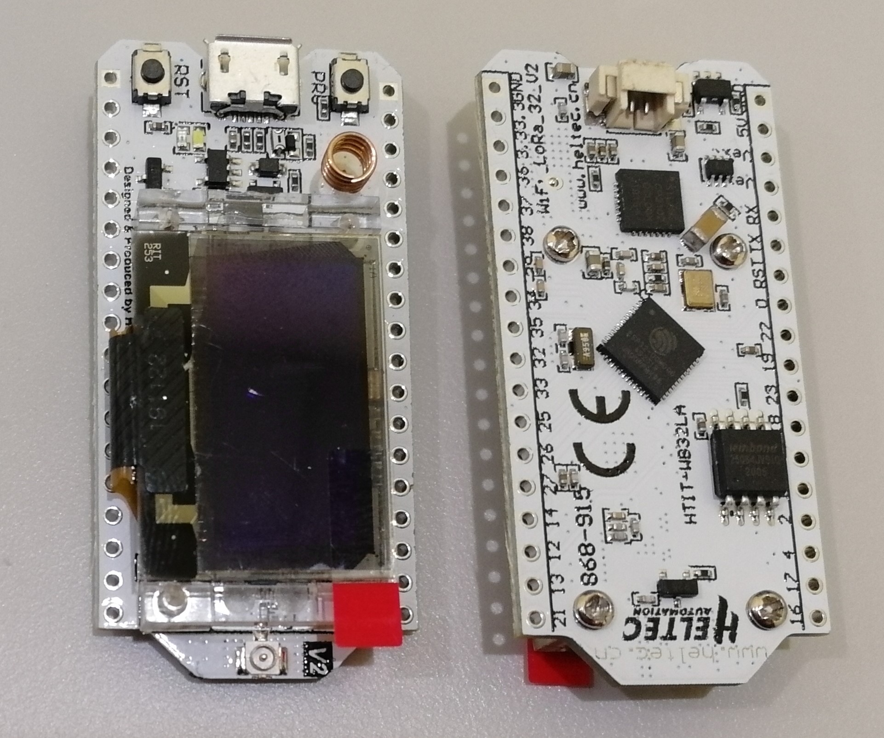
HASviolet ESP32 implementation tested in this guide uses the Heltec WiFi LoRa 32 v2.1 development board that includes the following components:

- ESP32 Microcontroller with WiFi
- SX1276 LoRa RF Module
- 0.96inch 128x32 OLED Display
- Push Button Input

Antenna
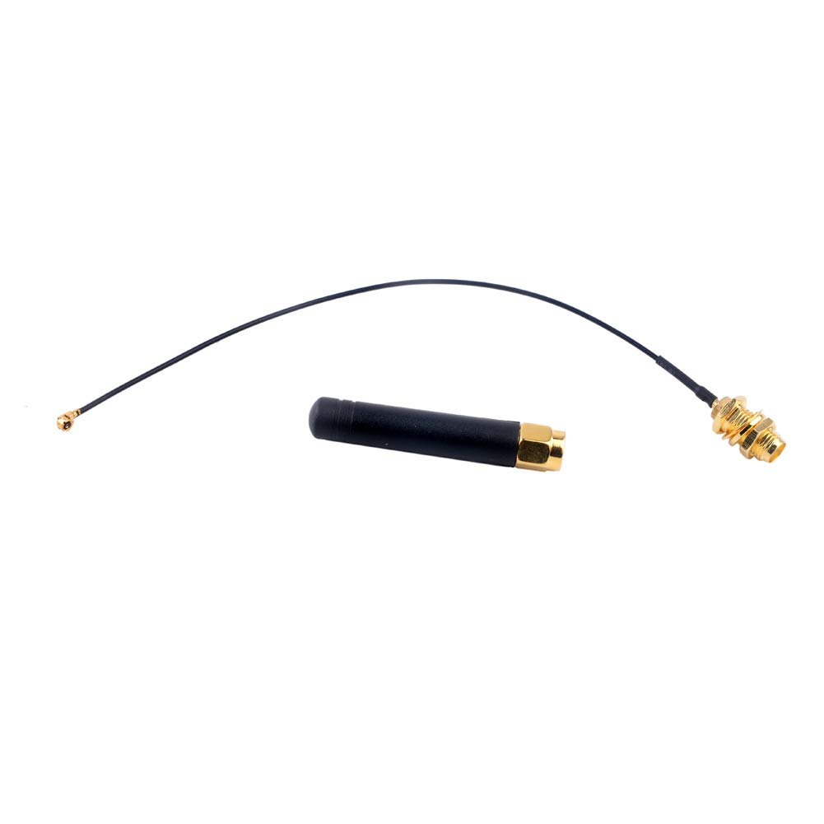
What antenna you use depends on your use case and the RAN coverage required. A Omnidirectional "stub" Antenna and a U.FL IPEX to SMA Connector is a good starting point for experimentation.

Firmware
A minimal development environment on your PC will be required to build, compile, and upload the firmware to your hardware. The same environment can be used for any modifications including hardware changes you make.

Build Environment
Even if you have no plans of writing code for the ESP32, you still need software to compile and upload the HASviolet ESP32 code from your computer to the ESP32. The Arduino Software (IDE) was initially used with then development moved to Platform IO on Visual Studio Code. In this section we will install PlatformIO, do an initial setup, and upload code to the board

Setup
- Go to the and Visual Studio Code site, download and install
- Go to PlatformIO site, download and install PlatformIO for VS Code.
- From the PIO Home tab, select the boards icon  - Enter your board on search line and search  - Click cart to install | 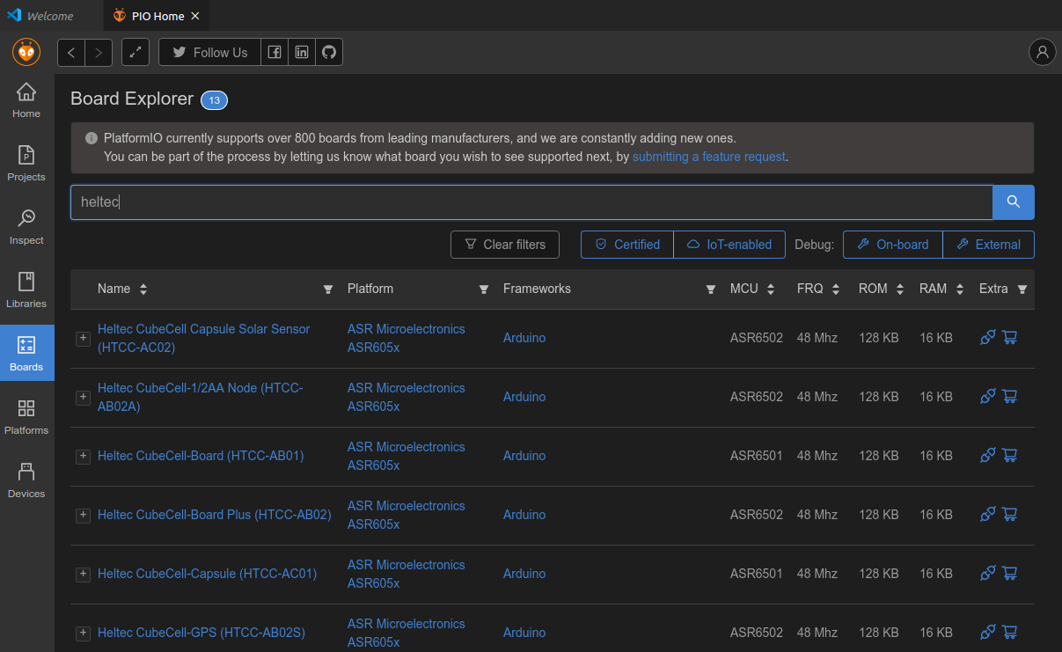
- From the PIO Home tab, select the libraries icon  - Search and install the following libraries  - <YOUR_ESP32>  - ArduinoJson-esphomelib  - AsynTCP-esphome  - ESPasyncTCP-esphome  - ESPAsyncWebServer-esphome  - SPIFFSIniFile  - Time | Development environment installation is complete
- Clone the HASviolet ESP32 repo to a local directory | cd home/joe  git clone https://github.com/hudsonvalleydigitalnetwork/hasviolet.git

Build
- Go to the cloned repo and navigate to the ESP32/duck directory  - Run the compiler | cd ~/hasviolet/ESP32/duck  pio run

pio run will compile all libraries and main firmware files into the the resulting binary is stored as
~/hasviolet/ESP32/duck/.pio/build/<YOUR_ESP32>/firmware.bin

Where <YOUR_ESP32> is the ESP32 board you have chosen to build HASviolet on.

Upload
- Connect your board via USB cable  - Run command to upload | cd ~/hasviolet/ESP32/duck  pio run -t upload -t uploadfs

Runtime
Once HASviolet ESP32 boots, the HVDN logo will display on the OLED and event messages will be sent to the serial port. This includes where the Duck is in the boot process and any errors encountered. The Duck will setup a WiFI AP with the SSID of Duck. Using a PC, smartphone, or tablet, connect to Duck with the passphrase of 123456789. With a web brwoser connect to the address of 192.168.4.1 to get the application page.Log in with admin and Quackers.

Proceed to the applications section for more info on the loaded firmware.

Appendices

XARPS
XARPS stands for eXtensible Amateur Radio Payload Specification. Referencing the Open Systems Interconnection model (OSI model), XARPS is an application layer protocol with link-level awareness for use by RF systems providing application level connectivity to other networked systems. ASCII (UTF-8) is used throughout the specification

Payload Fields
Source | Destination | Options | Data Type | Data
9 bytes (string) | 9 bytes (string) | 1 byte (hex) | 1 byte (hex) | 235 bytes (string)

Source and Destination
Each contain callsign/handle with SSID. Field size supports IARU decision for 7 character callsigns. Example source and destination data include W1FCC50, PURPLE53.
BEACON99 is a reserved word in the destination field for broadcast messages.

Options
Value | Option | Description
0x00 - 0x05 | Reserved
0x06 | ACK Response | Response to ACK Request
0x07 | ACK Request | Used when positive verification is required that a payload was received

Data Type
Value | Type | Description
0x00 | Reserved | Reserved
0x01 | Battery | Battery voltage update
0x02 | Time | Current time payload
0x03 | Position Update | GPS position update
0x04 | Weather Update | Weather station data
0x05 | Text Message | Text message between stations
0x06 | Broadcast | Broadcast Message to all stations
0x07 | Last Seen Stations | Digest of recent stations
0x08 | Binary Data | Binary Datat Transport
0x08 - 0x0F | Reserved | Reserved
0x46 | Gopher | Gopher
0x50 | HTTP | HTTP
0x71 | Ident | Ident
0x77 | NNTP | NNTP
0x7B | NTP | NTP
0xC2 | IRC | IRC

0x00 Reserved
Not used
0x01 Battery
This payload type provides battery voltage in ASCII numeric format, which may contain a floating point.
0x02 Time
This payload contains the time in epoch UTC
0x03 Position Update
This message is used to provide position updates, such as GPS locations of any station and is formatted as follows:
[time in UTC],[latitude],[longitude],[altitude],[speed],[direction],[station type]
Station types include:

Value | Type
0 | handheld
1 | pedestrian
2 | car
3 | truck
4 | van
5 | emergency vehicle
6 | ambulance
7 | fire truck
8 | command vehicle
9 | officer
10 | aircraft
11 | boat
12 | quadcopter UAV
13 | fixed wing UAV
14 | balloon
15 | float
16 | landmark
17 | road closed
18 | accident
19 | hazard
20 | Perimeter Marker
21-255 | reserved for future use

0x04 Weather Update
Weather updates are still in the definition process, but should utilize METAR format
0x05 Text Message
Free text field for text message between stations.
0x06 Broadcast Message
Broadcast and beacon messages. While BEACON99 is a reserved for any broadcast, it is recommended to BEACON and another SSID if you wish to send specific broadcast types like club bulletins, etc.
0x07 Last Seen Stations
Contains a comma delimited list of recently heard stations.
0x08 Binary Data
Binary Data transport
0x0F Reserved
Not used

