HASviolet
Build Guide

Hudson Valley Digital Network
5 March 2020
v1.0

Introduction
This build guide will walk you through the required hardware and software installation for HASviolet to function. HASviolet will require Internet connectivity via its onboard WiFi for update of the Raspbian Lite OS as well as use future use as a possible LoRaWAN gateway.

While the production of this guide and steps is focused on Linux users, references to
installation on Mac OSX and Windows platforms are called out within the text

All reference to “RPi” in this guide are an abbreviation for the Raspberry Pi Zero WH hardware.

Hardware
HASviolet consists of the following hardware:

Raspberry Pi Zero WH (Wireless with Headers)  - You will need to solder the 20-pin header to the board. | 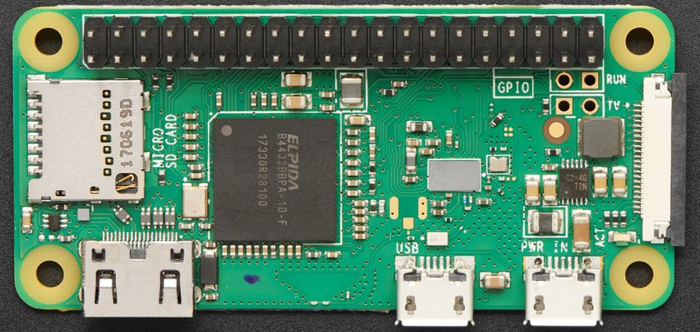
Adafruit LoRa Radio Bonnet with OLED – RFM95W @915Mhz  - Antenna is via a male U.FL connector | 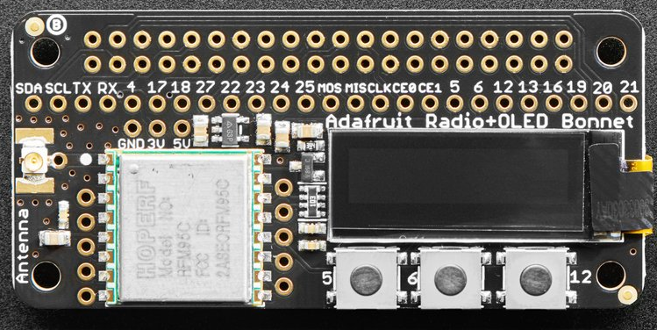
SanDisk Ultra 16GB RAM Class 10 MicroSD  - RPI require quality microSD cards at least Class 10 | 
Power Source 5V @ 2.5A minimum  - The hardware can be powered via USB to PC as part of setup but for operation it needs to be on a standalone power source | 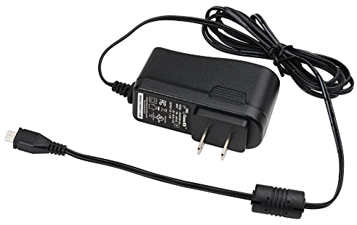
900 MHz Antenna with  U.FL IPEX to SMA Connector  - We will use a simple omnidirectional antenna to get started. Permanent installations should use antennas with greater gain | 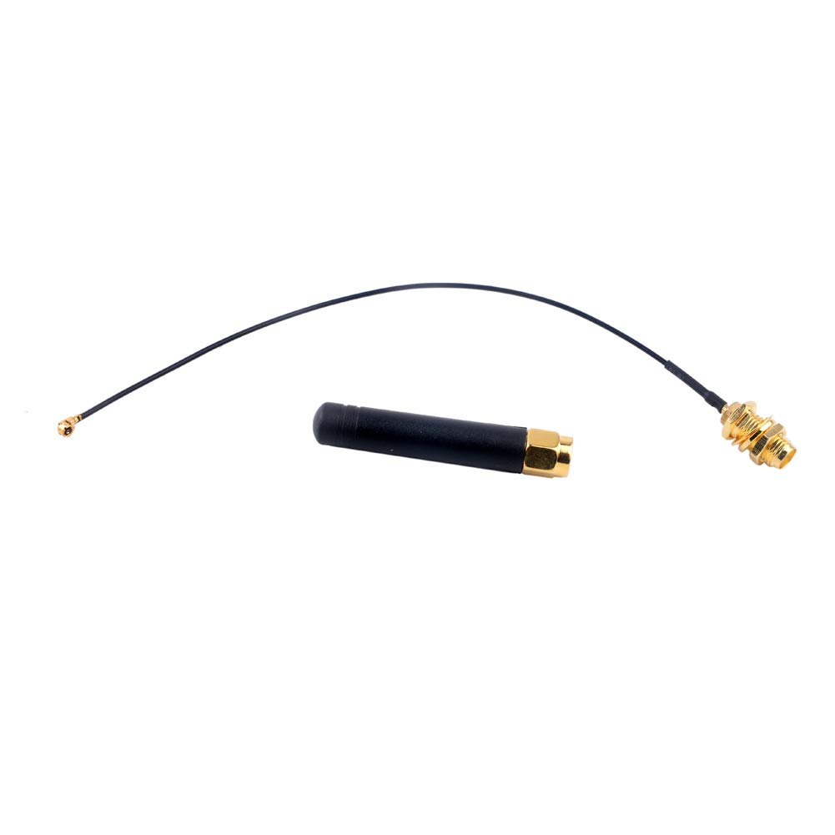

Preparing Media
Media installation and preparation for operating systems other than Linux can be found in the Raspberry Pi Documentation Section on Installing images.
- From your PC insert an SD Card  - Run sudo gparted partitioning software  - From Gparted menu select Devices and SD card inserted  - Unmount the SD card Delete any existing parititons  - Right click on unallocated, select new, select FAT32 as file system. Click add  - Click check mark to apply all operations | 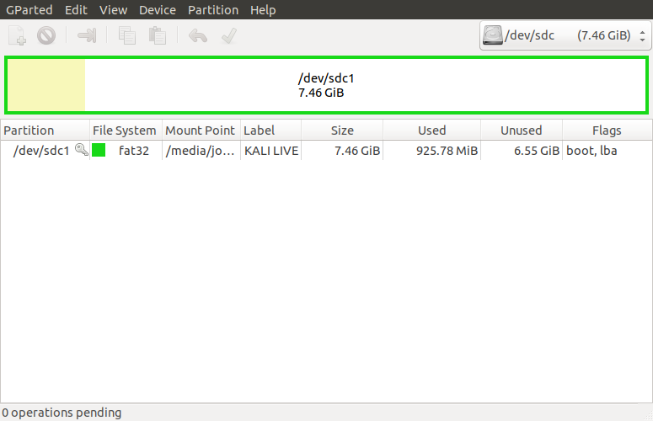
- Download Raspbian and Extract from ZIP file  - Install Raspbian on freshly formatted SD card | wget --max-redirect=3 https://downloads.raspberrypi.org/raspbian_lite_latest  unzip raspbian_lite_latest  sudo dd bs=4M if=2020-02-05-raspbian-buster-lite.img of=/dev/sdg conv=fsync

Pi Connectivity
Via connected keyboard, monitor and mouse
- Change to your home directory, run sync as sudo, and unmount the SD card  - Remove the SD card | cd ~  sudo sync  umount /media/sd-card/root  umount /media/sd-card/boot
- You will rerquire a mini HDMI adapter to your monitor (HDMI, VGA, mDP, etc)  - You will require a USB OTG cable to attach a keybaord | 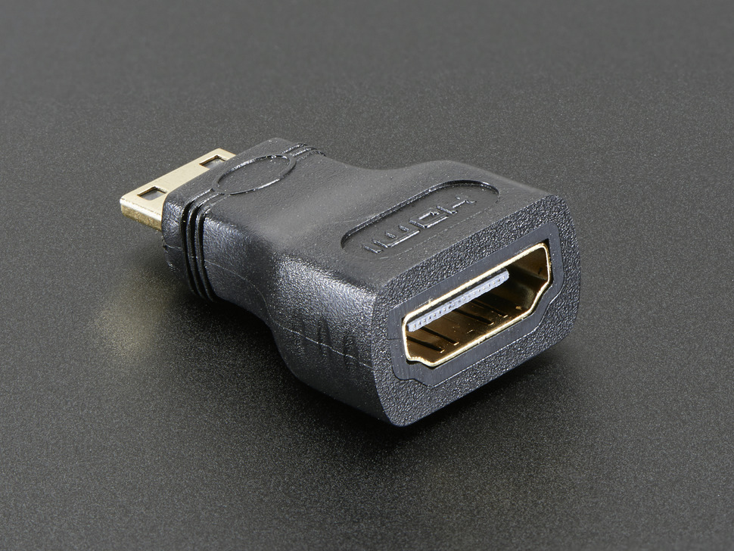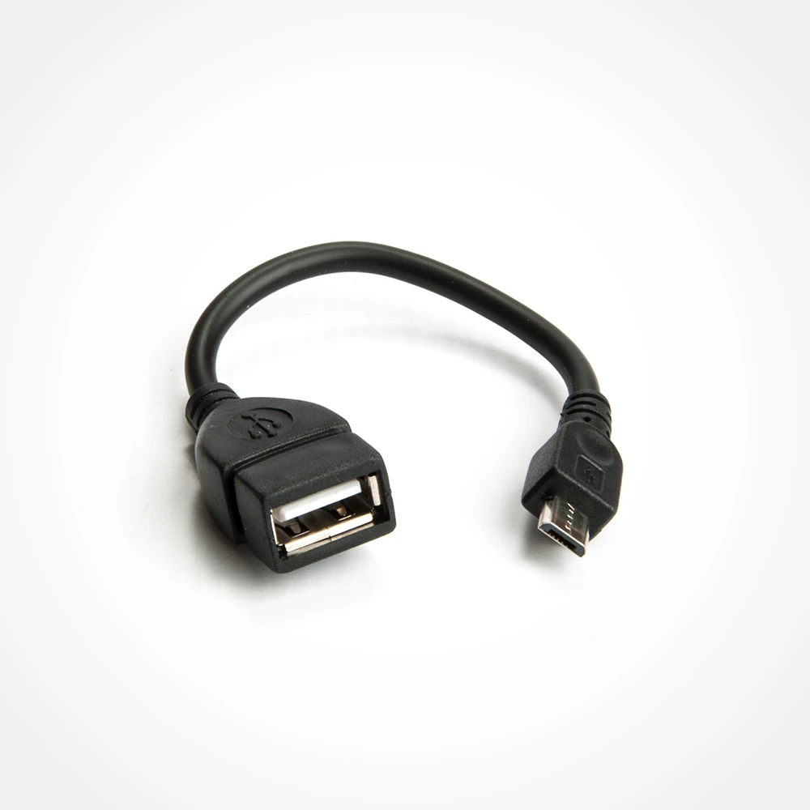
Via IP through Wireless Connection
- You can use this method if you wish to access the RPi via an existing WiFi network  - Change to the boot directory on the SD card  - Enable ssh access by creating a blank file named ssh | cd /media/sd-card/boot  touch ssh
- Within the boot directory, create a file called wpa_supplicant.conf and edit | vi wpa_supplicant.conf
- When you have opened the new file, add the configuration at right and save  - Be sure to replace SSID with your local wireless network SSID | country=US  ctrl_interface=DIR=/var/run/wpa_supplicant GROUP=netdev  update_config=1  network={  ssid="MyWiFiNetwork"  psk="aVeryStrongPassword"  key_mgmt=WPA-PSK  }
- Change to your home directory, run sync as sudo, and unmount the SD card  - Remove the SD card | cd ~  sudo sync  umount /media/sd-card/root  umount /media/sd-card/boot
Via IP through USB connection
If WiFi is not available is is possible for the Pi to be IP accessible via USB from a desktop/laptop that runs zero-configuration networking, namely BonJour Services developed by Apple. method is for when access to a network is not possible for the Rpi but network access is possible from a laptop or PC.
- For Linux add a USB Network Interface and a network with the Pi on the USB interface. Give it a static address (ie 169.254.15.1 ) | 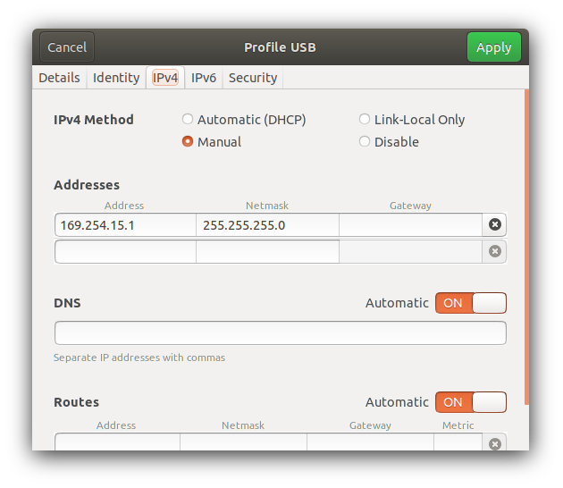
- Change to the boot directory on the SD card  - Edit the config.txt file | cd /media/sd-card/boot  vi config,txt  Append the following line:  dtoverlay=dwc2  Then save the file.
- While in the boot directory, edit the cmdline.txt file, replace a line, then save file. | vi cmdline,txt  Replace with the following all as one continuous line:  dwc_otg.lpm_enable=0 console=serial0,115200 console=tty1 root=/dev/mmcblk0p2 rootfstype=ext4 elevator=deadline fsck.repair=yes rootwait modules-load=dwc2,g_ether quiet init=/usr/lib/raspi-config/init_resize.sh  Than save the file.
- Remaining in the boot directory, enable ssh access by creating a blank file named ssh | touch ssh
- Change to the rootfs directory  - Edit the interfaces file | cd /media/sd-card/rootfs/etc/network  vi interfaces  Append the following lines:  allow-hotplug usb0  iface usb0 inet static  address 169.254.15.2  netmask 255.255.255.0  network 169.254.15.0  broadcast 169.254.15.255  gateway 169.254.15.1  Then save the file
- Change to your home directory, run sync as sudo, and unmount the SD card  - Remove the SD card | cd ~  sudo sync  umount /media/sd-card/root  umount /media/sd-card/b

Pi Setup
- Install Adafruit Radio Bonnet and Antenna  - Insert SD card  - Connect RPI and Power on  - Log in with default pi:raspberry | If accessing via IP over USB, connect PC USB port to RPi USB Data port (next to mini-HDMI port)  ssh -l pi <yourpi>  If connecting via SSH for first time click yes to accept fingerprint
- Run Configuration tool | sudo raspi-config
- Navigate through each menu making selections as noted then exit tool | 1. Change User Password to <something>  2. Network options  N1 Change hostname to your call + number [1-15]  yourcall-5  3. Boot Options  B1 Desktop/CLI  choose B1 Console  4. Localization  I1 Change Local to en_US.UTF-8  I2 Change Timezone  I4 Set to US  5. Interfacing options  P2 Enable SSH  P4 Enable SPI  P5 Enable I2C  7. Advanced Options  A3 memory Split  Reduce GPU from 64 to 16  8. Update
- Run sync as sudo, and reboot | sudo sync ; sudo sync ; sudo sync  sudo reboot

HASviolet Install
Copy Report and Run Install
- Ensure you are in the home directory  - Install Git  - Clone the Github HASviolet repo locally  - Go into the build directory and run the install shell script | cd ~  sudo apt-get install -y git  mkdir hvdn-repo ; cd hvdn-repo  git clone https://github.com/hudsonvalleydigitalnetwork/hasviolet.git  cd hasviolet/build  ./hvdn_hasviolet_install.sh
- Installation is complete. Apps are run from /home/pi/hvdn | Installed Directories include  - /home/pi/hvdn where the programs and their config files are to be run from  - /home/pi/hvdn-repo is local repo of hvdn apps are  - /home/pi/hvdn-repo/hasviolet is local repo of HASviolet

Using HASviolet
HVDN Communicator is data only currently designed to be used on local LoRa networks. It is installed in /home/pi/hvdn-comm

HVDN Communicator is built with Python. Applications include;

- hvdn_lora-beacon.py sends a repeating broadcast message
- hvdn_lora-chat.py is a half-duplex messaging app
- hvdn_lora-tx.py sends a message to another LoRa station
- hvdn_lora-rx.py listens for messages from other LoRa stations

Three files dependend by all applications are;

- hvdn-comm.ini is a configuration file
- rf95.py is a Python Library for the HOPE RFM95 modules on the Raspberry Radio Bonnet
- font5x8.bin used by the OLED on the Adafruit Radio Bonnet

hvdn_lora-beacon.py
Beacon a LoRa message
Usage: hvdn_lora-beacon.py -c COUNT -t DELAY "message"

OPTIONS
-c Number of times to repeat MESSAGE
-t NUmber of seconds before repeat MESSAGE
MESSAGE is message to be send within double quotes

hvdn_lora-chat.py
Half-duplex LoRa messaging app
Usage: ./hvdn_lora-chat [-r] [-s]

OPTIONS
-h, --help show this help message and exit
-r, --raw_data Receive raw data
-s, --signal Signal Strength
- Starts and loops in Listening Mode
- CTRL-Z to send a message, CTRL-C to exit program
- When in send mode
  - Recipient is node id (255 = broadcast address)
  - Message is whatever message followed by enter
  - Message is sent, return to listening mode

hvdn_lora-tx.py
Send a LoRa message
Usage: hvdn_lora-tx.py -d DESTINATION "message"

OPTIONS
-d Destination ID
MESSAGE is message to be send within double quotes

hvdn_lora-rx.py
Listens for messages from other LoRa stations
Usage: ./hvdn_lora-rx.py -r -s

OPTIONS
-h, --help show this help message and exit
-r, --raw_data Receive raw data
-s, --signal Signal Strength

HASviolet Manual Install
The build script (hvdn_hasviolet_install.sh) automates the following steps.

Install Raspbian Packages
- Log back into the RPi.  - Ensure you are in the home directory  - Install the following packages  - pip3 – Python Package Index  - Git – For cloning repositories | cd ~  sudo apt-get install python3-pip  sudo apt-get install git

Install Python Libraries
- Install the following Python libraries  - Python Image Library  - APRS and APRSlib  - Adafruit Radio Bonnet Libraries | sudo apt-get install python3-pil  sudo pip3 install aprs  sudo pip3 install aprslib  sudo pip3 install adafruit-circuitpython-rfm69  sudo pip3 install adafruit-circuitpython-rfm9x  sudo pip3 install adafruit-circuitpython-ssd1306  sudo pip3 install adafruit-circuitpython-framebuf
Install HVDN Repository
- Ensure you are in the home directory  - Make two new directories called hvdn and hvdn-repo  - Change directory to hvdn-repo and clone the HASViolet repo from Github  - Copy the HASviolet stable directory to hvdn | cd ~  mkdir hvdn-comm  mkdir hvdn-repo  cd hvdn-repo  git clone https://github.com/hudsonvalleydigitalnetwork/hasviolet.git  cp -R /home/pi/hvdn-repo/hasviolet/stable/* /home/pi/hvdn
- Installation is complete. Apps are run from /home/pi/hvdn | Installed Directories include  - /home/pi/hvdn where the programs and their config files are to be run from  - /home/pi/hvdn-repo is local repo of hvdn apps are  - /home/pi/hvdn-repo/hasviolet is local repo of HASviolet

