HVDN Communicator
Linux Distro Build Guide

Hudson Valley Digital Network
2 December 2019
v0.4

Introduction
This is a guide on how to build the distribution image for the HVDN Communicator. All reference to “RPi” in this guide are an abbreviation for the Raspberry Pi Zero W hardware. The desktop operating system used in preparing the build is assumed to be a Debian or Debian derivative distribution. Ubuntu 18.04 was use din the preparation of this guide.

Preparing Media
- From your PC mount an 8GB SD Card  - Run gparted partitioning software  - From Gparted menu select Device and SD card inserted  - Destroy any existing parititons on the SD card and format as FAT32  - Note only 4GB of the SD Card will be formatted | 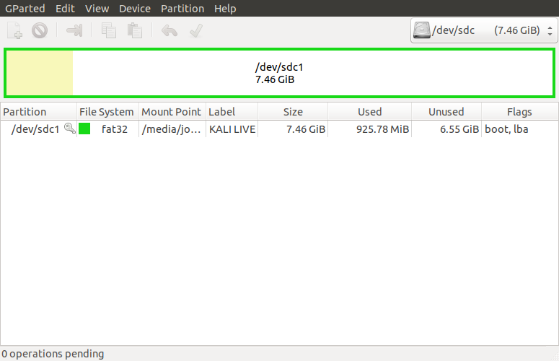
- Download Raspbian and Extract from ZIP file  - Install Raspbian on freshly formatted SD card | wget -O https://downloads.raspberrypi.org/raspbian_lite/images/raspbian_lite-2019-07-12/2019-07-10-raspbian-buster-lite.zip  unzip 2019-07-10-raspbian-buster-lite.zip  sudo dd bs=4M if=2019-07-10-raspbian-buster-lite.img of=/dev/sdg conv=fsync

Connectivity
Via connected keyboard, monitor and mouse  - Change to your home directory, run sync as sudo, and unmount the SD card  - Remove the SD card | cd ~  sudo sync  umount /media/sd-card/root  umount /media/sd-card/boot
Via IP through USB connection  - You can use this method if Bonjour Services are running on your PC. In this configuration you will be powering the RPi via the USB cable to your PC | cd /media/sd-card/boot  touch ssh  cd ~  sudo sync  umount /media/sd-card/root  umount /media/sd-card/boot
Via IP through Wireless Connection  - You can use this method you wish to access the RPi via an existing WiFi network. | cd /media/sd-card/boot  touch ssh  vi wpa_supplicant.conf
- When you have opened the new file wpa_supplicant.conf add the configuration at right and save.  - Be sure to replace SSID with your local wireless network SSID | country=US  ctrl_interface=DIR=/var/run/wpa_supplicant GROUP=netdev  update_config=1  network={  ssid="MyWiFiNetwork"  psk="aVeryStrongPassword"  key_mgmt=WPA-PSK  }
- Once saves, change directories, sync the drive and the unmount it | cd ~  sudo sync  umount /media/sd-card/root  umount /media/sd-card/boot

Pi Setup
- Install Adafruit Radio Bonnet and Antenna  - Insert SD card  - Connect RPI and Power on  - Log in with default pi:raspberry | If connnecting via SSH for first time click yes to accept fingerprint
- Run Configuration tool | sudo raspi-config
- Navigate throught each menu making selections as noted then exit tool | Change User Password to hvdnCOMM$  Network options, N1 Change hostname to your call + number [1-15]  Boot Options, B1 Desktop / CLI choose B1 Console  Localization, I1 Change Local to en_US.UTF-8, I2 Change Timezone  Interfacing options P2 Enable SSH, P4 Enable SPI, P5 Enable I2C  Advanced Options, A3 memory Split . Reduce GPU from 64 to 16  Update
- Run sync as sudo, and reboot | sudo sync  sudo reboot

Install Packages, Libraries and Repository
Packages
- Log back into the RPi.  - Ensure you are in the home directory  - Install the following packages  - pip3 – Python Package Index  - nginx – Web Server (Future Interface)  - Git – For cloning repositories  - Tilde – MS-DOS Style Text editor | cd ~  usdo apt-get install python3-pip  sudo apt-get install nginx  sudo apt-get install git  sudo apt-get install tilde
- Create self-signed SSL certificate for web server | sudo openssl req -x509 -nodes -days 3650 -newkey rsa:2048 -keyout /etc/ssl/private/hvdn-selfsigned.key -out /etc/sslrvices are not running on your PC and/or you wish to access the RPi via a WiFi network. In this configuration you will use an external power source for the RPi/certs/hvdn-selfsigned.crt
- Provide answers in bold to questions presented  - Press enter for EMAIL addressChanging Node ID | Generating a RSA private key  ...............................+++++  ...................+++++  writing new private key to '/etc/ssl/private/hvdn-selfsigned.key'  -----  You are about to be asked to enter information that will be incorporated  into your certificate request.  What you are about to enter is what is called a Distinguished Name or a DN.  There are quite a few fields but you can leave some blank  For some fields there will be a default value,  If you enter '.', the field will be left blank.  -----  Country Name (2 letter code) [AU]:US  State or Province Name (full name) [Some-State]:New York  Locality Name (eg, city) []:Hudson Valley  Organization Name (eg, company) [Internet Widgits Pty Ltd]:Hudson Valley Digital Network  Organizational Unit Name (eg, section) []:Communicator  Common Name (e.g. server FQDN or YOUR name) []:www.hvdn.org  Email Address []:
- Update web server to use SSL for connections by adding configuration to the default | sudo vi /etc/nginx/sites-enabled/default  Append the following lines:  listen 443 ssl default_server;  listen [::]:443 ssl default_server;  ssl on;  ssl_protocols TLSv1 TLSv1.1 TLSv1.2;  ssl_ciphers "HIGH:!aNULL:!MD5 or HIGH:!aNULL:!MD5:!3DES";  ssl_certificate /etc/ssl/certs/hvdn-selfsigned.crt;  ssl_certificate_key /etc/ssl/private/hvdn-selfsigned.key;

Python Libraries
- Install the following Python libraries  - APRS and APRSlib  - Adafruit Radio Bonnet Libraries | sudo pip3 install aprs  sudo pip3 install aprslib  sudo pip3 install adafruit-circuitpython-rfm69  sudo pip3 install adafruit-circuitpython-rfm9x  sudo pip3 install adafruit-circuitpython-ssd1306  sudo pip3 install adafruit-circuitpython-framebuf
HVDN Repository
- Ensure you are in the home directory  - Make two new directories called hvdn-comm and hvdn-repo  - Change directory to hvdn-repo and clone the HASViolet repo from Github  - Copy the HASviolet stable directory to hvdn-comm | cd ~  mkdir hvdn-comm  mkdir hvdn-repo  cd hvdn-repo  git clone https://github.com/hudsonvalleydigitalnetwork/hasviolet.git  cp /home/pi/hvdn-repo/hasviolet/stable /home/pi/hvdn-comm
Create Build Inventory
- Capture a list of currently installed packages and save to a date stamped file | sudo apt-cache pkgnames|sort>/home/pi/hvdn-comm_build_20191202

Using HVDN Communicator
HVDN Communicator is currently designed to be used on flat local LoRa networks with each node having a unique ID between 1 and 254. 255 is reserved as a broadcast address to all nodes.

HVDN Communicator applications and supporting code are stored in /home/pi/hvdn-comm

Executable applications include;

- hvdn-comm-lora-broadcast_rf95.py sends a repeating message to broadcast address (255)
- hvdn-comm-lora-message_rf95.py sends a message to another LoRa station
- hvdn-comm-lora-rx_rf95.py listens for messages from other LoRa stations

Running each command without arguments will provide you the syntax require to use it. Three files dependend by all applications are;

- hvdn-comm.ini is a configuration file where you set node ID
- rf95.py is a Python Library for the HOPE RFM95 modules on the Raspberyy Radio Bonnet
- font5x8.bin used by the OLED on the Adafruit Radio Bonnet

The only one of those three files that is edited for individual use is the hvdn-comm.ini file. A first step you need to do before transmitting is change the node address. While frequency and transmit power can be edited in that file, we recommend leaving the frequency until you are completely comfortable with using LoRa.

Changing Node ID  - Within the hvdn-comm.ini file change Node ID to a number unique on the network between 1 and 254 | [DEFAULT]  gpio_rfm_cs=1  gpio_rfm_irq = 22  node_address = 1  freqmhz = 911.25  txpwr = 5

