HASviolet
Installation Guide

Hudson Valley Digital Network
14 March 2020
v1.1

Introduction
This guide will walk you through the required hardware for HASviolet, installing the Raspbian Lite image, and running the HASviolet automated installation. Internet access will be required for installation via onboard WiFi for Raspbian Lite updates and retrieving the HASviolet software.

All reference to “RPi” in this guide are an abbreviation for the Raspberry Pi Zero WH hardware.

Hardware
HASviolet consists of the following hardware:

Raspberry Pi Zero WH (Wireless with Headers)  - You will need to solder the 20-pin header to the board. | 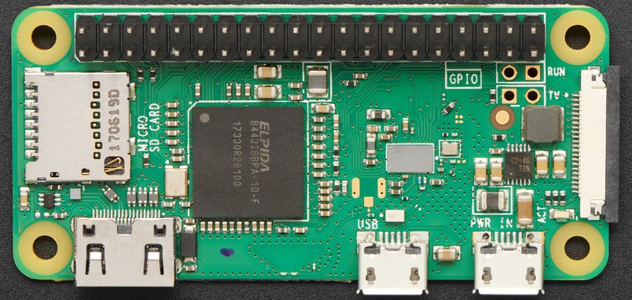
Adafruit LoRa Radio Bonnet with OLED – RFM95W @915Mhz  - Antenna is via a male U.FL connector | 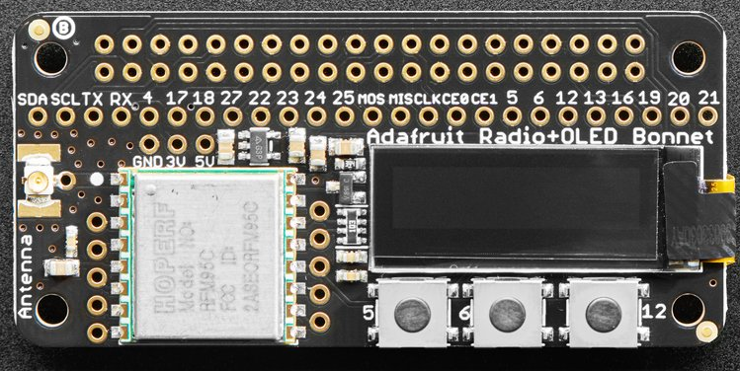
SanDisk Ultra 16GB RAM Class 10 MicroSD  - RPI require quality microSD cards at least Class 10 | 
Power Source 5V @ 2.5A minimum  - The hardware can be powered via USB to PC as part of setup but for operation it needs to be on a standalone power source | 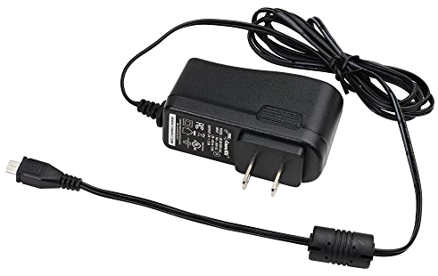
900 MHz Antenna with  U.FL IPEX to SMA Connector  - We will use a simple omnidirectional antenna to get started. Permanent installations should use antennas with greater gain | 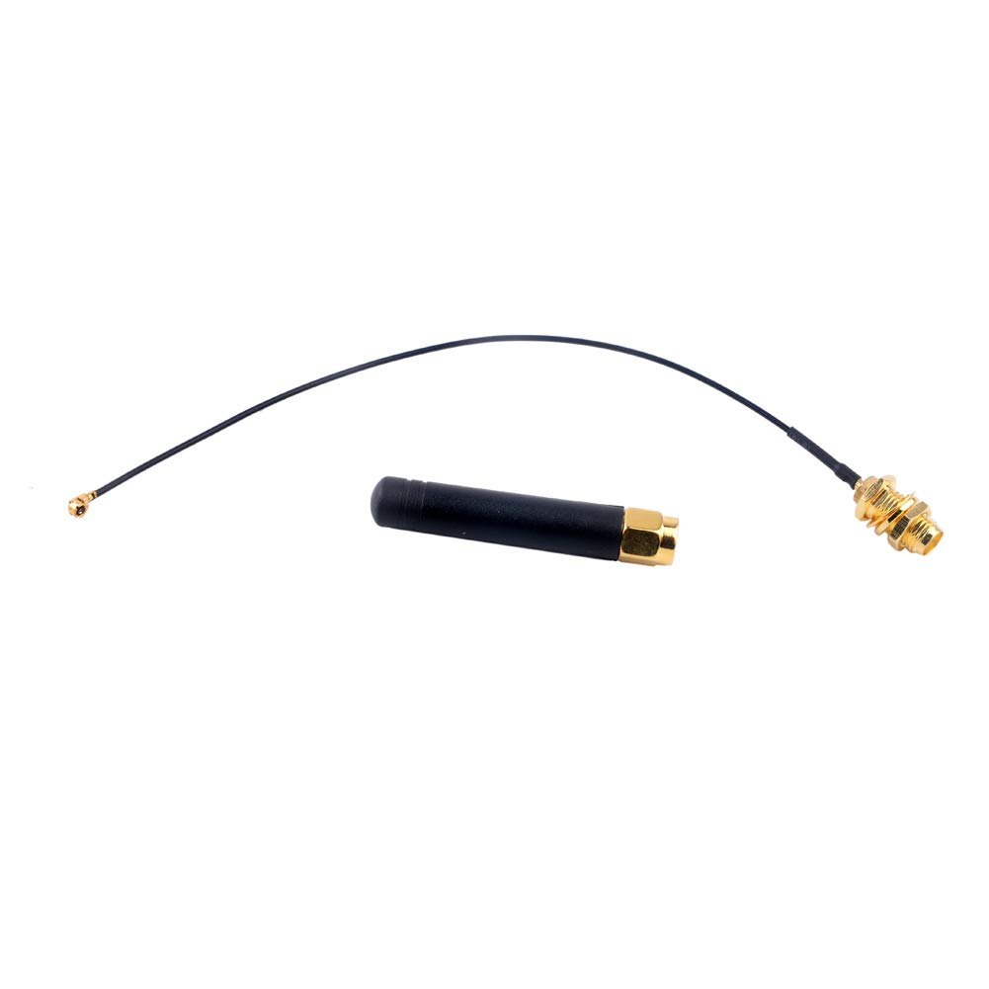

Installing Raspbian Lite
You will need another computer with an SD card reader in order to install Raspbian Lite.
Instructions for Linux, OSX, and Windows are available from the official Raspberry Pi site
at the following link:

https://www.raspberrypi.org/documentation/installation/installing-images/

When selecting an operating system, be sure to select Raspbian Lite. Within the Rapsbeery Pi Imager software it can be found under “Raspbian (other)” selection.

Pi Connectivity
Via connected keyboard, monitor and mouse
- You will require a mini HDMI adapter to your monitor (HDMI, VGA, mDP, etc)  - You will require a USB OTG cable to attach a keyboard | 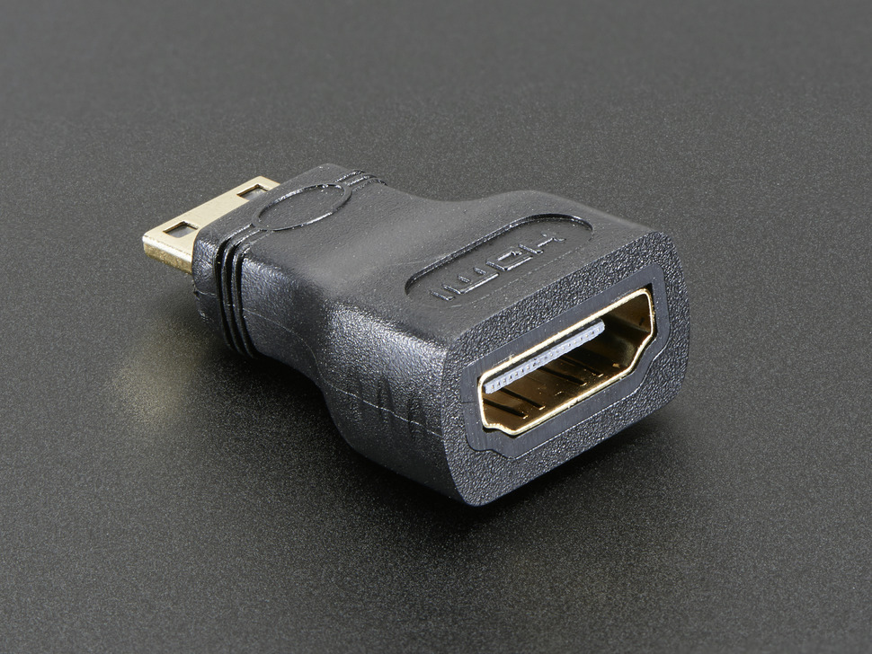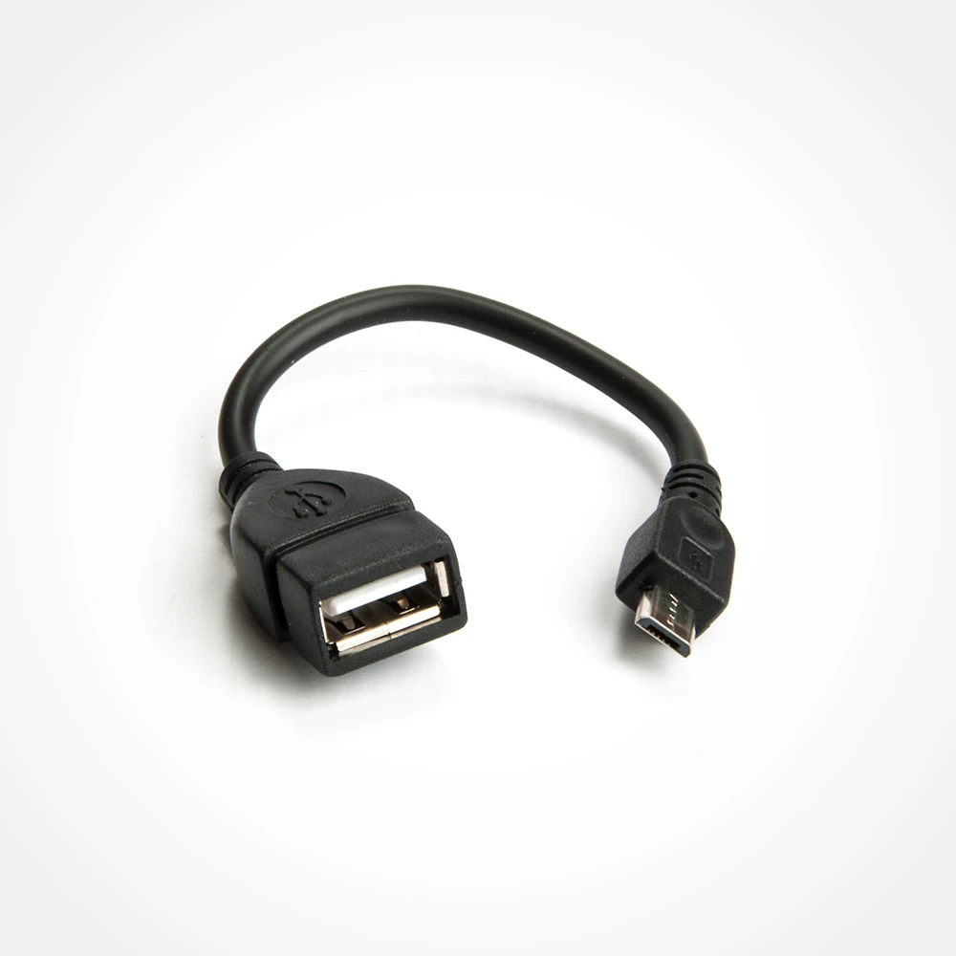
Via IP through Wireless Connection
- You can use this method if you wish to access the RPi via an existing WiFi network
- Change to the boot directory on the SD card
- Enable ssh access by creating a blank file named ssh
- Within the boot directory, create a file called wpa_supplicant.conf and edit
- When you have opened the new file, add the configuration at right and save  - Be sure to replace SSID with your local wireless network SSID | country=US  ctrl_interface=DIR=/var/run/wpa_supplicant  GROUP=netdev  update_config=1  network={  ssid="MyWiFiNetwork"  psk="aVeryStrongPassword"  key_mgmt=WPA-PSK  }
Via IP through USB connection
If WiFi is not available, using zero-configuration networking services may be an option. This is availabel on OSX and Windows using Apple BonJour Services. Bonjour is installed by default with OSX whereas Windows users can install Bonjour Services from the Apple site. Linux users will need to consult their distribution documentation on adding USB as an IP interface and any configuration changes to the installed Avahi software.
- Mount the SD card on your computer  - Change to the boot directory on the SD card  - Edit the config.txt file then save | Append config.txt with the following if it is not already there  dtoverlay=dwc2
- While in the boot directory, edit the cmdline.txt file  - Replace the line, then save file.  - Creat a blank file named ssh | Replace with the following all as one continuous line:  dwc_otg.lpm_enable=0 console=serial0,115200 console=tty1 root=/dev/mmcblk0p2 rootfstype=ext4 elevator=deadline fsck.repair=yes rootwait modules-load=dwc2,g_ether quiet init=/usr/lib/raspi-config/init_resize.sh

Pi Setup
- Install Adafruit Radio Bonnet and Antenna  - Insert SD card  - Connect RPI and Power on  - Log in with default pi:raspberry | If accessing via IP over USB, connect PC USB port to RPi USB Data port (next to mini-HDMI port)  ssh -l pi <yourpi>  If connecting via SSH for first time click yes to accept fingerprint
- Run Configuration tool | sudo raspi-config
- Navigate through each menu making selections as noted then exit tool | 1. Change User Password to <something>  2. Network options  N1 Change hostname to your call + number [50-99]  yourcall-50  3. Boot Options  B1 Desktop/CLI  choose B1 Console  4. Localization  I1 Change Local to <your country>.UTF-8  I2 Change Timezone  I4 Set to <your country>  5. Interfacing options  P2 Enable SSH  P4 Enable SPI  P5 Enable I2C  7. Advanced Options  A1 Expand Fileystem  A3 memory Split  Reduce GPU from 64 to 16  8. Update
- Run sync as sudo, and reboot | sudo sync  sudo reboot

HASviolet Install
- SSH into your Pi  - Run OS update and upgrade  - Retrieve the install script from Github  - Make the install script executable  - Run the install script | sudo apt-get update  sudo apt-get -y upgrade  cd ~  wget https://raw.githubusercontent.com/hudsonvalleydigitalnetwork/hasviolet/master/HASviolet_install.sh  chmod 755 HASviolet_install.sh  ./HASviolet_install.sh
- Once the scrip is complete, chang directories to /home/pi/HASviolet  - Edit the HASviolet.ini file  - Change NOCALL to your call or name and save the file | cd ~/HASviolet  vi HASviolet.ini
- Installation is complete. Apps are run from /home/pi/HASviolet | Installed Directories include  - /home/pi/HASviolet is where the programs with config files are run from  - /home/pi/HVDN-repo is local repo of HVDN projects  - /home/pi/HVDN-repo/hasviolet is local repo of HASviolet

HASviolet is now installed!

Get familiar with HASviolet. Go to the User Guide

