HVDN Communicator
Linux Distro Build Guide

Hudson Valley Digital Network
3 January 2020
v0.5

Introduction
This is a guide on how to build the distribution image for the HVDN Communicator. All reference to “RPi” in this guide are an abbreviation for the Raspberry Pi Zero W hardware. The desktop operating system used in preparing the build is assumed to be a Debian or Debian derivative distribution. Ubuntu 18.04 was use din the preparation of this guide.

Preparing Media
- From your PC mount an 8GB SD Card  - Run sudo gparted partitioning software  - From Gparted menu select Devices and SD card inserted  - Any existing partitions on the SD card right click and select Delete  - Right click on unallocated, select new, select FAT32 as file system. Click add  - Click check mark to apply all operations  - Note only up to 8GB of the SD Card will be formatted | 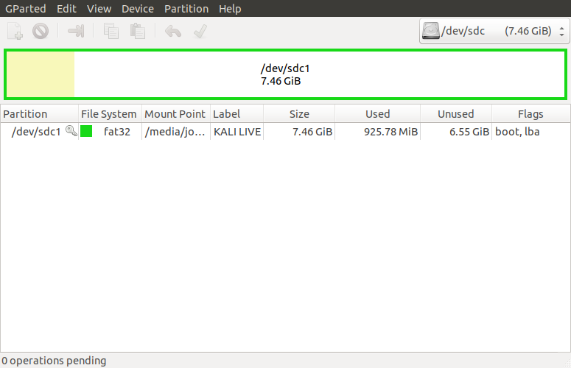
- Download Raspbian and Extract from ZIP file  - Install Raspbian on freshly formatted SD card | wget --max-redirect=3 https://downloads.raspberrypi.org/raspbian_lite_latest  unzip raspbian_lite_latest  sudo dd bs=4M if=2019-09-26-raspbian-buster-lite.img of=/dev/sdg conv=fsync

Connectivity
Via connected keyboard, monitor and mouse
- Change to your home directory, run sync as sudo, and unmount the SD card  - Remove the SD card | cd ~  sudo sync  umount /media/sd-card/root  umount /media/sd-card/boot
Via IP through Wireless Connection
- You can use this method if you wish to access the RPi via an existing WiFi network  - Change to the boot directory on the SD card  - Enable ssh access by creating a blank file named ssh | cd /media/sd-card/boot  touch ssh
- Within the boot directory, create a file called wpa_supplicant.conf and edit | vi wpa_supplicant.conf
- When you have opened the new file, add the configuration at right and save  - Be sure to replace SSID with your local wireless network SSID | country=US  ctrl_interface=DIR=/var/run/wpa_supplicant GROUP=netdev  update_config=1  network={  ssid="MyWiFiNetwork"  psk="aVeryStrongPassword"  key_mgmt=WPA-PSK  }
- Change to your home directory, run sync as sudo, and unmount the SD card  - Remove the SD card | cd ~  sudo sync  umount /media/sd-card/root  umount /media/sd-card/boot

Via IP through USB connection (Windows, Mac)
- Option available if RPI will be directly connected to a USB port on a Windows or Mac system with BonJour services installed  - In this configuration you will be powering the RPi via the USB cable to your PC  - Change to the boot directory on the SD card  - Edit the config.txt file, add a line, then save file | cd /media/sd-card/boot  vi config,txt  Append the following line:  dtoverlay=dwc2  Then save the file.
- While in the boot directory, edit the cmdline.txt file, replace a line, then save file. | vi cmdline,txt  Replace with the following all as one continuous line:  dwc_otg.lpm_enable=0 console=serial0,115200 console=tty1 root=/dev/mmcblk0p2 rootfstype=ext4 elevator=deadline fsck.repair=yes rootwait modules-load=dwc2,g_ether quiet init=/usr/lib/raspi-config/init_resize.sh  Than save the file.
- Remaining in the boot directory, enable ssh access by creating a blank file named ssh | touch ssh
- Change to your home directory, run sync as sudo, and unmount the SD card  - Remove the SD card | cd ~  sudo sync  umount /media/sd-card/root  umount /media/sd-card/boot

Pi Setup
- Install Adafruit Radio Bonnet and Antenna  - Insert SD card  - Connect RPI and Power on  - Log in with default pi:raspberry | If accessing via IP over USB, connect PC USB port to RPi USB Data port (next to mini-HDMI port)  If connecting via SSH for first time click yes to accept fingerprint
- Run Configuration tool | sudo raspi-config
- Navigate through each menu making selections as noted then exit tool | Change User Password to <something>  Network options, N1 Change hostname to your call + number [1-15]  Boot Options, B1 Desktop / CLI choose B1 Console  Localization, I1 Change Local to en_US.UTF-8, I2 Change Timezone  Interfacing options P2 Enable SSH, P4 Enable SPI, P5 Enable I2C  Advanced Options, A3 memory Split . Reduce GPU from 64 to 16  Update
- Run sync as sudo, and reboot | sudo sync  sudo reboot

Install Packages, Libraries and Repository
Packages
- Log back into the RPi.  - Ensure you are in the home directory  - Install the following packages  - pip3 – Python Package Index  - Git – For cloning repositories | cd ~  usdo apt-get install python3-pip  sudo apt-get install git

Python Libraries
- Install the following Python libraries  - Python Image Library  - APRS and APRSlib  - Adafruit Radio Bonnet Libraries | sudo apt-get install python3-pil  sudo pip3 install aprs  sudo pip3 install aprslib  sudo pip3 install adafruit-circuitpython-rfm69  sudo pip3 install adafruit-circuitpython-rfm9x  sudo pip3 install adafruit-circuitpython-ssd1306  sudo pip3 install adafruit-circuitpython-framebuf
HVDN Repository
- Ensure you are in the home directory  - Make two new directories called hvdn-comm and hvdn-repo  - Change directory to hvdn-repo and clone the HASViolet repo from Github  - Copy the HASviolet stable directory to hvdn-comm | cd ~  mkdir hvdn-comm  mkdir hvdn-repo  cd hvdn-repo  git clone https://github.com/hudsonvalleydigitalnetwork/hasviolet.git  cp /home/pi/hvdn-repo/hasviolet/stable /home/pi/hvdn-comm

Using HVDN Communicator
HVDN Communicator is data only currently designed to be used on local LoRa networks. It is installed in /home/pi/hvdn-comm

HVDN Communicator is built with Python. Applications include;

- hvdn_lora-beacon.py sends a repeating broadcast message
- hvdn_lora-chat.py is a half-duplex messaging app
- hvdn_lora-tx.py sends a message to another LoRa station
- hvdn_lora-rx.py listens for messages from other LoRa stations

Three files dependend by all applications are;

- hvdn-comm.ini is a configuration file
- rf95.py is a Python Library for the HOPE RFM95 modules on the Raspberry Radio Bonnet
- font5x8.bin used by the OLED on the Adafruit Radio Bonnet

hvdn_lora-beacon.py
Beacon a LoRa message
Usage: hvdn_lora-beacon.py -c COUNT -t DELAY "message"

OPTIONS
-c Number of times to repeat MESSAGE
-t NUmber of seconds before repeat MESSAGE
MESSAGE is message to be send within double quotes

hvdn_lora-chat.py
Half-duplex LoRa messaging app
Usage: ./hvdn_lora-chat [-r] [-s]

OPTIONS
-h, --help show this help message and exit
-r, --raw_data Receive raw data
-s, --signal Signal Strength
- Starts and loops in Listening Mode
- CTRL-Z to send a message, CTRL-C to exit program
- When in send mode
  - Recipient is node id (255 = broadcast address)
  - Message is whatever message followed by enter
  - Message is sent, return to listening mode

hvdn_lora-tx.py
Send a LoRa message
Usage: hvdn_lora-tx.py -d DESTINATION "message"

OPTIONS
-d Destination ID
MESSAGE is message to be send within double quotes

hvdn_lora-rx.py
Listens for messages from other LoRa stations
Usage: ./hvdn_lora-rx.py -r -s

OPTIONS
-h, --help show this help message and exit
-r, --raw_data Receive raw data
-s, --signal Signal Strength

