TESTING SHOPCAMP - KuyBelanjaProj

Tool yang digunakan : SELENIUM,Chrome, Netbeans IDE.

**Program Testing**

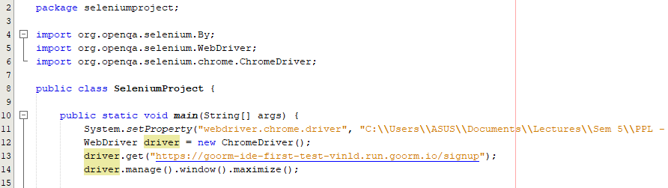

Program Proses Testing :

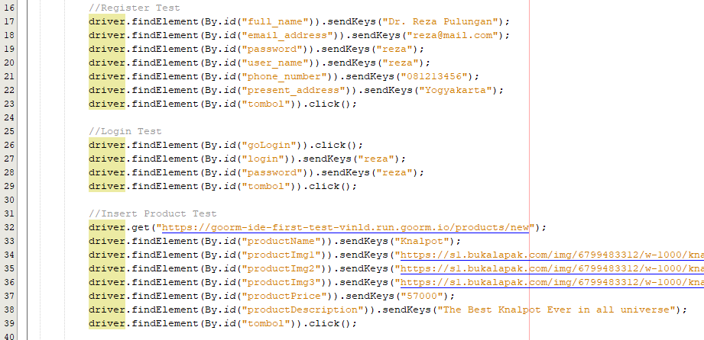

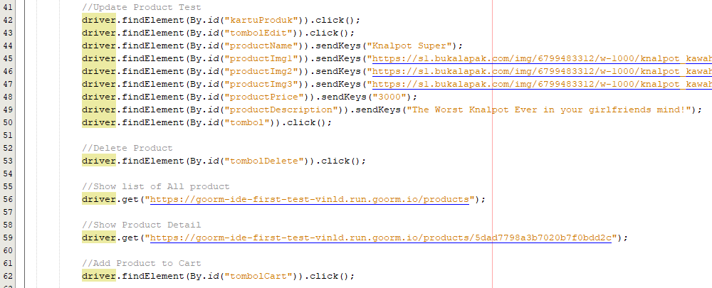

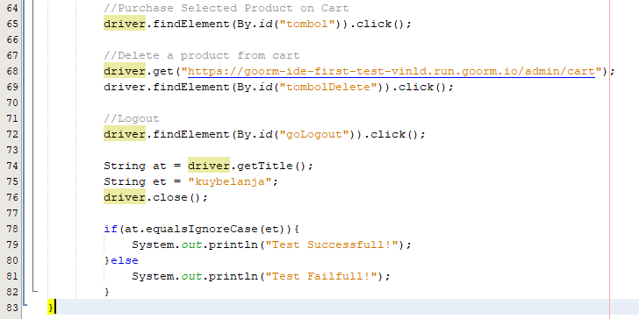

**Hasil Testing: Success**

