# Visualizing association between two quantitative variables

## M. Huebner 2014-03-28

Load crime data from 50 states.

data(USArrests)  
crime<-USArrests

To check what information is available in the dataset you an type ?USArrests. The data set contains * Murder arrests per 100,000 * Assault arrests per 100,000 * Percent urban population * Rape arrests per 100,000

Make a scatter plot of % urban population versus number of murder arrests. The ranges of the x-axis and y-axis are chosen automatically, or can be defined with xlim and ylim.

plot(Murder~UrbanPop, data=crime, xlim=c(15,100), ylim=c(0,20), pch=19, col="blue")  
# label the points with the state  
with(crime, text(Murder~UrbanPop, labels = row.names(crime), pos = 4, cex=0.5))

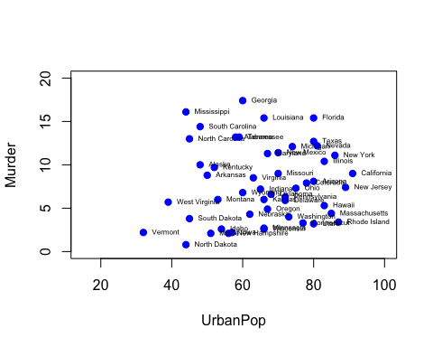

Which states have higher arrests for murder and assault?

plot(Murder~Assault, data=crime, xlim=c(40,400), ylim=c(0,20), xlab="Assault per 100,000", ylab="Murder per 100,000")  
with(crime, text(Murder~Assault, labels = row.names(crime), pos = 4, cex=0.5))

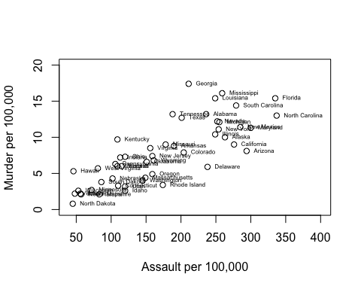

What is it in Michigan?

crime$state<-rownames(crime)  
crime[crime$state=="Michigan",]

## Murder Assault UrbanPop Rape state  
## Michigan 12.1 255 74 35.1 Michigan

#fig.width=7, fig.height=6  
# Label Michigan in the figure  
plot(Murder~Assault, data=crime, xlim=c(40,400), ylim=c(0,20), xlab="Assault per 100,000", ylab="Murder per 100,000")  
with(crime, text(Murder~Assault, labels = row.names(crime), pos = 4, cex=0.5))  
indx<-which(crime$state=="Michigan")  
points(crime$Assault[indx], crime$Murder[indx], pch=19, col="red")

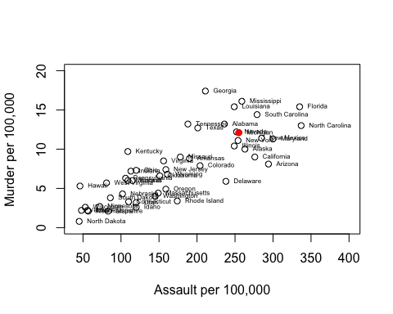

## Machine learning: principle component analysis (PCA)

apply(USArrests, 2, mean)

## Murder Assault UrbanPop Rape   
## 7.788 170.760 65.540 21.232

apply(USArrests, 2, var)

## Murder Assault UrbanPop Rape   
## 18.97 6945.17 209.52 87.73

A variable with larger variance, such as Assault, would dominate the principal components. So variables should be standardized before PCA. This step is built-in for the following function.

pca.out = prcomp(USArrests, scale = TRUE)  
pca.out

## Standard deviations:  
## [1] 1.5749 0.9949 0.5971 0.4164  
##   
## Rotation:  
## PC1 PC2 PC3 PC4  
## Murder -0.5359 0.4182 -0.3412 0.64923  
## Assault -0.5832 0.1880 -0.2681 -0.74341  
## UrbanPop -0.2782 -0.8728 -0.3780 0.13388  
## Rape -0.5434 -0.1673 0.8178 0.08902

biplot(pca.out, scale = 0, cex=0.6)

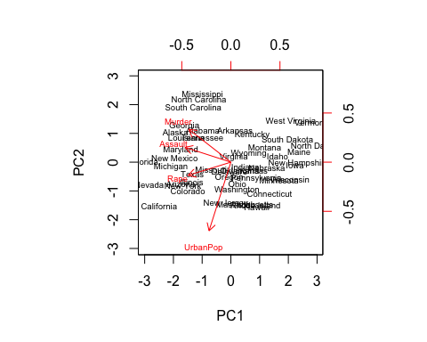

### The states with larger crime rates are towards the left. States with larger proportion of urban population are towards the bottom.