Lab_2:

Stage 1:

3.c.

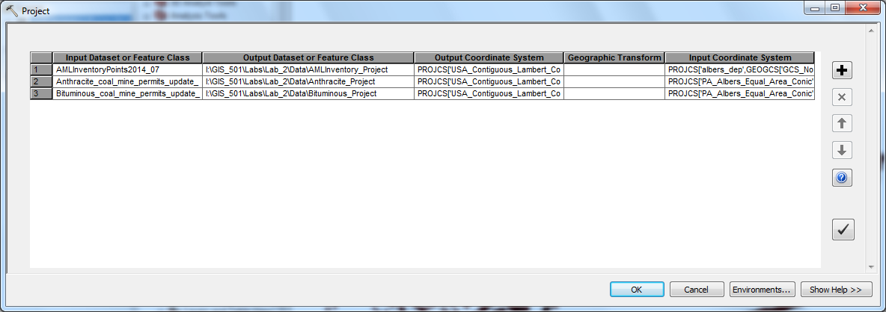

Stage 2:

2.d.

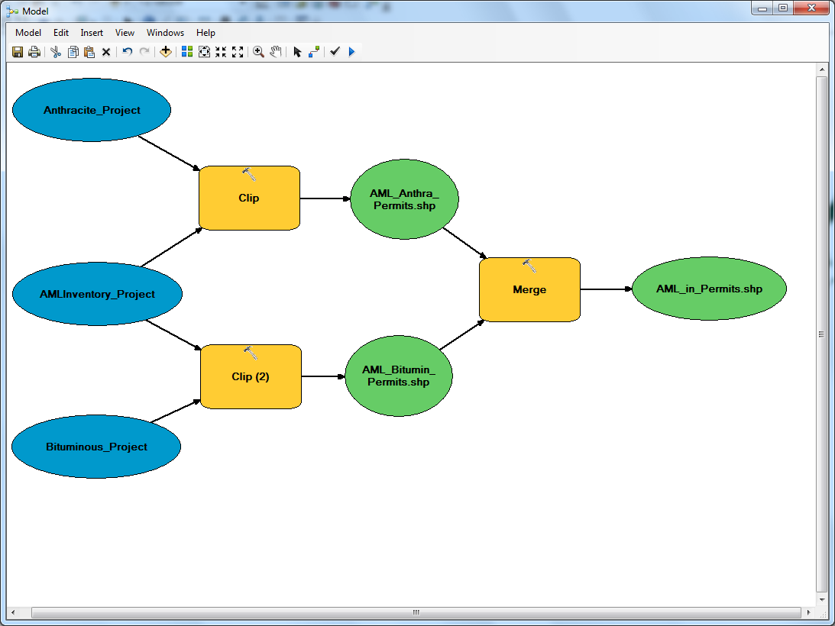

Stage 3:

8. 408-Abandoned mines.