# 示例一

|  |  |  |  |  |
| --- | --- | --- | --- | --- |
| 구분  판정요소 | 정상 | 요주의 | 이상 | 비고 |
| 온도차 | 5℃ 이하 | 5℃초과 ~10℃ | 10℃ 이상 |  |



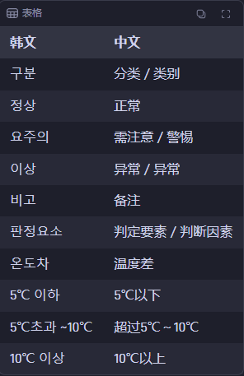

# 示例二

|  |  |  |  |  |  |
| --- | --- | --- | --- | --- | --- |
| 측정대상 |  | 사용전압 |  | 측정조건 |  |



# 示例三

|  |  |  |  |
| --- | --- | --- | --- |
| **测量部位** | Point 1 | Point 2 | Point 3 |
| 温度测量 |  |  |  |

# 示例四

|  |  |
| --- | --- |
| 热像图 | 可见光图 |
|  |  |

# 示例五

|  |  |  |  |  |  |
| --- | --- | --- | --- | --- | --- |
| 检测工况： | | | | | |
| 测试仪器 | |  | 图像编号 | |  |
| 天气 |  | 环境 |  | 湿度 |  |

# 示例六

|  |  |
| --- | --- |
| **Measurements** | |
| **Sp1** | 29.3℃ |
| **Bx1** |  |
| Max | 35.8℃ |
| Avg | 28.1℃ |
| Min | 23.2℃ |
| **Dt1(公式)** |  |
| Bx1.Max-Sp1  Delta  Value | 6.5℃ |