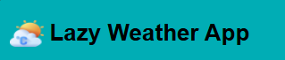

Home

Discover the most reliable and user-friendly way to stay informed about the weather in any location.

In our home weather dashboard, you can input any location you want. After you input any location you can see their next 5 days weather.

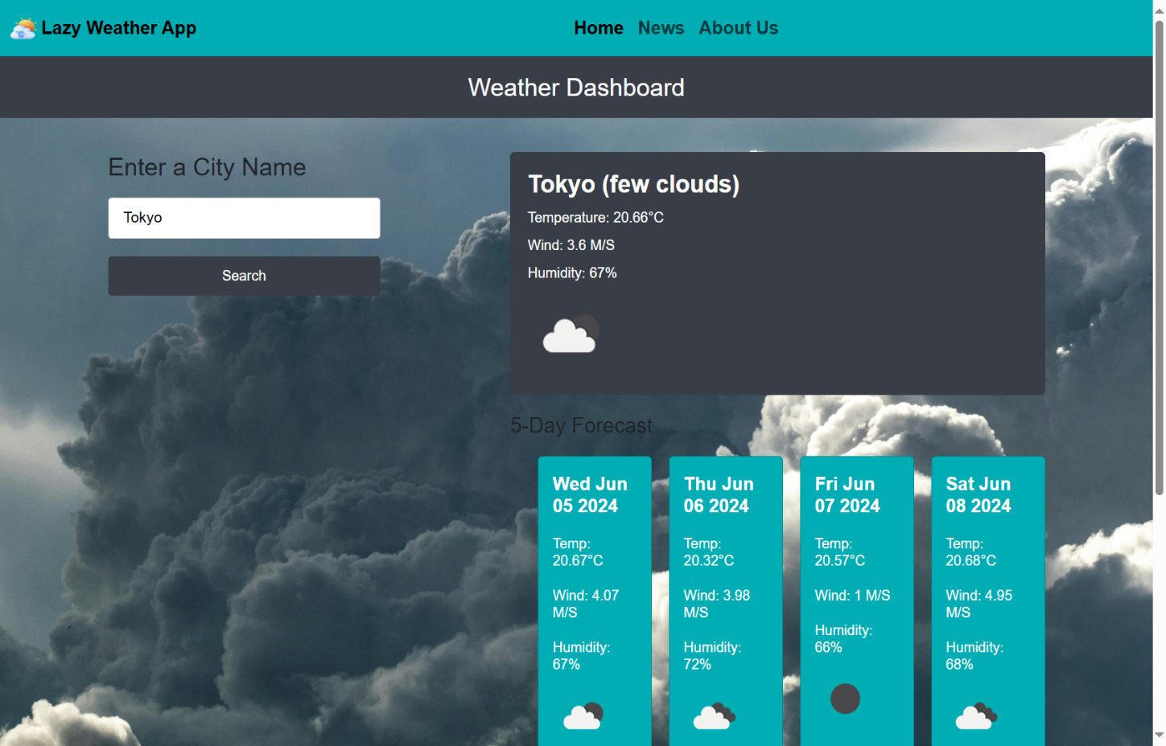

News Page

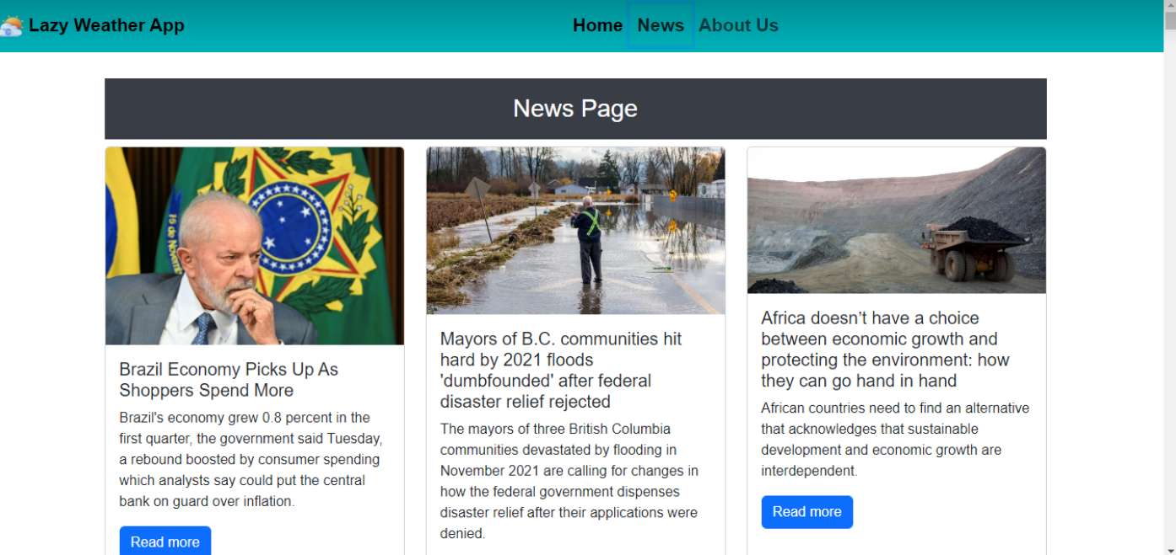

These apps offer a convenient way to stay informed about current events, breaking news, and a wide range of topics from various sources. Here you can see any news around the world.

**About us**

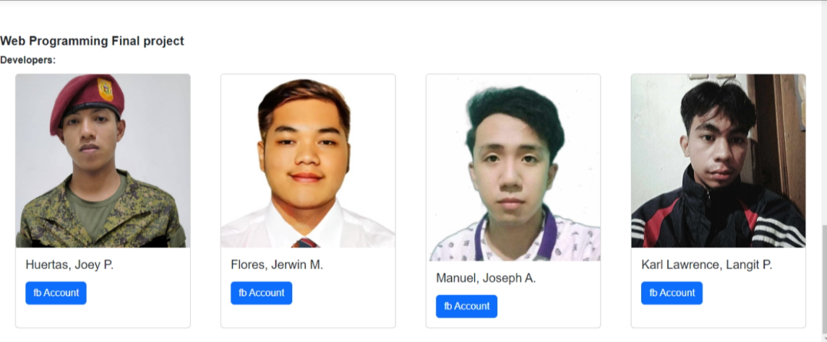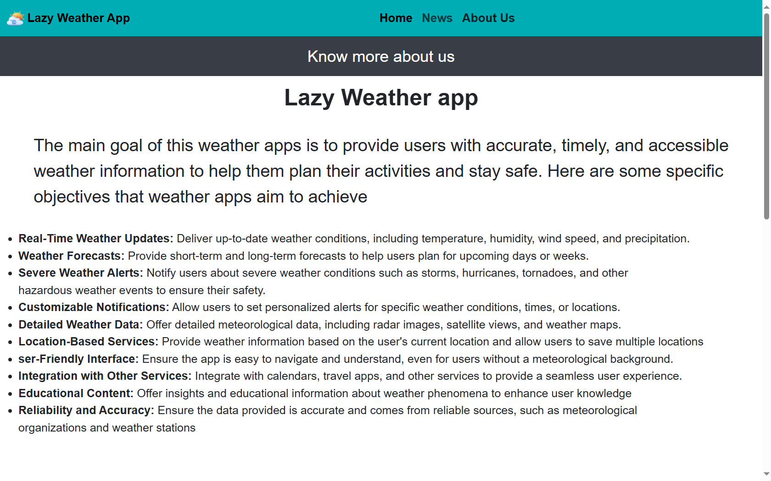

Here you can see the main goal and the overall functions of this website.