**Task 1**

**1. Simulating Geometric Brownian Motion (GBM)**

dS(t) = 0.1 dt + 0.26 dB(t); S(0) = 39 ; $μ=0.1$; $σ=0.26$

1000 runs of GBM are simulated for 0 < t < 3. Then, the time [0,3] is partitioned into 1000 subintervals. 5 realizations of GBM are plotted.

Stock prices are generated according to the stochastic differential equation (SDE) of GBM,

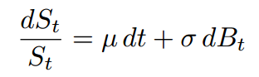

And the solution is,

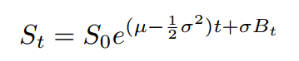

*Output:*

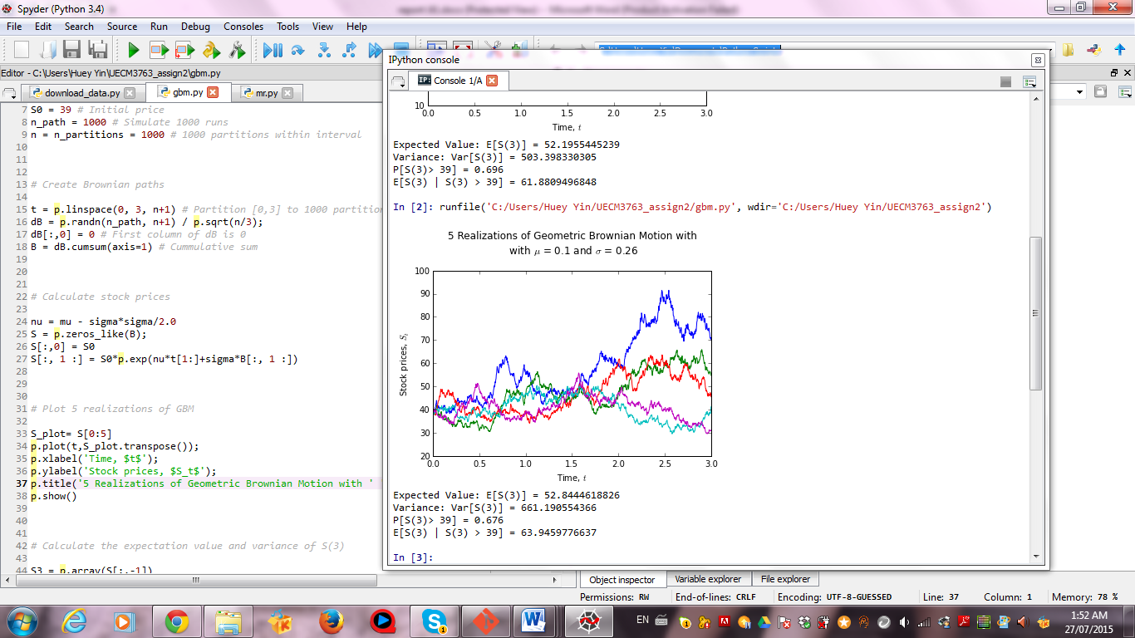

Then, an array S3 is created to store the value of last column of every row from the simulated Geometric Brownian Motion.

(i) Expectation value of S(3)

Here, E[S(3)] will be used to represent the expectation value of stock price for 0<t<3.

Numpy, a built in function, np.mean() is used to find E[S(3)].

By using hand calculation,

$$E[S\left(t\right)]=S\left(0\right)e^{\left(μt\right) }$$

$E[S\left(3\right)]=39e^{\left(0.1(3)\right) }$ = 52.6444935

(ii) Variance of S(3)

Here, Var[S(3)] will be used to represent the variance of stock price for 0<t<3.

Numpy, a built in function, np.var() is used to find Var[S(3)].

By using hand calculation,

$$Var\left[S\left(t\right)\right]={S\left(0\right)}^{2}e^{2μt}\left(e^{σ^{2}t}-1\right)$$

$Var\left[S\left(3\right)\right]={39}^{2}e^{2(0.1)(3)}\left(e^{{(0.26)}^{2}(3)}-1\right)$ = 623.0964723

(iii) P[S(3)> 39]

To obtain the probability of this, out of 1000 stock prices is the array S3, all the stock prices which are larger than 39 are first added up, and then divided by its length, the total number in the array. Command “sum(S3 > 39) / len(S3 > 39)” is used.

(iv) E[S3|S3>39]

Similarly, all the stock prices which are larger than 39 are being multiplied with the array S3, then sum it up and divided by the sum of S3>39 out of the 1000 stock prices.

**2. Simulating Mean Reversal Process**

According to the mean reverting SDE,

#### *t*

#### *t*

dR(t) = [0.064 – R(t)] dt + 0.27 R(t) dB(t) ; R(0) = 3 ; $α$ = 1 ; $θ=0.064$; $σ=0.27$

Again, similarly to part 1, 1000 runs of the above mean reversal process are simulated for 0 < t < 1. Then, the time [0,1] is partitioned into 1000 subintervals. 5 realizations of Mean Reversal Process are plotted.

To generate R, the mean reverting SDE equation that is mentioned above will be used. Thus, the command used will be as follow:

“ for col in range(n):

R[:,col+1] = R[:,col] + (theta-R[:,col])*dt + sigma*R[:,col]*dB[:,col+1] ”

*Output:*

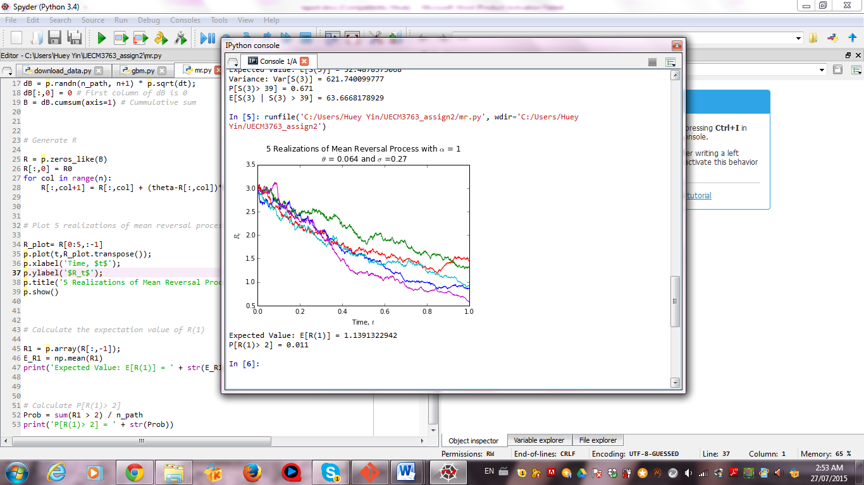

Then, an array R1 is created to store the value of last column of every row from the simulation.

E[R(1)] and P[R(1)>2] is calculated using the same method as part 1.

**Task 2**

**1. FTSE Bursa Malaysia KLCI Index**

There are a total of 30 component stocks in FTSEKLCI .

|  |  |  |  |  |  |  |
| --- | --- | --- | --- | --- | --- | --- |
|  |  |  |  | Data as at: 12 June 2015 |  | Data as at: 26 July 2015 |
| **Rank** | **Stock Code** | **Stock Name** | **Stock Sector** | **Weightage in FTSEKLCI (%)** | **P/E Ratio** | **Net Market Capital (Billion)** |
| 1 | 1295 | Public Bank BHD | Banks | 11.60 | 15.33 | 73.76 |
| 2 | 1155 | Malayan Banking | Banks | 9.32 | 12.47 | 88.04 |
| 3 | 5347 | Tenaga Nasional | Alternative Electricity | 9.28 | 9.15 | 69.30 |
| 4 | 1023 | CIMB Group Holdings | Banks | 5.76 | 17.42 | 46.69 |
| 5 | 6888 | Axiata Group Bhd | Mobile Telecommunications | 5.62 | 24.27 | 55.35 |
| 6 | 4197 | Sime Darby Bhd | Diversified Industrials | 5.51 | 21.76 | 52.67 |
| 7 | 6947 | Digi.com | Mobile Telecommunications | 4.16 | 21.02 | 41.83 |
| 8 | 3182 | Genting | Hotels | 3.68 | 19.54 | 30.96 |
| 9 | 5183 | PETRONAS Chemicals Group Bhd | Commodity Chemicals | 3.55 | 21.83 | 50.64 |
| 10 | 6012 | Maxis Bhd | Mobile Telecommunications | 3.45 | 30.05 | 49.41 |
| 11 | 6033 | Petronas Gas | Exploration & Production | 3.40 | 22.79 | 42.74 |
| 12 | 5225 | IHH Healthcare | Health Care Providers | 3.28 | 63.42 | 48.76 |
| 13 | 1961 | IOI | Farming & Fishing | 2.99 | 73.91 | 27.26 |
| 14 | 4863 | Telekom Malaysia | Fixed Line Telecommunications | 2.96 | 32.34 | 24.92 |
| 15 | 4715 | Genting Malaysia Bhd | Hotels | 2.50 | 20.21 | 25.24 |
| 16 | 3816 | MISC | Marine Transportation | 2.45 | 15.99 | 35.26 |
| 17 | 1015 | AMMB Holdings | Banks | 2.38 | 8.82 | 16.97 |
| 18 | 2445 | Kuala Lumpur Kepong | Farming & Fishing | 2.28 | 29.21 | 24.04 |
| 19 | 5218 | SapuraKencana Petroleum | Oil Equipment & Services | 1.98 | 12.08 | 14.32 |
| 20 | 4065 | PBB Group | Food Products | 1.80 | 18.13 | 18.23 |
| 21 | 4162 | British American Tobacco (Malaysia) | Tobacco | 1.70 | 20.06 | 18.45 |
| 22 | 5819 | Hong Leong Bank | Banks | 1.67 | 11.19 | 25.68 |
| 23 | 4677 | YTL Corp | Multiutilities | 1.63 | 14.95 | 17.27 |
| 24 | 4588 | UMW Holdings | Automobiles | 1.37 | 20.41 | 11.99 |
| 25 | 6399 | Astro Malaysia Holdings | Broadcasting & Entertainment | 1.22 | 28.32 | 15.76 |
| 26 | 5681 | Petronas Dagangan Bhd | Intrgrated Oil & Gas | 1.21 | 37.05 | 20.45 |
| 27 | 1066 | RHB Capital | Banks | 1.06 | 9.18 | 19.13 |
| 28 | 5246 | Westports Holdings | Transportation Services | 0.93 | 26.60 | 13.91 |
| 29 | 1082 | Hong Leong Financial | Banks | 0.64 | 9.94 | 16.25 |
| 30 | 5235SS | KLCC Prop & Reits - Stapled Sec | Real Estate Holding & Development | 0.63 | 28.20 | 12.73 |

|  |
| --- |
| **Sources** |
| 1. https://www.google.com/url?sa=t&rct=j&q=&esrc=s&source=web&cd=2&ved=0CCUQFjABahUKEwj67bG_yvjGAhVOc44KHTqlCGg&url=http%3A%2F%2Fwww.ftse.com%2FAnalytics%2FFactSheets%2FHome%2FDownloadSingleIssue%3FissueName%3DFBMKLCIRCO&ei=mLW0VfrBF87muQS6yqLABg&usg=AFQjCNGG1L6ovxeNXoxk4kBtV-JXgl2Tdw&bvm=bv.98717601,d.c2E&cad=rja |
| 2. http://quotes.wsj.com/ |

**2. Downloading data**

Genting Malaysia Bhd (code: 4715) is selected to be observed in this task. Its closing stock prices from 1 Jan 2011 until 20 July 2015 is obtained from Yahoo!Finance by using data reader.

To calculate 5-day moving average of the downloaded data, a built in function called pandas will be used. The command would be “mov_ave = pd.rolling_mean(GENM_close,ave)” where GENM_close is the closing stock prices of Genting Malaysia Bhd and ave = 5.

Then, a graph of the 5-day moving average of Genting Malaysia Bhd is plotted.

*Output:*

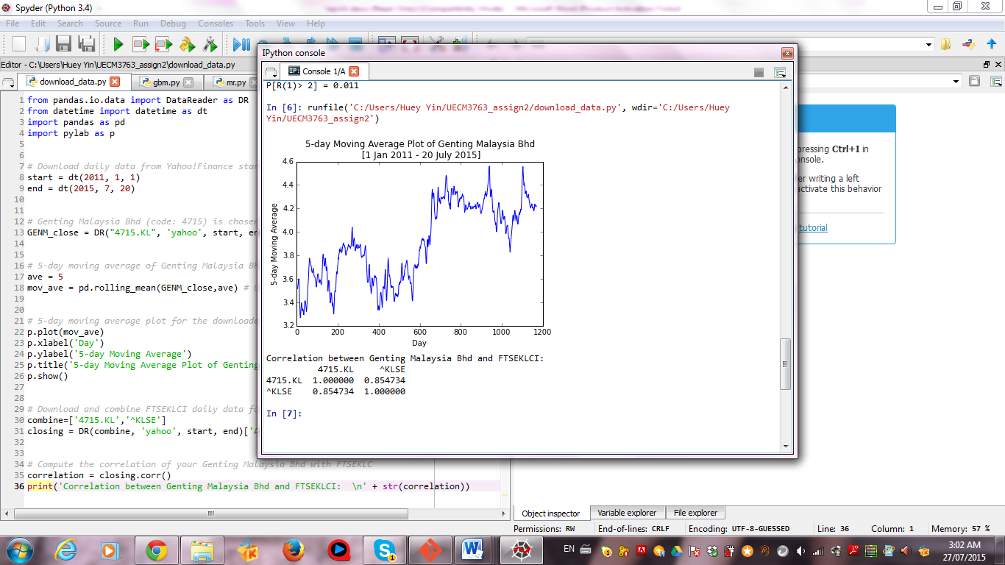

To compute the correlation of Genting Malaysia Bhd with FTSEKLC, FTSEKLCI daily data for the same duration is downloaded and combined with Genting Malaysia Bhd. Then, a correlation function in python is used to compute their correlation. Result showed that Genting Malaysia Bhd and FTSEKLCI are highly correlated with a correlation of 85.47%.