# Task 1 – Design Documentation

Contents

Task 1 – Design Documentation 1

Database Design 1

Tables 1

It is essential that we include documentation on the database design. Below is a detailed database design followed by the entity relationship diagram (ERD). Many parts of the database will be designed throughout the project as we do not know exactly what is needed for them, but the tables below give us an idea of how it will work.

## Database Design

A draft database has been developed in order to create the base database model, the data definition language and entity relationship diagram have been automatically generated through a database management tool.

### Tables

|  |  |  |  |  |
| --- | --- | --- | --- | --- |
| **Tables** | | | | |
| Table | Description | | | |
|  |  | | | |
| **usergroups** | **Table storing role data – id of the role and the name of the role** | | | |
| Column Name | Column Type | | | Column Description |
| id | SMALLINT  PRIMARY KEY  UNIQUE  NOT NULL | | | The ID of the role, this will be used to reference the role in other tables via foreign keys |
| name | VARCHAR(10)  UNIQUE  NOT NULL | | | The name of the role, this can be used by the system to display the name of the role |
|  |  | | | |
| **users** | **Table storing user data e.g. usernames and passwords and user groups** | | | |
| Column Name | Column Type | | | Column Description |
| id | INTEGER  PRIMARY KEY  UNIQUE  NOT NULL | | | The primary key of the table, each user will be assigned a user id (uid), and this can be referenced to reference a user |
| username | VARCHAR(20)  NOT NULL  UNIQUE | | | The column holding the value of the username, this can be a maximum of 10 characters and must be unique |
| email | VARCHAR(45)  UNIQUE  NOT NULL | | | The column holding the value of the email for the user |
| password | VARCHAR  NOT NULL | | | The column holding the value of the hashed password, the length constraint of the password column is validated by the system and not the SQLite database |
| datetime_created | DATETIME  DEFAULT (CURRENT_TIMESTAMP) NOT NULL | | | The column holding the value of the account creation date, this can be used by analytics tools for insights |
| last_login | DATETIME  DEFAULT(CURRENT_TIMESTAMP)  NOT NULL | | | The column holding the value of the last login datetime, this can be used by analytics tools for insights |
| usergroup | SMALLINT  DEFAULT ‘1’  NOT NULL | | | The column holding the integer reference to the role of the user, the default is 0 so that the user is automatically given the lowest permission level |
| FOREIGN KEY(usergroup) REFERENCES usergroups (id) | | | | |
|  |  | | |  |
| **loyalty_rewards** | **Table storing the types of rewards that can be redeemed with loyalty points** | | | |
| Column Name | Column Type | | | Column Description |
| id | INTEGER  NOT NULL UNIQUE PRIMARY KEY | | | The id for the reward, this will be referenced when calculating the amount of reward points a user has redeemed and in the log of loyalty points being redeemed |
| name | VARCHAR  NOT NULL  UNIQUE | | | The name of the loyalty reward |
| icon | VARCHAR  NOT NULL | | | The icon that will be used on the site when displaying the loyalty rewards |
| cost | INTEGER  NOT NULL | | | The amount of loyalty points it costs to redeem the reward |
|  |  | | |  |
| **loyalty_rewards_redeemed** | **Table storing the log of reward points being redeemed, this can be used by analytics tools to show the value of the loyalty reward scheme** | | | |
| Column Name | Column Type | | | Column Description |
| id | INTEGER  NOT NULL  UNIQUE  PRIMARY KEY | | | The log id number |
| uid | INTEGER  NOT NULL | | | The id referencing the user that redeemed the reward |
| rid | INTEGER  NOT NULL | | | The id referencing the reward that was redeemed |
| datetime_redeemed | DATETIME  DEFAULT (CURRENT_TIMESTAMP)  NOT NULL | | | The datetime that the reward was redeemed, this will be useful when analysing the value of the reward scheme |
| FOREIGN KEY(uid) REFERENCES users (id) | | | | |
| FOREIGN KEY(rid) REFERENCES loyalty_rewards (id) | | | | |
|  | |  |  | |
| **loyalty_points** | | **The table storing the number of loyalty points each user has and how many points they have redeemed** | | |
| Column Name | | Column Type | Column Description | |
| id | | INTEGER  NOT NULL  UNIQUE  PRIMARY KEY | The id of the user | |
| gathered | | INTEGER  NOT NULL  DEFAULT ‘0’ | The number of points they have gathered | |
| redeemed | | INTEGER  NOT NULL  DEFAULT ‘0’ | The number of points they have redeemed | |
| FOREIGN KEY(id) REFERENCES users(id) | | | | |
|  | |  |  | |
| **rooms** | | **The table storing the information on all the types of rooms available in the hotel** | | |
| Column Name | | Column Type | Column Description | |
| id | | INTEGER  NOT NULL  UNIQUE  PRIMARY KEY | The ID of the room type that makes the rows easily accessible by the **room_bookings** table | |
| name | | VARCHAR  NOT NULL  UNIQUE | The name of the type of room | |
| capacity | | INTEGER  NOT NULL | The maximum amount of people that can use the room | |
| price | | INTEGER  NOT NULL | The price of the room per night | |
| amount | | INTEGER  NOT NULL | The number of rooms in the on-site hotel of this type | |
|  | |  |  | |
| **room_bookings** | | **The table showing the information on room accessibility (if a room is booked and who by)** | | |
| Column Name | | Column Type | Column Description | |
| id | | INTEGER  NOT NULL  UNIQUE  PRIMARY KEY | The ID of the room accessibility record | |
| room_type | | INTEGER  NOT NULL | The type of room that the record is referencing | |
| is_booked | | SMALLINT  NOT NULL  DEFAULT ‘0’ | The flag to say if a room is booked or not, this can be done by checking for a record in the booked_by but it is better practice to have a column for this specifically | |
| booked_until | | DATETIME | The datetime that shows when the room is booked until | |
| booked_by | | INTEGER  UNIQUE | The reference to a user that shows who has booked the room | |
| booked_on | | DATETIME | The datetime that shows when the room was booked | |
| FOREIGN KEY(room_type) REFERENCES rooms (id) | | | | |
| FOREIGN KEY(booked_by) REFERENCES users (id) | | | | |
|  | |  |  | |

### Entity Relationship Diagram (ERD)

The green highlight references a foreign key in the table. The primary key of a table is indicated by the key icon next to the column name and is also the first column in the list and written in bold.

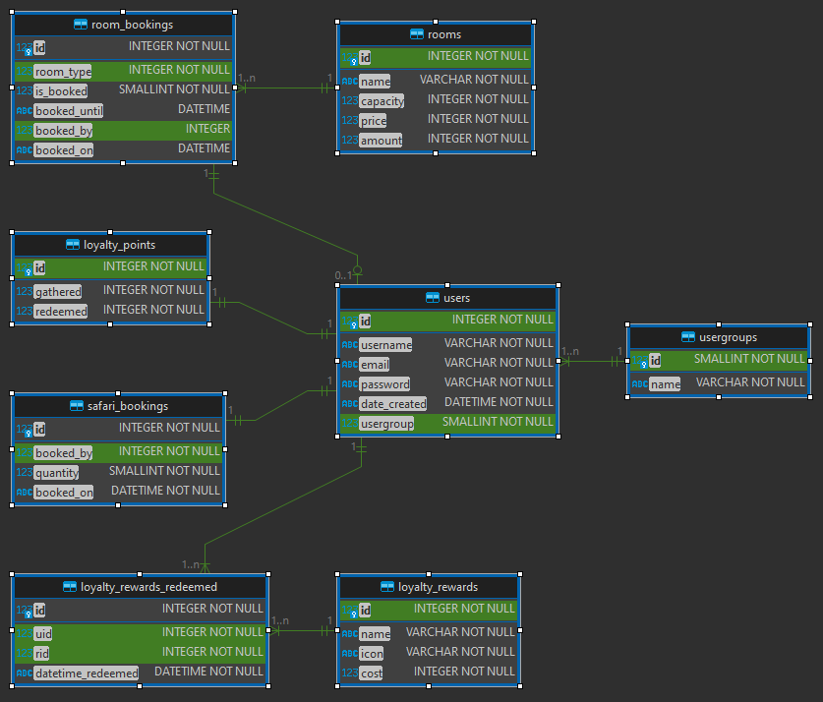

### Data Definition Language (DDL)

-- usergroups definition

**CREATE** **TABLE** usergroups (

id **SMALLINT** **NOT** **NULL**,

name **VARCHAR**(10) **NOT** **NULL**,

**PRIMARY** **KEY** (id),

**UNIQUE** (id),

**UNIQUE** (name)

);

-- users definition

**CREATE** **TABLE** users (

id **INTEGER** **NOT** **NULL**,

username **VARCHAR**(20) **NOT** **NULL**,

email **VARCHAR**(45) **NOT** **NULL**,

password **VARCHAR** **NOT** **NULL**,

date_created **DATETIME** **DEFAULT** (CURRENT_TIMESTAMP) **NOT** **NULL**,

usergroup **SMALLINT** **DEFAULT** **'1'** **NOT** **NULL**,

**PRIMARY** **KEY** (id),

**UNIQUE** (id),

**UNIQUE** (username),

**UNIQUE** (email),

**FOREIGN** **KEY**(usergroup) **REFERENCES** usergroups (id)

);

-- loyalty_rewards definition

**CREATE** **TABLE** loyalty_rewards (

id **INTEGER** **NOT** **NULL**,

name **VARCHAR** **NOT** **NULL**,

icon **VARCHAR** **NOT** **NULL**,

cost **INTEGER** **NOT** **NULL**,

**PRIMARY** **KEY** (id),

**UNIQUE** (id),

**UNIQUE** (name)

);

-- loyalty_rewards_redeemed definition

**CREATE** **TABLE** loyalty_rewards_redeemed (

id **INTEGER** **NOT** **NULL**,

uid **INTEGER** **NOT** **NULL**,

rid **INTEGER** **NOT** **NULL**,

datetime_redeemed **DATETIME** **DEFAULT** (CURRENT_TIMESTAMP) **NOT** **NULL**,

**PRIMARY** **KEY** (id),

**UNIQUE** (id),

**FOREIGN** **KEY**(uid) **REFERENCES** users (id),

**FOREIGN** **KEY**(rid) **REFERENCES** loyalty_rewards (id)

);

-- loyalty_points definition

**CREATE** **TABLE** loyalty_points (

id **INTEGER** **NOT** **NULL**,

gathered **INTEGER** **NOT** **NULL** **DEFAULT** **'0'**,

redeemed **INTEGER** **NOT** **NULL** **DEFAULT** **'0'**,

**PRIMARY** **KEY** (id),

**UNIQUE** (id),

**FOREIGN** **KEY**(id) **REFERENCES** users (id)

);

-- rooms definition

**CREATE** **TABLE** rooms (

id **INTEGER** **NOT** **NULL**,

name **VARCHAR** **NOT** **NULL**,

capacity **INTEGER** **NOT** **NULL**,

price **INTEGER** **NOT** **NULL**,

amount **INTEGER** **NOT** **NULL**,

**PRIMARY** **KEY** (id),

**UNIQUE** (id),

**UNIQUE** (name)

);

-- room_bookings definition

**CREATE** **TABLE** room_bookings (

id **INTEGER** **NOT** **NULL**,

room_type **INTEGER** **NOT** **NULL**,

is_booked **SMALLINT** **NOT** **NULL** **DEFAULT** **'0'**,

booked_until **DATETIME**,

booked_by **INTEGER**,

booked_on **DATETIME**,

**PRIMARY** **KEY** (id),

**UNIQUE** (id),

**UNIQUE** (booked_by),

**FOREIGN** **KEY**(room_type) **REFERENCES** rooms (id),

**FOREIGN** **KEY**(booked_by) **REFERENCES** users (id)

);

## Wireframe