Quantisation and data heterogeneity in federated LoRA fine-tuning of language models
[Your Name]
FOSE7901 STEM Research Placement
Macquarie University
Mentor: [Mentor name]
13 September 2026
Code and data: github.com/hufs0529/peft_fl_STEM_placement

1. Introduction
Instruction-tuned language models are increasingly trained on data that cannot be centralised, whether for privacy, regulatory or commercial reasons. Federated learning addresses this by keeping data on the client and exchanging only model updates [1]. The clients in such a federation are typically far more constrained than a datacentre node, and two constraints dominate in practice: how much GPU memory a client can devote to training, and how unevenly the training data are distributed across clients.
Both constraints have well-established individual remedies. Full fine-tuning of even a small language model is impractical on a constrained client, so parameter-efficient methods are used instead; Low-Rank Adaptation (LoRA) freezes the pre-trained weights and trains small low-rank adapters, reducing the number of trainable parameters by orders of magnitude [4]. Because only those adapters are exchanged, LoRA also reduces the federated communication payload. Memory can be reduced further by quantising the frozen base model, either to 8-bit integers [5] or, as in QLoRA, to 4-bit NormalFloat [6]. Separately, the effect of non-identically distributed client data is well documented: heterogeneous local objectives cause client updates to diverge, which slows convergence and degrades the aggregated model [2], and Dirichlet sampling has become the standard way to synthesise a controlled range of heterogeneity [3].
What is not established is whether these two pressures interact. A plausible mechanism suggests they should: a quantised model carries less numerical headroom, and might therefore absorb conflicting client updates less gracefully, so that the penalty for aggressive quantisation would grow as client data become more heterogeneous. If that is so, the choice of compression level cannot be made without knowing how heterogeneous the federation's data are, which is information a deployment rarely has in advance. If the two are instead independent, the choice collapses into a straightforward resource decision. The question is therefore of practical as well as theoretical interest, and it is the question this placement set out to answer.
Accordingly, this study asks: does the performance cost of quantising the frozen base model increase as client data become more non-identically distributed? The working hypothesis was that it does. Three objectives follow. The first is to quantify the main effect of compression level on both model quality and operational cost. The second, and primary, objective is to test for an interaction between compression level and data heterogeneity, across a Dirichlet concentration parameter spanning three orders of magnitude. The third is to characterise the resulting memory, accuracy and time trade-off in terms concrete enough to guide a deployment decision.
The study is deliberately bounded. It uses a single 0.5B-parameter instruction model (Qwen2.5-0.5B-Instruct [9]) fine-tuned on the Dolly-15k instruction corpus [8] across a simulated federation of eight clients, comparing three compression levels, two aggregation rules and four Dirichlet settings in a full factorial grid of 24 runs. This scale was chosen so that the complete grid could be executed within the GPU budget available for a six-week placement, at the cost of the limitations set out in Section 5.
2. Methods
2.1 Data
All experiments used databricks-dolly-15k [8], an open instruction-following corpus of 15,011 human-written records spanning eight task categories (brainstorming, classification, closed_qa, creative_writing, general_qa, information_extraction, open_qa and summarization). The dataset was obtained from the Hugging Face Hub and was not collected by the author; it is released by Databricks under the Creative Commons Attribution-ShareAlike 3.0 licence. Because the corpus is public and contains no personal data, no ethics approval was required. Before any client partitioning, a global held-out evaluation set was carved out by sampling 10% of each category (1,497 records), leaving 13,514 records for federated training. Holding out per category rather than uniformly ensured that every task type was represented in evaluation even when clients held skewed data. A category-stratified subsample of 200 held-out records was drawn once for generation-based evaluation.
2.2 Model and parameter-efficient fine-tuning
The base model was Qwen2.5-0.5B-Instruct [9], loaded in bfloat16. Fine-tuning used Low-Rank Adaptation (LoRA) [4] with rank r = 8, scaling alpha = 16, dropout 0.05, applied to the q_proj and v_proj projections of all 24 transformer layers. This yielded 540,672 trainable parameters, approximately 0.11% of the model. Three compression levels were compared: an uncompressed baseline with a bfloat16 base model, QLoRA with an 8-bit base model (bitsandbytes LLM.int8() [5], default outlier threshold), and QLoRA with a 4-bit NF4 base model [6] (bfloat16 compute dtype). In every condition the base model was frozen and only the LoRA adapter was trained and exchanged, and the adapter itself was always kept in fp32. Compression therefore altered client memory and computation but never the quantity of data transmitted. The base model is distributed under the Apache 2.0 licence; it was reduced from the originally planned Qwen2.5-3B partly for GPU budget reasons and partly because the 0.5B checkpoint carries this more permissive licence.
2.3 Federated setup and data partitioning
A federation of eight clients was simulated, with all eight participating in every round. Training data were distributed across clients using a Dirichlet(alpha) draw applied independently per task category [3], so that alpha controls how concentrated each category is on a few clients. Four values were swept: alpha = 0.1, 1, 10 and 100. At alpha = 0.1 the largest category accounted for 66% of a client's data on average and client dataset sizes ranged from 119 to 3,047 records; at alpha = 100 the largest category accounted for 25% and sizes ranged from 1,645 to 1,773 (Figure 2). Categories containing fewer than 150 records were upsampled with replacement before partitioning so that no client received an empty shard. Partitioning used a fixed seed (42), so all runs at a given alpha shared an identical data split and differed only in compression level and aggregation rule. Two aggregation rules were compared: FedAvg [1], and FedProx [2] with a proximal coefficient mu = 0.01.
2.4 Training and convergence criterion
Clients trained with AdamW at a learning rate of 2.0e-4, a micro-batch size of 4 and gradient accumulation over 4 steps (effective batch size 16), for one local epoch per round, with sequences truncated to 512 tokens. Prompt tokens were masked out of the loss (label -100) so that only response tokens contributed; when a prompt and response together exceeded the length limit, the prompt was truncated from its start so that response tokens were always retained. This detail matters because truncating from the end can leave an example with no unmasked labels, which produced NaN losses in an earlier pilot. Training ran for at most 10 rounds and stopped early when validation loss improved by less than 1% for three consecutive rounds. Model state was checkpointed after every round so that interrupted runs could resume.
2.5 Evaluation metrics
Evaluation was performed by the server on the global held-out set rather than by individual clients, so that all conditions were scored on identical data. Seven quantities were recorded per round: validation loss, validation perplexity, round wall-clock latency, communication payload, peak GPU memory, the round index, and, at the final round only, ROUGE-L. Perplexity is the exponential of the mean token-level cross-entropy and was computed every round over the full held-out set. ROUGE-L [10] requires autoregressive generation and is therefore expensive, so it was computed once at the final round over the 200-example stratified subsample using greedy decoding with a limit of 128 new tokens. Perplexity and ROUGE-L are complementary: the former scores the model under teacher forcing, whereas the latter scores text the model actually produced. Communication was recorded as the serialised size of the trainable parameters multiplied by the number of participating clients, and therefore counts the client-to-server direction only; the true bidirectional cost per round is twice the reported figure. Peak GPU memory was read from the CUDA allocator during each client's local training; because the simulation held all eight client models and the server model resident on a single GPU, this figure reflects the whole simulation rather than one device.
2.6 Experimental design
The design was a full factorial grid of 3 compression levels x 2 aggregation rules x 4 Dirichlet alpha values, giving 24 runs, each executed once. The primary question concerned the interaction between compression level and data heterogeneity, which is why alpha was swept across three orders of magnitude rather than fixed. The grid was originally specified with three alpha values; alpha = 100 was added after supervisory feedback in order to establish a near-IID endpoint. Earlier design iterations were revised for cost and scope: the base model was reduced from Qwen2.5-3B to Qwen2.5-0.5B-Instruct to fit the available GPU budget, and SCAFFOLD was dropped from the core design so that the compression axis could be widened, although its implementation and tests were retained in the codebase. In total the 24 runs consumed 33.7 GPU-hours.
2.7 Computing environment and reproducibility
Runs were executed on AWS EC2 GPU instances in the ap-northeast-2 region, each using a single NVIDIA A10G (23,028 MiB) under driver 595.91.07 with CUDA 13.2, on Ubuntu with the 7.0.0-1011-aws x86_64 kernel. The 18 runs at alpha = 0.1, 1 and 10 were executed in one environment; the six alpha = 100 runs were executed later in a separately provisioned environment running Python 3.13.15 with torch 2.14.0, transformers 5.16.1, peft 0.20.0, bitsandbytes 0.50.2, flwr 1.36.0 [7], datasets 5.0.1, tokenizers 0.23.2, accelerate 1.14.0, numpy 2.5.3 and rouge-score 0.1.2, at repository commit 7e8a7fa. The 18 runs were completed by 3 September 2026 and the six alpha = 100 runs by 10 September 2026, the dates on which their logs were committed to the repository. The complete package manifest for that environment is archived in the repository as env_alpha100.txt. The corresponding manifest for the first environment was not captured before that instance was terminated, which is a limitation of the experimental record. The two environments are known to differ: 8-bit rounds took 25.5 minutes in the first and 21.6 minutes in the second, while LoRA and 4-bit round times were unchanged, a pattern consistent with a change in the bitsandbytes kernel implementation. Timing comparisons in this report are therefore restricted to runs from the first environment. All random seeds were fixed at 42. The implementation was verified by an automated suite of 66 tests covering data preparation, partitioning, adapter wiring, aggregation, checkpointing, convergence and the analysis functions.
2.8 Analysis
Comparisons were made by pairing runs rather than by pooling them. Each compressed run was compared against the uncompressed run that shared its aggregation rule and its heterogeneity setting, so that the only difference within a pair was the quantity under study. Differences in perplexity are reported as relative percentages, obtained from the difference in validation loss and then converted: perplexity is the exponential of the loss, so a raw difference in perplexity would be inflated for conditions whose baseline is already higher, and the 4-bit condition would appear to suffer more than it does. ROUGE-L was compared cell by cell and summarised by how many cells moved in each direction, which is meaningful because every run was scored on the same 200 held-out examples.
No significance testing was performed, and this was a deliberate choice rather than an omission. Each of the 24 configurations was run once, so there is no replication from which to estimate run-to-run variability, and any formal test would have had to assume an error term rather than measure one. Variability was instead estimated empirically from the 8-bit condition, whose quality is indistinguishable from the uncompressed baseline and whose remaining scatter therefore reflects measurement noise rather than a real effect. Conclusions are stated as comparisons against that reference, and Section 3.4 states explicitly the size of effect this design would have detected. Were the grid repeated with several data splits, an analysis of variance over the three experimental factors would be the natural test to apply.
Analyses and figures were produced with Python 3.11.15 using numpy 2.4.6, rouge-score 0.1.2 and matplotlib 3.11.1. The scripts that generate every number and figure reported here, scripts/analyze_interaction.py and scripts/plot_results.py, are archived in the project repository alongside the logs they read, so the whole analysis can be regenerated from the committed data.
2.9 Data management
All code, configuration, logs and analysis scripts are version-controlled in a single Git repository (github.com/hufs0529/peft_fl_STEM_placement). The repository doubles as the experimental record: each week of the placement is preserved as its own branch (week1 to week6), so the state of the code at every stage is recoverable, and commit messages record the reason for each design change. Experimental outputs are stored as newline-delimited JSON. Each run produces {run_name}_rounds.jsonl, holding one record per round with validation loss, perplexity, round latency, communication bytes, peak GPU memory and, at the final round, ROUGE-L; and {run_name}_generations.jsonl, holding the 200 evaluated instructions with their reference and generated responses and category labels, which allows every generation metric to be recomputed without rerunning the model. Run names encode the full configuration, so a file identifies its own experimental condition. The logs and per-round checkpoints for the 18 original runs are committed on the week4-results branch (413 MB across 129 files) and the alpha = 100 logs on the week5 branch. Analysis and plotting scripts (run_experiment.py, run_alpha100.sh, analyze_interaction.py, plot_results.py) are archived alongside the data, so every figure and table in this report can be regenerated from the committed logs. For long-term preservation a tagged snapshot of the repository will be deposited with Zenodo, which mints a persistent DOI for a GitHub release. The deposited archive comprises the source code, the 48 JSONL log files (4.3 MB) and the environment manifests, which together are sufficient to regenerate every figure, table and statistic reported here. The per-round checkpoints (413 MB across 129 files) are retained only for the duration of the placement: they can be regenerated from the archived code and are not required to reproduce any reported result, so they are excluded from the permanent archive. Research data will additionally be retained in accordance with the Macquarie University research data management policy [CONFIRM the university-approved repository and retention period with the mentor].

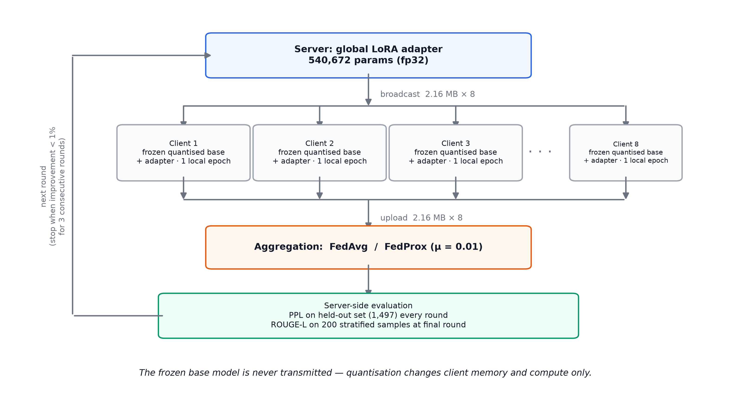
Figure 1. One round of federated training. Only the LoRA adapter is exchanged; the frozen base model is never transmitted, so the compression level changes client memory and computation but not the communication payload.

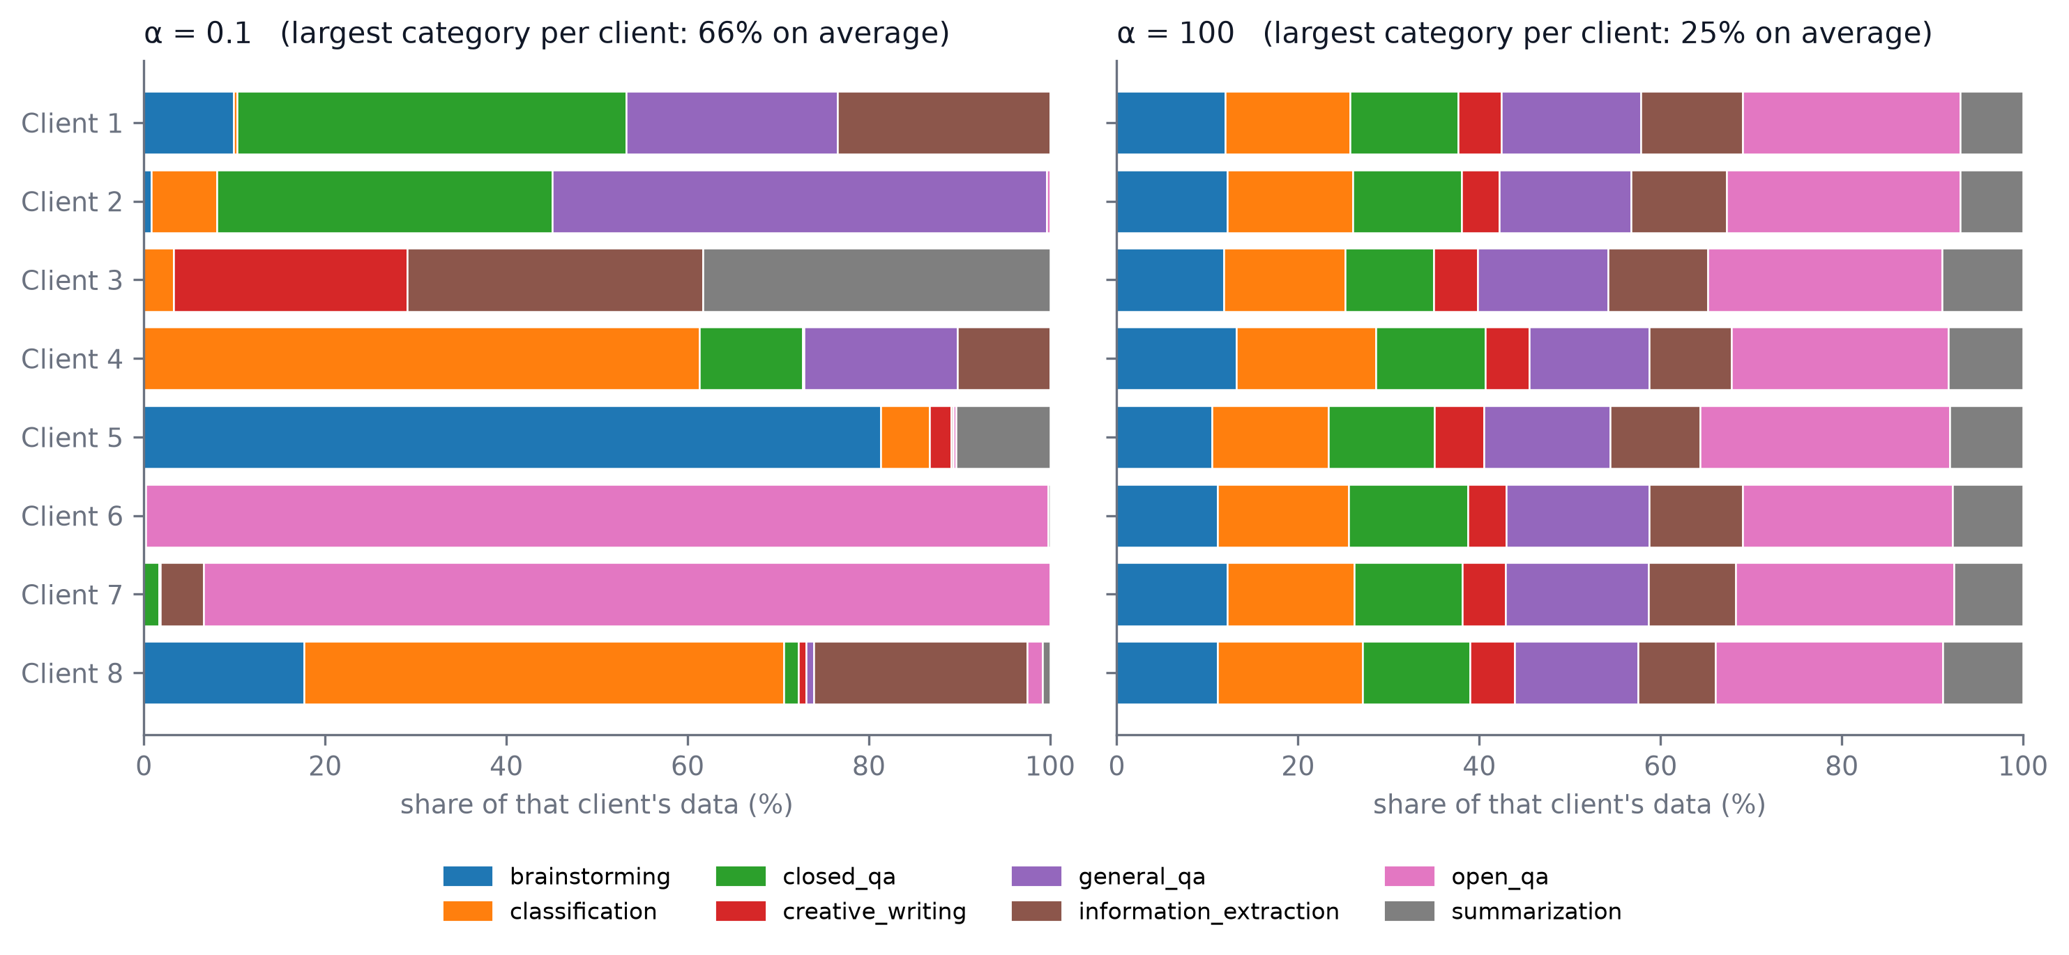
Figure 2. Task-category composition of each client's shard under the most uneven (alpha = 0.1) and most even (alpha = 100) Dirichlet partitions, seed 42. Under the uneven split one client draws 66% of its data from a single category on average; under the even split the largest category accounts for 25%.

3. Results
3.1 Overview
All 24 runs completed without failure. Validation loss rose between rounds in only two runs, by 0.0003 and 0.0031, and no run produced an invalid loss. Twenty-one runs stopped at the round-5 convergence threshold, two at round 6 and one at round 7, so the number of rounds carried almost no information about the experimental conditions. Final perplexity ranged from 6.108 to 6.610 across the grid; the complete record is in Table A1 and the pattern is plotted in Figure 3.
3.2 Effect of compression
Compression was the only factor with a large effect on quality. Measuring each compressed run against the uncompressed run that shares its aggregation rule and heterogeneity setting, QLoRA 8-bit cost 0.55% in perplexity on average and QLoRA 4-bit cost 5.74%. The two are not merely different in size but different in kind: the 4-bit penalty was positive in all eight cells, whereas the 8-bit penalty was positive in five and negative in three. A quantity that changes direction from cell to cell is not measuring a real effect.
ROUGE-L, which scores text the model actually generated rather than its confidence in the correct answer, gives the same picture. Every run was scored on the same 200 held-out examples, so the conditions are directly comparable. QLoRA 4-bit scored below the uncompressed baseline in all eight cells, by 0.014 on average. QLoRA 8-bit scored below it in five cells and above it in three, averaging 0.003. Two measures built on different principles therefore agree: 8-bit quantisation of the frozen model is effectively free at this scale, and 4-bit quantisation is not (Table A3).
3.3 Effect of data heterogeneity
Heterogeneity mattered early in training and then stopped mattering. At round 1 the gap between the most heterogeneous and the most uniform setting averaged 0.147 in perplexity, and it had the same sign in all six compression-by-algorithm combinations. By the final round that gap had shrunk to 0.024 and had reversed in one combination. Repeated averaging across clients absorbs most of the early disadvantage of unevenly distributed data.
Extending the sweep to the most uniform setting tested showed that nothing further changes once the data are reasonably even: the average difference in final loss between the two most uniform settings was 0.0010, smaller than the run-to-run variation described in the next section. Figure 2 shows what the two extremes look like in practice: with the most uneven split a client drew 66% of its data from a single task category and shard sizes ranged from 119 to 3,047 examples, while with the most even split the largest category accounted for 25% and all shards were close to equal.
3.4 Interaction between compression and data heterogeneity
The interaction that motivated the study was not found. The direct way to see this is to read the cost of compression off each heterogeneity setting in turn. Averaged over both aggregation rules, QLoRA 4-bit cost 5.66%, 5.57%, 5.94% and 5.79% in perplexity as the data went from most uneven to most even - a spread of 0.37 percentage points across a thousand-fold change in heterogeneity. The 8-bit figures were 0.72%, 0.19%, 0.54% and 0.73% (Table A2). Figure 3 shows the same result: the vertical distance between compression levels does not widen as the data become more uneven.
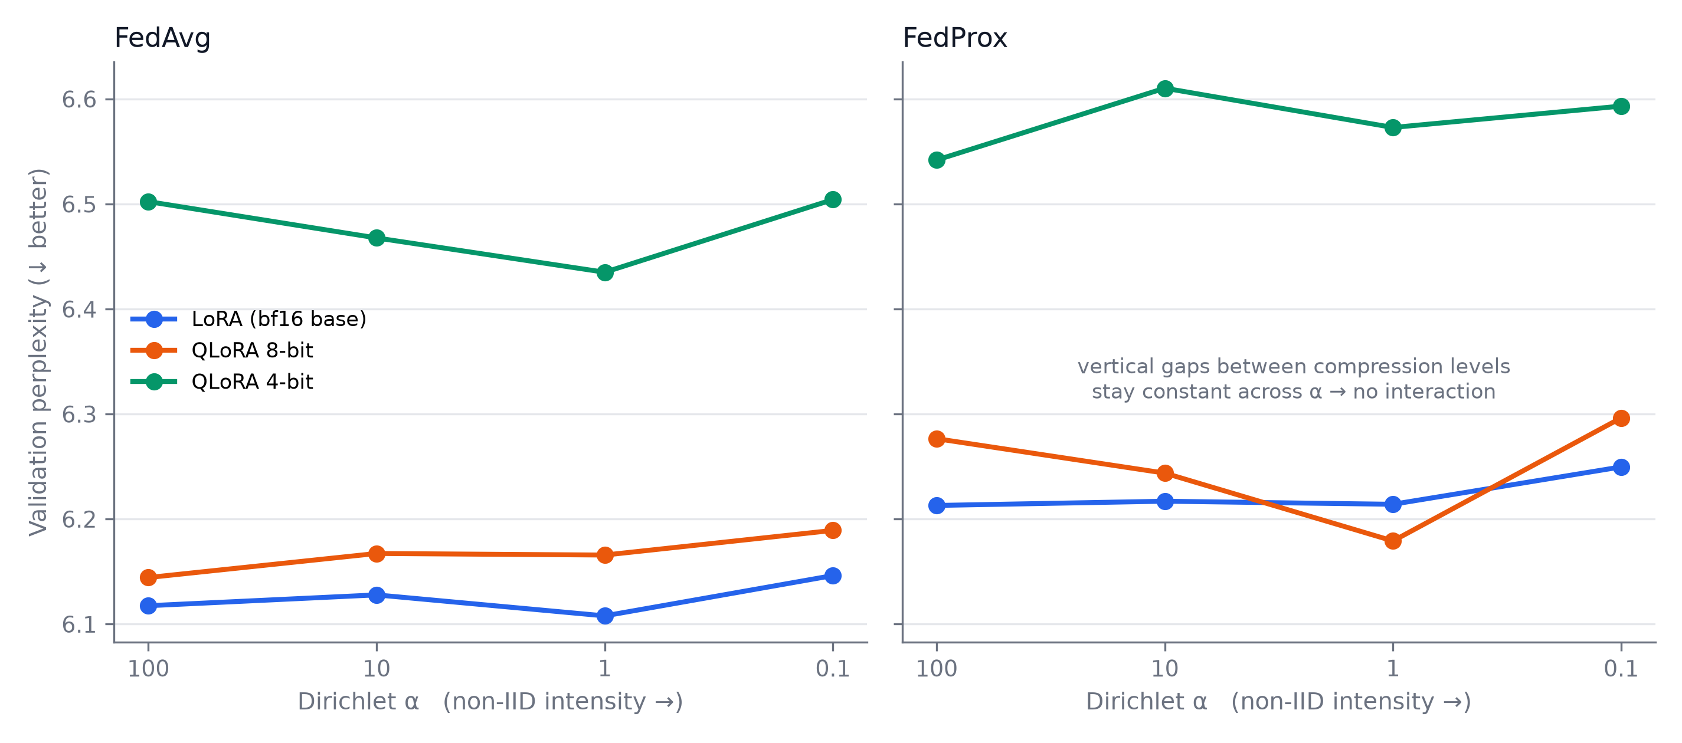
Figure 3. Final perplexity at each level of data unevenness, by compression level and aggregation rule. The vertical distance between compression levels does not widen as the data become more uneven.
Judging whether such a spread means anything requires knowing how much these runs move for reasons that have nothing to do with the experiment, and the 8-bit condition supplies that reference. Its quality is indistinguishable from the uncompressed baseline, so any movement in its penalty is measurement noise rather than a real effect. Across the eight cells that penalty ranged from -0.56% to +1.02%, a span of 1.58 percentage points. The 4-bit penalty, over the same eight cells, ranged from 5.29% to 6.33%, a span of 1.04 points. In other words the compression penalty moves around less across the entire experiment than a quantity that is known to carry no effect at all.
The direction is also wrong for the hypothesis. If quantisation error and uneven data compounded, the 4-bit penalty should have been largest where the data were most uneven. It was in fact largest at the most uniform setting.
It is worth stating what size of effect these data would have detected. For the hypothesis to matter in practice the penalty would have to grow appreciably as the data become uneven; a doubling, for instance, would put the 4-bit penalty near 11% at the most uneven setting. The largest 4-bit penalty recorded anywhere in the grid was 6.33%. An effect of that magnitude is therefore ruled out by these measurements, even though a small one cannot be.
One qualification. At round 1, before the averaging has had time to work, a pattern does appear that is consistent with the hypothesis: the gap between heterogeneity settings grows with compression level in three of the four algorithm-and-reference-point combinations examined (Table A6). This pattern is not stable. It depends on which uniform setting is used as the reference, and it is present only when the six runs at the most uniform setting are included - and those six were executed in a different software environment from the other eighteen (Section 2.7). It is reported here as an observation to be tested, not as a result.
3.5 Effect of the aggregation rule
FedProx was worse than FedAvg in every one of the twelve matched cells, by 1.51% in perplexity on average, and it also scored lower on ROUGE-L in eleven of the twelve (Table A5). It gained nothing in exchange: rounds to convergence averaged 5.25 against 5.08, and round time and peak memory were unchanged. The proximal term appears to have restrained each client more than this short training schedule rewarded.
3.6 Cost metrics
Peak GPU memory fell steadily with compression, from 14.44 GB uncompressed to 12.25 GB at 8-bit and 10.07 GB at 4-bit, and was unaffected by heterogeneity or aggregation rule. Round time did not follow the same order: 8-bit took 25.5 minutes per round against 11.7 uncompressed and 12.4 at 4-bit, so 8-bit is more than twice as slow while 4-bit adds only 7%. Communication was identical in every run at 17.3 MB per round, because the transmitted adapter is the same size no matter how the frozen model is stored; total communication therefore varied only with the number of rounds. Table A4 and Figure 4 summarise the complete cost picture.
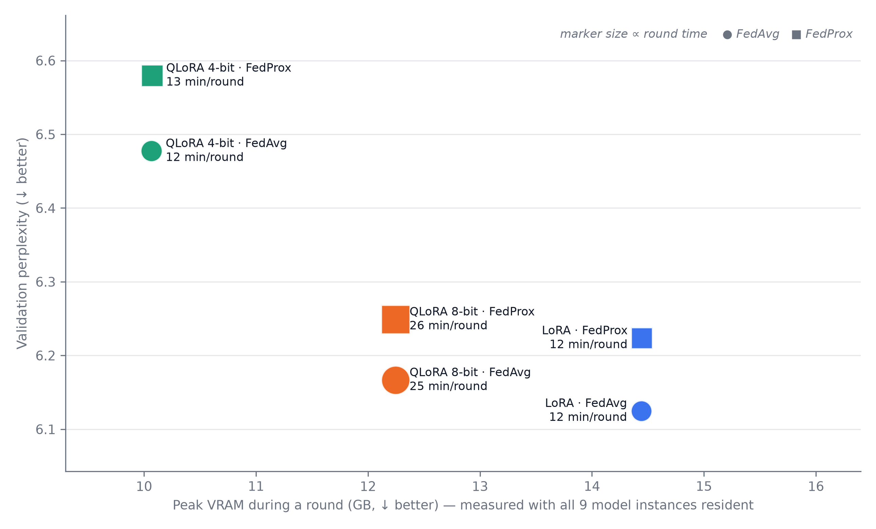
Figure 4. Memory, quality and time for the six compression-by-algorithm configurations, averaged over the four unevenness settings. Marker size is proportional to round time; circles are FedAvg and squares FedProx.
4. Discussion
Because the cost of compression does not depend on how uneven the data are, the compression level can be chosen on hardware grounds alone, without knowing the data distribution in advance - a useful simplification, since that distribution is rarely known before deployment. The real trade-off is between memory, quality and time (Figure 4), and the two compression steps are not equally priced. Moving from uncompressed to 8-bit costs almost no quality but adds 13.8 minutes to every round. Moving from 8-bit to 4-bit returns that time but costs about 5% in quality. In federated training the round time sets the pace of the whole federation, so this is not a minor consideration. If memory is not the binding constraint, the uncompressed configuration is better on both quality and time; if memory binds and time does not, 8-bit preserves quality; if both bind, 4-bit is what remains.
This recommendation carries one caveat about how memory was measured. The figures come from a simulation in which all eight client models and the server model were held on a single GPU, so they describe the simulation rather than a deployed client. Dividing the observed saving by the nine copies held in memory implies a saving of roughly 0.24 GB per model at 8-bit and 0.49 GB at 4-bit, which matches what the arithmetic of quantising a 0.5B-parameter model predicts. A single client would therefore save on the order of 4-7% rather than 15-30%, because at this model size the memory used by training activations dominates the memory used by weights. The case for quantising is correspondingly weaker here than the headline numbers suggest, and would strengthen for larger models where weights dominate.
5. Limitations
Each configuration was run once with a fixed partitioning seed, so run-to-run variation could not be measured directly and had to be estimated from a condition where no effect was expected. The same seed also means every run at a given heterogeneity setting shares one data split, so an unrepresentative split cannot be ruled out. The six runs at the most uniform setting were executed in a different software environment from the other eighteen, which is why the round-1 pattern is reported as unconfirmed and why timing comparisons use only the first environment. Convergence was fast enough to limit discrimination: every run finished within five to seven rounds and about 71% of the total improvement happened between rounds 1 and 2. Peak memory reflects the simulation rather than one device, and communication was counted in the client-to-server direction only, so the true two-way cost is twice the figure reported. Finally, these findings describe one 0.5B-parameter model trained for a single local epoch per round; larger models, longer local training and compression applied to the updates themselves remain untested.
6. Future work
Three extensions follow directly. Repeating the grid with at least three different data splits would replace the estimated run-to-run variation with a measured one. Increasing the amount of training each client does between synchronisations would widen the drift between clients and so test the hypothesis under harsher conditions. Applying compression to the adapter updates themselves, rather than to the frozen model, would put compression error and client drift into the same quantity, which is where an interaction would be most likely to appear.

References
[1] B. McMahan, E. Moore, D. Ramage, S. Hampson, and B. Agüera y Arcas, "Communication-efficient learning of deep networks from decentralized data," in Proc. 20th Int. Conf. Artificial Intelligence and Statistics (AISTATS), 2017, pp. 1273-1282.
[2] T. Li, A. K. Sahu, M. Zaheer, M. Sanjabi, A. Talwalkar, and V. Smith, "Federated optimization in heterogeneous networks," in Proc. Machine Learning and Systems (MLSys), vol. 2, 2020.
[3] T.-M. H. Hsu, H. Qi, and M. Brown, "Measuring the effects of non-identical data distribution for federated visual classification," arXiv:1909.06335, 2019.
[4] E. J. Hu, Y. Shen, P. Wallis, Z. Allen-Zhu, Y. Li, S. Wang, L. Wang, and W. Chen, "LoRA: Low-rank adaptation of large language models," in Proc. Int. Conf. Learning Representations (ICLR), 2022.
[5] T. Dettmers, M. Lewis, Y. Belkada, and L. Zettlemoyer, "LLM.int8(): 8-bit matrix multiplication for transformers at scale," in Advances in Neural Information Processing Systems (NeurIPS), vol. 35, 2022.
[6] T. Dettmers, A. Pagnoni, A. Holtzman, and L. Zettlemoyer, "QLoRA: Efficient finetuning of quantized LLMs," in Advances in Neural Information Processing Systems (NeurIPS), vol. 36, 2023.
[7] D. J. Beutel et al., "Flower: A friendly federated learning research framework," arXiv:2007.14390, 2020.
[8] M. Conover et al., "Free Dolly: Introducing the world's first truly open instruction-tuned LLM," Databricks Blog, 12 April 2023. Dataset: databricks/databricks-dolly-15k, licensed CC BY-SA 3.0.
[9] Qwen Team, "Qwen2.5 technical report," arXiv:2412.15115, 2024. Model: Qwen/Qwen2.5-0.5B-Instruct, Apache 2.0.
[10] C.-Y. Lin, "ROUGE: A package for automatic evaluation of summaries," in Text Summarization Branches Out, Barcelona, Spain: Association for Computational Linguistics, 2004, pp. 74-81.

Declaration of generative AI use
Macquarie University requires that any use of generative AI in an assessment be acknowledged, stating which tools were used and how. The exact placement and format should be confirmed with the unit convenor, and the assessment's AI category (Open or Observed) checked in the unit guide, since requirements differ between the two. The statement below is a draft to be edited so that it describes the actual use accurately.
Draft statement
Generative AI was used in the preparation of this placement deliverable, as follows. Claude Code (Anthropic, Claude Opus 5) was used between [START DATE] and [END DATE] to assist with implementing the federated learning pipeline and its test suite, to diagnose defects during development, to write the analysis and plotting scripts used to produce the figures and appendix tables, and to draft and edit sections of this report. All research decisions, including the research question, the experimental design, the choice of metrics and the interpretation of results, were made by the author in consultation with the placement mentor. All experiments were executed and supervised by the author. Every AI-assisted component was verified by the author: the implementation is covered by an automated suite of 66 tests, and every statistic, figure and table in this report is reproducible from the committed experiment logs using the analysis scripts archived in the project repository. All cited references were checked against publisher or arXiv records rather than accepted as generated. [Add or remove items so that this reflects your actual use.]
Points to confirm with the convenor or mentor
Whether this deliverable is categorised as AI Open or AI Observed, and whether that changes what is permitted.
Whether the declaration belongs on the title page, in a preface, or in an appendix.
Whether AI use also needs an in-text citation in IEEE style in addition to this statement.
Whether the same declaration is required for the accompanying presentation.

Appendix: Result tables
All values are measured quantities, differences between them, or counts, computed from the 24 run logs archived in the project repository.
Table A1. Complete per-run results for all 24 combinations
Compression | FL | alpha | val_loss | Perplexity | ROUGE-L | VRAM (GB) | Rounds | Upload (MB) | min/round
LoRA | FedAvg | 0.1 | 1.8158 | 6.1462 | 0.2884 | 14.44 | 5 | 86.5 | 11.6
LoRA | FedAvg | 1 | 1.8096 | 6.1078 | 0.2882 | 14.44 | 5 | 86.5 | 11.6
LoRA | FedAvg | 10 | 1.8128 | 6.1278 | 0.2935 | 14.44 | 5 | 86.5 | 11.6
LoRA | FedAvg | 100 | 1.8112 | 6.1175 | 0.2915 | 14.44 | 5 | 86.5 | 11.6
LoRA | FedProx | 0.1 | 1.8325 | 6.2497 | 0.2727 | 14.45 | 5 | 86.5 | 11.7
LoRA | FedProx | 1 | 1.8268 | 6.2141 | 0.2717 | 14.45 | 5 | 86.5 | 11.7
LoRA | FedProx | 10 | 1.8273 | 6.2170 | 0.2815 | 14.44 | 5 | 86.5 | 11.7
LoRA | FedProx | 100 | 1.8266 | 6.2130 | 0.2786 | 14.44 | 5 | 86.5 | 11.7
QLoRA 8-bit | FedAvg | 0.1 | 1.8228 | 6.1892 | 0.2911 | 12.24 | 5 | 86.5 | 25.4
QLoRA 8-bit | FedAvg | 1 | 1.8190 | 6.1658 | 0.2942 | 12.25 | 5 | 86.5 | 25.4
QLoRA 8-bit | FedAvg | 10 | 1.8193 | 6.1673 | 0.2860 | 12.25 | 5 | 86.5 | 25.4
QLoRA 8-bit | FedAvg | 100 | 1.8155 | 6.1444 | 0.2828 | 12.25 | 5 | 86.5 | 21.6
QLoRA 8-bit | FedProx | 0.1 | 1.8400 | 6.2964 | 0.2677 | 12.25 | 5 | 86.5 | 25.6
QLoRA 8-bit | FedProx | 1 | 1.8212 | 6.1792 | 0.2809 | 12.25 | 7 | 121.1 | 25.6
QLoRA 8-bit | FedProx | 10 | 1.8316 | 6.2438 | 0.2603 | 12.25 | 5 | 86.5 | 25.5
QLoRA 8-bit | FedProx | 100 | 1.8368 | 6.2766 | 0.2756 | 12.25 | 5 | 86.5 | 21.6
QLoRA 4-bit | FedAvg | 0.1 | 1.8725 | 6.5042 | 0.2732 | 10.07 | 5 | 86.5 | 12.3
QLoRA 4-bit | FedAvg | 1 | 1.8618 | 6.4350 | 0.2758 | 10.07 | 6 | 103.8 | 12.4
QLoRA 4-bit | FedAvg | 10 | 1.8668 | 6.4677 | 0.2615 | 10.07 | 5 | 86.5 | 12.4
QLoRA 4-bit | FedAvg | 100 | 1.8722 | 6.5023 | 0.2789 | 10.07 | 5 | 86.5 | 12.2
QLoRA 4-bit | FedProx | 0.1 | 1.8860 | 6.5933 | 0.2727 | 10.07 | 5 | 86.5 | 12.5
QLoRA 4-bit | FedProx | 1 | 1.8830 | 6.5729 | 0.2629 | 10.07 | 5 | 86.5 | 12.5
QLoRA 4-bit | FedProx | 10 | 1.8886 | 6.6103 | 0.2636 | 10.07 | 5 | 86.5 | 12.5
QLoRA 4-bit | FedProx | 100 | 1.8782 | 6.5419 | 0.2652 | 10.07 | 6 | 103.8 | 12.3

Upload counts the client-to-server direction only; the two-way total is twice this.
Table A2. Cost of compression at each level of data unevenness (perplexity, % worse than uncompressed)
Compression | alpha = 0.1 | alpha = 1 | alpha = 10 | alpha = 100 | Spread
QLoRA 8-bit | 0.72% | 0.19% | 0.54% | 0.73% | 0.54 pts
QLoRA 4-bit | 5.66% | 5.57% | 5.94% | 5.79% | 0.37 pts

Table A3. ROUGE-L difference from the uncompressed baseline, cell by cell
Compression | FL | a=0.1 | a=1 | a=10 | a=100 | Cells worse
QLoRA 8-bit | FedAvg | +0.0027 | +0.0060 | -0.0075 | -0.0087
QLoRA 8-bit | FedProx | -0.0050 | +0.0092 | -0.0212 | -0.0030 | 5 of 8
QLoRA 4-bit | FedAvg | -0.0152 | -0.0125 | -0.0320 | -0.0126
QLoRA 4-bit | FedProx | -0.0000 | -0.0088 | -0.0179 | -0.0134 | 8 of 8

A negative value means the compressed model scored lower. QLoRA 4-bit is lower in every cell; QLoRA 8-bit is lower in five and higher in three, so its difference changes direction and is not a real effect.
Table A4. Summary by compression level
Compression | Perplexity cost | ROUGE-L change | VRAM (GB) | VRAM saved | min/round | Times slower | Rounds
LoRA | +0.00% | +0.0000 | 14.44 | 0.0% | 11.7 | 1.00 | 5.00
QLoRA 8-bit | +0.55% | -0.0034 | 12.24 | 15.2% | 25.5 | 2.19 | 5.25
QLoRA 4-bit | +5.74% | -0.0141 | 10.07 | 30.3% | 12.4 | 1.07 | 5.25

Time columns use only the 18 runs from the first computing environment.
Table A5. FedProx compared with FedAvg, cell by cell
Compression | Measure | a=0.1 | a=1 | a=10 | a=100 | Cells worse
LoRA | Perplexity % worse | +1.68% | +1.74% | +1.46% | +1.56% | 4 of 4
 | ROUGE-L change | -0.0157 | -0.0166 | -0.0120 | -0.0129 | 4 of 4
QLoRA 8-bit | Perplexity % worse | +1.73% | +0.22% | +1.24% | +2.15% | 4 of 4
 | ROUGE-L change | -0.0234 | -0.0133 | -0.0258 | -0.0072 | 4 of 4
QLoRA 4-bit | Perplexity % worse | +1.37% | +2.14% | +2.20% | +0.61% | 4 of 4
 | ROUGE-L change | -0.0005 | -0.0129 | +0.0021 | -0.0137 | 3 of 4

Table A6. Round-1 gap between the most uneven setting and a uniform reference (perplexity)
Reference | FL | LoRA | QLoRA 8-bit | QLoRA 4-bit | Grows with compression?
alpha = 10 | FedAvg | +0.104 | +0.110 | +0.088 | no
alpha = 10 | FedProx | +0.166 | +0.206 | +0.209 | yes
alpha = 100 | FedAvg | +0.080 | +0.092 | +0.116 | yes
alpha = 100 | FedProx | +0.176 | +0.209 | +0.301 | yes

The pattern predicted by the hypothesis appears in three of the four rows, but only where alpha = 100 is the reference, and those runs came from a different software environment. It is therefore unconfirmed.

