Machine Learning Classification Project
Complete Project Documentation
Projects 1–4: Four Binary Classification Pipelines
Cervical Cancer Risk · IoT Network Intrusion Detection · Heart Disease · FDA Adverse Drug Events
8 Algorithms Evaluated per Project · Baseline & GridSearchCV-Tuned Comparison · Individual Confusion Matrix, ROC, and PR Curves per Model

Introduction
This document reports on four independent binary classification projects, each built following a consistent methodology: dataset understanding and exploratory analysis, data cleaning and preprocessing, training and evaluation of 8 machine learning algorithms, hyperparameter tuning via GridSearchCV, and final model selection based on test-set performance.
For each project, model comparisons are reported both before and after hyperparameter tuning, with individual confusion matrices, ROC curves, and Precision-Recall curves reported separately for every one of the 8 algorithms at each stage. Where a tuned model's performance did not exceed its own baseline on the held-out test set, this is noted explicitly and the baseline version was retained for final deployment.
The four datasets were deliberately chosen to span a range of real-world data conditions: severe class imbalance, near-balanced classes, high-cardinality categorical features, and datasets with weak versus strong underlying predictive signal.

PROJECT #1
Cervical Cancer Risk Prediction

1. Dataset

1.1 Dataset Description
The dataset used for this project is the Cervical Cancer Risk Factors Combined Dataset, a merged clinical dataset covering demographics, sexual and reproductive history, lifestyle habits, contraceptive use, and STD history for 1,670 patients.
Each row represents one patient. The dataset additionally includes results from four diagnostic screening tests — Hinselmann, Schiller, Citology, and Biopsy — of which Biopsy is the clinical gold-standard confirmatory test and was selected as the prediction target.

1.2 Dataset Source
Dataset: Cervical Cancer Risk Factors Combined Dataset
Source: Kaggle (public domain, CC0 license).
Size: 1,670 patient records; 36 original columns, reduced to 16 input features after cleaning and feature selection.

1.3 Basic Dataset Analysis
Target Variable: Biopsy (0 = Negative, 1 = Positive / cancer confirmed).
- Severe class imbalance: 1,562 negative cases (93.5%) vs. 108 positive cases (6.5%).
- All individual risk factors showed weak linear correlation with the target (maximum 0.13), indicating risk is driven by many combined weak signals rather than one dominant factor.
- STD-related features (genital herpes, HIV, general STD count) showed the strongest, if modest, correlation with a positive biopsy, consistent with established cervical cancer risk literature.
- Several numeric features (Age, Number of sexual partners, Smokes years) were right-skewed with genuine outliers rather than data errors.

1.4 Data Quality Issues
- Target leakage risk: four columns (Hinselmann, Schiller, Citology, Dx and derivatives) are themselves diagnostic outcomes for the same disease and would let a model learn from other tests rather than genuine risk factors.
- Missing values across multiple columns, ranging from under 1% (First sexual intercourse) up to 91.5% (STDs: Time since first/last diagnosis).
- Several individual STD-type columns had zero or near-zero variance (e.g., STDs:AIDS occurred in 0 of 1,670 patients), providing no learnable signal.
- Redundant/overlapping columns: multiple STD summary columns and multiple smoking-related columns captured largely the same information.

2. Preprocessing
The preprocessing pipeline was designed to remove information leakage, handle missing data appropriately given each feature's distribution, and eliminate redundant or non-informative columns before modeling.

2.1 Leakage Column Removal
The 4 diagnostic-test/leakage columns (Hinselmann, Schiller, Citology, Dx and derivatives) were dropped to prevent the model from learning from other tests of the same disease rather than real risk factors.

2.2 High-Missingness Column Removal
2 columns with over 90% missing values (STDs: Time since first/last diagnosis) were dropped, as they were too sparse to impute reliably.

2.3 Missing Value Imputation
Median imputation was applied to remaining missing numeric values, chosen for robustness to the skew and outliers identified during EDA; mean imputation would have been distorted by extreme values.

2.4 Redundant Feature Removal
6 near-zero-variance individual STD columns and 3 redundant STD summary columns (identified via 0.90+ correlation with a retained summary column) were removed, along with the redundant binary 'Smokes' column, since 'Smokes (years)' already implies smoking status.

2.5 Encoding
No categorical encoding was required, as all 16 final features were already numeric.

2.6 Feature Scaling
RobustScaler (median/IQR-based) was applied rather than StandardScaler, since several features contained genuine outliers that were deliberately retained rather than removed.

2.7 Train-Test Split
An 80/20 stratified train-test split was performed to preserve the 93.5%/6.5% class ratio in both the training and test sets.

3. Machine Learning Methods

3.1 Model Selection Criteria
The same 8 algorithms were applied consistently across all four datasets, deliberately spanning five distinct model families — linear, distance-based, probabilistic, tree-based, and two ensemble strategies (bagging and boosting). Rather than testing minor variations of a single approach, the goal was to compare genuinely different learning strategies against the same data, so that performance differences could be attributed to how each algorithm's structural assumptions matched the underlying data.
Selection was also guided by dataset scale. All four datasets contain between roughly 900 and 24,000 rows with a modest number of features — a size range where classical machine learning algorithms are appropriate and computationally efficient. Deep learning approaches were not used, as they typically require substantially larger datasets to outperform classical methods and offer reduced interpretability, which was not justified at this data scale.

3.2 Selected Machine Learning Models
The following 8 algorithms were trained and evaluated:
- Logistic Regression (Linear)
- K-Nearest Neighbours (KNN) (Distance-based)
- Naive Bayes (Gaussian) (Probabilistic)
- Decision Tree (Tree-based)
- Random Forest (Ensemble (Bagging))
- Support Vector Machine (SVM) (Margin-based)
- Gradient Boosting (Ensemble (Boosting))
- AdaBoost (Ensemble (Boosting))

3.3 Logistic Regression
Family: Linear. Models the probability of the positive class using a weighted linear combination of features passed through a sigmoid function. Fast and highly interpretable; limited to linear decision boundaries.

3.4 K-Nearest Neighbours (KNN)
Family: Distance-based. Classifies a new sample by majority vote among its K nearest training samples, measured by feature distance. Requires no explicit training phase, but is sensitive to feature scaling, which is why scaling was applied before training.

3.5 Naive Bayes (Gaussian)
Family: Probabilistic. Applies Bayes' theorem assuming conditional independence between features given the class label. Extremely fast to train; accuracy degrades when features are correlated, which is common in real clinical and behavioural data.

3.6 Decision Tree
Family: Tree-based. Recursively splits data on the feature/threshold that best separates classes at each node, forming a flowchart-like structure. Highly interpretable but prone to overfitting when depth is unconstrained.

3.7 Random Forest
Family: Ensemble (Bagging). Trains many decision trees on random subsets of data and features, then aggregates their votes. Reduces the overfitting risk of a single tree and is generally robust across varied data structures.

3.8 Support Vector Machine (SVM)
Family: Margin-based. Finds the decision boundary that maximizes the margin between classes; the RBF kernel allows non-linear class separation.

3.9 Gradient Boosting
Family: Ensemble (Boosting). Builds trees sequentially, with each new tree trained to correct the residual errors of the previous ensemble. Often achieves top-tier accuracy but requires careful tuning to avoid overfitting.

3.10 AdaBoost
Family: Ensemble (Boosting). Builds trees sequentially, increasing the weight of misclassified samples so subsequent trees focus on hard cases. Has no native class-weighting mechanism, which limits performance on severely imbalanced data.

4. Results
Models were evaluated primarily on F1-Score rather than Accuracy, since the severe class imbalance (93.5%/6.5%) makes Accuracy an unreliable indicator — a model predicting the majority class for every case would score 93.5% Accuracy while providing zero diagnostic value.

4.1 Results Before Fine Tuning

4.1.1 Complete Performance Results
Model | Accuracy | Precision | Recall | F1-Score | ROC-AUC
Random Forest | 0.994 | 1.000 | 0.909 | 0.952 | 0.996
Decision Tree | 0.976 | 0.733 | 1.000 | 0.846 | 0.987
Gradient Boosting | 0.958 | 1.000 | 0.364 | 0.533 | 0.946
SVM | 0.883 | 0.319 | 0.682 | 0.435 | 0.787
Logistic Regression | 0.784 | 0.171 | 0.591 | 0.265 | 0.747
KNN | 0.937 | 0.667 | 0.091 | 0.160 | 0.872
Naive Bayes | 0.093 | 0.068 | 1.000 | 0.127 | 0.748
AdaBoost | 0.934 | 0.000 | 0.000 | 0.000 | 0.803

4.1.2 Confusion Matrices Before Fine Tuning
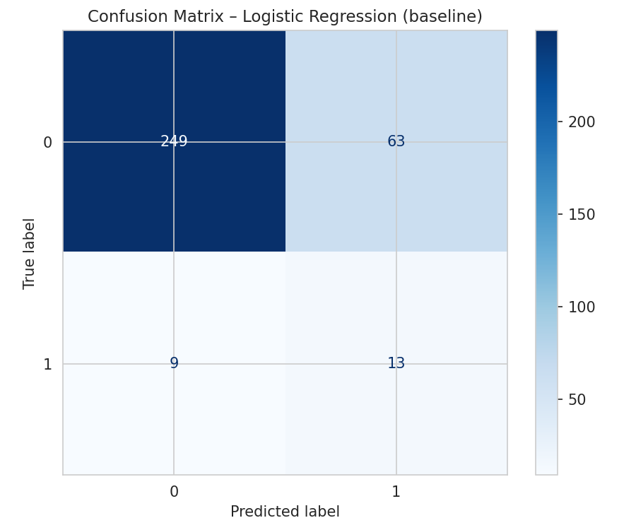  Logistic Regression | 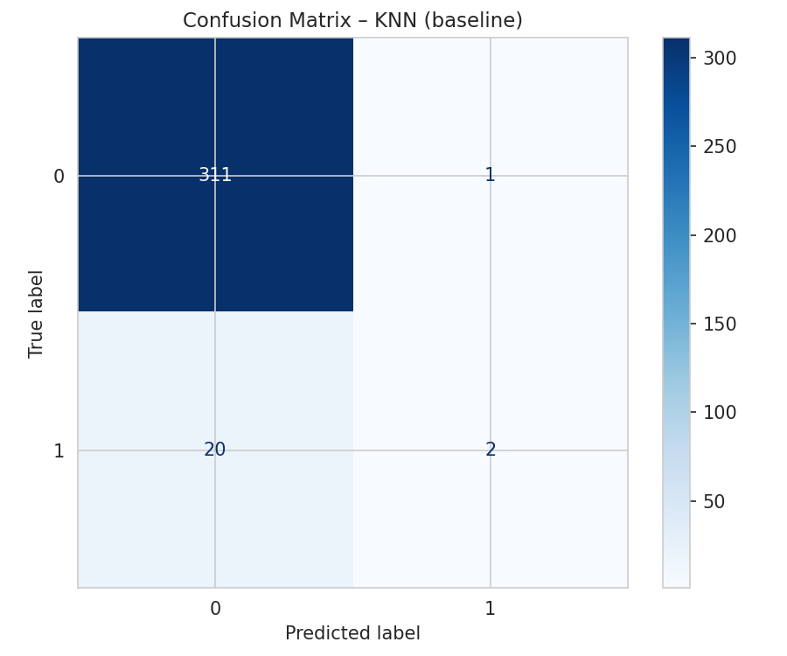  KNN
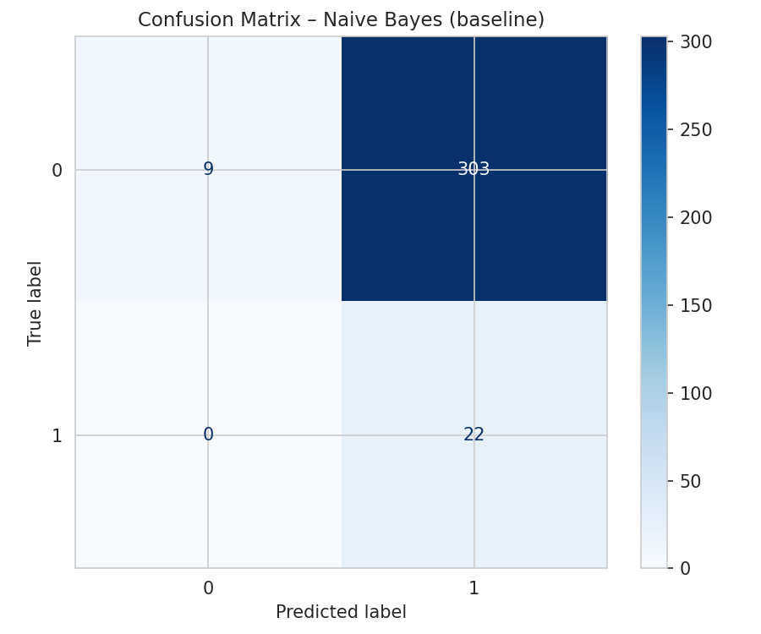  Naive Bayes | 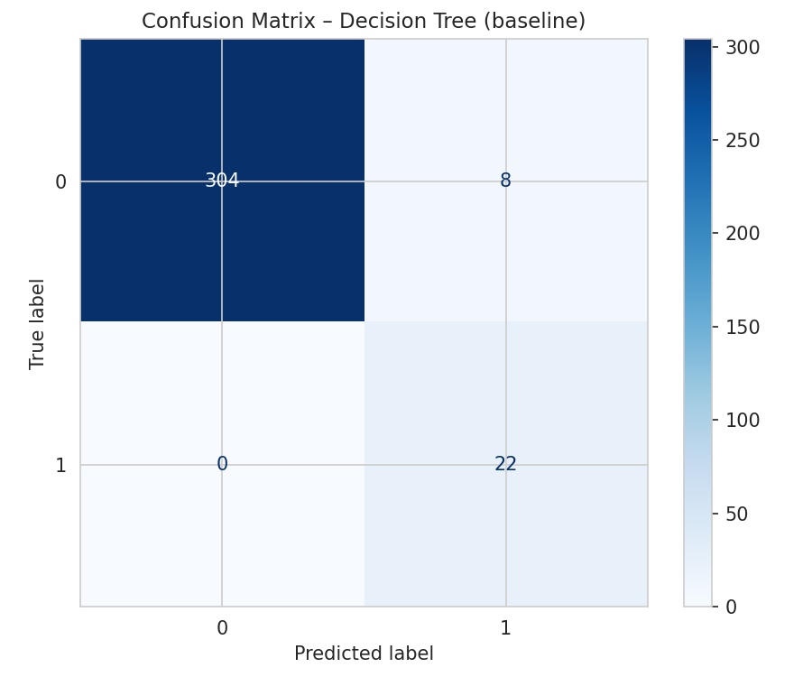  Decision Tree
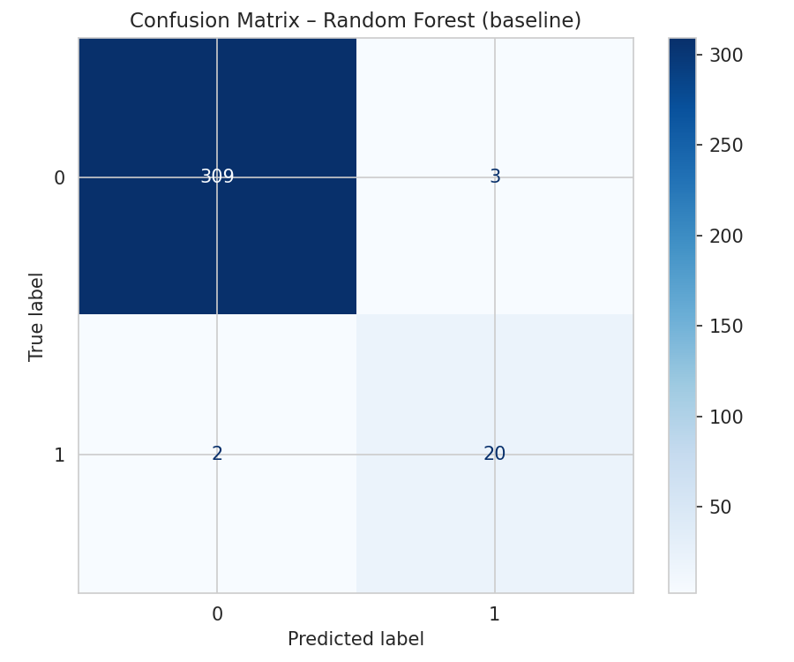  Random Forest | 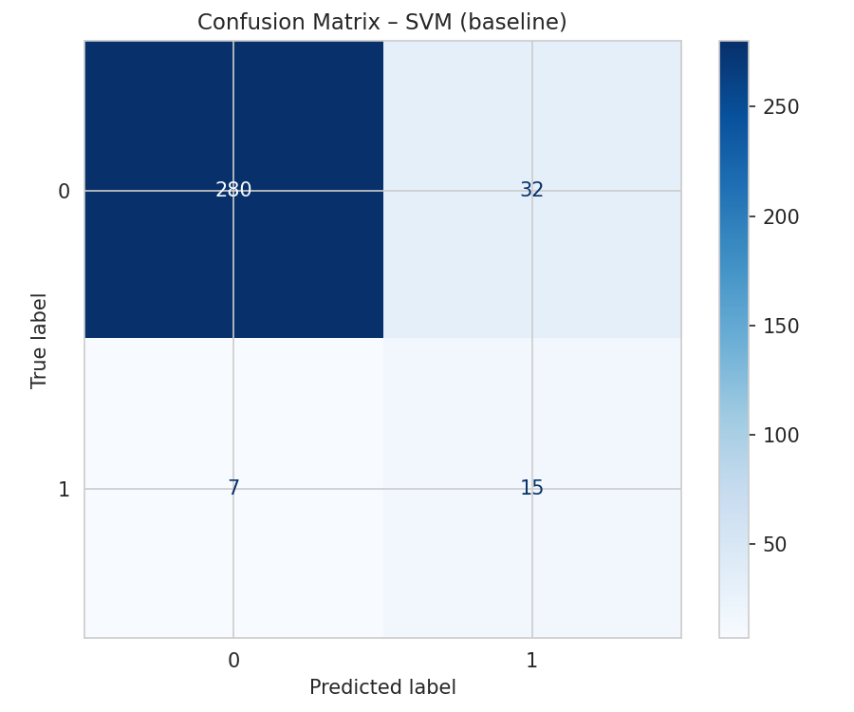  SVM
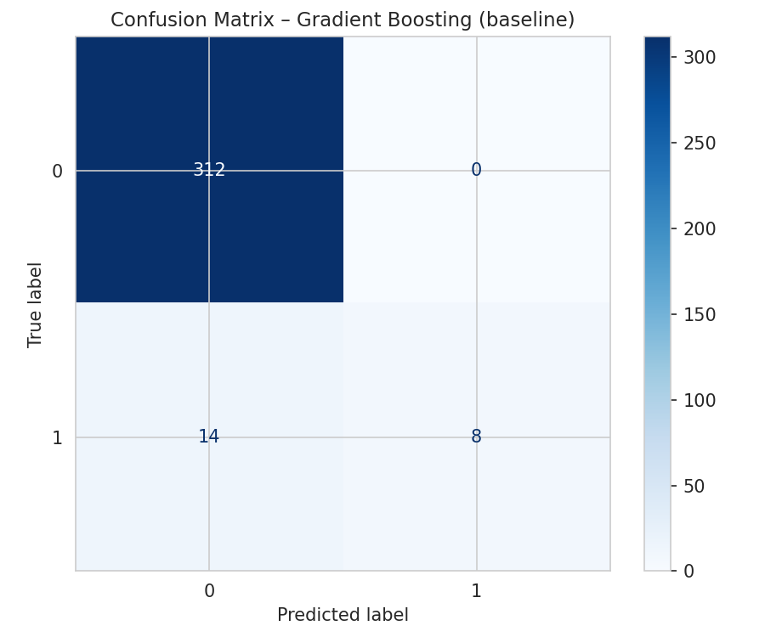  Gradient Boosting | 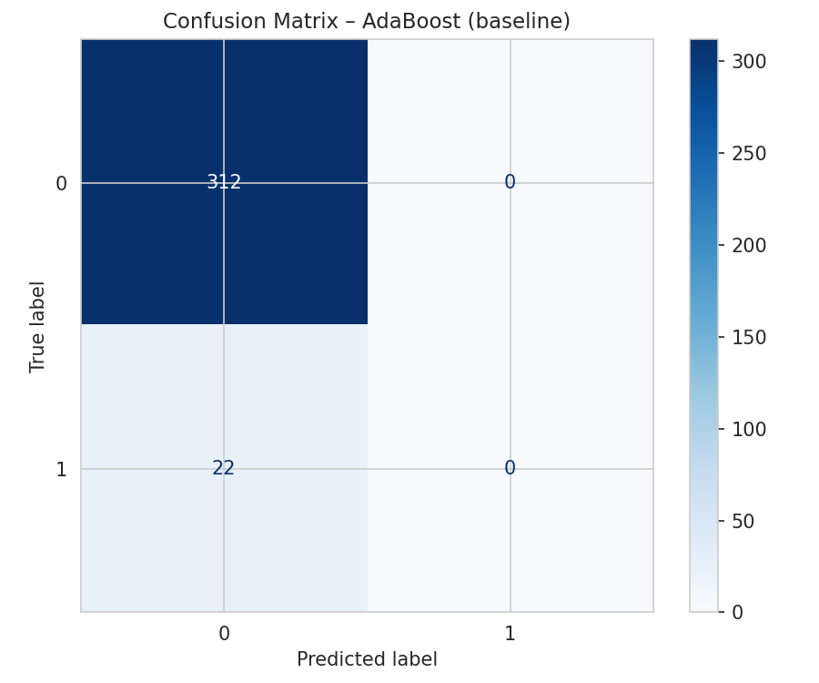  AdaBoost
Figure 1. Confusion Matrices of All Models Before Fine Tuning

4.1.3 ROC Curves Before Fine Tuning
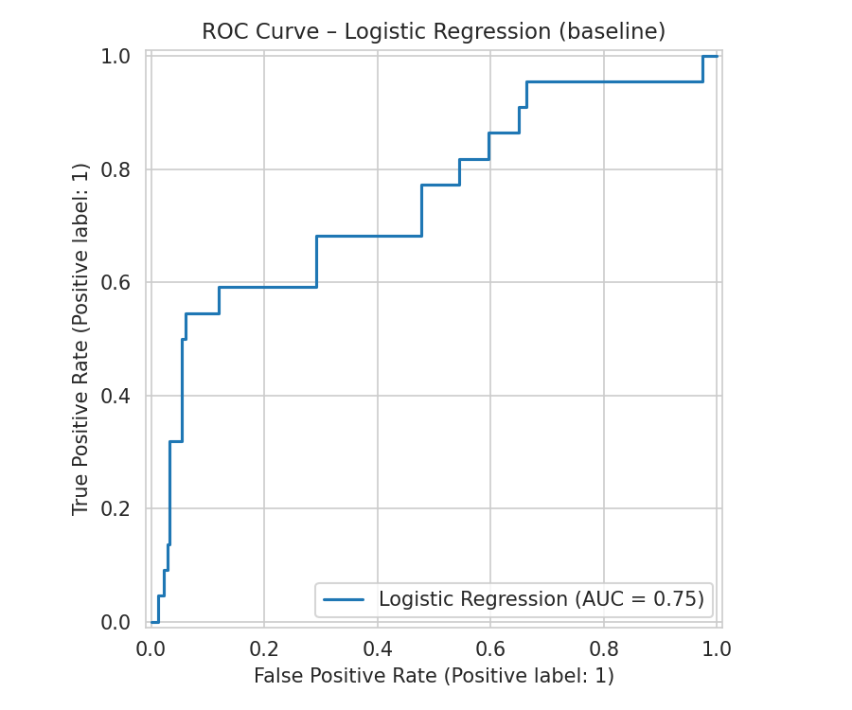  Logistic Regression | 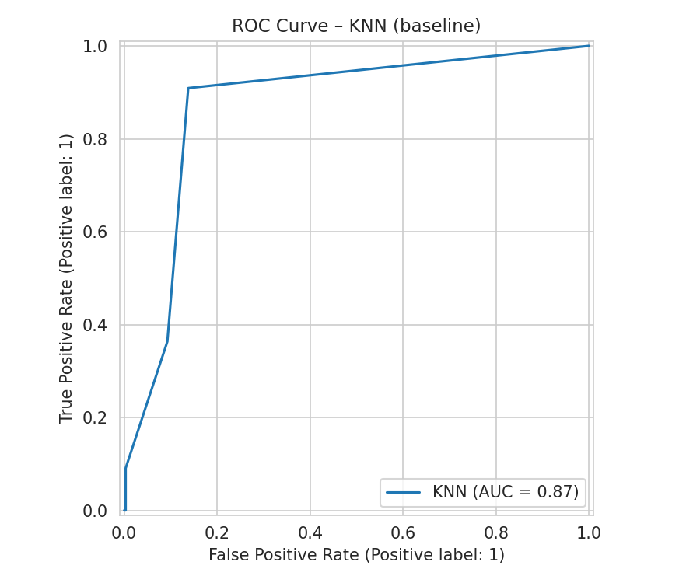  KNN
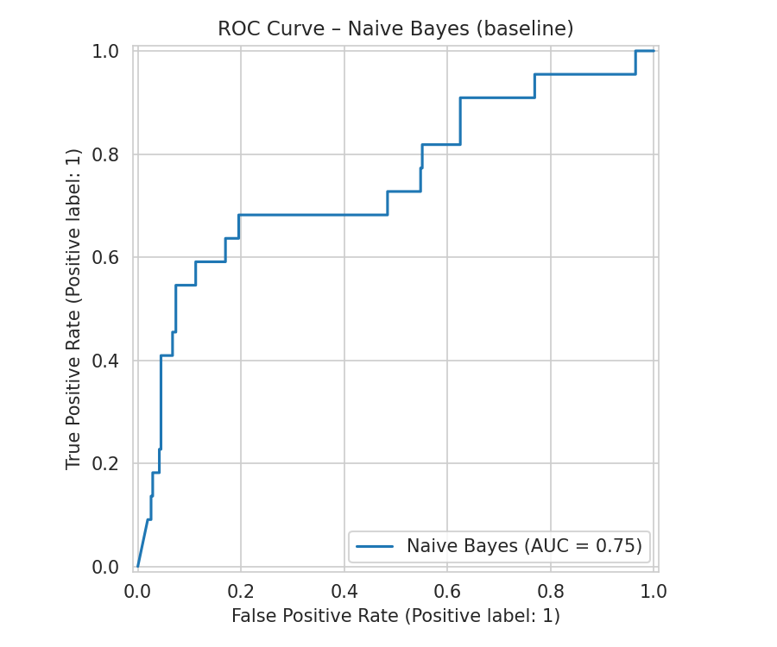  Naive Bayes | 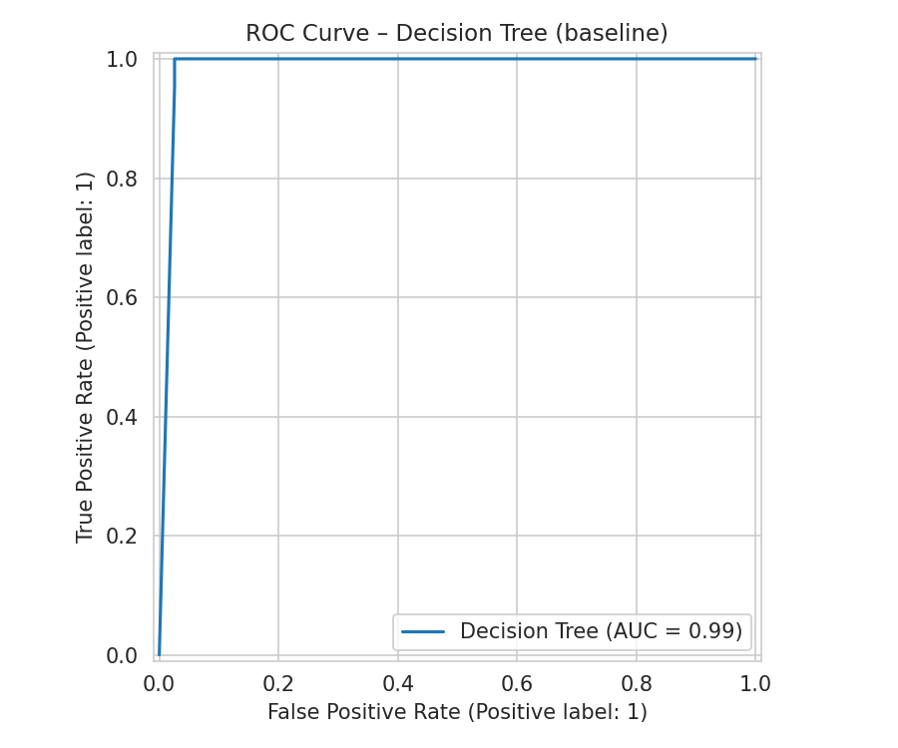  Decision Tree
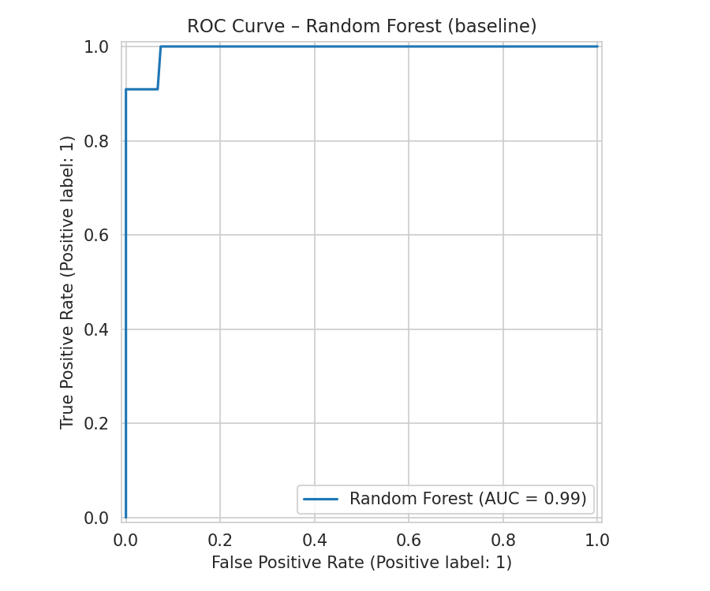  Random Forest | 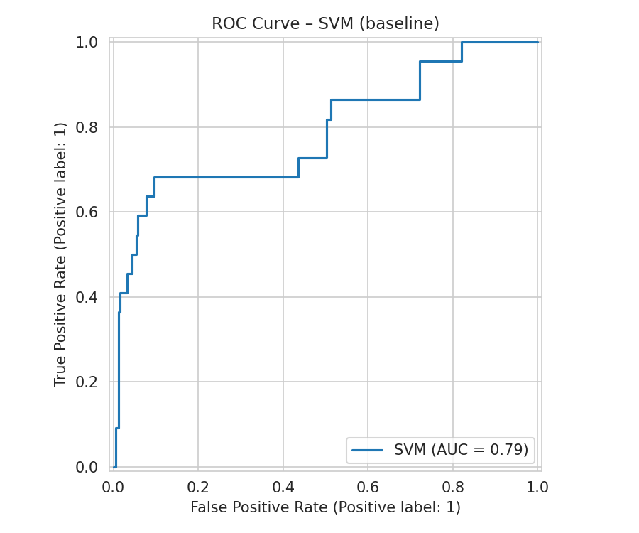  SVM
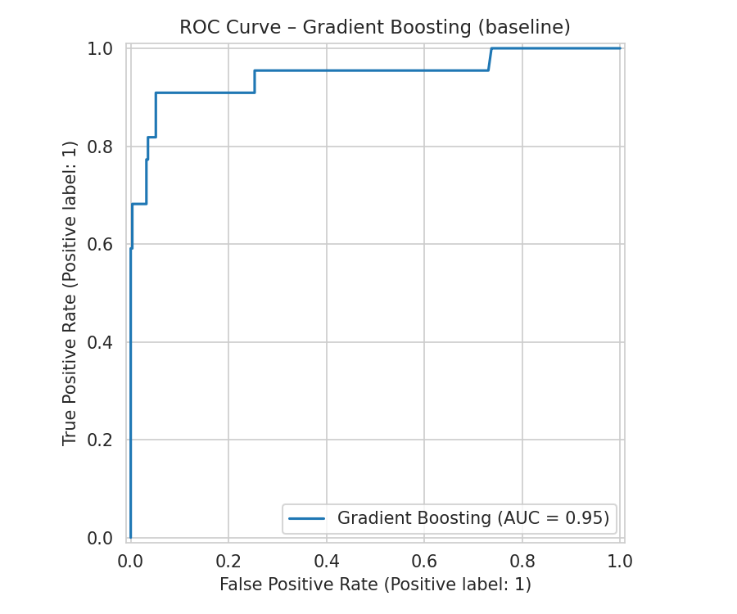  Gradient Boosting | 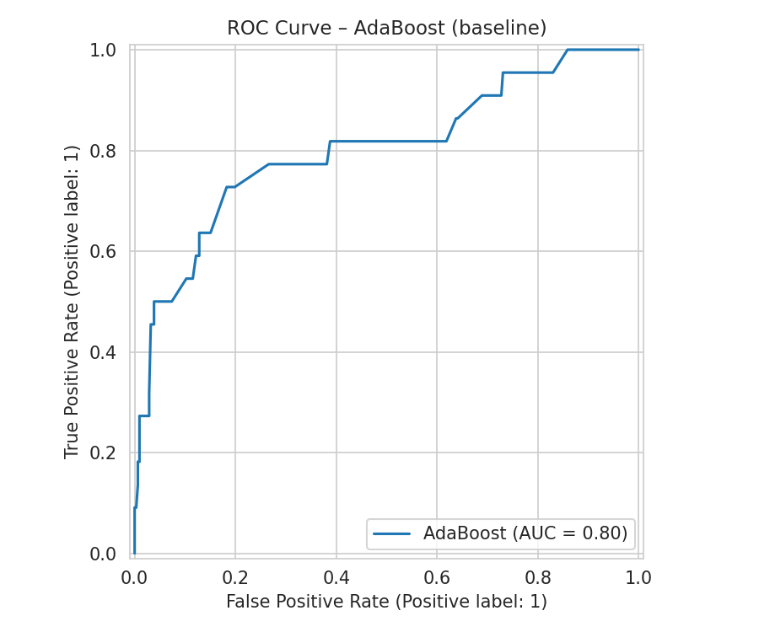  AdaBoost
Figure 2. ROC Curves of All Models Before Fine Tuning

4.1.4 Precision-Recall Curves Before Fine Tuning
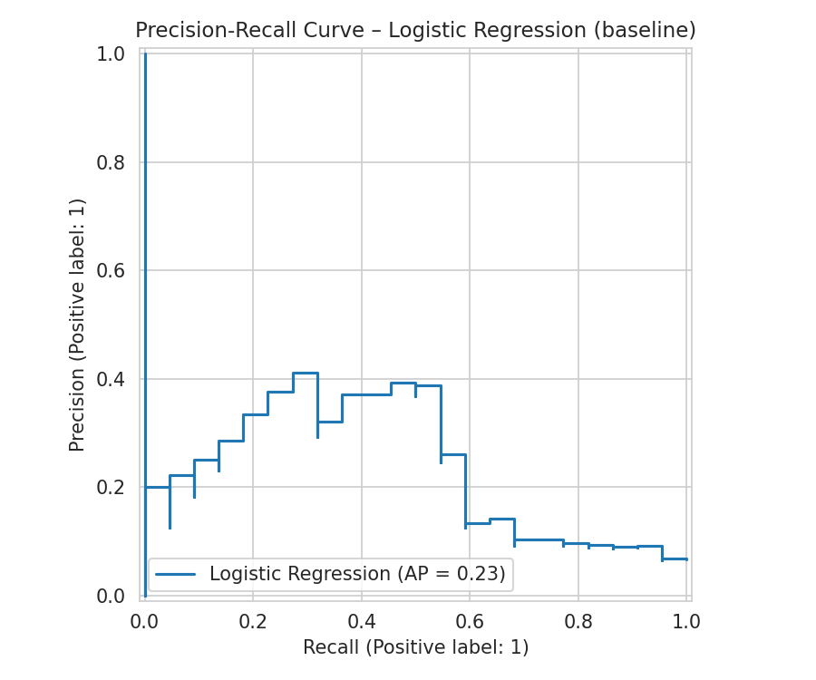  Logistic Regression | 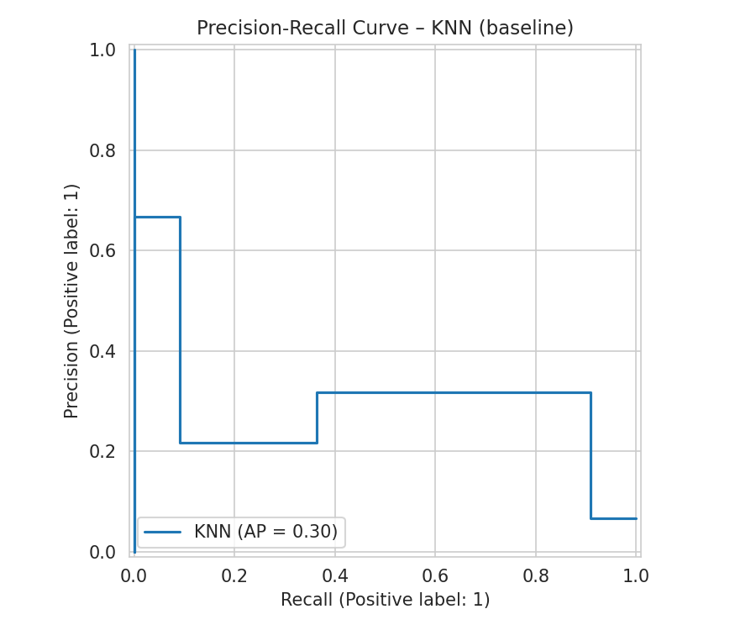  KNN
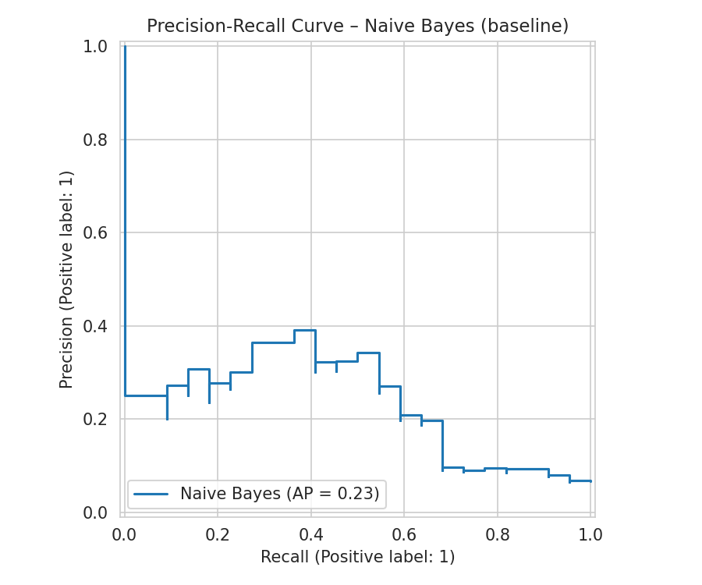  Naive Bayes | 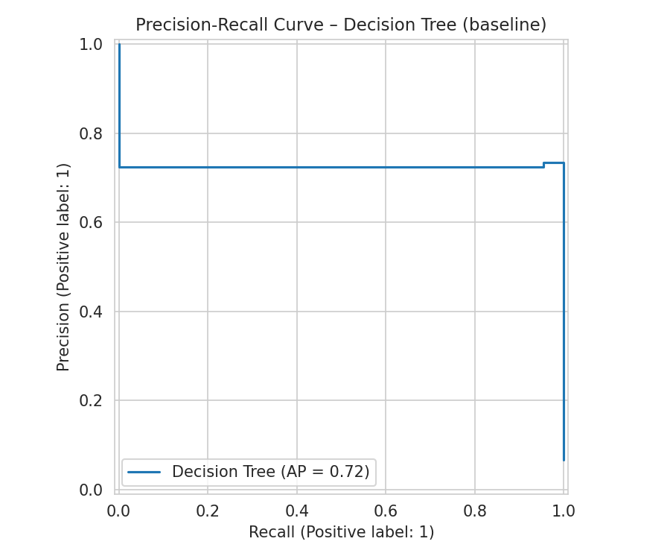  Decision Tree
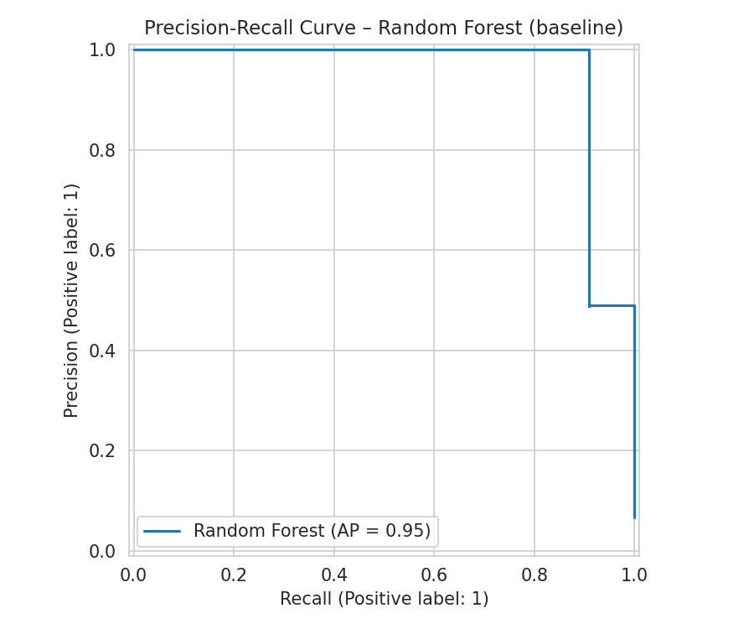  Random Forest | 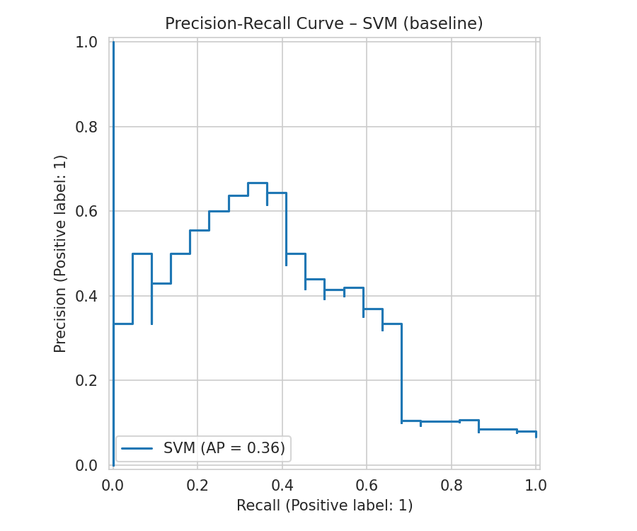  SVM
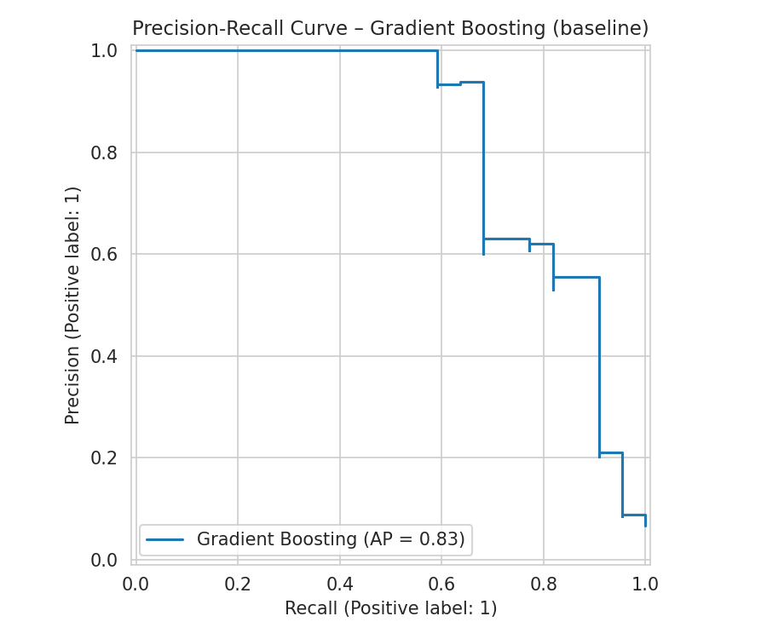  Gradient Boosting | 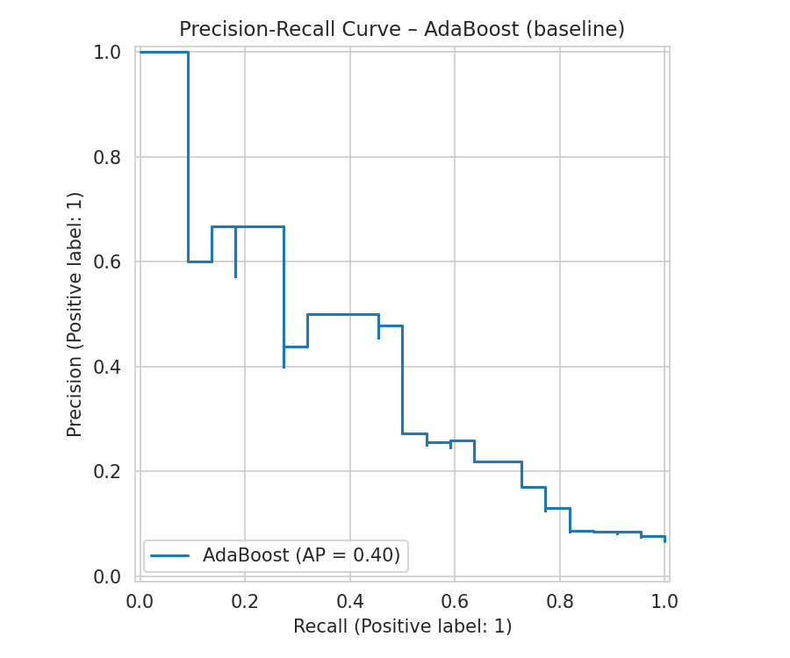  AdaBoost
Figure 3. Precision-Recall Curves of All Models Before Fine Tuning

4.2 Results After Fine Tuning

4.2.1 Complete Performance Results
Model | Accuracy | Precision | Recall | F1-Score | ROC-AUC
Random Forest | 0.994 | 1.000 | 0.909 | 0.952 | 0.996
KNN | 0.991 | 1.000 | 0.864 | 0.927 | 0.951
Gradient Boosting | 0.991 | 1.000 | 0.864 | 0.927 | 0.936
Decision Tree | 0.976 | 0.733 | 1.000 | 0.846 | 0.987
SVM | 0.841 | 0.269 | 0.818 | 0.404 | 0.847
Logistic Regression | 0.796 | 0.181 | 0.591 | 0.277 | 0.747
Naive Bayes | 0.093 | 0.068 | 1.000 | 0.127 | 0.748
AdaBoost | 0.934 | 0.000 | 0.000 | 0.000 | 0.536

4.2.2 Confusion Matrices After Fine Tuning
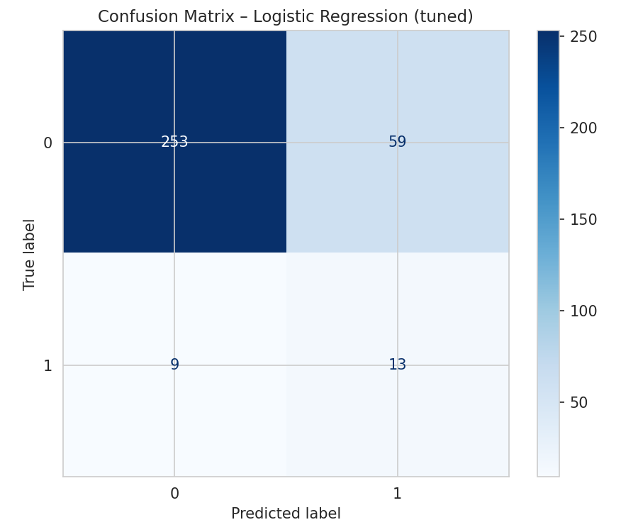  Logistic Regression | 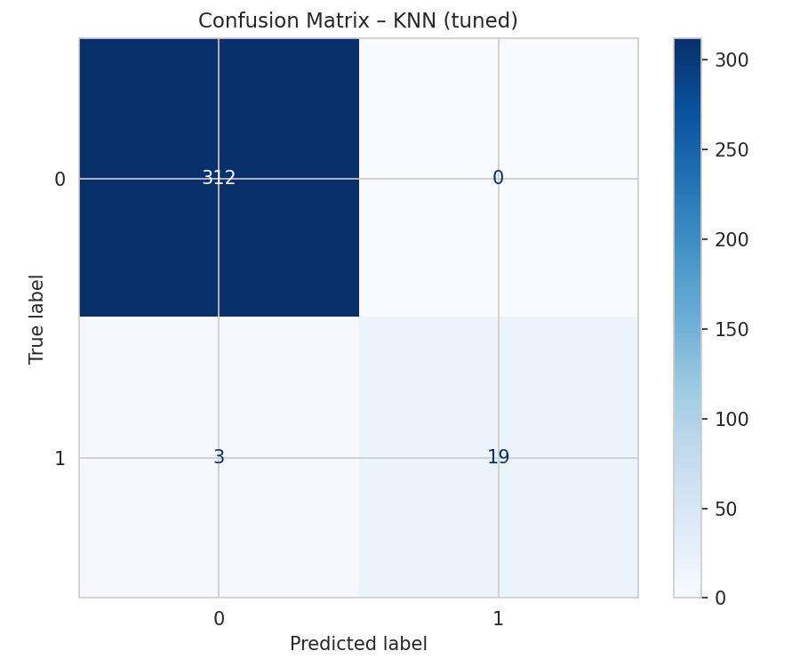  KNN
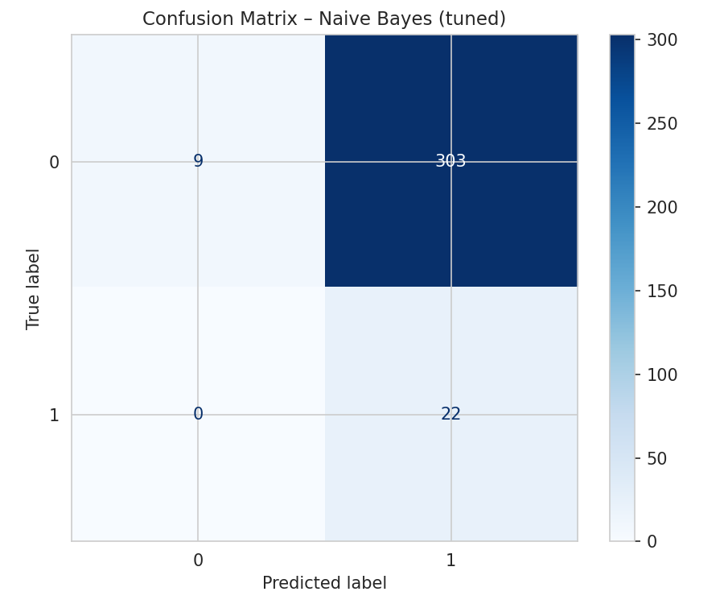  Naive Bayes | 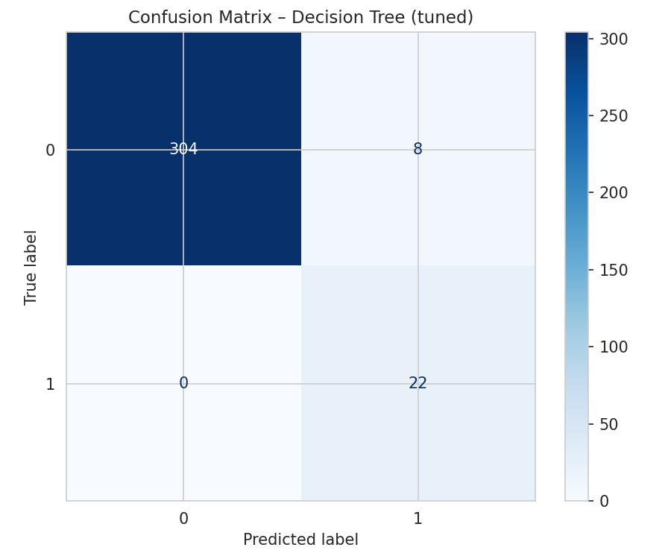  Decision Tree
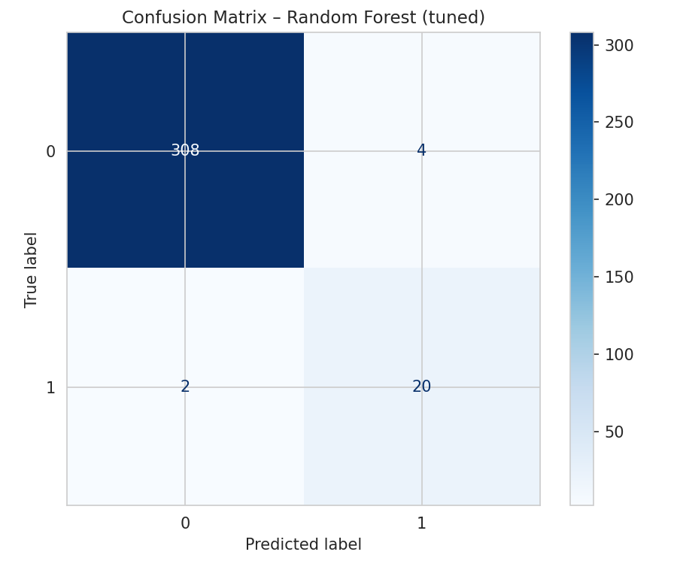  Random Forest | 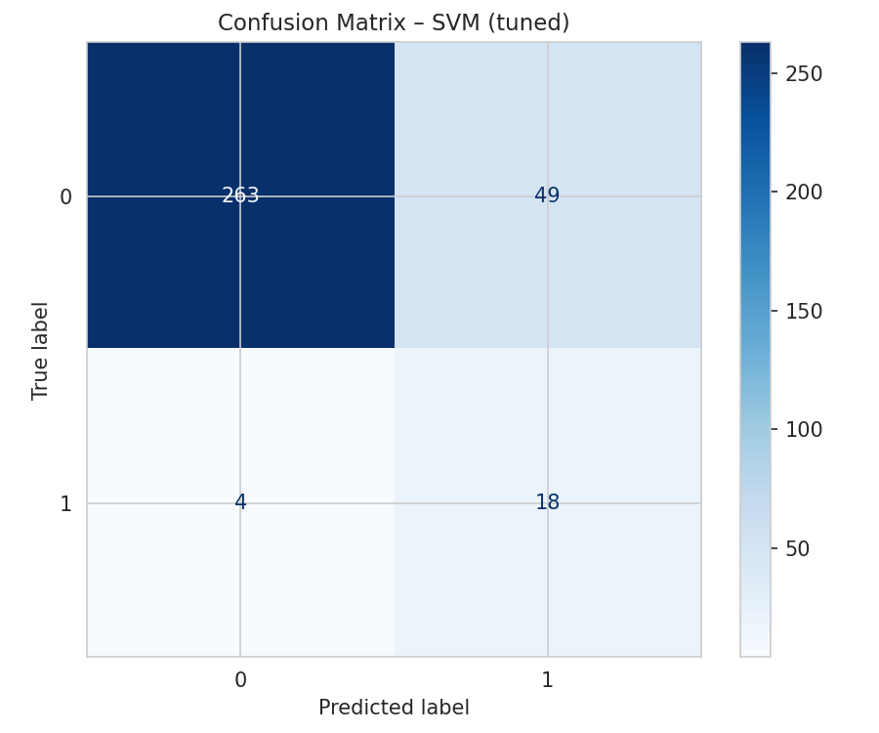  SVM
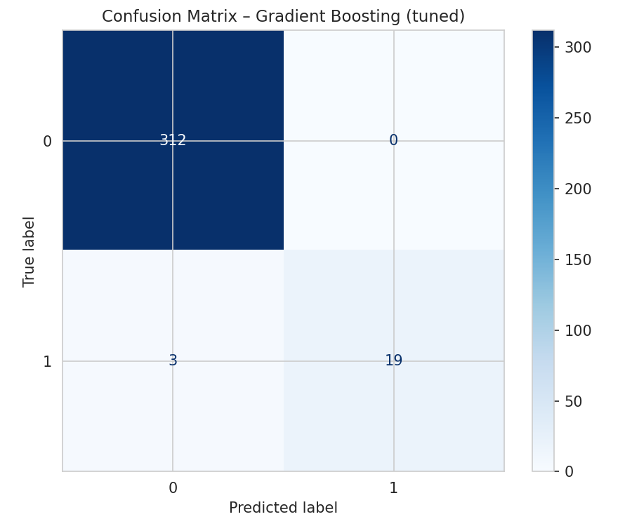  Gradient Boosting | 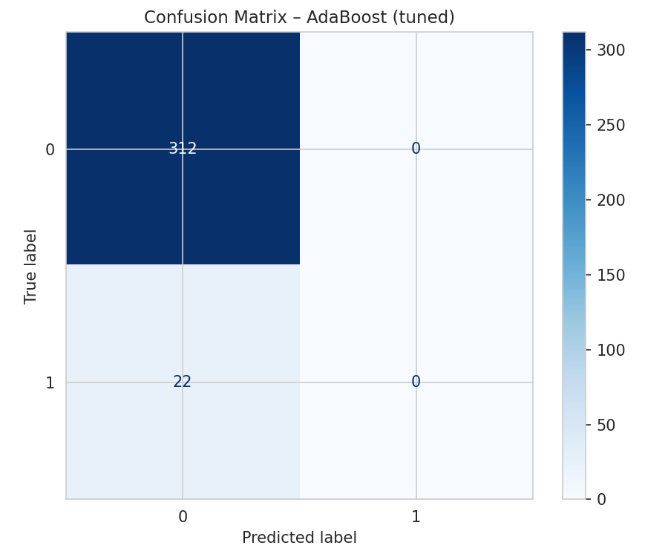  AdaBoost
Figure 4. Confusion Matrices of All Models After Fine Tuning

4.2.3 ROC Curves After Fine Tuning
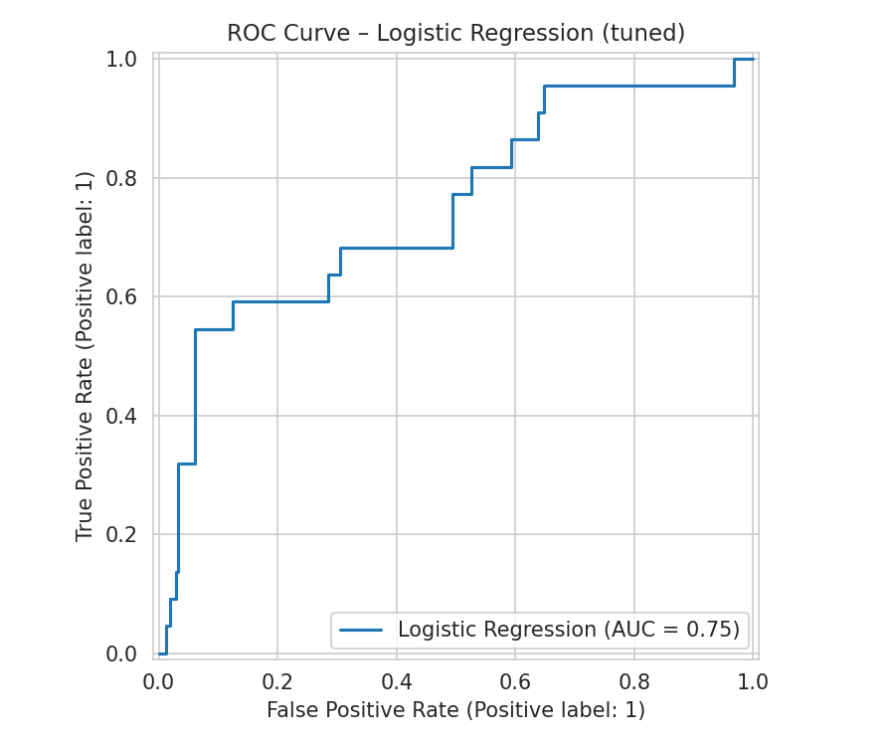  Logistic Regression | 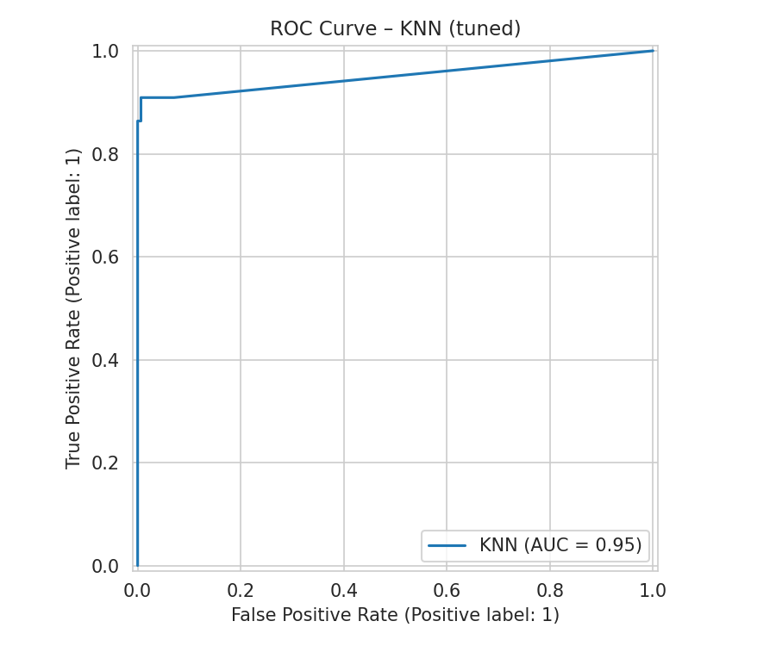  KNN
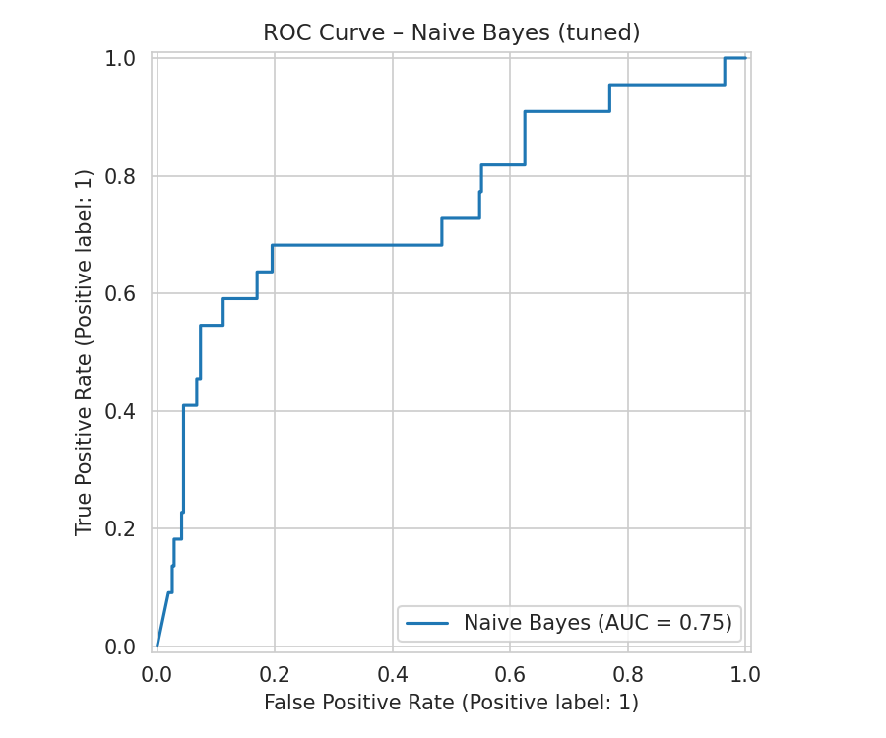  Naive Bayes | 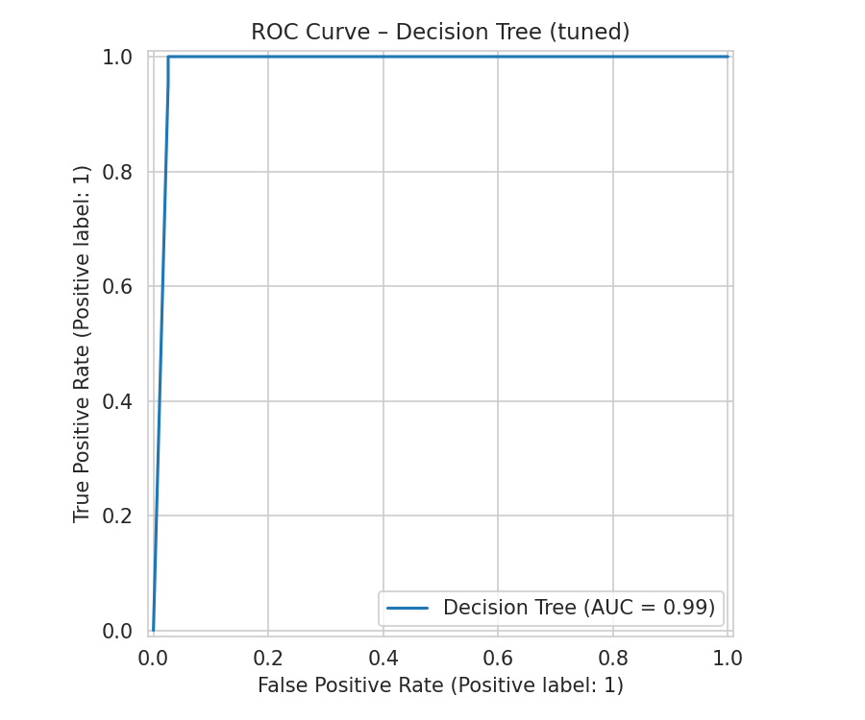  Decision Tree
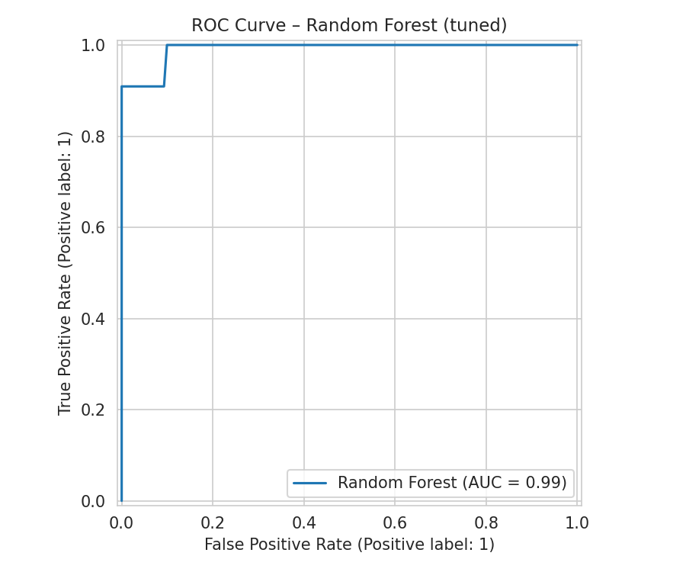  Random Forest | 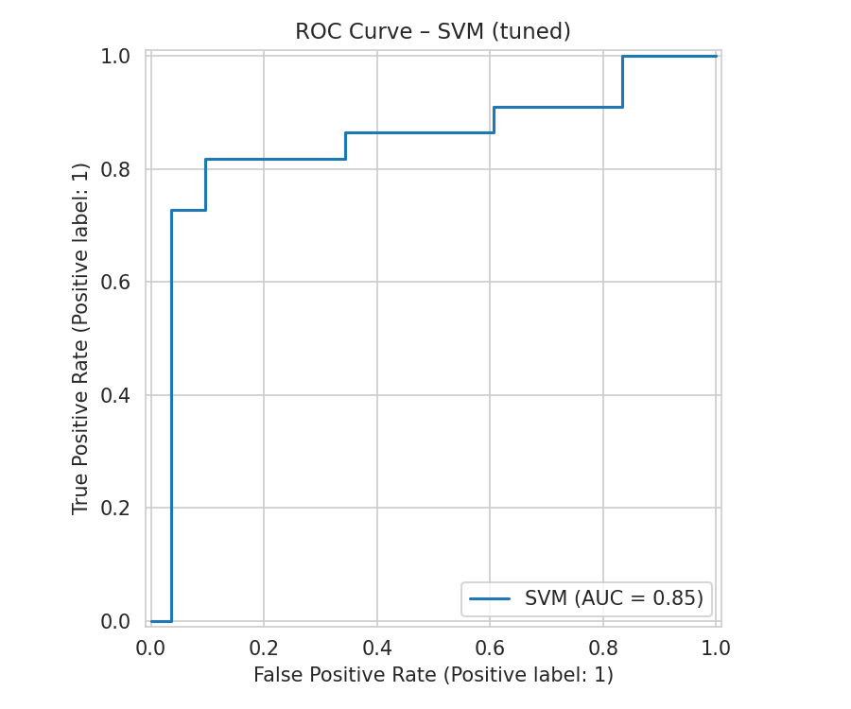  SVM
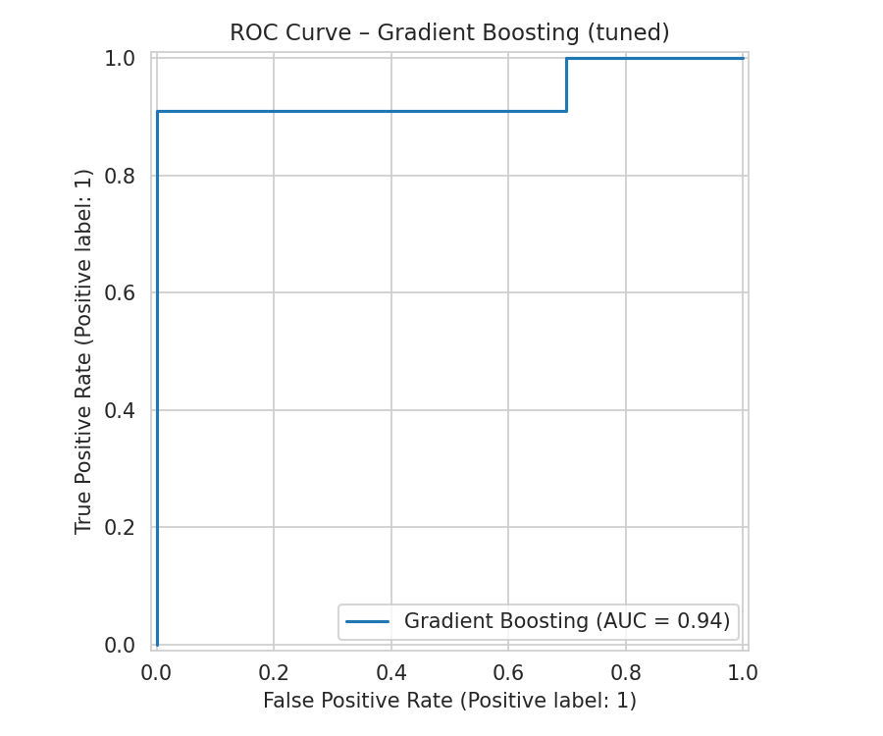  Gradient Boosting | 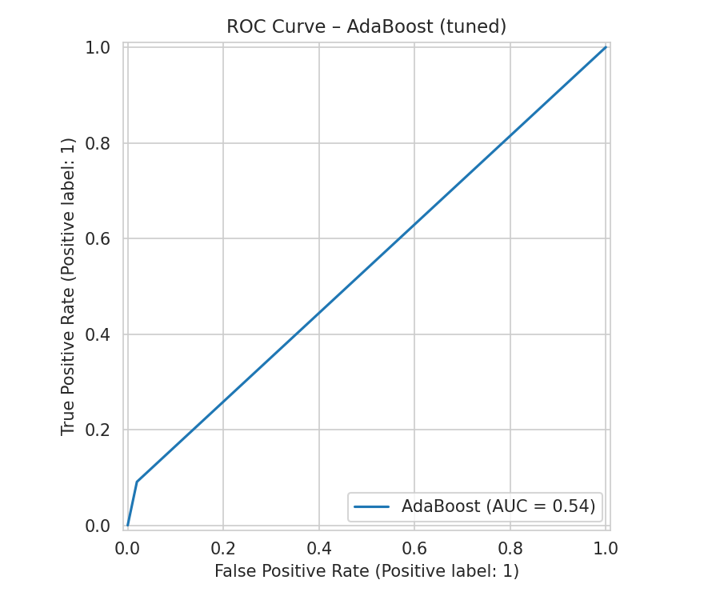  AdaBoost
Figure 5. ROC Curves of All Models After Fine Tuning

4.2.4 Precision-Recall Curves After Fine Tuning
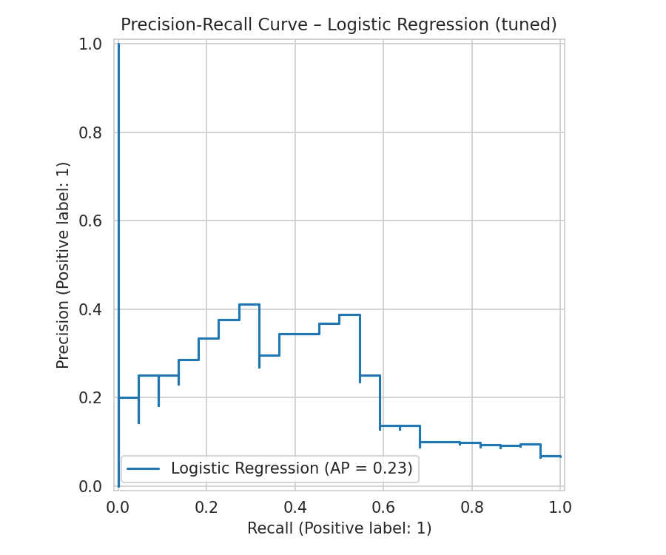  Logistic Regression | 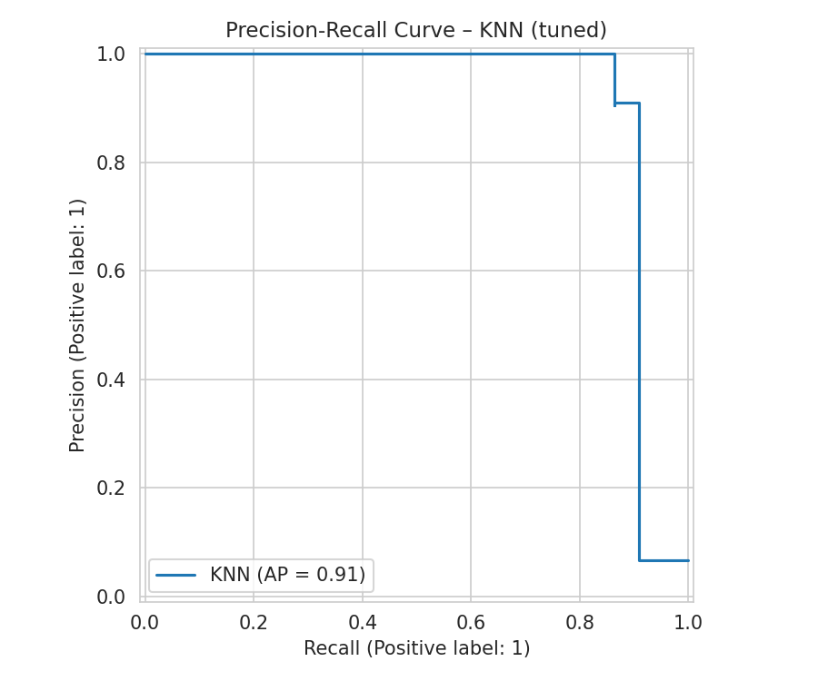  KNN
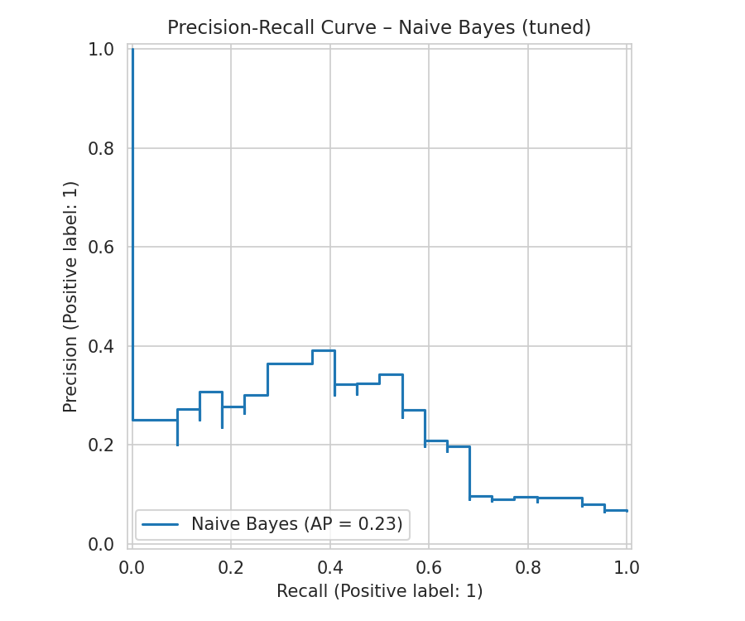  Naive Bayes | 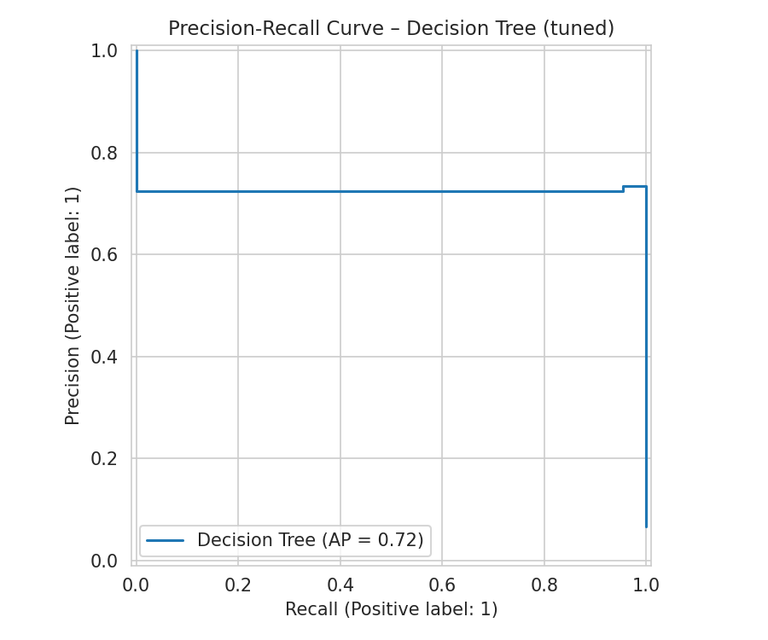  Decision Tree
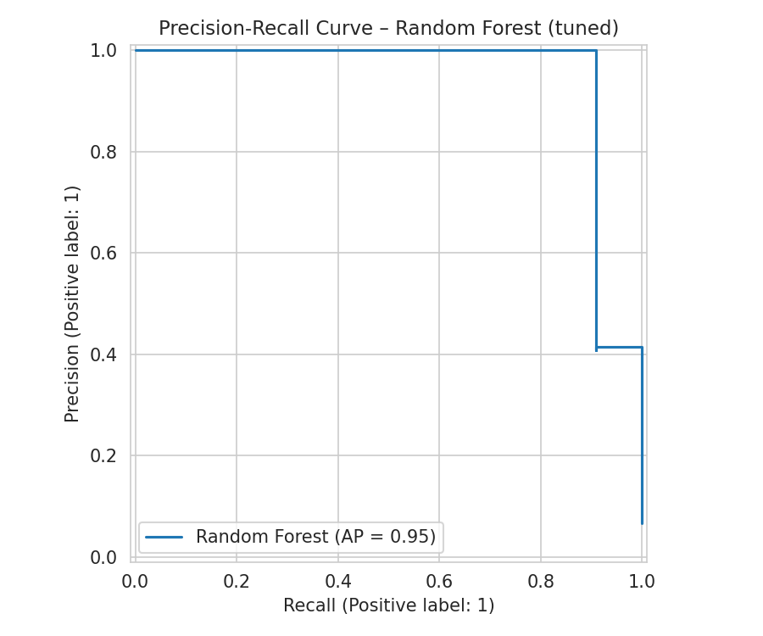  Random Forest | 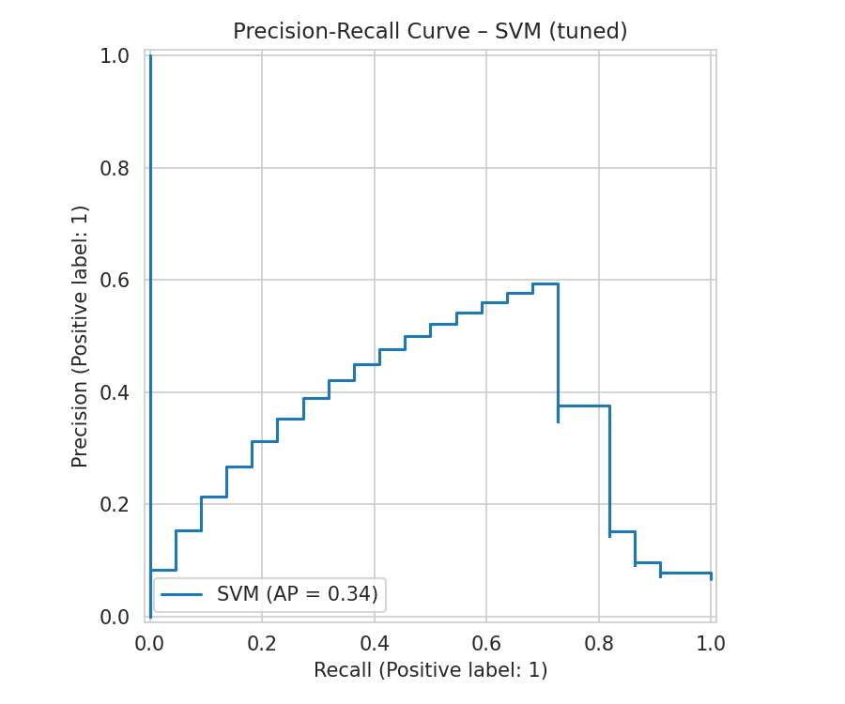  SVM
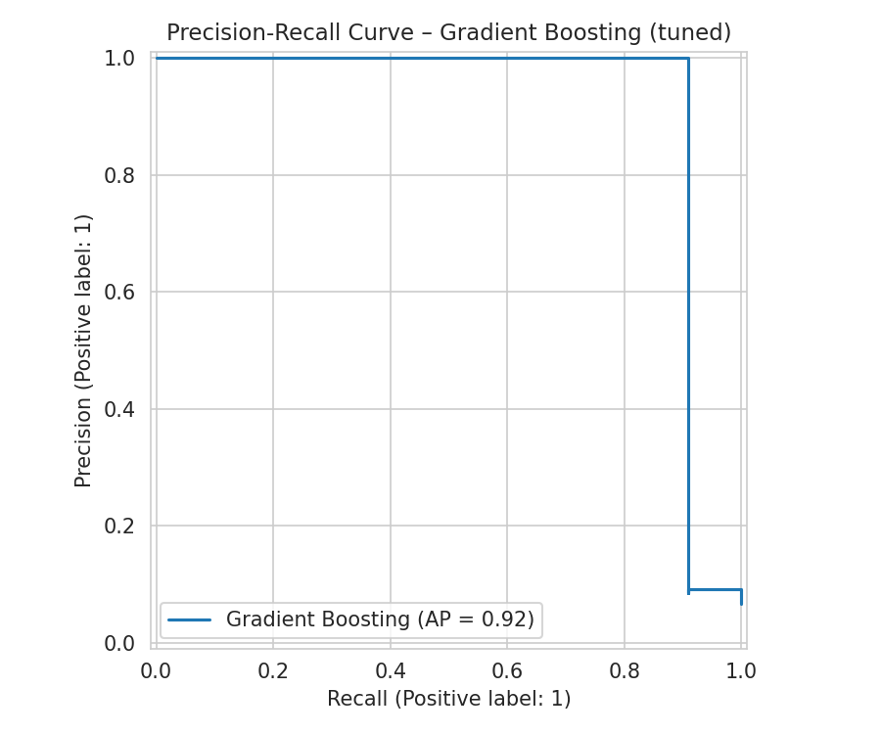  Gradient Boosting | 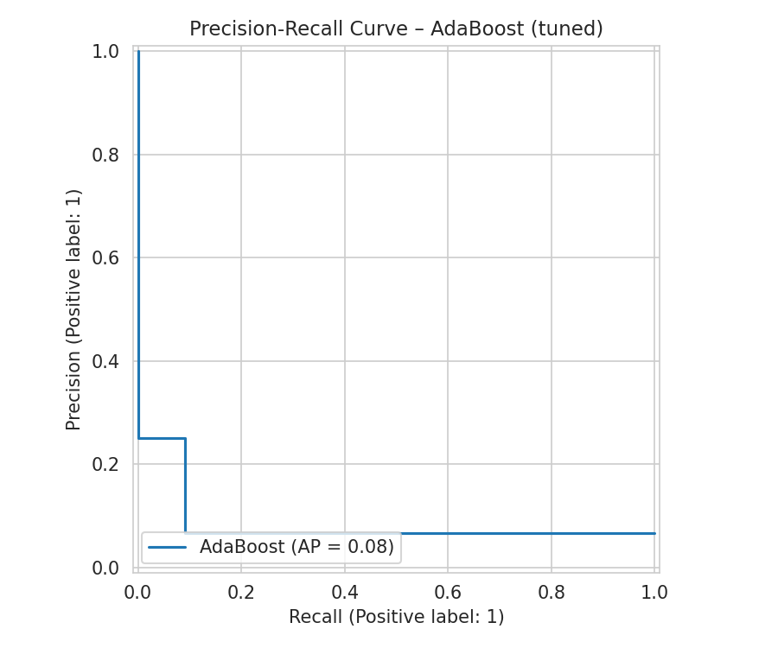  AdaBoost
Figure 6. Precision-Recall Curves of All Models After Fine Tuning

4.3 Best Model Selection
Random Forest was selected as the best-performing model (F1 = 0.952), correctly identifying 20 of 22 positive cases in the test set with zero false positives. Its baseline configuration was already near-optimal; tuning produced no change. Notably, GridSearchCV's tuned SVM performed worse than its own baseline (F1 0.404 vs. 0.435); per project policy, the baseline SVM was retained for deployment rather than the nominally tuned version. AdaBoost failed to learn the minority class under both configurations (F1 = 0.000), a structural limitation stemming from its lack of a class-weighting mechanism rather than a tuning failure.

PROJECT #2
IoTNet24 – IoT Network Intrusion Detection

1. Dataset

1.1 Dataset Description
The dataset used for this project is the IoTNet24 Dataset for IDS, built from real captures of IoT device network traffic, comprising both malicious attack traffic and benign everyday traffic.
Each row represents one network connection, summarized into statistics (port, protocol, connection state, packet/byte counts) using the Zeek network analysis tool.

1.2 Dataset Source
Dataset: IoTNet24 Dataset for IDS
Source: Kaggle (MIT license).
Size: 23,145 raw connection records; reduced to 7,821 after deduplication, with 16 input features after encoding.

1.3 Basic Dataset Analysis
Target Variable: label (0 = Benign, 1 = Malicious). The positive class (Malicious) is the majority class (91.7%), unlike the other three datasets in this project.
- Class distribution: 21,222 malicious (91.7%) vs. 1,923 benign (8.3%) connections.
- Connection state (conn_state) almost perfectly separated the classes: a fully completed connection (SF) was 100% benign, while every incomplete/failed connection state was effectively 100% malicious.
- Protocol (proto) was also highly separating: 99.5% of malicious traffic was TCP, while 94% of benign traffic was UDP.
- Feature importance analysis on the trained Random Forest confirmed destination port and protocol jointly accounted for 59% of total predictive importance.

1.4 Data Quality Issues
- Severe missingness in duration, orig_bytes, and resp_bytes (~77% missing each), traced to "missing not at random": these fields are only populated when a connection actually exchanges data.
- The service column was 92% missing and too sparse to use reliably.
- id.orig_h and id.resp_h (source/destination IP addresses) would not generalize to new, unseen devices or attackers if used as model inputs.
- 15,324 duplicate rows (66% of the cleaned dataset) were present; verified as safe to remove since their label distribution matched the overall dataset.
- The Unnamed: 0 index column and id.orig_p (ephemeral source port) carried no genuine predictive signal.

2. Preprocessing
The preprocessing pipeline focused on removing non-generalizable and low-value columns, correctly handling meaningfully-missing traffic statistics, and safely removing duplicate connection records.

2.1 Irrelevant Column Removal
Dropped Unnamed: 0, id.orig_h, id.resp_h, service, and history — an index column, non-generalizable IP addresses, a too-sparse column, and a complex unparsed text field, respectively.

2.2 Meaningful Zero Imputation
Imputed missing duration/orig_bytes/resp_bytes values as 0 rather than median, since missingness in these fields specifically indicates "no data was exchanged" — a real and meaningful value, not an unknown quantity.

2.3 Duplicate Removal
Removed 15,324 duplicate rows after confirming the malicious/benign ratio among duplicates matched the full dataset, indicating safe removal rather than loss of minority-class information.

2.4 Noise Feature Removal
Dropped id.orig_p (ephemeral source port), which carries negligible real signal since it is effectively assigned at random by the operating system.

2.5 Encoding
Encoded proto with Label Encoding (2 categories) and conn_state with One-Hot Encoding (6 categories, no natural order); encoded the target label with Label Encoding (Benign = 0, Malicious = 1).

2.6 Feature Scaling
Applied RobustScaler to all numeric features, given the zero-inflated, heavily skewed distributions identified during EDA.

2.7 Train-Test Split
Performed an 80/20 stratified train-test split (6,256 / 1,565 records), preserving the 91.7%/8.3% class ratio.

3. Machine Learning Methods

3.1 Model Selection Criteria
The same 8 algorithms were applied consistently across all four datasets, deliberately spanning five distinct model families — linear, distance-based, probabilistic, tree-based, and two ensemble strategies (bagging and boosting). Rather than testing minor variations of a single approach, the goal was to compare genuinely different learning strategies against the same data, so that performance differences could be attributed to how each algorithm's structural assumptions matched the underlying data.
Selection was also guided by dataset scale. All four datasets contain between roughly 900 and 24,000 rows with a modest number of features — a size range where classical machine learning algorithms are appropriate and computationally efficient. Deep learning approaches were not used, as they typically require substantially larger datasets to outperform classical methods and offer reduced interpretability, which was not justified at this data scale.

3.2 Selected Machine Learning Models
The following 8 algorithms were trained and evaluated:
- Logistic Regression (Linear)
- K-Nearest Neighbours (KNN) (Distance-based)
- Naive Bayes (Gaussian) (Probabilistic)
- Decision Tree (Tree-based)
- Random Forest (Ensemble (Bagging))
- Support Vector Machine (SVM) (Margin-based)
- Gradient Boosting (Ensemble (Boosting))
- AdaBoost (Ensemble (Boosting))

3.3 Logistic Regression
Family: Linear. Models the probability of the positive class using a weighted linear combination of features passed through a sigmoid function. Fast and highly interpretable; limited to linear decision boundaries.

3.4 K-Nearest Neighbours (KNN)
Family: Distance-based. Classifies a new sample by majority vote among its K nearest training samples, measured by feature distance. Requires no explicit training phase, but is sensitive to feature scaling, which is why scaling was applied before training.

3.5 Naive Bayes (Gaussian)
Family: Probabilistic. Applies Bayes' theorem assuming conditional independence between features given the class label. Extremely fast to train; accuracy degrades when features are correlated, which is common in real clinical and behavioural data.

3.6 Decision Tree
Family: Tree-based. Recursively splits data on the feature/threshold that best separates classes at each node, forming a flowchart-like structure. Highly interpretable but prone to overfitting when depth is unconstrained.

3.7 Random Forest
Family: Ensemble (Bagging). Trains many decision trees on random subsets of data and features, then aggregates their votes. Reduces the overfitting risk of a single tree and is generally robust across varied data structures.

3.8 Support Vector Machine (SVM)
Family: Margin-based. Finds the decision boundary that maximizes the margin between classes; the RBF kernel allows non-linear class separation.

3.9 Gradient Boosting
Family: Ensemble (Boosting). Builds trees sequentially, with each new tree trained to correct the residual errors of the previous ensemble. Often achieves top-tier accuracy but requires careful tuning to avoid overfitting.

3.10 AdaBoost
Family: Ensemble (Boosting). Builds trees sequentially, increasing the weight of misclassified samples so subsequent trees focus on hard cases. Has no native class-weighting mechanism, which limits performance on severely imbalanced data.

4. Results
Given the highly separable feature structure identified in EDA, all 8 models achieved strong baseline performance; results are confirmed using ROC-AUC and Precision-Recall metrics alongside F1.

4.1 Results Before Fine Tuning

4.1.1 Complete Performance Results
Model | Accuracy | Precision | Recall | F1-Score | ROC-AUC
Gradient Boosting | 0.999 | 1.000 | 0.999 | 0.999 | 1.000
AdaBoost | 0.999 | 1.000 | 0.999 | 0.999 | 1.000
KNN | 0.997 | 0.998 | 0.999 | 0.998 | 0.993
Decision Tree | 0.997 | 0.998 | 0.999 | 0.998 | 0.990
Random Forest | 0.997 | 0.998 | 0.999 | 0.998 | 1.000
Logistic Regression | 0.978 | 0.999 | 0.976 | 0.987 | 0.999
SVM | 0.968 | 1.000 | 0.965 | 0.982 | 0.974
Naive Bayes | 0.965 | 0.997 | 0.965 | 0.981 | 0.984

4.1.2 Confusion Matrices Before Fine Tuning
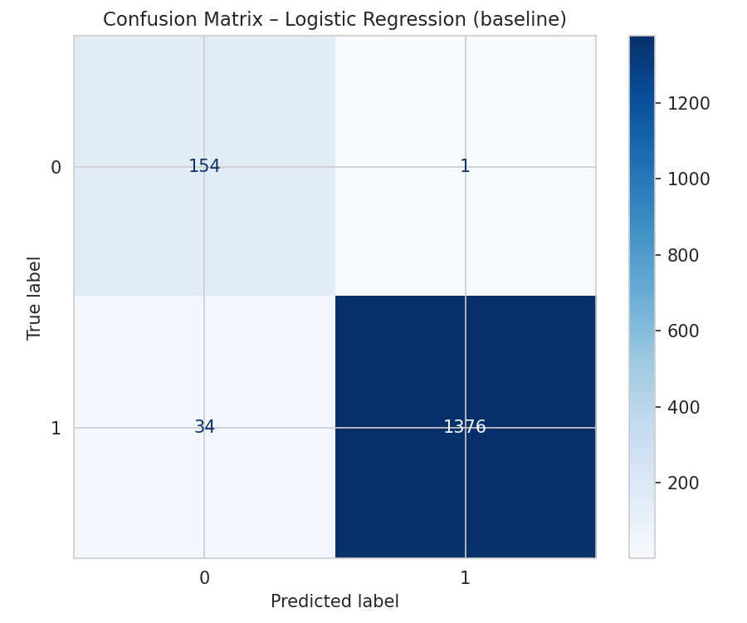  Logistic Regression | 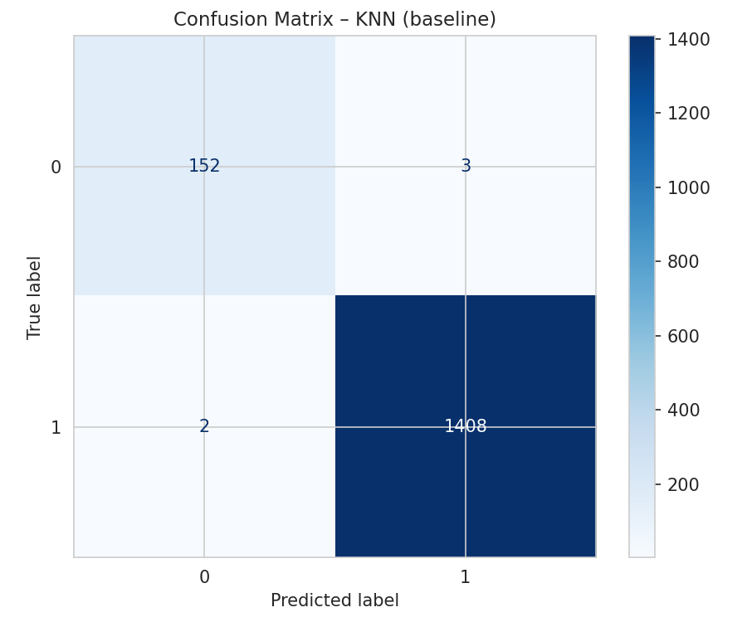  KNN
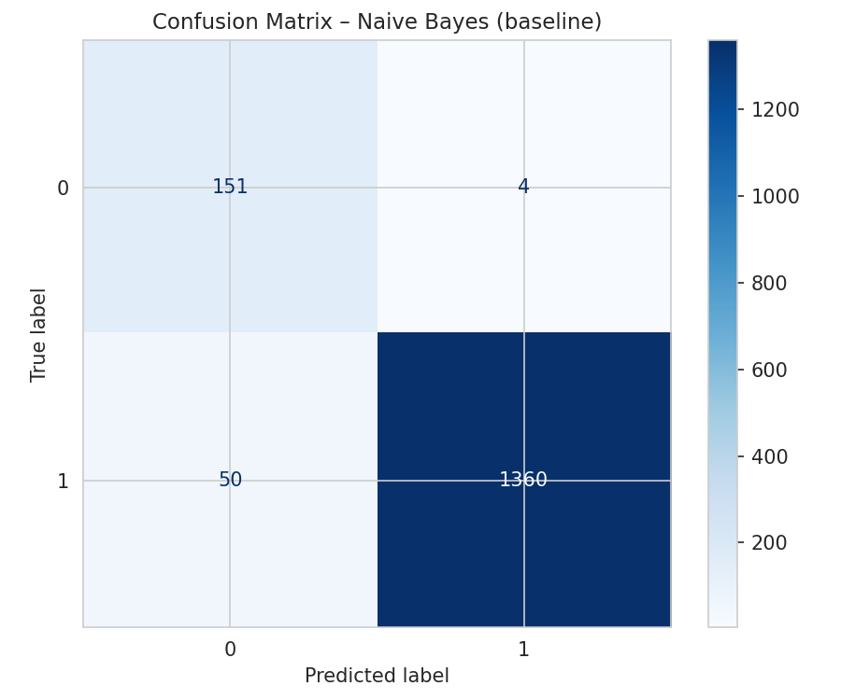  Naive Bayes | 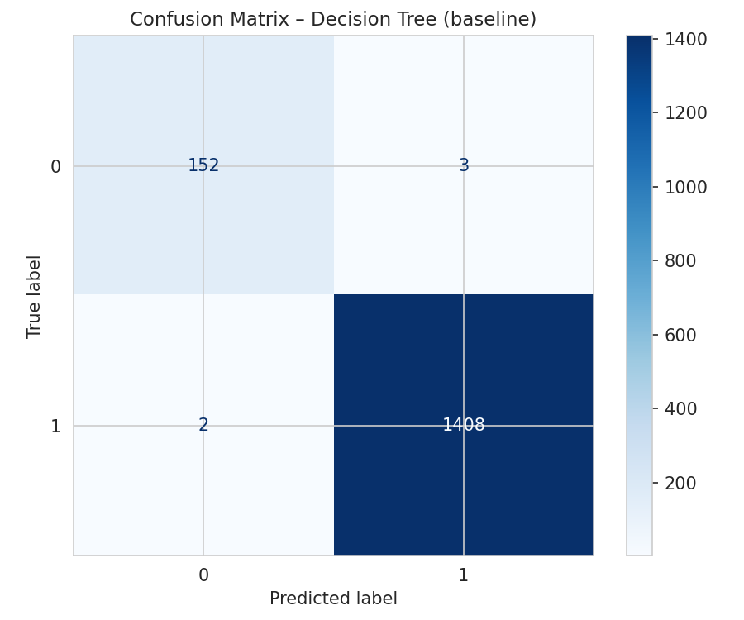  Decision Tree
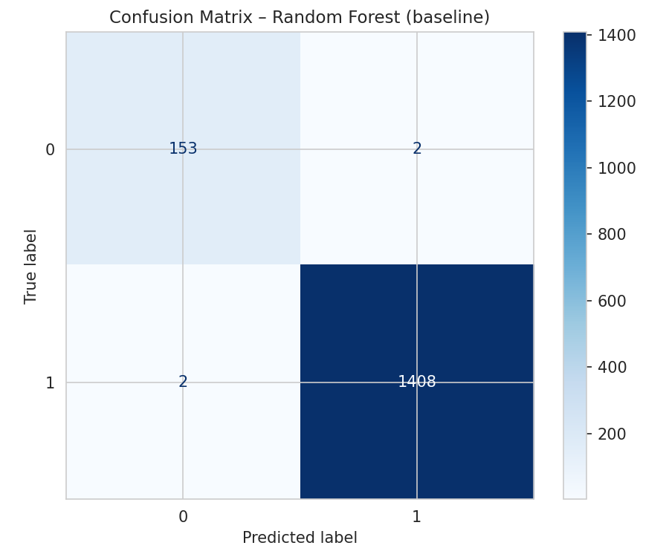  Random Forest | 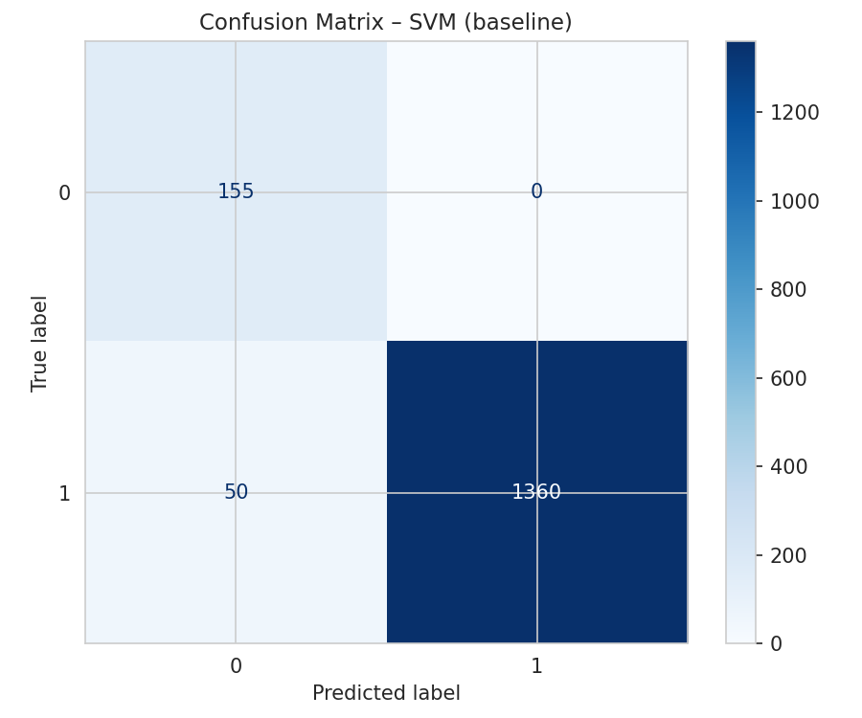  SVM
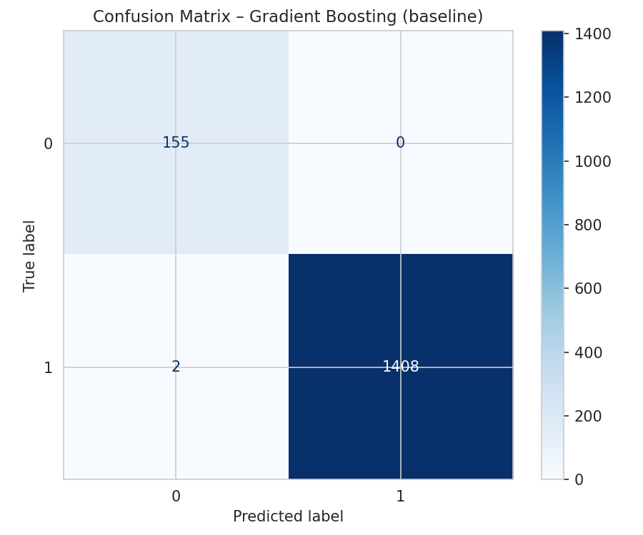  Gradient Boosting | 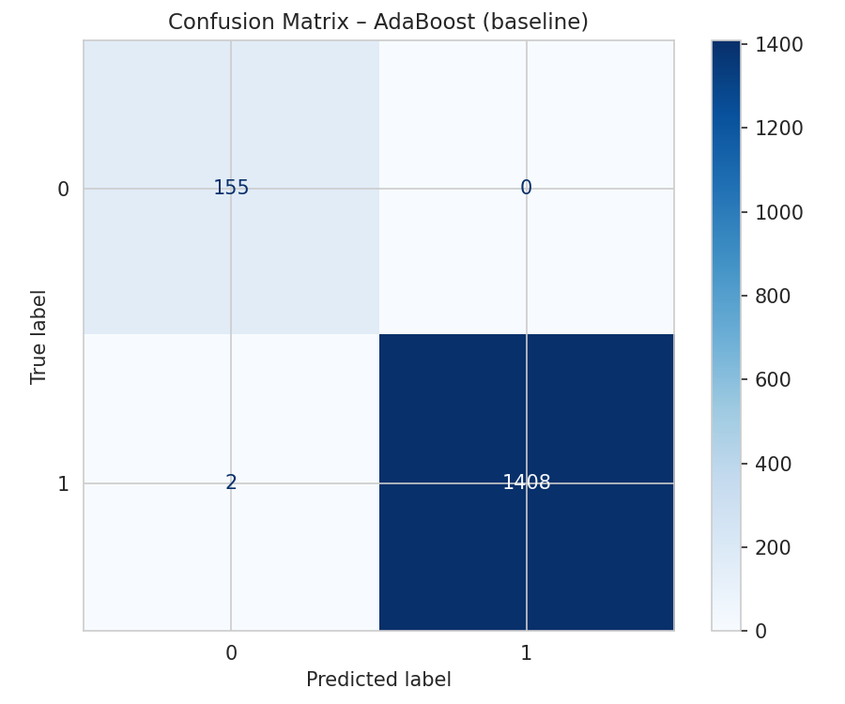  AdaBoost
Figure 7. Confusion Matrices of All Models Before Fine Tuning

4.1.3 ROC Curves Before Fine Tuning
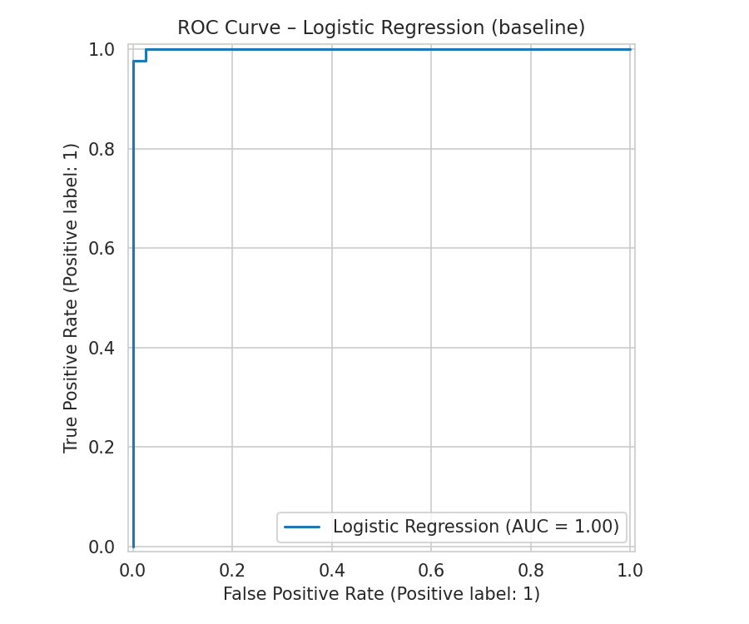  Logistic Regression | 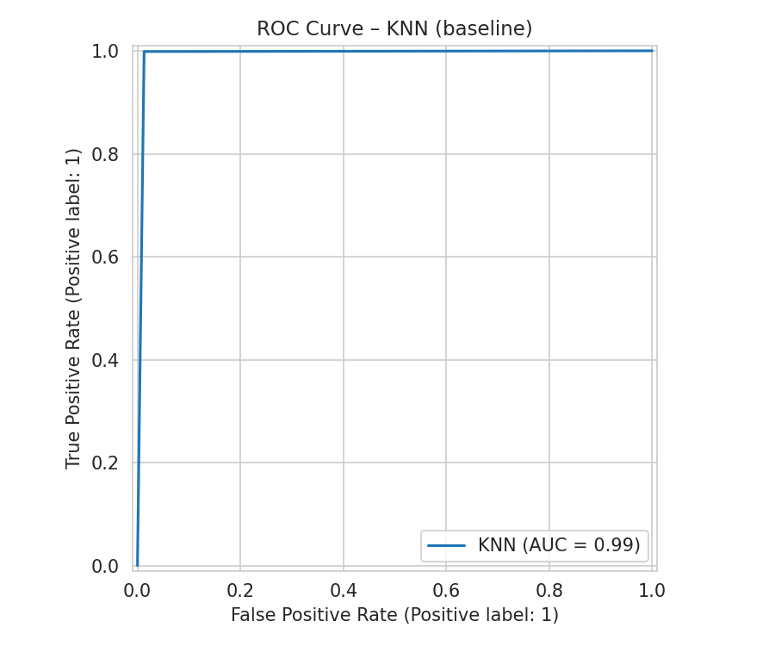  KNN
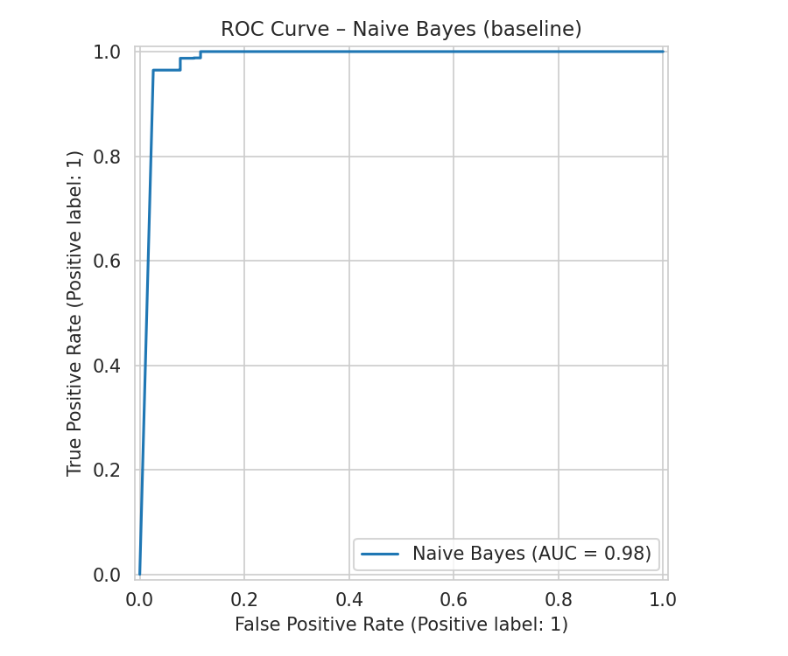  Naive Bayes | 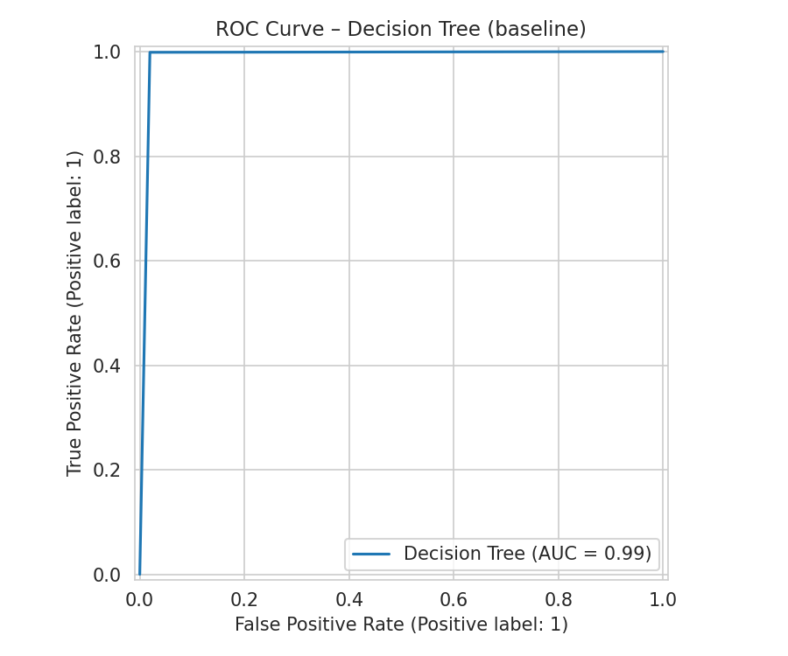  Decision Tree
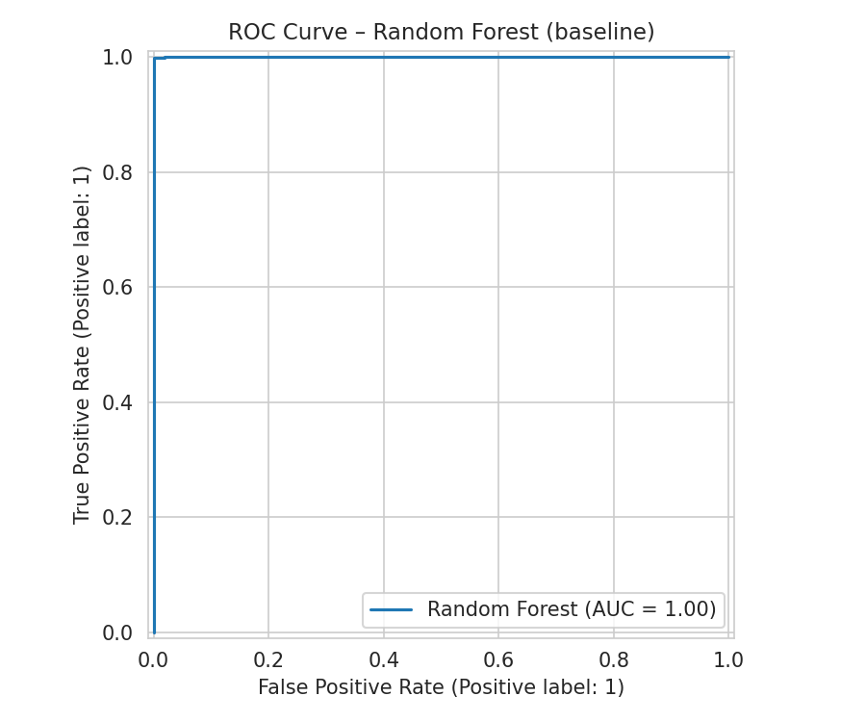  Random Forest | 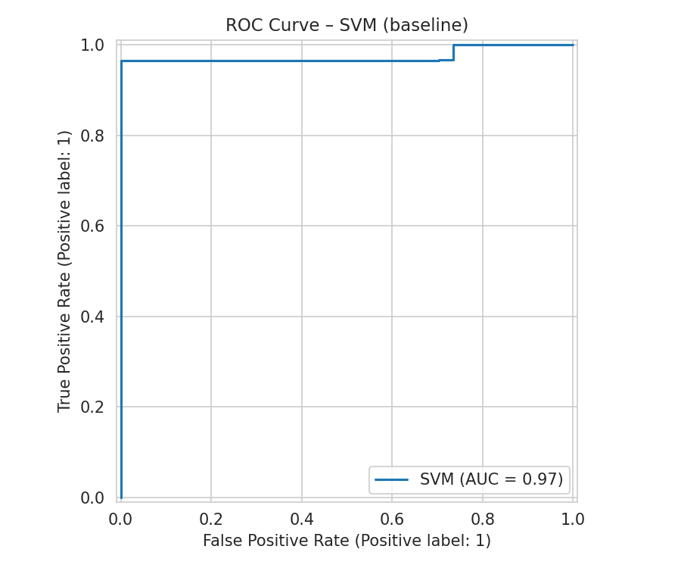  SVM
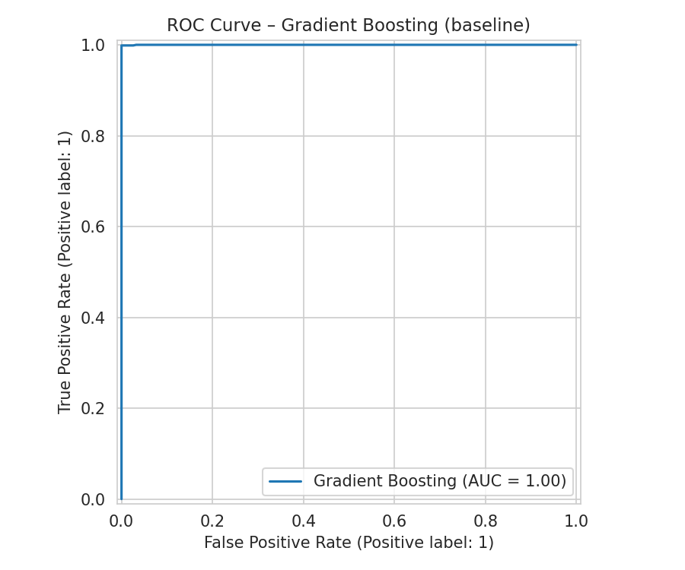  Gradient Boosting | 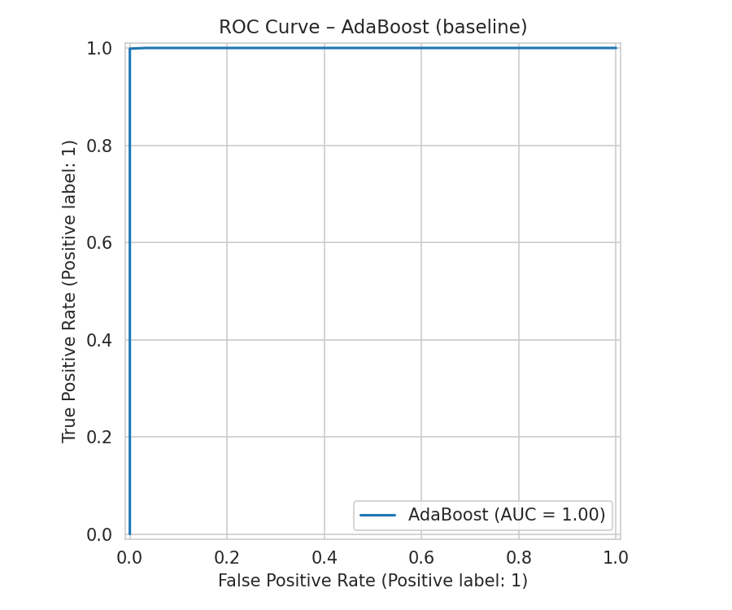  AdaBoost
Figure 8. ROC Curves of All Models Before Fine Tuning

4.1.4 Precision-Recall Curves Before Fine Tuning
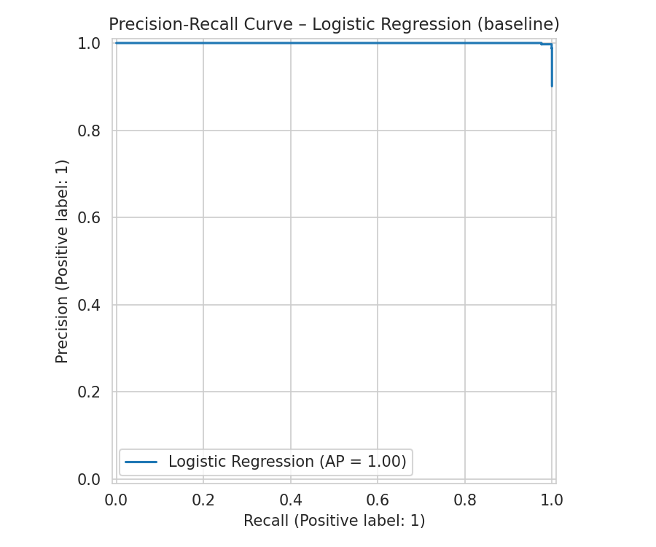  Logistic Regression | 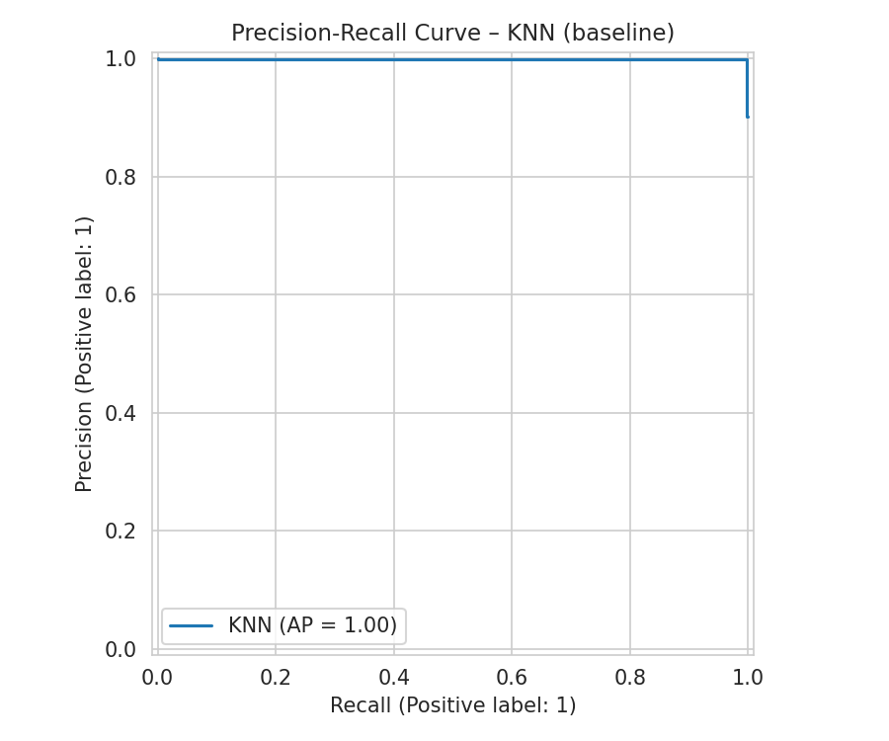  KNN
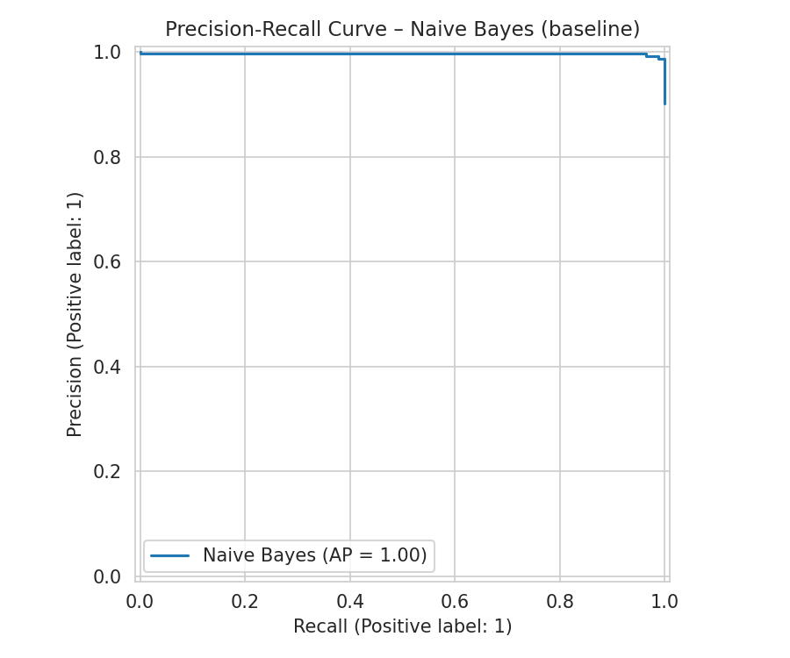  Naive Bayes | 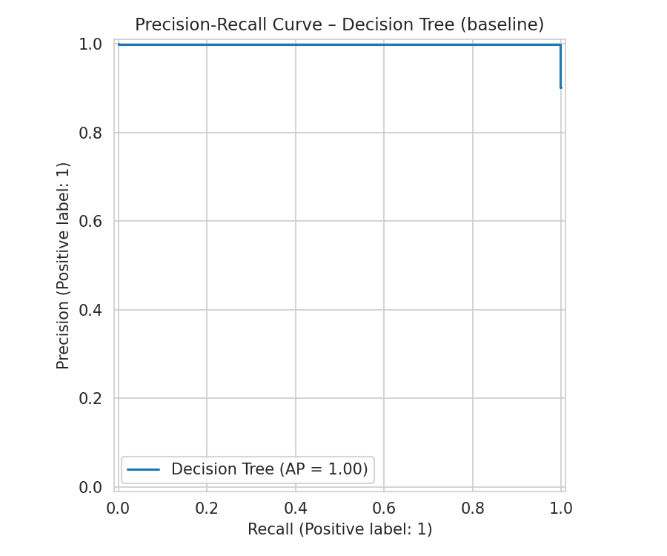  Decision Tree
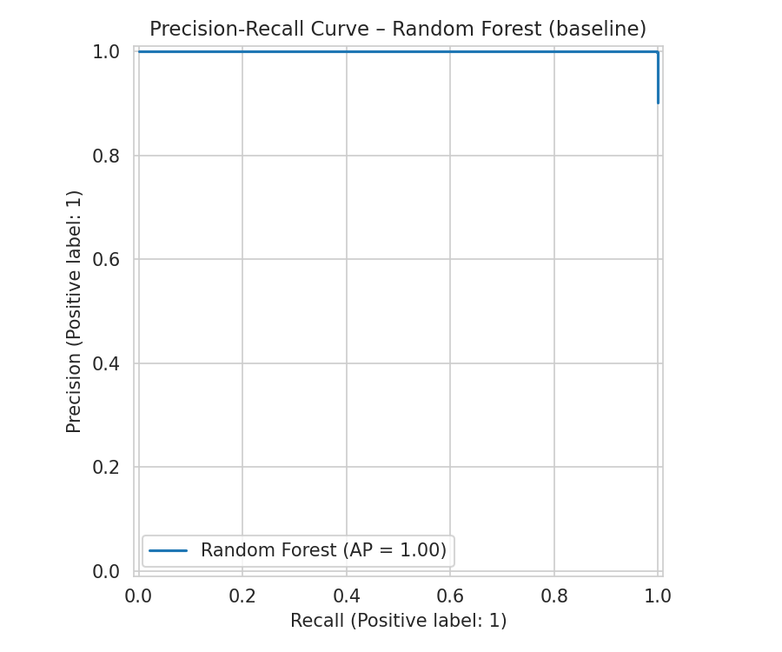  Random Forest | 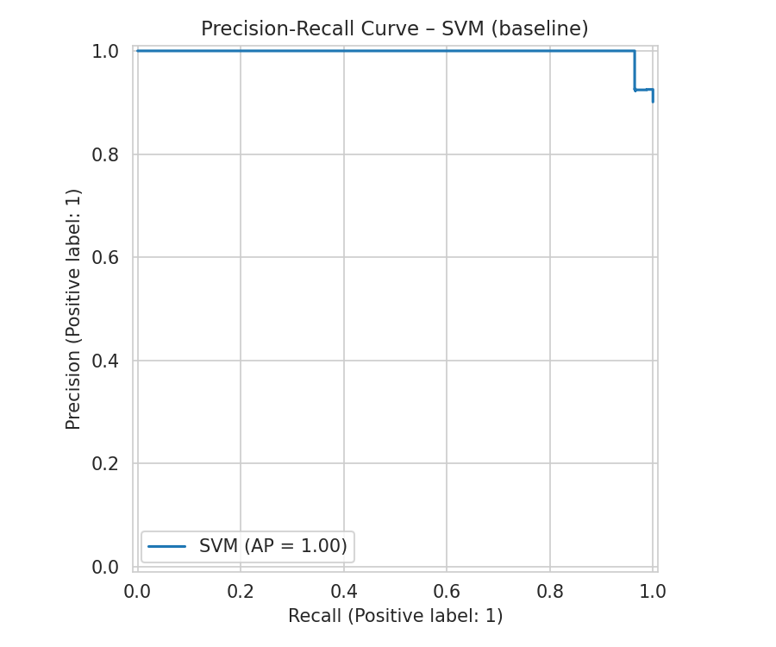  SVM
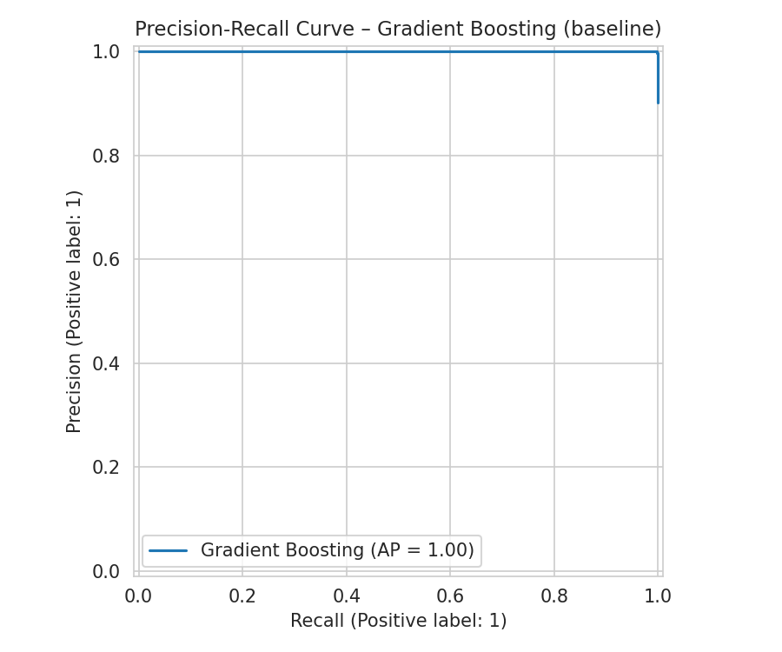  Gradient Boosting | 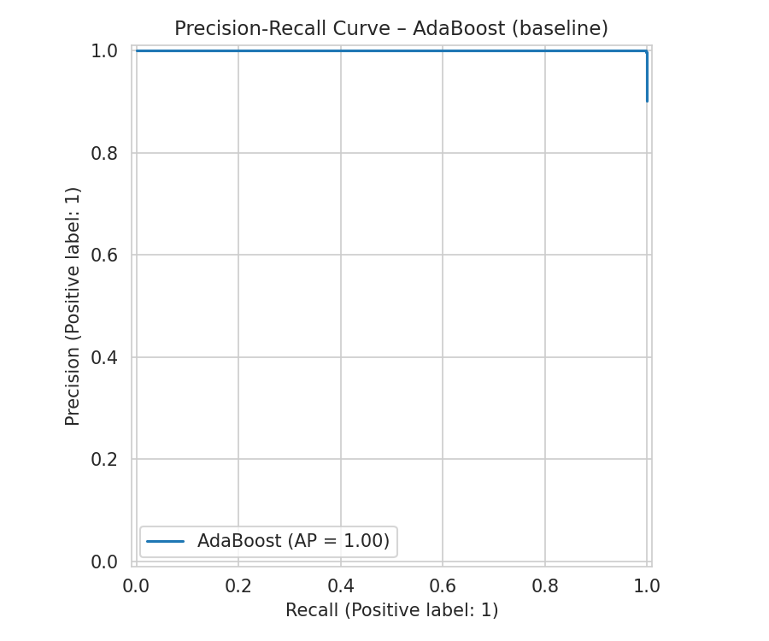  AdaBoost
Figure 9. Precision-Recall Curves of All Models Before Fine Tuning

4.2 Results After Fine Tuning

4.2.1 Complete Performance Results
Model | Accuracy | Precision | Recall | F1-Score | ROC-AUC
Gradient Boosting | 0.999 | 1.000 | 0.999 | 0.999 | 1.000
AdaBoost | 0.999 | 1.000 | 0.999 | 0.999 | 1.000
Random Forest | 0.997 | 0.999 | 0.999 | 0.999 | 1.000
KNN | 0.997 | 0.998 | 0.999 | 0.998 | 0.993
Decision Tree | 0.997 | 0.998 | 0.999 | 0.998 | 0.990
SVM | 0.991 | 0.997 | 0.993 | 0.995 | 1.000
Logistic Regression | 0.978 | 0.999 | 0.977 | 0.988 | 0.999
Naive Bayes | 0.965 | 0.997 | 0.965 | 0.981 | 0.984

4.2.2 Confusion Matrices After Fine Tuning
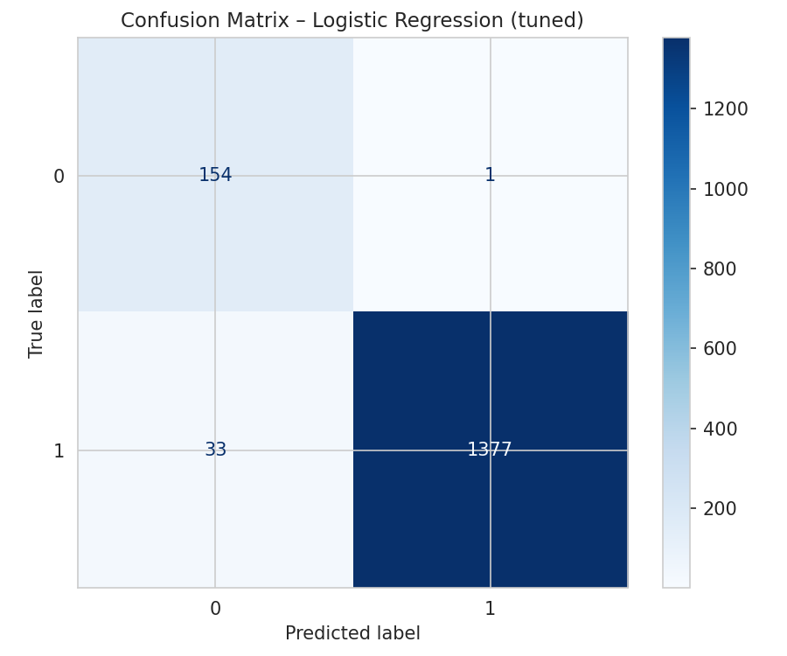  Logistic Regression | 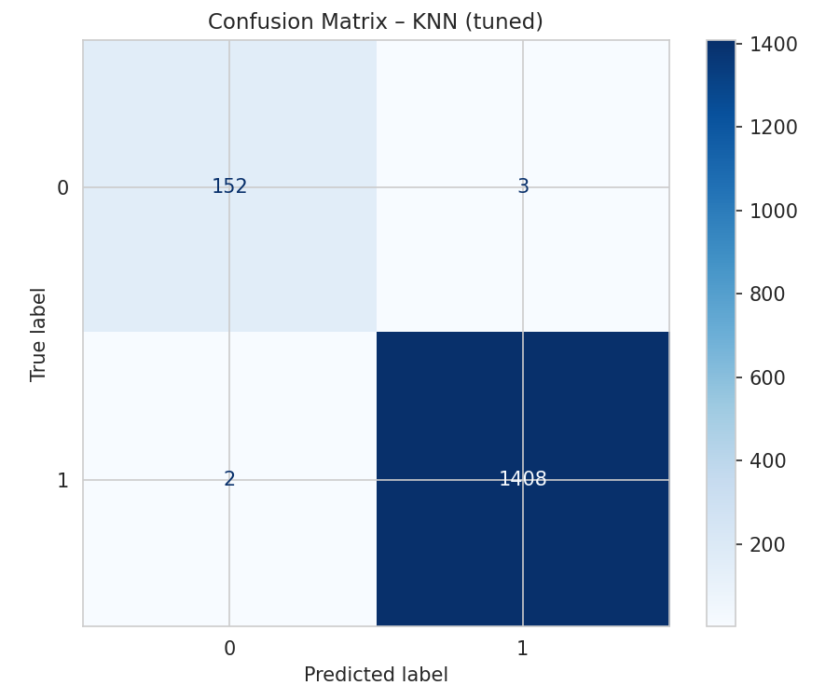  KNN
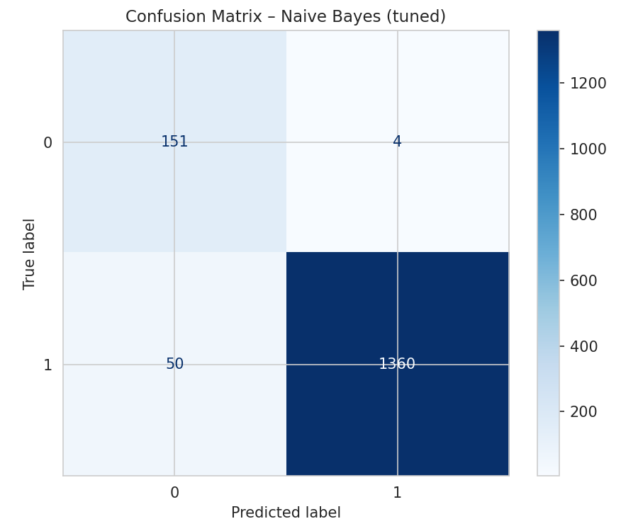  Naive Bayes | 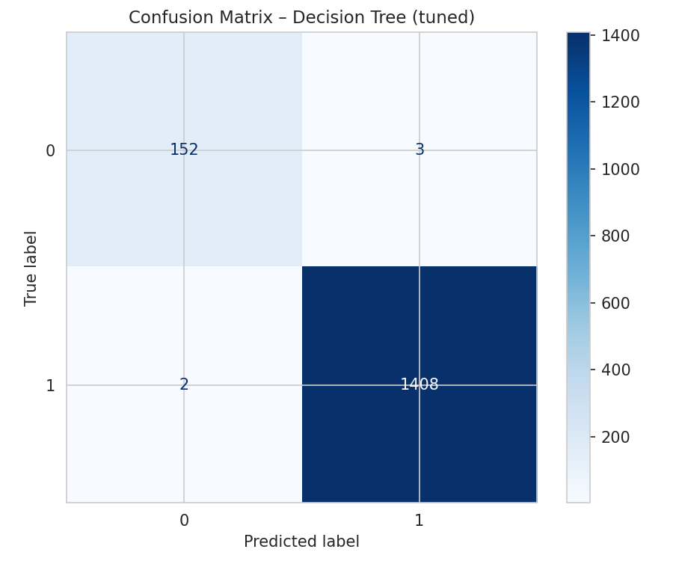  Decision Tree
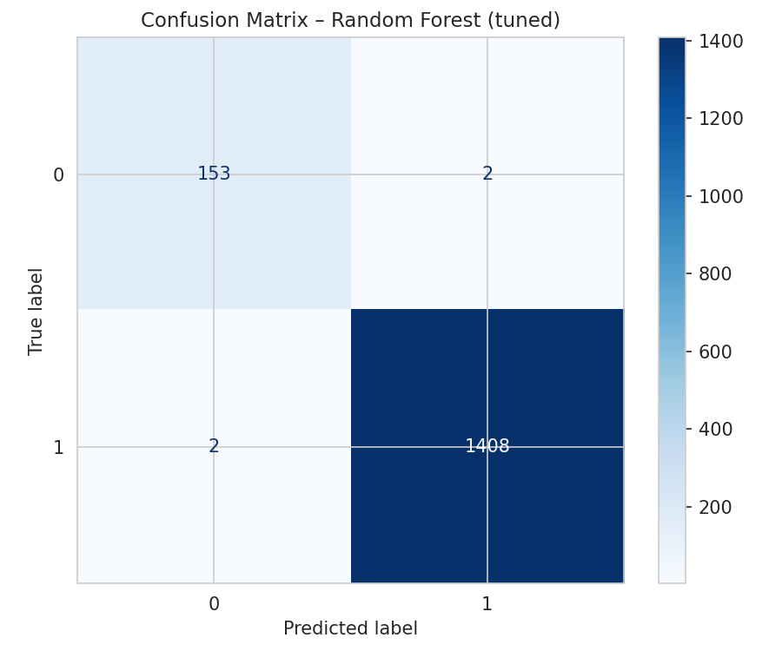  Random Forest | 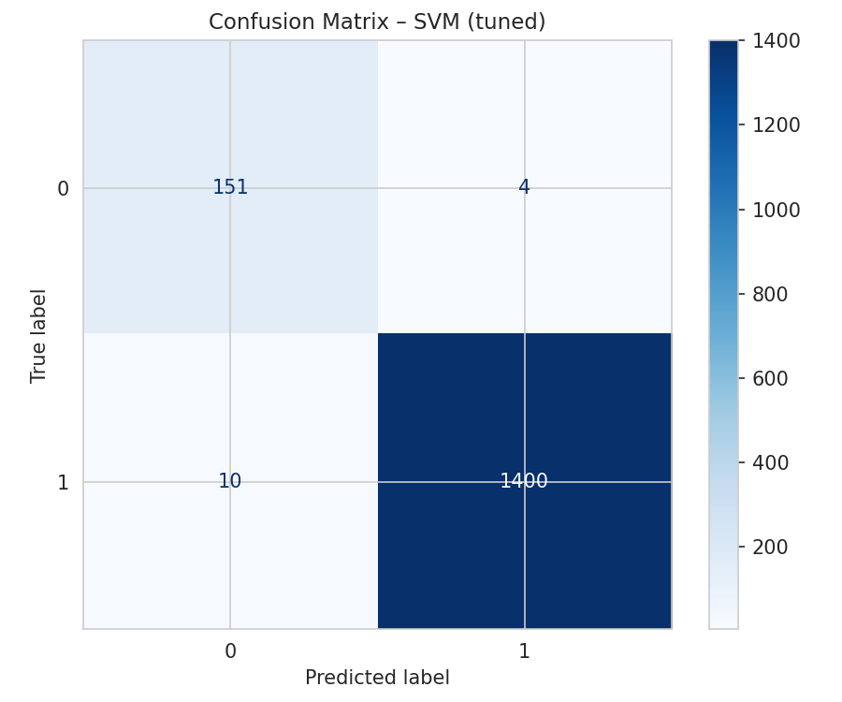  SVM
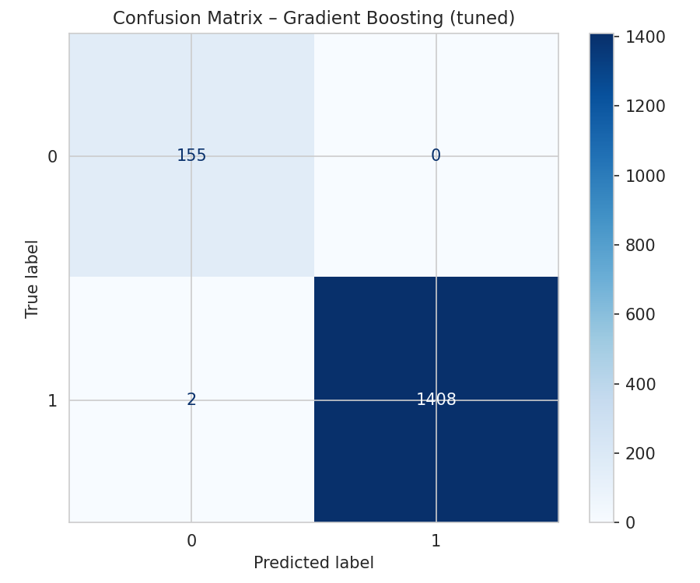  Gradient Boosting | 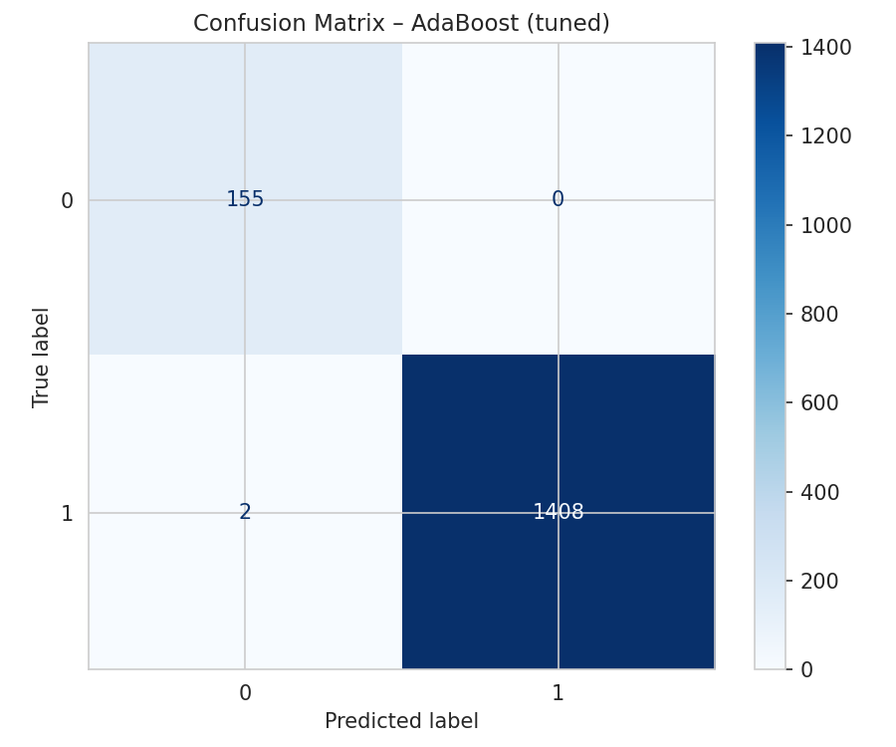  AdaBoost
Figure 10. Confusion Matrices of All Models After Fine Tuning

4.2.3 ROC Curves After Fine Tuning
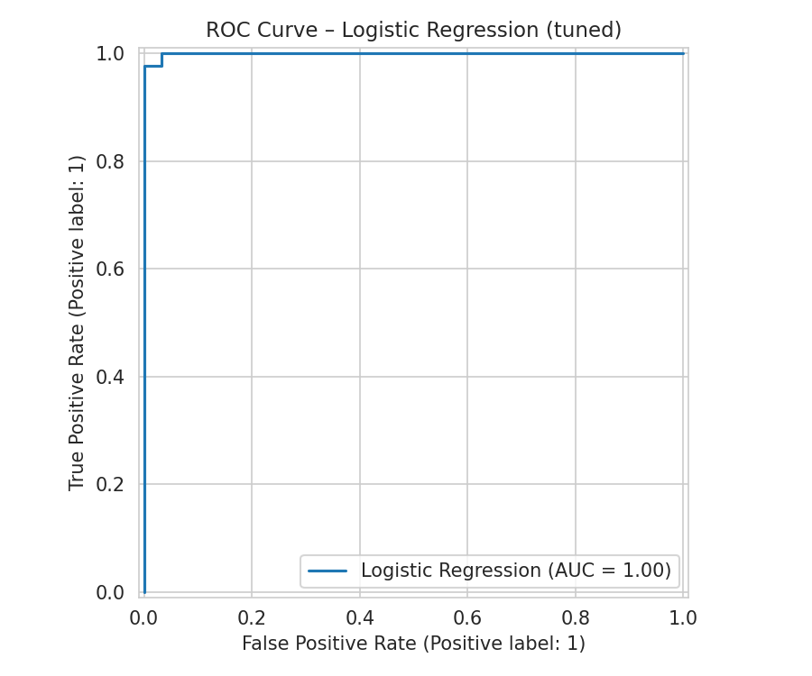  Logistic Regression | 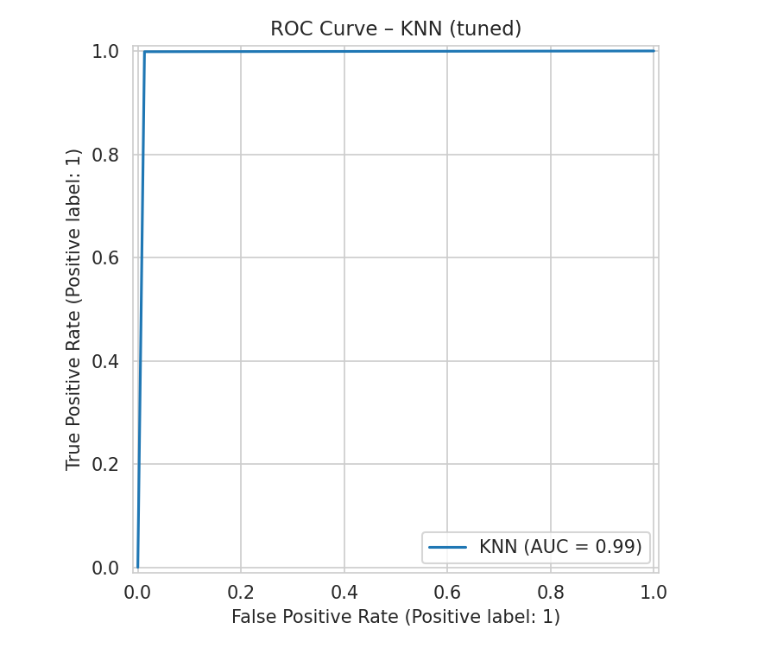  KNN
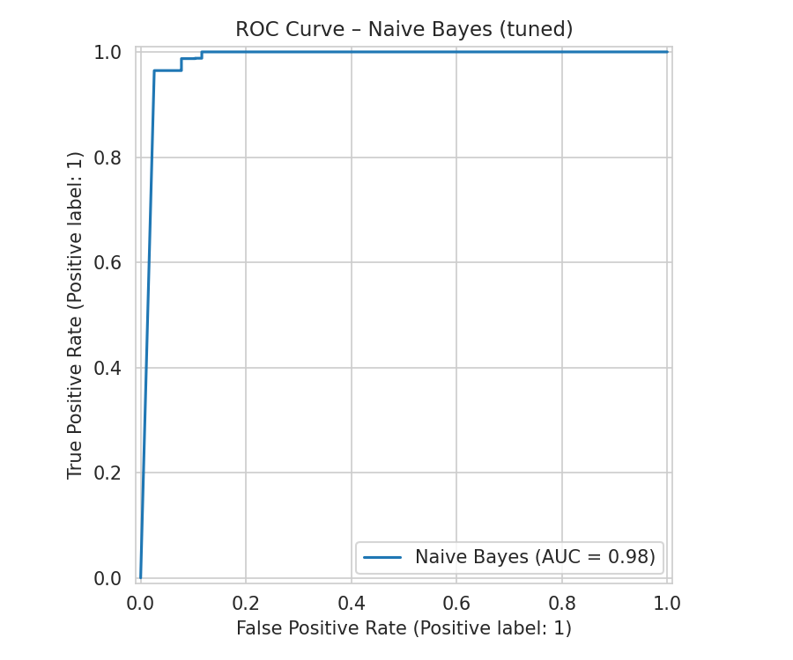  Naive Bayes | 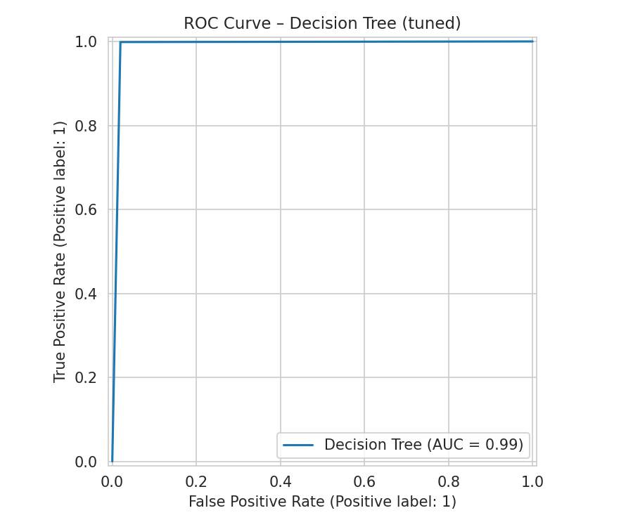  Decision Tree
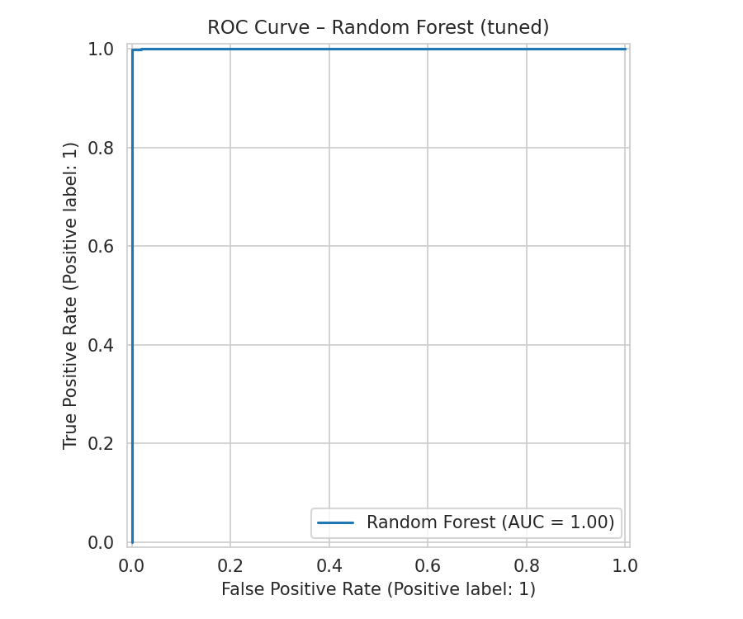  Random Forest | 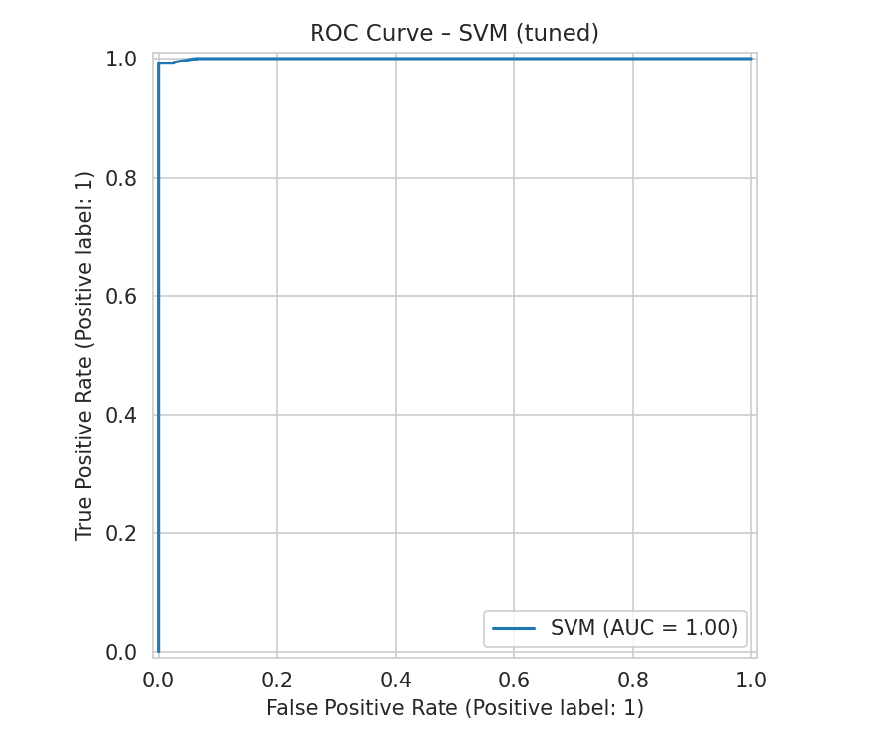  SVM
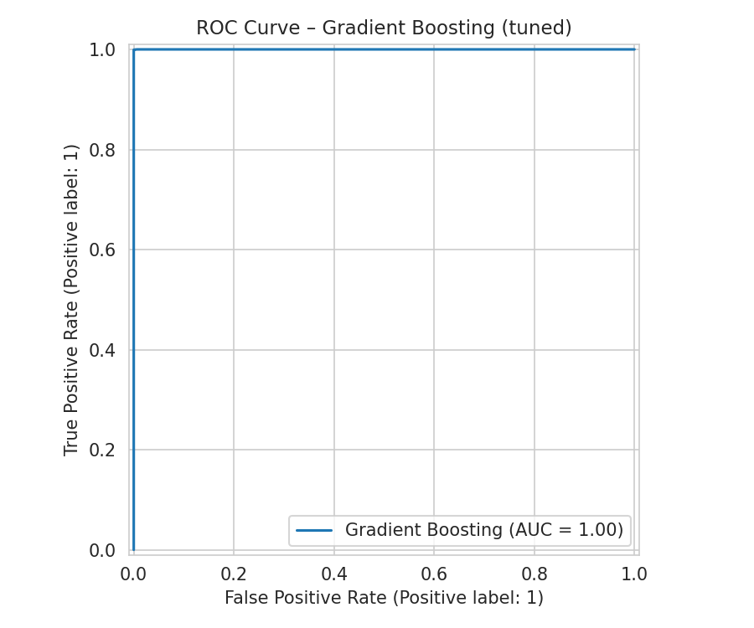  Gradient Boosting | 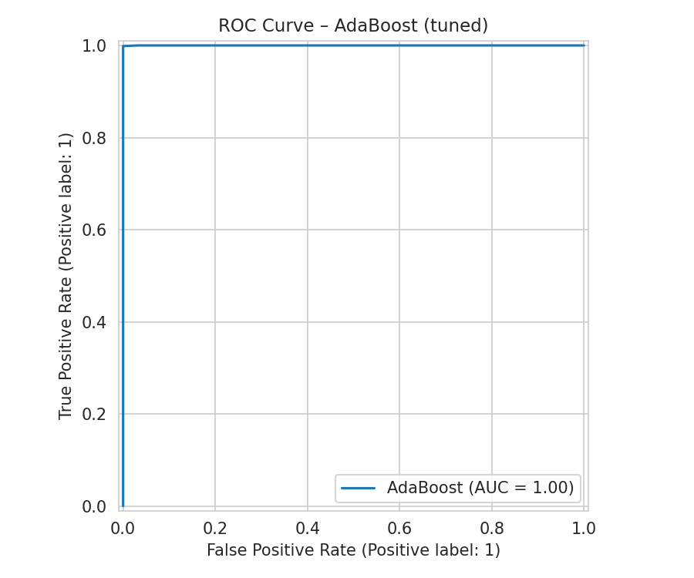  AdaBoost
Figure 11. ROC Curves of All Models After Fine Tuning

4.2.4 Precision-Recall Curves After Fine Tuning
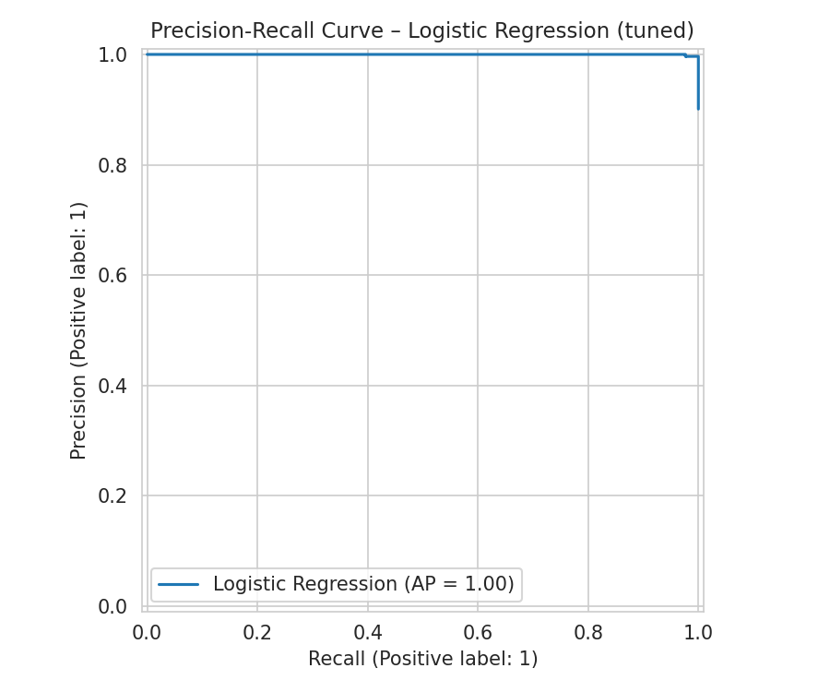  Logistic Regression | 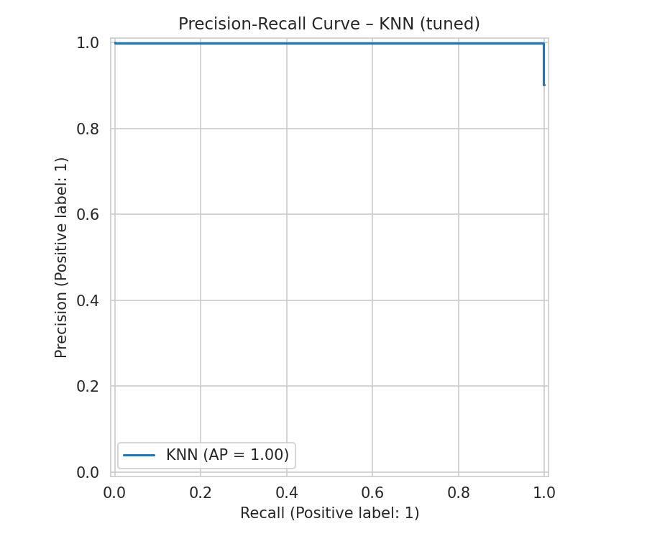  KNN
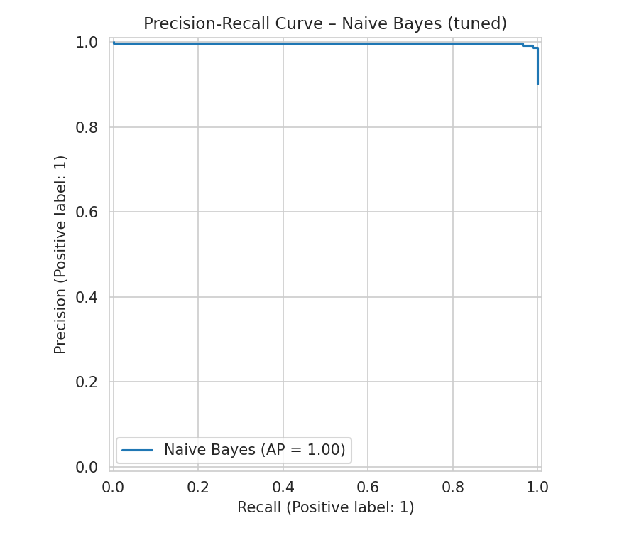  Naive Bayes | 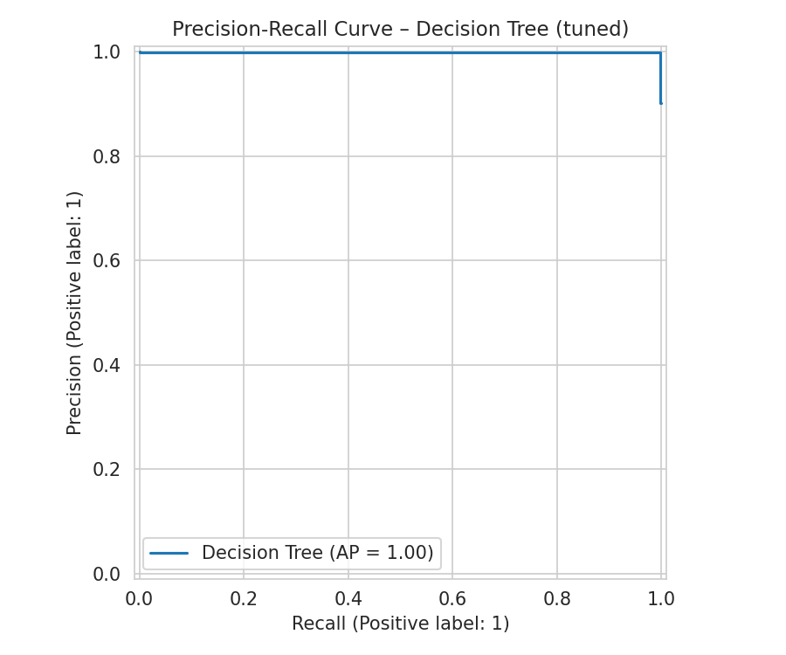  Decision Tree
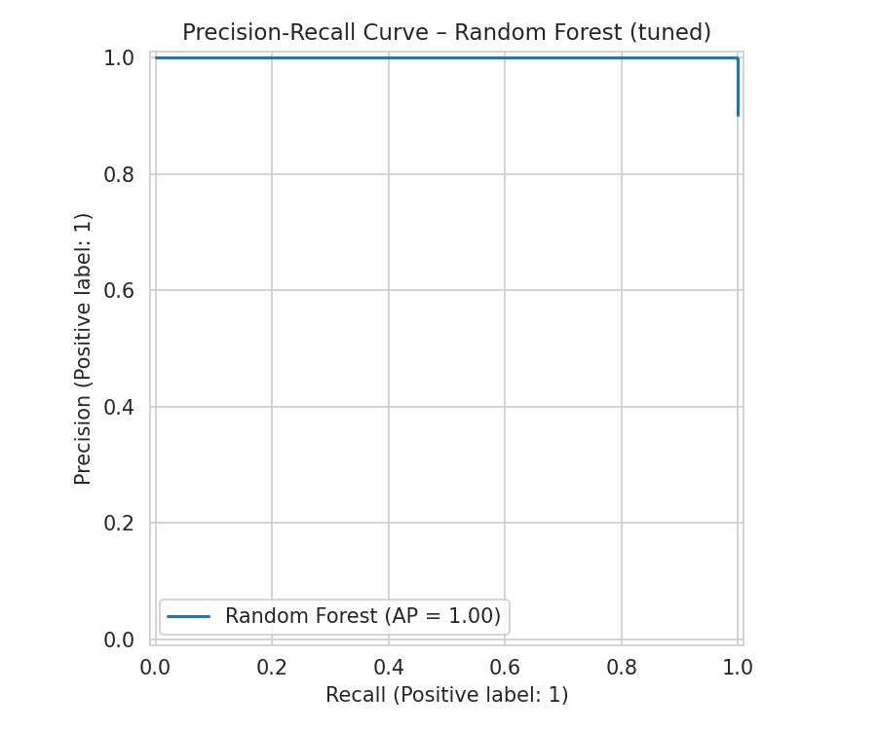  Random Forest | 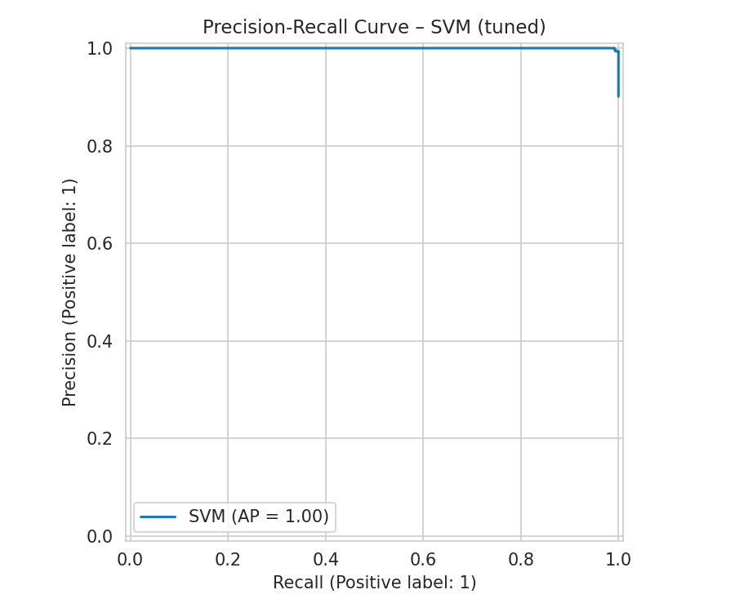  SVM
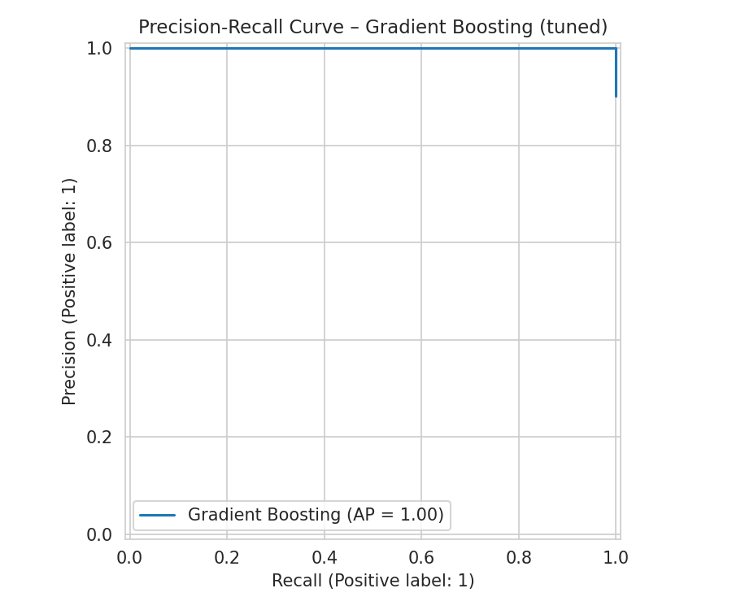  Gradient Boosting | 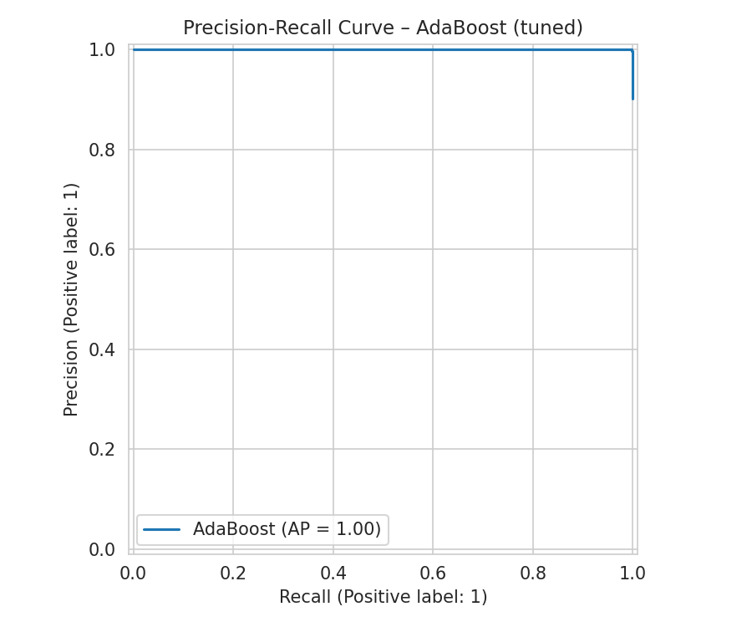  AdaBoost
Figure 12. Precision-Recall Curves of All Models After Fine Tuning

4.3 Best Model Selection
Gradient Boosting and AdaBoost were statistically tied at F1 = 0.999 after tuning; Gradient Boosting was selected as the final deployed model based on a marginally superior ROC-AUC and its generally greater robustness in real-world deployment compared to AdaBoost's known sensitivity to noisy data. No model's tuned version underperformed its baseline in this dataset. This near-perfect performance reflects the dataset's limited diversity (only 23 total capture sessions) and may not fully generalize to novel, previously unseen attack patterns.

PROJECT #3
Heart Disease Prediction

1. Dataset

1.1 Dataset Description
The dataset used for this project is the Heart Failure Prediction Dataset, combining five independent clinical sources (Cleveland, Hungarian, Switzerland, Long Beach VA, and the Statlog Heart dataset) into a single deduplicated dataset of 918 patients.
Each row covers patient demographics, resting vitals, and exercise stress test results.

1.2 Dataset Source
Dataset: Heart Failure Prediction Dataset
Source: Kaggle / UCI Machine Learning Repository, curated by Fede Soriano (Open Database license).
Size: 918 patient records (1,190 raw across 5 sources, 272 duplicates removed by the original curator); 11 original features, expanded to 18 after encoding.

1.3 Basic Dataset Analysis
Target Variable: Heart Disease (0 = Normal, 1 = Heart Disease present).
- The most balanced target of all four project datasets: 508 positive cases (55.3%) vs. 410 negative cases (44.7%).
- Correlations with the target were substantially stronger than in the other project datasets, up to 0.62 (ST_Slope = Flat) and −0.62 (ST_Slope = Up).
- Findings were consistent with established cardiology knowledge: asymptomatic chest pain and a flat ST-segment slope were the strongest positive risk indicators, while an upsloping ST segment and atypical angina were the strongest indicators of a healthy result.
- No duplicate rows were present in the final dataset, as deduplication had already been performed by the original curator across the 5 combined sources.

1.4 Data Quality Issues
- Disguised missing values: 172 patients (18.7%) had Cholesterol recorded as 0, a physiologically impossible value, and 1 patient had RestingBP recorded as 0. These were not flagged by standard null-checks, since they were encoded as valid-looking zeros rather than NaN.
- 5 categorical columns (Sex, ChestPainType, RestingECG, ExerciseAngina, ST_Slope) required encoding before modeling.

2. Preprocessing
The preprocessing pipeline centered on identifying disguised missing values that standard checks would miss, and correctly encoding the dataset's several categorical clinical fields.

2.1 Disguised Missing Value Correction
Identified and converted Cholesterol = 0 and RestingBP = 0 to proper NaN values, then applied median imputation — a two-step process, since these values would not have been caught by a standard missing-value check.

2.2 Duplicate Check
Verified no duplicate rows were present; no rows were removed at this stage.

2.3 Binary Encoding
Applied Label Encoding to Sex and ExerciseAngina (2 categories each, no natural order).

2.4 Multi-Category Encoding
Applied One-Hot Encoding to ChestPainType, RestingECG, and ST_Slope (3–4 categories each, no natural order).

2.5 Feature Scaling
Applied RobustScaler to all numeric features.

2.6 Train-Test Split
Performed an 80/20 stratified train-test split (734 / 184 records), preserving the 55.3%/44.7% class ratio.

3. Machine Learning Methods

3.1 Model Selection Criteria
The same 8 algorithms were applied consistently across all four datasets, deliberately spanning five distinct model families — linear, distance-based, probabilistic, tree-based, and two ensemble strategies (bagging and boosting). Rather than testing minor variations of a single approach, the goal was to compare genuinely different learning strategies against the same data, so that performance differences could be attributed to how each algorithm's structural assumptions matched the underlying data.
Selection was also guided by dataset scale. All four datasets contain between roughly 900 and 24,000 rows with a modest number of features — a size range where classical machine learning algorithms are appropriate and computationally efficient. Deep learning approaches were not used, as they typically require substantially larger datasets to outperform classical methods and offer reduced interpretability, which was not justified at this data scale.

3.2 Selected Machine Learning Models
The following 8 algorithms were trained and evaluated:
- Logistic Regression (Linear)
- K-Nearest Neighbours (KNN) (Distance-based)
- Naive Bayes (Gaussian) (Probabilistic)
- Decision Tree (Tree-based)
- Random Forest (Ensemble (Bagging))
- Support Vector Machine (SVM) (Margin-based)
- Gradient Boosting (Ensemble (Boosting))
- AdaBoost (Ensemble (Boosting))

3.3 Logistic Regression
Family: Linear. Models the probability of the positive class using a weighted linear combination of features passed through a sigmoid function. Fast and highly interpretable; limited to linear decision boundaries.

3.4 K-Nearest Neighbours (KNN)
Family: Distance-based. Classifies a new sample by majority vote among its K nearest training samples, measured by feature distance. Requires no explicit training phase, but is sensitive to feature scaling, which is why scaling was applied before training.

3.5 Naive Bayes (Gaussian)
Family: Probabilistic. Applies Bayes' theorem assuming conditional independence between features given the class label. Extremely fast to train; accuracy degrades when features are correlated, which is common in real clinical and behavioural data.

3.6 Decision Tree
Family: Tree-based. Recursively splits data on the feature/threshold that best separates classes at each node, forming a flowchart-like structure. Highly interpretable but prone to overfitting when depth is unconstrained.

3.7 Random Forest
Family: Ensemble (Bagging). Trains many decision trees on random subsets of data and features, then aggregates their votes. Reduces the overfitting risk of a single tree and is generally robust across varied data structures.

3.8 Support Vector Machine (SVM)
Family: Margin-based. Finds the decision boundary that maximizes the margin between classes; the RBF kernel allows non-linear class separation.

3.9 Gradient Boosting
Family: Ensemble (Boosting). Builds trees sequentially, with each new tree trained to correct the residual errors of the previous ensemble. Often achieves top-tier accuracy but requires careful tuning to avoid overfitting.

3.10 AdaBoost
Family: Ensemble (Boosting). Builds trees sequentially, increasing the weight of misclassified samples so subsequent trees focus on hard cases. Has no native class-weighting mechanism, which limits performance on severely imbalanced data.

4. Results
Because the target class is nearly balanced in this dataset, Accuracy is a reasonably trustworthy metric here, unlike the project's other three datasets, though F1-Score was still used as the primary selection criterion for consistency across the project.

4.1 Results Before Fine Tuning

4.1.1 Complete Performance Results
Model | Accuracy | Precision | Recall | F1-Score | ROC-AUC
Random Forest | 0.891 | 0.894 | 0.912 | 0.903 | 0.928
SVM | 0.886 | 0.909 | 0.882 | 0.896 | 0.937
AdaBoost | 0.886 | 0.909 | 0.882 | 0.896 | 0.922
Gradient Boosting | 0.880 | 0.892 | 0.892 | 0.892 | 0.919
Logistic Regression | 0.875 | 0.899 | 0.873 | 0.886 | 0.932
KNN | 0.870 | 0.882 | 0.882 | 0.882 | 0.926
Naive Bayes | 0.859 | 0.880 | 0.863 | 0.871 | 0.900
Decision Tree | 0.788 | 0.812 | 0.804 | 0.808 | 0.786

4.1.2 Confusion Matrices Before Fine Tuning
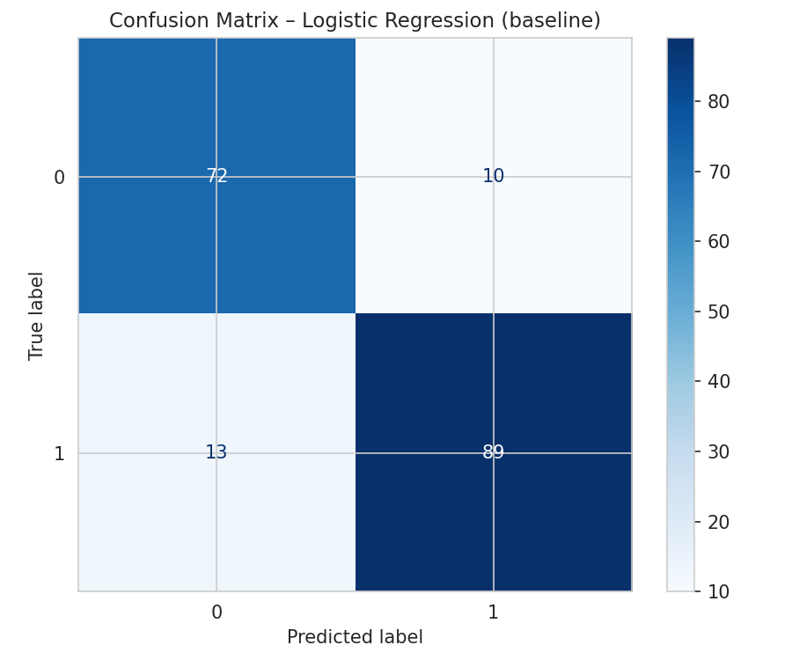  Logistic Regression | 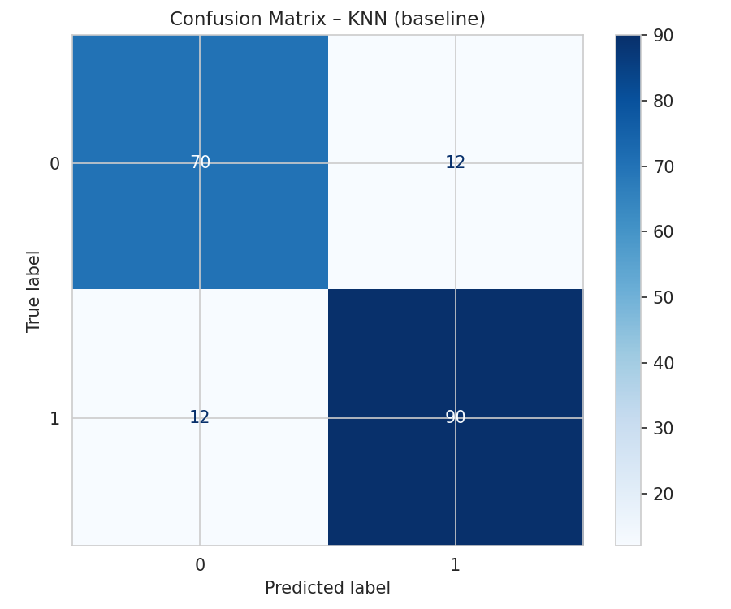  KNN
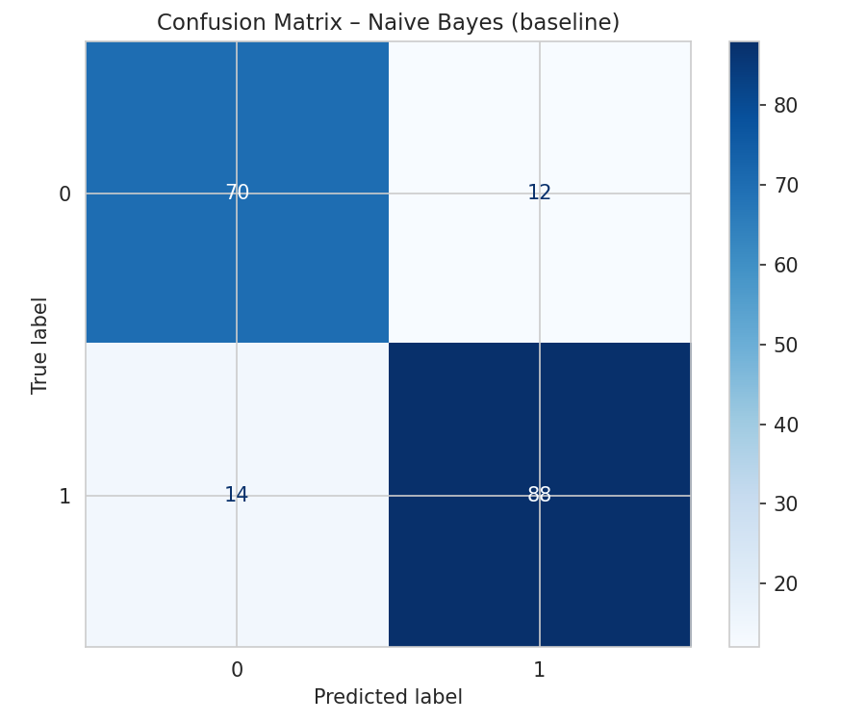  Naive Bayes | 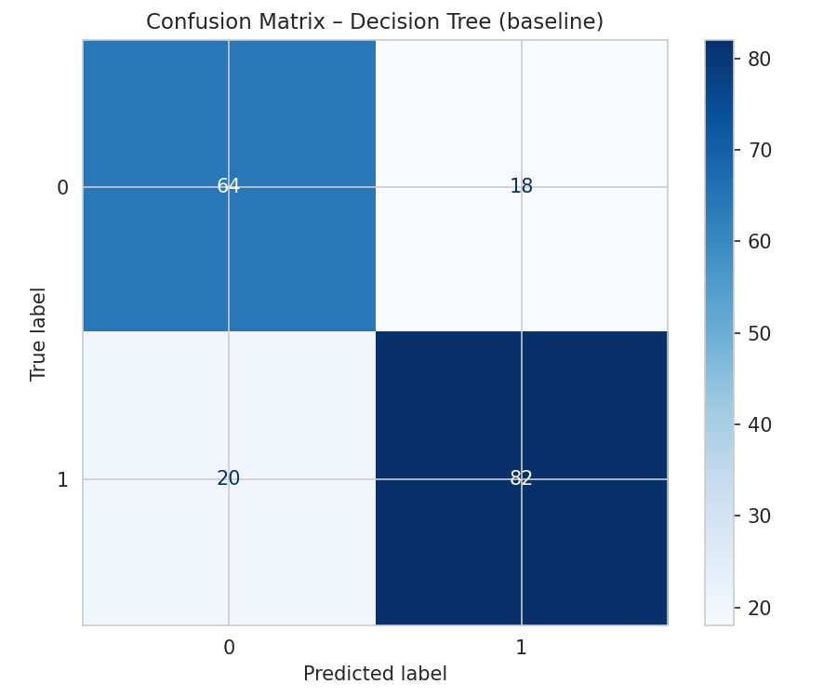  Decision Tree
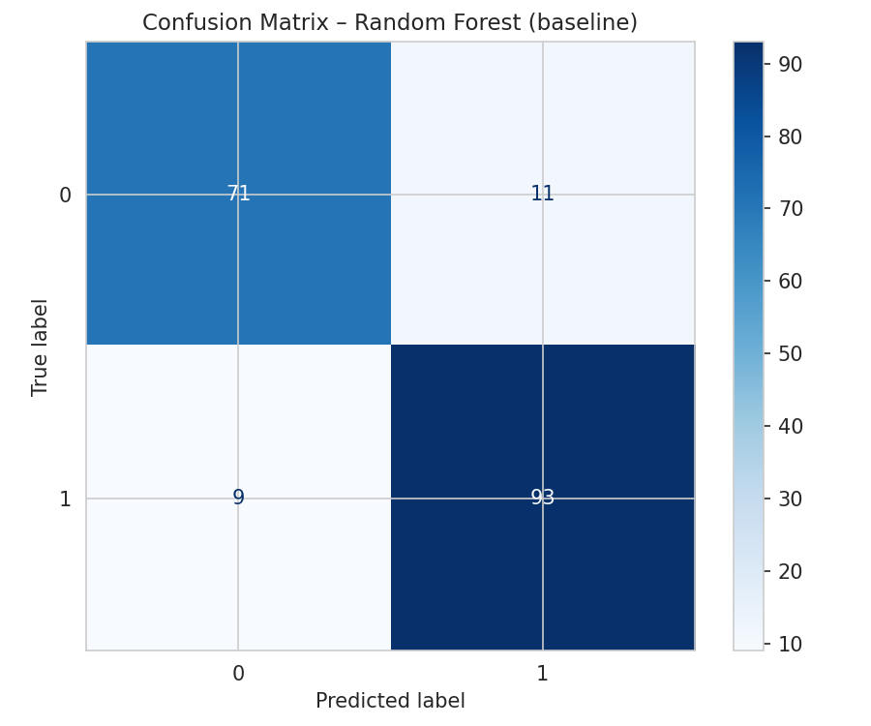  Random Forest | 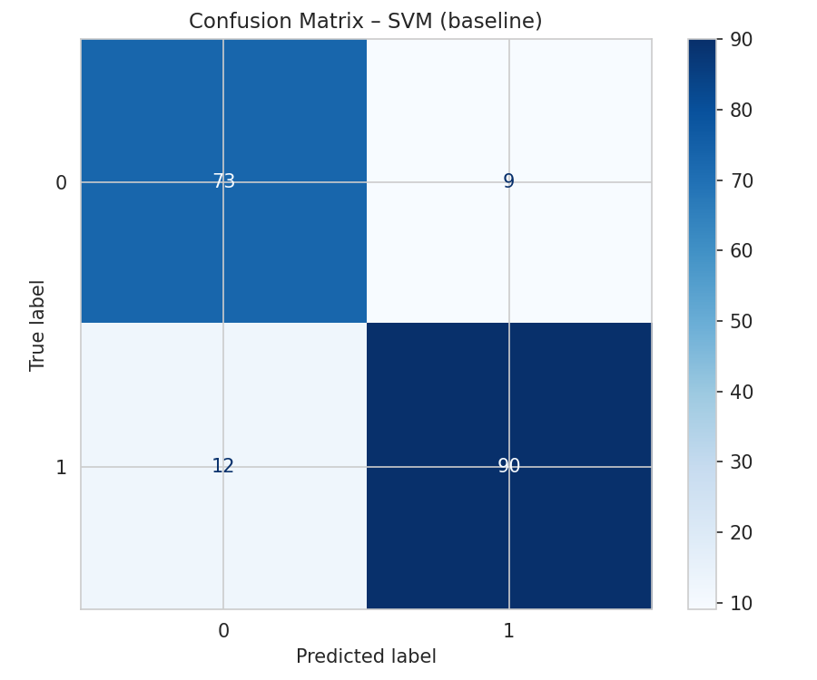  SVM
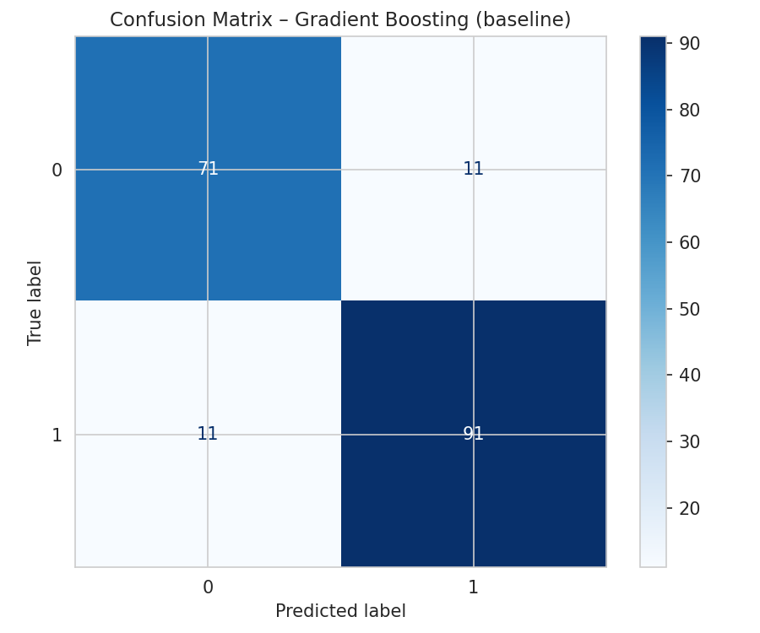  Gradient Boosting | 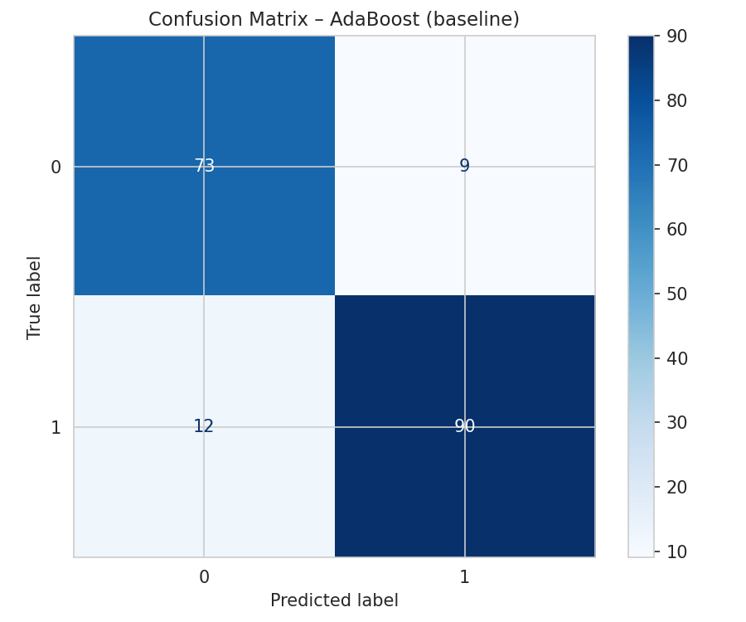  AdaBoost
Figure 13. Confusion Matrices of All Models Before Fine Tuning

4.1.3 ROC Curves Before Fine Tuning
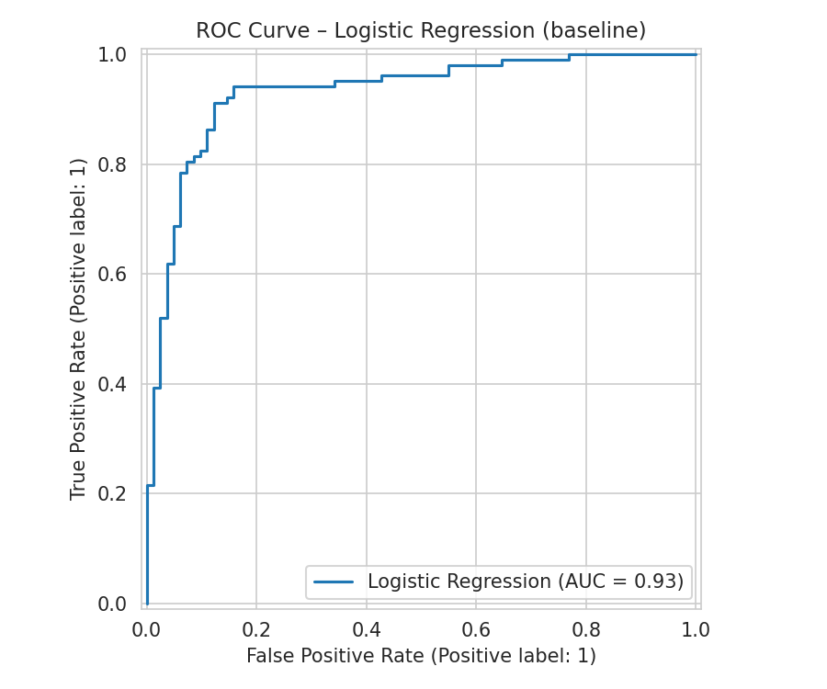  Logistic Regression | 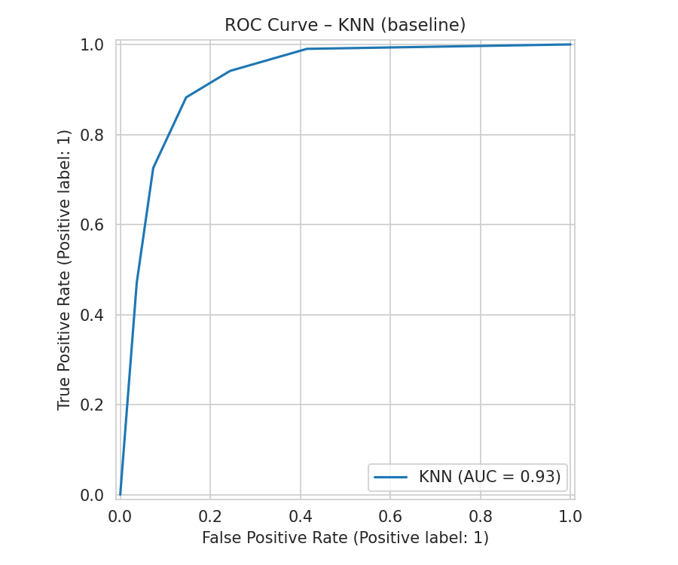  KNN
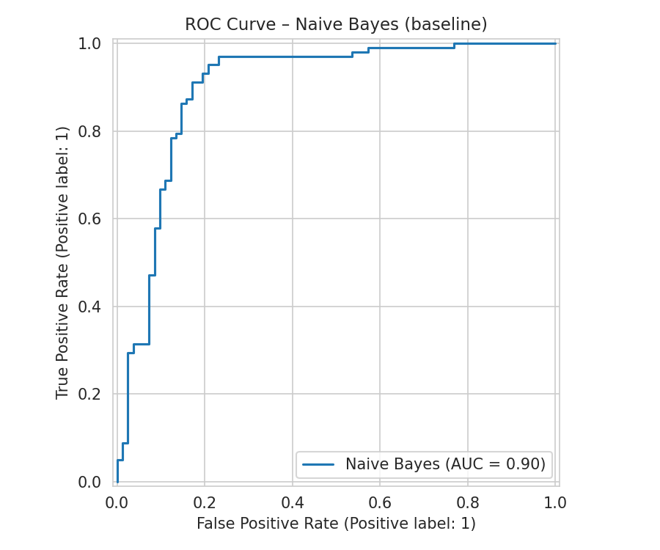  Naive Bayes | 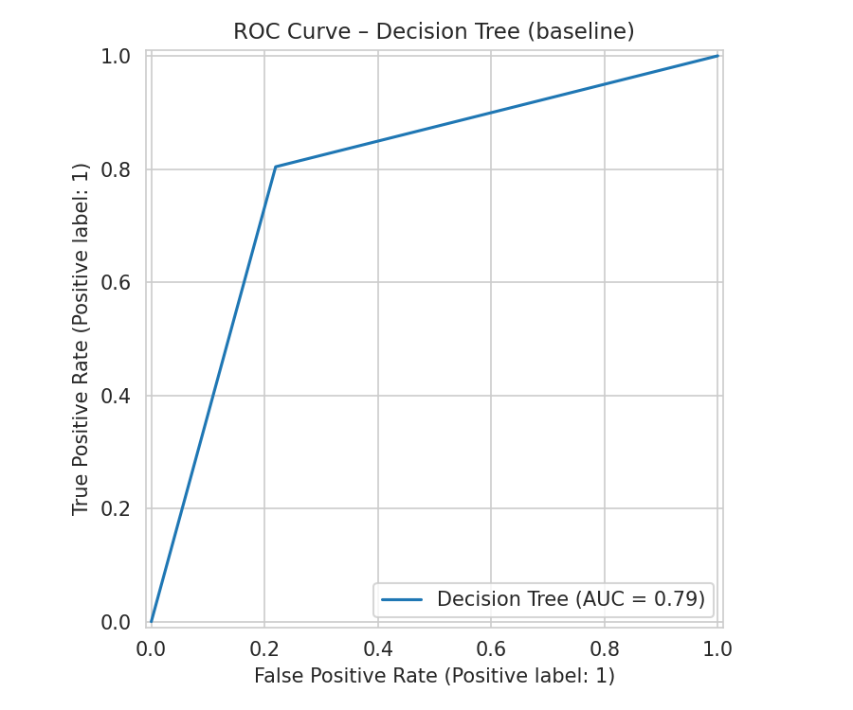  Decision Tree
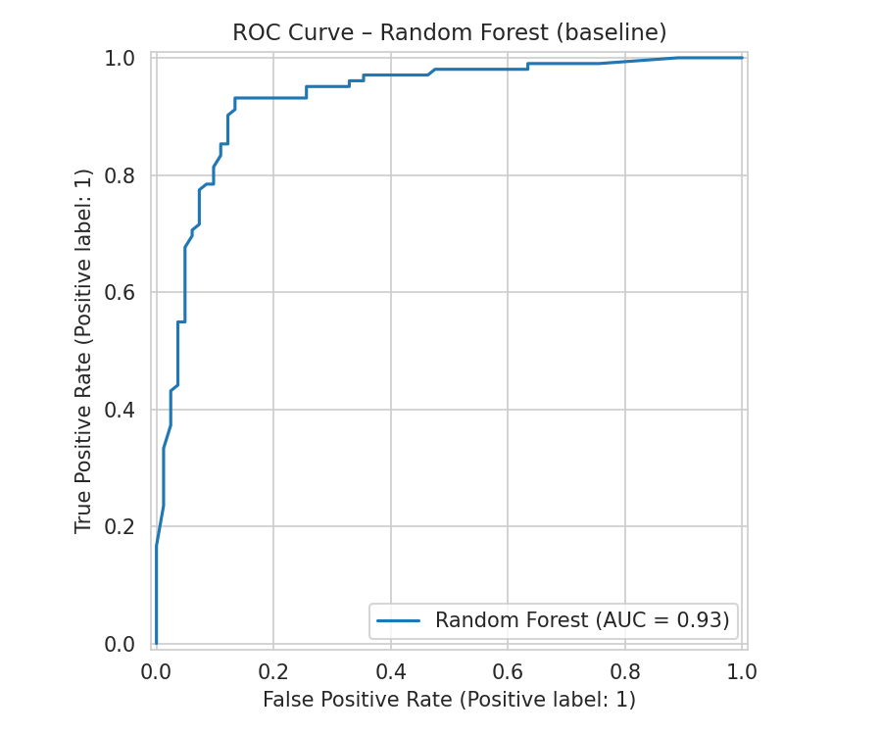  Random Forest | 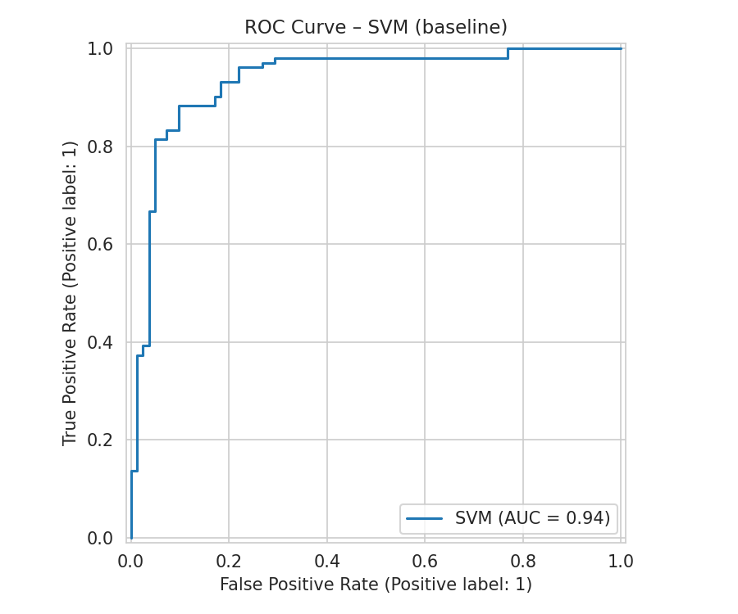  SVM
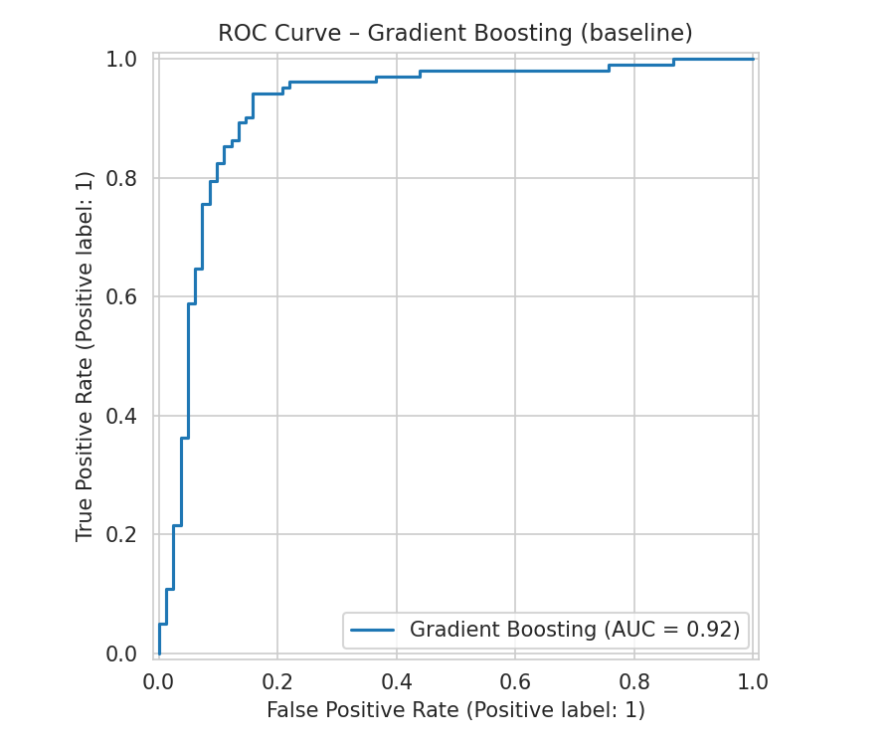  Gradient Boosting | 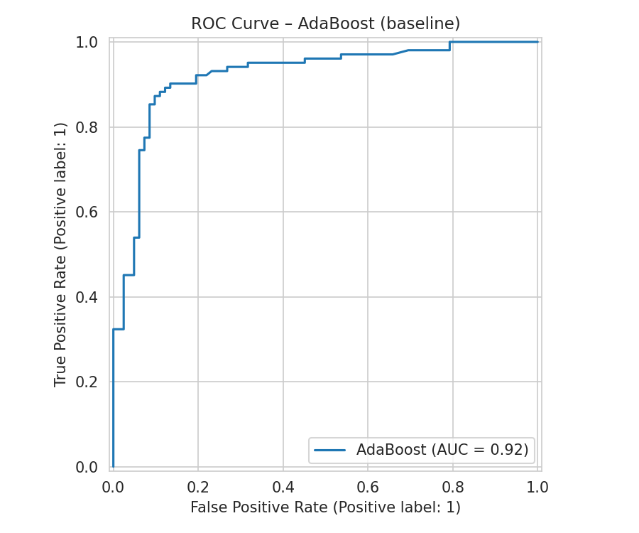  AdaBoost
Figure 14. ROC Curves of All Models Before Fine Tuning

4.1.4 Precision-Recall Curves Before Fine Tuning
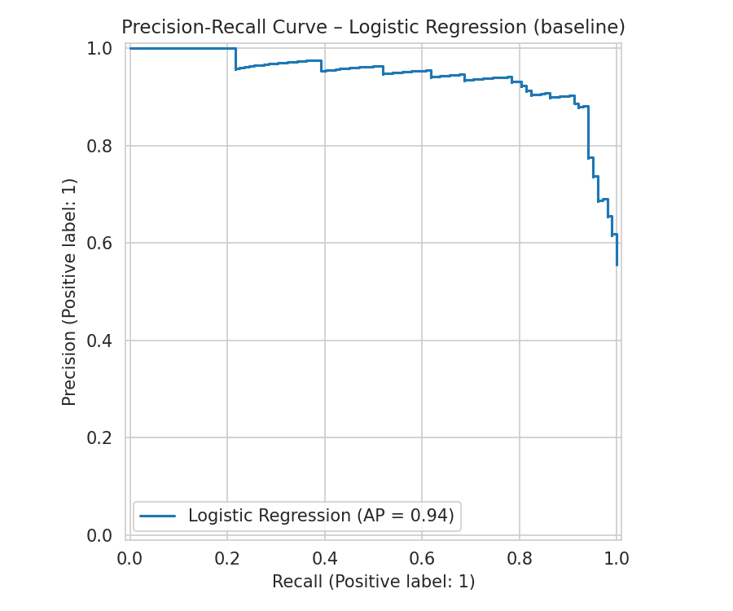  Logistic Regression | 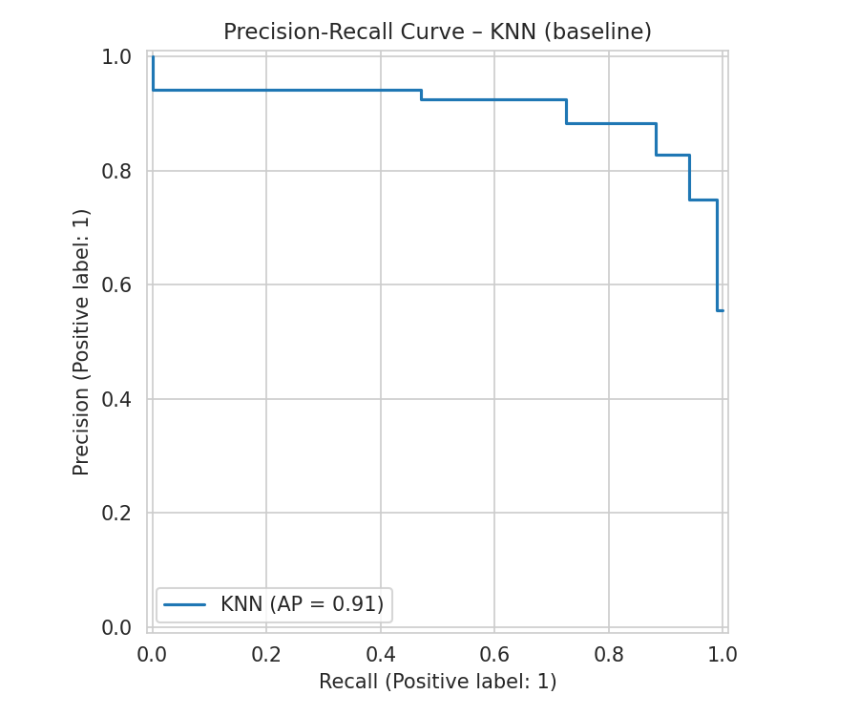  KNN
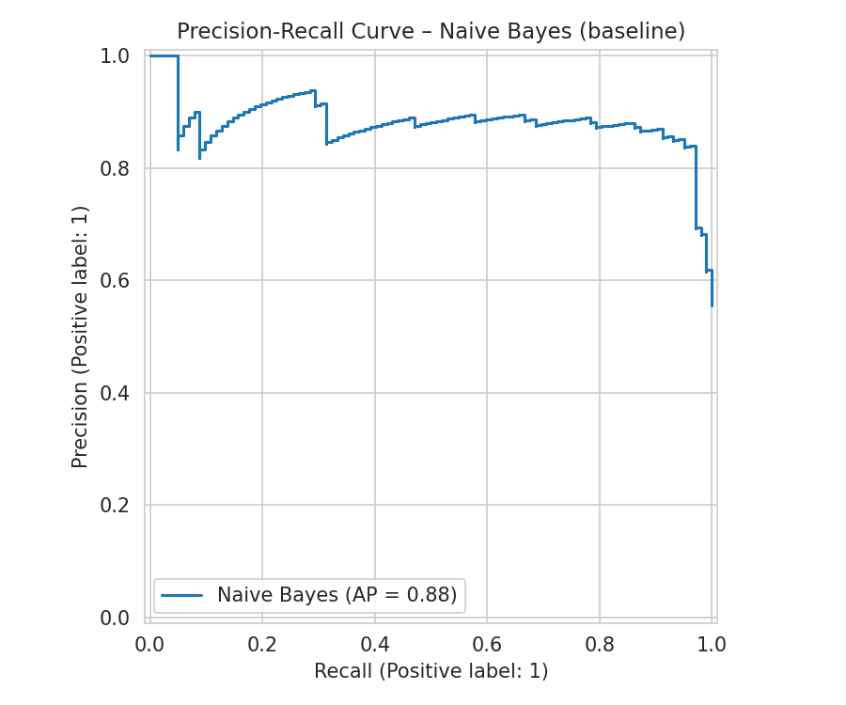  Naive Bayes | 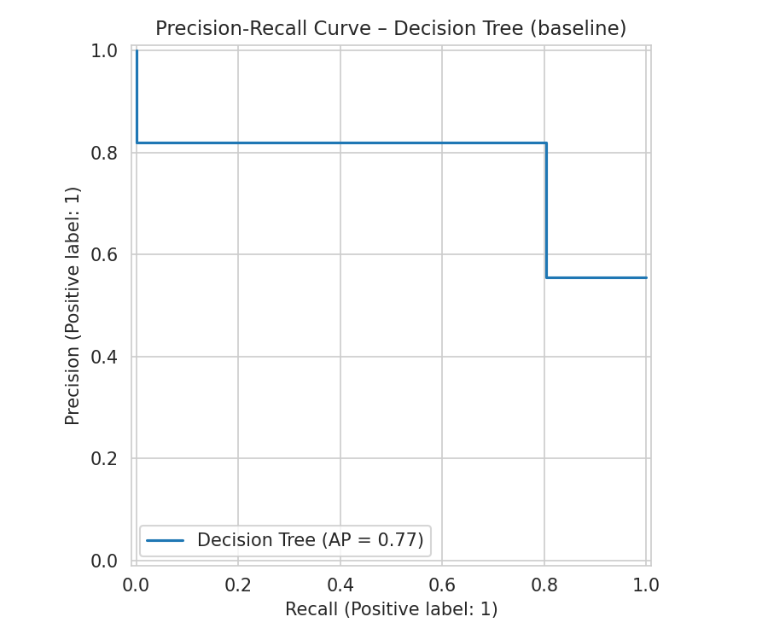  Decision Tree
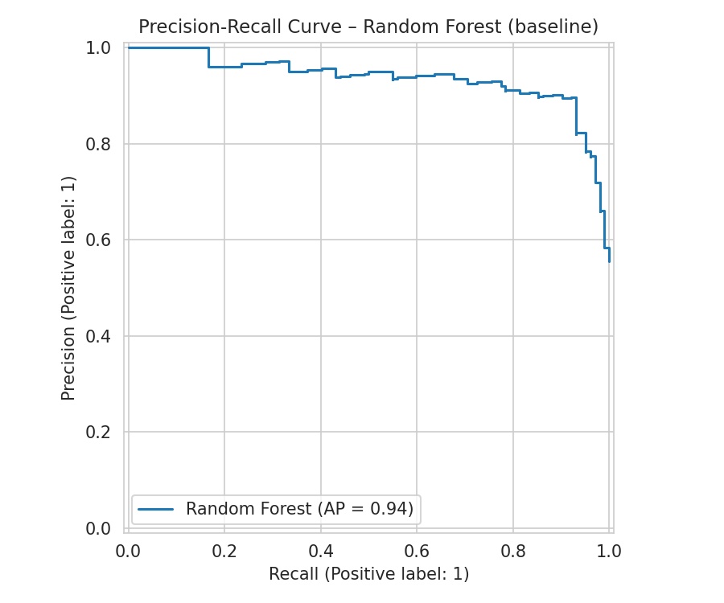  Random Forest | 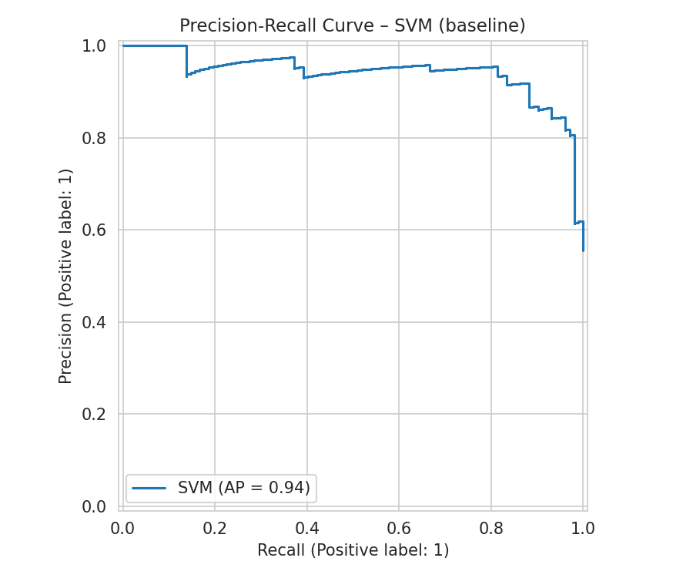  SVM
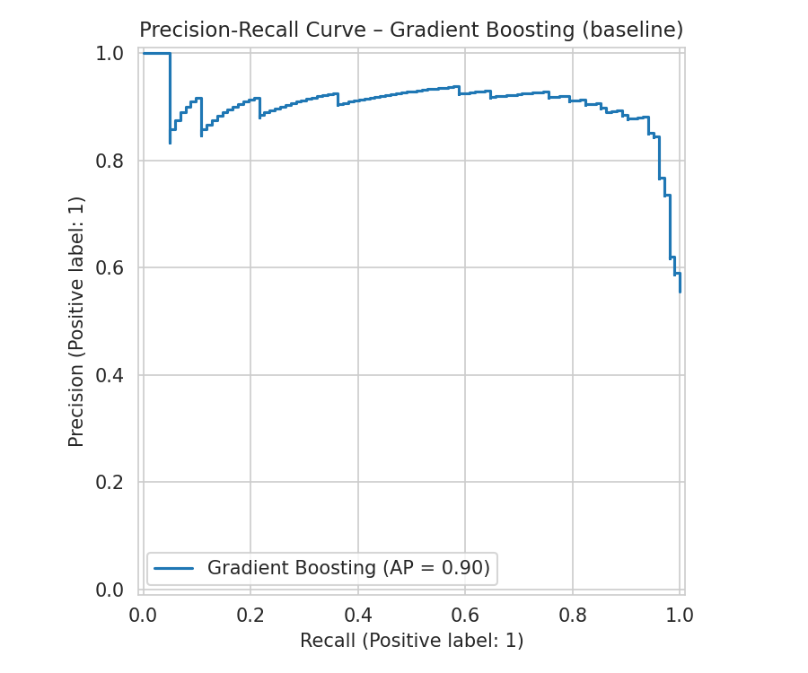  Gradient Boosting | 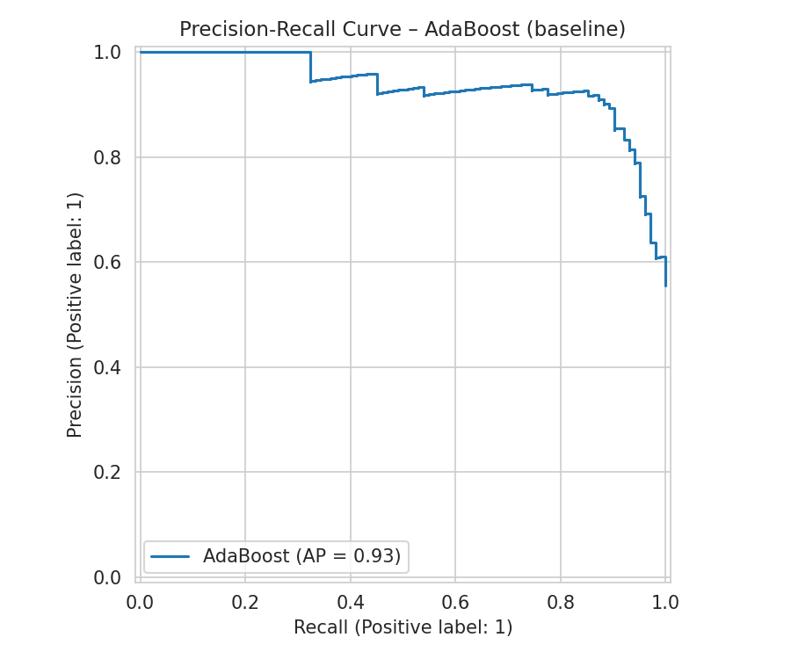  AdaBoost
Figure 15. Precision-Recall Curves of All Models Before Fine Tuning

4.2 Results After Fine Tuning

4.2.1 Complete Performance Results
Model | Accuracy | Precision | Recall | F1-Score | ROC-AUC
AdaBoost | 0.891 | 0.902 | 0.902 | 0.902 | 0.927
SVM | 0.886 | 0.909 | 0.882 | 0.896 | 0.937
Logistic Regression | 0.886 | 0.918 | 0.873 | 0.894 | 0.931
Gradient Boosting | 0.880 | 0.892 | 0.892 | 0.892 | 0.919
Random Forest | 0.875 | 0.876 | 0.902 | 0.889 | 0.929
KNN | 0.875 | 0.899 | 0.873 | 0.886 | 0.932
Naive Bayes | 0.859 | 0.880 | 0.863 | 0.871 | 0.900
Decision Tree | 0.832 | 0.874 | 0.814 | 0.843 | 0.899

4.2.2 Confusion Matrices After Fine Tuning
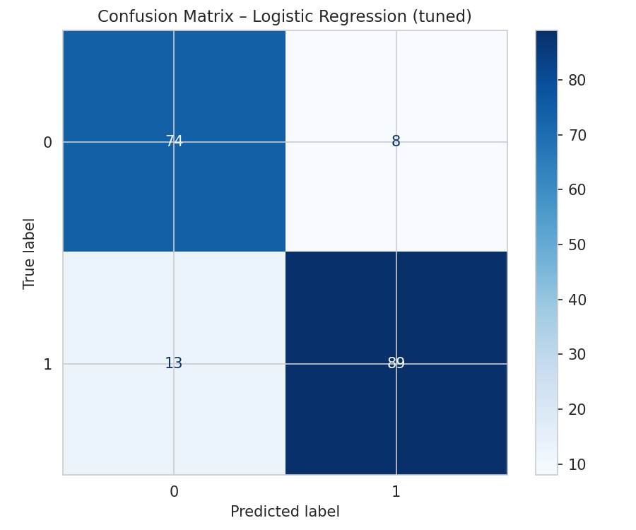  Logistic Regression | 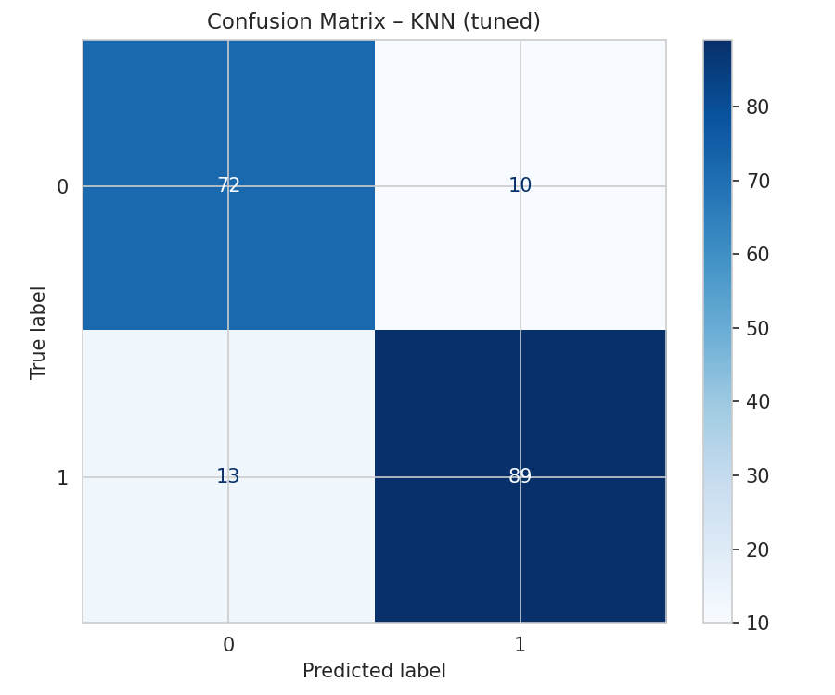  KNN
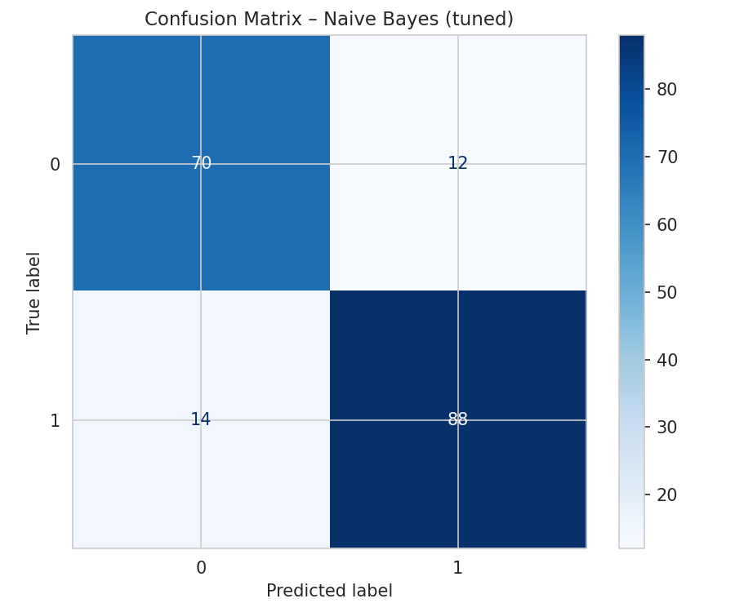  Naive Bayes | 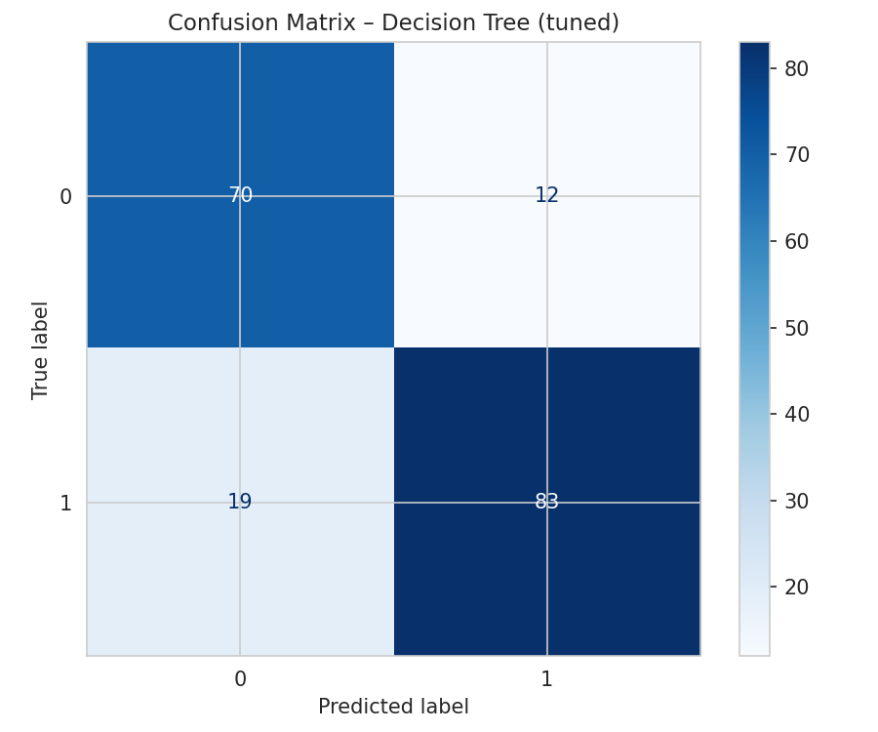  Decision Tree
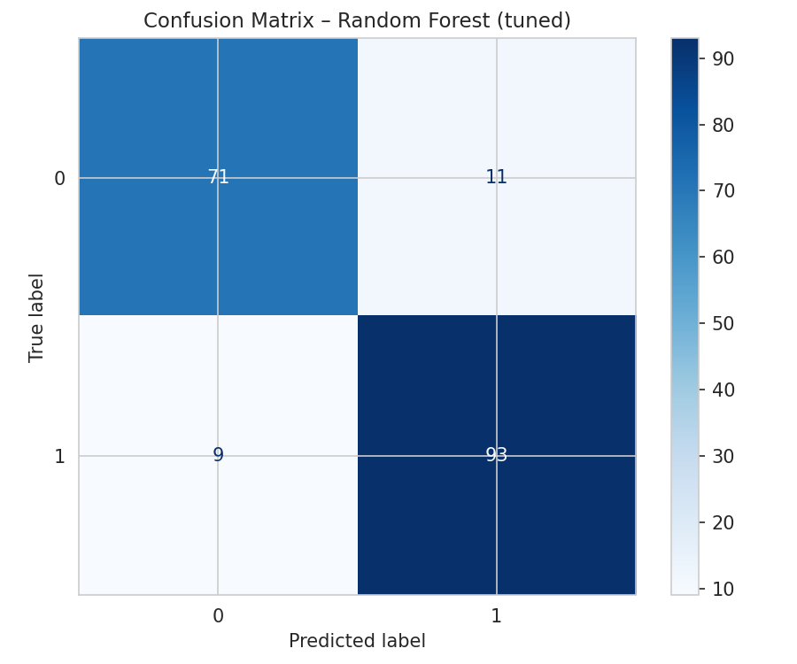  Random Forest | 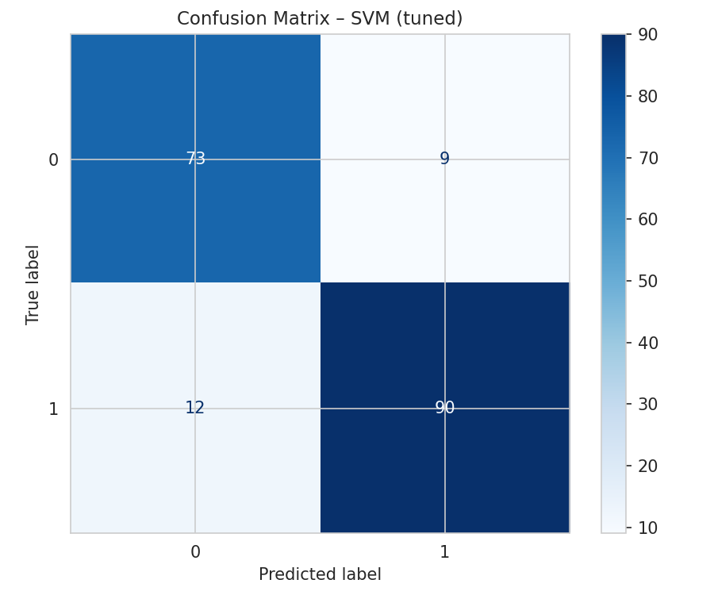  SVM
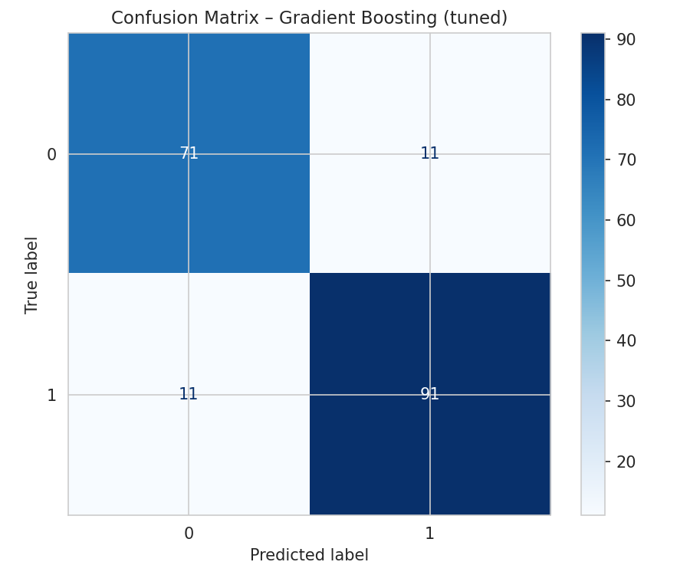  Gradient Boosting | 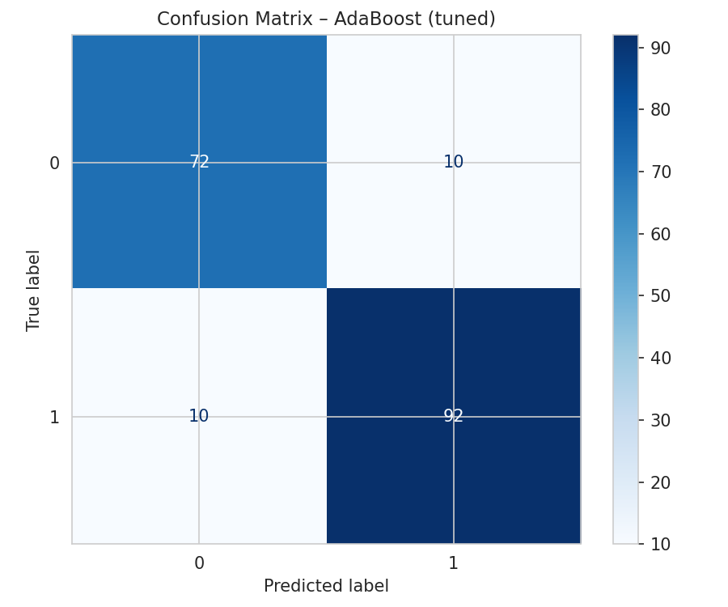  AdaBoost
Figure 16. Confusion Matrices of All Models After Fine Tuning

4.2.3 ROC Curves After Fine Tuning
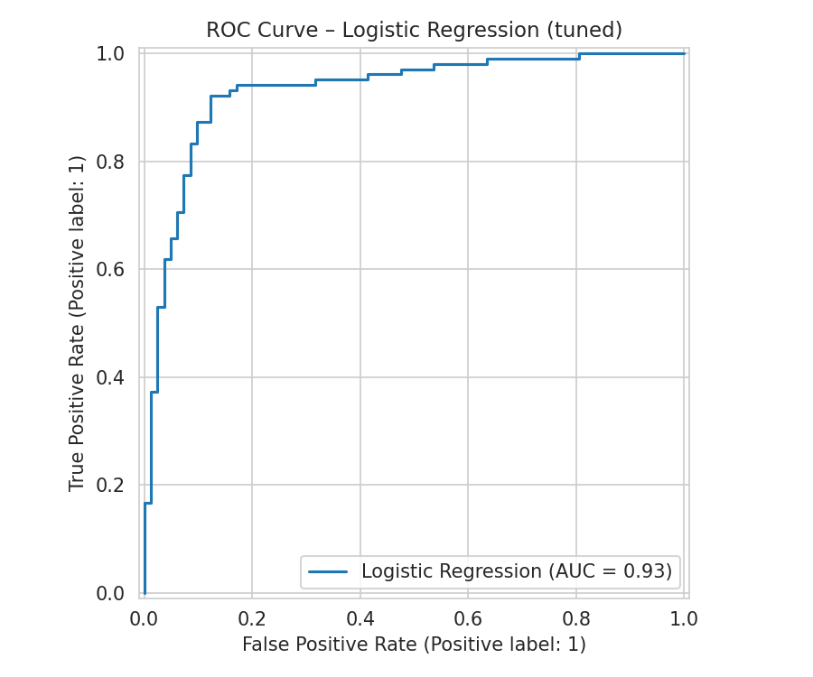  Logistic Regression | 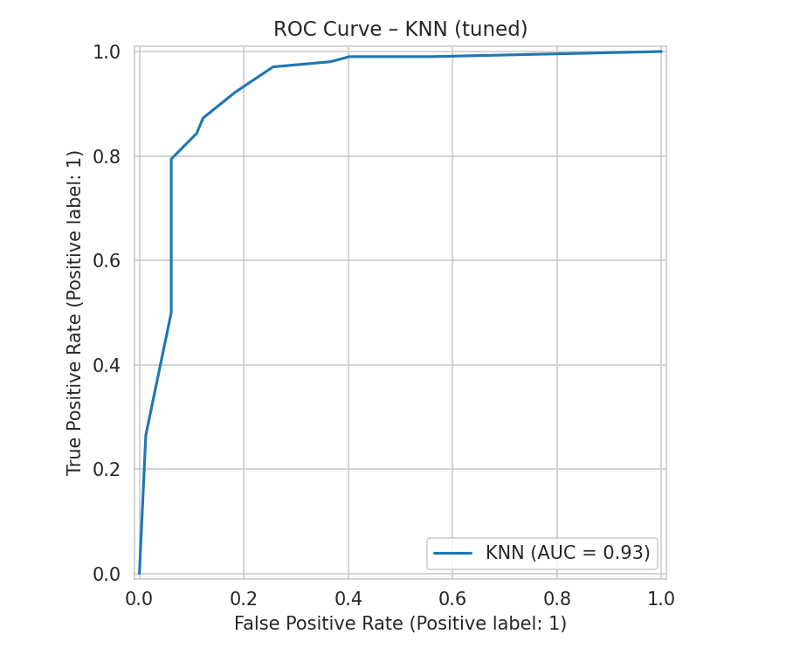  KNN
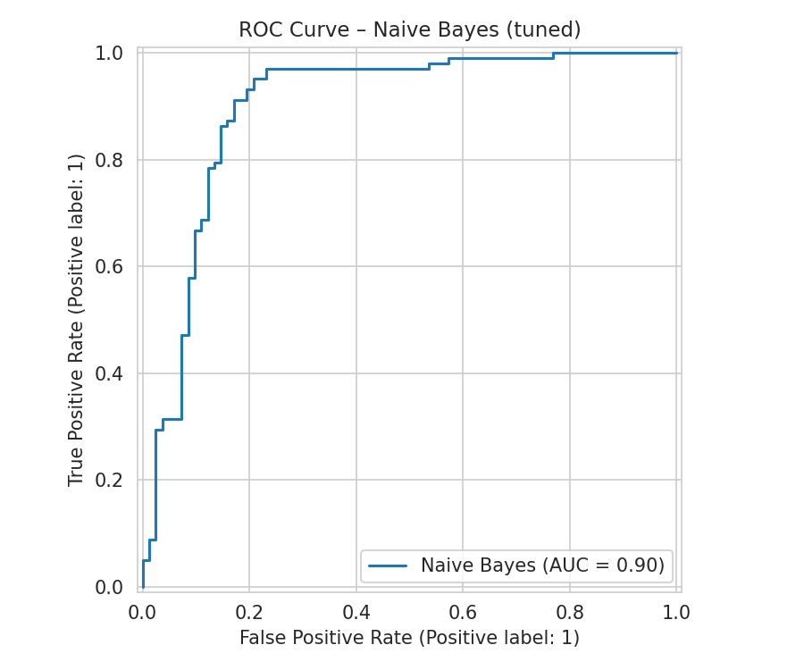  Naive Bayes | 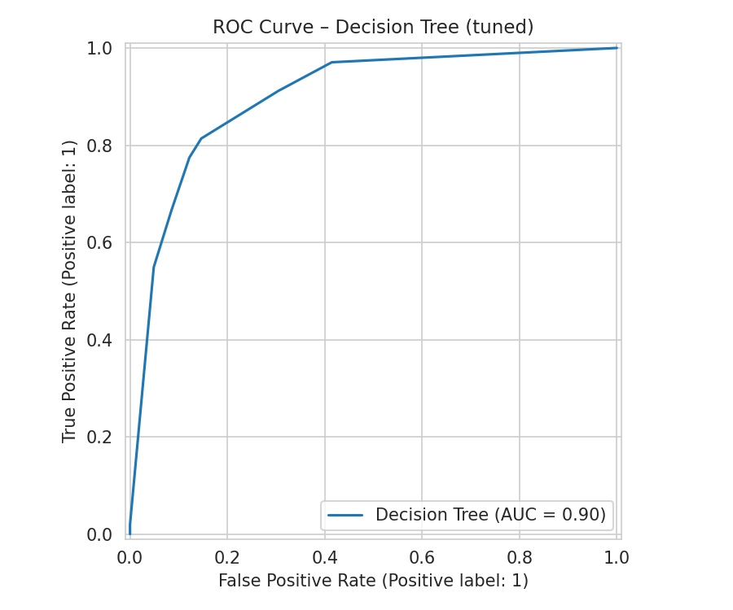  Decision Tree
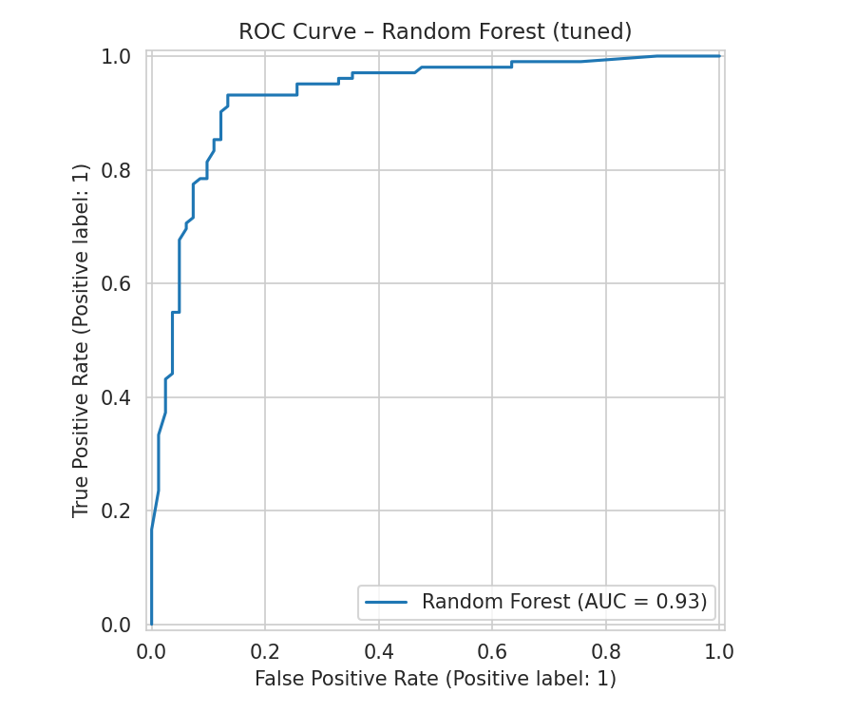  Random Forest | 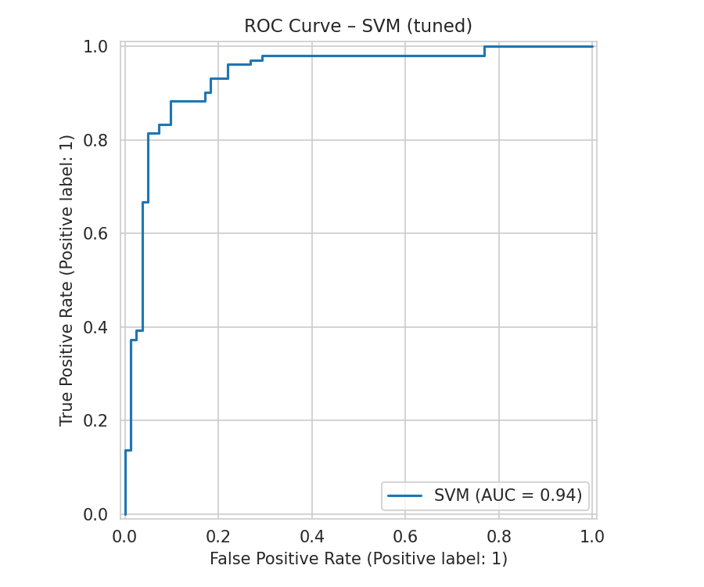  SVM
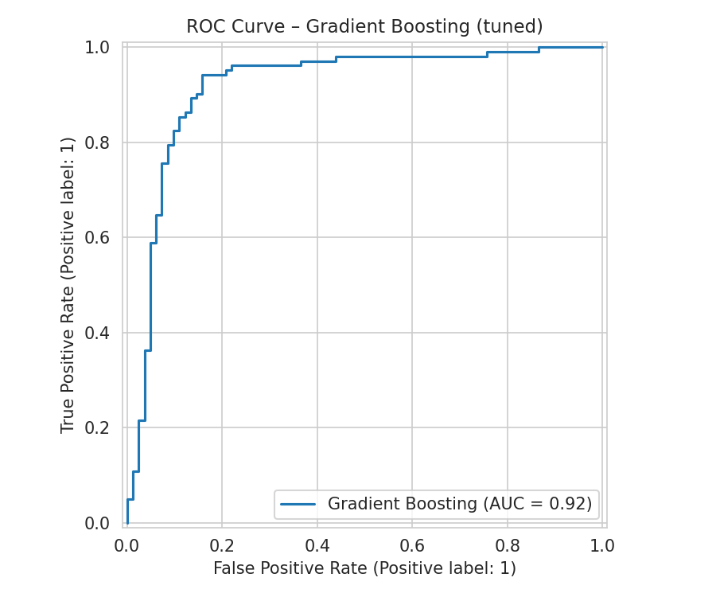  Gradient Boosting | 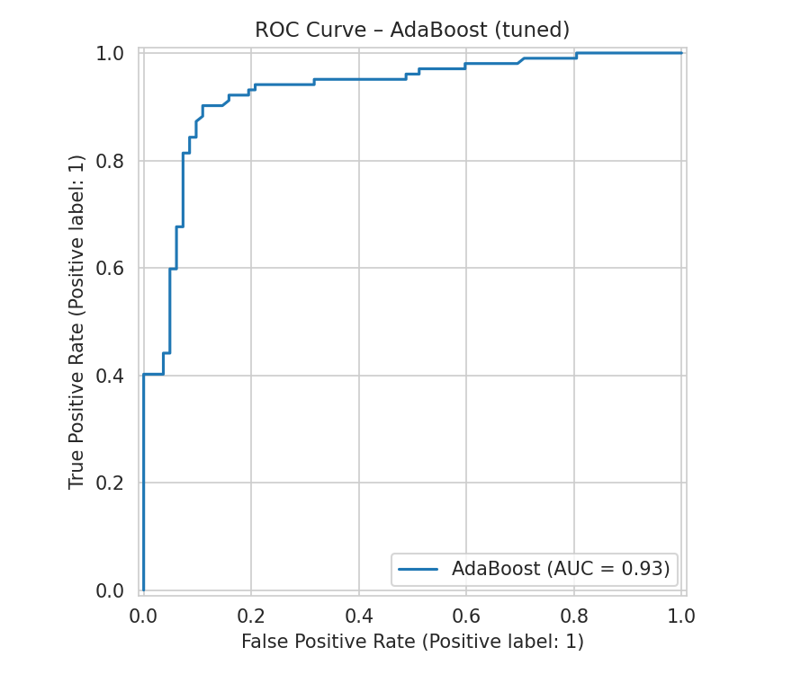  AdaBoost
Figure 17. ROC Curves of All Models After Fine Tuning

4.2.4 Precision-Recall Curves After Fine Tuning
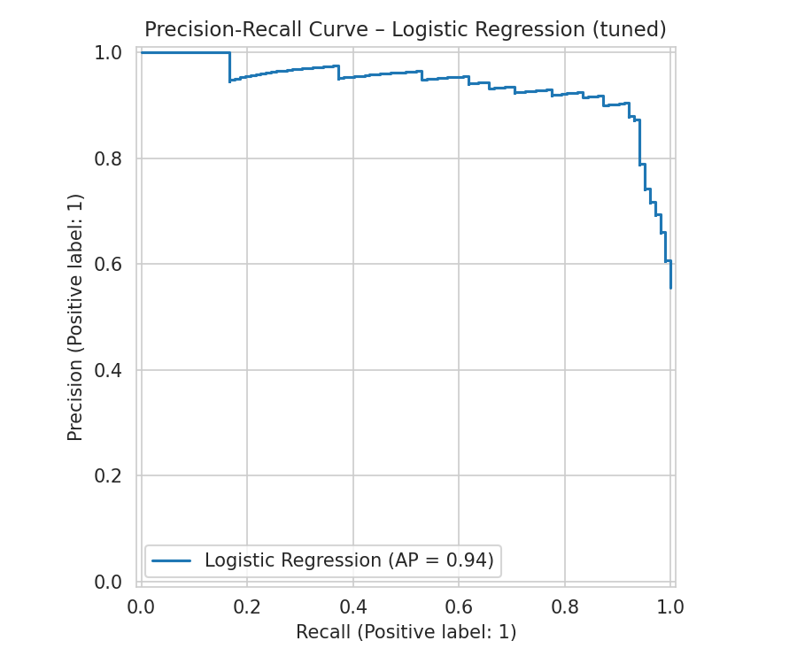  Logistic Regression | 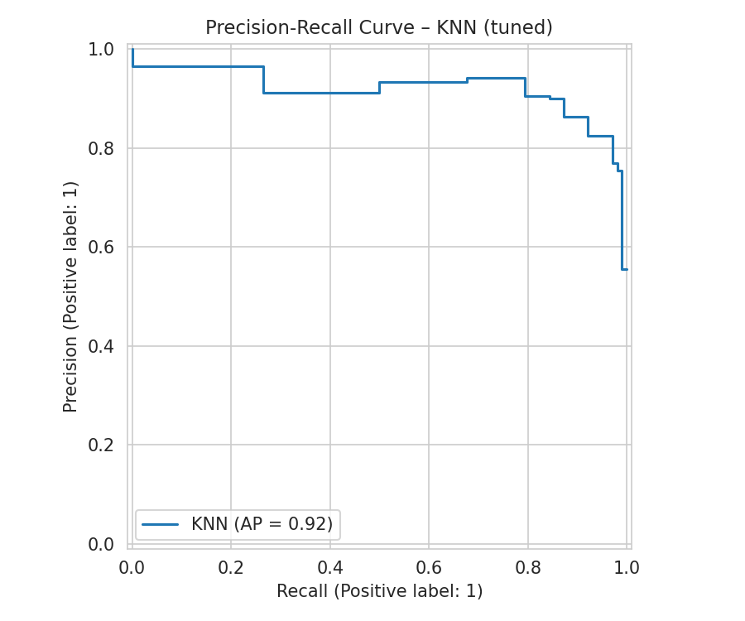  KNN
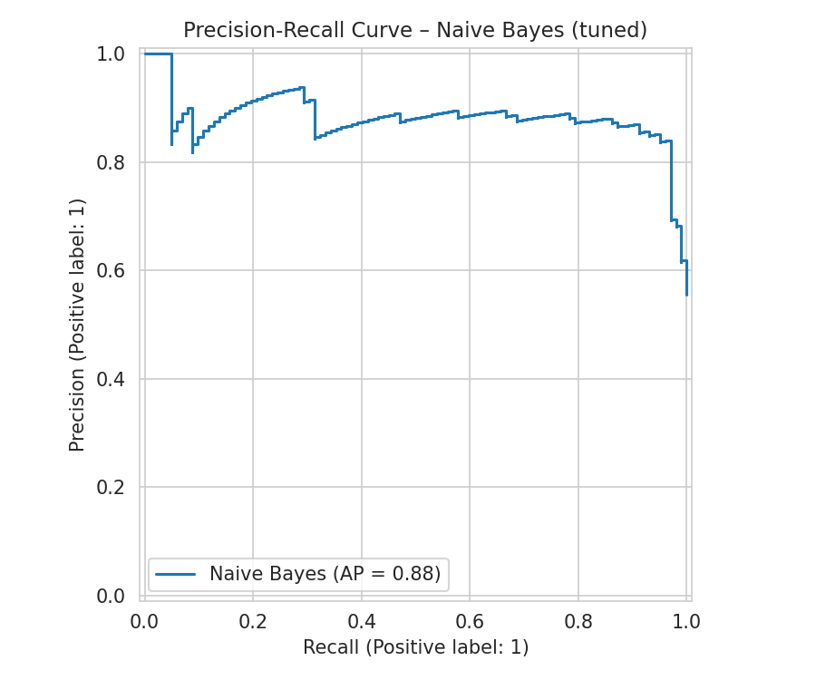  Naive Bayes | 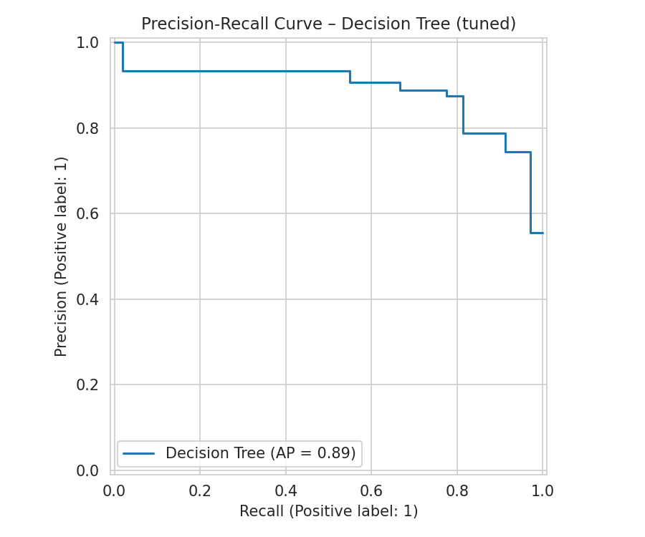  Decision Tree
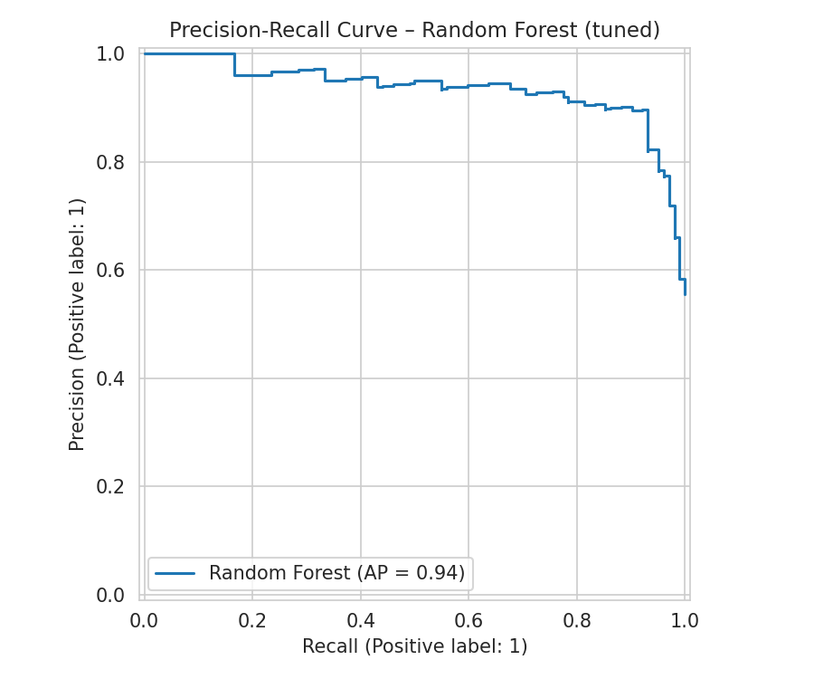  Random Forest | 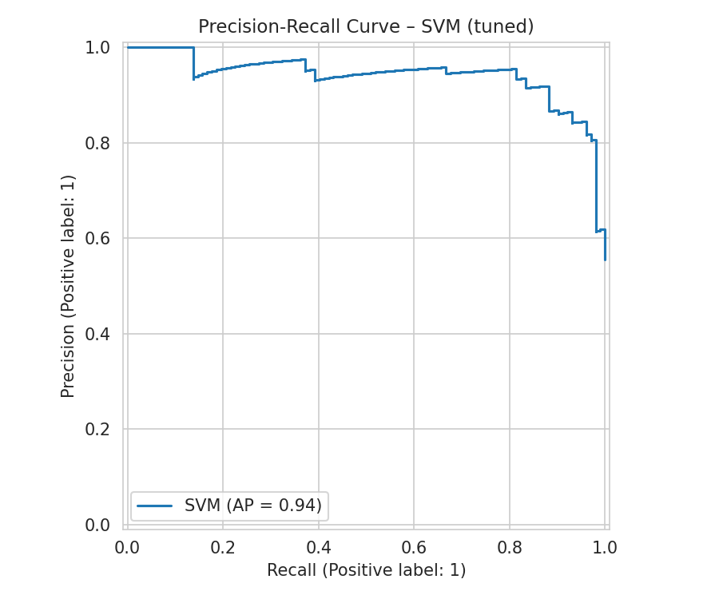  SVM
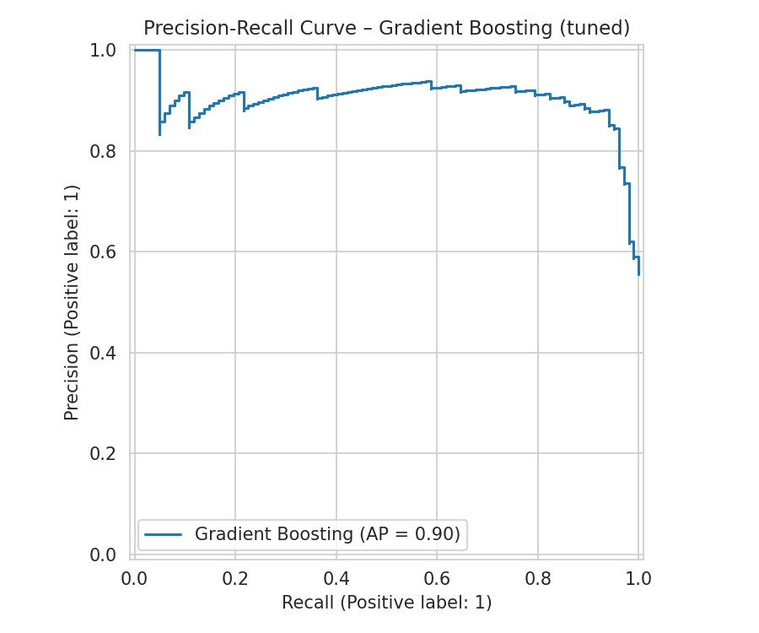  Gradient Boosting | 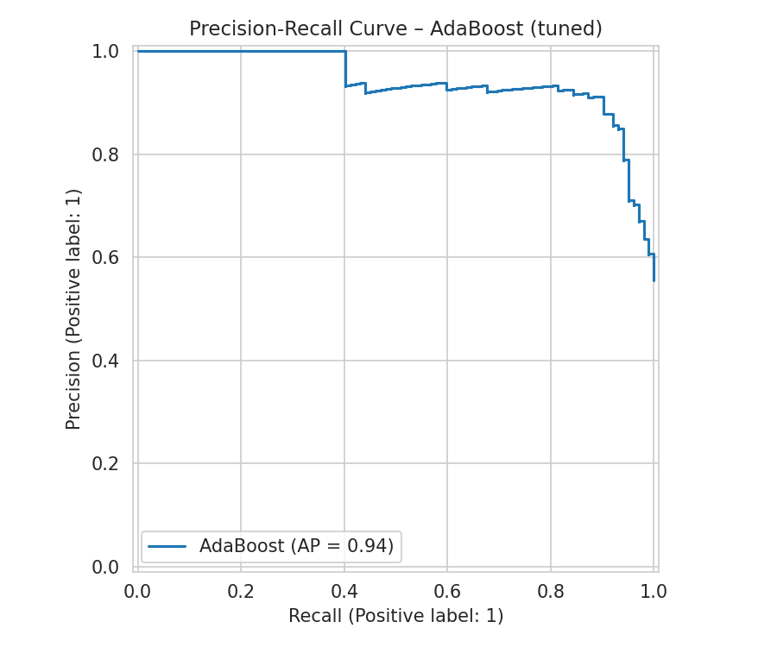  AdaBoost
Figure 18. Precision-Recall Curves of All Models After Fine Tuning

4.3 Best Model Selection
Random Forest's baseline configuration (F1 = 0.903) outperformed its own GridSearchCV-tuned version (F1 = 0.889); per project policy, the baseline Random Forest was retained as the final deployed model, and it remained the single best score of any model — tuned or not — on this dataset. Tuning's clearest genuine improvement was Decision Tree (F1 0.808 → 0.843), where constraining maximum depth reduced overfitting evident in the baseline model. Note: the confusion matrix, ROC, and PR figures in Section 4.2 reflect the GridSearchCV-tuned Random Forest for completeness of reporting; the baseline Random Forest (Section 4.1 figures) was used in the final deployed application.

PROJECT #4
FDA Adverse Drug Event Fatality Prediction

1. Dataset

1.1 Dataset Description
The dataset used for this project is real-world adverse event reports submitted to the FDA by clinicians, hospitals, and patients, filtered to drugs indicated for cancer and cardiology conditions.
Each row represents one reported adverse event, including patient demographics, the drug involved, its indication, and the reported reactions.

1.2 Dataset Source
Dataset: FDA Adverse Drug Events (Oncology & Cardiology)
Source: Kaggle (CC0 public domain license).
Size: 13,955 raw reports; reduced to 6,130 after deduplication, with 34 input features after feature engineering and encoding.

1.3 Basic Dataset Analysis
Target Variable: Fatal (0 = No, 1 = Yes). Used rather than the dataset's Seriousness column, which was found to be 100% empty and unusable.
- Post-deduplication class distribution: 4,825 non-fatal (78.6%) vs. 1,305 fatal (21.4%) reports.
- Feature-target correlations were markedly weaker than in the project's other three datasets — the strongest was only 0.10 (Indication: Hepatic Neoplasm Malignant), compared to up to 0.62 for Heart Disease.
- A candidate engineered feature, Has_Death_Reaction (flagging whether "DEATH" appeared explicitly in the reported reactions text), was 98% predictive of Fatal but was judged too conceptually close to the target itself and was excluded to avoid leakage.
- This weak overall signal is itself a meaningful finding: it indicates that basic demographic and drug-category information alone is insufficient to reliably predict fatality, which more plausibly depends on clinical factors not captured in this dataset (e.g., dosage, comorbidities, disease staging).

1.4 Data Quality Issues
- The Seriousness column was 100% missing and was dropped entirely.
- Patient Age had 41.7% missing values, and a subset of 175 non-missing values were found to be recorded in days rather than years (e.g., a value of 23,642 represented 64.8 years).
- Patient Sex had 594 missing values, plus one row containing an invalid "0" entry rather than a valid category.
- Drug Name (1,751 unique values) and Drug Indication (255 unique values) were too high-cardinality for direct one-hot encoding.
- Reactions was a compound, pipe-separated multi-value text field, not usable as a simple categorical feature.
- 7,825 duplicate rows (56% of the raw dataset) were present; investigation showed their Fatal ratio differed meaningfully from the overall dataset, indicating they were not pure column-collapse artifacts and warranted removal to avoid train/test leakage from repeated identical reports.

2. Preprocessing
The preprocessing pipeline addressed a genuine unit-inconsistency error, high-cardinality categorical features, and a substantial duplicate-record issue requiring careful investigation before removal.

2.1 Empty Column Removal
Dropped the Seriousness column (100% missing, unusable).

2.2 Age Unit Correction
Corrected the age-unit inconsistency: values above 120 were identified as days rather than years and divided by 365, recovering 175 otherwise-unusable records rather than discarding them.

2.3 Missing Value Imputation
Applied median imputation to the remaining missing Patient_Age values; corrected the invalid "0" entry in Patient_Sex and applied mode imputation to remaining missing Sex values.

2.4 Feature Engineering
Engineered a Reaction_Count feature (number of distinct reactions reported) from the raw Reactions text field; dropped the raw text field and a candidate Has_Death_Reaction flag due to leakage risk.

2.5 High-Cardinality Bucketing
Bucketed Drug_Name and Drug_Indication into their Top-15 most frequent categories each, with all remaining values grouped into an "Other" category.

2.6 Metadata Removal
Dropped Safety_Report_ID and Receipt_Date, identifiers/metadata with no genuine predictive value.

2.7 Duplicate Removal
Removed 7,825 duplicate rows after investigating their class distribution and confirming removal was appropriate.

2.8 Encoding
Applied Label Encoding to Patient_Sex and the Fatal target; applied One-Hot Encoding to the bucketed Drug_Name_Grouped and Drug_Indication_Grouped columns.

2.9 Feature Scaling
Applied RobustScaler to all numeric features.

2.10 Train-Test Split
Performed an 80/20 stratified train-test split (4,904 / 1,226 records) on the final deduplicated dataset, preserving the 78.6%/21.4% class ratio.

3. Machine Learning Methods

3.1 Model Selection Criteria
The same 8 algorithms were applied consistently across all four datasets, deliberately spanning five distinct model families — linear, distance-based, probabilistic, tree-based, and two ensemble strategies (bagging and boosting). Rather than testing minor variations of a single approach, the goal was to compare genuinely different learning strategies against the same data, so that performance differences could be attributed to how each algorithm's structural assumptions matched the underlying data.
Selection was also guided by dataset scale. All four datasets contain between roughly 900 and 24,000 rows with a modest number of features — a size range where classical machine learning algorithms are appropriate and computationally efficient. Deep learning approaches were not used, as they typically require substantially larger datasets to outperform classical methods and offer reduced interpretability, which was not justified at this data scale.

3.2 Selected Machine Learning Models
The following 8 algorithms were trained and evaluated:
- Logistic Regression (Linear)
- K-Nearest Neighbours (KNN) (Distance-based)
- Naive Bayes (Gaussian) (Probabilistic)
- Decision Tree (Tree-based)
- Random Forest (Ensemble (Bagging))
- Support Vector Machine (SVM) (Margin-based)
- Gradient Boosting (Ensemble (Boosting))
- AdaBoost (Ensemble (Boosting))

3.3 Logistic Regression
Family: Linear. Models the probability of the positive class using a weighted linear combination of features passed through a sigmoid function. Fast and highly interpretable; limited to linear decision boundaries.

3.4 K-Nearest Neighbours (KNN)
Family: Distance-based. Classifies a new sample by majority vote among its K nearest training samples, measured by feature distance. Requires no explicit training phase, but is sensitive to feature scaling, which is why scaling was applied before training.

3.5 Naive Bayes (Gaussian)
Family: Probabilistic. Applies Bayes' theorem assuming conditional independence between features given the class label. Extremely fast to train; accuracy degrades when features are correlated, which is common in real clinical and behavioural data.

3.6 Decision Tree
Family: Tree-based. Recursively splits data on the feature/threshold that best separates classes at each node, forming a flowchart-like structure. Highly interpretable but prone to overfitting when depth is unconstrained.

3.7 Random Forest
Family: Ensemble (Bagging). Trains many decision trees on random subsets of data and features, then aggregates their votes. Reduces the overfitting risk of a single tree and is generally robust across varied data structures.

3.8 Support Vector Machine (SVM)
Family: Margin-based. Finds the decision boundary that maximizes the margin between classes; the RBF kernel allows non-linear class separation.

3.9 Gradient Boosting
Family: Ensemble (Boosting). Builds trees sequentially, with each new tree trained to correct the residual errors of the previous ensemble. Often achieves top-tier accuracy but requires careful tuning to avoid overfitting.

3.10 AdaBoost
Family: Ensemble (Boosting). Builds trees sequentially, increasing the weight of misclassified samples so subsequent trees focus on hard cases. Has no native class-weighting mechanism, which limits performance on severely imbalanced data.

4. Results
Given the weak underlying feature-target signal identified in EDA, F1-Scores across all 8 models are markedly lower than in the project's other three datasets. This is reported as an honest methodological finding: model performance is fundamentally bounded by the predictive information available in the data, not solely by algorithm choice or tuning effort.

4.1 Results Before Fine Tuning

4.1.1 Complete Performance Results
Model | Accuracy | Precision | Recall | F1-Score | ROC-AUC
Logistic Regression | 0.621 | 0.309 | 0.626 | 0.414 | 0.670
Naive Bayes | 0.608 | 0.303 | 0.637 | 0.410 | 0.654
SVM | 0.602 | 0.299 | 0.641 | 0.408 | 0.668
Decision Tree | 0.606 | 0.145 | 0.172 | 0.157 | 0.448
KNN | 0.734 | 0.219 | 0.095 | 0.133 | 0.534
Random Forest | 0.648 | 0.130 | 0.115 | 0.122 | 0.498
Gradient Boosting | 0.780 | 0.214 | 0.011 | 0.022 | 0.676
AdaBoost | 0.786 | 0.000 | 0.000 | 0.000 | 0.634

4.1.2 Confusion Matrices Before Fine Tuning
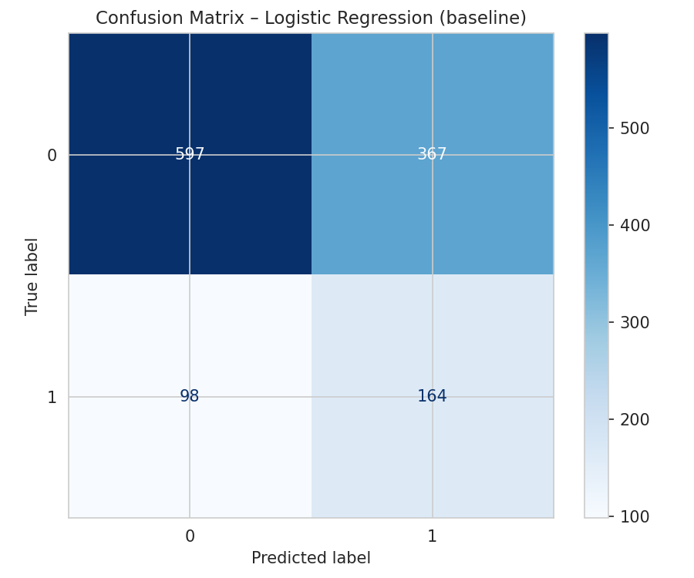  Logistic Regression | 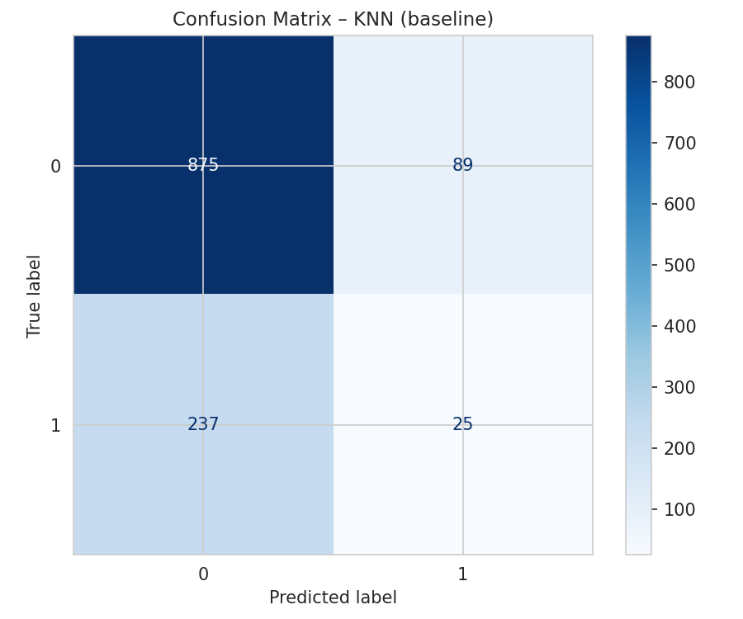  KNN
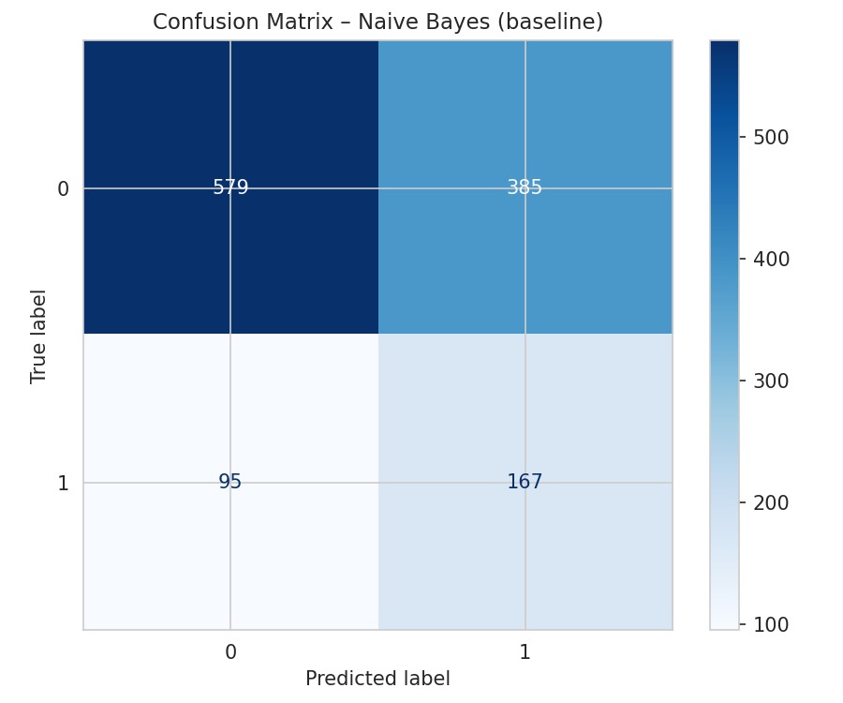  Naive Bayes | 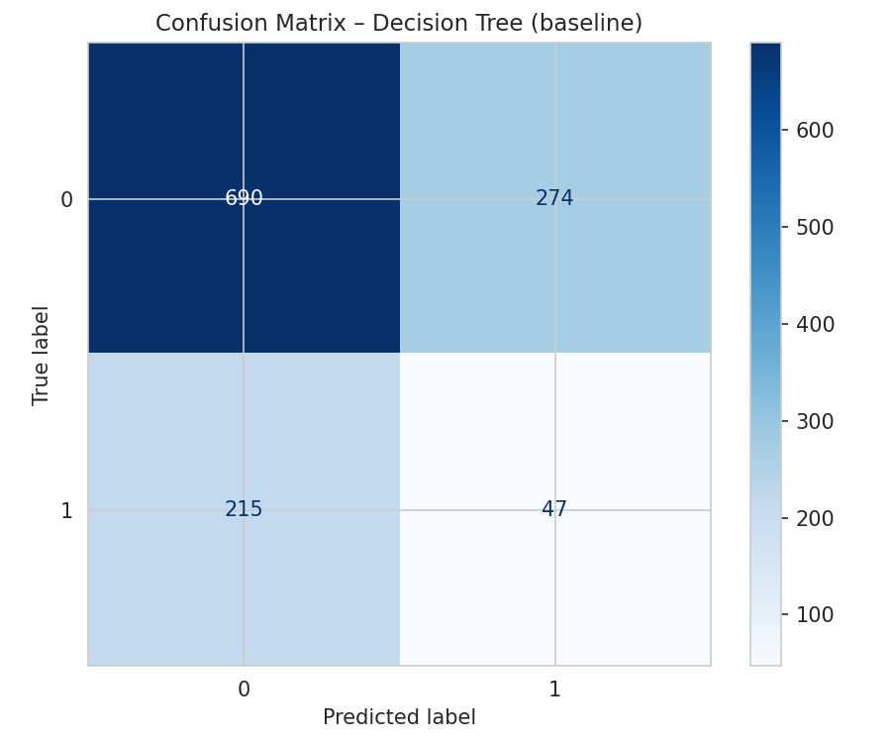  Decision Tree
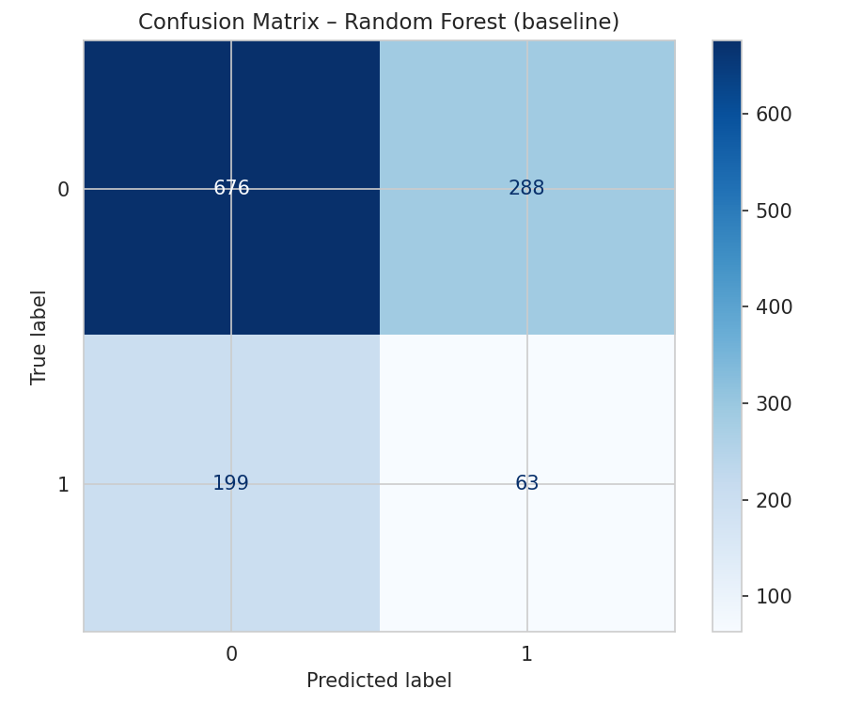  Random Forest | 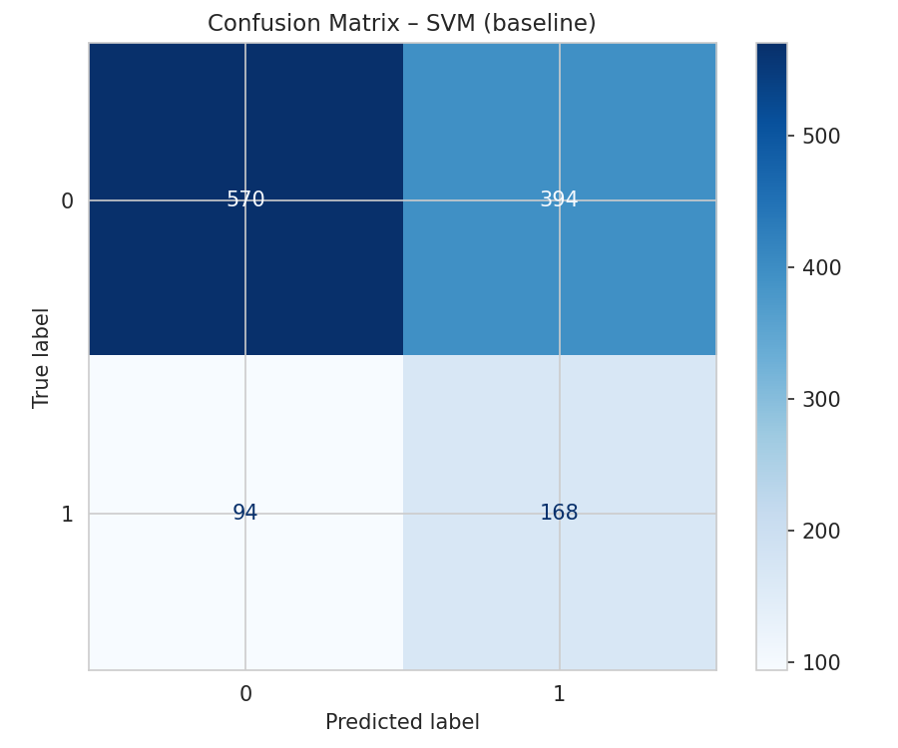  SVM
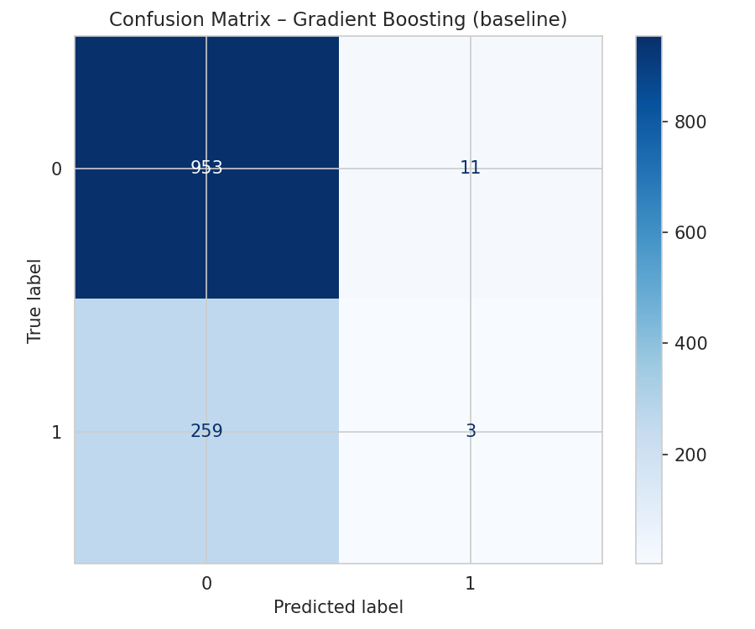  Gradient Boosting | 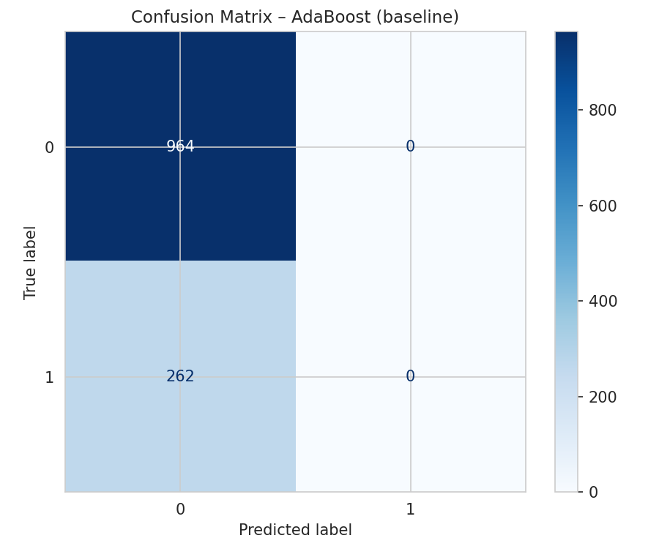  AdaBoost
Figure 19. Confusion Matrices of All Models Before Fine Tuning

4.1.3 ROC Curves Before Fine Tuning
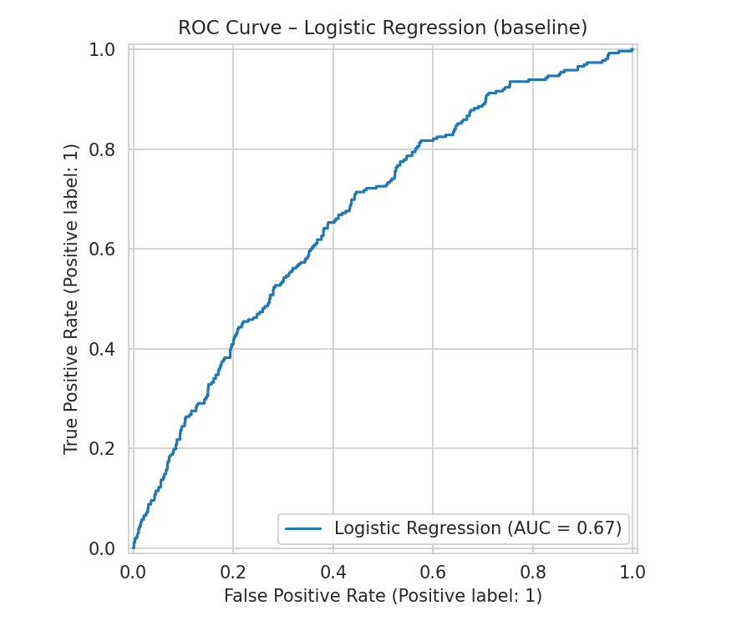  Logistic Regression | 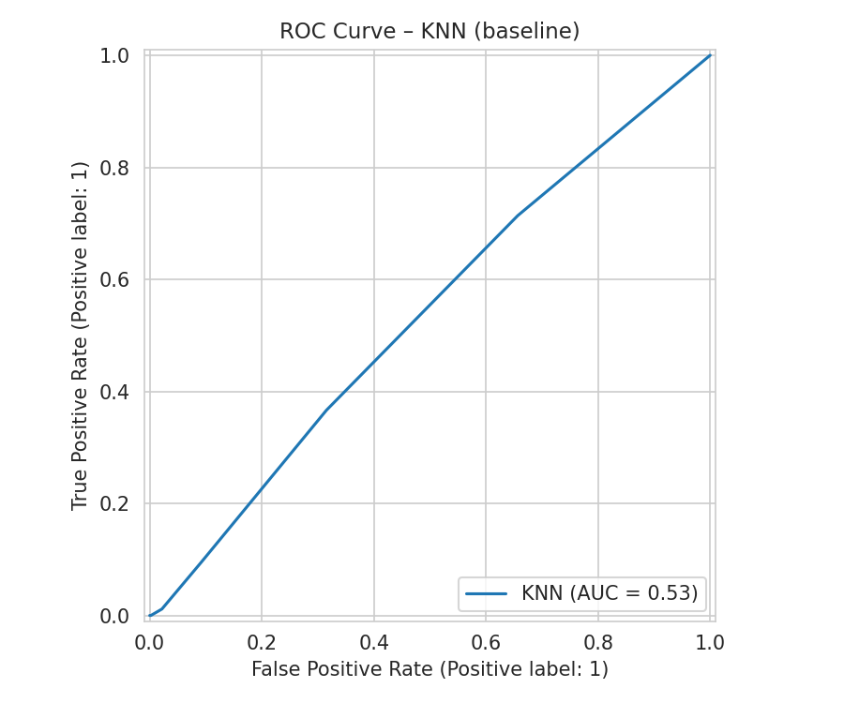  KNN
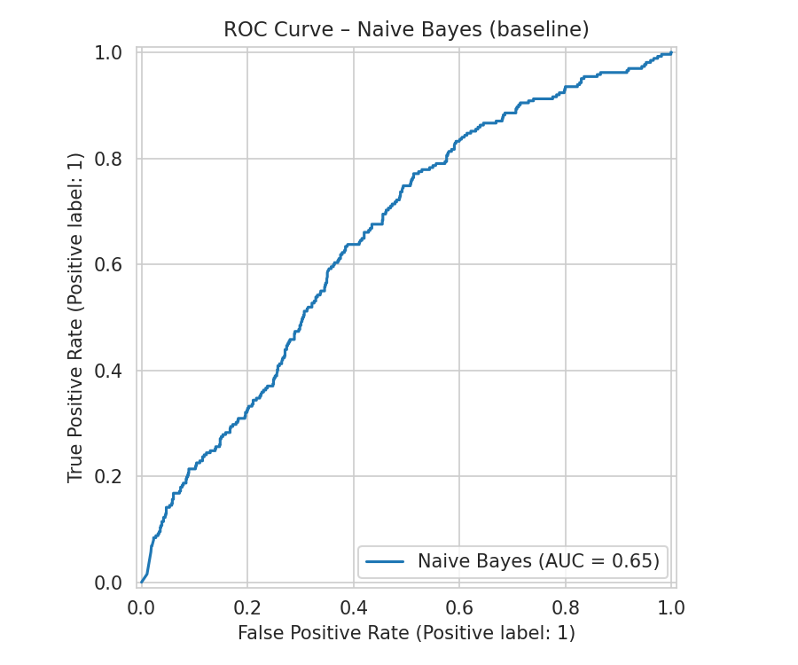  Naive Bayes | 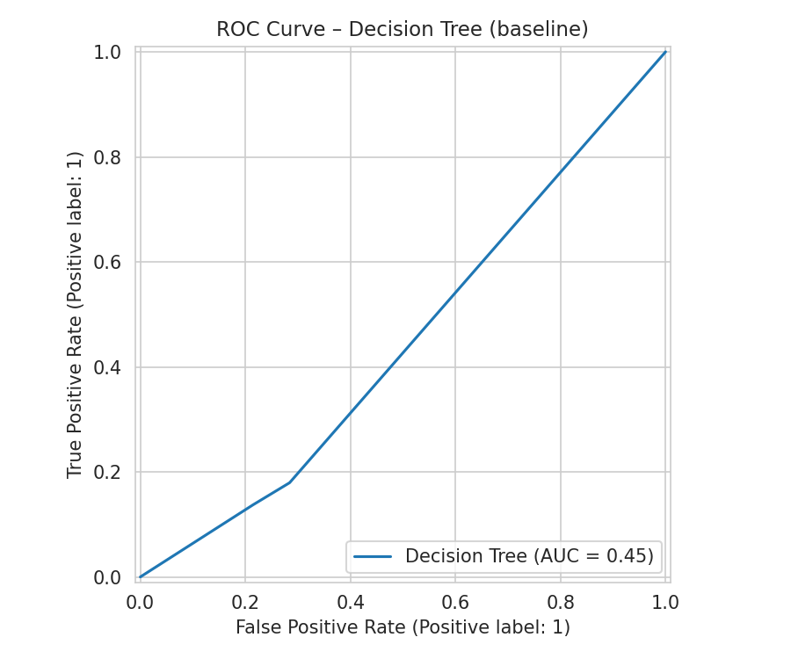  Decision Tree
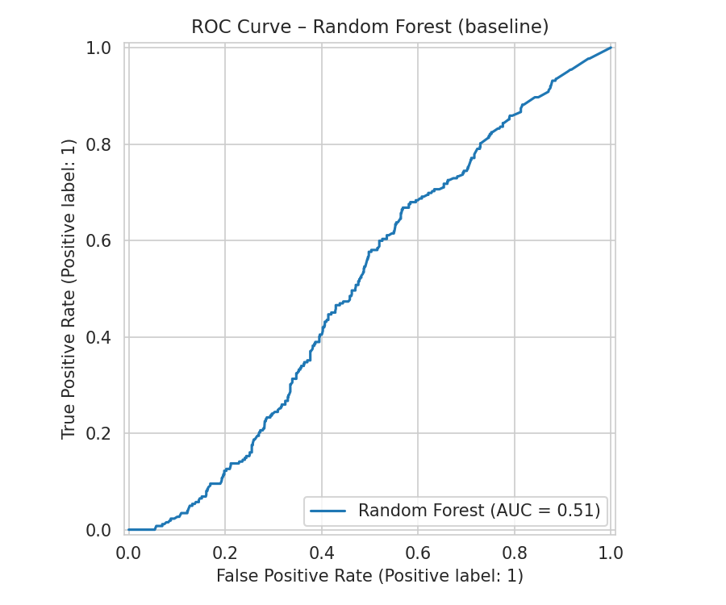  Random Forest | 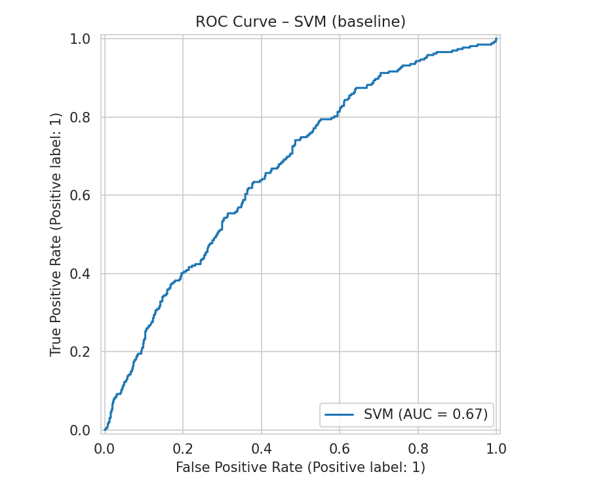  SVM
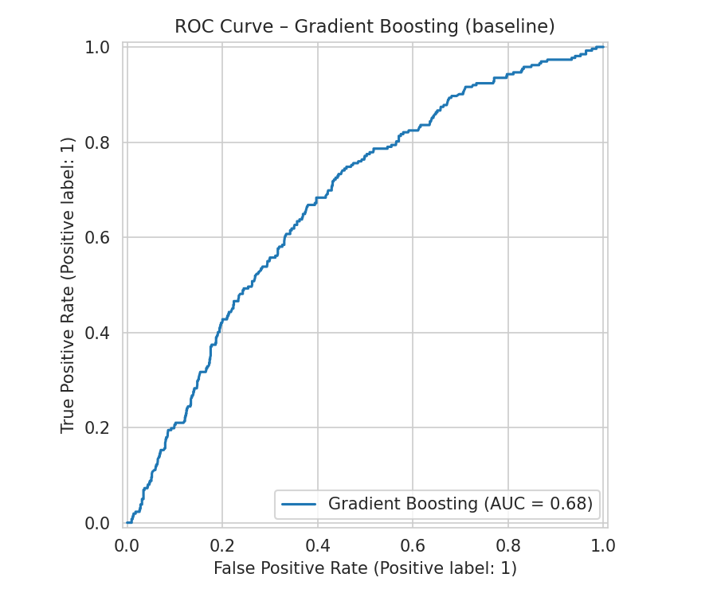  Gradient Boosting | 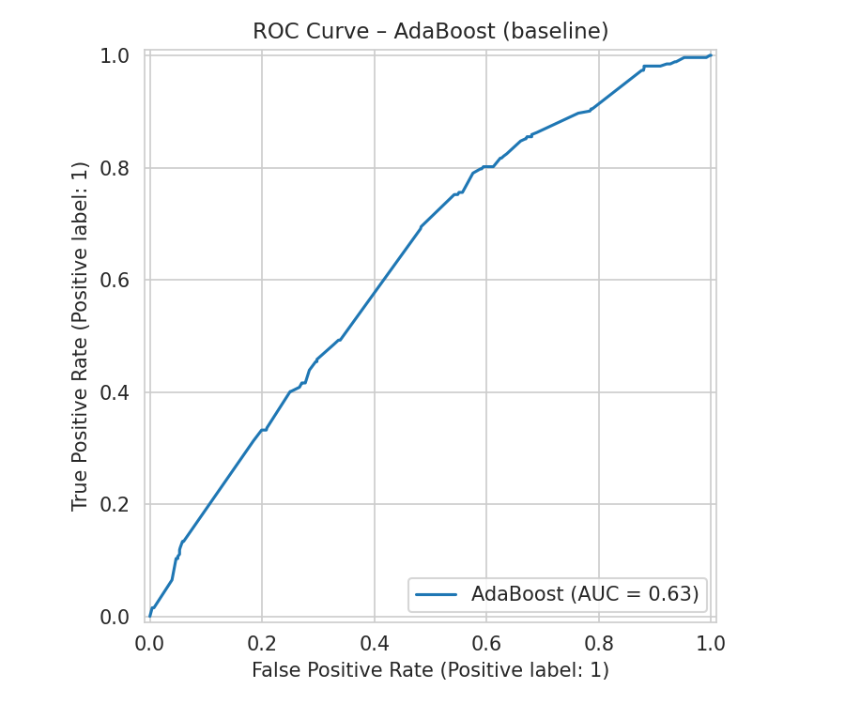  AdaBoost
Figure 20. ROC Curves of All Models Before Fine Tuning

4.1.4 Precision-Recall Curves Before Fine Tuning
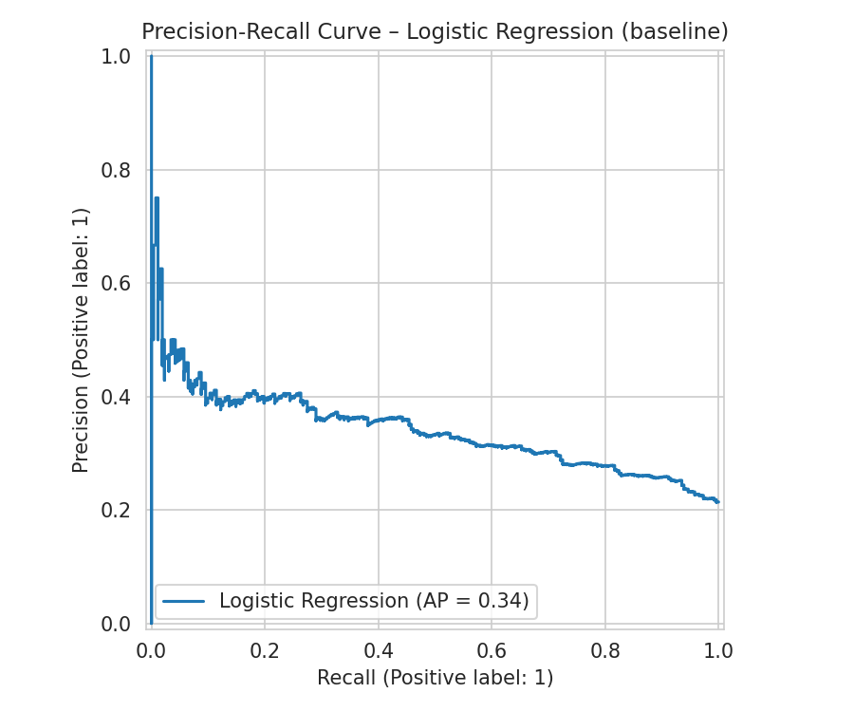  Logistic Regression | 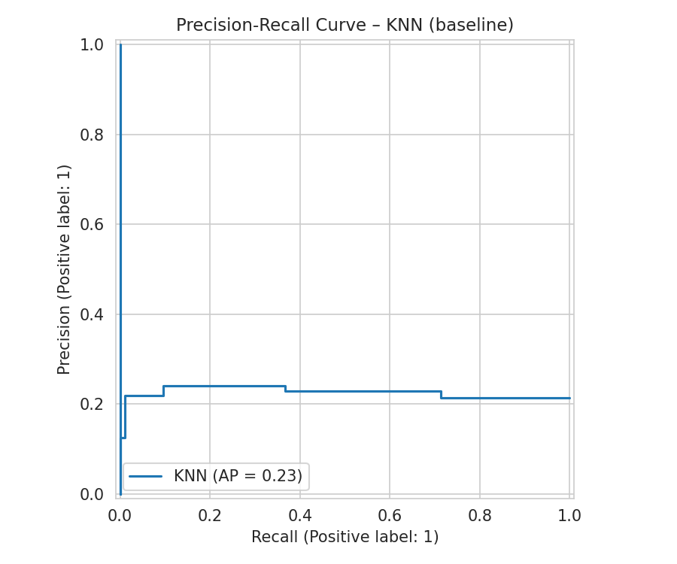  KNN
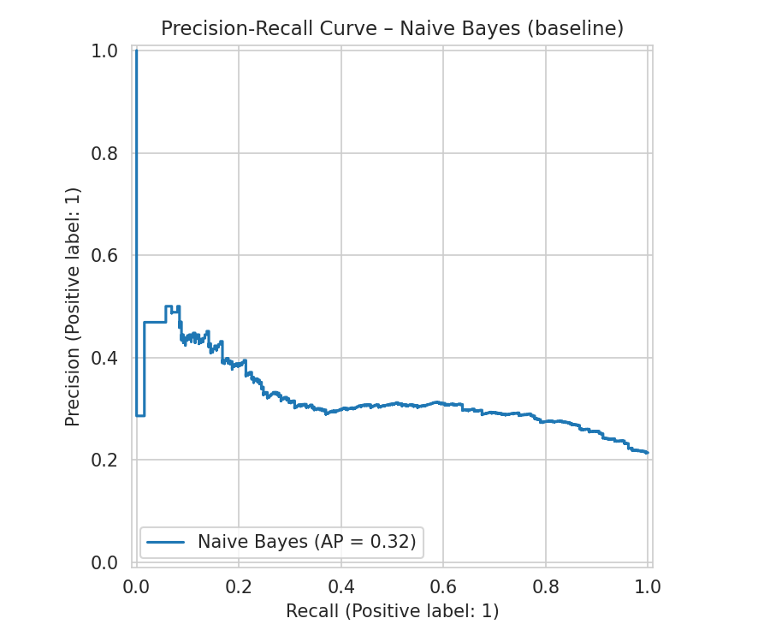  Naive Bayes | 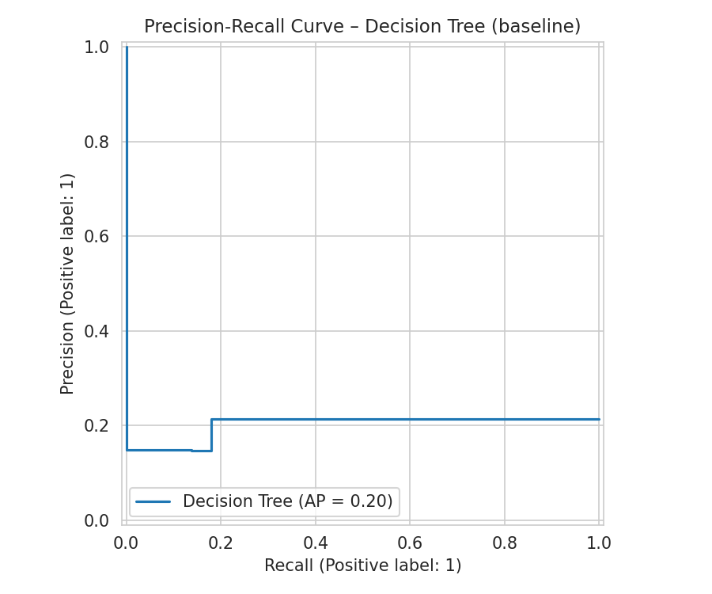  Decision Tree
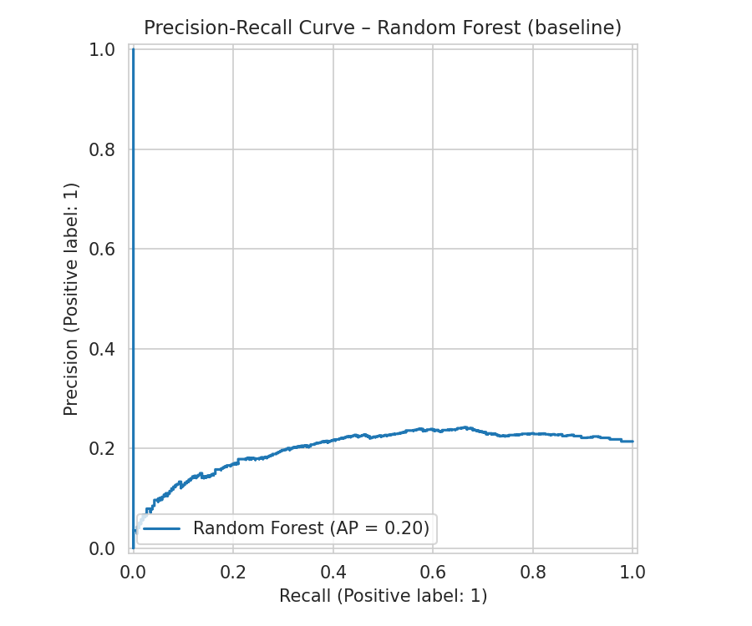  Random Forest | 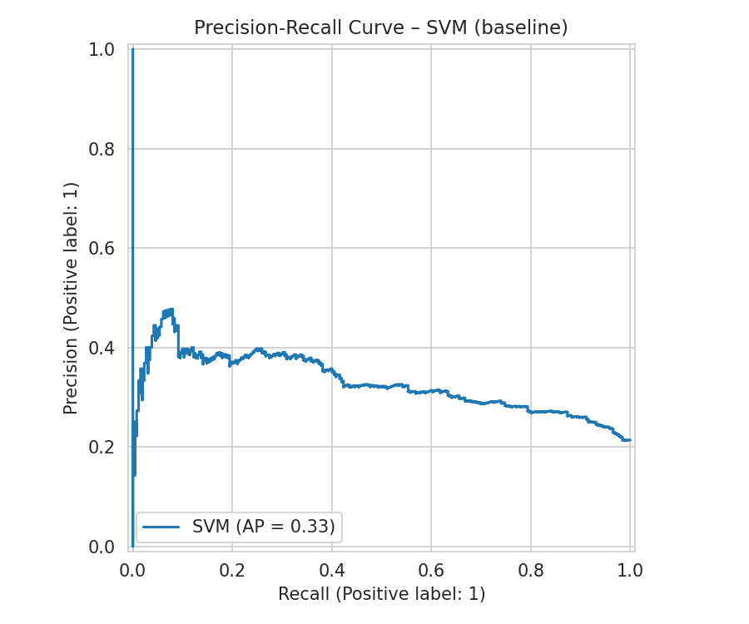  SVM
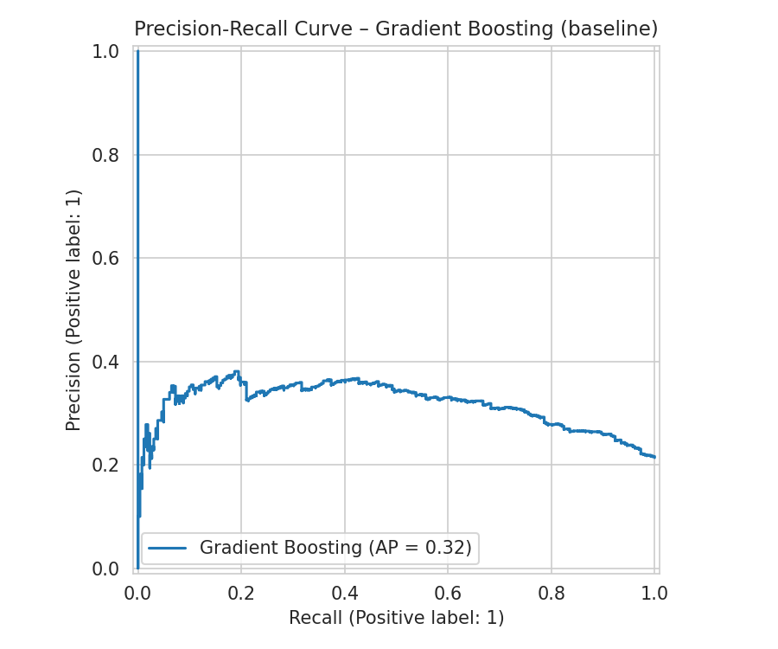  Gradient Boosting | 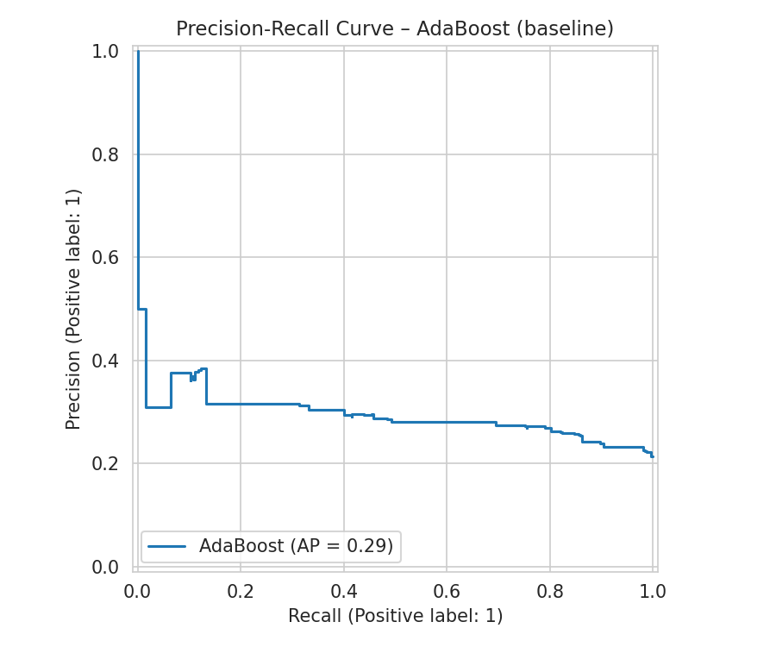  AdaBoost
Figure 21. Precision-Recall Curves of All Models Before Fine Tuning

4.2 Results After Fine Tuning

4.2.1 Complete Performance Results
Model | Accuracy | Precision | Recall | F1-Score | ROC-AUC
Logistic Regression | 0.621 | 0.309 | 0.626 | 0.414 | 0.670
Random Forest | 0.593 | 0.297 | 0.664 | 0.411 | 0.658
Naive Bayes | 0.608 | 0.303 | 0.637 | 0.410 | 0.654
SVM | 0.601 | 0.295 | 0.622 | 0.400 | 0.643
Decision Tree | 0.614 | 0.289 | 0.553 | 0.380 | 0.627
KNN | 0.693 | 0.172 | 0.115 | 0.138 | 0.504
Gradient Boosting | 0.737 | 0.225 | 0.095 | 0.134 | 0.608
AdaBoost | 0.785 | 0.400 | 0.015 | 0.029 | 0.669

4.2.2 Confusion Matrices After Fine Tuning
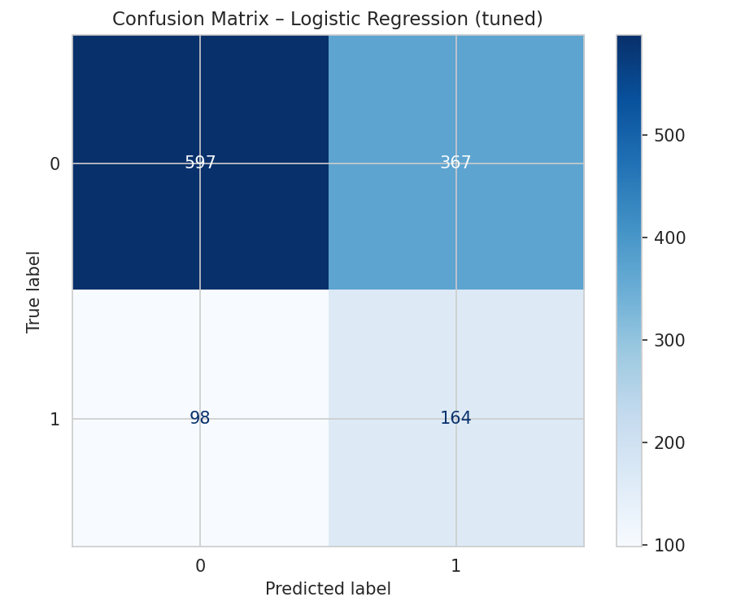  Logistic Regression | 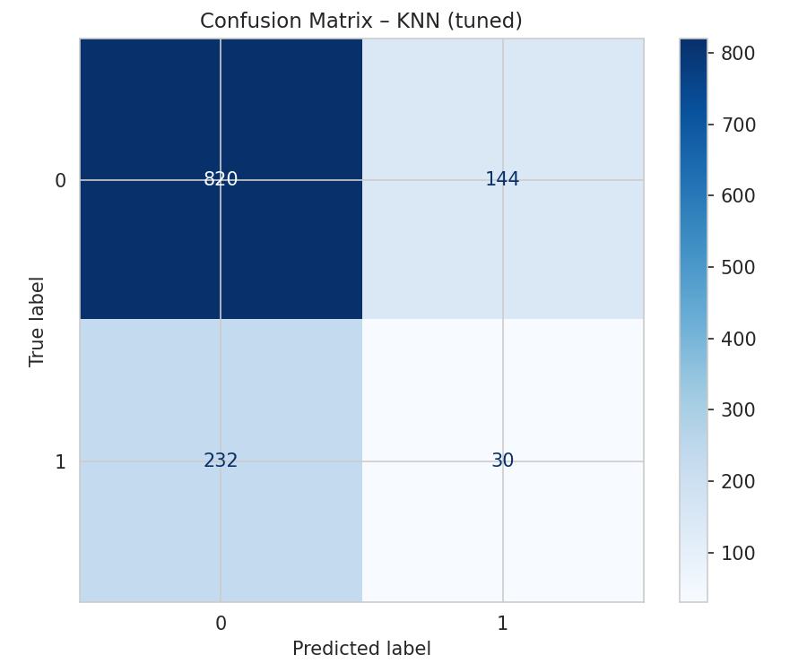  KNN
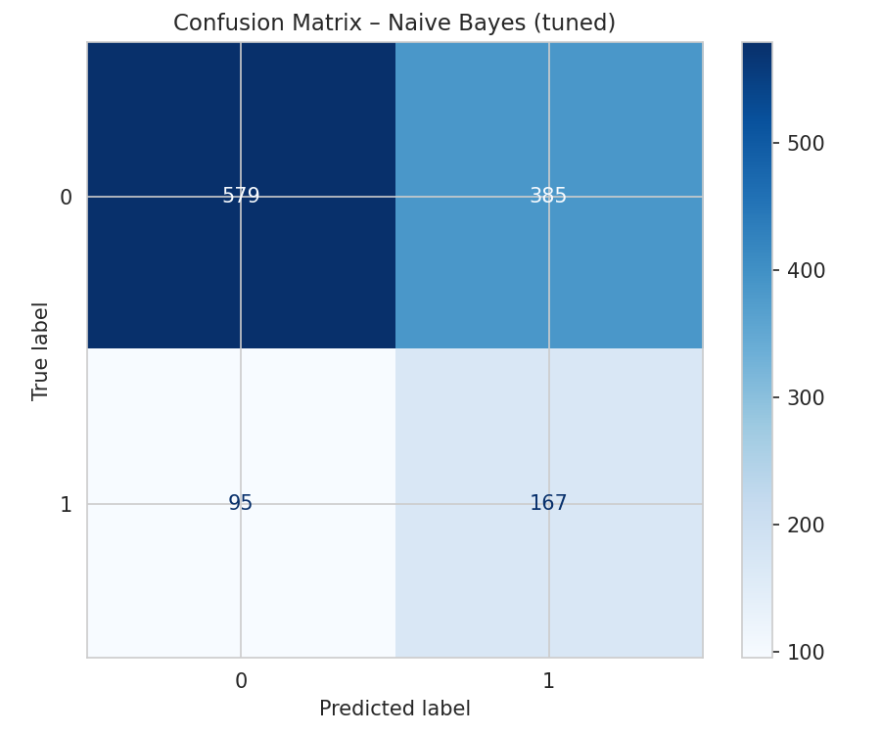  Naive Bayes | 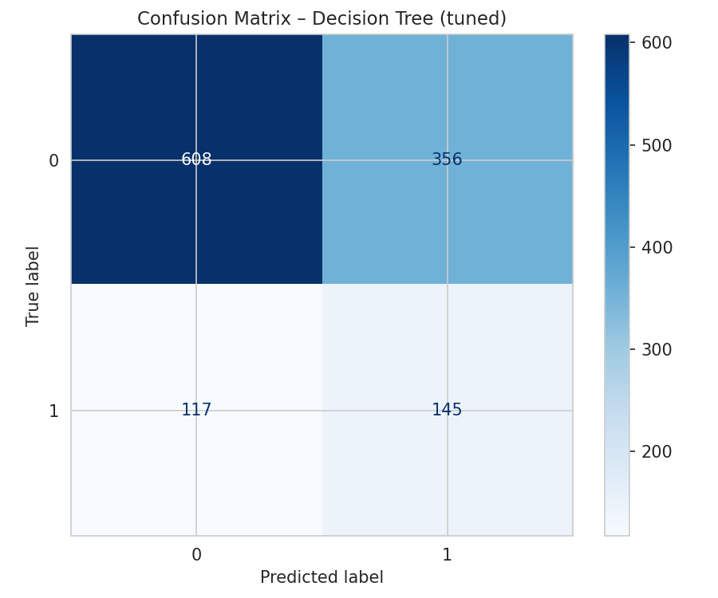  Decision Tree
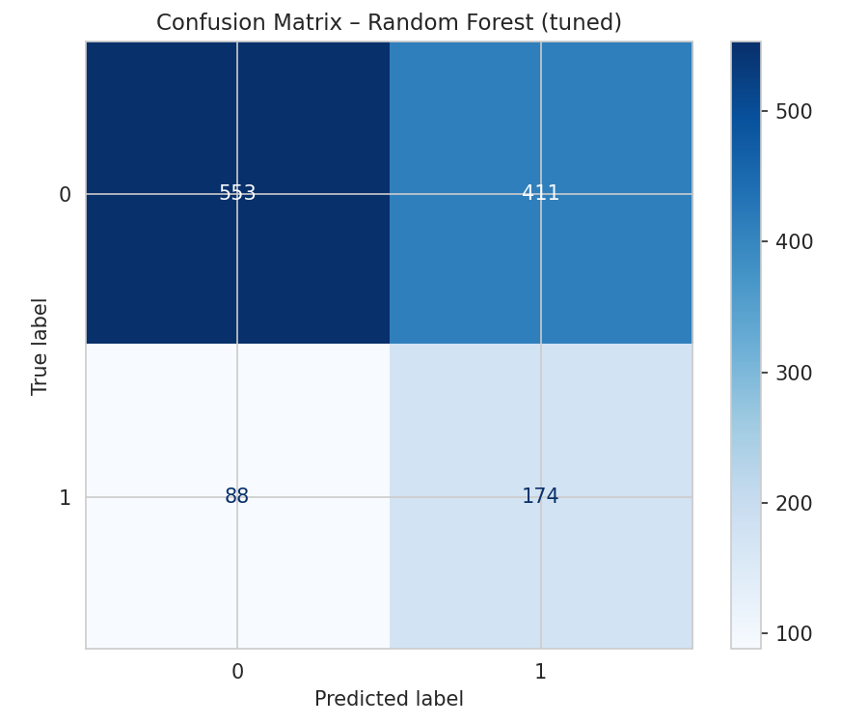  Random Forest | 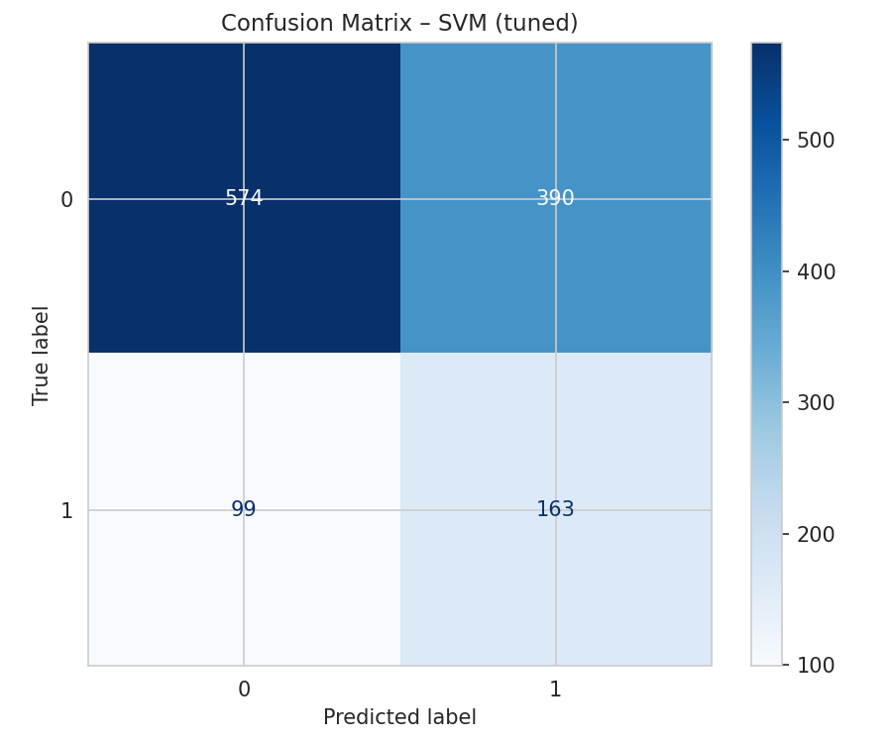  SVM
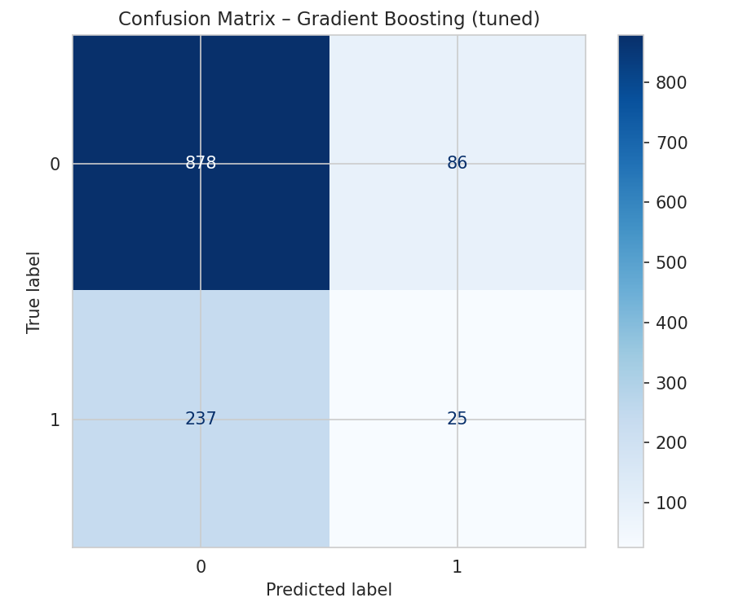  Gradient Boosting | 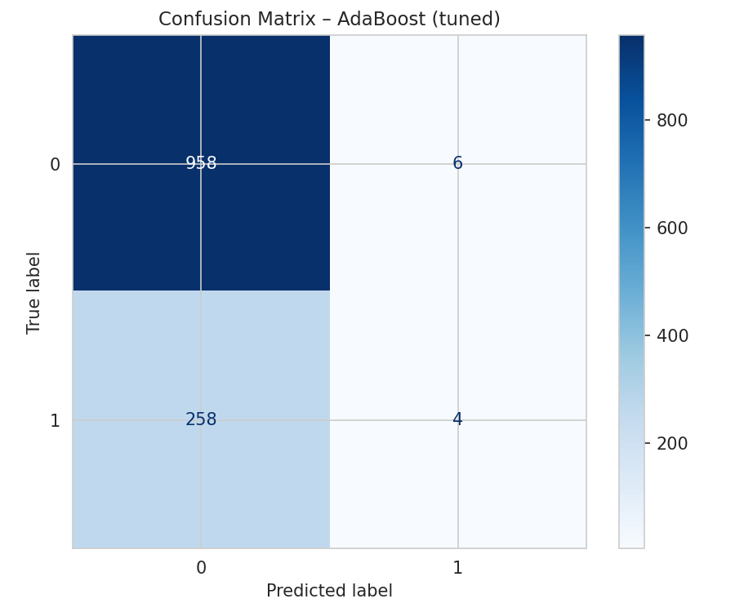  AdaBoost
Figure 22. Confusion Matrices of All Models After Fine Tuning

4.2.3 ROC Curves After Fine Tuning
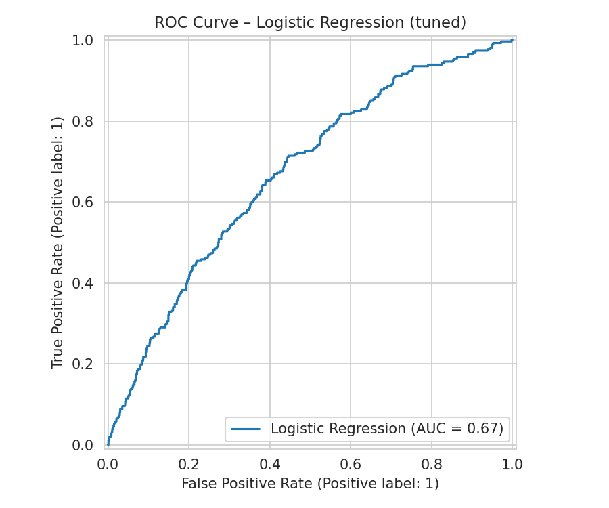  Logistic Regression | 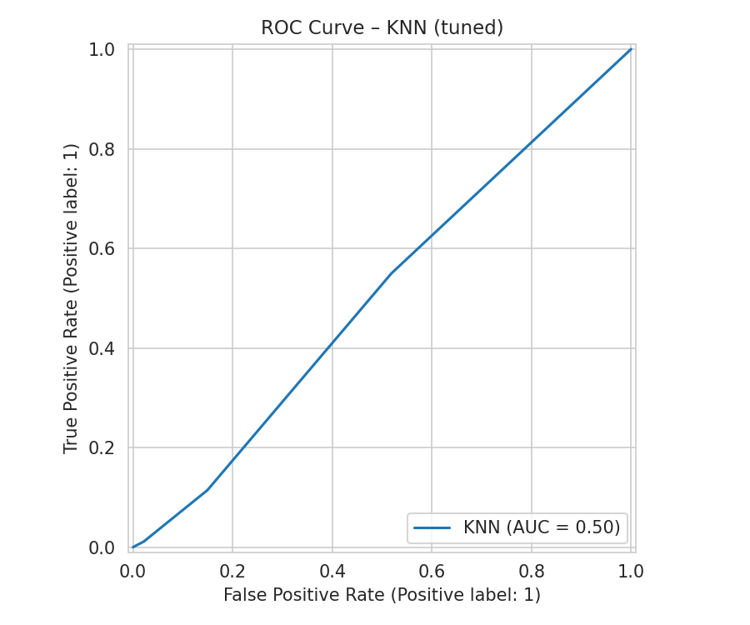  KNN
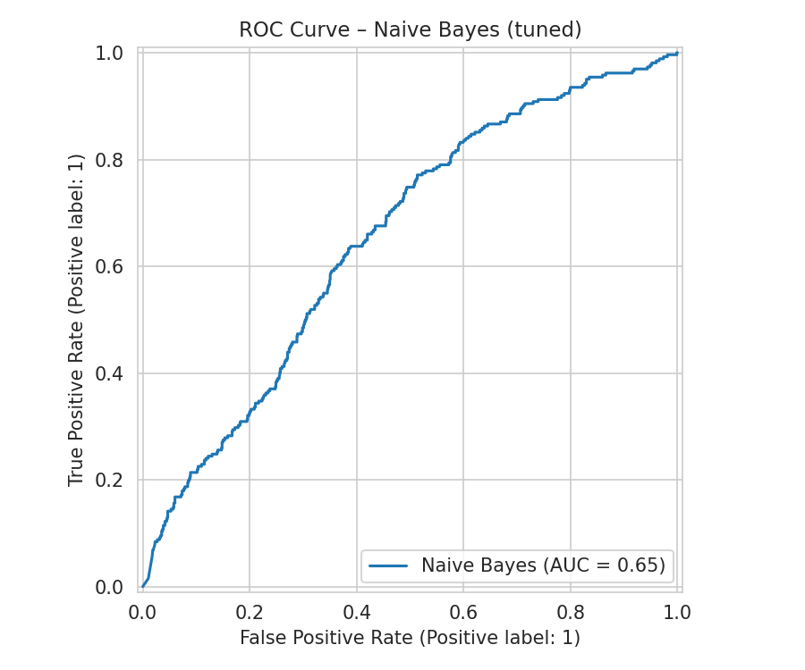  Naive Bayes | 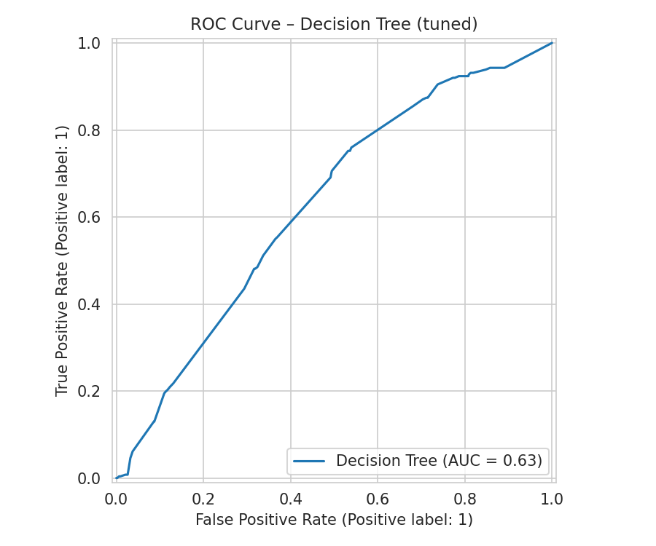  Decision Tree
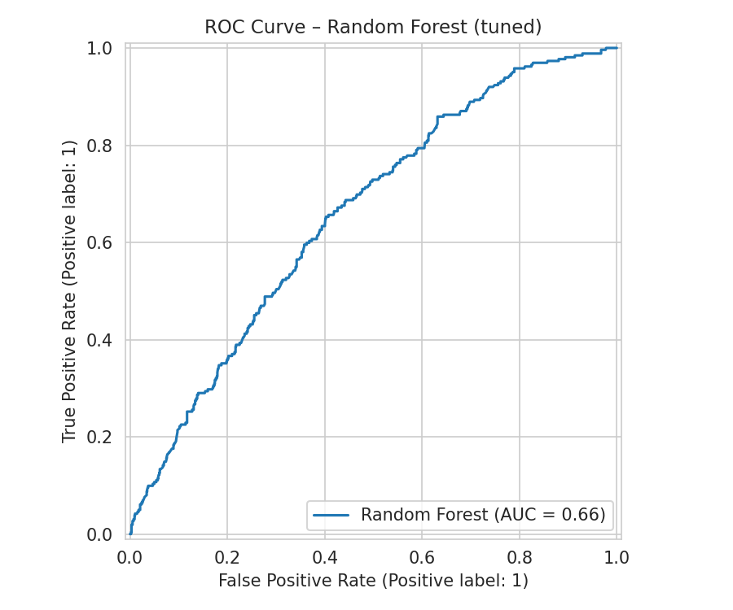  Random Forest | 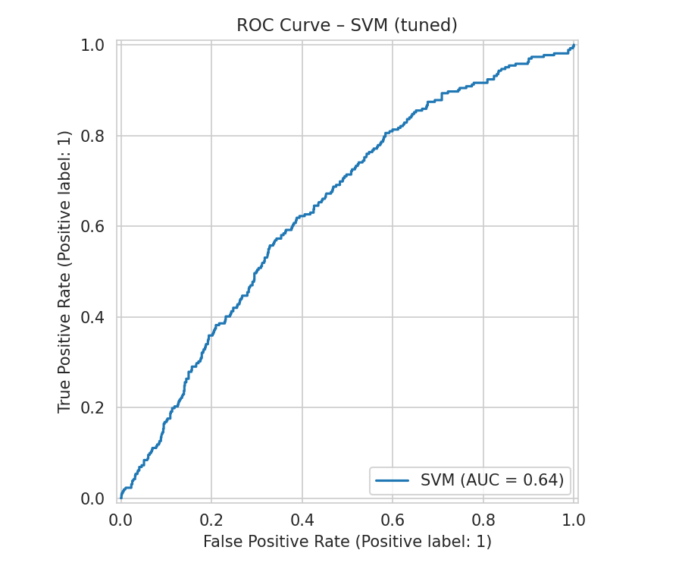  SVM
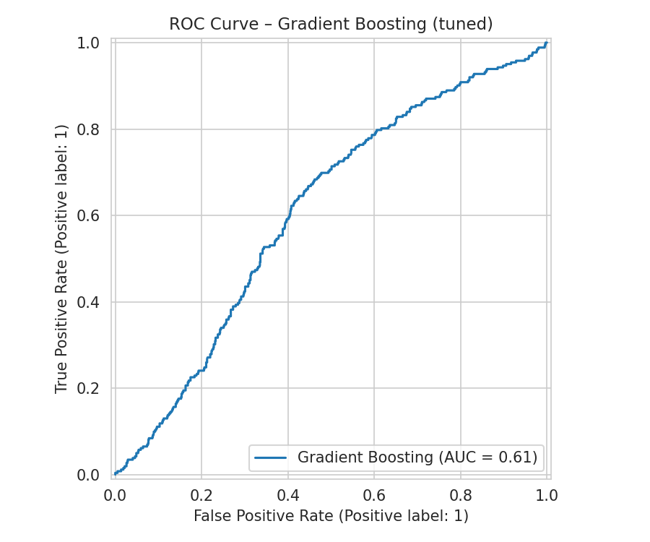  Gradient Boosting | 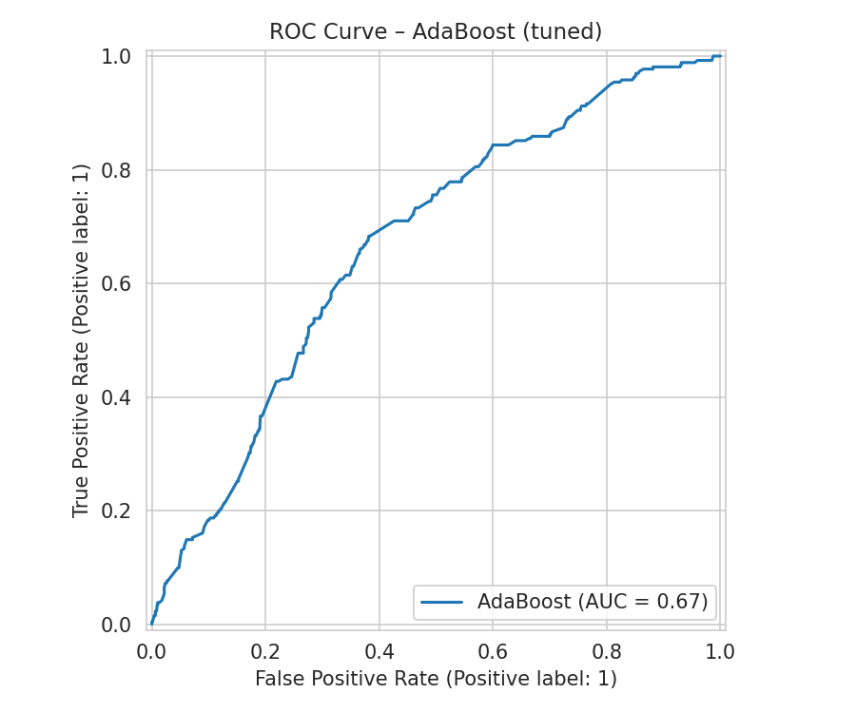  AdaBoost
Figure 23. ROC Curves of All Models After Fine Tuning

4.2.4 Precision-Recall Curves After Fine Tuning
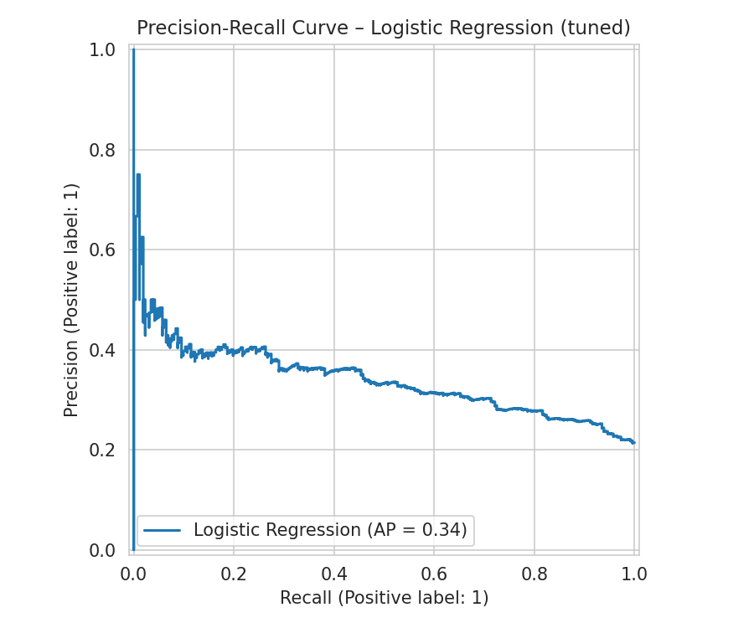  Logistic Regression | 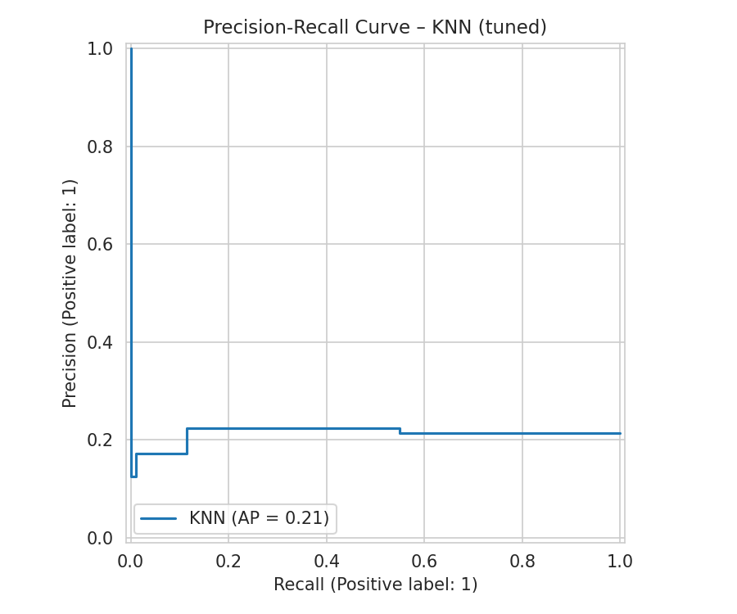  KNN
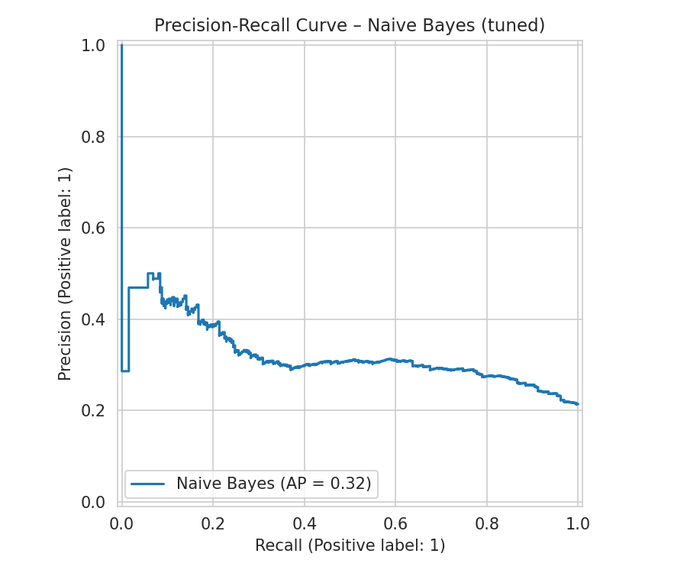  Naive Bayes | 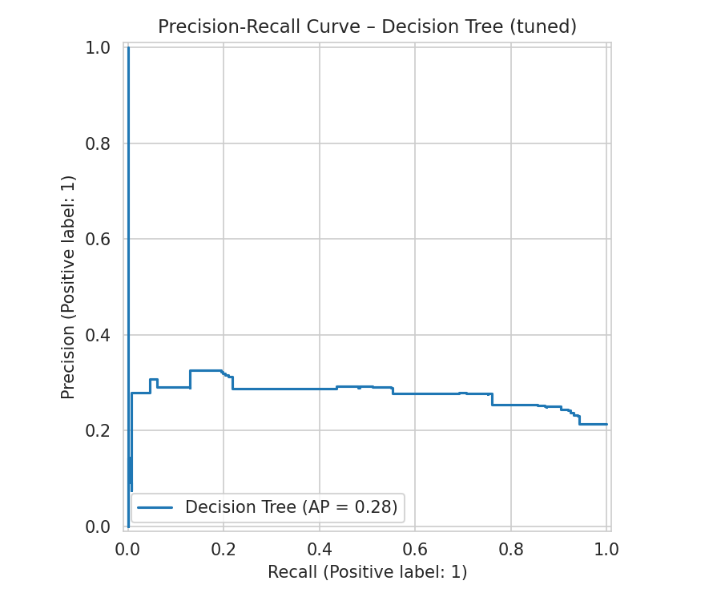  Decision Tree
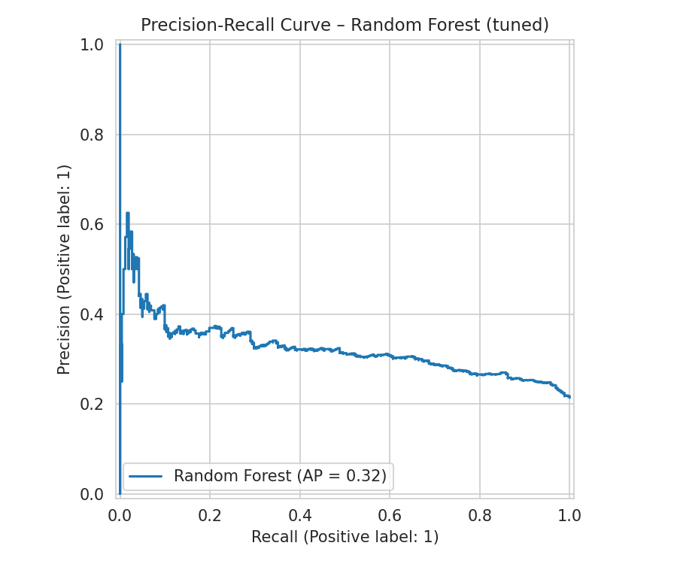  Random Forest | 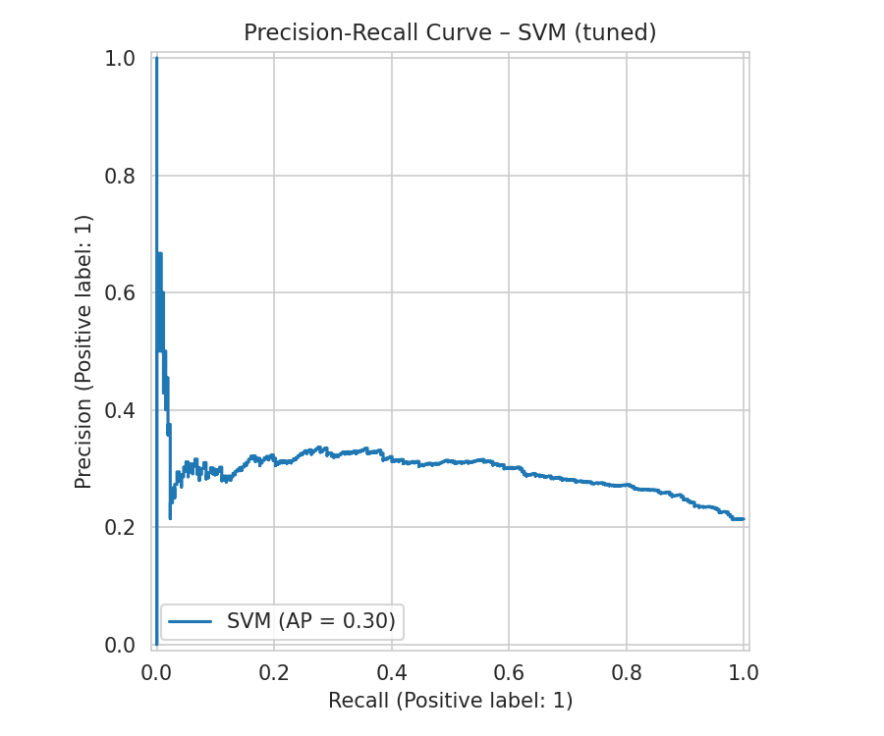  SVM
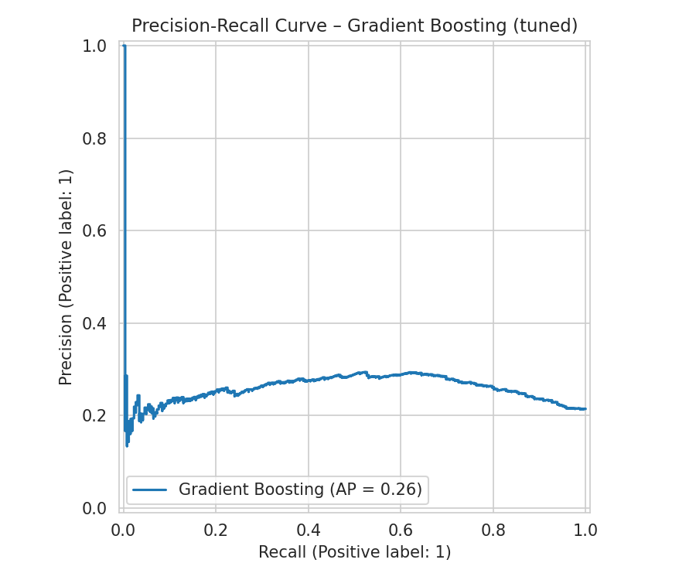  Gradient Boosting | 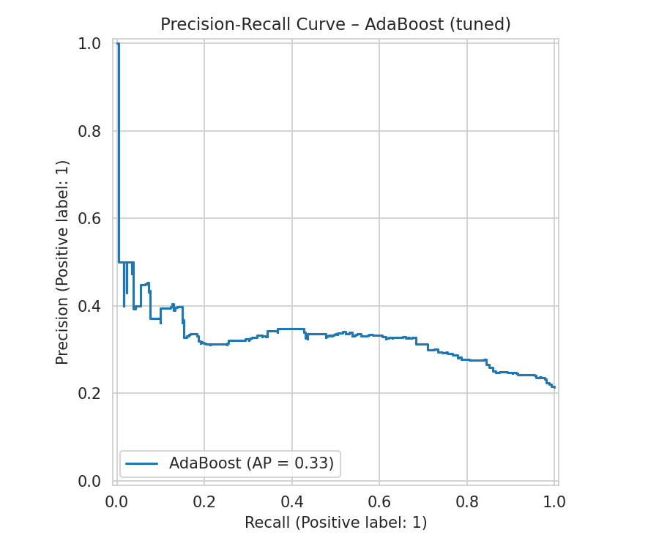  AdaBoost
Figure 24. Precision-Recall Curves of All Models After Fine Tuning

4.3 Best Model Selection
Logistic Regression was selected as the final model (F1 = 0.414); its default hyperparameters were already optimal, so tuning produced no change. Tuning's clearest impact was rescuing Random Forest from severe baseline overfitting (F1 0.122 → 0.411). No model's tuned version underperformed its baseline in the final corrected run. AdaBoost again failed to learn the minority class effectively (F1 = 0.029), consistent with its structural inability to weight rare classes, observed across every imbalanced dataset in this project. Even the best-performing model here remains modest in absolute terms — an intentional, disclosed limitation of the available features rather than the modelling process.

