/Views/Students/Index.cshtml - crop in on the list of students showing 2 added entries, one showing your info, one showing mine

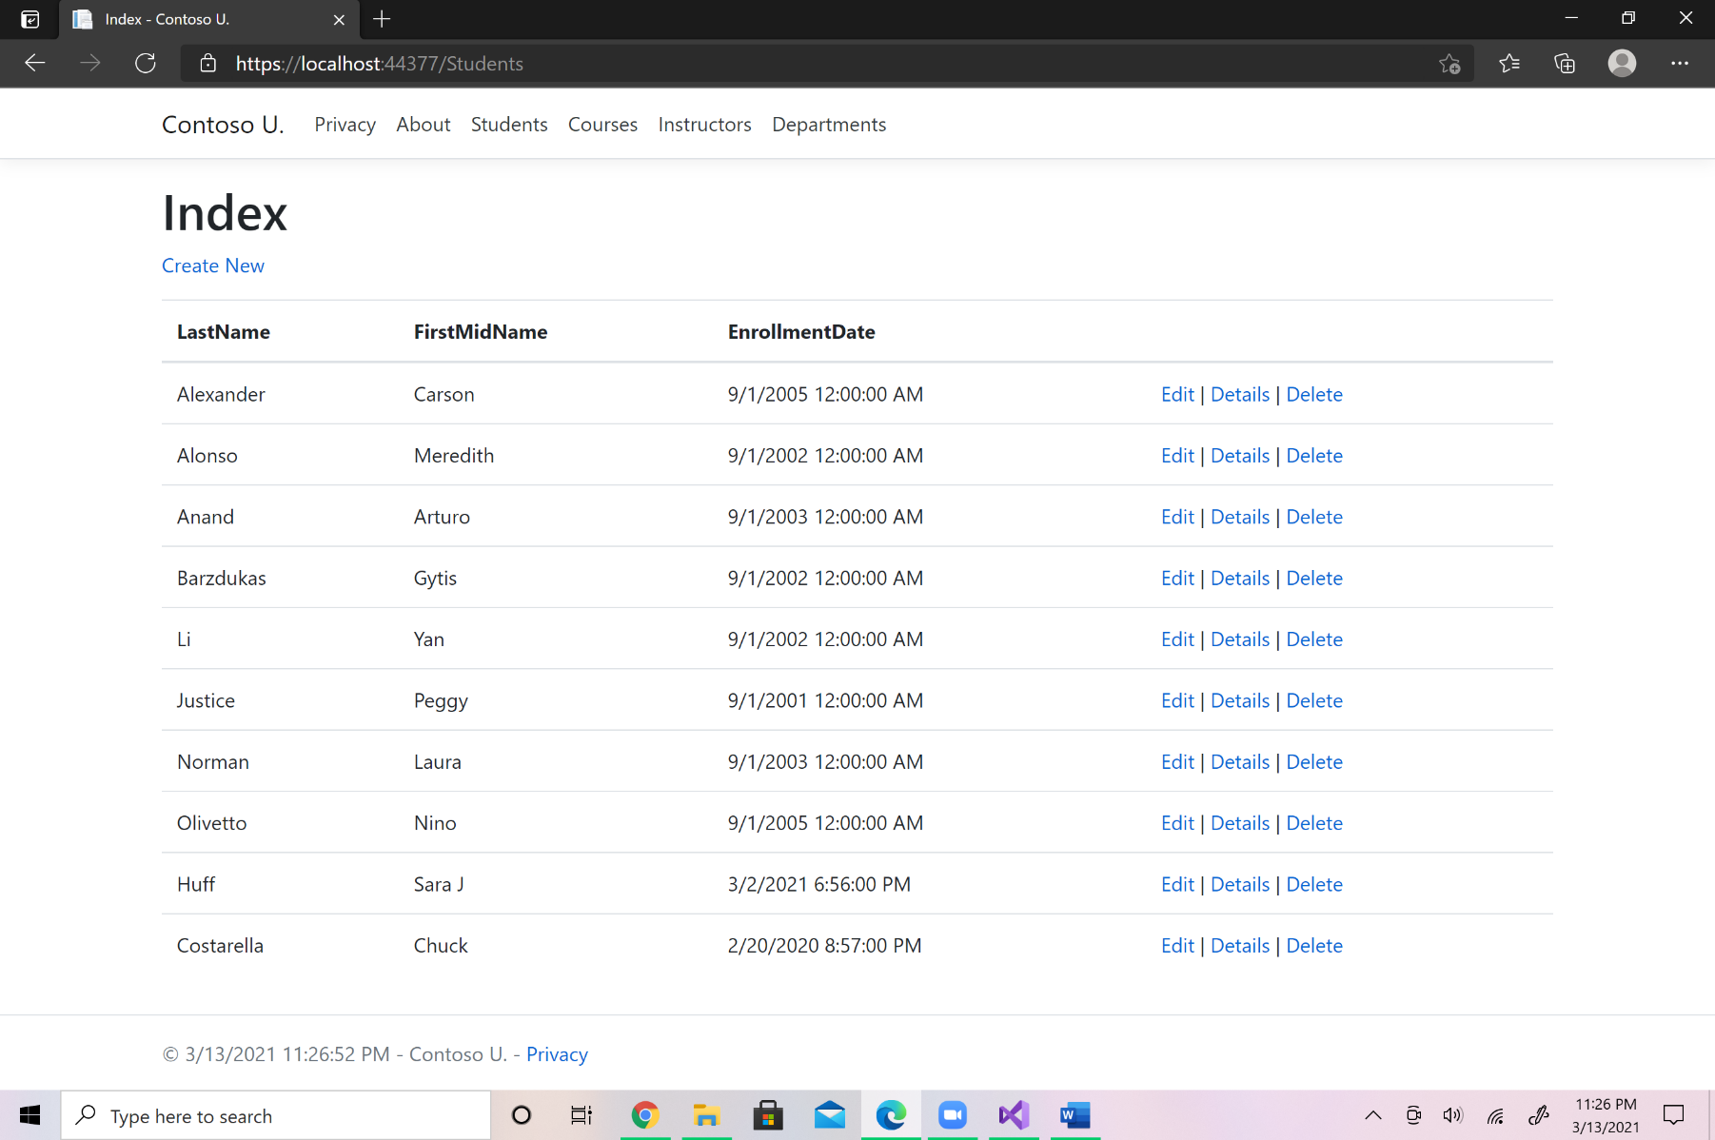

/Views/Students/Edit.cshtml - crop in on the entry fields, show new values for your last name and mine, change yours to Hendrix, mine to Clapton

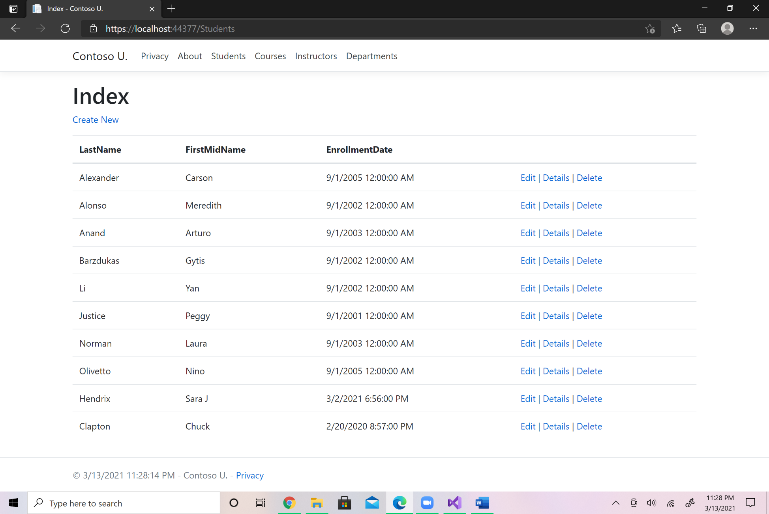

Screen shot the SQL Server Object Explorer showing the Students.dbo table using the View Data command. Make sure the two new added students, (you and me with rock star last names), are clearly readable in the screen shot. Crop tightly and zoom in using the corners. Don't skew the aspect ratio and NO FULL SCREEN IMAGES!!!

