Emergenry Call & NetWork Name & Lock Op
- First of all, press“Load”read the parameter from the FWP before configure any parameters
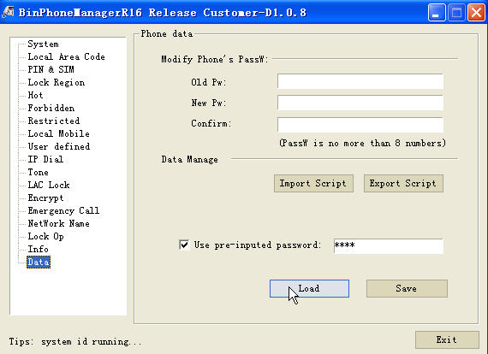
P1. Load Setting from phone
- Emergenry Call
then，press “Emergency Call”，you can fill the emergency call number in this table, you can dial out such number without SIM card:
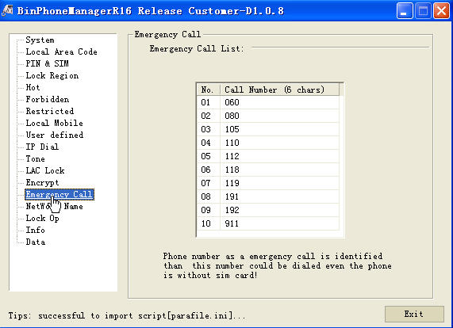
P2. Emergenry Call
Idle mode (without SIM card)
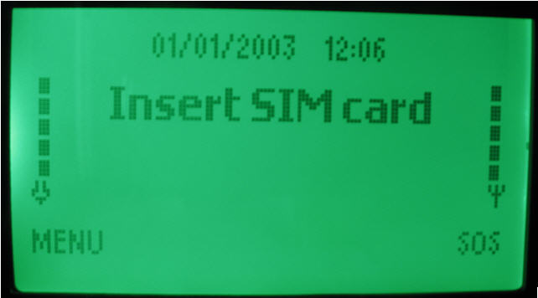
P3. No Sim

Press right-soft key, you can enter the Emergency list as follow:
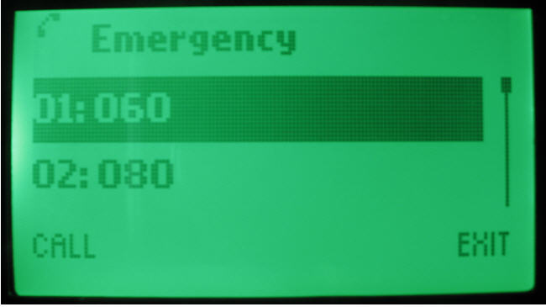
P4. Emergenry Call List

If not comply as your require, you can re-set these number by PC tool, the maximal length for Emergency call number is 6 digits, also you can leave it as empty. It means not support such emergency number if you still cannot dial out such number

- NetWork Name
Client must configure such parameter before release such sample to market if we hadn’t do it.
3.1 To confirm whether“Mcc-Mnc-NetWork Name” had been configured
After step1-“Load”，press “NetWork Name”, IT means you haven’t do such configure if the list is empty 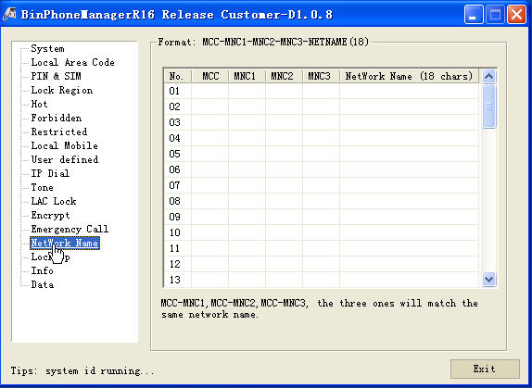
P5. Mcc-Mnc-NetWork Name is empty

It will only show the MNC-MCC code of current SIM card:
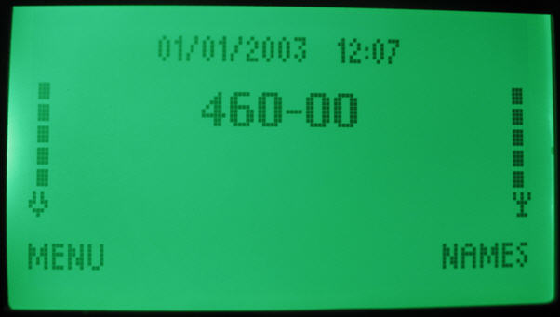
P6. MCC-MNC display
“460”means MCC, “00”means MNC, so we must do the NetWork Name setting.
3.2 how to setup“Mcc-Mnc-NetWork Name”list
Format:MCC-MNC1-MNC2-MNC3-NETNAME18
MCC、MNC1、MNC2、MNC3 is HEX format，between0~0xFFF;
“NetWork Name” relate to MCC-MNC1,MCC-MNC2,MCC-MNC3，18 digits at most
For example:
MCC = “460”
MNC1 = “00” or “0”
MNC2 = Empty or “FFF”
MNC3 = Empty or “FFF”
NetWork Name = “CMCC”
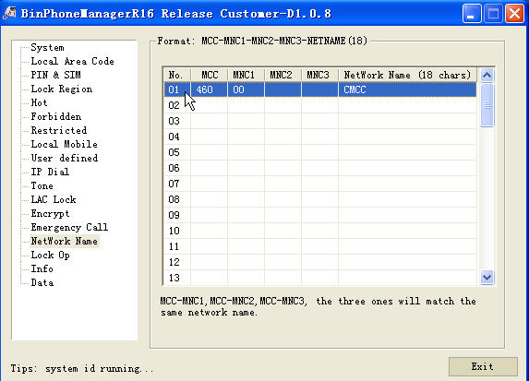
P7. 460-00 display “CMCC”

All the above had finish , press save to import such parameter into your phone, Use pre-inputed password is “0123”:
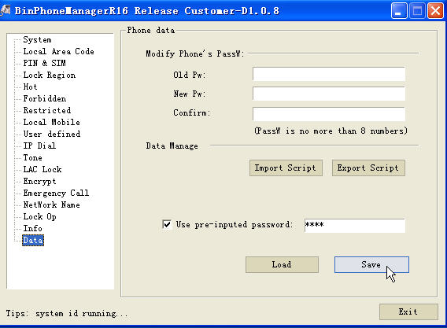
P8. “Save” setting to phone

After that, the phone could display the network name rightly
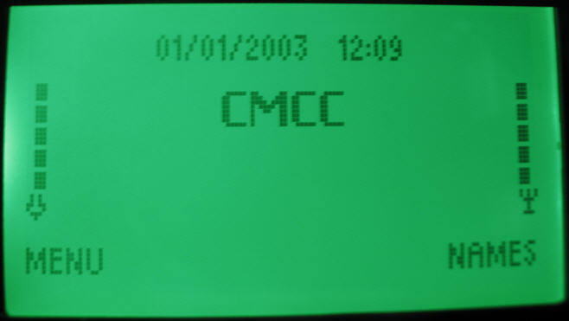
P9. NetWork Name “CMCC” display on phone

4. Lock Op
The phone could only using the appointed operator SIM card if you lock it.
4.1 instruction:
4.1.1. after finished step1-“Load”,press “Lock Op”,
4.1.2 “Lock Operator” select-“Yes”
4.1.3 “operator”: input the operator code for locked.
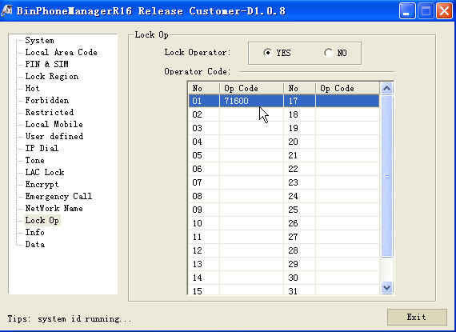
P10. lock “71600”
4.2 unlock the operator lock
“Lock Operator”select-“No”
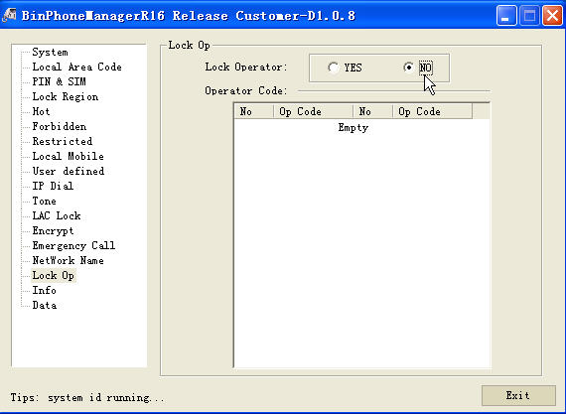
P10. unlock
All the above process had finish , press “Save”.
Also, you can do this using the dark code:
Format:
1). *#8599*index*mcc*mnc#* -- appointed operator
Index --- the “No.”of table in “Lock Op”
Mcc --- the mcc of the operator code(3 digits)
Mnc --- the mnc of the operator code(2 or 3digits，except mcc in operator code)
2). *#85991# --- active the operator lock, lock the above operator code. take effect when restart.
3). *#85990# --- unlock it unlock the operator lock.
for example：lock 71606
a. *#8599*1*716*00#* appointed operator code “71600”, and stored in No.1
b. *#85991# active the operator lock

5. Export Script
Export such script to save as script file, then we can use the same parameter for bass produce
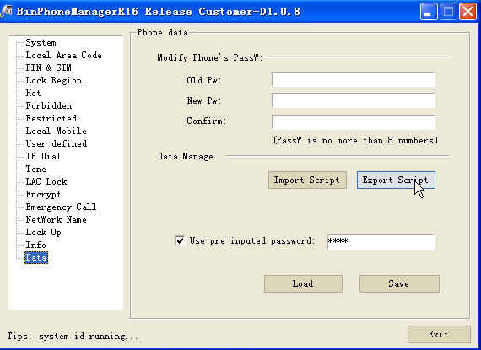
P11. export your setting as a script and send back to us

