Lab : 1

F1 = A’B’C+A’B’C+A’BC+ABC’+ABC+A’B’+BC’+AB

|  |  |  |  |
| --- | --- | --- | --- |
| A | B | C | F1 |
| 0 | 0 | 0 | 1 |
| 0 | 0 | 1 | 1 |
| 0 | 1 | 0 | 1 |
| 0 | 1 | 1 | 1 |
| 1 | 0 | 0 | 0 |
| 1 | 0 | 1 | 0 |
| 1 | 1 | 0 | 1 |
| 1 | 1 | 1 | 1 |
|  |  |  |  |

2.

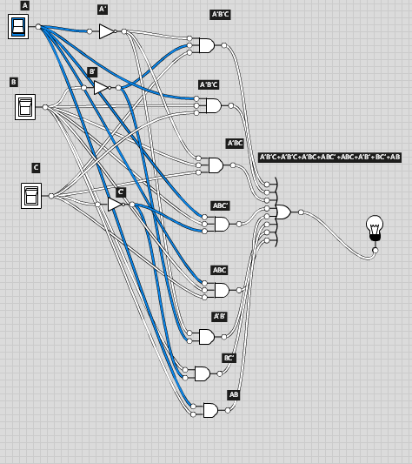

3.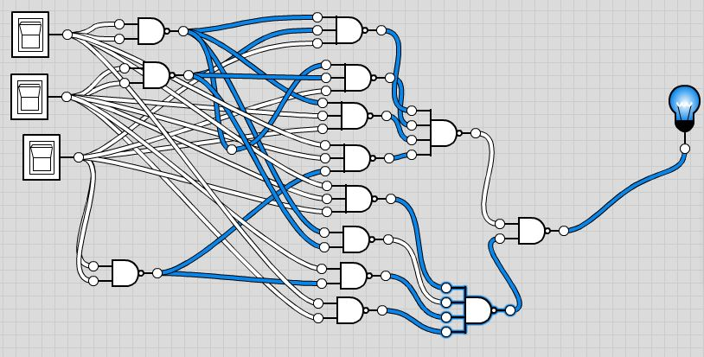

4.

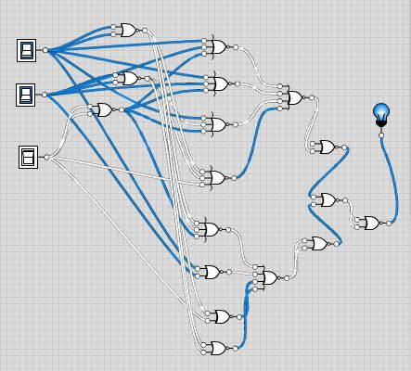

F2 = A’B’C’D+AB’C’D+A’BC’D+ABC’D+A’BCD+ABCD

|  |  |  |  |  |
| --- | --- | --- | --- | --- |
| A | B | C | D | F2 |
| 0 | 0 | 0 | 0 | 0 |
| 0 | 0 | 0 | 1 | 1 |
| 0 | 0 | 1 | 0 | 0 |
| 0 | 0 | 1 | 1 | 0 |
| 0 | 1 | 0 | 0 | 0 |
| 0 | 1 | 0 | 1 | 1 |
| 0 | 1 | 1 | 0 | 0 |
| 0 | 1 | 1 | 1 | 1 |
| 1 | 0 | 0 | 0 | 0 |
| 1 | 0 | 0 | 1 | 1 |
| 1 | 0 | 1 | 0 | 0 |
| 1 | 0 | 1 | 1 | 0 |
| 1 | 1 | 0 | 0 | 0 |
| 1 | 1 | 0 | 1 | 1 |
| 1 | 1 | 1 | 0 | 0 |
| 1 | 1 | 1 | 1 | 1 |

2.

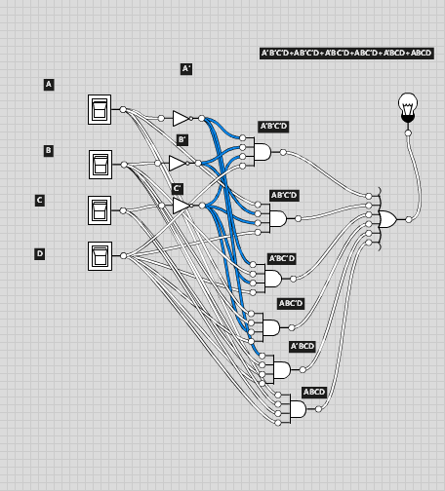

3.

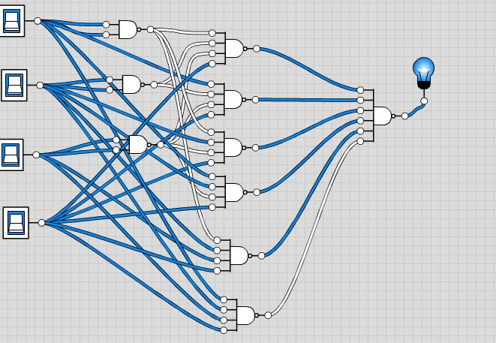

4.

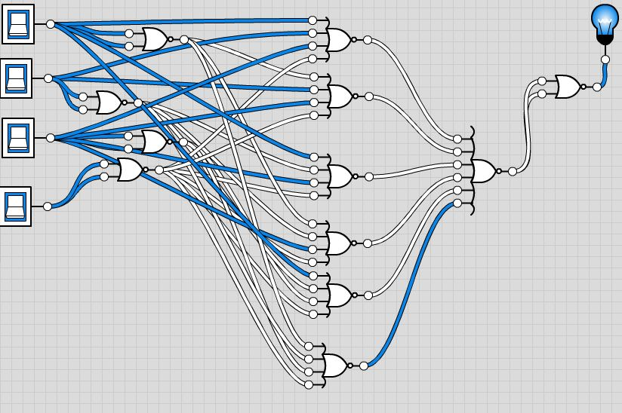

F3 = AB+A’BC’D+A’BCD+AB’C’D

|  |  |  |  |  |
| --- | --- | --- | --- | --- |
| A | B | C | D | F3 |
| 0 | 0 | 0 | 0 | 0 |
| 0 | 0 | 0 | 1 | 0 |
| 0 | 0 | 1 | 0 | 0 |
| 0 | 0 | 1 | 1 | 0 |
| 0 | 1 | 0 | 0 | 0 |
| 0 | 1 | 0 | 1 | 1 |
| 0 | 1 | 1 | 0 | 0 |
| 0 | 1 | 1 | 1 | 1 |
| 1 | 0 | 0 | 0 | 0 |
| 1 | 0 | 0 | 1 | 1 |
| 1 | 0 | 1 | 0 | 0 |
| 1 | 0 | 1 | 1 | 0 |
| 1 | 1 | 0 | 0 | 1 |
| 1 | 1 | 0 | 1 | 1 |
| 1 | 1 | 1 | 0 | 1 |
| 1 | 1 | 1 | 1 | 1 |

2.

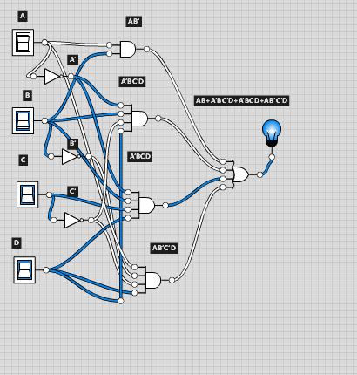

3.

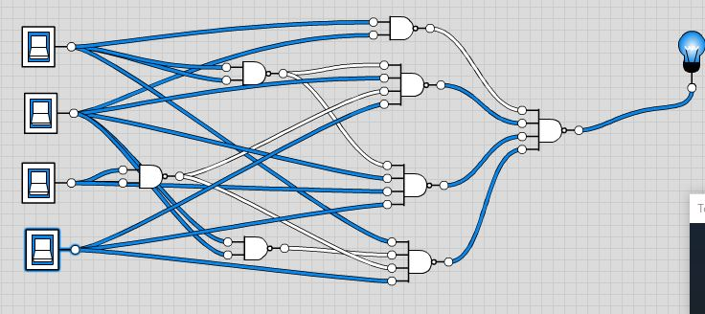

4.

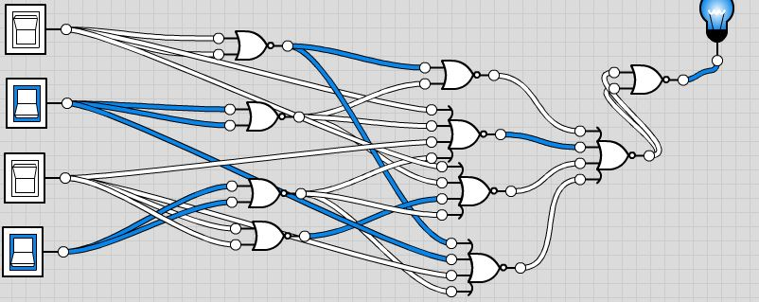

F4 = C + S where C = xy + xz + yz and S = C’ (x + y+ z) + xyz

|  |  |  |  |
| --- | --- | --- | --- |
| x | y | z | F4 |
| 0 | 0 | 0 | 0 |
| 0 | 0 | 1 | 1 |
| 0 | 1 | 0 | 1 |
| 0 | 1 | 1 | 0 |
| 1 | 0 | 0 | 1 |
| 1 | 0 | 1 | 0 |
| 1 | 1 | 0 | 0 |
| 1 | 1 | 1 | 1 |

2.

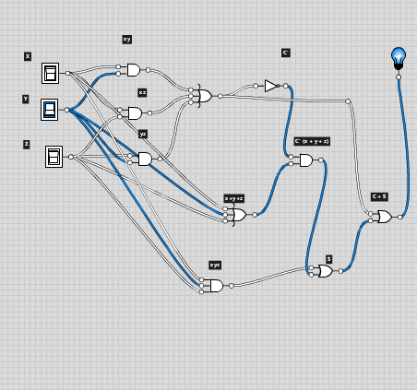

3.

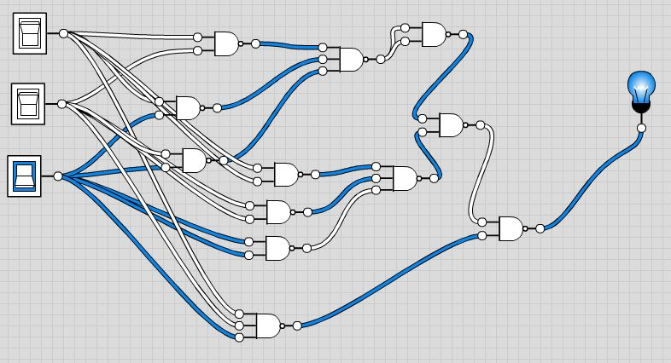

4.

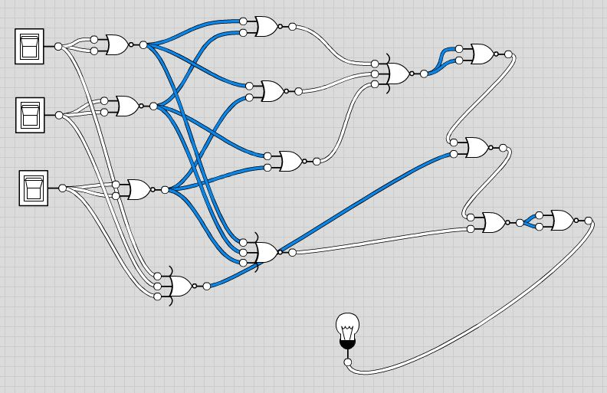

F5 = F1 + F2 (F4)

1.

|  |  |  |  |  |  |  |  |
| --- | --- | --- | --- | --- | --- | --- | --- |
| A/X | B/Y | C/Z | D | F1 | F2 | F4 | F5 |
| 0 | 0 | 0 | 0 | 1 | 0 | 0 | 1 |
| 0 | 0 | 0 | 1 | 1 | 1 | 0 | 1 |
| 0 | 0 | 1 | 0 | 1 | 0 | 1 | 1 |
| 0 | 0 | 1 | 1 | 1 | 0 | 1 | 1 |
| 0 | 1 | 0 | 0 | 1 | 0 | 1 | 1 |
| 0 | 1 | 0 | 1 | 1 | 1 | 1 | 1 |
| 0 | 1 | 1 | 0 | 1 | 0 | 1 | 1 |
| 0 | 1 | 1 | 1 | 1 | 1 | 1 | 1 |
| 1 | 0 | 0 | 0 | 0 | 0 | 1 | 0 |
| 1 | 0 | 0 | 1 | 0 | 1 | 1 | 1 |
| 1 | 0 | 1 | 0 | 0 | 0 | 1 | 0 |
| 1 | 0 | 1 | 1 | 0 | 0 | 1 | 0 |
| 1 | 1 | 0 | 0 | 1 | 0 | 1 | 1 |
| 1 | 1 | 0 | 1 | 1 | 1 | 1 | 1 |
| 1 | 1 | 1 | 0 | 1 | 0 | 1 | 1 |
| 1 | 1 | 1 | 1 | 1 | 1 | 1 | 1 |

2.

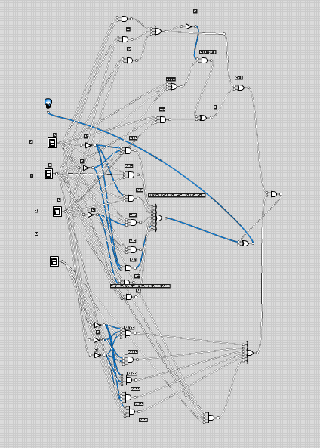

3.

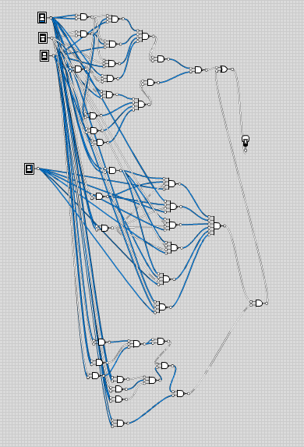

4.

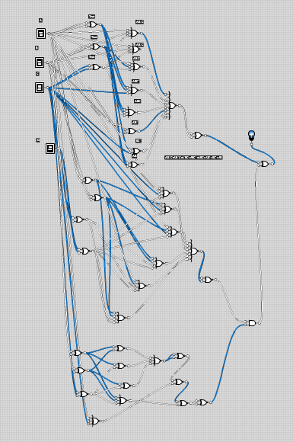

Lab: 2-3

F1 = A’B’+AB’C+’BC+AB’+C+AB’+C’+AB

1.

|  |  |  |  |
| --- | --- | --- | --- |
| A | B | C | F1 |
|  |  |  |  |
| 0 | 0 | 0 | 1 |
| 0 | 0 | 1 | 1 |
| 0 | 1 | 0 | 1 |
| 0 | 1 | 1 | 1 |
| 1 | 0 | 0 | 1 |
| 1 | 0 | 1 | 1 |
| 1 | 1 | 0 | 1 |
| 1 | 1 | 1 | 1 |

2.

Min terms = A’B’C’ + A’B’C + A’BC’ + A’BC’ + AB’C + AB’C’ + ABC’ + ABC

3.

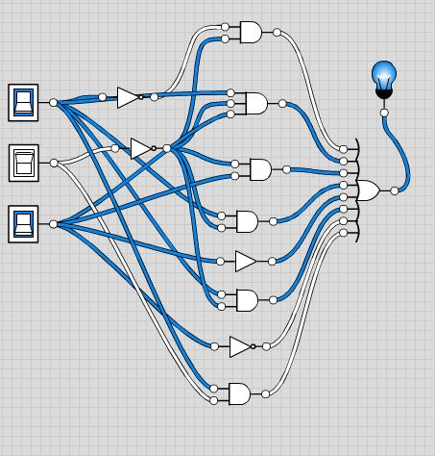

4.

|  |  |  |  |  |
| --- | --- | --- | --- | --- |
| A | B | C | F1 | F1’ |
|  |  |  |  |  |
| 0 | 0 | 0 | 1 | 0 |
| 0 | 0 | 1 | 1 | 0 |
| 0 | 1 | 0 | 1 | 0 |
| 0 | 1 | 1 | 1 | 0 |
| 1 | 0 | 0 | 1 | 0 |
| 1 | 0 | 1 | 1 | 0 |
| 1 | 1 | 0 | 1 | 0 |
| 1 | 1 | 1 | 1 | 0 |

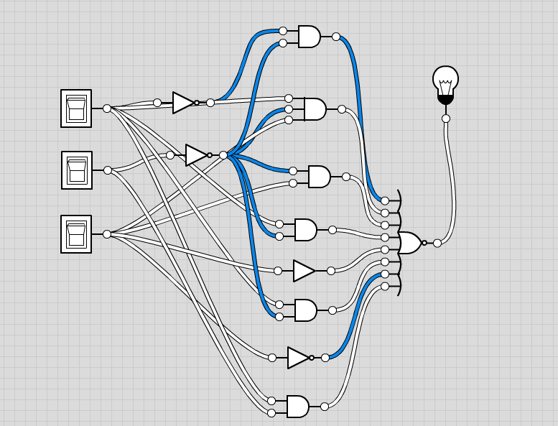

F2 = AB’C’D+ABC’+C’D+BC’D+A’B+AD

1.

|  |  |  |  |  |  |  |
| --- | --- | --- | --- | --- | --- | --- |
| A | B | C | D | F2 | F2’ | F2 |
| 0 | 0 | 0 | 0 | 0 | 1 | 0 |
| 0 | 0 | 0 | 1 | 1 | 0 | 1 |
| 0 | 0 | 1 | 0 | 0 | 1 | 0 |
| 0 | 0 | 1 | 1 | 0 | 1 | 0 |
| 0 | 1 | 0 | 0 | 1 | 0 | 1 |
| 0 | 1 | 0 | 1 | 1 | 0 | 1 |
| 0 | 1 | 1 | 0 | 1 | 0 | 1 |
| 0 | 1 | 1 | 1 | 1 | 0 | 1 |
| 1 | 0 | 0 | 0 | 0 | 1 | 0 |
| 1 | 0 | 0 | 1 | 1 | 0 | 1 |
| 1 | 0 | 1 | 0 | 0 | 1 | 0 |
| 1 | 0 | 1 | 1 | 1 | 0 | 1 |
| 1 | 1 | 0 | 0 | 1 | 0 | 1 |
| 1 | 1 | 0 | 1 | 1 | 0 | 1 |
| 1 | 1 | 1 | 0 | 0 | 1 | 0 |
| 1 | 1 | 1 | 1 | 1 | 0 | 1 |

2.

Min Terms = A’B’C’D + A’BC’D’ + A’BC’D + A’BCD’ + A’BCD + AB’C’ D+ AB’CD + ABC’D’ + ABC’D + ABCD

3.

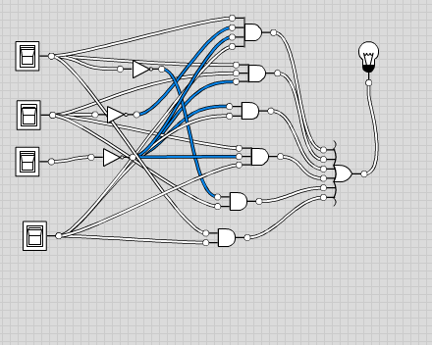

4.

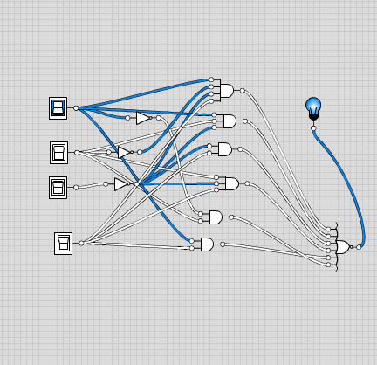

F3 = AB+A’B’D+A’B+AB’C’D

1.

|  |  |  |  |  |  |
| --- | --- | --- | --- | --- | --- |
| A | B | C | D | F3 | F3’ |
| 0 | 0 | 0 | 0 | 0 | 1 |
| 0 | 0 | 0 | 1 | 1 | 0 |
| 0 | 0 | 1 | 0 | 0 | 1 |
| 0 | 0 | 1 | 1 | 1 | 0 |
| 0 | 1 | 0 | 0 | 1 | 0 |
| 0 | 1 | 0 | 1 | 1 | 0 |
| 0 | 1 | 1 | 0 | 1 | 0 |
| 0 | 1 | 1 | 1 | 1 | 0 |
| 1 | 0 | 0 | 0 | 0 | 1 |
| 1 | 0 | 0 | 1 | 1 | 0 |
| 1 | 0 | 1 | 0 | 0 | 1 |
| 1 | 0 | 1 | 1 | 0 | 1 |
| 1 | 1 | 0 | 0 | 1 | 0 |
| 1 | 1 | 0 | 1 | 1 | 0 |
| 1 | 1 | 1 | 0 | 1 | 0 |
| 1 | 1 | 1 | 1 | 1 | 0 |

2.

Min Terms = A’B’C’D+A’B’CD+A’BC’D’+A’BC’D+A’BCD’ A’BCD+AB’C’D+ABC’D’+ABC’D+ABCD’+ABCD

3.

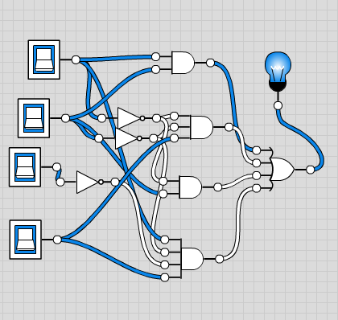

4.

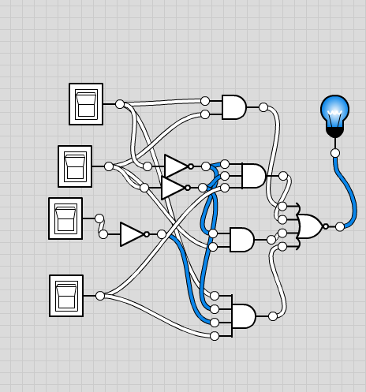

F4 = C + S where C = xy + yz and S = C’ (x + y) + xyz

|  |  |  |  |  |
| --- | --- | --- | --- | --- |
| x | y | z | F4 | F4’ |
| 0 | 0 | 0 | 0 | 1 |
| 0 | 0 | 1 | 0 | 1 |
| 0 | 1 | 0 | 1 | 0 |
| 0 | 1 | 1 | 1 | 0 |
| 1 | 0 | 0 | 1 | 0 |
| 1 | 0 | 1 | 1 | 0 |
| 1 | 1 | 0 | 1 | 0 |
| 1 | 1 | 1 | 1 | 0 |

2.

Min Terms = x’yz’+x’yz+xy’z’+xy’z+xyz’+xyz

3.

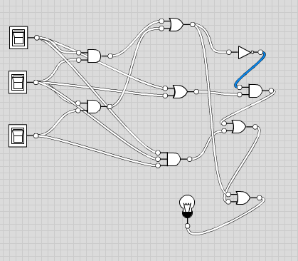

4.

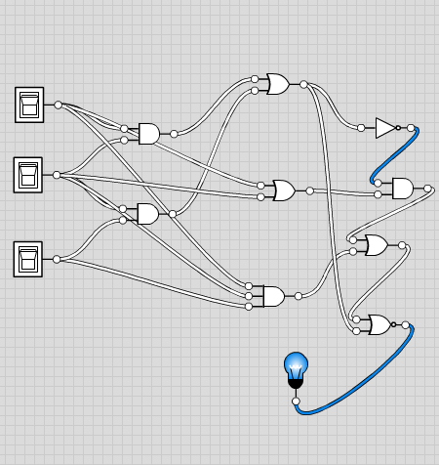

F5 = F3 + F1 (F4)

1.

|  |  |  |  |  |  |  |  |
| --- | --- | --- | --- | --- | --- | --- | --- |
| A/X | B/Y | C/Z | D | F1 | F3 | F4 | F5 |
| 0 | 0 | 0 | 0 | 0 | 0 | 0 | 0 |
| 0 | 0 | 0 | 1 | 1 | 1 | 0 | 1 |
| 0 | 0 | 1 | 0 | 0 | 0 | 0 | 0 |
| 0 | 0 | 1 | 1 | 0 | 1 | 0 | 1 |
| 0 | 1 | 0 | 0 | 1 | 1 | 1 | 1 |
| 0 | 1 | 0 | 1 | 1 | 1 | 1 | 1 |
| 0 | 1 | 1 | 0 | 1 | 1 | 1 | 1 |
| 0 | 1 | 1 | 1 | 1 | 1 | 1 | 1 |
| 1 | 0 | 0 | 0 | 0 | 0 | 1 | 0 |
| 1 | 0 | 0 | 1 | 1 | 1 | 1 | 1 |
| 1 | 0 | 1 | 0 | 0 | 0 | 1 | 0 |
| 1 | 0 | 1 | 1 | 1 | 0 | 1 | 1 |
| 1 | 1 | 0 | 0 | 1 | 1 | 1 | 1 |
| 1 | 1 | 0 | 1 | 1 | 1 | 1 | 1 |
| 1 | 1 | 1 | 0 | 0 | 1 | 1 | 1 |
| 1 | 1 | 1 | 1 | 1 | 1 | 1 | 1 |

2.

Min Terms = F3F1F4’+F3’F1F4+F3F1F4+F3F1F4+F3F1F4+F3F1F4+F3F1F4

3.

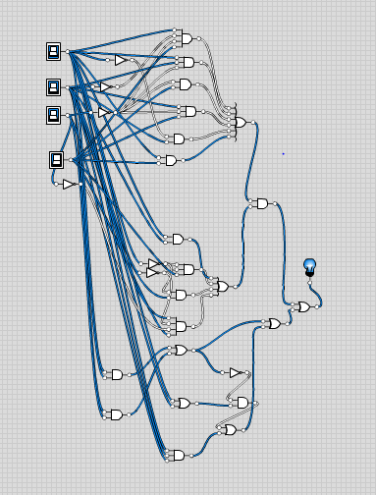

4.

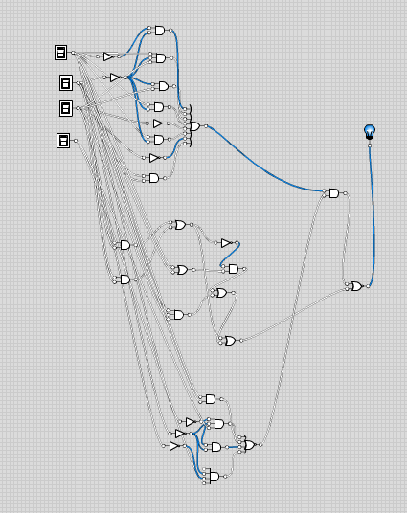

Lab: 4-5

F1 = A’B’+AB’C+A’BC+AB’+C+AB’+C’+AB

1.

|  |  |  |  |
| --- | --- | --- | --- |
| A | B | C | F1 |
| 0 | 0 | 0 | 1 |
| 0 | 0 | 1 | 1 |
| 0 | 1 | 0 | 1 |
| 0 | 1 | 1 | 1 |
| 1 | 0 | 0 | 1 |
| 1 | 0 | 1 | 1 |
| 1 | 1 | 0 | 1 |
| 1 | 1 | 1 | 1 |

2.

K-MAP

|  |  |  |  |
| --- | --- | --- | --- |
| 1 | 1 | 1 | 1 |
| 1 | 1 | 1 | 1 |

EQUATION IS : 1

3.

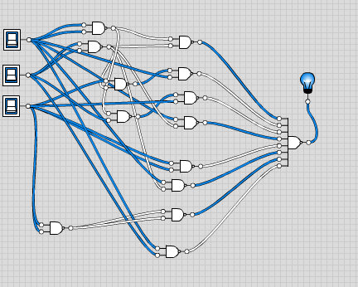

F2 = AB’C’D+AC’D+C’D+C’D+A’B+AD

1.

|  |  |  |  |  |
| --- | --- | --- | --- | --- |
| A | B | C | D | F2 |
| 0 | 0 | 0 | 0 | 0 |
| 0 | 0 | 0 | 1 | 1 |
| 0 | 0 | 1 | 0 | 0 |
| 0 | 0 | 1 | 1 | 0 |
| 0 | 1 | 0 | 0 | 1 |
| 0 | 1 | 0 | 1 | 1 |
| 0 | 1 | 1 | 0 | 1 |
| 0 | 1 | 1 | 1 | 1 |
| 1 | 0 | 0 | 0 | 0 |
| 1 | 0 | 0 | 1 | 1 |
| 1 | 0 | 1 | 0 | 0 |
| 1 | 0 | 1 | 1 | 1 |
| 1 | 1 | 0 | 0 | 0 |
| 1 | 1 | 0 | 1 | 1 |
| 1 | 1 | 1 | 0 | 0 |
| 1 | 1 | 1 | 1 | 1 |

2.

K-MAP

|  |  |  |  |
| --- | --- | --- | --- |
| 0 | 1 | 0 | 0 |
| 1 | 1 | 1 | 1 |
| 0 | 1 | 1 | 0 |
| 0 | 1 | 1 | 0 |

EQUATION IS : C’D + A’B + AD

3.

F2 = AB’C’D+AC’D+C’D+C’D+A’B+AD

1.

|  |  |  |  |  |
| --- | --- | --- | --- | --- |
| A | B | C | D | F2 |
| 0 | 0 | 0 | 0 | 0 |
| 0 | 0 | 0 | 1 | 1 |
| 0 | 0 | 1 | 0 | 0 |
| 0 | 0 | 1 | 1 | 0 |
| 0 | 1 | 0 | 0 | 1 |
| 0 | 1 | 0 | 1 | 1 |
| 0 | 1 | 1 | 0 | 1 |
| 0 | 1 | 1 | 1 | 1 |
| 1 | 0 | 0 | 0 | 0 |
| 1 | 0 | 0 | 1 | 1 |
| 1 | 0 | 1 | 0 | 0 |
| 1 | 0 | 1 | 1 | 1 |
| 1 | 1 | 0 | 0 | 0 |
| 1 | 1 | 0 | 1 | 1 |
| 1 | 1 | 1 | 0 | 0 |
| 1 | 1 | 1 | 1 | 1 |

2.

K-MAP

|  |  |  |  |
| --- | --- | --- | --- |
| 0 | 1 | 0 | 0 |
| 1 | 1 | 1 | 1 |
| 0 | 1 | 1 | 0 |
| 0 | 1 | 1 | 0 |

EQUATION IS : C’D + A’B + AD

3.

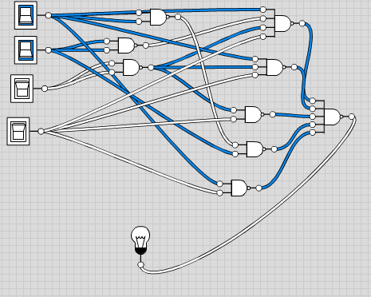

F3 = AB+A’C’D+A’BD+AB’C’

1.

|  |  |  |  |  |
| --- | --- | --- | --- | --- |
| A | B | C | D | F3 |
| 0 | 0 | 0 | 0 | 0 |
| 0 | 0 | 0 | 1 | 1 |
| 0 | 0 | 1 | 0 | 0 |
| 0 | 0 | 1 | 1 | 0 |
| 0 | 1 | 0 | 0 | 0 |
| 0 | 1 | 0 | 1 | 1 |
| 0 | 1 | 1 | 0 | 0 |
| 0 | 1 | 1 | 1 | 1 |
| 1 | 0 | 0 | 0 | 1 |
| 1 | 0 | 0 | 1 | 1 |
| 1 | 0 | 1 | 0 | 0 |
| 1 | 0 | 1 | 1 | 0 |
| 1 | 1 | 0 | 0 | 1 |
| 1 | 1 | 0 | 1 | 1 |
| 1 | 1 | 1 | 0 | 1 |
| 1 | 1 | 1 | 1 | 1 |

2.

K-MAP

|  |  |  |  |
| --- | --- | --- | --- |
| 0 | 1 | 0 | 0 |
| 0 | 1 | 1 | 0 |
| 1 | 1 | 1 | 1 |
| 1 | 1 | 0 | 0 |

EQUATION IS : C’D + BD+ AC’ + AB

3.

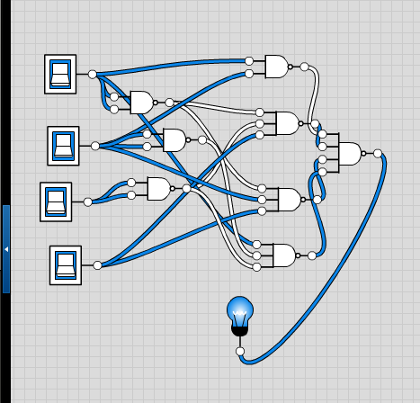

F4 = C + S where C = xy + yz and S = C’ (x + y) + xyz

1.

|  |  |  |  |
| --- | --- | --- | --- |
| x | y | z | F4 |
| 0 | 0 | 0 | 0 |
| 0 | 0 | 1 | 0 |
| 0 | 1 | 0 | 1 |
| 0 | 1 | 1 | 1 |
| 1 | 0 | 0 | 1 |
| 1 | 0 | 1 | 1 |
| 1 | 1 | 0 | 1 |
| 1 | 1 | 1 | 1 |

2.

k-map

|  |  |  |  |
| --- | --- | --- | --- |
| 0 | 0 | 1 | 1 |
| 1 | 1 | 1 | 1 |

Equation is : x + y

3.

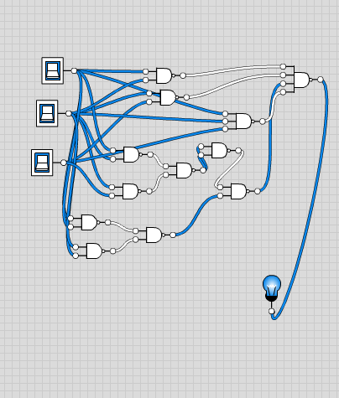

F5 = F3 + F1 (F4)

|  |  |  |  |  |  |  |  |
| --- | --- | --- | --- | --- | --- | --- | --- |
| A | B | C | D | F1 | F4 | F3 | F5 |
| 0 | 0 | 0 | 0 | 1 | 0 | 0 | 0 |
| 0 | 0 | 0 | 1 | 1 | 0 | 1 | 1 |
| 0 | 0 | 1 | 0 | 1 | 0 | 0 | 0 |
| 0 | 0 | 1 | 1 | 1 | 0 | 0 | 0 |
| 0 | 1 | 0 | 0 | 1 | 1 | 0 | 1 |
| 0 | 1 | 0 | 1 | 1 | 1 | 1 | 1 |
| 0 | 1 | 1 | 0 | 1 | 1 | 1 | 1 |
| 0 | 1 | 1 | 1 | 1 | 1 | 1 | 1 |
| 1 | 0 | 0 | 0 | 1 | 1 | 1 | 1 |
| 1 | 0 | 0 | 1 | 1 | 1 | 1 | 1 |
| 1 | 0 | 1 | 0 | 1 | 1 | 0 | 1 |
| 1 | 0 | 1 | 1 | 1 | 1 | 0 | 1 |
| 1 | 1 | 0 | 0 | 1 | 1 | 1 | 1 |
| 1 | 1 | 0 | 1 | 1 | 1 | 1 | 1 |
| 1 | 1 | 1 | 0 | 1 | 1 | 1 | 1 |
| 1 | 1 | 1 | 1 | 1 | 1 | 1 | 1 |

2.

K-map.

|  |  |  |  |
| --- | --- | --- | --- |
| 1 | 1 |  |  |
| 1 | 1 | 1 | 1 |
| 1 | 1 | 1 | 1 |
| 1 | 1 | 1 | 1 |

Equation is A’C’ + B+A

3.

