Lab : 1

F1 = A’B’C+A’B’C+A’BC+ABC’+ABC+A’B’+BC’+AB

A | B | C | F
0 | 0 | 0 | 1
0 | 0 | 1 | 1
0 | 1 | 0 | 1
0 | 1 | 1 | 1
1 | 0 | 0 | 0
1 | 0 | 1 | 0
1 | 1 | 0 | 1
1 | 1 | 1 | 1

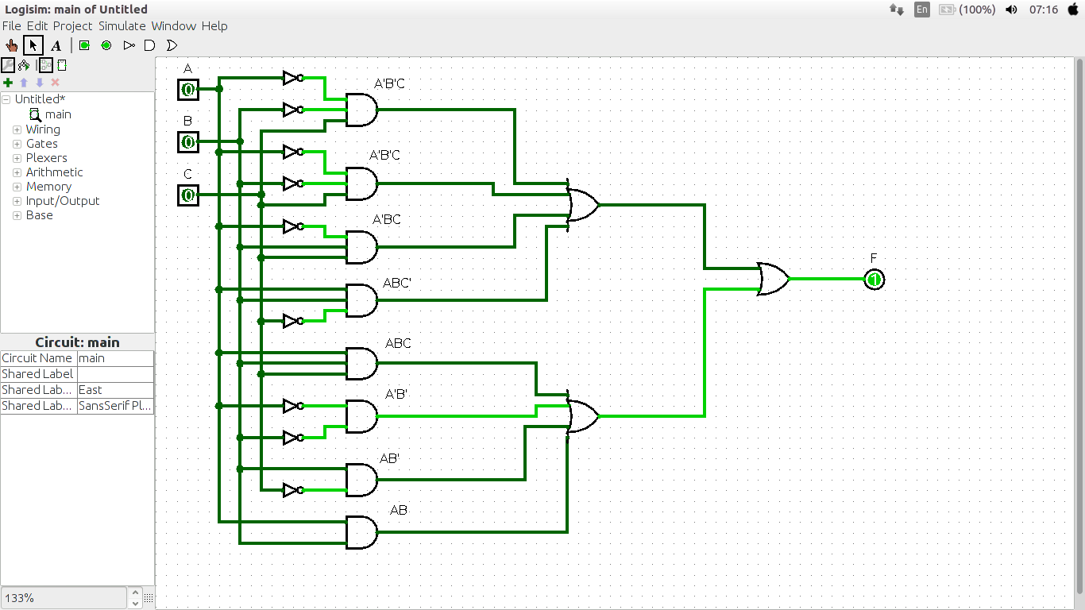

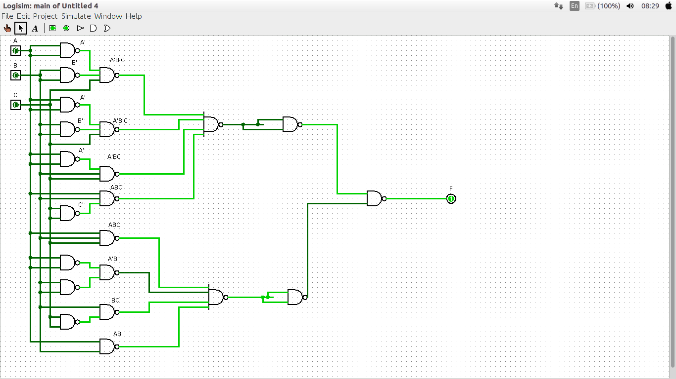

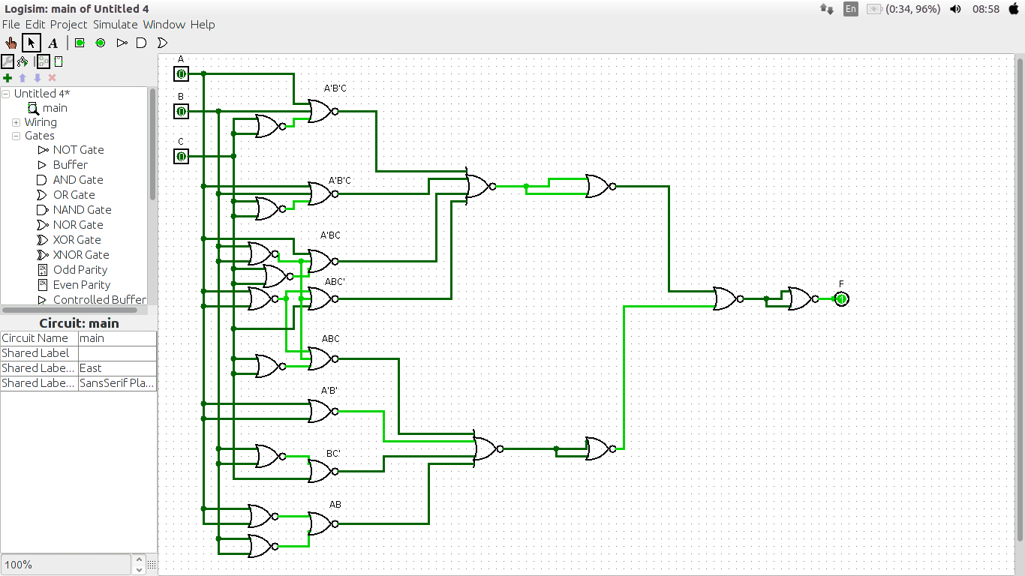

F2 = A’B’C’D+AB’C’D+A’BC’D+ABC’D+A’BCD+ABCD

A | B | C | D | F2
0 | 0 | 0 | 0 | 0
0 | 0 | 0 | 1 | 1
0 | 0 | 1 | 0 | 0
0 | 0 | 1 | 1 | 0
0 | 1 | 0 | 0 | 0
0 | 1 | 0 | 1 | 1
0 | 1 | 1 | 0 | 0
0 | 1 | 1 | 1 | 1
1 | 0 | 0 | 0 | 0
1 | 0 | 0 | 1 | 1
1 | 0 | 1 | 0 | 0
1 | 0 | 1 | 1 | 0
1 | 1 | 0 | 0 | 0
1 | 1 | 0 | 1 | 1
1 | 1 | 1 | 0 | 0
1 | 1 | 1 | 1 | 1
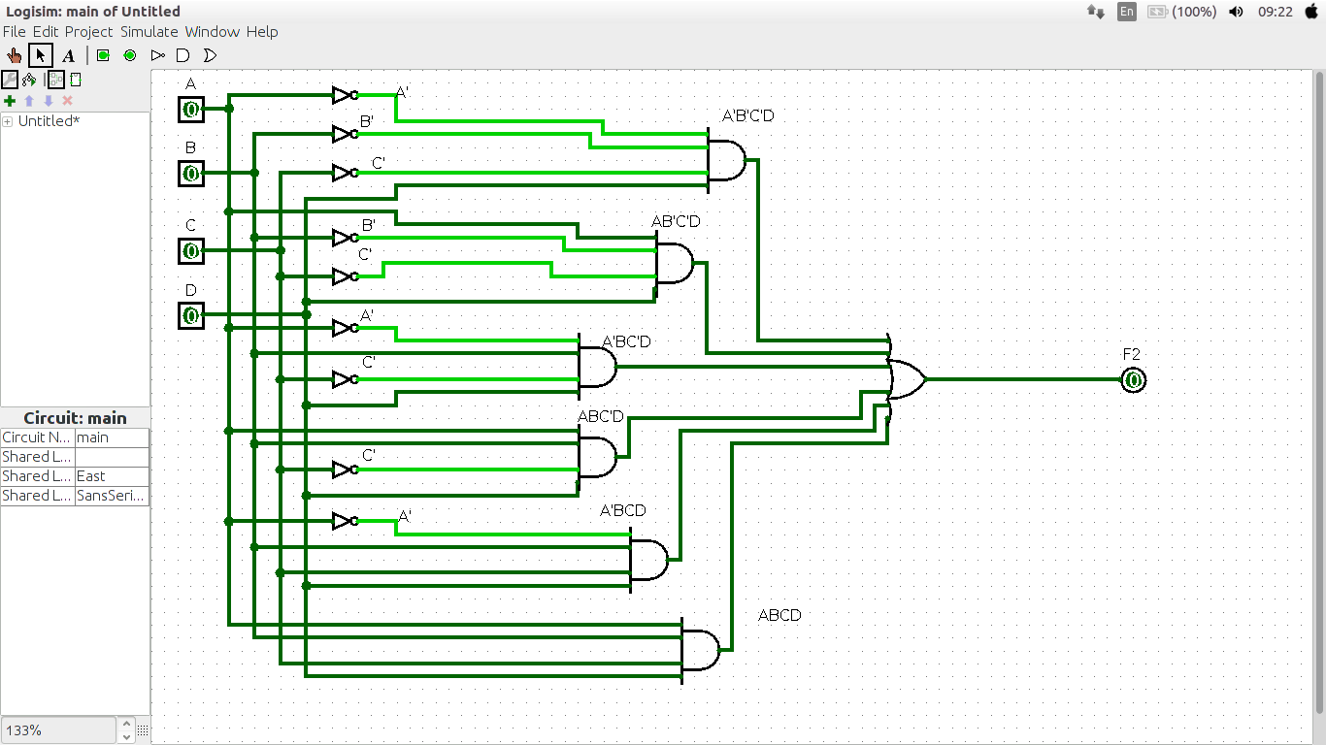
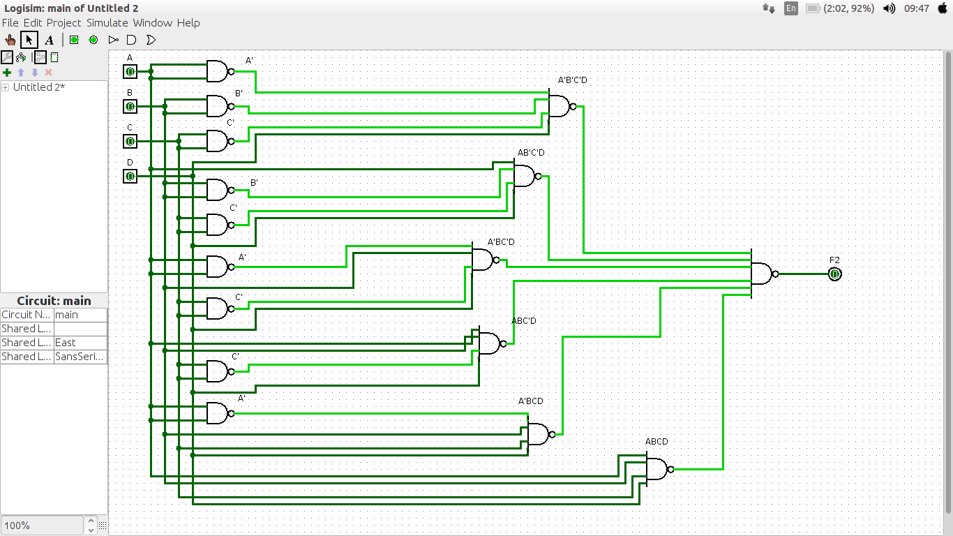

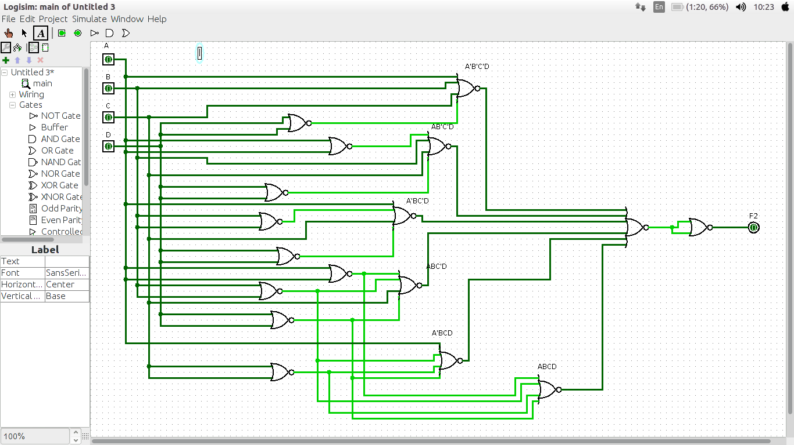

F3 = AB+A’BC’D+A’BCD+AB’C’D

A | B | C | D | F3
0 | 0 | 0 | 0 | 0
0 | 0 | 0 | 1 | 0
0 | 0 | 1 | 0 | 0
0 | 0 | 1 | 1 | 0
0 | 1 | 0 | 0 | 0
0 | 1 | 0 | 1 | 1
0 | 1 | 1 | 0 | 0
0 | 1 | 1 | 1 | 1
1 | 0 | 0 | 0 | 0
1 | 0 | 0 | 1 | 1
1 | 0 | 1 | 0 | 0
1 | 0 | 1 | 1 | 0
1 | 1 | 0 | 0 | 1
1 | 1 | 0 | 1 | 1
1 | 1 | 1 | 0 | 1
1 | 1 | 1 | 1 | 1

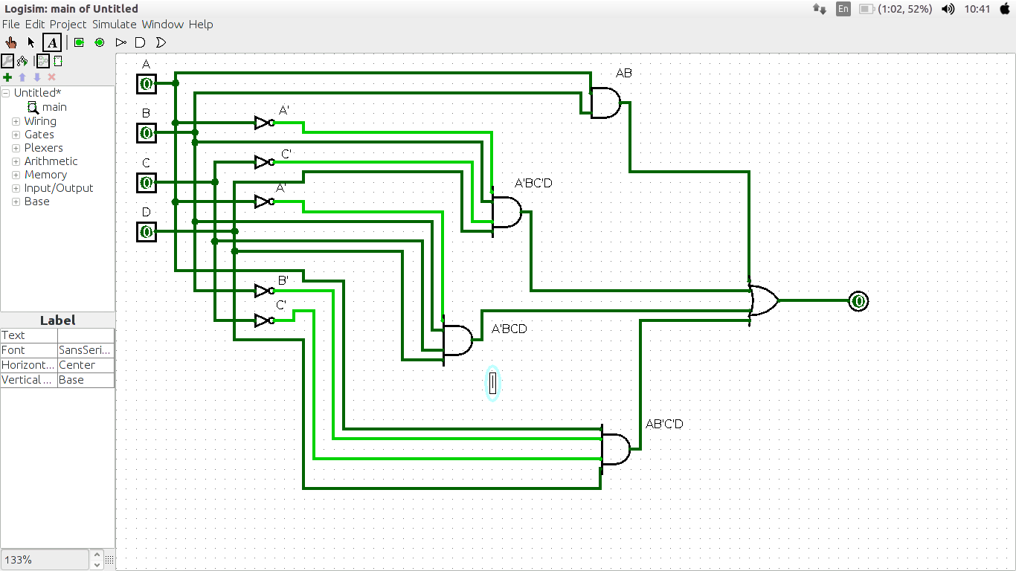
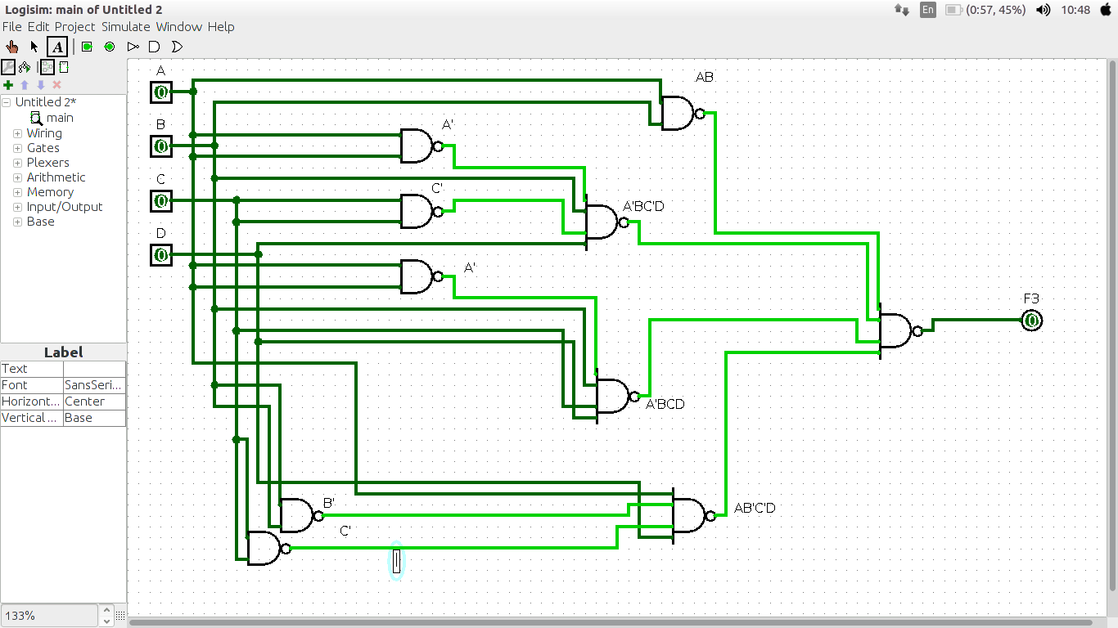

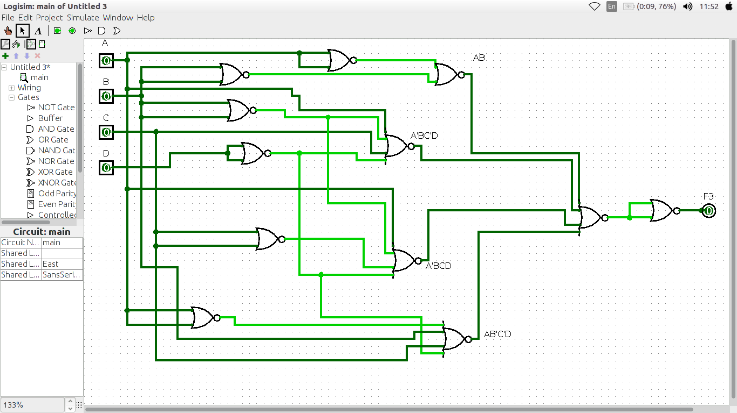

F4 = C + S where C = xy + xz + yz and S = C’ (x + y+ z) + xyz

x | y | z | F4
0 | 0 | 0 | 0
0 | 0 | 1 | 1
0 | 1 | 0 | 1
0 | 1 | 1 | 0
1 | 0 | 0 | 1
1 | 0 | 1 | 0
1 | 1 | 0 | 0
1 | 1 | 1 | 1

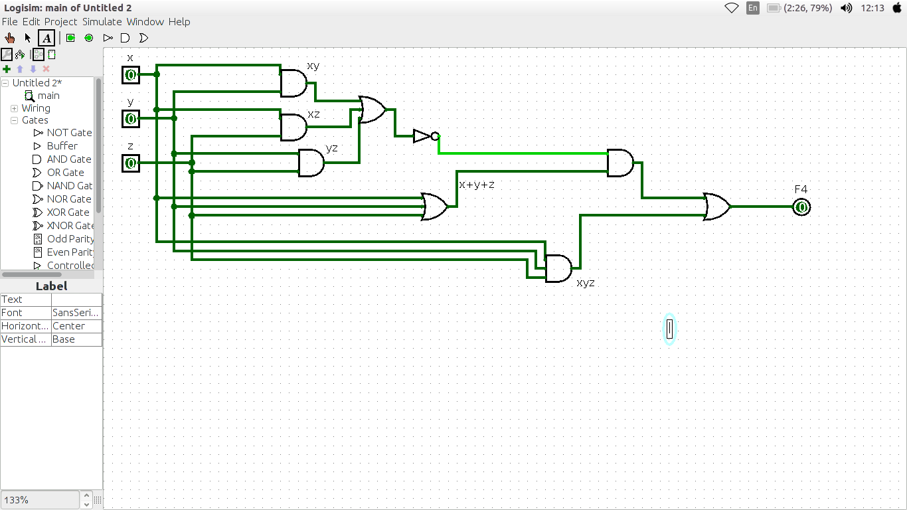

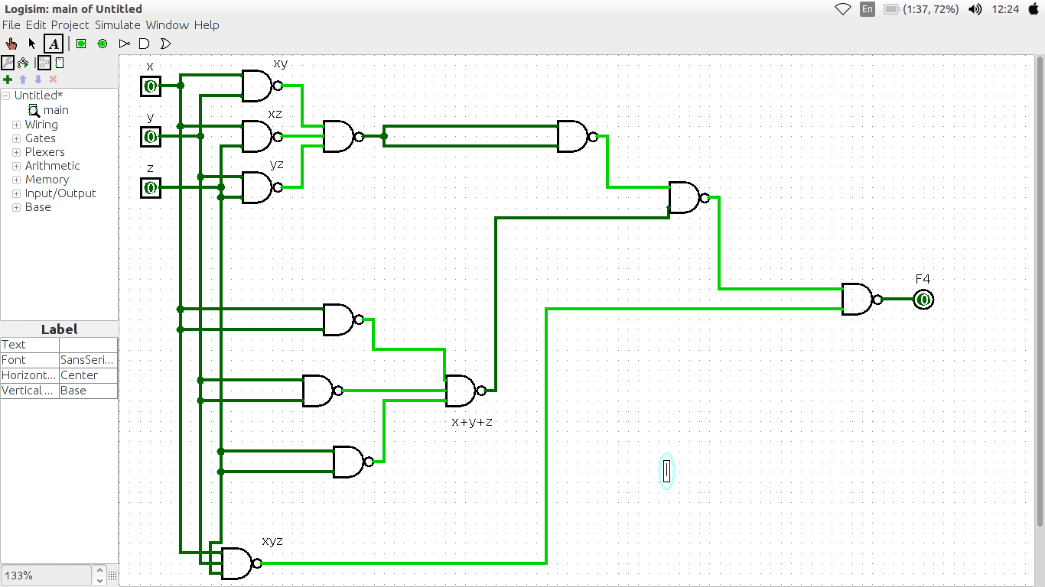

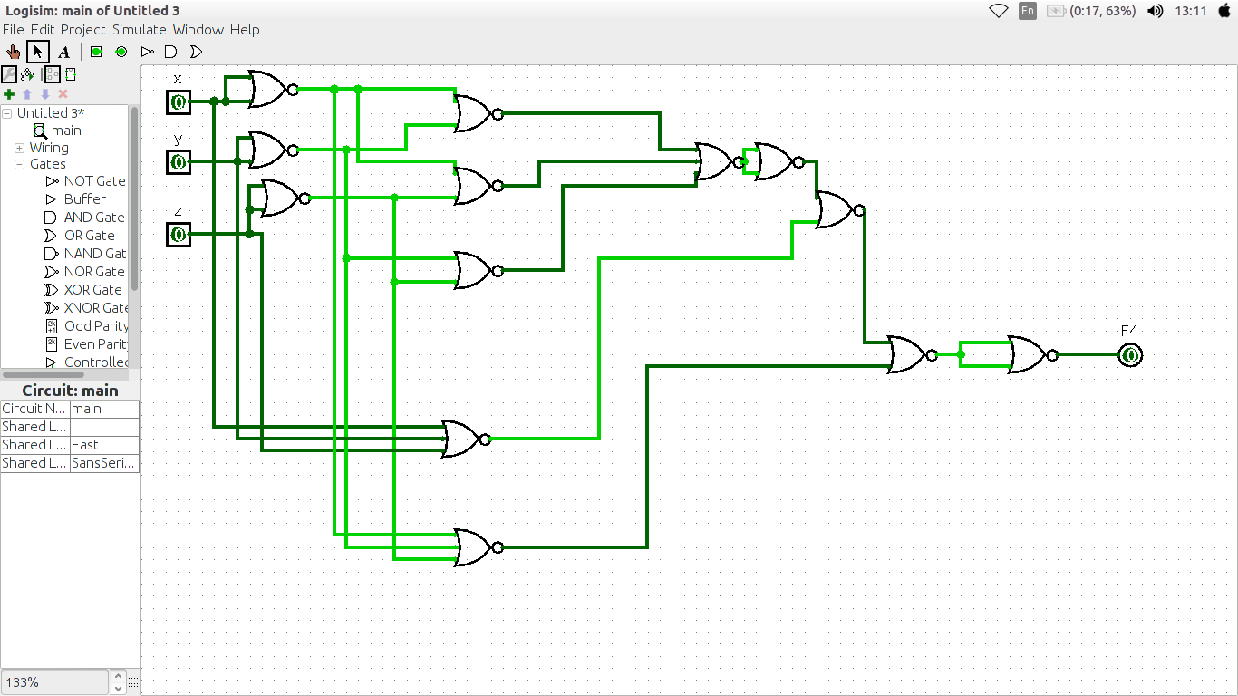

Lab: 2-3

F1 = A’B’+AB’C+’BC+AB’+C+AB’+C’+AB
1.

A | B | C | F1
0 | 0 | 0 | 1
0 | 0 | 1 | 1
0 | 1 | 0 | 1
0 | 1 | 1 | 1
1 | 0 | 0 | 1
1 | 0 | 1 | 1
1 | 1 | 0 | 1
1 | 1 | 1 | 1

2.

Min terms = A’B’C’ + A’B’C + A’BC’ + A’BC’ + AB’C + AB’C’ + ABC’ + ABC
Max terms = no Max terms

3.

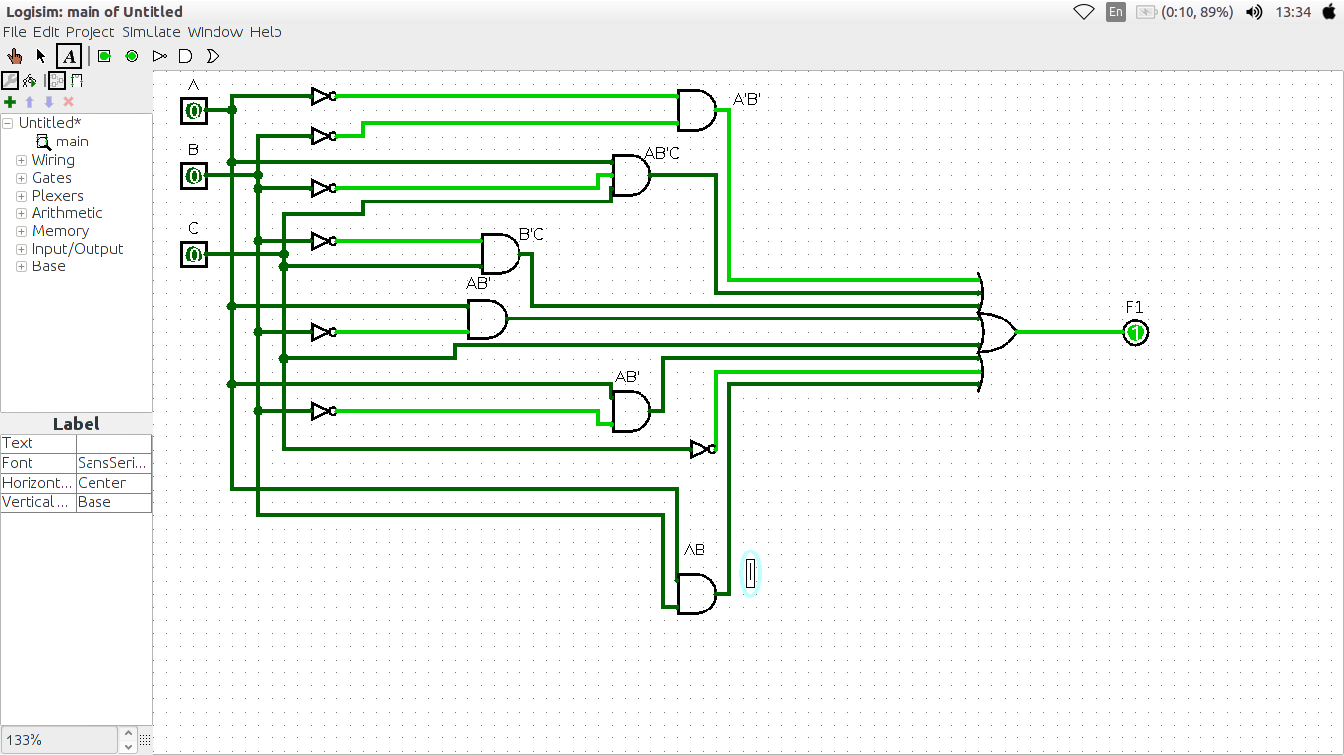
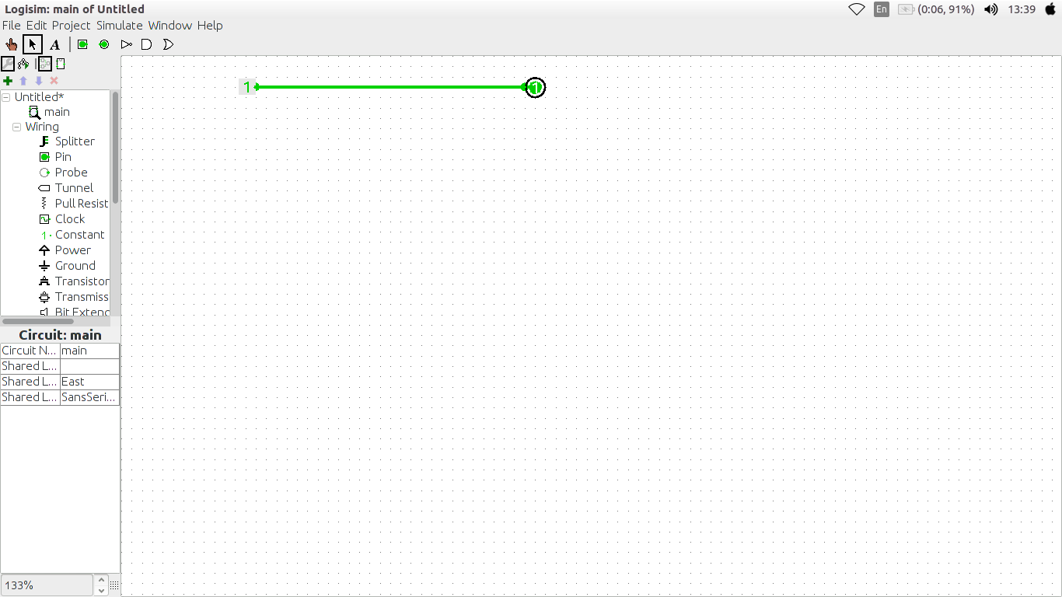

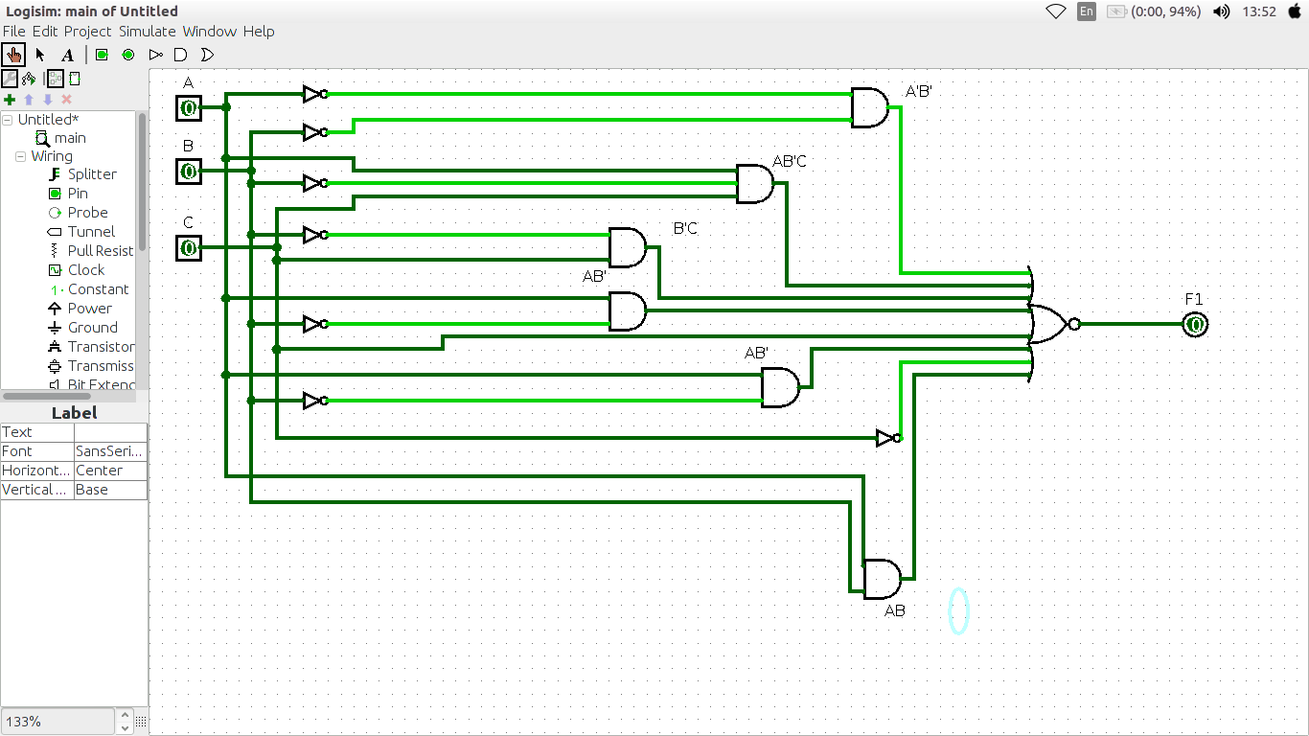

4.

F2 = AB’C’D+ABC’+C’D+BC’D+A’B+AD

1.

A | B | C | D | F2
0 | 0 | 0 | 0 | 0
0 | 0 | 0 | 1 | 1
0 | 0 | 1 | 0 | 0
0 | 0 | 1 | 1 | 0
0 | 1 | 0 | 0 | 1
0 | 1 | 0 | 1 | 1
0 | 1 | 1 | 0 | 1
0 | 1 | 1 | 1 | 1
1 | 0 | 0 | 0 | 0
1 | 0 | 0 | 1 | 1
1 | 0 | 1 | 0 | 0
1 | 0 | 1 | 1 | 1
1 | 1 | 0 | 0 | 1
1 | 1 | 0 | 1 | 1
1 | 1 | 1 | 0 | 0
1 | 1 | 1 | 1 | 1
2.
Min Terms = A’B’C’D + A’BC’D’ + A’BC’D + A’BCD’ + A’BCD + AB’C’ D+ AB’CD + ABC’D’ + ABC’D + ABCD

MaX Terms = (A+B+C+D) (A+B+C’+D)(A+B+C’+D’)(A’+B+C+D)(A’+B+C’+D)(A’+B’+C’+D)

3.

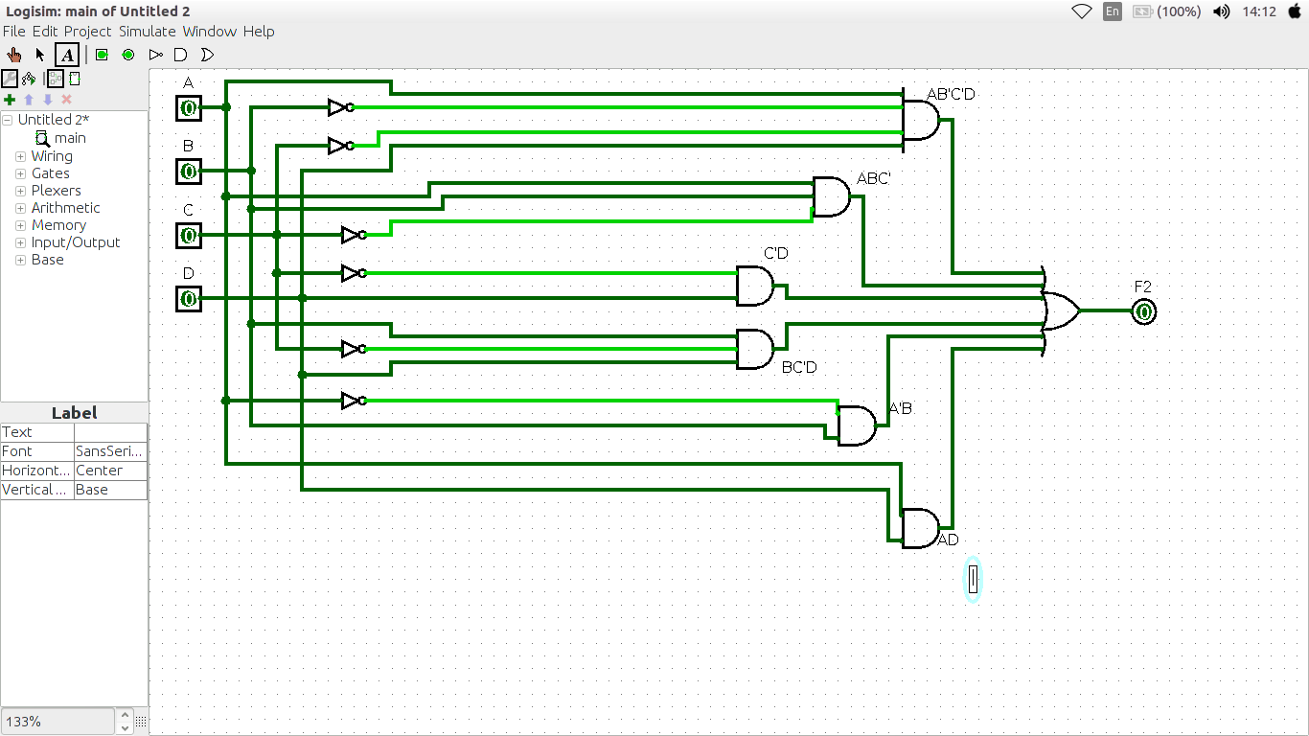

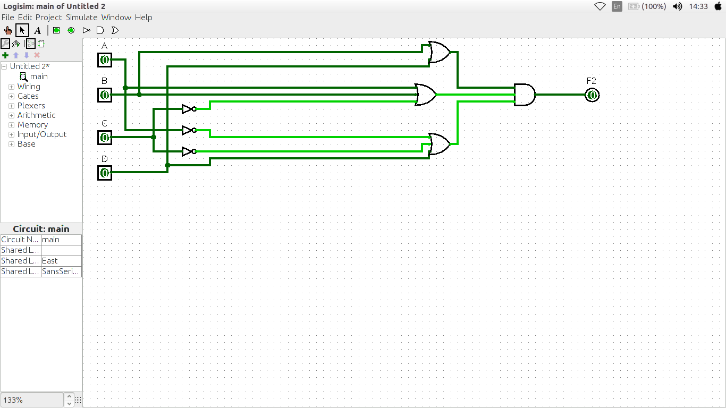

4.

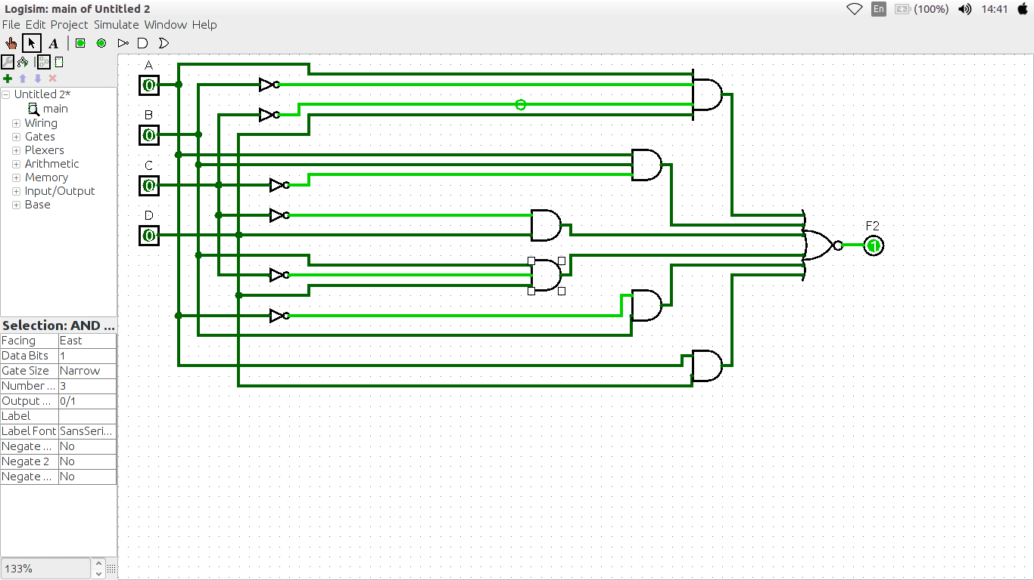

F3 = AB+A’B’D+A’B+AB’C’D

1.

A | B | C | D | F3
0 | 0 | 0 | 0 | 0
0 | 0 | 0 | 1 | 1
0 | 0 | 1 | 0 | 0
0 | 0 | 1 | 1 | 1
0 | 1 | 0 | 0 | 1
0 | 1 | 0 | 1 | 1
0 | 1 | 1 | 0 | 1
0 | 1 | 1 | 1 | 1
1 | 0 | 0 | 0 | 0
1 | 0 | 0 | 1 | 1
1 | 0 | 1 | 0 | 0
1 | 0 | 1 | 1 | 0
1 | 1 | 0 | 0 | 1
1 | 1 | 0 | 1 | 1
1 | 1 | 1 | 0 | 1
1 | 1 | 1 | 1 | 1

2.

Min Terms = A’B’C’D+A’B’CD+A’BC’D’+A’BC’D+A’BCD’ A’BCD+AB’C’D+ABC’D’+ABC’D+ABCD’+ABCD

Max Terms = (A+B+C+D)(A+B+C’+D)(A’+B+C+D)(A’+B+C’+D)(A’+B+C’+D’)

3.
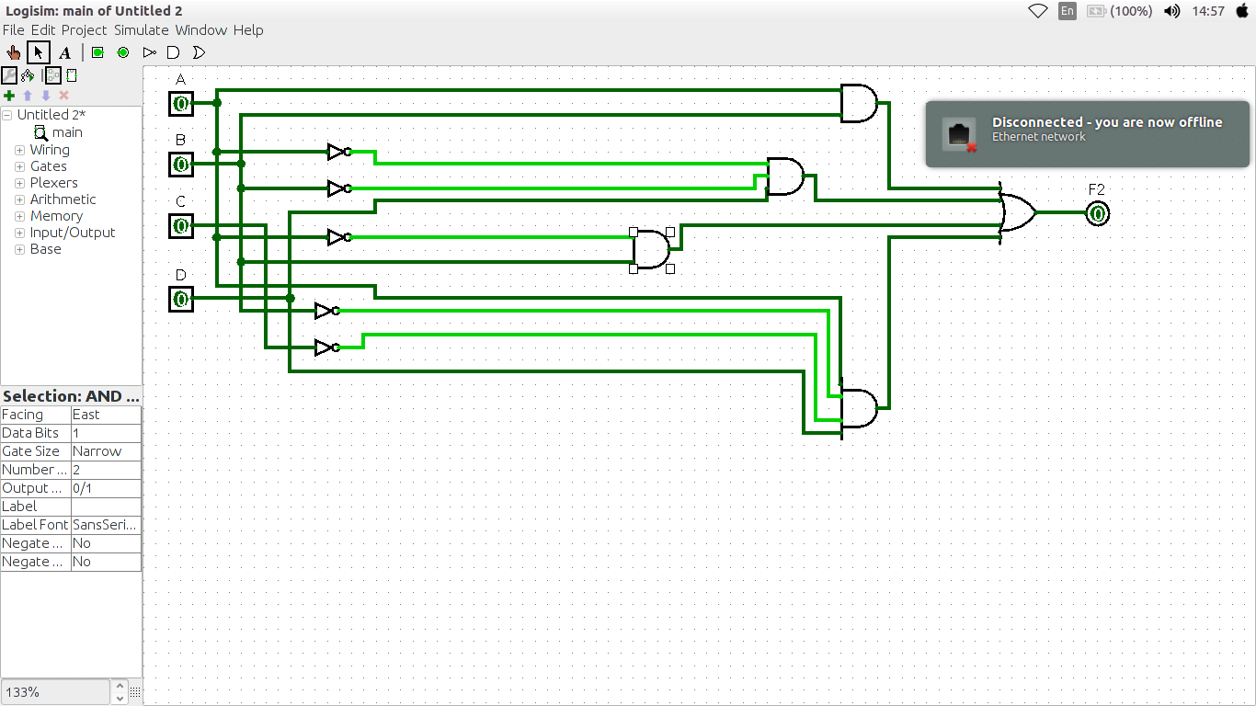
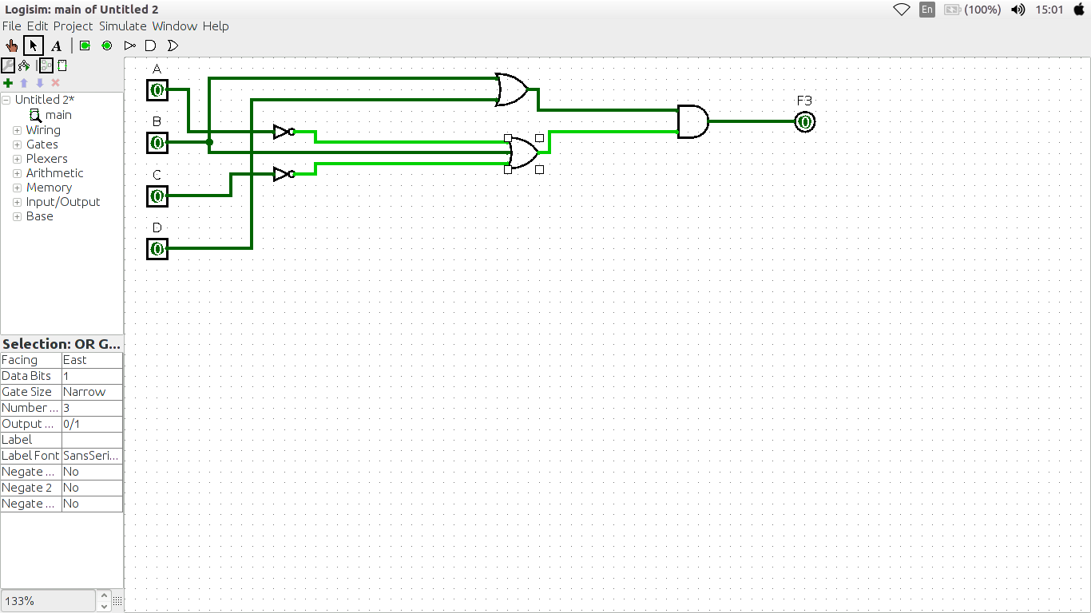

4.

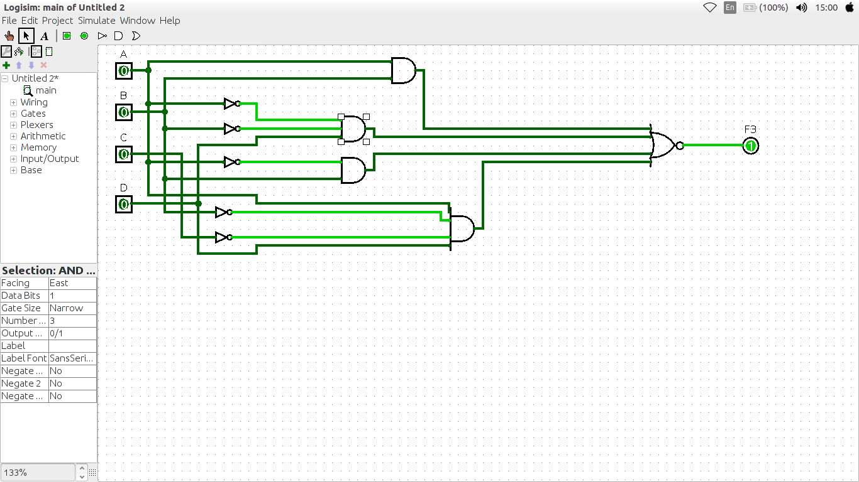

F4 = C + S where C = xy + yz and S = C’ (x + y) + xyz

x | y | z | F4
0 | 0 | 0 | 0
0 | 0 | 1 | 0
0 | 1 | 0 | 1
0 | 1 | 1 | 1
1 | 0 | 0 | 1
1 | 0 | 1 | 1
1 | 1 | 0 | 1
1 | 1 | 1 | 1

2.
Min Terms = x’yz’+x’yz+xy’z’+xy’z+xyz’+xyz
Max Terms = (x+y+z)(x+y+z’)

3.

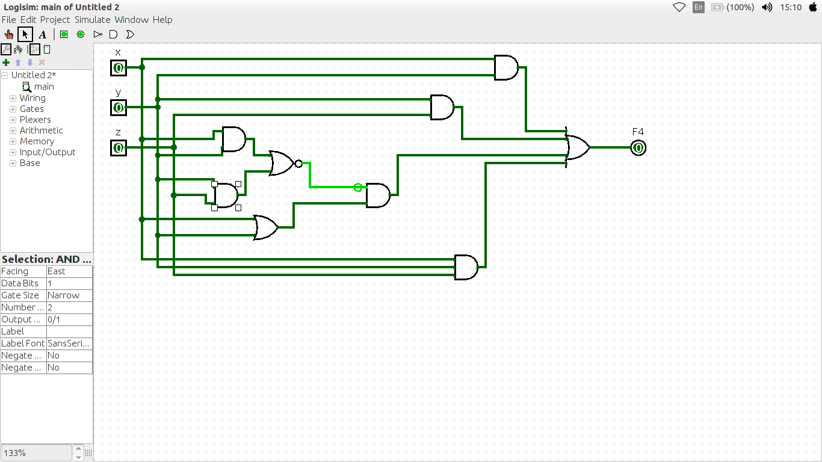
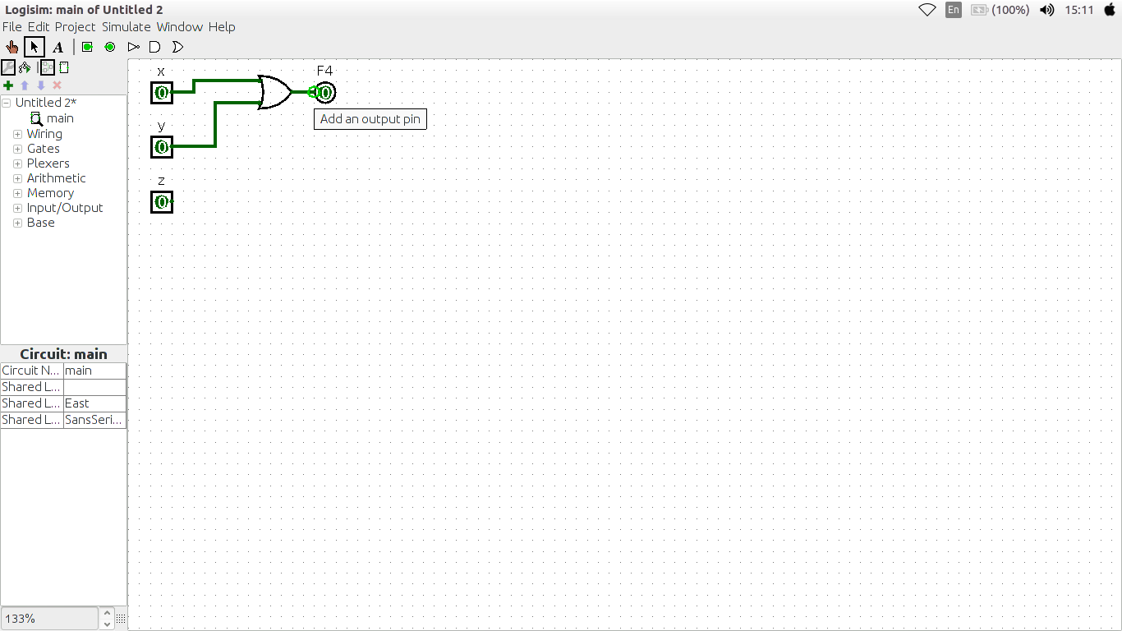

4.

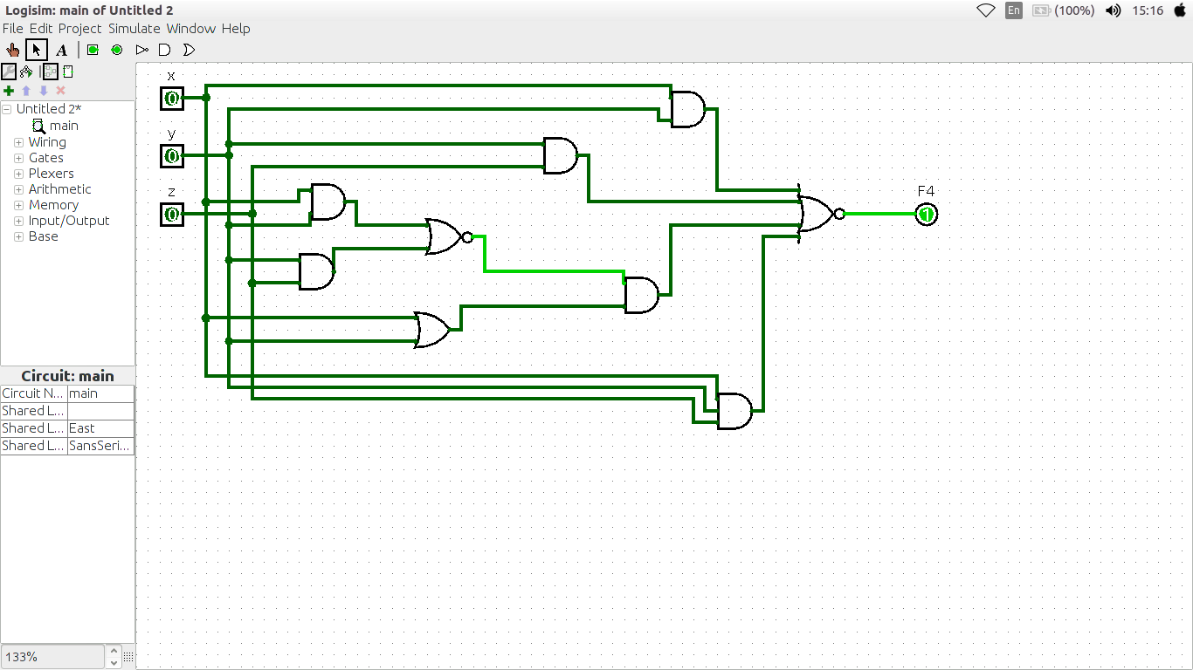

Lab: 4-5
F1 = A’B’+AB’C+A’BC+AB’+C+AB’+C’+AB

1.

A | B | C | F1
0 | 0 | 0 | 1
0 | 0 | 1 | 1
0 | 1 | 0 | 1
0 | 1 | 1 | 1
1 | 0 | 0 | 1
1 | 0 | 1 | 1
1 | 1 | 0 | 1
1 | 1 | 1 | 1

2.

K-MAP

1 | 1 | 1 | 1
1 | 1 | 1 | 1

EQUATION IS : 1

3.

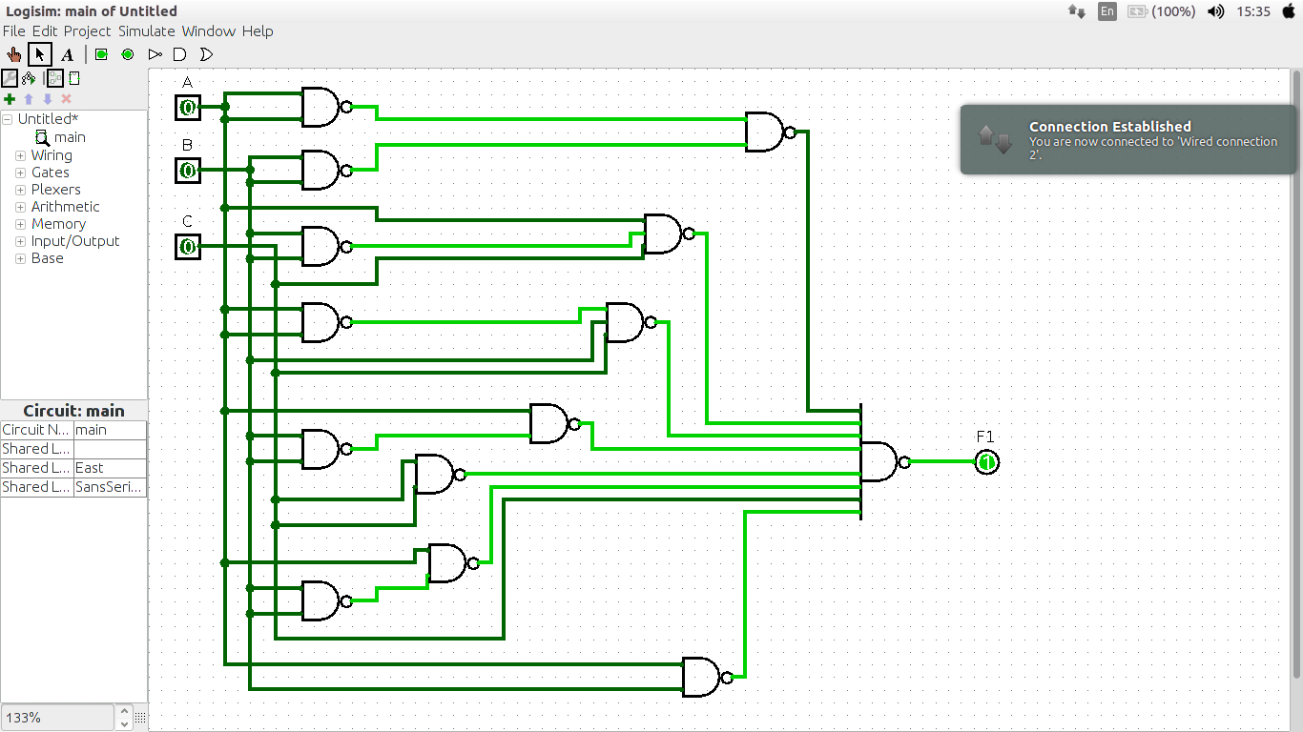

F2 = AB’C’D+AC’D+C’D+C’D+A’B+AD

1.

A | B | C | D | F2
0 | 0 | 0 | 0 | 0
0 | 0 | 0 | 1 | 1
0 | 0 | 1 | 0 | 0
0 | 0 | 1 | 1 | 0
0 | 1 | 0 | 0 | 1
0 | 1 | 0 | 1 | 1
0 | 1 | 1 | 0 | 1
0 | 1 | 1 | 1 | 1
1 | 0 | 0 | 0 | 0
1 | 0 | 0 | 1 | 1
1 | 0 | 1 | 0 | 0
1 | 0 | 1 | 1 | 1
1 | 1 | 0 | 0 | 0
1 | 1 | 0 | 1 | 1
1 | 1 | 1 | 0 | 0
1 | 1 | 1 | 1 | 1

2.

K-MAP

0 | 1 | 0 | 0
1 | 1 | 1 | 1
0 | 1 | 1 | 0
0 | 1 | 1 | 0

EQUATION IS : C’D + A’B + AD

3.

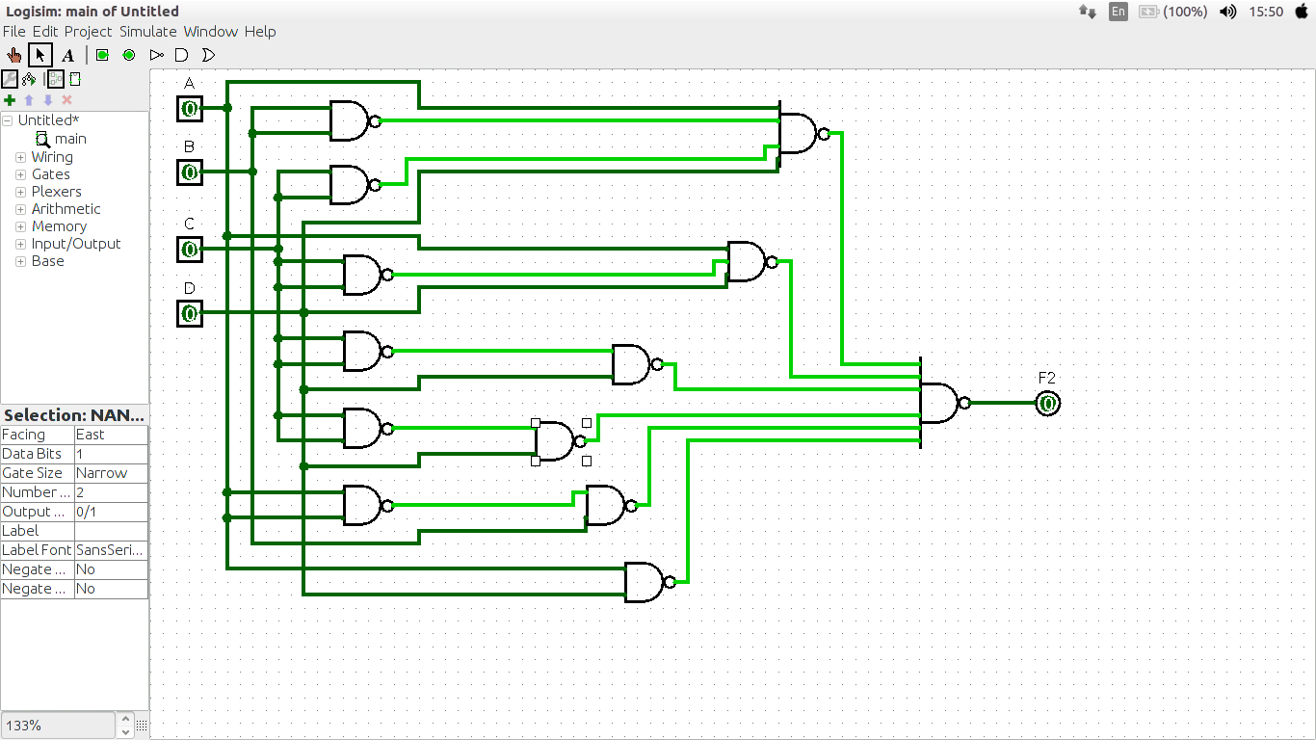

F3 = AB+A’C’D+A’BD+AB’C’

1.

A | B | C | D | F3
0 | 0 | 0 | 0 | 0
0 | 0 | 0 | 1 | 1
0 | 0 | 1 | 0 | 0
0 | 0 | 1 | 1 | 0
0 | 1 | 0 | 0 | 0
0 | 1 | 0 | 1 | 1
0 | 1 | 1 | 0 | 0
0 | 1 | 1 | 1 | 1
1 | 0 | 0 | 0 | 1
1 | 0 | 0 | 1 | 1
1 | 0 | 1 | 0 | 0
1 | 0 | 1 | 1 | 0
1 | 1 | 0 | 0 | 1
1 | 1 | 0 | 1 | 1
1 | 1 | 1 | 0 | 1
1 | 1 | 1 | 1 | 1

2.

K-MAP

0 | 1 | 0 | 0
0 | 1 | 1 | 0
1 | 1 | 1 | 1
1 | 1 | 0 | 0

EQUATION IS : C’D + BD+ AC’ + AB

3.

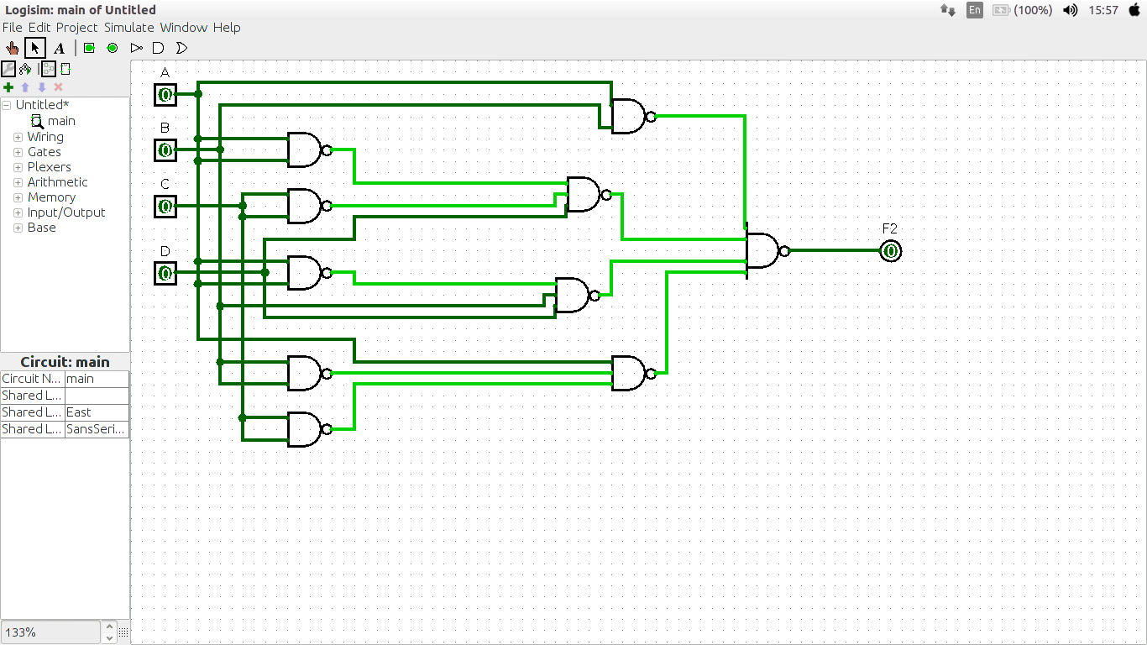

F4 = C + S where C = xy + yz and S = C’ (x + y) + xyz

1.

x | y | z | F4
0 | 0 | 0 | 0
0 | 0 | 1 | 0
0 | 1 | 0 | 1
0 | 1 | 1 | 1
1 | 0 | 0 | 1
1 | 0 | 1 | 1
1 | 1 | 0 | 1
1 | 1 | 1 | 1

2.

k-map

0 | 0 | 1 | 1
1 | 1 | 1 | 1

Equation is : x + y

3.

