Supporting Online Material

Surgery and recording
Three male Long-Evans rats (330-400 g) were implanted bilaterally with 32 and/or 64-site silicon probes (4 or 8 shanks 200 µm apart, 8 recording sites per shank, 20 µm spacing between the sites, 1) under isoflurane anesthesia. Rat 4 was implanted with 4 tetrodes (2). The silicon probes/tetrodes were lowered into hippocampal CA1 pyramidal layer within two weeks after surgery. After full recovery (approximately 2 weeks after surgery), access to water was restricted and the rats were allowed to explore the task maze and identify the position of the water ports (Fig. 1A). During physiological recording, data from all channels were filtered (1Hz-5kHz), amplified (gain = 1000) and continuously sampled at 20 kHz on a 128-channel DataMax system (16-bit resolution). Two small light-emitting diodes (5-cm separation), mounted above the headstage, were recorded by an overhead digital video camera and sampled (at 30 Hz). For offline spike sorting, the wideband signals were digitally high-pass filtered (0.8-5 kHz). Spike sorting was performed semi-automatically, followed by manual adjustment of the clusters (3-5). We cannot exclude the possibility that some neurons recorded in different sessions were identical because spikes from each session were sorted separately. However, the likelihood of recording from the same neuron is small either because the probes moved spontaneously across recording sessions, as evidenced by the change in ripple amplitude or the loss/appearance of fast firing interneurons, or because the probe was moved by the experimenter. All protocols were approved by the Institutional Animal Care and Use Committee of Rutgers University.

Behavioral training and recording
Delayed spontaneous alternation task. The maze (100 cm by 120 cm) had a shape of figure 8 with two water spouts. A delay area was located at the junction of three arms between the reward sites (Fig. 1A). The delay area was separated from the two reward sites and the third arm (main stem) by three doors, controlled by the experimenter. The running wheel (10 cm wide, 29.5 cm diameter) was attached to a wall of the delay area (Fig. 1A). Speed and direction of the wheel rotation was tracked with an optical sensor (0.72º resolution), attached to the axis of the wheel rotation. Infrared-beam photo-detectors were fixed in all arms of the maze and were used to track the movement of an animal in the maze and to control the delivery of water reward (0.05 ml) after correct choices.
Each session began by placing the rat into the delay area while all three doors were closed. During the first day of the training the animal was required to run in the wheel for at least 3 sec, after which the main-stem door was opened. Rats were not allowed to return to the main stem after making a choice at the T-junction of arms. After the consumption of the reward (or no reward), rats walked back to the delay area and could initiate a new trial by entering the wheel. The required length of a wheel running was gradually increased from the initial 3 sec up to 10 sec in rat 1 and up to 20 sec in rats 2 and 3. All rats were required to run steadily in the wheel, always facing the same direction in each trial (West, Fig. 1, S1). All rats reached high performance of spontaneous alternation (>90% correct choices) and steady wheel running within a week. A session was terminated after the animal failed to initiate a new trial within 2 minutes. After entering the wheel, the velocity of running increased rapidly and reached a steady level within a few seconds (Fig. S1). This stereotypic initial acceleration was used as a trigger to mark the beginning of a trial in offline data processing in both the memory task and in the control tasks (threshold speed: 20cm/sec).

Control task 1: Wheel running for a water reward. Rats 3 and 4 were trained to run in a running wheel for a water reward. A wheel, identical to the one used in the maze, was attached to one side of a rectangular box (30x40x35 cm). A water port was placed on the wall opposite to the wheel. At the beginning of each session, a rat was introduced into a box and required to run for a fixed period of time (rat 3, 20sec; rat 4, 10sec). As in the alternation task, rats were trained to run with steady speed and heading always in the same direction. All trials were rewarded by water (2, 6).

Control task 2: Spontaneous wheel running. A wheel, identical to the one used in the maze, was attached to the home cage of the rat (30 x 40 x 35 cm). The rats (rat 2 and 3) had free access to the wheel and could run in either direction. The trials were defined as at least 10 second-long periods of wheel running with the running speed maintained above 50 cm/sec and preceded by at least 2 seconds of exploration in the home cage. Maze and control task recording sessions were alternated in rats 2 and 3.

Hippocampal inactivation
Five additional male rats (335 - 400 g) were implanted with stainless steel injection guide cannulae (27 gauges) above dorsal hippocampi bilaterally (7-8) under Isoflurane anesthesia. After recovery, the rats were water restricted and trained in both non-delayed (zero) and delayed (15 sec) versions of left/right alternation task until their performance reached a steady level (5 days). These rats were not required to run in the wheel but were simply confined in the delay area for the duration of the delay. Lidocaine (4%, 0.5µl) or saline were slowly (5 min) injected into hippocampi bilaterally through a 33-gauge cannula connected to a 10-µl Hamilton syringe through tygon tubing. The injection cannula was left at its position for 1min before and after an injection. Five minutes after the injection, the rat was tested in either the non-delayed or delayed version of the alternation task. The order of lidocaine and saline injections and order of delayed and non-delayed versions of the task varied across animals.

Data processing
Place and episode fields. On each trial each neuron's spike train was convolved with a Gaussian (SD = 100msec, sampling rate 1250 Hz). Firing rate profile of each neuron triggered at the beginning of a wheel or a maze run (‘post-stimulus time histogram’ with the moment of wheel/maze running initiation at time zero) was calculated from action potentials generated during trails of the same type (e. g., during wheel or maze runs before left or right turn). In order to distinguish between place fields on a maze and bouts of increased firing generated by pyramidal neurons during wheel running, we refer to the areas of an increased firing rate in a wheel as “episode fields”. Place fields on the maze and episode fields in the wheel were defined by a minimal peak firing rate of 6.0 Hz or 5Hz and peak firing rate being at least 4.5-times or 3-times SD above a mean firing rate, respectively. Using these different criteria yielded similar results. The width of individual fields was determined by the onset and offset of >10 % rate of the peak firing rate of that field (9-10).
Neuronal sequences. In each session two firing rate profiles for each neuron were constructed and normalized by their peak firing rate: one from action potentials generated during wheel runs before correct left arm choice (“left trials”) and one from action potentials generated during wheel runs before correct right arm choice (“right trials”) (e. g., Fig. 1D, E). Mean rate histograms of all neurons within each trial type (left or right) were ordered according to the latencies of peak firing rates of individual neurons (e.g., Fig. 1E). To establish an estimate of statistically reliable firing rate differences between left and right trial types we shuffled left and right single trial firing rate histograms in a randomized manner (11). Thus, we examined the null hypothesis whether real firing patterns of neurons during left and right trials differed significantly, and at which portion of trials these differences occurred. Note that this approach is more rigorous than simply comparing firing rate differences between left and right trials and may at least partially explain the low number of trial discriminating neurons in the stem of the maze, compared to previous findings (12-17).
Population vector correlation. In the spatial domain, “spatial scale factor” of the hippocampal population is a measure of distance traveled by a rat over which temporally overlapping neuronal populations become de-correlated (18-20). Analogously, we calculated a “temporal scale factor”, which estimates an amount of time it took for population activity to become de-correlated (‘life-time’ of population activity). Firing rate histograms of all neurons within each trial type (see above) were binned into 100 msec bins. Thus, activity of the whole neuronal population within each 100 msec time bin was described by a vector that had a length of the number of active neurons (population vector). Spearman rank correlation between all pairs of population vectors characterizing all time bins was calculated. Values of correlation coefficients were color-coded and plotted (Fig 1G). The ‘life-time’ of population activity was characterized as a width of a region along the diagonal of a correlation matrix with increased correlation coefficient values (19-20).
Correlation of population vectors representing the same time bin is equal to 1 (and thus all values along a diagonal of a correlation matrix are equal to 1) unless different subsets of trials are used to build population vectors representing the same time bin (19-20, Fig. 1G). In order to exclude a bias of auto-correlation values along a correlation matrix diagonal, we constructed population vectors from activity generated during trialsn and trialsn+1. Due to the trial-by-trial variability of firing rates, the value of correlation between these population vectors is typically smaller than 1 (Fig. 3B, 5C, only pixels with significant correlation coefficient values are shown, p < 0.01). In the memory task, the correlation matrix was calculated from activity generated during trials with the same future choices (L-trials_{n} vs. L-trials_{n+1} and R-trials_{n} vs. R-trials_{n+1}). In the control tasks, the correlation matrix was calculated from activity generated during even and odd trials (trials_{n} vs. trials_{n+1;} Fig. S9).
Phase precession. Instantaneous theta phase was derived by Hilbert transform from filtered (4-10 Hz) LFP trace and a phase value was assigned to each action potential. Spearman rank correlation was used to estimate relationship between the phase precession slope and place/episode field size (9).
Frequency of single unit oscillation. All action potentials emitted by a neuron during each pass through a field were convolved with a Gaussian function (SD = 1 msec), convolved with the first four Slepian functions and the dominant oscillations frequency was estimated with Fast Fourier Transform, as described in detail earlier (9). The frequency shift between the unit and LFP power spectra was estimated by cross-correlation. Only units with significant theta modulation were included in this analysis.
Compression index. Correlation of the distance between place/episode fields of two neurons in a maze or a wheel with the mean temporal offset of action potentials of the same pair of neurons within a theta cycle is called ‘compression index’ (10). Only pairs of pyramidal neurons with robust place/episode fields and significant cross-correlogram peaks were used for this analysis (10). We obtained similar compression index values (0.75, 0.62, 0.59, p < 0.0001 for all) after selecting place fields based on three different sets of parameters: minimal peak firing rate of 6 Hz, 4.5 Hz or 5 Hz and the peak firing rate 4.5, 3.4 or 3 SDabove the mean firing rate.
Firing ‘fields’ of neurons. Neurons in the control tasks, strictly speaking, did not have fields. We compared activity of neurons generated during wheel running in the memory and control tasks in the temporal domain. An autocorrelogram of each neuron was filtered between 0.2 Hz and 2 Hz and the local minima of the filtered trace closest to zero were detected. “Intra-field” spikes were defined as spikes which occurred within 10% boundaries of the peak rate, and “extra-field” spikes those that occurred outside of this boundary. This index is high for compact episode/place fields and low for neurons with sustained or random spiking patterns.
Inferring behavioral choice from neural activity. In addition to identifying neurons that reliably discriminate between left and right trials in some portion of wheel running, we also used a probabilistic model to predict future L/R trial type from total population activity during the preceding wheel run. To infer the L/R trial type for a given trial, we fit the model on all other trials in the same session and used it to predict the remaining trial type. The set of trials on which the model was fit is called the training set; the trial that is predicted from the model is called the test set. The percentage of correctly inferred trials was computed across all training/test set trial combinations, with leave-one-out cross-validation. The significance of this prediction was determined on a session-by-session basis by comparing the true values with the distribution of shuffled data. Each ‘shuffled’ data set was constructed by randomly shuffling the left/right labels between the trial spike trains from each cell across all eligible trials. Only behaviorally correct trials of length ≥ 7s for rat 1, and ≥ 17s for rats 2 and 3 were considered for model-fitting and for correct trial-type inference. For each training set and each k-th putative pyramidal cell that had an average firing rate of > 0.1Hz we computed the “predictability index” I_{k} from the ratio of minimal and maximal average spike-counts across left and right trials:
,
(here is the average spike count of the k-th neuron across the considered left trials, and is the average spike count of the k-th neuron across the considered right trials.) The higher the value of I_{k} the more selective the cell on the training set (I_{k} = 1 for the most selective, and I_{k} = 0 for the least selective.) While this index is not necessarily indicative of statistical significance of left/right selectivity of a given cell, it was used for ranking cells in order of their tendency to be predictive.
Putative pyramidal cells were ordered according to I_{k} in each training set. Ten cells with the highest predictability index were selected for prediction in each training set. For each trial we computed a binary population vector as follows. For each trial the cell could be in one of two states: u_{k}=“high” if , and u_{k}=“low” if , where is the average spike-count of the considered cell across all trials. We denote by the probabilities of observing k-th selected neuron (k = 1,…,10) in the state u= “low” or u=“high” during a trial of type q=L,R:
=Prob( k-th neuron is in the state u | given trial type q).
Note that because there are only two states, . We assume that the neurons fire independently from each other. This is of course an incorrect assumption. However the prediction (based on this assumption) can be only worse than a prediction that would take correlations into account. Under this assumption the probability of observing a binary population vector during trial type q can be computed as

Given a new test-set trial, with binary population vector , the model predicts the trial type (=L or R) via maximum-likelihood:
if and if .
The same analysis was repeated on 100 shuffled data sets. The prediction for a given session was considered to be significant if the percentage of trials correctly inferred from the real data was higher than the percentage of trials correctly inferred from at least 95 of the shuffled data sets.
Error trials. For each session, only those error trials were selected that were longer than 7s for rat 1, and 17s for rats 2 and 3 (as in the selection of behaviorally correct trials). In order to predict error trials, the model was fit on all behaviorally correct trials in the same session. This model was then used to predict the L/R type of each error trial in a session, as described above.
Supplementary figures

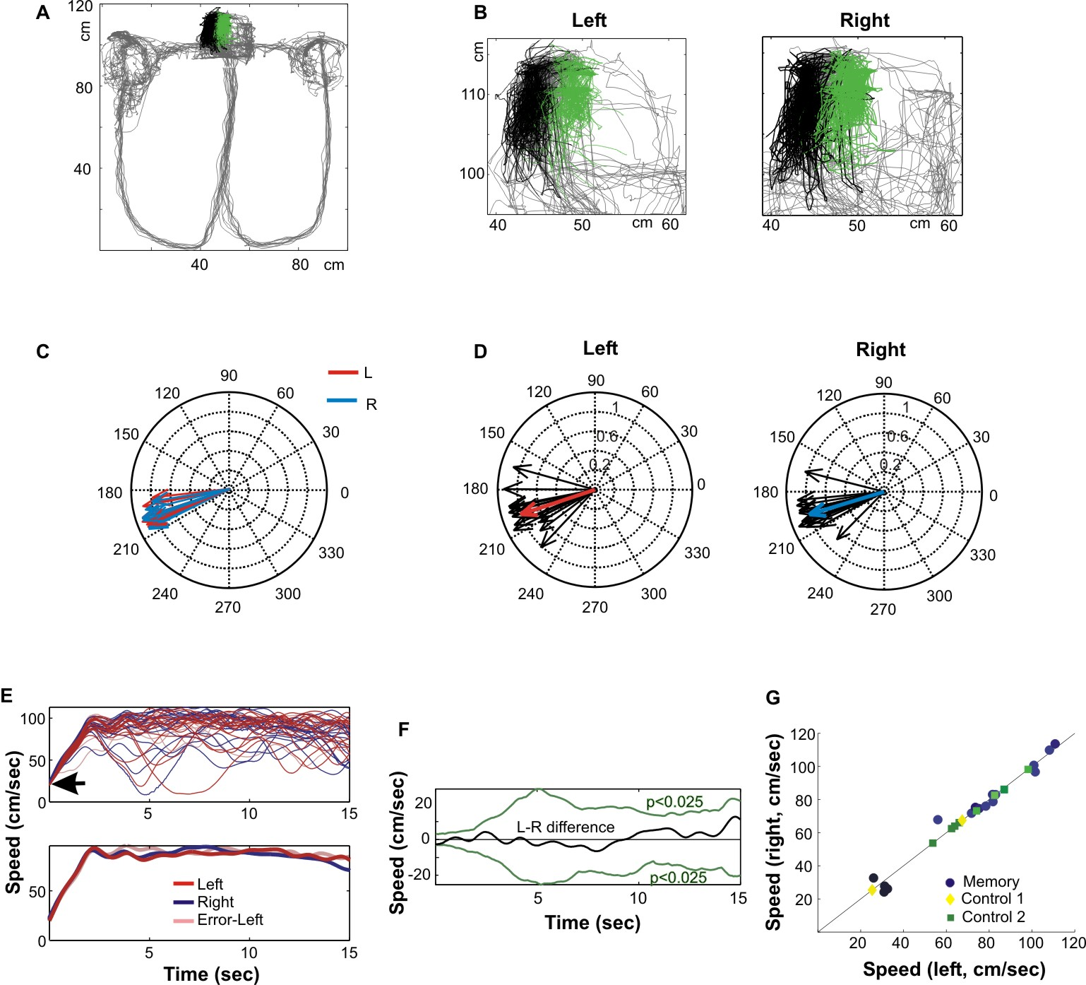

Fig. S1. Motor correlates of wheel running A. Top view of the testing apparatus. Gray lines: trajectory of the animal. Black and green, position of front and rear LEDs during wheel running (all wheel runs within one recording session). B. Head position of the rat shown separately for the wheel running trials with future left and right choices (trials) in the maze. C. Grand mean head-direction angular vectors for all analyzed sessions (3 rats combined, red arrows: mean of all trials from one session followed by left turn choices, blue: mean of all trials from one session followed by right turn choices). D. Examples of single running wheel trial mean head-direction angles (black) and session mean (red, left trials, blue, right trials) head direction angles. Data from the same rat as shown in A and B. E. top: Running speed during single wheel running trials (the same color-scheme as in the bottom panel, the same recording sessions as in Fig. 5 and Fig. S13). Bottom: Average running speed during correct left, correct right and error trials (the same data as in the upper panel). F. The significance level of speed differences between left and right trials was estimated based by the shuffling of the left and right speed labels (green lines, p<0.025 each, 11). Running speed during left and right trials did not differ significantly in any of the analyzed sessions. G. Mean running speed during L and R trials of all sessions of the memory tasks and during all trials of the control tasks. Note that head position, head direction and speed are not significantly different between trials followed by different behavioral choices. These observations indicate that idiothetic cues alone cannot be responsible for the choice-specific firing patterns of neurons (Fig. 4; 5, 12, 14).

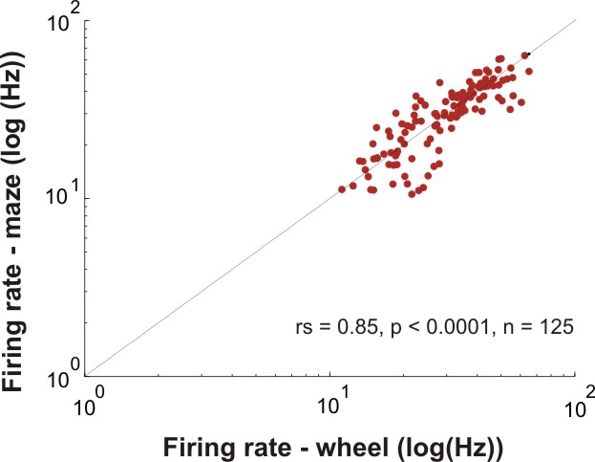

Fig. S2. Firing rates of putative interneurons in the wheel and in the maze are correlated. In contrast to pyramidal neurons (episode cells and place cells, Fig. 1C), the firing rates of putative interneurons were correlated significantly in the wheel and maze. This may occur because interneurons are typically controlled by multiple pyramidal cell assemblies (19, 9).

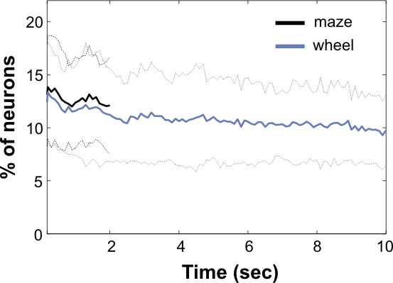

Fig. S3. Proportion of active neurons during wheel and maze running is similar at each moment in time. Percentage of neurons firing at least one spike within 100 msec windows during maze (black) and wheel (blue) running (dashed lines: SD). Note that similar fraction of neurons is active in the wheel and in the maze at each moment in time, despite the spatial 'over-representation' of the head position in the wheel by multiple neurons (Fig. 1B). This can occur because different episode cells in the wheel are activated in a sequence.

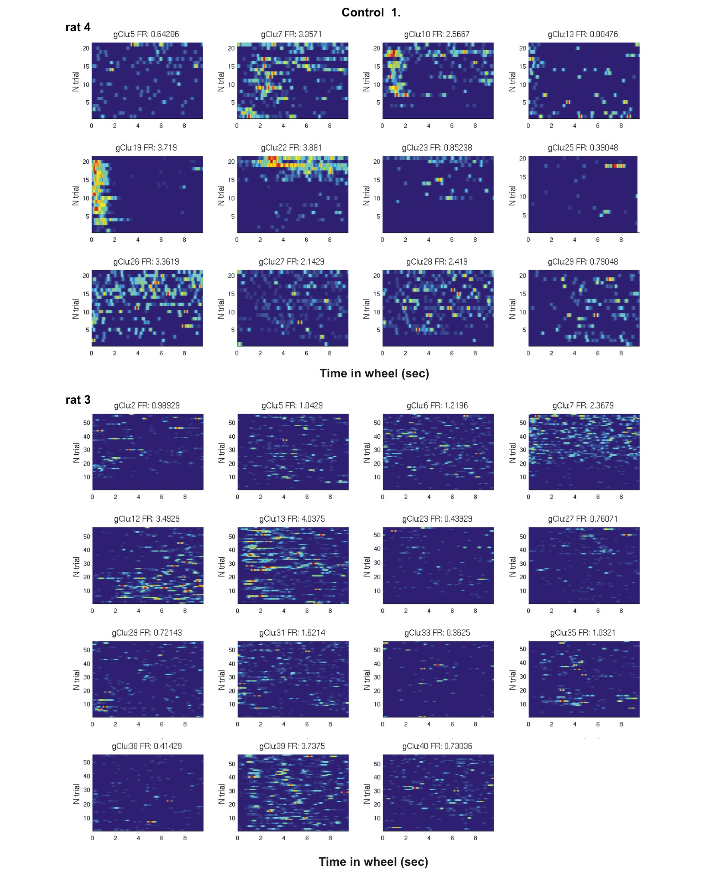
Fig. S4. Control task 1. Rats were trained to run for water reward. Rat 4, twelve simultaneously recorded neurons (each panel shows activity of one neuron, rows: peak-normalized firing rate profiles of a neuron in 21 successive wheel running trials). Rat 3, 15 simultaneously recorded neurons in a session with 58 trials. Only pyramidal neurons with mean firing rate higher than 0.35 Hz are shown. Note that most neurons fire in a relatively sustained manner (2, 6) and that firing rate profiles of almost all neurons vary from trial to trial.

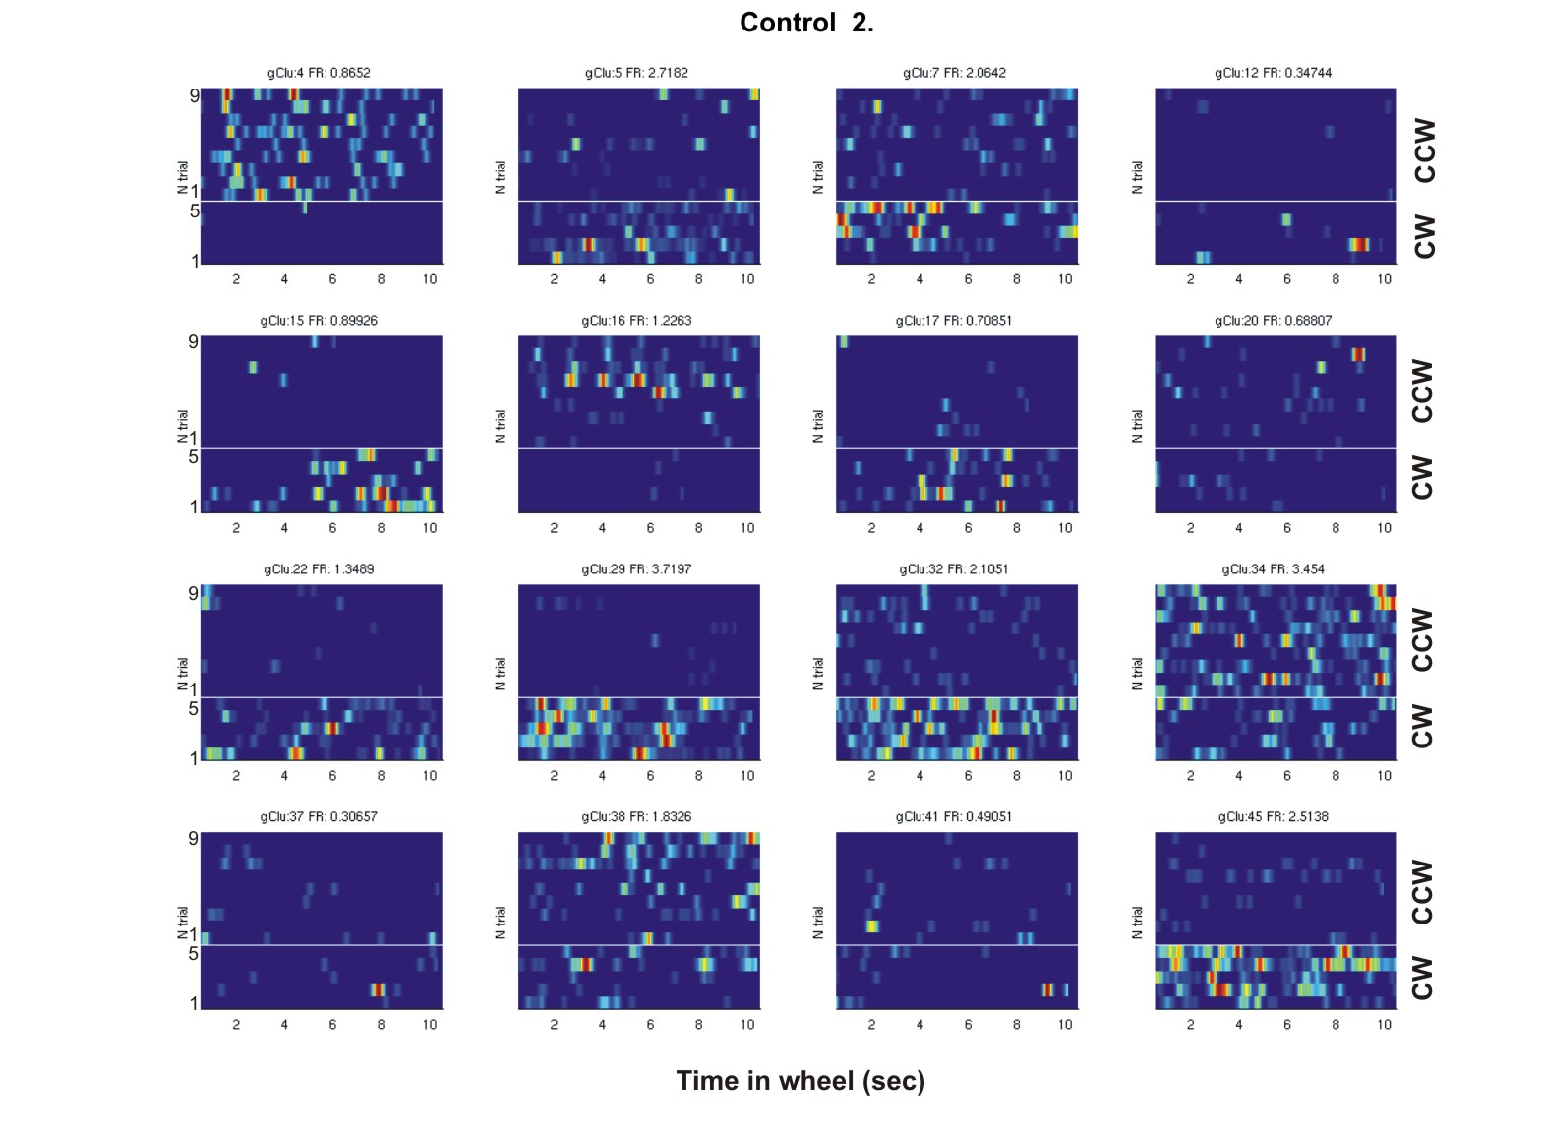

Fig. S5. Control task 2. Rats could freely run in the wheel, attached to the wall of a home cage. No reward was delivered. Each panel shows activity of one neuron; all 16 neurons were recorded simultaneously (rat 2; single session). Rows show peak-normalized firing rate profiles of a neuron in successive trials. Trials are grouped according to the animal’s head-direction/sense of the wheel rotation during trials (counter clockwise – CCW, clockwise – CW). Note that most neurons show differential firing rates depending on the rat’s head direction. This observation emphasizes the dominance of distant cues in this control task (2, 6).

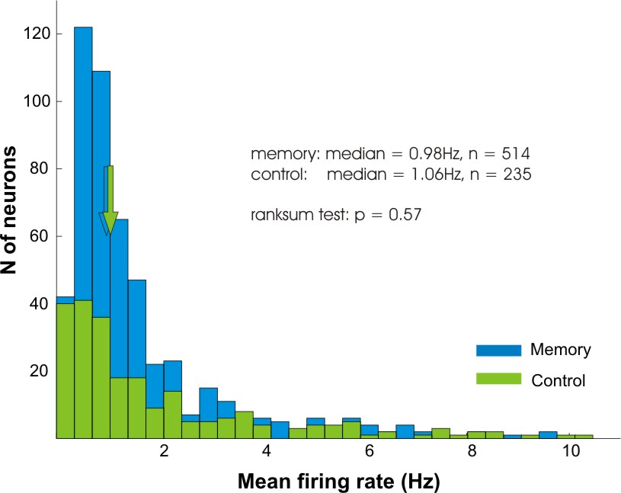

Fig. S6. Distribution of mean firing rates of neurons in the memory and control tasks. Note similar distribution of firing rates in both tasks. Arrows, medians.

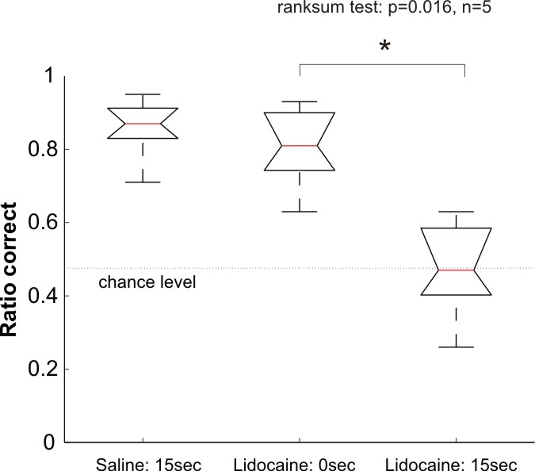

Fig. S7. Performance of rats in the delayed alternation task is impaired after bilateral inactivation of dorsal hippocampi. Five rats (different from rats 1-4 and not equipped with electrodes) were trained in the alternation task with both 0 and 15 sec delays. Bilateral inactivation of dorsal hippocampi (4% lidocaine, 0.5 µl) impaired performance of the animals during sessions with 15 sec delay between trials but did not affect performance of the same animals during sessions with no waiting period between trials (see also ref. 17 for similar results).

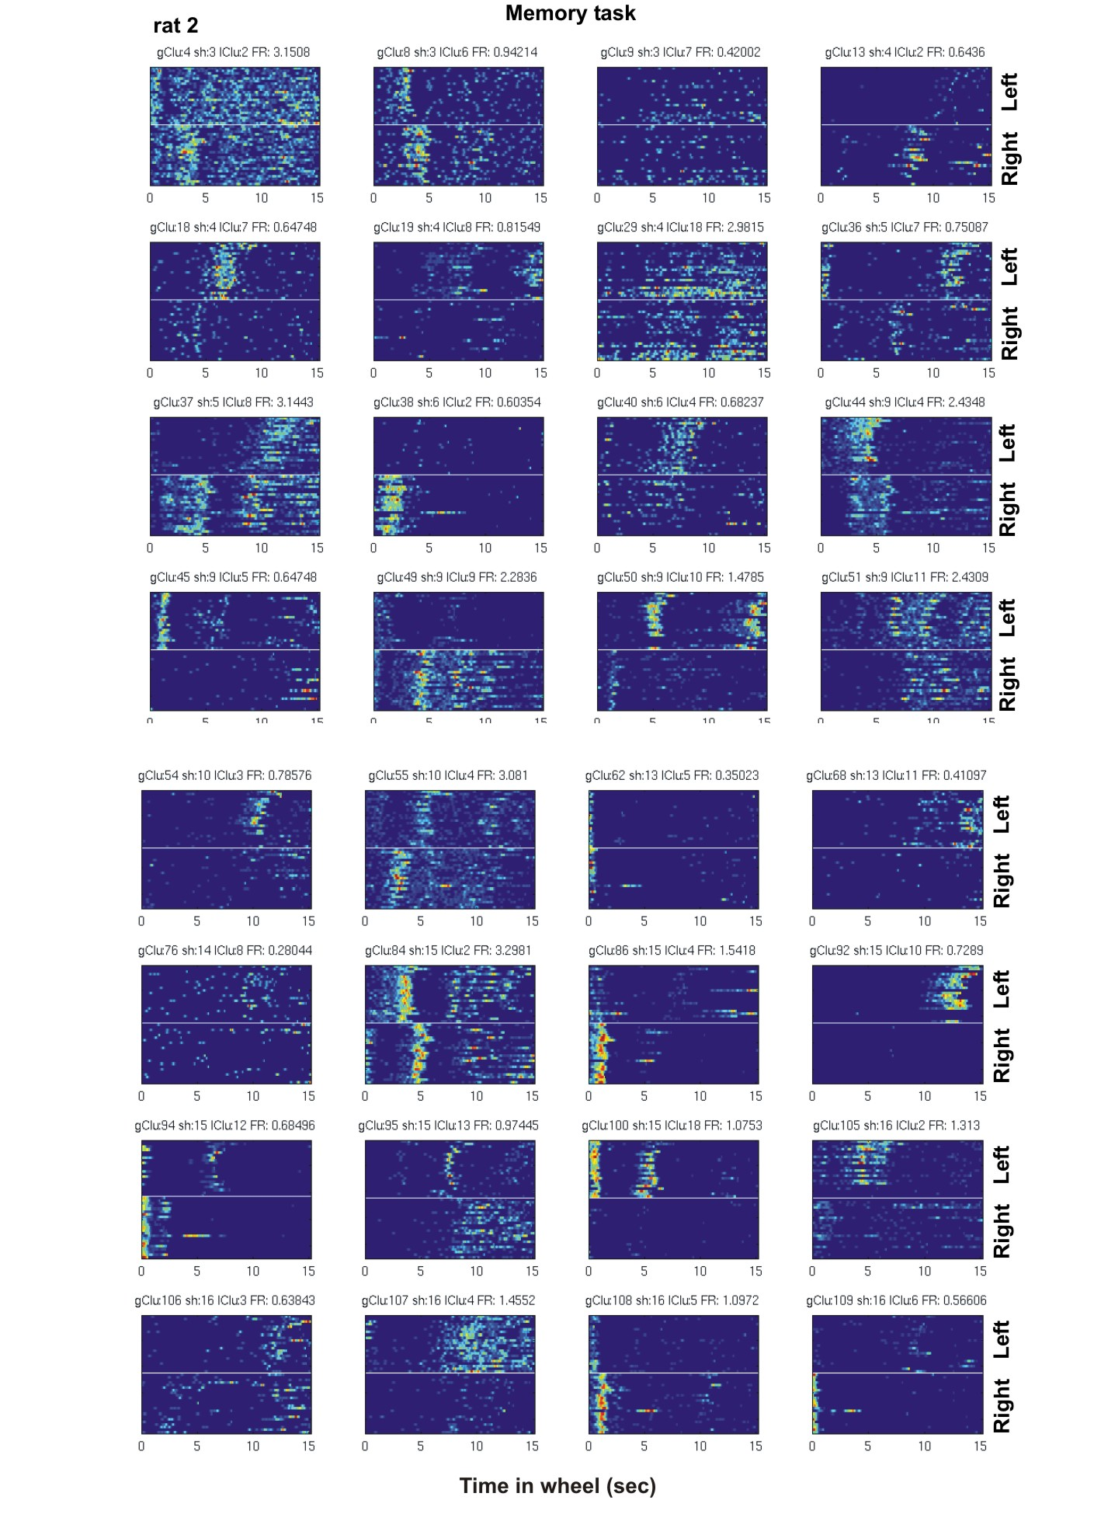
Fig. S8. Episode fields in the memory task. Activity of individual neurons during wheel running predicts future behavior of an animal in the maze. Firing patterns of 32 simultaneously recorded neurons in Rat 2 during wheel running in the delayed alternation task, separated on the basis of future left and right correct turns in the maze. Each line corresponds to a single trial. Clu, cluster identity. FR: Firing rate (Hz). Note that many neurons fire only for a short duration (“life time”) and consistently at the same time after the beginning of wheel running. Note also robust firing pattern differences between left and right trials in several neurons.

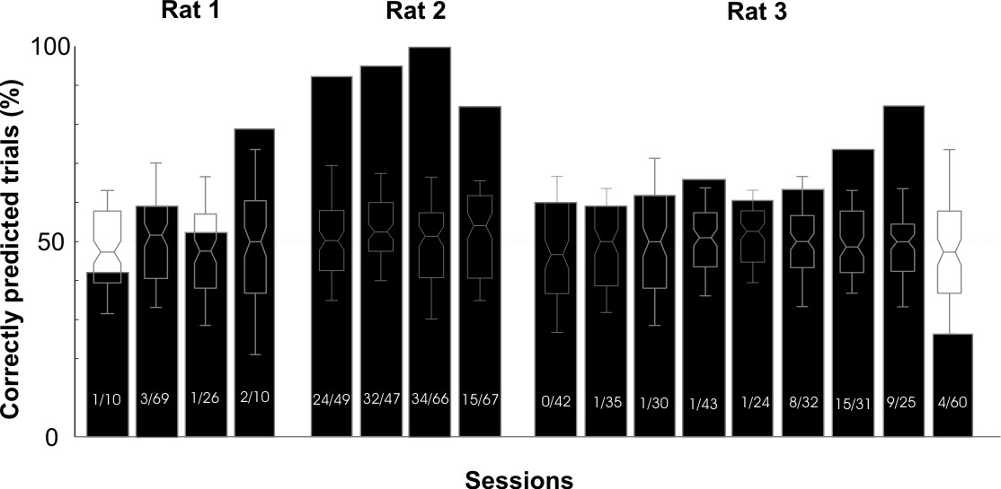

Fig. S9. Prediction of behavioral choices in the maze from the population activity during wheel running. In addition to identifying individual neurons with differential firing rate patterns before left and right choices (Fig. 4), we also examined how well population activity can predict correct choices. In this analysis, we used the best 10 discriminating neurons (based on mean spike count during wheel running before left and right choices), irrespective of whether they individually showed significant choice differences. In order to infer the left/right trial type for a given trial, we fit a model on all other trials (excluding the one to be predicted) and used the model to predict the remaining trial type (leave-one-out cross-validation procedure). Black bars indicate the percentage of correctly predicted trials during each session. The significance of the prediction was determined by comparing the original data set with shuffled data from the same session (box plots; see Methods). Box plots display median, the first and third quartiles and 95% confidence intervals for model predictions based on shuffled data sets. Numbers at the bottom of each bar indicate the fraction of neurons that significantly differentiated between left and right trials on at least a portion of wheel running trials (Fig. 4B) compared with the total number of pyramidal neurons within a session. Rat 3 lost the implant after the last recording session.

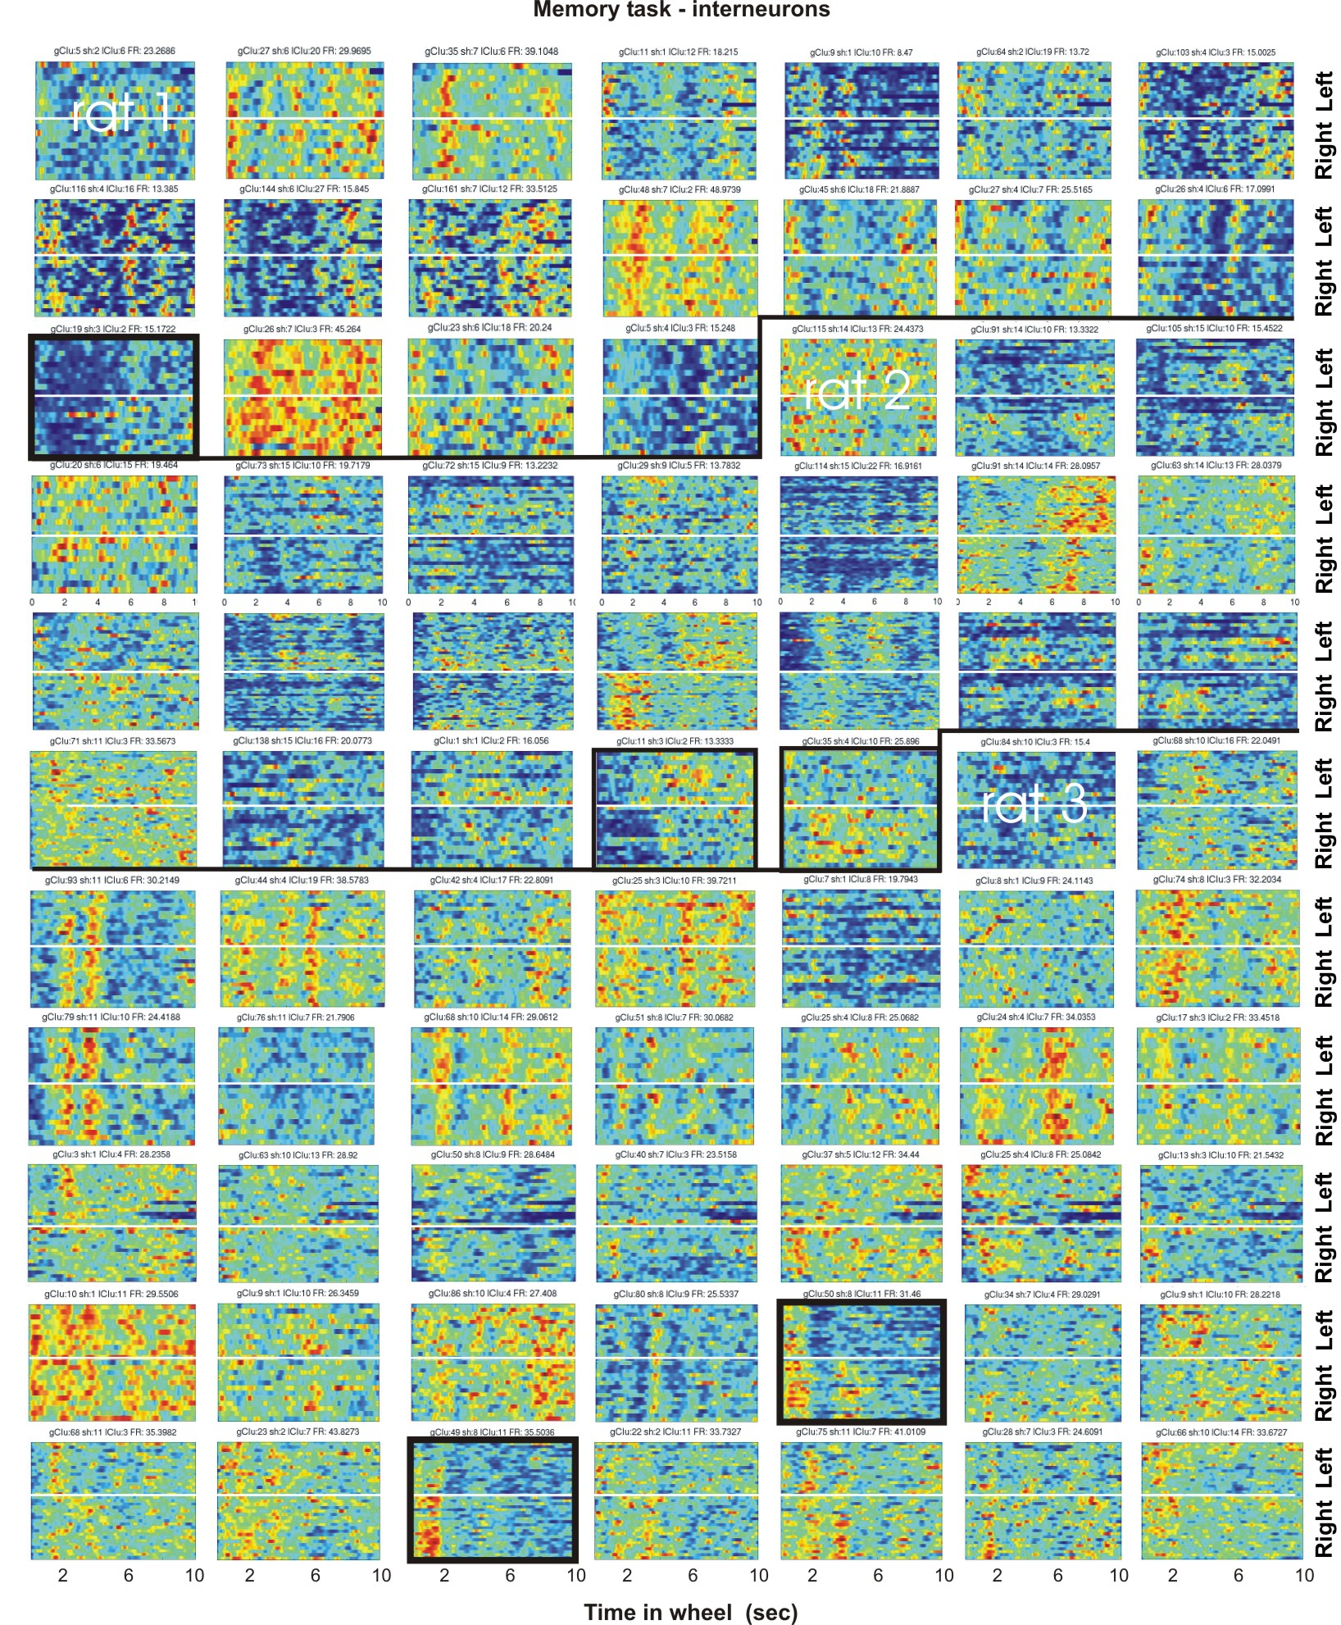

Fig. S10. Firing rates of some interneurons correlate with specific aspects of the memory task. Each map shows activity of a putative interneuron. Rows, wheel running trials separated according to the future choices in the maze (left, right). Neurons from 3 rats (n = 77 neurons). Several interneurons show increase or decrease of a firing rate at a specific portion of a wheel run (as visualized by the vertical color-stripes). Interneurons, whose firing patterns were correlated with future left or right choices are highlighted (black frames). These observations are in register with recent observations reporting that a fraction of interneurons also show place or other task-related specificity (19, 21, 9).

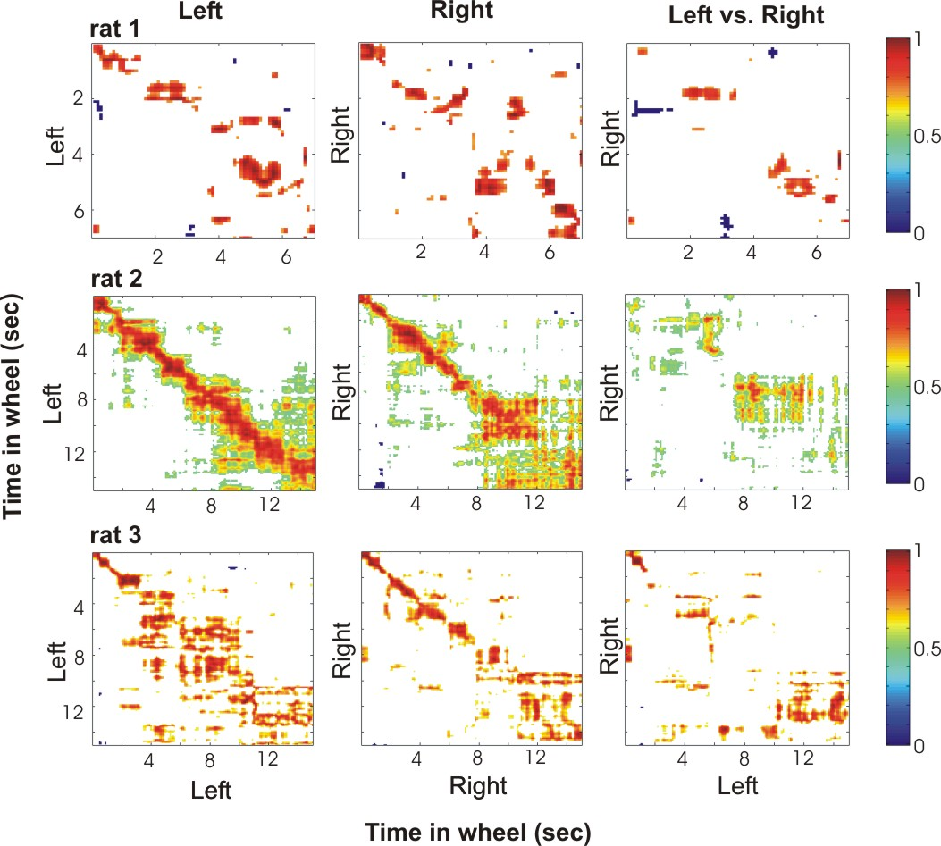

Fig. S11. Population vector cross-correlation matrices for a single session in each rat (rows). Matrices were calculated from population vectors representing activity during trials with either the same (Left: L-trial_{n} vs L-trial_{n+1}; Right: R-trial_{n+1} vs R-trial_{n+1}, Supplementary Methods) or different future choice (Left vs. Right: L-trial_{n} vs R-trial_{n}). The trial-to-trial consistency of subsequent trials that were followed by the same arm choice can be judged from the intensity of the diagonal. Note the lack of diagonal in the matrices calculated from trials followed by opposite choices (third column).

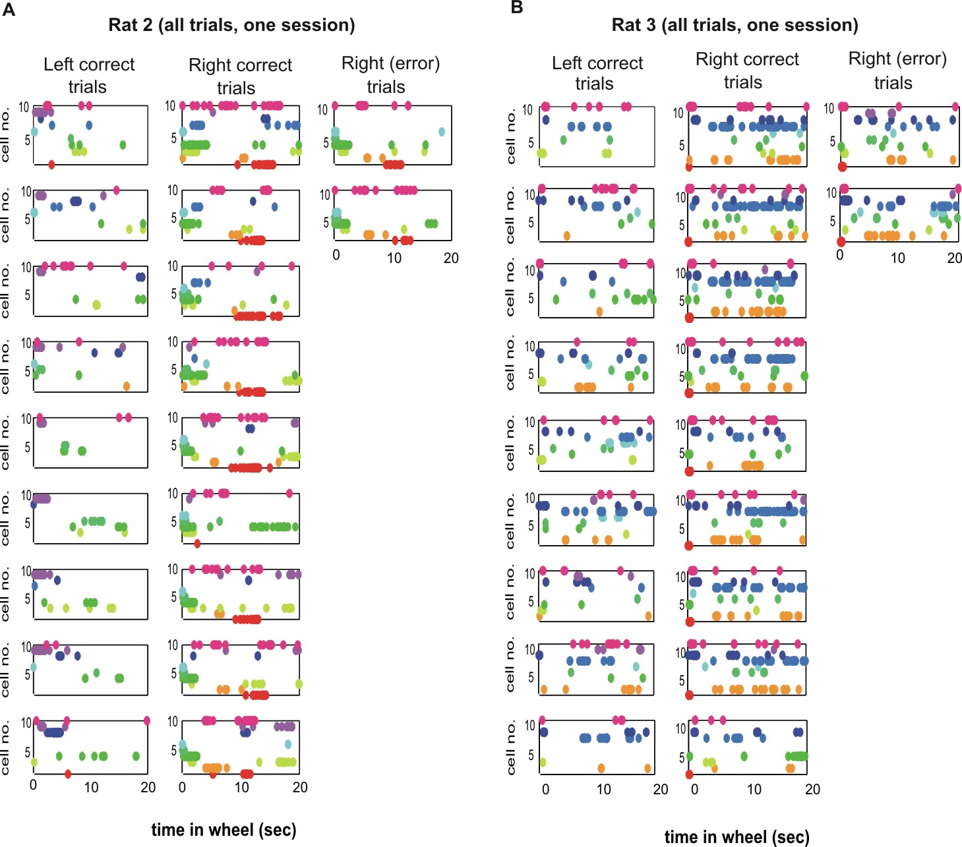

Fig. S12. Behavioral errors in the maze can be predicted from firing patterns during wheel running. Two representative sessions from 2 rats (each session with 9 left and 9 right correct trials and 2 error trials). For each rat, 10 best left/right discriminating neurons (color-coded dots) from a larger population were chosen. Note that firing patterns of right error trials and right correct trials are similar. These findings suggest that assembly sequences of neurons reflect planned travel path of the rat. During most error trials the rat ran smoothly in the wheel and through the center arm as well as the T-junction in one swift trajectory, and the commission error became detectable only after the wrong behavioral turn. Deadwyler et al. (23) referred to this kind of error as “miscoding”, implying that the previous choice is not correctly interpreted and the rat behaves indistinguishably from correct trials. The second type of error trials was associated with overt behavioral changes, such as stopping and premature departure from the wheel and return to the wheel, grooming and immobility in the wheel or delay area (analogous to the “delay-dependent” errors in ref. 23). The neuronal patterns associated with such behaviorally abnormal trials were often not possible to predict reliably from neuronal patterns, mainly because comparable correct reference assembly patterns were not available. Nevertheless, our anecdotal observations indicate that even such late errors could be distinguished by neurons with perfect left vs right discrimination (e.g., error trial in Movie 1). In the presented analyses (Fig. 5) all errors are presented, since the main goal was to differentiate between the effect of past and future movement paths of the rat.

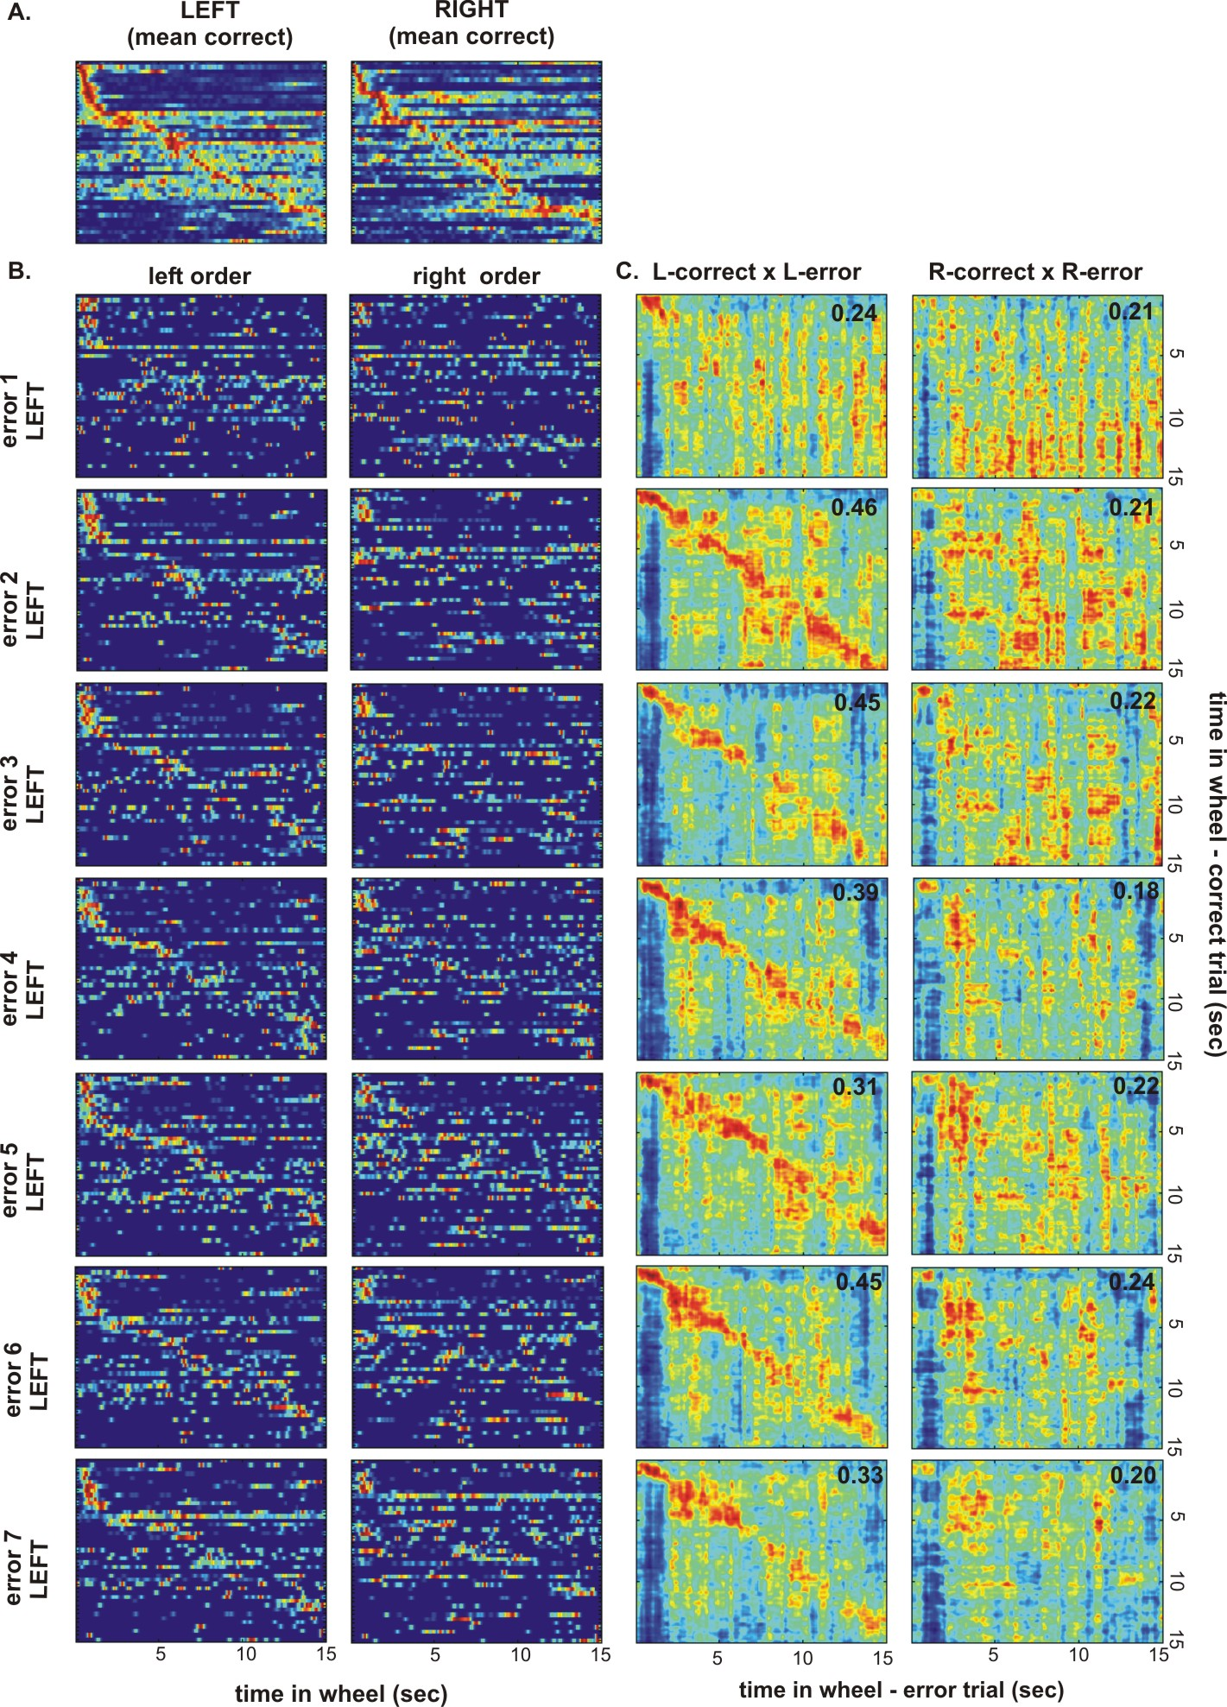

Fig. S13. Supplementary information for Fig. 5. A. Peak rate-normalized firing rates of 43 neurons simultaneously recorded during wheel running, ordered by the latency of peak firing rates during correct left trials (left) and correct right trials (right). Note that while in Fig. 5B neuron order 1 to 43 is the same for both panels, here the ordering of neurons for LEFT and RIGHT trials was done separately. B. Activity of the same neurons as in A during seven error trials. Neuronal order in the left column is the same as in the correct-left matrix in A. Neuronal order in the right column is the same as in the correct-right matrix in A. C. Correlation between population vectors from the left-correct and left-error matrices (left column) and correlation between population vectors from the right-correct and right-error matrices (right column). Mean correlation coefficient along the correlation matrix diagonal (± 0.5 sec) is given in the upper right corner of each correlation matrix. Note that left correct vs. left error mean correlation coefficient is higher than right correct vs. right error correlation coefficient in all 7 left-error trials.

Table S1. Variability between animals: selected behavioral and electrophysiological measures for rat 1-3. 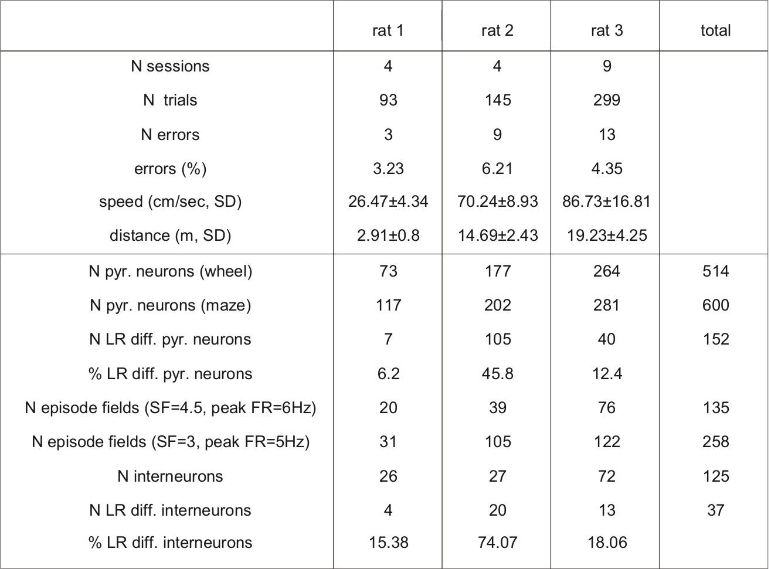

Movie 1. Single neurons can reliably predict future left and right turns. Running wheel on the right, the right and left side arms of the maze are on the top and bottom of the movie, respectively. Color LEDs indicate head orientation. This strongly discriminating neuron was virtually silent during wheel runs before right turns. Note that on the error trial (6th), the erroneous turn to the left is predicted by the increased firing of the cell at the end of the delay period. On another trial (last one in movie), the rat headed back toward the wheel. Prior to turning back toward the T junction the neuron became active followed by the neuron-predicted behavioral choice to the left. Although this neuron reliably discriminated left and right turns, it alone cannot be responsible for guiding future motor behavior since it fired transiently at the beginning of wheel running. This information should be passed onto further neuronal assemblies, which continue to discriminate between left and right movement trajectories during later parts of running in the wheel and in the stem area (“prospective” neurons, 12-14).

Supplementary References
1. J. Csicsvari, D. A. Henze, B. Jamieson, K. D. Harris, A. Sirota, P. Barthó, K. D. Wise, G. Buzsáki, J. Neurophysiol. 90, 1314-23 (2003).
2. H. Hirase, A. Czurko, J. Csicsvari, G. Buzsáki, Eur J Neurosci 11, 4373-4380 (1999).
3. K. D. Harris, D. A. Henze, J. Csicsvari, H. Hirase, G. Buzsáki, J. Neurophysiol.
84, 401–414 (2000).
4. J. Csicsvari, H. Hirase, A. Czurko, G. Buzsáki, Neuron 21, 179–189 (1998).
5. L. Hazan, M. Zugaro, G. Buzsáki, J Neurosci Methods 155, 207–216 (2006).
6. A. Czurko, H. Hirase, J. Csicsvari, G. Buzsáki, Eur J Neurosci 11, 344-352 (1999).
7. D. Klement, E. Pastalkova, A. A. Fenton, Hippocampus, 15, 460–471 (2005).
8. E. Pastalkova, P. Serrano, D. Pinkhasova, E. Wallace, A. A. Fenton, T. C. Sacktor, Science 313, 1141-1144 (2006).
9. C. Geisler, D. Robbe, M. Zugaro, A. Sirota, G. Buzsáki, Proc. Natl. Acad. Sci. U. S. A. 104, 8149-54 (2007).
10. G. Dragoi, G. Buzsáki, Neuron 50, 145-57 (2006).
11. S. Fujisawa, A. Amarasingham, M. T. Harrison, G. Buzsáki, Nature Neurosci 11, 823 - 833 (2008).
12. L. M. Frank, E. N. Brown, M. Wilson, Neuron 27, 169-178 (2000).
13. J. Ferbinteanu, M. L. Shapiro, Neuron 40, 1227-1239, (2003).
14. E. R. Wood, P. A. Dudchenko, R. J. Robitsek, H. Eichenbaum, Neuron 27, 623-633 (2000).
15. M. R. Bower, D. R. Euston, B. L. McNaughton, J Neurosci 25, 1313-23 (2005).
16. J. A. Ainge, M. Tamosiunaite F. Woergoetter, P. A. Dudchenko, J Neurosci 27, 9769-79 (2007).
17. J. A. Ainge, M. A. van der Meer, R. F. Langston, E. R. Wood, Hippocampus 17, 988-1002 (2007).
18. K. M. Gothard, W. E. Skaggs, B. L. McNaughton, J Neurosci 16, 8027-8040 (1996).
19. A. P. Maurer, S. L. Cowen, S. N. Burke, C. A. Barnes, B. L. McNaughton, J. Neurosci. 26, 13485-92 (2006).
20. A. Terrazas, M. Krause, P. Lipa, K. M. Gothard, C. A. Barnes, B. L. McNaughton, J Neurosci 25, 8085-96 (2005).

21. W. B. Wilent, D. A. Nitz, J. Neurophysiol. 97, 4152-61 (2007).
22. V. Ego-Stengel, M. A. Wilson, Hippocampus, 17, 161-174 (2007).
23. A. Deadwyler, T. Bunn, R. E. Hampson, J Neurosci 16, 354-72 (1996).

