Simulation of line load and moment with a Fourier transform method

This exercise demonstrates how to simulate a line load and line moment on a thin elastic plate using a Fourier transform method. The objectives are to first demonstrate that the Fourier method agrees with the analytic solutions to better than 1 part in 10⁶ for the line load case. The second objective is to develop a numerical approximation to a line moment and show agreement to 1 part in 10⁴. Given a linear combination of these two solutions one can generate a trench profile of an arbitrary shape. The ultimate goal is to develop this approach in 3-D so we can model subduction flexure at a trench of arbitrary geometry.

The differential equation for the deflection of a thin elastic plate w(x) in response to a line load 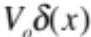is:

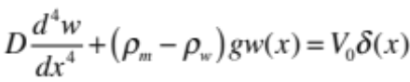 (1)

where is the deflection of the plate as a function of distance , is the flexural rigidity, 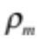 and 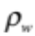 are the densities of the mantle and seawater respectively (3300 kgm⁻³, 1000 kgm⁻³) is the acceleration of gravity (9.8 ms⁻²) and 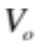 is the amplitude of the line load. The solution to this problem is provided in Turcotte and Schubert [2002] and also in Sandwell’s online geodynamics notes http://topex.ucsd.edu/geodynamics/12flexure.pdf . The solution for 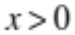is

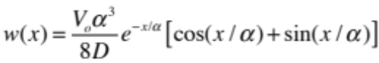 (2)

where the flexural parameter is given by

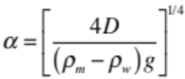. (3)

A plot of this function is shown in Figure 1a where the result was normalized by the factor

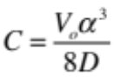. (4)

This problem can also be solved using the Fourier transform method. Let the forward and inverse Fourier transforms be defined as

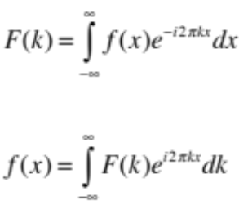 (5)

where 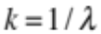 is the wavenumber for a wavelength . The Fourier transform of equation (1) is

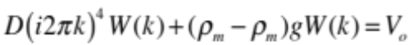 (6)

and one can solve for the plate deflection directly.

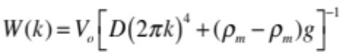. (7)

We can compare this numerical approach with the analytic solution using Matlab. The steps are as follows. 1) Generate a load vector of length N where all the elements are zero except element N/2 which is equal to 1. This represents our line load. 2) Generate the positions and wavenumbers associated with this array in the space domain and Fourier domain, respectively. 3) Take the Fourier transform of the load vector and multiply by the transfer function given in equation (7). Note that one must divide by a scale factor dx to have the correct scaling. 4) Take the inverse transform of this result and also normalize by the scale factor provided in equation (4). The result is a near perfect match to the analytic solution and the difference between the two solutions is plotted in Figure 1b.
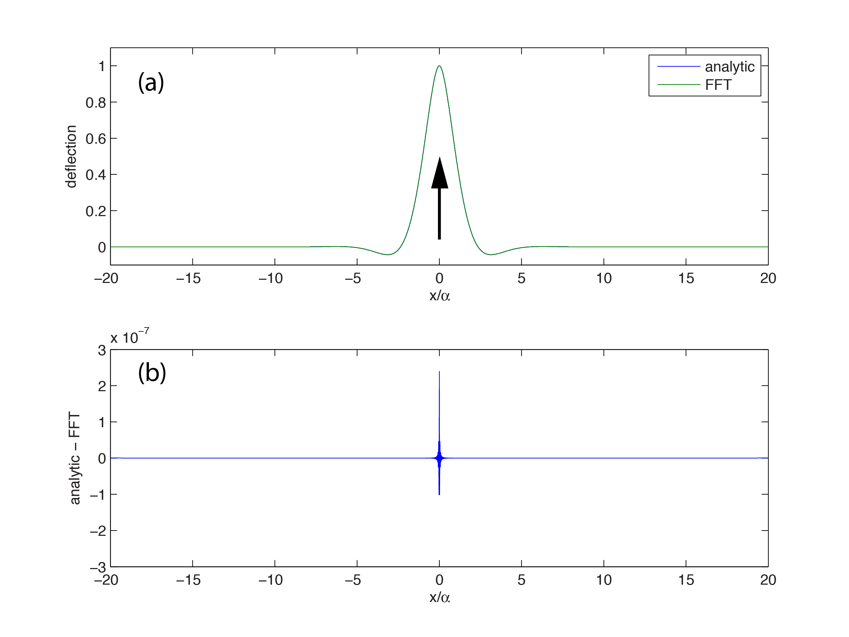
Figure 1 (a) Normalized deflection of a thin elastic plate from a line load calculated from the analytic expression (blue) and also using the Fourier transform method (green). (b) Difference between the two methods has the largest amplitude at the position of the load.

The next step is to use a similar approach to simulate a bending moment. The analytic expression for this is developed from the derivative of the line response given equation (2).

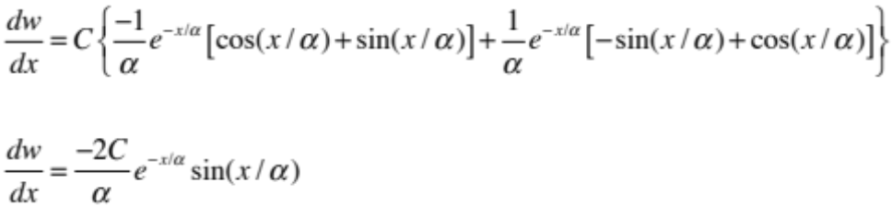. (8)

Next assume that two equal and opposite loads of strength are applied with an offset of 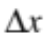. Then the deflection of the plate will be given by.

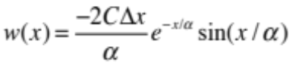. (9)
The corresponding moment is 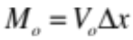.

Again we can compare a purely numerical computation using a line load couple to the solution given in equation (9). The computation is exactly the same as described above but rather than place a single load of 1 at the memory location N/2 we also place a load of -1 at location N/2+1. The spacing between these loads used in equation (9) is the natural x-spacing in the load vector. A comparison between these two approaches is provided in Figure 2. One cannot distinguish between the two calculations when they are plotted together in Figure 2a. Their difference is less than 1 part in 10⁴ (Figure 2b).
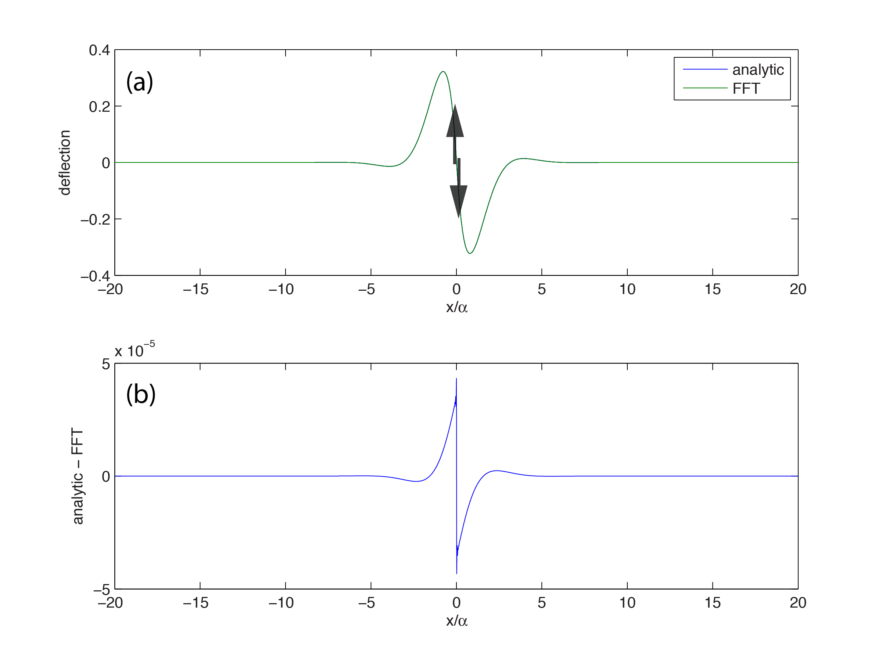
Figure 2 (a) Normalized deflection of a thin elastic plate from a line moment calculated from the analytic expression (blue) and also using the Fourier transform method (green). (b) Difference between the two methods has the largest amplitude at the position of the opposing loads.

The overall objective of this exercise is to demonstrate that one can generate these two fundamental solutions, a line load and line moment, using a Fourier approach with a numerical approximation. As an example a superposition of these two solutions is provided in Figure 3 where only the 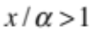 part of the solution is plotted. By varying and 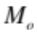 one can adjust both the amplitude and phase of the trench flexure profile.

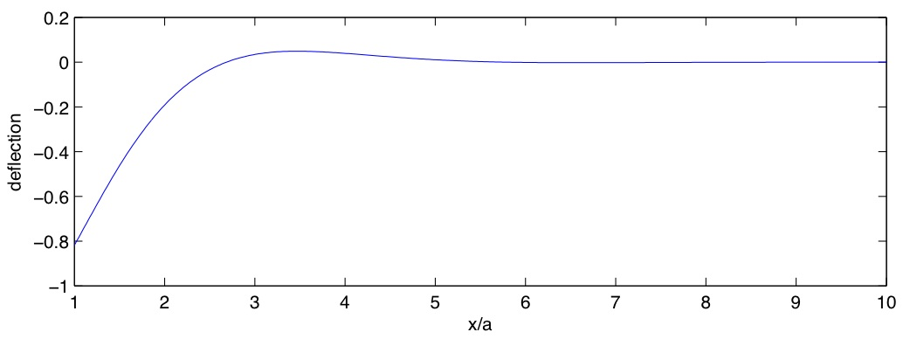
Figure 3 Normalized deflection of a thin elastic plate from negative line load and positive line moment calculated from the Fourier transform method (blue).

The Matlab code to do these calculations is provided on the following pages.

%
% demonstrate equivalence of inverse fourier method and the analytic solution
%
% set some constants
%
clear
rm=3300;
rw=1000;
g=9.8;
E=6.e10;
nu=0.25;
h=30000;
D=E*h^3/(12.*(1-nu^2));
alph=(4*D/((rm-rw)*g))^.25;
V0=1.;
cnst=V0*alph^3/(8.*D); % constant provided in T&S
cnstm=cnst/alph;
%
% set the x and the wavenumber
%
N = 2048; % number of points in the series should be a power of 2
L = 3.e6; % set the overall length of the profile
dx= L/N; % this is the data spacing
x = dx*(1:N)-L/2; % generate x-vector and put the origin arbitrarily at L/4.
k = -(N/2):(N/2-1); % generate the integer part pf the wavenumber vector
k = 2.*pi*k./L; % convert from integer to radians per meter
ks= ifftshift(k); % move the zero wavenumber to the center of the array
%
% place a 1 at the center of the array
%
w=zeros(1,length(x));
w(N/2)=1;
cw=fft(w);
%
% compute W(k)
%
demon=D*(ks.^4)+(rm-rw)*g;
cw=cw./demon/dx; % divide by dx to get the units correct
w1=real(ifft(cw))/cnst; % shift the origin to the center of the array
% divide by the constant from T&S
%
% now compute analytic solution
%
xa=abs(x)/alph;
wm=exp(-xa).*(cos(xa)+sin(xa)); % don't multiply by the constant from T&S
%
% plot the line load
%
figure(1)
clf
subplot(2,1,1),plot(x/alph,w1,x/alph,wm)
axis([-20,20,-.1,1.1])
legend('analytic','FFT')
xlabel('x/a')
ylabel('deflection')
subplot(2,1,2),plot(x/alph,wm-w1)
axis([-20,20,-3.e-7,3.e-7])
xlabel('x/a')
ylabel('analytic - FFT')
%
% now compute the response to a bending moment using two approaches
%
w=zeros(1,length(x));
w(N/2)=1;
w(N/2+1)=-1;
cw=fft(w);
cw=cw./demon/dx; % divide by dx to get the units correct
w2=real(ifft(cw))/(cnstm*2*dx) ; % shift the origin to the center of the array
% divide by the constant from T&S
%
% now compute analytic solution
%
xa=(x-dx/2)/alph;
wm=-exp(-abs(xa)).*sin(xa); % don't multiply by the constant from T&S
figure(2)
clf
subplot(2,1,1),plot(x/alph,w2,x/alph,wm)
axis([-20,20,-.4,.4])
legend('analytic','FFT')
xlabel('x/a')
ylabel('deflection')
subplot(2,1,2),plot(x/alph,wm-w2)
axis([-20,20,-5.e-5,5.e-5])
xlabel('x/a')
ylabel('analytic - FFT')
%
% now make a trench simulation
%
w=zeros(1,length(x));
w(N/2)=1;
w(N/2+1)=-1;
w=w/(2*dx/alph); % need to scale the moment by 2*dx/alpha
w(N/2)=w(N/2)-1.;
cw=fft(w)/cnst;
cw=cw./demon/dx; % divide by dx to get the units correct
w3=real(ifft(cw));
figure(3)
clf
subplot(2,1,1),plot(x/alph,w3)
axis([1,10,-1.,.2])
xlabel('x/a')
ylabel('deflection')

3-D simulation of line load and moment with a Fourier transform method

The approached developed above for the 2-D case can be done in a similar fashion in 3-D using a fortran program called trench_3d.f . The first example provides the response of a thin elastic plate and then a thick elastic plate [Smith and Sandwell 2006] to a vertical line load. The thick elastic plate is offset from the other two solutions because the mean value was removed in the analysis. Also note that the amplitude of the thick elastic plate model is slightly larger due to the local deformation of the plate near the source. In this case the difference is larger than for the 2-D example. This could be due to the fact that the 3-D Fourier analysis was done using single precision while the 2-D case was done using double precision.

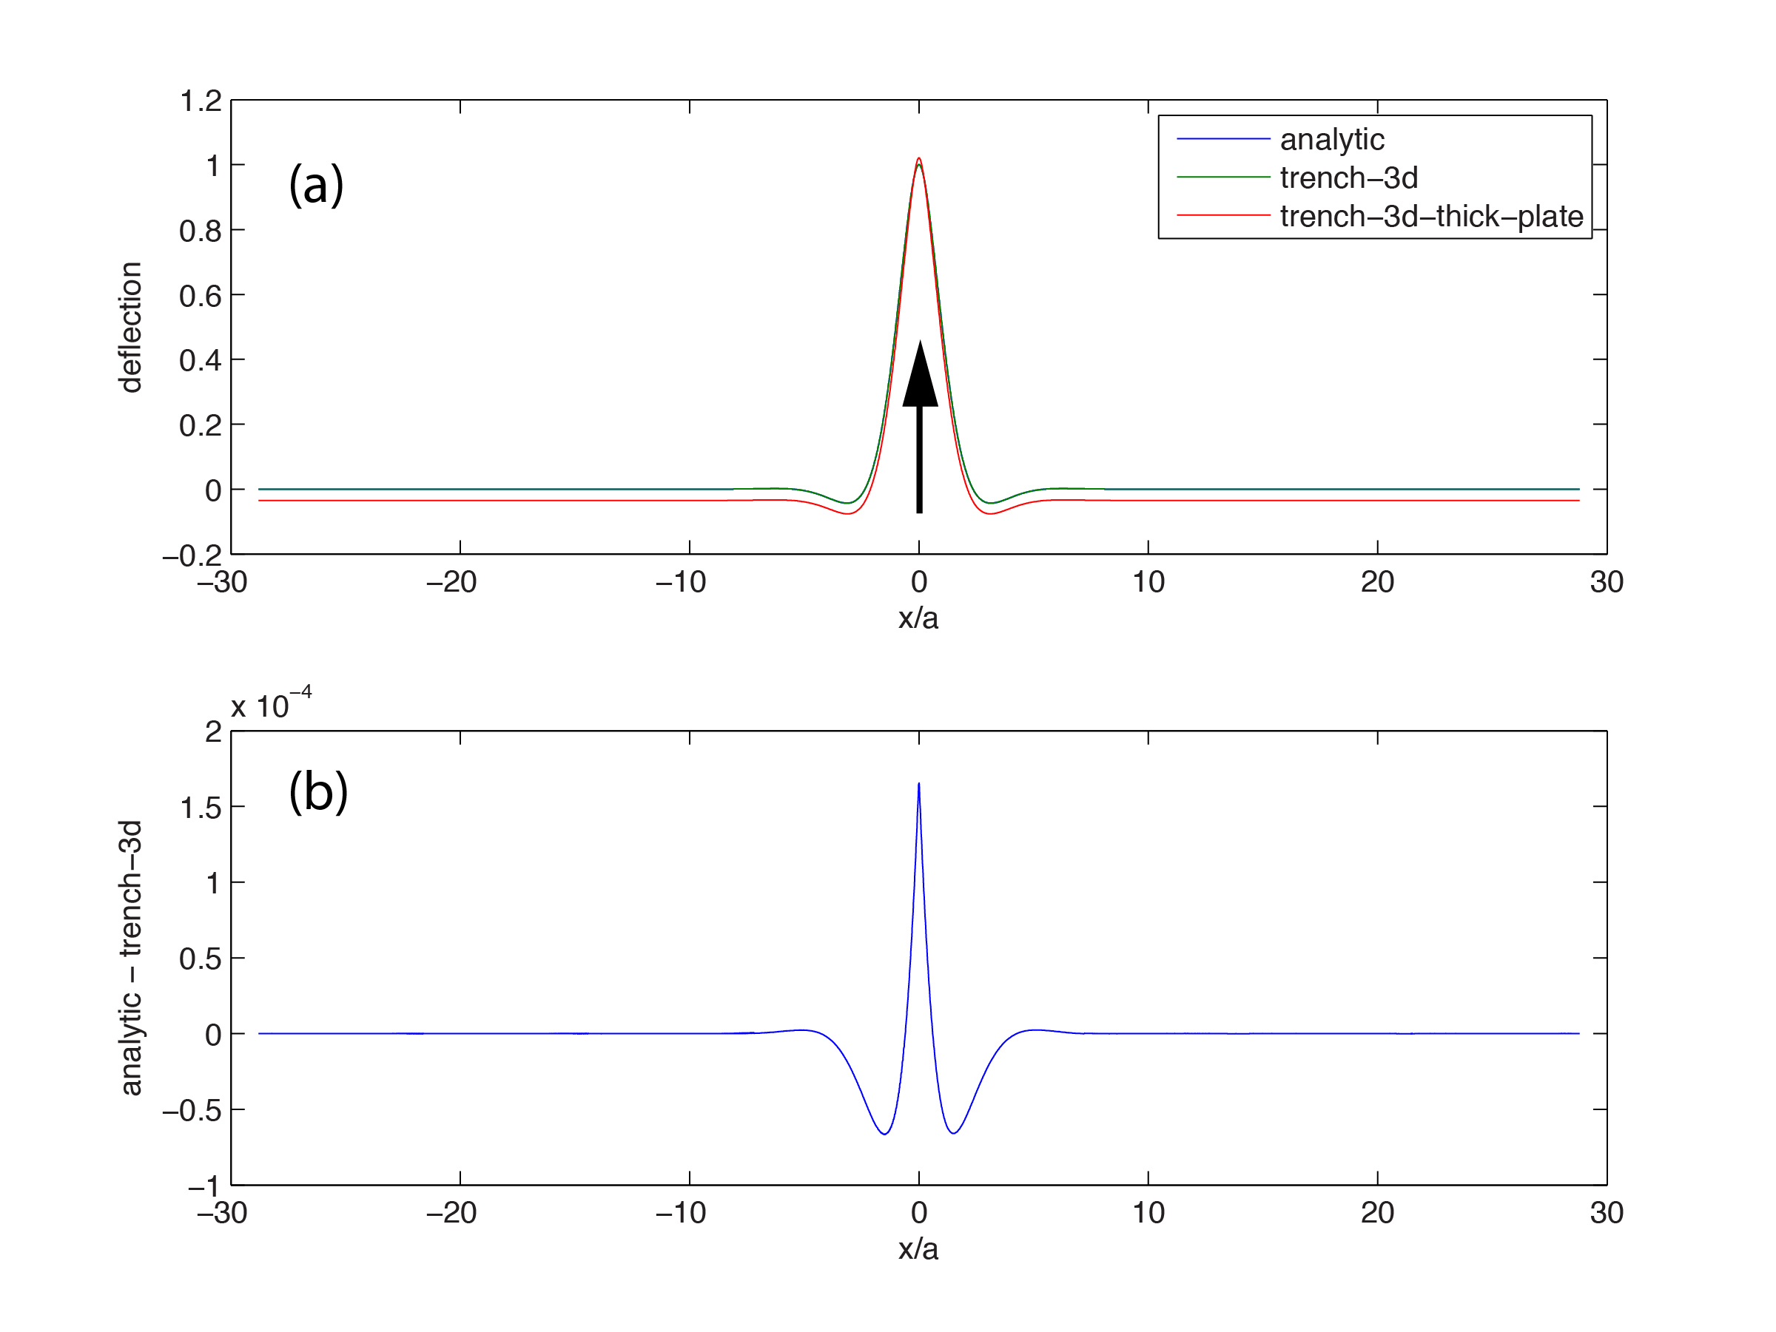
Figure 4 (a) Normalized deflection of a thin elastic plate from a line load calculated from the analytic expression (blue) and also using the 2.5-D Fourier transform method (green) as well as a 3-D thick elastic plate (red). (b) Difference between the two methods has the largest amplitude at the position of the load and is about 10⁴ times smaller than the plate deflection.

The second example uses the force couple to simulate a moment. Note again that amplitude of the thick plate solution is slightly greater than the thin plate close to the force couple because of local elastic deformation of the plate. In this case the difference is larger than for the 2-D example. This could be due to the fact that the 3-D Fourier analysis was done using single precision while the 2-D case was done using double precision.
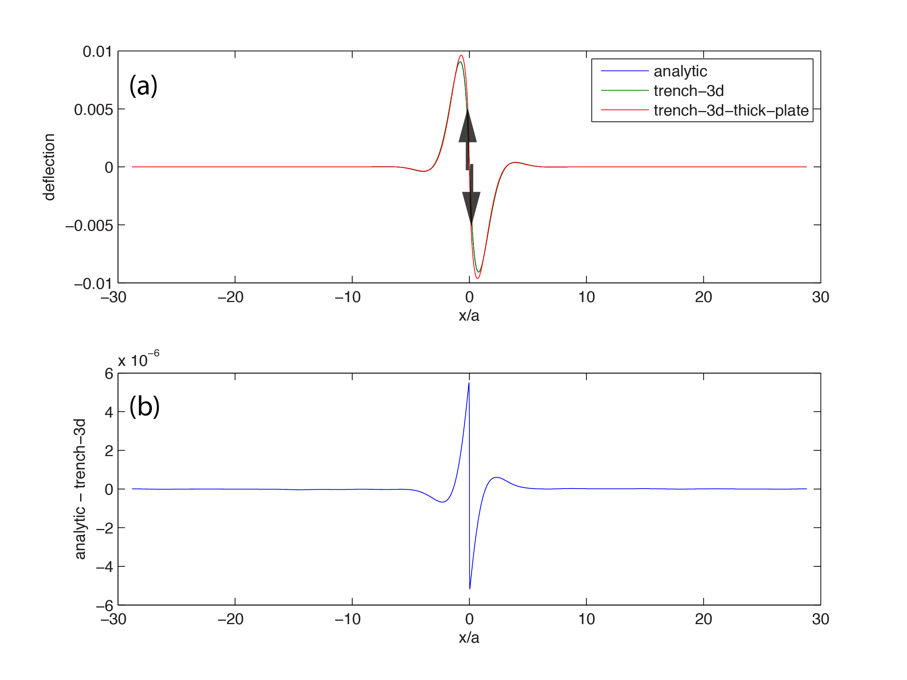

Figure 5 (a) Normalized deflection of a thin elastic plate from a line moment calculated from the analytic expression (blue) and also using the 2.5-D Fourier transform method (green) ) as well as a 3-D thick elastic plate (red). (b) Difference between the two methods has the largest amplitude at the position of the opposing loads.

Armed with this new capability to calculate thin and thick elastic plate over large areas, it is now possible to simulate the response for any shaped load. We tested this approach with a simulation of a trench consisting of an arcuate section similar in radius to the Mariana Trench with straight segments extending to the north and south. The program trench_3d ingests a segment file such as the following:
lon_start lon_end lat_start lat_end vert_load moment
-90.0012160591 -89.9367031338 7.31842590238 6.47001181567 -1.e15 -4.e17
-89.9367031338 -89.7452246505 6.47001181567 5.63929842209 -1.e15 -4.e17
-89.7452246505 -89.2994535554 5.63929842209 5.06405283518 -1.e15 -4.e17
-89.2994535554 -88.6093272092 5.06405283518 4.67592770078 -1.e15 -4.e17
-88.6093272092 -87.5857448071 4.67592770078 4.35960224553 -1.e15 -4.e17
-87.5857448071 -86.6535779456 4.35960224553 3.82216437650 -1.e15 -4.e17
-86.6535779456 -85.9391023567 3.8221643765 3.15266909782 -1.e15 -4.e17
-85.9391023567 -85.4826760589 3.15266909782 2.41814029924 -1.e15 -4.e17
-85.4826760589 -85.2189753611 2.41814029924 1.71091618709 -1.e15 -4.e17
-85.2189753611 -85.0668217784 1.71091618709 0.86312659865 -1.e15 -4.e17
-85.0668217784 -84.9956457464 0.86312659865 -0.02435019413 -1.e15 -4.e17
-84.9956457464 -85.0631294611 -0.02435019413 -0.96591513470 -1.e15 -4.e17
-85.0631294611 -85.1682311767 -0.96591513470 -1.63684163804 -1.e15 -4.e17

The segments are arranged end-to-end. The computer code convolves these line segments for the vertical load with a Gaussian function and creates a 2-D grid of vertical forces. For the moment, the derivative of a Gaussian normal to the segment is used for the convolution filter. The grid of vertical forces is fourier transformed in 2-D and the result is multiplied by the thin or thick-plate transfer function (40 km elastic plate thickness). The result is inversed transformed to make topography, gravity, or a stress tensor.
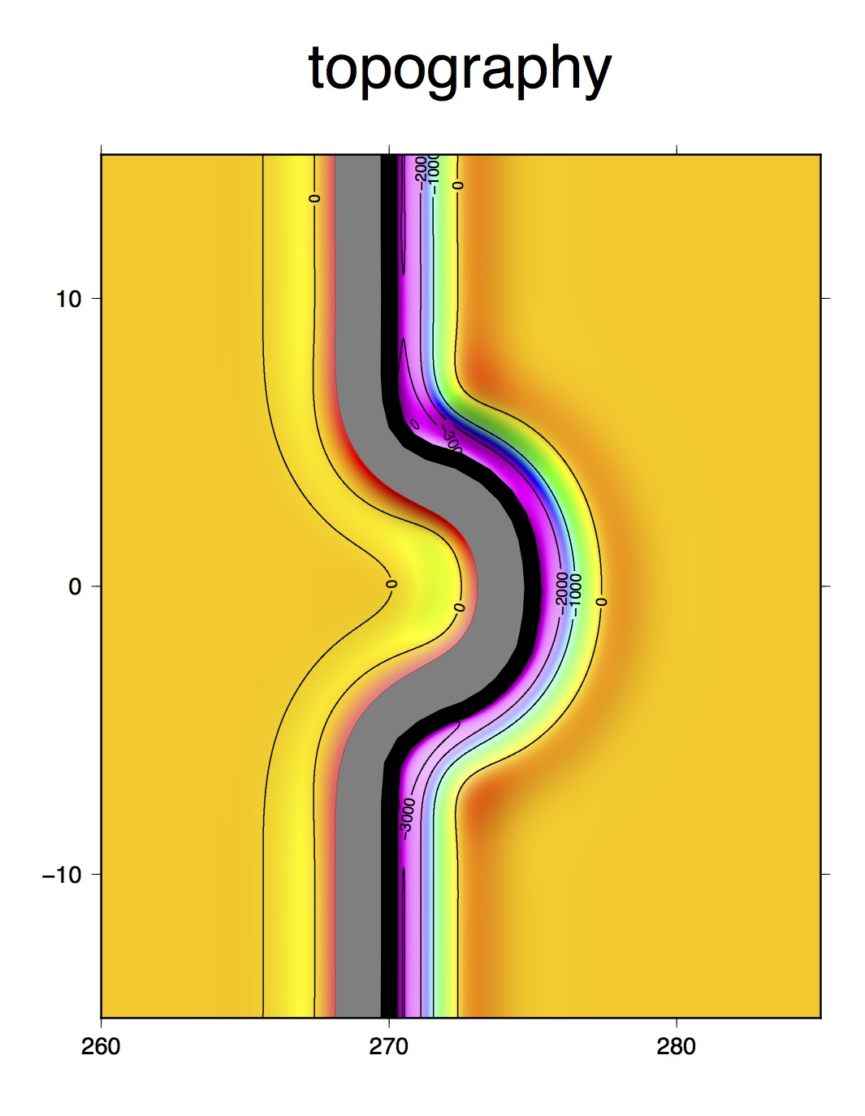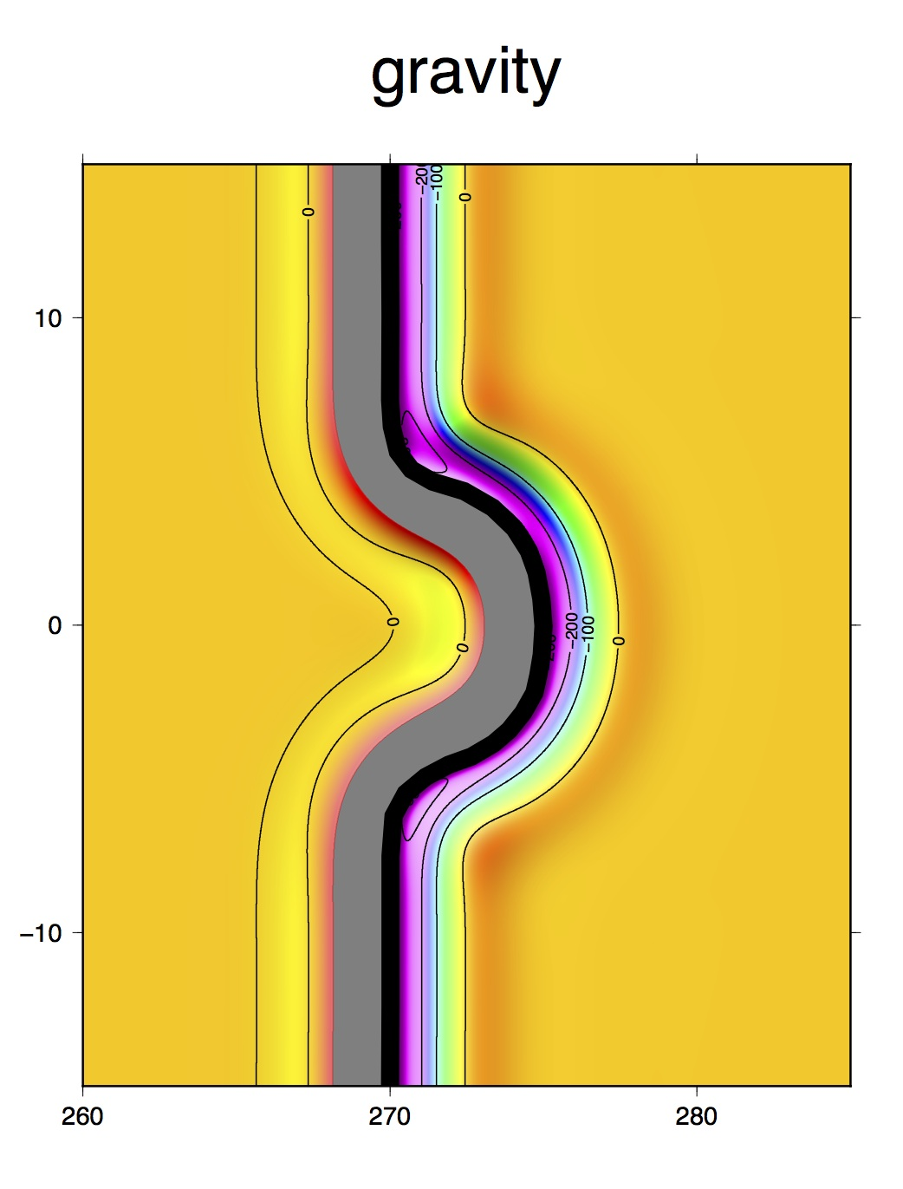
Figure 6 (left) Flexural topography for a trench simulation (1000 m contours) where both vertical loads and bending moments were applied along the black line. (right) upward continued gravity anomaly (100 mGal contours) for this same simulation. The grey area is masked and represents a flexural uplift due to the applied moment. Only the model to the right of the load should be interpreted as a trench.

This simulation shown in Figure 6 highlights the importance of the curved planform of many trenches. The topography and gravity of a straight trench can be accurately modeled using single profiles perpendicular to the trench and all(?) previous publications take this approach. However when the planform of the trench is curved the shape of the flexural topography becomes more complicated. For example the peak in the outer rise topography gravity at point A is 134 m, at point B is 215 m and at point C is 110 m. The gravity shows similar variations (A= 11 mGal, B=18 mGal, C= 9 mGal). The vertical load and moment are uniform along this entire trench but if one solved for moment using the standard profile approach, one could have erroneous variations up to a factor of two simply because the planform of the trench was not considered.

