**Using Google trends to compare search volume between terms.**

1. Navigate to : http://www.google.com/trends/, hit ‘explore’

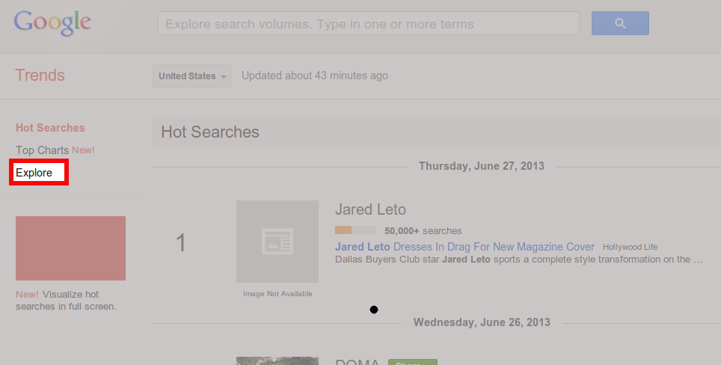

1. Enter search terms.

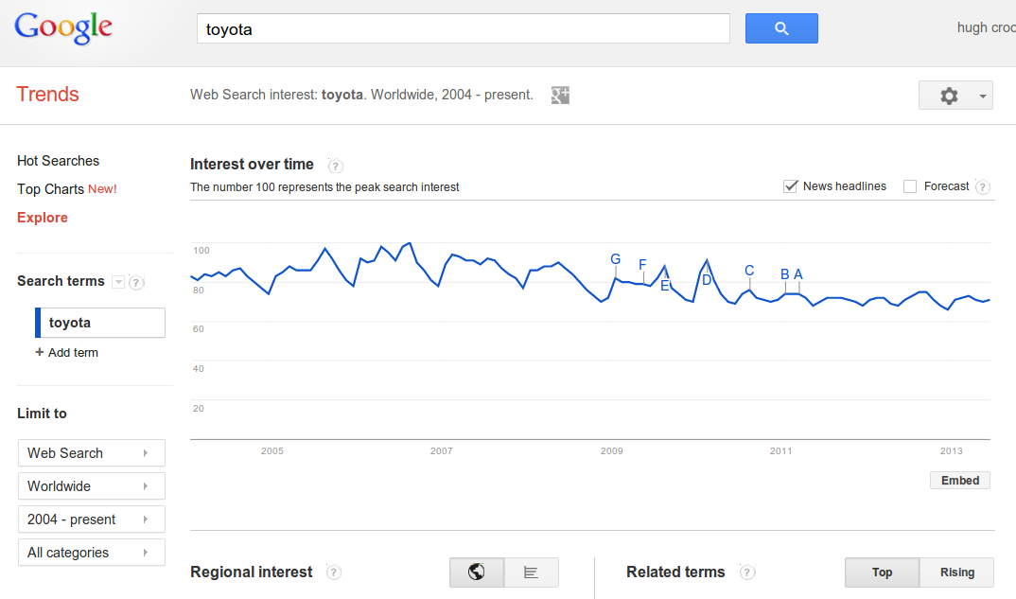Search volume is shown as percentage of peak, with headlines indicated by letters (e.g. D = prius recall)

1. 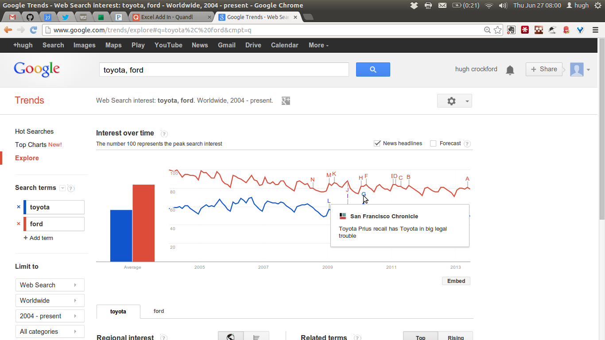More terms can be added and terms compared, again as a percentage of max search volume.
2. The chart data can be downloaded using ‘download as CSV’ (comma separated values)

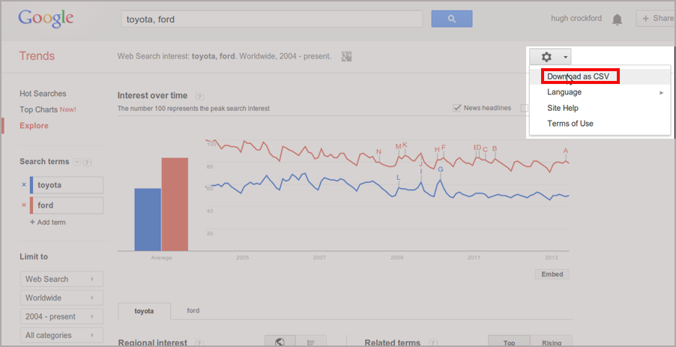

1. This data can then be imported to excel.

Browse to the location of downloaded file and change ‘files of type to ‘ text files (*.prn, *.txt,*.csv). This data can then be copied out of excel and into minitab.

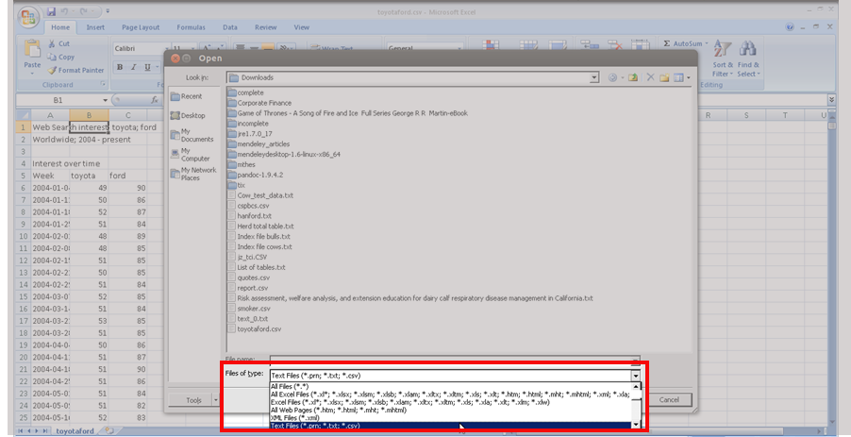

**Using Quandl Excel Addin to access financial datasets**

1. Set up an account at <http://www.quandl.com/users/sign_up>

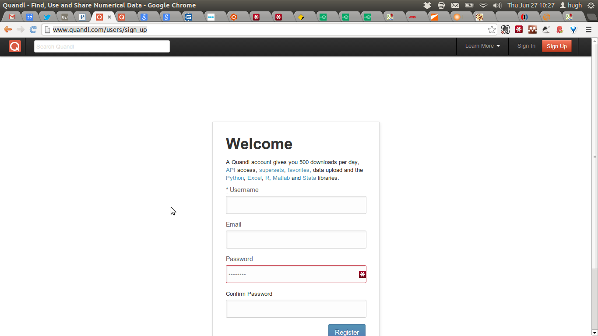

1. Go to ‘Account’, ‘API’ and copy your unique auth token for step 6.

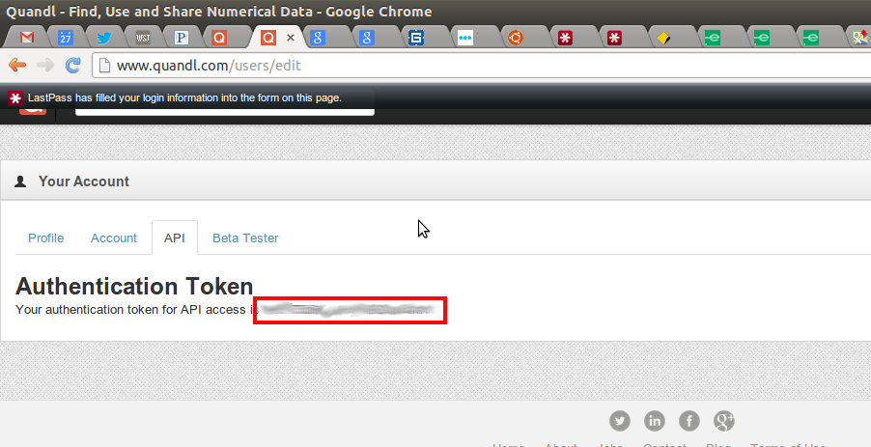

1. Go to <http://www.quandl.com/help/packages/excel-add-in> and download Quandl.xlam

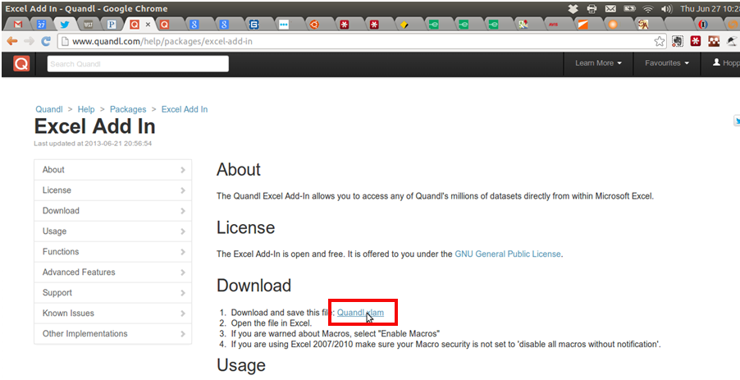

1. Open the file in excel. 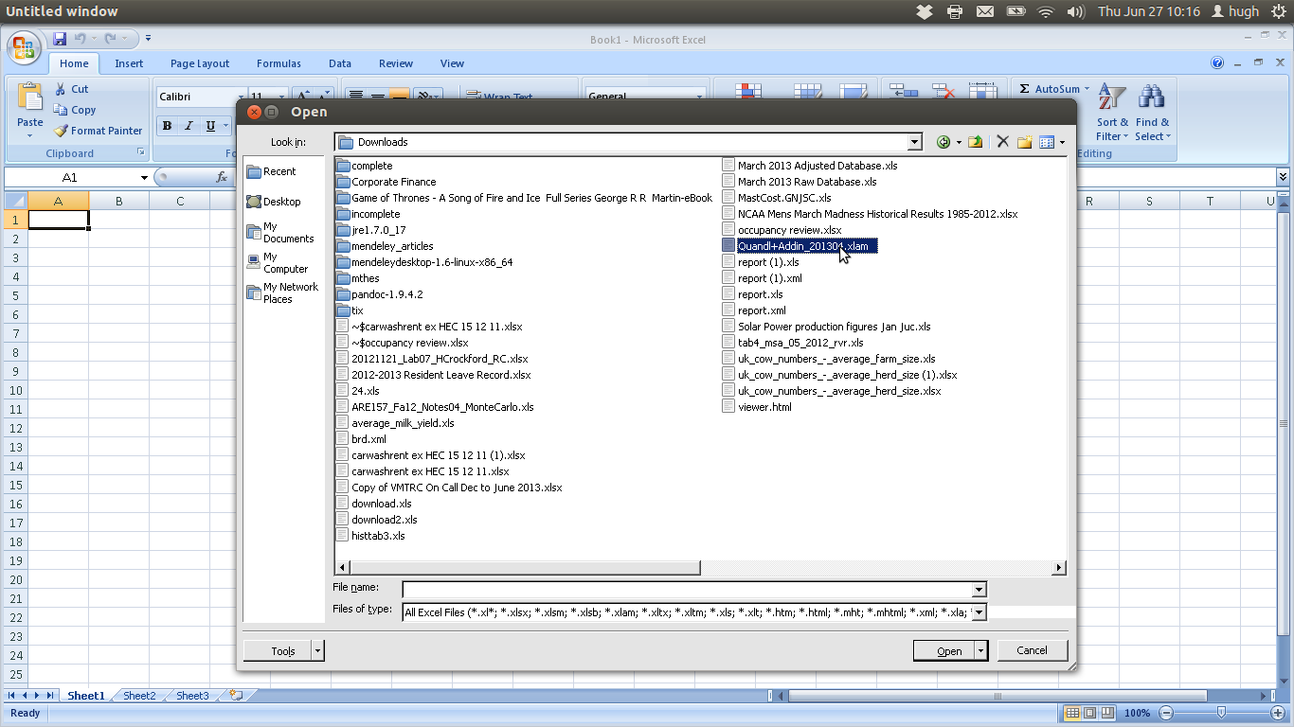
2. When prompted, Enable Macro’s

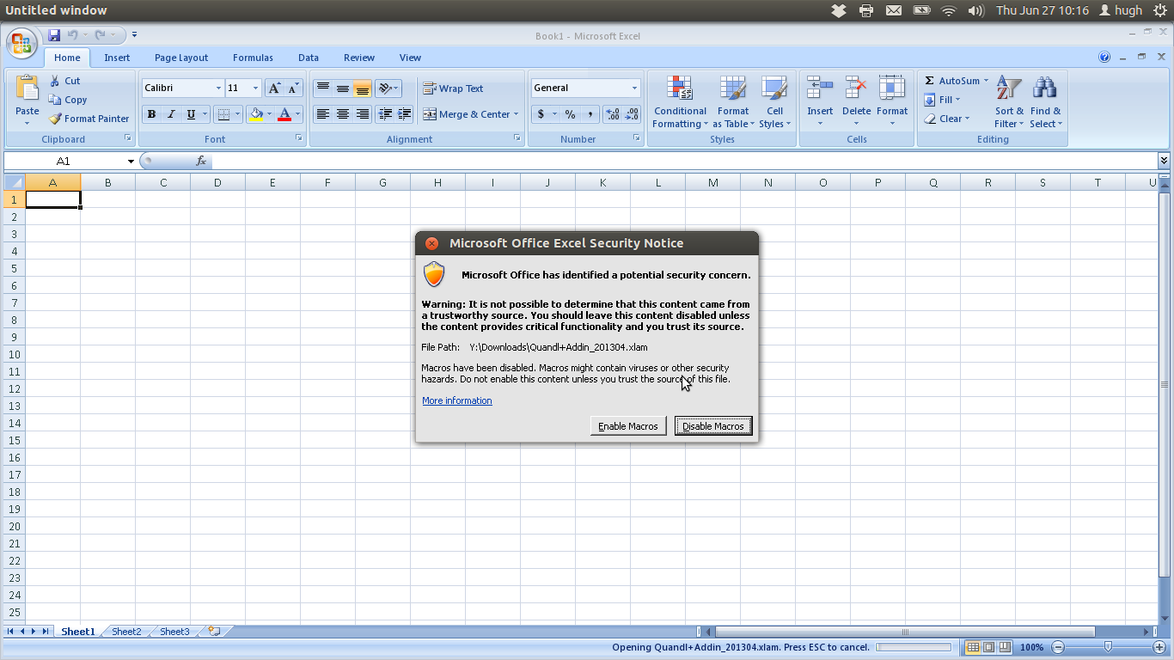

1. A new ribbon will appear, select it and enter in auth token from step 3.

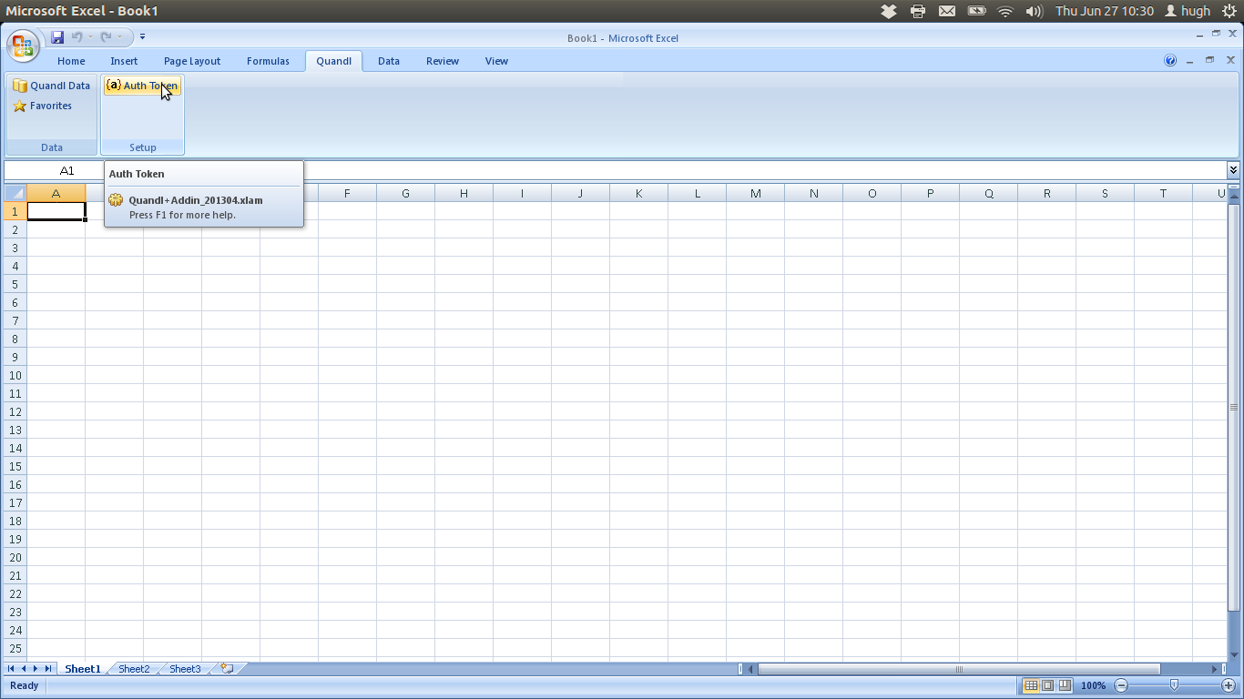

1. Once the auth token is entered, datasets can be downloaded using ‘Quandl Data’ and saved as ‘favorites’ but you will need quandl code of each time series to import, this can be found in the ‘Dataset Information’ on the Quandl website for each series.

