My Title

Hugh Gifford1

# AlphaBash

Important Chunks

You can do amazing things with bash. For example, let’s pick a dataset1. …

Now, let’s use the awk language, named after its three creators Alfred Aho, Brian Kernighan, and Peter J. Weinberger around 1977. Note, the quarto chunk has changed language.

I’m going to ask awk to print the first column of this dataframe, followed by a tab, followed by the filename. This could be useful when you want to extract a number of columns from several files and include the filename.

state data/fatalaties.tsv  
al data/fatalaties.tsv  
al data/fatalaties.tsv  
al data/fatalaties.tsv  
al data/fatalaties.tsv  
al data/fatalaties.tsv  
al data/fatalaties.tsv  
al data/fatalaties.tsv  
az data/fatalaties.tsv  
az data/fatalaties.tsv  
az data/fatalaties.tsv  
az data/fatalaties.tsv  
az data/fatalaties.tsv  
az data/fatalaties.tsv  
az data/fatalaties.tsv  
ar data/fatalaties.tsv  
ar data/fatalaties.tsv  
ar data/fatalaties.tsv  
ar data/fatalaties.tsv  
ar data/fatalaties.tsv  
ar data/fatalaties.tsv  
ar data/fatalaties.tsv  
ca data/fatalaties.tsv  
ca data/fatalaties.tsv  
ca data/fatalaties.tsv  
ca data/fatalaties.tsv  
ca data/fatalaties.tsv  
ca data/fatalaties.tsv  
ca data/fatalaties.tsv  
co data/fatalaties.tsv  
co data/fatalaties.tsv  
co data/fatalaties.tsv  
co data/fatalaties.tsv  
co data/fatalaties.tsv  
co data/fatalaties.tsv  
co data/fatalaties.tsv  
ct data/fatalaties.tsv  
ct data/fatalaties.tsv  
ct data/fatalaties.tsv  
ct data/fatalaties.tsv  
ct data/fatalaties.tsv  
ct data/fatalaties.tsv  
ct data/fatalaties.tsv  
de data/fatalaties.tsv  
de data/fatalaties.tsv  
de data/fatalaties.tsv  
de data/fatalaties.tsv  
de data/fatalaties.tsv  
de data/fatalaties.tsv  
de data/fatalaties.tsv  
fl data/fatalaties.tsv  
fl data/fatalaties.tsv  
fl data/fatalaties.tsv  
fl data/fatalaties.tsv  
fl data/fatalaties.tsv  
fl data/fatalaties.tsv  
fl data/fatalaties.tsv  
ga data/fatalaties.tsv  
ga data/fatalaties.tsv  
ga data/fatalaties.tsv  
ga data/fatalaties.tsv  
ga data/fatalaties.tsv  
ga data/fatalaties.tsv  
ga data/fatalaties.tsv  
id data/fatalaties.tsv  
id data/fatalaties.tsv  
id data/fatalaties.tsv  
id data/fatalaties.tsv  
id data/fatalaties.tsv  
id data/fatalaties.tsv  
id data/fatalaties.tsv  
il data/fatalaties.tsv  
il data/fatalaties.tsv  
il data/fatalaties.tsv  
il data/fatalaties.tsv  
il data/fatalaties.tsv  
il data/fatalaties.tsv  
il data/fatalaties.tsv  
in data/fatalaties.tsv  
in data/fatalaties.tsv  
in data/fatalaties.tsv  
in data/fatalaties.tsv  
in data/fatalaties.tsv  
in data/fatalaties.tsv  
in data/fatalaties.tsv  
ia data/fatalaties.tsv  
ia data/fatalaties.tsv  
ia data/fatalaties.tsv  
ia data/fatalaties.tsv  
ia data/fatalaties.tsv  
ia data/fatalaties.tsv  
ia data/fatalaties.tsv  
ks data/fatalaties.tsv  
ks data/fatalaties.tsv  
ks data/fatalaties.tsv  
ks data/fatalaties.tsv  
ks data/fatalaties.tsv  
ks data/fatalaties.tsv  
ks data/fatalaties.tsv  
ky data/fatalaties.tsv  
ky data/fatalaties.tsv  
ky data/fatalaties.tsv  
ky data/fatalaties.tsv  
ky data/fatalaties.tsv  
ky data/fatalaties.tsv  
ky data/fatalaties.tsv  
la data/fatalaties.tsv  
la data/fatalaties.tsv  
la data/fatalaties.tsv  
la data/fatalaties.tsv  
la data/fatalaties.tsv  
la data/fatalaties.tsv  
la data/fatalaties.tsv  
me data/fatalaties.tsv  
me data/fatalaties.tsv  
me data/fatalaties.tsv  
me data/fatalaties.tsv  
me data/fatalaties.tsv  
me data/fatalaties.tsv  
me data/fatalaties.tsv  
md data/fatalaties.tsv  
md data/fatalaties.tsv  
md data/fatalaties.tsv  
md data/fatalaties.tsv  
md data/fatalaties.tsv  
md data/fatalaties.tsv  
md data/fatalaties.tsv  
ma data/fatalaties.tsv  
ma data/fatalaties.tsv  
ma data/fatalaties.tsv  
ma data/fatalaties.tsv  
ma data/fatalaties.tsv  
ma data/fatalaties.tsv  
ma data/fatalaties.tsv  
mi data/fatalaties.tsv  
mi data/fatalaties.tsv  
mi data/fatalaties.tsv  
mi data/fatalaties.tsv  
mi data/fatalaties.tsv  
mi data/fatalaties.tsv  
mi data/fatalaties.tsv  
mn data/fatalaties.tsv  
mn data/fatalaties.tsv  
mn data/fatalaties.tsv  
mn data/fatalaties.tsv  
mn data/fatalaties.tsv  
mn data/fatalaties.tsv  
mn data/fatalaties.tsv  
ms data/fatalaties.tsv  
ms data/fatalaties.tsv  
ms data/fatalaties.tsv  
ms data/fatalaties.tsv  
ms data/fatalaties.tsv  
ms data/fatalaties.tsv  
ms data/fatalaties.tsv  
mo data/fatalaties.tsv  
mo data/fatalaties.tsv  
mo data/fatalaties.tsv  
mo data/fatalaties.tsv  
mo data/fatalaties.tsv  
mo data/fatalaties.tsv  
mo data/fatalaties.tsv  
mt data/fatalaties.tsv  
mt data/fatalaties.tsv  
mt data/fatalaties.tsv  
mt data/fatalaties.tsv  
mt data/fatalaties.tsv  
mt data/fatalaties.tsv  
mt data/fatalaties.tsv  
ne data/fatalaties.tsv  
ne data/fatalaties.tsv  
ne data/fatalaties.tsv  
ne data/fatalaties.tsv  
ne data/fatalaties.tsv  
ne data/fatalaties.tsv  
ne data/fatalaties.tsv  
nv data/fatalaties.tsv  
nv data/fatalaties.tsv  
nv data/fatalaties.tsv  
nv data/fatalaties.tsv  
nv data/fatalaties.tsv  
nv data/fatalaties.tsv  
nv data/fatalaties.tsv  
nh data/fatalaties.tsv  
nh data/fatalaties.tsv  
nh data/fatalaties.tsv  
nh data/fatalaties.tsv  
nh data/fatalaties.tsv  
nh data/fatalaties.tsv  
nh data/fatalaties.tsv  
nj data/fatalaties.tsv  
nj data/fatalaties.tsv  
nj data/fatalaties.tsv  
nj data/fatalaties.tsv  
nj data/fatalaties.tsv  
nj data/fatalaties.tsv  
nj data/fatalaties.tsv  
nm data/fatalaties.tsv  
nm data/fatalaties.tsv  
nm data/fatalaties.tsv  
nm data/fatalaties.tsv  
nm data/fatalaties.tsv  
nm data/fatalaties.tsv  
nm data/fatalaties.tsv  
ny data/fatalaties.tsv  
ny data/fatalaties.tsv  
ny data/fatalaties.tsv  
ny data/fatalaties.tsv  
ny data/fatalaties.tsv  
ny data/fatalaties.tsv  
ny data/fatalaties.tsv  
nc data/fatalaties.tsv  
nc data/fatalaties.tsv  
nc data/fatalaties.tsv  
nc data/fatalaties.tsv  
nc data/fatalaties.tsv  
nc data/fatalaties.tsv  
nc data/fatalaties.tsv  
nd data/fatalaties.tsv  
nd data/fatalaties.tsv  
nd data/fatalaties.tsv  
nd data/fatalaties.tsv  
nd data/fatalaties.tsv  
nd data/fatalaties.tsv  
nd data/fatalaties.tsv  
oh data/fatalaties.tsv  
oh data/fatalaties.tsv  
oh data/fatalaties.tsv  
oh data/fatalaties.tsv  
oh data/fatalaties.tsv  
oh data/fatalaties.tsv  
oh data/fatalaties.tsv  
ok data/fatalaties.tsv  
ok data/fatalaties.tsv  
ok data/fatalaties.tsv  
ok data/fatalaties.tsv  
ok data/fatalaties.tsv  
ok data/fatalaties.tsv  
ok data/fatalaties.tsv  
or data/fatalaties.tsv  
or data/fatalaties.tsv  
or data/fatalaties.tsv  
or data/fatalaties.tsv  
or data/fatalaties.tsv  
or data/fatalaties.tsv  
or data/fatalaties.tsv  
pa data/fatalaties.tsv  
pa data/fatalaties.tsv  
pa data/fatalaties.tsv  
pa data/fatalaties.tsv  
pa data/fatalaties.tsv  
pa data/fatalaties.tsv  
pa data/fatalaties.tsv  
ri data/fatalaties.tsv  
ri data/fatalaties.tsv  
ri data/fatalaties.tsv  
ri data/fatalaties.tsv  
ri data/fatalaties.tsv  
ri data/fatalaties.tsv  
ri data/fatalaties.tsv  
sc data/fatalaties.tsv  
sc data/fatalaties.tsv  
sc data/fatalaties.tsv  
sc data/fatalaties.tsv  
sc data/fatalaties.tsv  
sc data/fatalaties.tsv  
sc data/fatalaties.tsv  
sd data/fatalaties.tsv  
sd data/fatalaties.tsv  
sd data/fatalaties.tsv  
sd data/fatalaties.tsv  
sd data/fatalaties.tsv  
sd data/fatalaties.tsv  
sd data/fatalaties.tsv  
tn data/fatalaties.tsv  
tn data/fatalaties.tsv  
tn data/fatalaties.tsv  
tn data/fatalaties.tsv  
tn data/fatalaties.tsv  
tn data/fatalaties.tsv  
tn data/fatalaties.tsv  
tx data/fatalaties.tsv  
tx data/fatalaties.tsv  
tx data/fatalaties.tsv  
tx data/fatalaties.tsv  
tx data/fatalaties.tsv  
tx data/fatalaties.tsv  
tx data/fatalaties.tsv  
ut data/fatalaties.tsv  
ut data/fatalaties.tsv  
ut data/fatalaties.tsv  
ut data/fatalaties.tsv  
ut data/fatalaties.tsv  
ut data/fatalaties.tsv  
ut data/fatalaties.tsv  
vt data/fatalaties.tsv  
vt data/fatalaties.tsv  
vt data/fatalaties.tsv  
vt data/fatalaties.tsv  
vt data/fatalaties.tsv  
vt data/fatalaties.tsv  
vt data/fatalaties.tsv  
va data/fatalaties.tsv  
va data/fatalaties.tsv  
va data/fatalaties.tsv  
va data/fatalaties.tsv  
va data/fatalaties.tsv  
va data/fatalaties.tsv  
va data/fatalaties.tsv  
wa data/fatalaties.tsv  
wa data/fatalaties.tsv  
wa data/fatalaties.tsv  
wa data/fatalaties.tsv  
wa data/fatalaties.tsv  
wa data/fatalaties.tsv  
wa data/fatalaties.tsv  
wv data/fatalaties.tsv  
wv data/fatalaties.tsv  
wv data/fatalaties.tsv  
wv data/fatalaties.tsv  
wv data/fatalaties.tsv  
wv data/fatalaties.tsv  
wv data/fatalaties.tsv  
wi data/fatalaties.tsv  
wi data/fatalaties.tsv  
wi data/fatalaties.tsv  
wi data/fatalaties.tsv  
wi data/fatalaties.tsv  
wi data/fatalaties.tsv  
wi data/fatalaties.tsv  
wy data/fatalaties.tsv  
wy data/fatalaties.tsv  
wy data/fatalaties.tsv  
wy data/fatalaties.tsv  
wy data/fatalaties.tsv  
wy data/fatalaties.tsv  
wy data/fatalaties.tsv

# Analysing the data

Once you’ve cleaned the data, it can be loaded into R and sorted using R verbs and plotted using ggplot2.

I’m just showing a figure here as an example2.

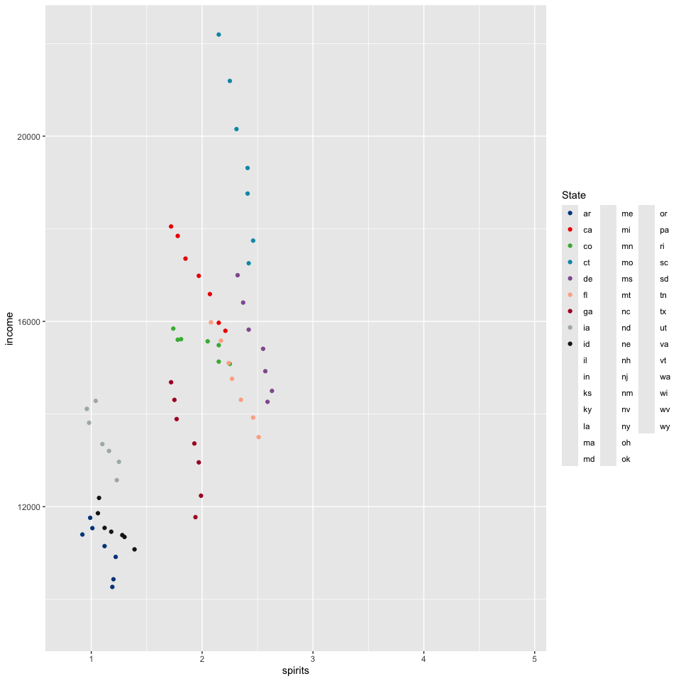

1. Stephenson, J. C., Garza, D. R. & Bouklas, T. [A Fungus for Our Time: *Candida auris* Emerges into the Anthropocene](https://doi.org/10.1007/s40475-023-00293-w). *Current Tropical Medicine Reports* **10**, 244–251 (2023).

2. Heymann, P. *et al.* [The Siderophore iron transporter of *Candida albicans* (Sit1p/Arn1p) mediates uptake of ferrichrome-type siderophores and Is required for epithelial invasion](https://doi.org/10.1128/iai.70.9.5246-5255.2002). *Infection and Immunity* **70**, 5246–5255 (2002).