Hugh Han

Marc Feldman

Matthew Cowen-Green

Seung Hwan Lee

**UI Sketch**

Starting the Game

In the beginning of the game, the user will be prompted if he would like to start a new game or load an existing game. If he chooses to load an existing game, then he will be prompted to enter the file location and name of the existing game. This may throw an error, and in that case, he will be prompted again if would like to start a new game or load an existing game.

If the user chooses to start a new game, then he will be prompted to first enter the name of this game, and then enter the number of total players (including both humans and computers). He will then be prompted to enter the names of each player, and whether they are humans or computers.

Playing the Game

This game will be a pass-and-play-type game. Player 1 starts the game. The visual representation of the game from the current player’s point of view will be printed to the screen. Player 1 will then have several options of moves he would like to make. He will first be prompted which of his cards (from his hand, discard pile, stockpile) that he would like to move into a different pile. He will then be prompted to which pile he would like to move the selected card. If the player attempts to make an invalid move (such as trying to move something from the discard pile to you hand, or moving the 5 card to a build pile with 7 at the top), he will be told that his proposed move is illegal and that he should make another move. After every move, the visual representation of the game from the current player’s point of view will be printed again. When the current player feels that he does not have any more moves, he ends his turn by moving a card from his hand to the discard pile, and his turn ends. He is told to pass the game to the next player, and upon receiving confirmation that this has happened, the next player’s turn begins. The next player now follows the same process.

When it is a computer player’s turn, the computer will make its moves, and once it finishes its turn, the next player’s turn begins.

Ending the Game

Players will have the option to quit the game by pressing ‘q’. Whenever the game is quit the user will be prompted if he/she would like to save the game. When a player has used all of the cards in his/her stockpile, the game will automatically end and a winner will be declared.

Example Run

Welcome to Skip-Bo!

1. Start New Game

2. Load Game

3. Quit

Choice: 4

Error: Invalid Choice. Please make a valid choice.

1. Start New Game

2. Load Game

3. Quit

Choice: 1

Starting New Game…

Please enter the number of players:

4

Please enter the name of the 1st player:

Player1

Is Player1 a human or a computer?

Human

Please enter the name of the 2nd player:

Player2

Is Player2 a human or a computer?

Computer

Please enter the name of the 3rd player:

Player3

Is Player3 a human or a computer?

Computer

Please enter the name of the 4th player:

Player4

Is Player4 a human or a computer?

Computer

How many cards do you want in each stockpile (default is 30)?

5

Player1’s turn (press any key to start turn)

(Press q to quit the game)

Player2 Player3 Player4

(5) Discard (5) Discard (5) Discard

5 - - - - 12 - - - - 2 - - - -

[a] [b] [c] [d]

Build Piles - - - -

Player1

Hand Discard Piles Stockpile

[1] [2] [3] [4] [5] [6] [7] [8] [9] [0]

1 6 W 3 5 - - - - 4 (5)

Select pile to move from:

1

Select pile to move to:

a

Player2 Player3 Player4

(5) Discard (5) Discard (5) Discard

5 - - - - 12 - - - - 2 - - - -

[a] [b] [c] [d]

Build Piles 1 - - -

Player1

Hand Discard Piles Stockpile

[1] [2] [3] [4] [5] [6] [7] [8] [9] [0]

- 6 W 3 5 - - - - 4 (5)

Select pile to move from:

3

Select pile to move to:

a

Player2 Player3 Player4

(5) Discard (5) Discard (5) Discard

5 - - - - 12 - - - - 2 - - - -

[a] [b] [c] [d]

Build Piles 2 - - -

Player1

Hand Discard Piles Stockpile

[1] [2] [3] [4] [5] [6] [7] [8] [9] [0]

- 6 - 3 5 - - - - 4 (5)

Select pile to move from:

4

Select pile to move to:

a

Player2 Player3 Player4

(5) Discard (5) Discard (5) Discard

5 - - - - 12 - - - - 2 - - - -

[a] [b] [c] [d]

Build Piles 3 - - -

Player1

Hand Discard Piles Stockpile

[1] [2] [3] [4] [5] [6] [7] [8] [9] [0]

- 6 - - 5 - - - - 4 (5)

Select pile to move from:

0

Select pile to move to:

a

Player2 Player3 Player4

(5) Discard (5) Discard (5) Discard

5 - - - - 12 - - - - 2 - - - -

[a] [b] [c] [d]

Build Piles 4 - - -

Player1

Hand Discard Piles Stockpile

[1] [2] [3] [4] [5] [6] [7] [8] [9] [0]

- 6 - - 5 - - - - 11 (4)

Select pile to move from:

5

Select pile to move to:

a

Player2 Player3 Player4

(5) Discard (5) Discard (5) Discard

5 - - - - 12 - - - - 2 - - - -

[a] [b] [c] [d]

Build Piles 5 - - -

Player1

Hand Discard Piles Stockpile

[1] [2] [3] [4] [5] [6] [7] [8] [9] [0]

- 6 - - - - - - - 11 (4)

Select pile to move from:

2

Select pile to move to:

a

Player2 Player3 Player4

(5) Discard (5) Discard (5) Discard

5 - - - - 12 - - - - 2 - - - -

[a] [b] [c] [d]

Build Piles 6 - - -

Player1

Hand Discard Piles Stockpile

[1] [2] [3] [4] [5] [6] [7] [8] [9] [0]

9 10 11 12 12 - - - - 11 (4)

Select pile to move from:

5

Select pile to move to:

6

Player2 Player3 Player4

(5) Discard (5) Discard (5) Discard

5 - - - - 12 - - - - 2 - - - -

[a] [b] [c] [d]

Build Piles 6 - - -

Player1

Hand Discard Piles Stockpile

[1] [2] [3] [4] [5] [6] [7] [8] [9] [0]

9 10 11 12 - 12 - - - 11 (4)

Select pile to move from:

5

Select pile to move to:

6

Player2 Player3 Player4

(5) Discard (5) Discard (5) Discard

5 8 - - - 12 3 - - - 2 9 - - -

[a] [b] [c] [d]

Build Piles 10 3 - -

Player1

Hand Discard Piles Stockpile

[1] [2] [3] [4] [5] [6] [7] [8] [9] [0]

9 10 11 12 W 12 - - - 11 (4)

Select pile to move from:

0

Select pile to move to:

a

Player2 Player3 Player4

(5) Discard (5) Discard (5) Discard

5 8 - - - 12 3 - - - 2 9 - - -

[a] [b] [c] [d]

Build Piles 11 3 - -

Player1

Hand Discard Piles Stockpile

[1] [2] [3] [4] [5] [6] [7] [8] [9] [0]

9 10 11 12 W 12 - - - 12 (3)

Select pile to move from:

0

Select pile to move to:

a

Player2 Player3 Player4

(5) Discard (5) Discard (5) Discard

5 8 - - - 12 3 - - - 2 9 - - -

[a] [b] [c] [d]

Build Piles - 3 - -

Player1

Hand Discard Piles Stockpile

[1] [2] [3] [4] [5] [6] [7] [8] [9] [0]

9 10 11 12 W 12 - - - 1 (3)

Select pile to move from:

0

Select pile to move to:

a

Player2 Player3 Player4

(5) Discard (5) Discard (5) Discard

5 8 - - - 12 3 - - - 2 9 - - -

[a] [b] [c] [d]

Build Piles 1 3 - -

Player1

Hand Discard Piles Stockpile

[1] [2] [3] [4] [5] [6] [7] [8] [9] [0]

9 10 11 12 W 12 - - - 2 (2)

Select pile to move from:

0

Select pile to move to:

a

Player2 Player3 Player4

(5) Discard (5) Discard (5) Discard

5 8 - - - 12 3 - - - 2 9 - - -

[a] [b] [c] [d]

Build Piles 2 3 - -

Player1

Hand Discard Piles Stockpile

[1] [2] [3] [4] [5] [6] [7] [8] [9] [0]

9 10 11 12 W 12 - - - 3 (1)

Select pile to move from:

0

Select pile to move to:

a

Player2 Player3 Player4

(5) Discard (5) Discard (5) Discard

5 8 - - - 12 3 - - - 2 9 - - -

[a] [b] [c] [d]

Build Piles 3 3 - -

Player1

Hand Discard Piles Stockpile

[1] [2] [3] [4] [5] [6] [7] [8] [9] [0]

9 10 11 12 W 12 - - - - (0)

GAME OVER! Player1 has won the game!

**Class diagram**

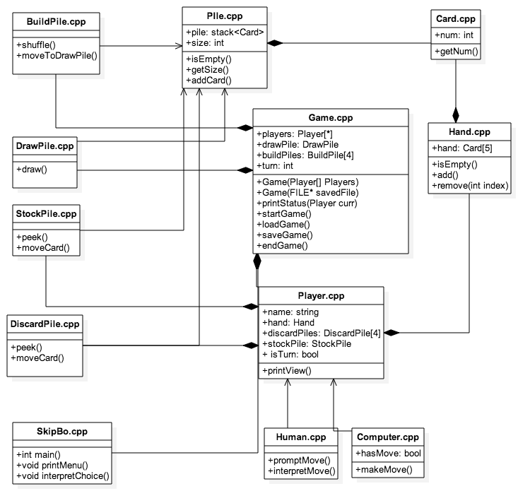

**Class overview**

*SkipBo.cpp*

This class is responsible for starting the program, and prompting the user on how he/she would like to start the game. For example, it will ask whether he/she wants to start a new game or load a game, how many players, etc. After the user answers the prompts, SkipBo.cpp creates a new Game.

*Game.cpp*

This class is the class that controls the flow of the entire game. It contains an array of players, which represents all of the players in the game. It also contains data about whose turn it currently is, functions to start, save, load, and end the game.

*Player.cpp*

This class represents an individual player in the game. Each player can either be a Human or a Computer, and has a name, multiple data structures containing its hand and card piles, and a Boolean value representing if it is currently this player’s turn. printView() is used to print out the current player’s view of the game by calling printStatus(this) from the Game class, and setTurn() is used to switch the Boolean value of this player’s turn.

*Human.cpp*

This class represents a human player. A human player will have its view printed to the screen after each move, and then prompted to make a move. A turn is ended by pressing ‘e’, and the user will then be prompted to move a card from his hand into the discard pile.

*Computer.cpp*

This class represents a computer player. A computer player checks if it has any moves left this turn, and makes moves only if it does have valid moves left. Otherwise, it ends its turn and moves a random card from its hand into a random discard pile.

*Card.cpp*

This class represents a card, which only contains an integer value and a method to see this value.

*Pile.cpp*

This is an abstract class, and represents a stack of cards.

*BuildPile.cpp*

This is an implementation of a Pile, and represents the build pile that players build upon. A BuildPile can only be added to if the cards being added are valid. When a BuildPile reaches a Card containing 12, that BuildPile will be shuffled and then moved to the bottom of the draw pile.

*DrawPile.cpp*

This is an implementation of a Pile, and represents the draw pile that players draw from. A DrawPile can only be added to from a BuildPile, when that BuildPile is full. At the beginning of the game, cards from the DrawPile will be dealt out so that each player has a Hand containing 5 cards. At the end of a player’s turn, cards from the DrawPile will be added to that player’s hand until he/she has 5 cards.

*StockPile.cpp*

This is an implementation of a Pile, and represents the pile that each player must get rid of to win the game. When a StockPile becomes empty, the Player owning that StockPile will be declared the winner, and the game will be ended.

DiscardPile.cpp

This is an implementation of a Pile, and represents one of four discard piles that each player has. Cards can be moved to this pile at the end of each player’s turn, and cards in a DiscardPile can be moved to a BuildPile if those cards are valid.

**Implementation Plan**

The most challenging part of this project will most likely be determining how to game will run, and how the structure should be designed. The roles described below will most likely change as the project progresses, and they will be just a rough idea of what each team member will be responsible for.

Coding will most likely be done in pairs, and the team will meet up approximately twice a week.

Team Members; Roles

*Hugh & Marc*

First, we will figure out how to implement Card.cpp, Pile.cpp and Hand.cpp. Afterwards, we will work on Human.cpp. After these are all finished, we will join up with Matthew & Seung Hwan to all work together on the rest of the game.

*Matthew & Seung Hwan*

First, we will figure out how to implement Player.cpp. Afterwards we will work on Computer.cpp. After these are all finished, we will join up with Hugh & Marc to all work together on the rest of the game.

|  |  |
| --- | --- |
| Dates | Events & Deadlines |
| 4/18/2015 | Discuss project; start Part A |
| 4/20/2015 | Finish Part A |
| 4/22/2015 | Finish implementing Card.cpp, Pile.cpp, Hand.cpp, and Player.cpp |
| 4/25/2015 | Finish implementing Human.cpp and Computer.cpp |
| 4/27/2015 | Discuss progress of Game.cpp and integrate code |
| 4/29/2015 | Finish Game.cpp with few bugs |
| 4/30/2015 | Finish testing Game.cpp; finish SkipBo.cpp |
| 5/01/2015 | Finish testing entire program as a whole |